How accurately does the Australian Immunisation Register identify children overdue for vaccine doses?
A national cross-sectional study
Lauren G Dalton, Kelley N Meder, Frank H Beard, Aditi Dey, Brynley P Hull, Kristine K Macartney, Peter B McIntyre

Abstract
The accuracy of data recorded in the Australian Immunisation Register (AIR) is important for assessment of population-level vaccine coverage but has not been assessed nationally since 2001. We undertook a cross-sectional study in five states in 2017 using standard criteria to validate AIR records classified as three months overdue for any vaccine at 12, 24 and 48 months. Of 2,000 records selected for audit, 905 were assessable, of which 124 (14%) were misclassified as overdue (errors). Among 563 general practice (GP) records, 91 (16.1%) were errors. Compared with Victoria (1/99; 1%), errors were significantly higher in Western Australia (11/106; 10.4%), Queensland (13/104; 12.5%), South Australia (23/110; 20.9%) and New South Wales (43/144; 29.9%); p < 0.01 for all. Among 165 council and community health centre providers, the overall error rate (17; 10.3%) was non-significantly lower than for GP providers, with an odds ratio (OR) of 0.6 and a 95% confidence interval (95% CI) of 0.3–1.1, and did not differ between states. Records were transmitted to the AIR by paper-based methods in 13 cases, with significantly higher error rates (7/13; 54%) than for practice management software (77/630; 12.2%); OR 9.8 (95% CI 2.8–36.4) or the AIR secure site (23/87; 26.4%); OR 2.6 (95% CI 1.4–4.5). Accuracy is increasingly important, with mandatory reporting to the AIR for all National Immunisation Program vaccines from July 2021, and best achieved by uniform use of practice management software.
Keywords: immunisation coverage; immunisation register; audit; accuracy

Introduction
Australia is one of very few countries to have had a national immunisation register in place for over 20 years.¹ Beginning as the Australian Childhood Immunisation Register (ACIR) from 1996, it was built on the platform of the Medicare database, with all people registered with Medicare (estimated to be around 99% of the resident population) automatically included.² Vaccines given to non-Medicare card holders were also able to be recorded. In late 2016, the ACIR became the Australian Immunisation Register (AIR), recording vaccines given to people of all ages.
Accuracy of the AIR is important at multiple levels. First, for individual families, Australia is almost unique in using data on the immunisation status of children to determine eligibility for federal government childcare and other family benefits.³ Second, in 2016, medical contraindications became the only exception to vaccination requirements for benefit eligibility, and required certification by a general practitioner. Third, assessment of vaccination coverage targets overall, and at state and primary health network levels, relies on the accuracy of the AIR.⁴ Fourth, AIR data is essential, with other data, to monitor vaccine effectiveness and safety.
The effectiveness of the transfer of the data to the ACIR/AIR has not been systematically assessed at national level since a study in 2001 estimated that true rates of complete immunisation were about 3% higher than those derived from ACIR records.⁵ Subsequently, one study at state level (New South Wales [NSW], 2017)⁶ and regional studies in NSW^{7–9} and Western Australia (WA)¹⁰ have identified key issues impacting on the accuracy of data held by AIR. These include failure to capture data on children vaccinated overseas; inaccuracies in data entry; problems with data transmission from practice software to the AIR; and issues managing data after successful transmission to the AIR.
The aims of this study were: first, to quantify the accuracy of AIR data relating to children recorded as overdue for vaccines from a representative national sample; and, second, among children with inaccurate records, to identify patterns by area of residence, provider type and method of data transfer indicating potential for improvements. Continuous quality improvement is important, as inaccurate AIR records can cause significant challenges for individual families and their immunisation providers, and a national 95% coverage target leaves little room for error.

Methods
Detailed methods are provided in an initial report on this study available online.¹¹ Briefly, a cross-sectional sample of 2000 was randomly selected from children in four age groups (9 to < 12 , 15 to 18, 21 to 24 and 51 to 54 months of age) who, based on AIR data, were at least three months overdue on 4 October 2017 for at least one vaccine required by the National Immunisation Program (NIP) schedule. A sample of 400 records was selected in each of the five states which agreed to participate (NSW, Queensland, Victoria, South Australia [SA] and WA), with further stratification to select 50% (200) residing in low vaccine coverage (< 90%) postcodes, 20% (80) in high coverage (> 95%) postcodes and 30% (120) in postcodes with coverage of 90–95%. At the beginning of the study, the Northern Territory (NT) also agreed to participate; but, due to the now-discontinued practice of recording birth Hepatitis B under “baby of”, was so different from the record-keeping practices of other jurisdictions that data could not be meaningfully combined with other sites.¹¹ The number of records in each coverage category across the four age groups was selected based on the overall distribution of children recorded as overdue in AIR by age group. A sample of 400 provided 80% power to identify differences of 5% or more in the prevalence of up to two variables of interest (e.g. age group and coverage level, error type, provider type) in each state. Participating centres (Primary Health Networks and/or health departments) in each state were assigned equivalent numbers of records; these centres then followed specified procedures for contact with, and interview of, providers or parents over a seven-week period.¹¹ First, contact was attempted with the last known immunisation provider or, if no provider was listed, the parent/carer. If contact was made, a standard, pre-piloted questionnaire was used, with interviews following a written script. Records were defined using pre-determined criteria as ‘accurate’ (child truly overdue for the relevant antigen and dose) or ‘inaccurate’ (child up to date for the relevant antigen and dose). Other variables collected included Aboriginal and Torres Strait Islander status; provider type; method of data transfer to AIR; vaccine antigen and dose number; and geographic remoteness.¹¹ Frequency counts were generated at national and state level; error rates were calculated as the proportion of children’s AIR records which were not truly overdue for each category of interest.
We examined univariate associations between a record being misclassified as overdue and the explanatory variables provider type, state of residence and mode of transmission (paper records vs practice management software) using Fisher’s exact test with a p value < 0.05 considered significant.
Ethical approval was granted by Australian National University Human Research Ethics Committee (#2017/370).

Results
Of 400 eligible records in each of the five states (2,000), a subtotal of 892 (44.6%) had no data available, mainly due to provider or parent/carer contact not achieved (830/892; 93.0%) or to the family moving interstate or overseas (44/892; 5.0%). Only 14 families (< 1% of total) refused to participate. Of the remaining 1108 children, 203 were excluded because the child was no longer recorded as overdue in the AIR, leaving 905/2000 assessable records (45.2%) (Figure 1).
Figure 1: Process to identify assessable overdue records
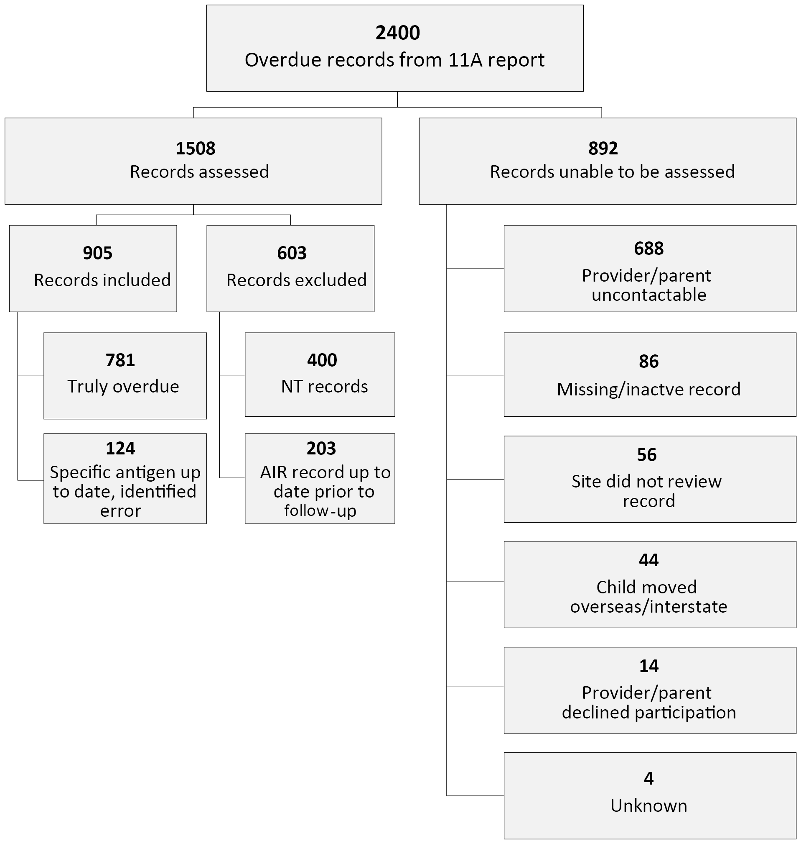

Providers and transfer methods
Among assessable records, provider type was specified in 775/905 (85.6%). General practitioners (GPs) were the largest group (563/775; 62%); followed by public sector providers (councils and community health centres) which accounted for 165 records (21%); with 47 (6%)records grouped under other provider categories, including Aboriginal health workers, hospitals, public health departments and the Royal Flying Doctor Service. The proportion of children immunised by GP providers varied substantially by state: this proportion was less than 70% in three states [WA 106/168 (63.1%), SA 110/164 (67.0%) and Victoria 99/147 (67.3%)]; more than 75% in Queensland (104/135; 77.0%); and almost 90% in NSW (144/161; 89.4%). The method by which records were transmitted to the AIR was known in 748 cases (83%). The most common method was practice management software (PMS), in 640 (85.6%) cases, with much smaller numbers transmitted via the AIR secure site (87; 11.6%) and paper records (13; 1.7%).

Records misclassified as overdue
With respect to accuracy, 781 (86%) of 905 records were assessed as truly overdue (that is, accurate) and 124 (14%) as inaccurate because the child was confirmed as up to date for the relevant vaccine. Among these 124 inaccurate records, the source of error in 34/124 instances (27%) was a duplicate record in the AIR database. Of 90 inaccurate records excluding duplicates, 72/90 (80%) were transferred to the AIR via PMS; 11/90 (14%) via the AIR secure site; and 7/90 (8%) using paper forms. The error rate by state, in ascending order for all 124 inaccurate records including duplicates, was 2.6% (4) in Victoria; 8.5% (19) in Queensland; 10.4% (18) in WA; 19.2% (36) in SA; and 29% (47) in NSW (Table 1). Among records transmitted via PMS, practice-level data entry errors were identified in 27/72 instances (37.5%), with the most common being incorrect vaccine name or dose number (8); overseas vaccine history incorrectly recorded (7); and child name or address differing from the Medicare record (6). In 31/72 instances (43.1%), although the encounter was correctly recorded, and identified as sent by PMS, it did not appear in the AIR.
Table 1: Status of overdue AIR records, post audit, by state
Category | Stateª |  |  |  |  | Total
 | NSW | Qld | SA | Vic. | WA
Confirmed error (up to date) | 47 | 19 | 36 | 4 | 18 | 124
Confirmed overdue | 118 | 205 | 152 | 151 | 155 | 781
Total | 165 | 224 | 188 | 155 | 173 | 905
Error rate (%)^{b} | 28.5% | 8.5% | 19.2% | 2.6% | 10.4% | 13.7%
a Qld: Queensland; Vic.: Victoria.
b Number of records up to date (ie confirmed error) divided by the total records in each jurisdiction, multiplied by 100.

Error rate by vaccine coverage level and age group
At a national level, the error rate was similar in areas with different vaccine coverage levels (< 90% = 14.1%; 90–95% = 14.2%; > 95% 12.1%) but differed by age group, being almost twice as high in the youngest age cohort of 9 to < 12 months (20.8% of 173), compared to around 12% among the older age groups (range 11.8 to 12.3%).
Error rate by remoteness, provider type, method of transfer to AIR and state is shown in Table 2.

Table 2: Inaccurate AIR records by provider type, remoteness, and method of transmission to AIR
 | Known provider typeª |  | Remoteness | Method of transmission
 | GP  inaccurate/total  (%) | Public sector^{b}  inaccurate/total  (%) | Remote areas  inaccurate/total  (%) | PMS^{c}  inaccurate/total  (%) | Paper forms  inaccurate/total  (%)
NSW (N = 165)^{d} | 43/144 (29.9%) | 0/8 (0%) | 1/8 (12.5%) | 33/128 (25.8%) | 3/5 (60.0%)
Qld (N = 224)^{d} | 13/104 (12.5%) | 2/20 (8.7%) | 0/4 (0%) | 9/101 (8.9%) | 3/3 (100.0%)
SA (N = 188)^{d} | 23/110 (20.9%) | 6/43 (13.0%) | 1/5 (20.0%) | 17/125 (13.6%) | 1/5 (20.0%)
Vic. (N = 155)^{d} | 1/99 (1.0%) | 3/44 (7.1%) | 0/0 (0%) | 4/146 (2.7%) | 0/0 (0%)
WA (N = 173)^{d} | 11/106 (10.4%) | 6/50 (12.0%) | 4/9 (44.4%) | 14/130 (10.8%) | 0/0 (0)%
Total (905)^{d} | 91/563 (16.1%) | 17/165 (10.3%) | 6/26 (23.1%) | 77/630 (12.2%) | 7/13 (53.8%)
a Provider type unknown for 130 records (NSW 4, Qld 89, SA 24, Vic 8, WA 5).
b Public sector providers: councils and Community Health Centres.
c Practice management software.
d Total surveyed in each state for all age groups is not sum of known and unknown provider types; see reference 11 Appendix.

Error rate by remoteness
No children in Victoria lived in remote areas. Among the 26 children in remote areas in other states, the error rate of 23%, although almost twice as high as in regional (13.1% of 145) or urban areas (13.4% of 726), was not statistically significant (OR 2.0; 95% CI 0.63–5.17).

Error rate by method of transfer to AIR
Transfer methods differed by state, with no records transferred using paper forms in Victoria or WA; and no records transmitted from the AIR secure site in Victoria and only 5 in Queensland, compared with 40 in SA, 31 in WA and 24 in NSW. Compared to the error rate for PMS (77/630; 12.2%), errors in records transferred via paper-based forms (7/13; 54%) and the AIR secure site (23/87; 26.4%) were significantly increased (OR 2.6; 95% CI 1.4–4.5 and 9.8; 95% CI 2.8–36.4 respectively).

Error rate by provider category
The error rate was lowest for councils and community health centres (17/165; 10.3%) and the rate among GPs was non-significantly higher (91/563; 16.2%; OR 1.7; 95% CI 0.95–3.1). Errors among other provider categories, many in remote locations, were significantly more common (13/44; 29.5%; OR 3.6; 95% CI 1.5–8.9). Among GP providers, error rates varied substantially by state. Compared with the error rate among GPs in Victoria of 1%, those in WA (10.4%), Queensland (12.5%), SA (20.9%) and NSW (29.9%) were all significantly higher (p < 0.01 for all comparisons). Among the largest public sector providers (Councils and Community Health Centres), error rates were much less variable (Table 2) and did not differ significantly from GPs in any state. However, the error rate for data transfers via PMS among all providers in Victoria (2.7%) was significantly lower (p < 0.01) than in any other state (8.9% to 25.8%; Table 2).

Discussion
This study provides the first national analysis on the quality of data in the AIR since 2001. Importantly, erroneous classification of children as overdue for vaccines has steadily improved over the approximately 20 years during which Australia has had an immunisation register recording vaccines given to children, with clear benefits to individuals, immunisation providers and health authorities. In 1997, a NSW study found that over 80% of 12 month old children recorded as overdue on the AIR were up-to-date and had been erroneously classified.¹² This decreased to 56% in the national study in 2001.⁵ Our study found an error rate of 21% for children in the 9 to < 12 months age group, which was highest in NSW (31%) and SA (38%) and lowest in Victoria (7%).¹¹ Our estimate for NSW, based on 35 children in this age group,¹¹ was similar to estimates from a concurrent, but different, sample of 414 NSW children in 2017 (35%), which showed variations within NSW from 12 to 54% by region.⁶ This supports the validity of our estimate, while demonstrating that as well as variation between states, there may be significant regional differences within states which we could not evaluate in our sample. However, unlike the NSW study,¹² we studied a range of age groups, and found that error rates progressively decreased with increasing age to 11% in children in the 51–53 months age group.
Victoria had the lowest estimated all-age AIR record error rate of 2.6%. In Victoria, all records were transmitted via PMS, whereas in other jurisdictions, fewer records (around 80%) were transmitted by PMS and the error rate, from 9% to 26%, was significantly higher. Another potential factor may have been the early introduction of No Jab No Play legislation in Victoria from 2016, which imposed strict immunisation requirements for enrolment in childcare services.¹³ It is plausible that state-based No Jab No Play policies heighten the attention given by parents and immunisation providers to record accurately. If so, as similar policies have been implemented in several states since 2018, error rates may have further reduced since our study. Given its potential importance, this impact would benefit from further assessment. Although numerically small, the higher error rates we identified in remote areas, and for over half of the 13 instances of transmission to the AIR using paper records, have implications for service provision in these settings. Ideally, audits such as ours would be conducted regularly; although resource-intensive, this would provide regular information for quality improvement.
Limitations of our study are that three jurisdictions (NT, Tasmania, and the Australian Capital Territory) were not included, and there are substantial differences between immunisation service delivery by jurisdiction. Our inability to include data from NT limited our capacity to examine AIR accuracy in more remote areas with high Aboriginal and Torres Strait Islander populations. In the five included states, 44% of selected records could not be assessed, primarily due to the immunisation provider, parent or carer not being able to be contacted. Prior to follow-up, 10% of records had already been updated on the AIR, making the child no longer overdue. Our inability to contact the immunisation provider, parent or carer limited our power to examine some relevant sub-groups and may have reduced the representativeness of our study.
However, it is important to emphasise that the proportion of children’s AIR records misclassified as overdue in 2017 represents less than 1%, and in some jurisdictions less than 0.1%, of relevant birth cohorts. This indicates a high level of system performance for providers in general practice, which provides more than 70% of childhood vaccines nationally, and for larger public sector providers such as councils and community health centres. However, as erroneous records can be highly inconvenient for affected families, implementing measures to ensure that all name, address, vaccine name and dose number details are correctly entered is important at the individual level and for the accuracy of population-level coverage. Future technological enhancements, such as use of bar code readers to scan vaccine vials, have the potential to further improve the accuracy of data entry.¹⁴ Accuracy of reporting to AIR will become increasingly important, as mandatory reporting to the AIR has been legislated and commenced for all coronavirus disease 2019 (COVID-19) vaccines from February 2021, followed by influenza vaccines and NIP vaccines in March 2021 and July 2021 respectively.¹⁵

Author details
Ms Lauren G Dalton,¹ Immunisation Liaison Officer
Ms Kelley N Meder,^{1,2} Master of Philosophy (Applied Epidemiology) Scholar
Dr Frank H Beard,^{1,3} Associate Director
Dr Aditi Dey,^{1,3} Senior Research Fellow
Mr Brynley P Hull,¹ Epidemiologist
Prof Kristine K Macartney,^{1,3} Director
Prof Peter B McIntyre,^{1,3} Professorial Fellow

- National Centre for Immunisation Research and Surveillance, Westmead, NSW, Australia
- Australian National University, Canberra, ACT, Australia
- The University of Sydney, NSW, Australia

Corresponding author
Lauren G Dalton
National Centre for Immunisation Research and Surveillance,
Kids Research, Sydney Children’s Hospitals Network,
Locked Bag 4001, Westmead, NSW 2145 Australia
Email: lauren.dalton@health.nsw.gov.au
Telephone: 0427 815 283

References
- Pebody R. Vaccine registers--experiences from Europe and elsewhere. Euro Surveill. 2012;17(17):20159. doi: https://doi.org/10.2807/ese.17.17.20159-en.
- Hull BP, Deeks SL, McIntyre PB. The Australian Childhood Immunisation Register – a model for universal immunisation registers? Vaccine. 2009;27(37):5054–60. doi: https://doi.org/10.1016/j.vaccine.2009.06.056.
- Ward K, Hull BP, Leask J. Financial incentives for childhood immunisation – a unique but changing Australian initiative. Med J Aust. 2013;198:590–2. See also Med J Aust. 2013;199(1):29.
- Beard FH, Hull BP, Leask J, Dey A, McIntyre PB. Trends and patterns in vaccination objection, Australia, 2002–2013. Med J Aust. 2016;204:275. doi: https://doi.org/10.5694/mja15.01226.
- Lawrence GL, Hull BP, MacIntyre CR, McIntyre PB. Reasons for incomplete immunisation among Australian children: a national survey of parents. Aust Fam Physician. 2004;33(7):568–71.
- Law C, McGuire R, Ferson MJ, Reid S, Gately C, Stephenson J et al. Children overdue for immunisation: a question of coverage or reporting? An audit of the Australian Immunisation Register. Aust N Z J Public Health. 2019;43(3):214–20. doi: https://doi.org/10.1111/1753-6405.12891.
- Botham SJ, Poulos RG, McFarland KJ, Ferson MJ. Getting it right--the Australian Childhood Immunisation Register and immunisation rates in south-eastern Sydney. Aust N Z J Public Health. 2004;28(1):68–71.
- Ferson MJ, Orr K. Some truths about the “low” childhood vaccination coverage in Sydney’s eastern suburbs. Med J Aust. 2015;203(3):153e.1.
- Miles TA, Granger LV, Gately CL. Improving the accuracy of ACIR data and increasing vaccination rates. Commun Dis Intell (2018). 2019;43. doi: https://doi.org/10.33321/cdi.2019.43.46.
- Gibbs RA, Hoskins C, Effler PV. Children with no vaccinations recorded on the Australian Childhood Immunisation Register. Aust N Z J Public Health. 2015;39(3):294–5.
- National Centre for Immunistion Research and Surveillance (NCIRS). Australian Immunisation Register Data Transfer Study: Stage 2 Final Report. August 2018. Sydney: NCIRS; August 2018. Available from: http://ncirs.org.au/sites/default/files/2018-12/2018%20AIR%20data%20tranfer%20report_FINAL_0.pdf.
- Conaty SJ, McAnulty JM. The Australian Childhood Immunisation Register: validation of the immunisation status of children who are very overdue. Aust N Z J Public Health. 2001;25(2):138–40.
- Fielding JE, Bolam B, Danchin MH. Immunisation coverage and socioeconomic status – questioning inequity in the ‘No Jab, No Pay’ policy. Aust N Z J Public Health. 2017;41(5):455–7. doi: https://doi.org/10.1111/1753-6405.12676.
- Chrapkowska C, Galanis I, Kark M, Lepp T, Lindstrand A, Roth A et al. Validation of the new Swedish vaccination register – accuracy and completeness of register data. Vaccine. 2020;38(25):4104–10. doi: https://doi.org/10.1016/j.vaccine.2020.04.020.
- Australian Government Department of Health. Building a stronger Australian Immunisation Register. [Internet.] Canberra: Australian Government Department of Health, The Hon Greg Hunt MP; 5 February 2021. [Accessed on 19 February 2021.] Available from https://www.health.gov.au/ministers/the-hon-greg-hunt-mp/media/building-a-stronger-australian-immunisation-register.

Communicable Diseases Intelligence
ISSN: 2209-6051 Online

Communicable Diseases Intelligence (CDI) is a peer-reviewed scientific journal published by the Office of Health Protection and Response, Department of Health. The journal aims to disseminate information on the epidemiology, surveillance, prevention and control of communicable diseases of relevance to Australia.

Editor: Noel Lally
Deputy Editor: Simon Petrie
Design and Production: Kasra Yousefi
Editorial Advisory Board: David Durrheim, Mark Ferson, John Kaldor, Martyn Kirk and Linda Selvey

Website: http://www.health.gov.au/cdi

Contacts
CDI is produced by the Office of Health Protection and Response, Australian Government Department of Health, GPO Box 9848, (MDP 6) CANBERRA ACT 2601

Email: cdi.editor@health.gov.au

Submit an Article
You are invited to submit your next communicable disease related article to the Communicable Diseases Intelligence (CDI) for consideration. More information regarding CDI can be found at: http://health.gov.au/cdi.
Further enquiries should be directed to: cdi.editor@health.gov.au.

This journal is indexed by Index Medicus and Medline.

Creative Commons Licence - Attribution-NonCommercial-NoDerivatives CC BY-NC-ND
© 2021 Commonwealth of Australia as represented by the Department of Health
This publication is licensed under a Creative Commons Attribution-NonCommercial-NoDerivatives 4.0 International Licence from https://creativecommons.org/licenses/by-nc-nd/4.0/legalcode (Licence). You must read and understand the Licence before using any material from this publication.

Restrictions
The Licence does not cover, and there is no permission given for, use of any of the following material found in this publication (if any):
- the Commonwealth Coat of Arms (by way of information, the terms under which the Coat of Arms may be used can be found at www.itsanhonour.gov.au);
- any logos (including the Department of Health’s logo) and trademarks;
- any photographs and images;
- any signatures; and
- any material belonging to third parties.

Disclaimer
Opinions expressed in Communicable Diseases Intelligence are those of the authors and not necessarily those of the Australian Government Department of Health or the Communicable Diseases Network Australia. Data may be subject to revision.

Enquiries
Enquiries regarding any other use of this publication should be addressed to the Communication Branch, Department of Health, GPO Box 9848, Canberra ACT 2601, or via e-mail to: copyright@health.gov.au

Communicable Diseases Network Australia
Communicable Diseases Intelligence contributes to the work of the Communicable Diseases Network Australia.
http://www.health.gov.au/cdna

