Not everything that can be counted counts: defining and evaluating tuberculosis mortality in Australia
Justin T Denholm on behalf of the National Tuberculosis Advisory Committee

Background
Mortality is a critically important statistic recorded by healthcare services and tuberculosis (TB) programs globally and is used as a marker of the overall effectiveness of management and services.^{1,2} Data on TB mortality are compiled by the World Health Organization and other bodies, and targets for reduction in TB mortality are central to the End TB strategy.^{3,4} However, while death is an objectively defined outcome, there are concerns that classification whether a death is ‘TB-related’ may have significant variation between settings and practitioners.⁵ Although over-inclusive approaches to reporting—such as all-cause mortality within a period following TB disease onset—avoids some issues, it may limit recognition and correction of specific drivers of poor outcome, particularly in settings where TB is frequently co-existing with other potentially fatal conditions. The Australian National Tuberculosis Advisory Committee (NTAC) considers accurate and consistent classification of TB-associated mortality to be a high priority for programmatic monitoring and strengthening, and this consensus statement has been developed to assist in optimising Australian classification and evaluation of death potentially associated with TB.

Classification of mortality in Australia
In Australia, cause of death certification is multi-tiered. A primary cause of death, and antecedent factors leading to the cause of death, are required to be reported.⁶ In addition, medical practitioners certifying death may nominate other conditions present which are judged to have contributed to death, even if they were not directly related to the cause. In theory, such a classification system should allow for consideration of a range of factors relating to death associated with a TB notification. However, there are a variety of reasons jurisdictional TB mortality data may be inaccurate, and classifications vary. Assigning cause of death can be complicated, and frequently clinical judgement plays an important role. Cause of death may be centrally recorded by programmatic staff with a variable amount of direct involvement in management. In some published series with detailed review, up to half of deaths among notified TB cases were not considered primarily caused by TB, so incorrect classification may have substantial impact on mortality and case fatality estimates.⁷ While TB notification is mandatory in Australia, TB programs do not typically have routine access to individualised death certificates or data unless generated by program staff, and so death occurring after treatment completion or loss to follow up may be unrecognised.⁸

Empiric evaluation of TB mortality classification
Prior to developing policy regarding optimal classification, NTAC recognised that understanding variation in classification and the reason for differences was important for improving the reliability and consistency of reported TB-associated mortality. We therefore undertook a survey of clinicians and public health practitioners in Australia to explore variability in TB-associated death classification.⁹ Respondents were presented with a series of hypothetical scenarios involving potentially TB-related death, and asked to classify mortality using several approaches. This survey identified broad consensus in classification where death was directly associated with TB disease progression, such as in the case of death from pulmonary haemorrhage in untreated pulmonary TB. It also found several areas where there was considerable variation in practice, including disagreement regarding the classification of death associated with medication adverse effects, non-microbiologically-confirmed TB, and cardiovascular death occurring during TB treatment.

NTAC consensus statement
Collection of data regarding TB-associated death by programmatic services is primarily to allow opportunities for improvement of response and reduction in mortality. It follows, then, that to be maximally useful, potentially TB-associated death should not be excluded from classification without a clear basis. This committee therefore takes the view that collection of all-cause mortality, supplemented by expert review regarding likely primary cause and secondary contributors to death, is most appropriate.
Jurisdictional TB programs have most ready access to TB-related outcomes during the period of active disease management; that is, from the time of case notification to the intended completion date. The intended completion date may vary, based on factors such as drug susceptibility testing, adherence, initial burden of disease or interruptions to treatment, but will not be less than 180 days from treatment initiation (Figure 1). We intend to maintain this definition even in the event that future treatment protocols allow shorter durations of therapy than currently in use, to support maximal continuity of outcome monitoring. Death occurring during this period should be recorded, whether patients are actively receiving anti-TB therapy at the time of death or not. For programmatic purposes, deaths occurring up to 90 days prior to TB notification should also be included, such as may occur when mycobacterial cultures become positive after death, or where the findings of a post-mortem examination indicate TB.
This committee regards death occurring subsequent to completion of TB therapy as also being an important area for consideration. However, not all jurisdictions will have routine access to outcome data beyond successful completion of therapy, and data may be incomplete. While beyond the remit of this committee, we therefore encourage alternative approaches to assessment of post-TB outcomes in an Australian context including (but not limited to) mortality, such as by data linkage and/or longitudinal studies.

Figure 1: Timeframe for all-cause mortality recording of TB-associated deaths
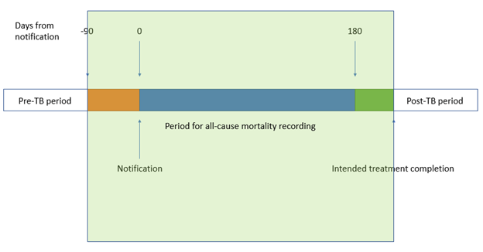

Committee plans for oversight/monitoring/review
Following from this consensus, NTAC will adopt several strategies for ongoing review of TB-associated mortality. This statement will be distributed to jurisdictional TB program managers, in order to support inclusion of all appropriate episodes. NTAC will convene an annual meeting in which a summary of TB-related deaths will be presented for expert review, including classification of whether TB should be considered as the cause of death, a contributor to death, or unrelated to death, and interjurisdictional review focused on potentially-avoidable deaths. A voluntary data collection instrument has been developed to support jurisdictions in this process, and is attached as Appendix A. TB will be considered the cause of death if due to adverse effects to TB medications. Following classification, NTAC will also consider themes and potentially-remediable issues which may support jurisdictional responses to reduce TB mortality in future. Periodically, NTAC will produce summary reports addressing overall and thematic issues relating to TB mortality and interventions to improve outcomes.

Author details

Corresponding author
Professor Justin T Denholm
Victorian Tuberculosis Program
Peter Doherty Institute of Infection and Immunity
792 Elizabeth Street, Melbourne Victoria 3055
Email: justin.denholm@mh.org.au
Phone: +61 3 9342 9428

References
- Tok PSK, Liew SM, Wong LP, Razali A, Loganathan T, Chinna K et al. Determinants of unsuccessful treatment outcomes and mortality among tuberculosis patients in Malaysia: a registry-based cohort study. PLoS One. 2020;15(4):e0231986. doi: https://doi.org/10.1371/journal.pone.0231986.
- Dos Santos DT, Alves LS, Arcoverde MAM, Arroyo LH, Berra TZ, Ramos ACV et al. Social risk and its association with tuberculosis mortality in a context of high inequality in South Brazil: a geo-epidemiology analysis. J Infect Public Health. 2020;13(8):1148–55. doi: https://doi.org/10.1016/j.jiph.2020.03.010.
- MacNeil A, Glaziou P, Sismanidis C, Date A, Maloney S, Floyd K. Global epidemiology of tuberculosis and progress toward meeting global targets—worldwide, 2018. MMWR Morb Mortal Wkly Rep. 2020;69(11):281–5. doi: https://doi.org/10.15585/mmwr.mm6911a2.
- Harding E. WHO global progress report on tuberculosis elimination. Lancet Respir Med. 2020;8(1):19. doi: https://doi.org/10.1016/S2213-2600(19)30418-7.
- Svendsen MT, Bøggild H, Skals RK, Mortensen RN, Kragholm K, Hansen SM et al. Uncertainty in classification of death from fatal myocardial infarction: a nationwide analysis of regional variation in incidence and diagnostic support. PLoS One. 2020;15(7):e0236322. doi: https://doi.org/10.1371/journal.pone.0236322.
- Bird S. How to complete a death certificate – a guide for GPs. Aust Fam Physician. 2011;40(6)446–9.
- Gallivan MD, Lofy KH, Goldbaum GM. Use of death certificates to identify tuberculosis-related deaths in Washington State. J Public Health Manag Pract. 2017;23(2): e12–5. doi: https://doi.org/10.1097/PHH.0b013e3182aaa1d8.
- Dale K, Tay E, Trevan P, Denholm JT. Mortality among tuberculosis cases in Victoria, 2002–2013: case fatality and factors associated with death. Int J Tuberc Lung Dis. 2016;20(4): 515–23. doi: https://doi.org/10.5588/ijtld.15.0659.
- Denholm JT, Marais BJ, Donnan EJ, Waring J, Stapledon R, Taylor JW et al. Tuberculosis mortality: quantifying agreement in clinical cause of death assessments. Aust NZ J Public Health. 2022. doi: https://doi.org/10.1111/1753-6405.13204.

Appendix A: Data collection instrument
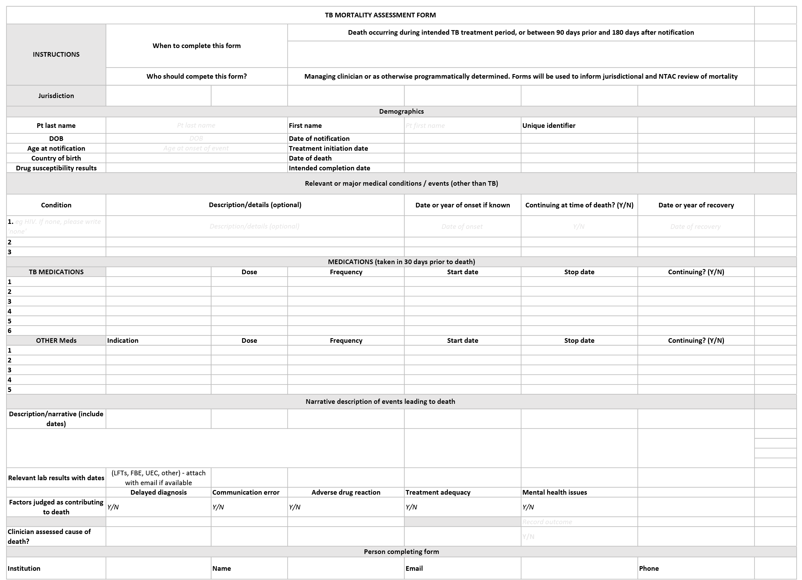
Communicable Diseases Intelligence
ISSN: 2209-6051 Online

Communicable Diseases Intelligence (CDI) is a peer-reviewed scientific journal published by the Office of Health Protection and Response, Department of Health and Aged Care. The journal aims to disseminate information on the epidemiology, surveillance, prevention and control of communicable diseases of relevance to Australia.

Editor: Noel Lally
Deputy Editor: Simon Petrie
Design and Production: Kasra Yousefi
Editorial Advisory Board: David Durrheim, Mark Ferson, John Kaldor, Martyn Kirk and Linda Selvey

Website: http://www.health.gov.au/cdi

Contacts
CDI is produced by the Office of Health Protection and Response, Australian Government Department of Health and Aged Care, GPO Box 9848, (MDP 6) CANBERRA ACT 2601

Email: cdi.editor@health.gov.au

Submit an Article
You are invited to submit your next communicable disease related article to the Communicable Diseases Intelligence (CDI) for consideration. More information regarding CDI can be found at: http://health.gov.au/cdi.
Further enquiries should be directed to: cdi.editor@health.gov.au.

This journal is indexed by Index Medicus and Medline.

Creative Commons Licence - Attribution-NonCommercial-NoDerivatives CC BY-NC-ND
© 2022 Commonwealth of Australia as represented by the Department of Health and Aged Care
This publication is licensed under a Creative Commons Attribution-NonCommercial-NoDerivatives 4.0 International Licence from https://creativecommons.org/licenses/by-nc-nd/4.0/legalcode (Licence). You must read and understand the Licence before using any material from this publication.

Restrictions
The Licence does not cover, and there is no permission given for, use of any of the following material found in this publication (if any):
- the Commonwealth Coat of Arms (by way of information, the terms under which the Coat of Arms may be used can be found at www.itsanhonour.gov.au);
- any logos (including the Department of Health and Aged Care’s logo) and trademarks;
- any photographs and images;
- any signatures; and
- any material belonging to third parties.

Disclaimer
Opinions expressed in Communicable Diseases Intelligence are those of the authors and not necessarily those of the Australian Government Department of Health and Aged Care or the Communicable Diseases Network Australia. Data may be subject to revision.

Enquiries
Enquiries regarding any other use of this publication should be addressed to the Communication Branch, Department of Health and Aged Care, GPO Box 9848, Canberra ACT 2601, or via e-mail to: copyright@health.gov.au

Communicable Diseases Network Australia
Communicable Diseases Intelligence contributes to the work of the Communicable Diseases Network Australia.
http://www.health.gov.au/cdna

ntac.secretariat@health.gov.au.

