Report on influenza viruses received and tested by the Melbourne WHO Collaborating Centre for Reference and Research on Influenza during 2020–2021
Genevieve O’Neill, Ammar Aziz, Miku Kuba, Sook Kwan Brown, Hilda Lau, Sally Soppe, Mariana Baz, Heidi Peck, Yi-Mo Deng, Kanta Subbarao, Ian G Barr

Abstract
As part of its role in the World Health Organization’s (WHO) Global Influenza Surveillance and Response System (GISRS), the WHO Collaborating Centre for Reference and Research on Influenza in Melbourne received a total of 2,393 human influenza positive samples between 1 January 2020 and 31 December 2021 (2020: n = 2,021 samples; 2021: n = 372 samples). Viruses were analysed for their antigenic, genetic and antiviral susceptibility properties. Selected viruses were propagated in qualified cells or embryonated hen’s eggs for potential use in seasonal influenza virus vaccines.
During 2020–2021, influenza A viruses (A(H1N1)pdm09 in 2020 and A(H3N2) in 2021) predominated over influenza B viruses. In 2020, the majority of A(H1N1)pdm09, A(H3N2) and influenza B viruses analysed at the Centre were found to be antigenically similar to the respective WHO recommended vaccine strains for the southern hemisphere in 2020. In 2021, the majority of A(H1N1)pdm09 and A(H3N2) viruses were found to be antigenically distinct relative to the WHO recommended vaccine strains for the southern hemisphere in 2021. Of the influenza B viruses analysed at the Centre, 46.7% were found to be antigenically distinct to the respective WHO recommended vaccine strains.
Of 1,538 samples tested for susceptibility to the neuraminidase inhibitors oseltamivir and zanamivir (in 2020, n = 1,374; in 2021, n = 164), two A(H1N1)pdm09 viruses showed highly reduced inhibition against oseltamivir, and one A(H1N1)pdm09 virus showed highly reduced inhibition against zanamivir. All of these samples were received in 2020.
Keywords: influenza; vaccines; GISRS; surveillance; laboratory; annual report; WHO

Introduction
The WHO Collaborating Centre for Reference and Research on Influenza in Melbourne (the Centre) is part of the World Health Organization Global Influenza Surveillance and Response System (WHO GISRS). GISRS is a worldwide network of laboratories that was established in 1952 to monitor changes in influenza viruses circulating in the human population, with the aim of reducing its impact through the use of vaccines and antiviral drugs.^{1,2} The Centre in Melbourne is one of five such Collaborating Centres (the others being in Atlanta, Beijing, London and Tokyo) that monitor antigenic and genetic changes in circulating human influenza viruses and participate in making the WHO bi-annual recommendations on which influenza strains should be included in the influenza vaccine for the upcoming influenza season in either the northern or southern hemisphere. This report summarises the results of virological surveillance activities undertaken at the Centre in Melbourne during 2020 and 2021. Both of these years were heavily impacted by government restrictions and various non-pharmaceutical interventions that were introduced in response to the coronavirus disease 2019 (COVID-19) pandemic which emerged in early 2020.^{3–5} These measures saw a swift decrease in laboratory-confirmed influenza notifications from March 2020, resulting in only 21,266 notifications reported in 2020 and an even lower number in 2021 (598 notifications), compared to the large number of notifications reported in 2019 (313,080 notifications) and in previous years.^{4,5}
Two types of influenza viruses (A and B) cause significant disease in humans. Influenza A viruses are further classified into subtypes, based on their haemagglutinin (HA) and neuraminidase (NA) surface proteins. Globally, there are currently two influenza A subtypes circulating in the human population: A(H1N1)pdm09 and A(H3N2). Influenza B viruses are not classified into subtypes; however, there are two distinct co-circulating lineages of influenza B viruses: B/Victoria/2/87 (B/Victoria lineage) and B/Yamagata/16/88 (B/Yamagata lineage). Influenza C viruses are also detected each year from humans, but these viruses do not cause severe disease and are not a major focus of influenza surveillance.

Methods

Virus isolation
All A(H1N1)pdm09 and influenza B original clinical specimens and viral isolates received at the Centre were passaged in cell culture using Madin-Darby Canine Kidney (MDCK) cells, whilst all A(H3N2) original clinical specimens and viral isolates were passaged in MDCK-SIAT-1 cells.⁶ A smaller subset of influenza positive original clinical samples was directly inoculated into eggs and a qualified cell line to generate potential candidate influenza vaccine viruses.

Antigenic analysis
The antigenic properties of influenza viral isolates were analysed using the haemagglutination inhibition (HI) assay as previously described,⁷ and using the Focus Reduction Assay (FRA) for a subset of A(H3N2) viruses. HI assays were performed manually, or using the TECAN Freedom EVO200 robot platform which incorporates a camera (SciRobotics, Kfar Saba, Israel) and imaging software (FluHemaTM) for automated analysis. In HI assays, viruses were tested for their ability to agglutinate turkey (A(H1N1)pdm09 and B viruses) or guinea pig (A(H3N2)) red blood cells (RBC) in the presence of receptor-destroying enzyme (RDE)-treated post-infection ferret antisera raised against several reference viruses. Isolates were identified as antigenically similar to the reference strain if the test samples had a titre that was no more than 4-fold higher than the titre of the homologous reference strain. In 2020 and 2021, results were reported with reference to the relevant viruses that were recommended for inclusion in the southern hemisphere influenza vaccine (Table 1).
Table 1: Southern hemisphere influenza vaccine reference strains used for reporting purposes by the Centre, 2020 and 2021
Subtype/lineage | 2020 | 2021
A(H1N1)pdm09 | A/Brisbane/02/2018 (H1N1pdm09)-like | A/Victoria/2570/2019 (H1N1pdm09)-like
A(H3N2) | A/South Australia/34/2019 (H3N2)-like | A/Darwin/726/2019 (H3N2)-likeª
B/Victoria-lineage | B/Washington/02/2019 (B/Victoria lineage)-like | B/Washington/02/2019 (B/Victoria lineage)-like
B/Yamagata-lineage | B/Phuket/3073/2013 (B/Yamagata lineage)-like | B/Phuket/3073/2013 (B/Yamagata lineage)-like
a A/Darwin/726/2019 (H3N2)-like is the cell equivalent of A/Hong Kong/2671/2019 H3N2 vaccine strain.
In recent years (including 2020–2021), HI assays involving A(H3N2) viruses have been performed in the presence of 20 nM oseltamivir carboxylate (OC) to reduce non-specific binding of the NA protein.⁸ This addition of OC can reduce the number of influenza virus isolates that could be tested by HI, as viruses may lose the ability to bind RBC. In 2020–2021, this was not a problem, as no H3N2 viruses lost their ability to bind to RBC, and all isolates were able to be tested using the HI assay. The Centre still tested a subset of H3N2 viruses using the FRA, a microneutralisation assay which is more sensitive than the HI assay and does not require binding to RBCs.⁶ The FRA utilised the same ferret antisera as the HI assay and was performed as previously described,⁷ but with 1.2% Avicell RC591 (IMCD Mulgrave, Australia) replacing carboxymethyl cellulose.

Genetic analysis
For influenza-positive samples that failed to grow in MDCK cells, real-time reverse transcription polymerase chain reaction (RT-PCR) was performed to determine the influenza type/subtype/lineage using the CDC Influenza Virus Real-Time RT-PCR kit. A substantial subset of influenza viruses underwent genetic analysis by sequencing of viral RNA genes – usually HA and NA genes as well as the matrix gene for influenza A viruses and the non-structural protein gene (NS) for influenza B viruses. Whole genome sequencing (WGS) of a smaller subset of viruses was also performed by next generation sequencing (NGS).
For sequencing, RNA was extracted from isolates or original clinical specimens using either a manual QIAGEN QIAamp Viral RNA kit or the automated QIAGEN QIAXtractor platform. For Sanger sequencing, RT-PCR with BIOLINE MyTaq one step reverse transcription PCR kit and gene-specific primers (primer sequences available on request) was used to amplify HA/NA/MP genes, and then sequencing was carried out on purified PCR products using an Applied Biosystems 3500XL Genetic Analyzer (Applied Biosystems, Foster City, CA, USA) as previously described.⁹ Sequence assembly was performed using Geneious Prime software version 9.0.4 (Biomatters Ltd, Auckland, New Zealand).
Next generation sequencing was used for either WGS or sequencing of HA/NA/MP for influenza A or HA/NA for influenza B as previously described,^{10,11} and was conducted using an illumina iSeq 100 according to the manufacturer’s recommendations. Sequence data were analysed using adapted pipeline IRMA.^{11,12} Phylogenetic analysis was performed using Geneious 9.0.4 and FigTree v1.3.1 software.

Antiviral drug resistance testing
Circulating viruses were tested for their sensitivity to the currently-used neuraminidase inhibitors oseltamivir (Tamiflu) and zanamivir (Relenza). The neuraminidase inhibition (NAI) assay used a fluorescence-based assay with the substrate MUNANA. The susceptibility of test viruses to the antiviral drugs was measured in terms of the drug concentration needed to reduce the influenza neuraminidase enzymatic activity by 50% (IC₅₀), and compared to values obtained with sensitive reference viruses of the same subtype or lineage. As previously described,¹³ NAI assays were performed with the incorporation of a robotic platform by TECAN EVO200 and Infinite 200 Pro for liquid handling and plate reading (Tecan Australia). For reporting purposes, highly reduced inhibition of influenza A viruses has been defined by WHO as a ≥ 100-fold increase in IC₅₀ in an NAI assay. For influenza B viruses, this figure was a ≥ 50-fold increase.¹⁴ However, it should be noted that the relationship between the IC₅₀ value and the clinical effectiveness of a neuraminidase inhibitor is not yet well understood and a small or moderate reduction in inhibition may not be clinically significant.
Viruses found to have highly reduced inhibition by either oseltamivir or zanamivir underwent genetic analysis using pyrosequencing, Sanger sequencing or WGS to determine the presence of amino acid substitutions in the NA protein that were associated with the reduction of inhibition by neuraminidase inhibitors. For example, a change from histidine to tyrosine at position 275 (H275Y) of the NA protein of A(H1N1)pdm09 viruses is known to reduce inhibition by oseltamivir, as does the H273Y NA mutation in B viruses.¹³ Pyrosequencing was also performed on original clinical specimens of selected A(H1N1)pdm09 viruses to detect the presence of the H275Y mutation if no isolate was available for phenotypic testing. Pyrosequencing was performed as previously described,¹⁵ using the MyTaq One-Step RT-PCR Kit (QIAGEN, Hilden, Germany) for virus amplification, with pyrosequencing reactions performed using the PyroMark instrument (QIAGEN, Hilden, Germany).

Candidate vaccine strains
The viruses which are used to produce human influenza vaccines are required by regulatory authorities to be isolated and passaged in embryonated hen’s eggs or qualified cell lines^{16–18} directly from human clinical respiratory samples. The Centre has undertaken primary isolation of selected viruses from clinical samples directly into eggs, using previously-described methods.¹⁹ Briefly, the viruses were inoculated into the amniotic cavity of embryonated eggs and, once virus growth was established, isolates were passaged in the allantoic cavity until a sufficient titre was obtained. Egg incubation conditions differed slightly, with A(H1N1)pdm09 and A(H3N2) viruses incubated at 35 ºC for three days, and influenza B viruses incubated at 33 ºC for three days. In addition, selected clinical samples were inoculated into the qualified cell line MDCK 33016PF (Seqirus Limited, Holly Springs, NC, USA)²⁰ and incubated at 35 ºC for three days, with viral growth monitored by haemagglutination of turkey or guinea pig RBC. These isolates were then analysed by HI assay, real time RT-PCR and genetic sequencing using the methods described above.

Results
During 2020–2021, the Centre received 2,393 samples; this is considerably fewer than the average number received in previous years.^{21–26} In 2020, similar to the trend reported in 2019,²⁶ the majority of samples were received between January and April (n = 1,063; 53%), before the typical southern hemisphere temperate regions influenza season. In contrast, the majority of samples in 2021 were received between September and December (n = 194; 52%), after the typical southern hemisphere temperate regions influenza season. Figure 1 shows the weekly temporal distribution of samples sent to the Centre by type and subtype/lineage.

Figure 1: Number of samples received at the Centre by week of sample collection: (A) 2020 and (B) 2021
2020
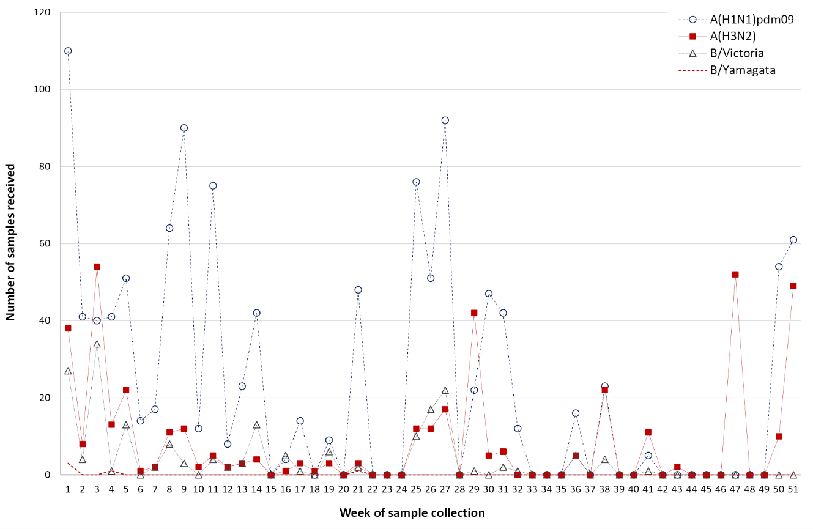
2021
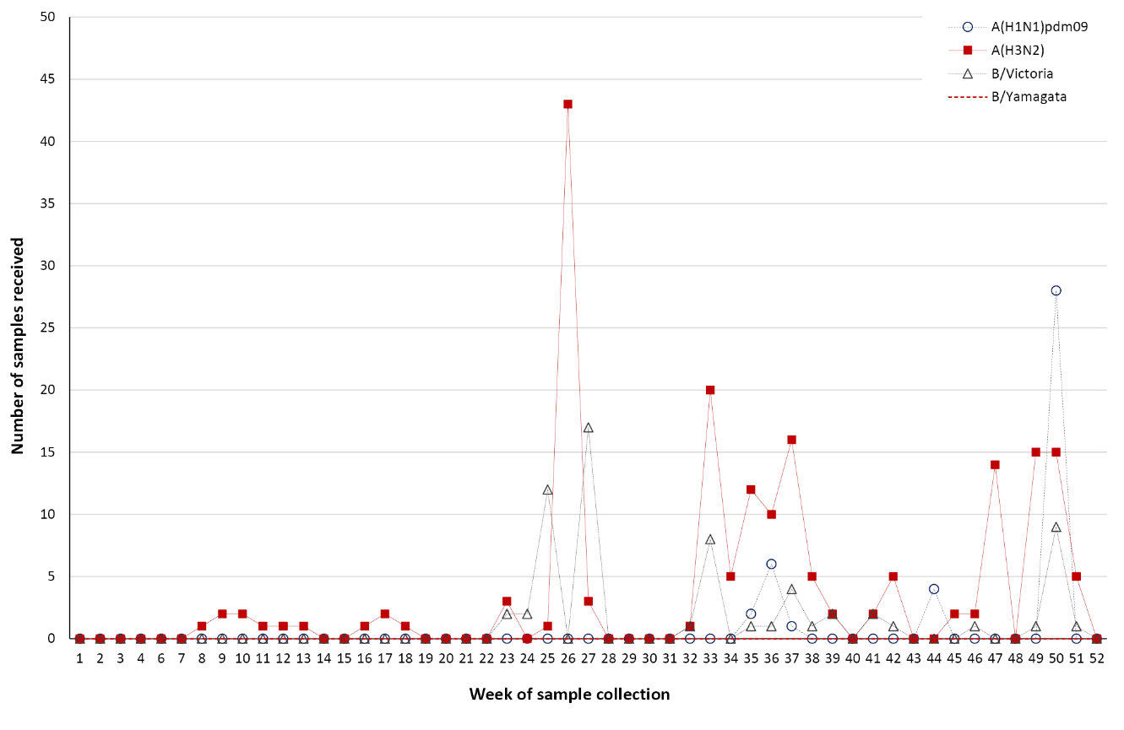

2020
During 2020, the Centre received 2,021 samples (including 1,204 clinical specimens; 571 virus isolates; 238 paired specimens and isolates; and 8 other specimen types [RNA or tissue samples]) from 31 laboratories in 14 countries (Figure 2). Australian laboratories sent the highest number of samples to the Centre (n = 906; 44.8%), followed by laboratories in Malaysia (n = 322; 15.9%) and Cambodia (n = 192; 9.5%). In 2020, A(H1N1)pdm09 was the predominant circulating strain submitted, followed by A(H3N2) and B (Figure 1). Of the influenza B samples received from Australian laboratories where the lineage was confirmed (n = 65), B/Victoria viruses greatly exceeded B/Yamagata viruses (n = 63, 96.9%; and n = 2, 3.1%, respectively). Overall, isolation and re-passaging was attempted for 1,962 of the samples received (97.9%) and this yielded 1,383 isolates (overall isolation rate of 70.5%). Isolation rates were lower for clinical specimens (51.5%) than for virus re-isolations (97%). Of the viruses for which type and subtype could be confirmed, isolation rates by cell propagation were 86.7% (170/196) for influenza B, 82.8% (337/407) for A(H3N2) and 72.7% (873/1,201) for A(H1N1)pdm09. However, amongst the A(H3N2) viruses, 2.1% of isolates (7/337) did not reach sufficient titres for antigenic analysis. A total of 1,063 viral isolates were successfully characterised by HI assay, and were compared to the 2020 reference viruses (Table 2). In addition, 128 samples were characterised by real-time RT-PCR to determine their type/subtype or lineage. Sanger sequencing and/or NGS techniques were used to sequence the HA genes of 687 viruses. The full genomes of 197 viruses and near-full genomes of a further 27 viruses were also obtained using NGS. Of the samples for which results could be obtained by antigenic or genetic analysis (n = 1,479), influenza A(H1N1)pdm09 viruses predominated, comprising 60.6% (n = 897) of viruses received and analysed.

Figure 2: Geographic distribution of influenza laboratories sending viruses to the Centre: (A) 2020 and (B) 2021
2020
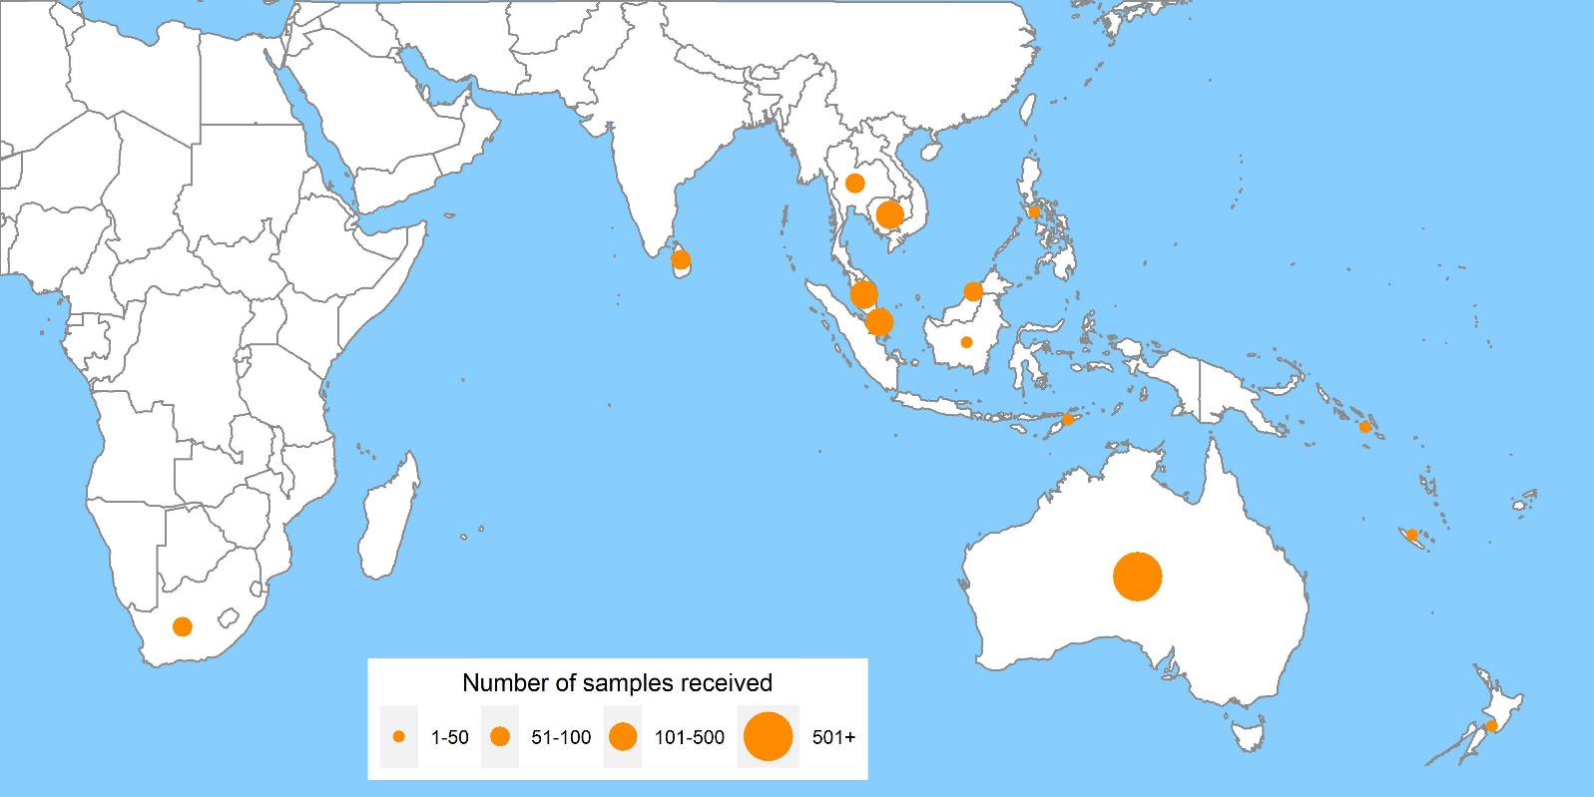
2021
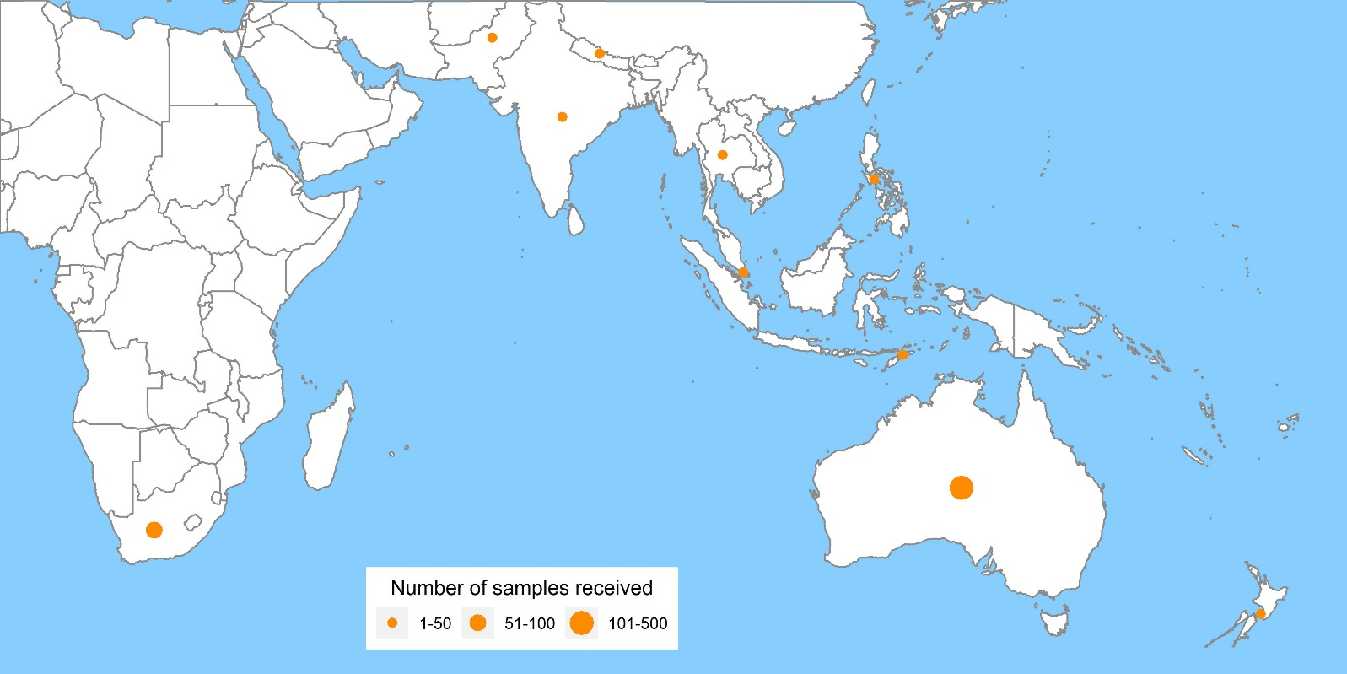

Table 2: Antigenic analysis of viruses received by the Centre in 2020, by geographic region of origin
 | A(H1N1)pdm09 reference strain: |  | A(H3N2)ª reference strain: |  | B/Victoria reference strain: |  | B/Yamagata reference strain:
 | A/Brisbane/02/2018 (cell) |  | A/South Australia/34/2019 (cell) |  | B/Washington/02/2019 (cell) |  | B/Phuket/3073/2013 (cell)
Region | Like | Low reactor (%) | Like | Low reactor (%) | Like | Low reactor (%) | Like | Low reactor (%)
Africa | 12 | 17 (44.7) | 4 | 2 (33.3) | 9 | 0 | 0 | 0
Australasia | 173 | 164 (48.7) | 21 | 16 (43.2) | 38 | 2 (5.0) | 1 | 0
South Asia | 4 | 4 (50.0) | 5 | 0 | 5 | 0 | 0 | 0
South East Asia | 276 | 100 (26.6) | 118 | 36 (23.4) | 21 | 0 | 3 | 0
South Pacific | 10 | 1 (9.1) | 0 | 0 | 1 | 0 | 0 | 0
Total | 484 | 286 (37.1%) | 148 | 54 (26.7%) | 85 | 2 (2.3%) | 4 | 0 (0%)
a Note that a small number of A(H3N2) virus isolates that were obtained could not be analysed by HI assay due to low haemagglutination assay (HA) titre in the presence of oseltamivir.

A(H1N1)pdm09
Of the 770 A(H1N1)pdm09 isolates analysed by HI assay using ferret antisera in 2020, the majority (62.9%) were antigenically similar to the vaccine reference strain A/Brisbane/02/2018 (Table 2). Sequencing was attempted on 326 viruses; results were obtained from 299 viruses. Sequencing and phylogenetic analysis of HA genes from these viruses showed that almost all of the A(H1N1)pdm09 viruses sent to the Centre during 2020 fell into the 6B.1.A.5 clade (n = 297), with viruses in subclades 6B.1A.5a.2 (n = 140), 6B.1A.5a.1 (n = 113), 6B.1A.5a (n = 22), and 6B.1A.5b (n = 2) (Figure 3) compared to the 2020 SH vaccine reference strain, A/Brisbane/02/2018, which was in subclade 6B.1A.1. The majority of A(H1N1)pdm09 viruses received in 2020 had collection dates up to the end of March. For the most part, the A(H1N1)pdm09 viruses collected in January–March 2020 were antigenically similar to the 2020 vaccine reference strain A/Brisbane/02/2018 (subclade 6B.1A.1) as determined by their reactivity in HI assays using ferret antisera. However, among A(H1N1)pdm09 viruses received after March 2020, following the emergence of the COVID-19 pandemic, these were predominately of the subclade 6B.1A.5a.2, and were antigenically distinct to A/Brisbane/02/2018.
Eleven A(H1N1)pdm09 viruses were inoculated into eggs for isolation of candidate vaccine strains, with nine (89%) successfully isolated. These consisted of one virus from genetic subclade 6B.1A.5a.1, six from 6B.1A.5a.2, and two from 6B.1A.5b. Thirty-six viruses were also inoculated into the qualified cell line MDCK 33016PF, of which 22 (61%) grew successfully; these consisted of 16 viruses from genetic subclade 6B.1A.5a and six from 6B.1A.5b.
Of the 869 A(H1N1)pdm09 viruses tested, two viruses (both from Australia) exhibited highly-reduced inhibition by oseltamivir and had the NA H275 mutation (known to cause high-level inhibition). One virus from Malaysia exhibited highly-reduced inhibition by zanamivir and contained the Q136K NA substitution (a known mutation normally induced by cell culture).²⁷

Figure 3: Phylogenetic tree of haemagglutinin genes of A(H1N1)pdm09 viruses received by the Centre during 2020 and 2021
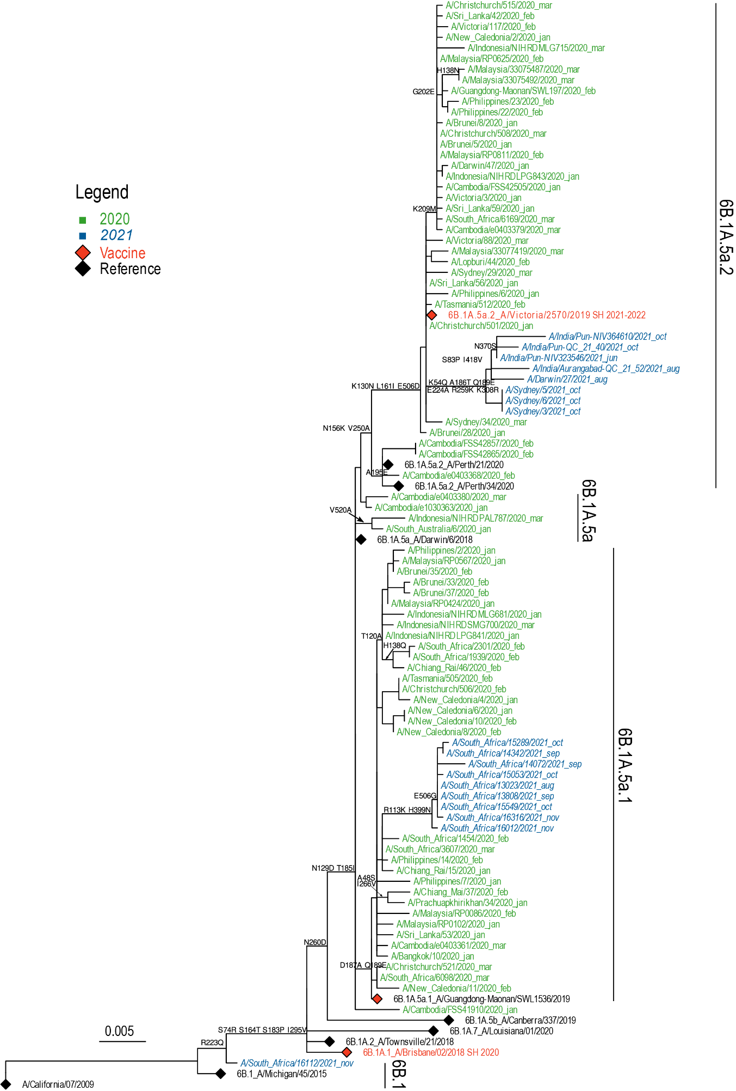

A(H3N2)
Antigenic analysis of 202 A(H3N2) subtype isolates using the HI assay showed that 73.3% were similar to the ferret antisera prepared against the cell-propagated reference strain A/South Australia/34/2019 (Table 2). Similarly, 22.3% of viruses were low reactors to the ferret antisera prepared against the egg-propagated strain A/South Australia/34/2019 (data not shown). An additional seven A(H3N2) viruses were isolated by cell culture but did not reach sufficient titres for antigenic analysis, whilst a further eight were successfully isolated but did not reach sufficient titres when tested by HI assay in the presence of OC.
A total of 63 A(H3N2) viruses that could not be characterised by HI assay were analysed using FRA. The FRA indicated that 34 of these viruses (54%) showed greater than fourfold difference in titre compared to the cell-propagated reference strain A/South Australia/34/2019; however, none of the viruses had a greater than fourfold difference in titre compared to the egg-propagated strain (data not shown).
The HA genes of 254 A(H3N2) viruses were sequenced, with 219 yielding results (Figure 4). Phylogenetic analysis of the HA gene indicated that the majority of circulating viruses fell into subclade 3C.2a1b.2 (n = 118); 27 viruses into clade 3C.2a1b.2; and others into subclades 3C.2a1b.2a.1 (n = 54), 3C.2a1b.2a.2 (n = 15), 3C.2a1b.2b (n = 14), and 3C.2a1b.2a (n = 8).
Influenza A(H3N2) viruses received by the Centre in 2020 showed that they were generally well matched to the 2020 vaccine reference strain A/South Australia/34/2019.
Thirty-six viruses were inoculated into eggs, of which 13 (36%) grew successfully, consisting of one virus from genetic subclade 3C.2a1b.1, two from 3C.2a1b.1a, seven from 3C.2a1b.1b, one from 3C.2a1b.2, and two from 3C.2a1b.2a.1. Fifty-eight viruses were inoculated into the qualified cell line MDCK 33016PF, of which 28 (48%) grew successfully, with two viruses from genetic subclades 3C.2a1b.2, three from 3C.2a1b.1, thirteen from 3C.2a1b.2b, five from 3C.2a1b.2a.1, four from 3C.2a1b.2a.2 and one from 3C.2a1.
None of the 334 A(H3N2) viruses tested by NAI assay showed highly-reduced inhibition by oseltamivir or zanamivir.
Figure 4: Phylogenetic tree of haemagglutinin genes of A(H3N2) viruses received by the Centre during 2020 and 2021
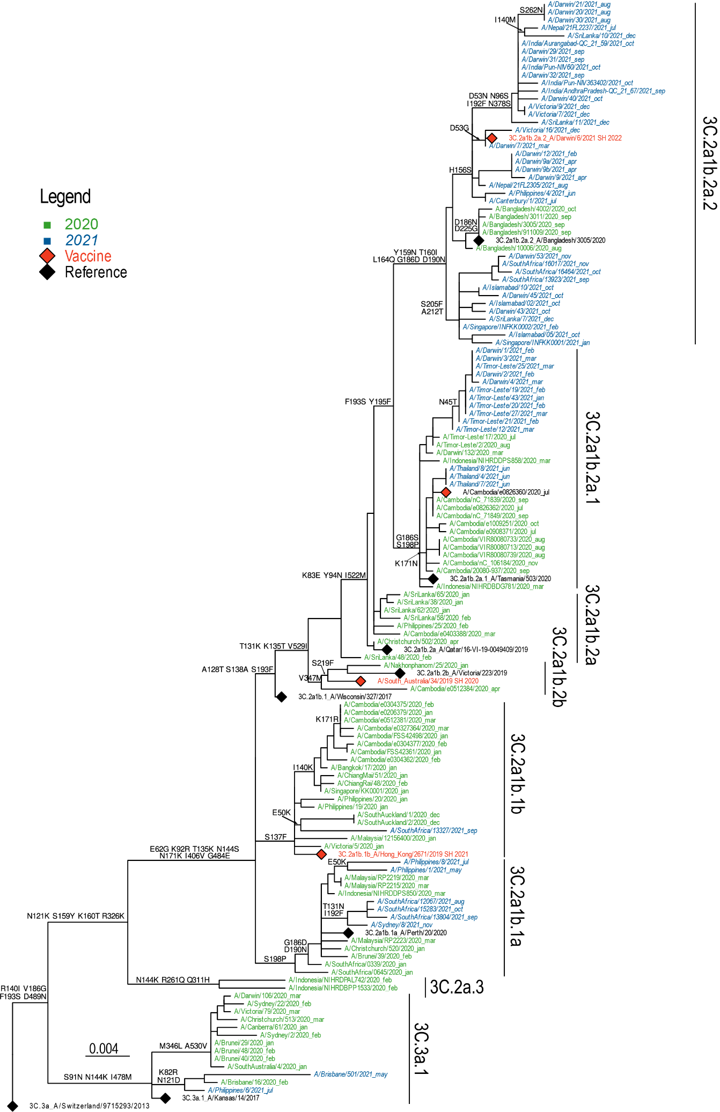

Influenza B
Amongst influenza B viruses received at the Centre during 2020, B/Victoria-lineage viruses predominated over B/Yamagata-lineage viruses (Figure 1). A total of 91 influenza B viruses were characterised by HI assay (Table2). All B/Yamagata-lineage viruses were antigenically similar to the B/Phuket/3073/2013-like vaccine virus, while 97.7% of B/Victoria-lineage viruses were antigenically similar to the B/Washington/02/2019 vaccine virus (Table 2).
Sequencing was attempted on 115 B/Victoria viruses and one B/Yamagata virus, with 93 B/Victoria viruses and one B/Yamagata virus yielding results. Phylogenetic analysis on HA genes of these viruses indicated that the majority of circulating B/Victoria viruses fell into clade V1A.3a (n = 92), which included the 2020 vaccine strain B/Washington/02/2019. One B/Victoria virus fell into the V1A.2 clade (Figure 5). The B/Yamagata-lineage virus (n = 1) belonged to genetic clade Y3, which was the same genetic clade as the 2019 vaccine strain B/Phuket/3073/2013 (Figure 5).
Egg isolation was attempted for five B/Victoria-lineage viruses, all of which were successfully isolated, and belonged to genetic subclade V1A.3a. No B/Yamagata-lineage virus was attempted for egg isolation in 2020. Twenty-eight B/Victoria-lineage viruses were also inoculated into the qualified cell line MDCK 33016PF, of which twelve (45%) were isolated (all from V1A.3a subclade). In addition, one B/Yamagata-lineage (Y3 clade) virus was also inoculated and isolated in MDCK 33016PF cell.
Of the 170 influenza B viruses (B/Victoria n = 166; B/Yamagata n = 4) tested by NAI assay, none showed highly-reduced inhibition by oseltamivir or zanamivir.

Figure 5: Phylogenetic tree of haemagglutinin genes of B/Victoria-lineage viruses received by the Centre during 2020 and 2021
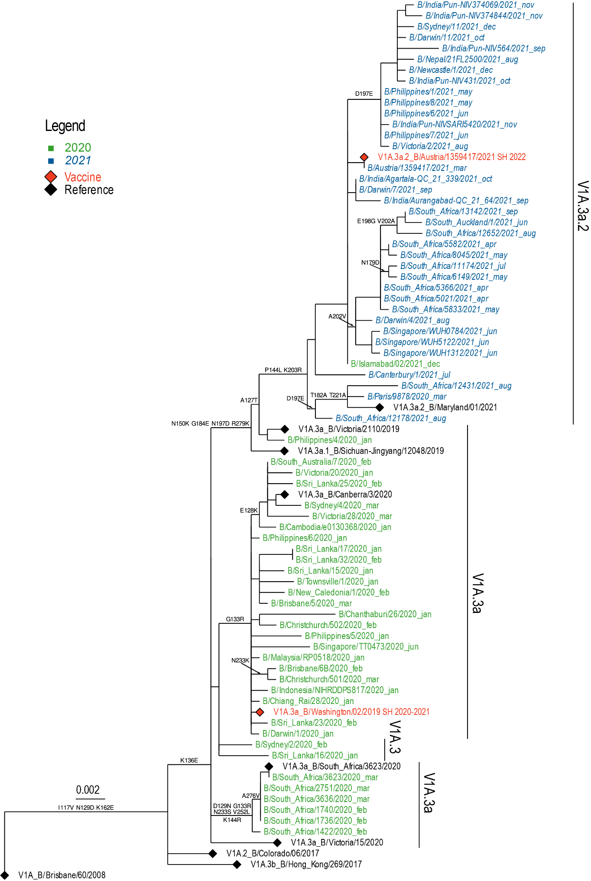

2021
In 2021, the Centre received 372 samples (including 279 clinical specimens; 32 virus isolates; 59 paired specimens and isolates; and two other specimen types [RNA or tissue samples]) from 25 laboratories in 10 countries (Figure 2). Australian laboratories sent the highest number of samples to the Centre (n = 146; 39.2%), followed by laboratories in South Africa (n = 62; 16.7%) and Timor-Leste (n = 44; 11.8%). Influenza A(H3N2) was the predominant circulating strain in 2021, followed by A(H1N1)pdm09 and B (Figure 1). For samples received from Australian laboratories where the lineage was confirmed (n = 13), only B/Victoria-lineage viruses were detected (13/13, 100%). Overall, isolation and re-passaging was attempted for 332 (89.2%) of the samples received and this yielded 167 isolates (overall isolation rate of 50.3%). Isolation rates were lower for clinical specimens (36.6%) than for virus isolates (96.7%). Of the viruses for which type and subtype could be confirmed, isolation rates by cell propagation were 92.5% for A(H1N1)pdm09 (37/40); 82.8% for influenza B (48/58); and 45.1% for A(H3N2) (79/175). Amongst these viruses, all A(H3N2) isolates reached sufficient titres for antigenic analysis. A total of 145 viral isolates were successfully characterised by HI assay, and were compared to the 2021 reference viruses (Table 3). In addition, 146 samples were characterised by real-time RT-PCR to determine their type/subtype or lineage. Sanger sequencing and NGS techniques were used to sequence the HA genes of 210 viruses. The full genomes of 51 viruses, and partial genomes from a further 22 viruses, were also sequenced using either Sanger sequencing or NGS. Of the samples for which results could be obtained by antigenic or genetic analysis (n = 275), influenza A(H3N2) viruses predominated, comprising 60.4% (n = 166) of viruses received and analysed.
Table 3: Antigenic analysis of viruses received by the Centre in 2021, by geographic region of origin
 | A(H1N1)pdm09 reference strain: |  | A(H3N2) reference strain: |  | B/Victoria reference strain: |  | B/Yamagata reference strain:
 | A/Victoria/2570/2019 (cell) |  | A/Darwin/726/2019ª (cell) |  | B/Washington/02/2019 (cell) |  | B/Phuket/3073/2013 (cell)
Region | Like | Low reactor (%) | Like | Low reactor (%) | Like | Low reactor (%) | Like | Low reactor (%)
Africa | 1 | 24 (96.0) | 2 | 8 (80.0) | 7 | 14 (66.7) | 0 | 0
Australasia | 4 | 0 | 4 | 32 (88.9) | 3 | 0 | 0 | 0
South Asia | 6 | 0 | 0 | 4 (100.0) | 0 | 0 | 0 | 0
South East Asia | 0 | 0 | 3 | 12 (80.0) | 14 | 7 (33.3) | 0 | 0
Total | 11 | 24 (68.6%) | 9 | 56 (86.2%) | 24 | 21 (46.7%) | 0 | 0
a A/Darwin/726/2019 is the cell equivalent of A/Hong Kong/2671/2019 H3N2 vaccine strain.

A(H1N1)pdm09
Of the 35 A(H1N1)pdm09 isolates analysed by HI assay using ferret antisera in 2021, a minority (31.4%) were antigenically similar to the vaccine reference strain A/Victoria/2570/2019 (Table 3), while most of the viruses obtained from South Africa (24/25; Table 3) were low reacting to ferret antisera to A/Victoria/2570/2019. Sequencing and phylogenetic analysis of HA genes from 32 viruses (28 yielding results) showed that the majority of A(H1N1)pdm09 viruses sent to the Centre during 2021 fell into the 6B.1A.5a clade (n = 26), with subclades 6B.1A.5a.1 (n = 21) and 6B.1A.5a.2 (n = 5); the latter clade contained the 2021 vaccine strain A/Victoria/2570/2019 (Figure 3).
Five A(H1N1)pdm09 viruses were inoculated into eggs for isolation of candidate vaccine strains, with one (20%) successfully isolated; it fell into the genetic subclade 6B.1A.5a.2. Seven viruses were inoculated into the qualified cell line MDCK 33016PF, of which three (43%) grew successfully and all also fell into the genetic subclade 6B.1A.
Of the 37 A(H1N1)pdm09 viruses tested by NAI assay, none exhibited highly-reduced inhibition by oseltamivir or zanamivir.

A(H3N2)
Of the 65 A(H3N2) isolates analysed by HI assay using ferret antisera in 2021, a minority (13.8%) were antigenically similar to the cell-propagated reference strain A/Darwin/726/2019 (Table 3). In contrast, no isolates were antigenically similar when analysed by ferret antisera prepared against the egg-propagated strain A/Hong Kong/2671/2019 (data not shown). None of the A(H3N2) viruses inoculated and isolated by cell culture had insufficient titres for antigenic analysis or when tested by HI assay in the presence of OC.
A total of 54 A(H3N2) viruses were analysed using FRA; 90.7% (n = 49) of these viruses showed greater than a fourfold difference in titre compared to the cell-propagated reference strain A/Darwin/726/2019, while 100% (n = 39) of viruses tested against the egg-propagated strain (A/Hong Kong/2671/2019) had a greater than fourfold difference in titre (data not shown).
The HA genes of 129 A(H3N2) viruses were sequenced, with 76 yielding results. Phylogenetic analysis indicated that the majority of circulating viruses fell into clade 3C.2a1b.2a (total = 64) based on their HA genes (ancestral 3C.2a1b.2a [n = 1], with subclades 3C.2a1b.2a.2 [n = 46] and 3C.2a1b.2a.1 [n = 17]) (Figure 4).
Twenty-six viruses were inoculated into eggs, of which 15 (58%) grew successfully and consisted of three viruses from genetic subclade 3C.2a1b.2a, two from 3C.2a1b.2a.1 and ten from 3C.2a1b.2a.2. Twenty-eight viruses were inoculated into the qualified cell line MDCK 33016PF, of which 15 (53%) grew successfully, with one virus from genetic subclade 3C.2a1b.1a, four from 3C.2a1b.2a.1 and ten from 3C.2a1b.2a.
None of the 79 A(H3N2) viruses tested by NAI assay showed highly-reduced inhibition by oseltamivir or zanamivir.

A(H3N2)v
One A(H3N2) variant (A(H3N2)v) virus was detected from South Australia in January 2021. Virus isolation was attempted but failed; only sequence data was obtained from this original specimen. The whole genome showed this was a reassortant virus, with HA and NA sequences belong to an older human seasonal H3N2 virus, whereas all internal genes were contributed by a recent A(H1N1)pdm09 virus. Similar reassortant viruses have been detected in swine in the United States of America (USA); this variant’s detection highlights the potential risk of swine influenza A virus infecting humans in Australia, as has been previously reported in the USA and other countries.³⁰ All sequences of the A(H3N2)v sample were nearly identical to a A(H3N2)v virus detected in South Australia in 2018;³¹ both viruses contained HA and NA genes derived from 1990s-like human A(H3N2) viruses which have not circulated in humans since this time, but which are still present in some Australian swine.

Influenza B
Amongst influenza B viruses received at the Centre during 2021, B/Victoria-lineage viruses were the only influenza B viruses received (Figure 1). A total of 45 B/Victoria-lineage viruses were characterised by HI assay, showing that 53.3% were similar to the ferret antisera prepared against the cell-propagated reference strain B/Washington/02/2019 (Table 3).
Sequencing was performed on HA and NA genes from 44 B/Victoria viruses, with 34 yielding results. Phylogenetic analysis indicated that all of the circulating B/Victoria viruses fell into clade V1A.3a.2 (n = 34) (Figure 5).
Egg isolation was attempted for nine B/Victoria-lineage viruses, of which eight (89%) were successfully isolated; all were of the V1A.3a.2 subclade. For viruses inoculated into the qualified cell line MDCK 33016PF, eleven of 14 B/Victoria-lineage viruses (78%) grew successfully, of which one virus was from genetic subclade V1A.3 and ten were from V1A.3a.2. No B/Yamagata-lineage virus was isolated.
Of the 47 B/Victoria-lineage viruses tested by NAI assay, none displayed highly-reduced inhibition by oseltamivir or zanamivir.

Discussion
During 2020 and 2021, the Centre received considerably fewer samples than previous years. In 2020, the Centre received the smallest annual number of samples since 2010³² and this number was further reduced in 2021, with the Centre receiving the smallest annual number of samples since 1997, when annual reporting commenced.^{21–26,32–45} The lower number of samples received thoughout 2020–2021 correlated with the global reduction in influenza activity that occurred in early 2020, after the emergence of the Coronavirus disease 2019 (COVID-19) pandemic and the introduction of non-pharmaceutical interventions by many countries.^{3,46}

2020
In 2020, the majority of samples were received between January and April. This corresponded with national laboratory-confirmed influenza notification data, which showed increased inter-seasonal activity in early 2020.⁵ The predominant circulating virus reported to the Australian National Notifiable Diseases Surveillance System (NNDSS) in 2020 was influenza A (87.1%), with A(H1N1)pdm09 predominant in samples that could be subtyped.⁵ This is in agreement with samples from Australia received by the Centre, with A(H1N1)pdm09 viruses accounting for the majority of the viruses analysed. Globally, influenza A(H1N1)pdm09, A(H3N2) and influenza B viruses co-circulated in varying proportions.^{46–48} In the southern hemisphere, influenza A(H1N1)pdm09 was the most frequently reported subtype.⁴⁸ In the temperate areas of South America, influenza B predominated; influenza A(H1N1)pdm09 predominated in southern Africa and Oceania, while influenza A(H3N2) predominated in countries in Asia, such as Cambodia and China.^{48,49}
Younger populations are typically more affected in years when A(H1N1)pdm09 viruses predominate, while older populations are usually more affected by A(H3N2) viruses.⁵⁰ Consistent with this observation, higher notification rates in 2020 were observed among children under 10 years of age (115.6 per 100,000 population) than among adults aged ≥ 65 years (73.8 per 100,000 population).⁵ As a result of the low number of notifications, hospital and intensive care unit admissions associated with laboratory-confirmed influenza were lower in 2020 than in previous years.⁵ Death associated with influenza and pneumonia in 2020 was the seventeenth leading cause of death, with 2,287 deaths recorded.⁵¹ This was a considerable reduction on 2019 when influenza and pneumonia were the ninth leading cause of death, with 4,124 deaths recorded.⁵¹
Antigenic analysis of influenza A(H1N1)pdm09 viruses showed that the majority of viruses displayed similar antigenic characteristics to the cell-propagated vaccine strain, A/Brisbane/02/2018. There were several distinct genetic clades amongst circulating A(H1N1)pdm09 viruses, with different genetic clades predominating before and after the emergence of the COVID-19 pandemic. As a result, the 2021 southern hemisphere A(H1N1)pdm09 vaccine component was changed to A/Victoria/2570/2019.²⁸
Most of the influenza A(H3N2) viruses received by the Centre were antigenically and genetically similar to the 2020 vaccine reference strain, A/South Australia/34/2019. However, due to regional heterogeneity in circulating A(H3N2) viruses in 2020, the 2021 southern hemisphere A(H3N2) vaccine component was changed to A/Hong Kong/2671/2019.²⁸
The majority of influenza B isolates analysed at the Centre belonged to the B/Victoria-lineage (98.2%). The analysed B/Victoria-lineage and B/Yamagata-lineage viruses were mostly antigenically and genetically similar to their relevant vaccine strains.

2021
During 2021, the number of samples received by the Centre was very low and corresponded with notifications of laboratory-confirmed influenza (Australian NNDSS data), which was the lowest since influenza was made a notifiable disease in 2001.⁴ In Australia, higher notification rates occurred among adults aged ≥ 85 years (4.9 per 100,000 population), adults aged 60–69 (4.8 per 100,000 population), and children aged younger than 5 years old (3.5 per 100,000 population).⁴ This age profile of influenza notifications is consistent with previous years when A(H3N2) viruses predominated, albeit with much lower levels of circulation in 2021.^{24,26}
Antigenic analysis of influenza A(H1N1)pdm09 viruses showed that the majority of viruses were antigenically distinct to the cell-propagated vaccine strain, A/Victoria/2570/2019. However, as there were two distinct A(H1N1)pdm09 groups of viruses co-circulating in different geographical regions, the decision was made that 2022 southern hemisphere vaccine component should not be changed.²⁹
Antigenic analysis of A(H3N2) viruses showed that the majority of circulating viruses were antigenically distinct from A/Darwin/726/2019 (the cell equivalent of the A/Hong Kong/2671/2019 vaccine strain). With this finding, the 2022 southern hemisphere vaccine component was changed to A/Darwin/9/2021.²⁹
In 2021, all of the influenza B isolates analysed at the Centre belonged to the B/Victoria-lineage. Almost half of these B/Victoria-lineage viruses were antigenically and genetically distinct from the vaccine strain B/Washington/02/2019. Hence, the 2022 Southern Hemisphere B/Victoria vaccine component was changed to B/Austria/1359417/2021.²⁹
In 2021, the Centre did not receive a single B/Yamagata virus. This correlates with international findings where no B/Yamagata viruses were successfully isolated or sequenced in 2021.⁵² With the global lack of B/Yamagata identification in 2021, it is possible that B/Yamagata is now extinct; however, it is difficult to determine whether the lack of B/Yamagata viruses reported globally is due to a lack of detection or represents a true extinction.⁵²
With the ongoing evolution of seasonal influenza viruses and the absence of an effective universal vaccine, there remains a need for continuous influenza surveillance and regular updating of seasonal influenza vaccines. The work performed by the Centre in Melbourne is part of the ongoing efforts of the WHO GISRS to perform these tasks in an effort to better control the disease burden of influenza, and to provide effective countermeasures, such as vaccines, to ameliorate the impact of influenza on the human population.

Acknowledgements
The authors would like to thank all the National Influenza Centres and other contributing laboratories who sent influenza positive samples to the Centre during 2020 and 2021. The Melbourne WHO Collaborating Centre for Reference and Research on Influenza is supported by the Australian Government Department of Health and Aged Care.

Author details
Ms Genevieve O’Neill, Epidemiologist¹
Dr Ammar Aziz, Bioinformatician¹
Dr Miku Kuba, Communications and Data Officer¹
Mrs Sook Kwan Brown, Medical Scientist¹
Ms Hilda Lau, Medical Scientist¹
Ms Sally Soppe, Medical Scientist¹
Dr Mariana Baz, Head, Antiviral Drug Sensitivity division¹
Ms Heidi Peck, Head, Serology division¹
Dr Yi-Mo Deng, Head, Genetic Analysis division¹
Prof Kanta Subbarao, Director¹
Prof Ian G. Barr, Deputy Director¹
- WHO Collaborating Centre for Reference and Research on Influenza

Corresponding author
Dr Yi-Mo Deng,
WHO Collaborating Centre for Reference and Research on Influenza
Peter Doherty Institute for Infection and Immunity
792 Elizabeth St
Melbourne 3000
Email: Yi-Mo.Deng@influenzacentre.org

References
- Hay AJ, McCauley JW. The WHO global influenza surveillance and response system (GISRS)—a future perspective. Influenza Other Respir Viruses. 2018;12(5):551–7. doi: https://doi.org/10.1111/irv.12565.
- Monto AS. Reflections on the global influenza surveillance and response system (GISRS) at 65 years: an expanding framework for influenza detection, prevention and control. Influenza Other Respir Viruses. 2018;12(1):10–2. doi: https://doi.org/10.1111/irv.12511.
- Sullivan SG, Carlson S, Cheng AC, Chilver MB, Dwyer DE, Irwin M et al. Where has all the influenza gone? The impact of COVID-19 on the circulation of influenza and other respiratory viruses, Australia, March to September 2020. Euro Surveill. 2020;25(47):2001847. doi: https://doi.org/10.2807/1560-7917.ES.2020.25.47.2001847.
- Australian Government Department of Health. Australian Influenza Surveillance Report No. 16, 2021. Reporting fortnight: 25 October to 07 November 2021. Canberra: Australian Government Department of Health; November 2021. Available from: https://www1.health.gov.au/internet/main/publishing.nsf/Content/018A35D7E15F04C0CA25878D0078D70B/$File/flu-16-2021.pdf.
- Australian Government Department of Health. Australian Influenza Surveillance Report No. 17, 2020. Reporting fortnight: 16 to 29 November 2020. Canberra: Australian Government Department of Health; 4 December 2020. Available from: https://www1.health.gov.au/internet/main/publishing.nsf/Content/9C53D5FF0B103751CA25862600034B44/$File/flu-17-2020.pdf.
- Oh DY, Barr IG, Mosse JA, Laurie KL. MDCK-SIAT1 cells show improved isolation rates for recent human influenza viruses compared to conventional MDCK cells. J Clin Microbiol. 2008;46(7):2189–94. doi: https://doi.org/10.1128/JCM.00398-08.
- Hobson D, Curry RL, Beare AS, Ward-Gardner A. The role of serum haemagglutination-inhibiting antibody in protection against challenge infection with influenza A2 and B viruses. J Hyg (Lond). 1972;70(4):767–77. doi: https://doi.org/10.1017/s0022172400022610.
- Lin YP, Gregory V, Collins P, Kloess J, Wharton S, Cattle N et al. Neuraminidase receptor binding variants of human influenza A(H3N2) viruses resulting from substitution of aspartic acid 151 in the catalytic site: a role in virus attachment? J Virol. 2010;84(13):6769–81. doi: https://doi.org/10.1128/JVI.00458-10.
- Deng YM, Spirason N, Iannello P, Jelley L, Lau H, Barr IG. A simplified Sanger sequencing method for full genome sequencing of multiple subtypes of human influenza A viruses. J Clin Virol. 2015;68:43–8. doi: https://doi.org/10.1016/j.jcv.2015.04.019.
- Zhou B, Donnelly ME, Scholes DT, St George K, Hatta M, Kawaoka Y et al. Single-reaction genomic amplification accelerates sequencing and vaccine production for classical and swine origin human influenza A viruses. J Virol. 2009;83(19):10309–13. doi: https://doi.org/10.1128/JVI.01109-09.
- Zhou B, Deng YM, Barnes JR, Sessions OM, Chou TW, Wilson M et al. Multiplex reverse transcription-PCR for simultaneous surveillance of influenza A and B viruses. J Clin Microbiol. 2017;55(12):3492–501. doi: https://doi.org/10.1128/JCM.00957-17.
- Shepard SS, Meno S, Bahl J, Wilson MM, Barnes J, Neuhaus E. Viral deep sequencing needs an adaptive approach: IRMA, the iterative refinement meta-assembler. BMC Genomics. 2016;17(1):708. doi: https://doi.org/10.1186/s12864-016-3030-6.
- Hurt AC, Besselaar TG, Daniels RS, Ermetal B, Fry A, Gubareva L et al. Global update on the susceptibility of human influenza viruses to neuraminidase inhibitors, 2014–2015. Antiviral Res. 2016;132:178–85. doi: https://doi.org/10.1016/j.antiviral.2016.06.001.
- World Health Organization (WHO) Global Influenza Programme. Laboratory methodologies for testing the antiviral susceptibility of influenza viruses: Neuraminidase inhibitor (NAI). [Webpage.] Geneva: WHO; 2022. Available from: https://www.who.int/teams/global-influenza-programme/laboratory-network/quality-assurance/antiviral-susceptibility-influenza/neuraminidase-inhibitor.
- Deng YM, Caldwell N, Barr IG. Rapid detection and subtyping of human influenza A viruses and reassortants by pyrosequencing. PLoS One. 2011;6(8):e23400. doi: https://doi.org/10.1371/journal.pone.0023400.
- Gerdil C. The annual production cycle for influenza vaccine. Vaccine. 2003;21(16):1776–9. doi: https://doi.org/10.1016/s0264-410x(03)00071-9.
- Stöhr K, Bucher D, Colgate T, Wood J. Influenza virus surveillance, vaccine strain selection, and manufacture. Methods Mol Biol. 2012;865:147–62. doi: https://doi.org/10.1007/978-1-61779-621-0_9.
- Weir JP, Gruber MF. An overview of the regulation of influenza vaccines in the United States. Influenza Other Respir Viruses. 2016;10(5):354–60. doi: https://doi.org/10.1111/irv.12383.
- WHO Global Influenza Surveillance Network. Manual for the laboratory diagnosis and virological surveillance of influenza. Geneva: WHO; I January 2011. Available from: https://www.who.int/publications/i/item/manual-for-the-laboratory-diagnosis-and-virological-surveillance-of-influenza.
- Roth B, Mohr H, Enders M, Garten W, Gregersen JP. Isolation of influenza viruses in MDCK 33016PF cells and clearance of contaminating respiratory viruses. Vaccine. 2012;30(3):517–22. doi: https://doi.org/10.1016/j.vaccine.2011.11.063.
- Leung VK, Deng YM, Kaye M, Buettner I, Lau H, Leang SK et al. Annual report on influenza viruses received and tested by the Melbourne WHO Collaborating Centre for Reference and Research on Influenza in 2016. Commun Dis Intell (2018). 2019;43. doi: http://doi.org/10.33321/cdi.2019.43.3.
- Sullivan SG, Chow MK, Barr IG, Kelso A. Influenza viruses received and tested by the Melbourne WHO Collaborating Centre for Reference and Research on Influenza annual report, 2014. Commun Dis Intell Q Rep. 2015;39(4):E602–11.
- Leung VK, Spirason N, Lau H, Buettner I, Leang SK, Chow MK. Influenza viruses received and tested by the Melbourne WHO Collaborating Centre for Reference and Research on Influenza annual report, 2015. Commun Dis Intell Q Rep. 2017;41(2):E150–60.
- Roe M, Kaye M, Iannello P, Lau H, Buettner I, Tolosa MX et al. Report on influenza viruses received and tested by the Melbourne WHO Collaborating Centre for Reference and Research on Influenza in 2017. Commun Dis Intell (2018). 2019;43. doi: https://doi.org/10.33321/cdi.2019.43.25.
- Price OH, Spirason N, Rynehart C, Brown SK, Todd A, Peck H et al. Report on influenza viruses received and tested by the Melbourne WHO Collaborating Centre for Reference and Research on Influenza in 2018. Commun Dis Intell (2018). 2020;44. doi: https://doi.org/10.33321/cdi.2020.44.16.
- Peck H, Moselen J, Brown SK, Triantafilou M, Lau H, Grau M et al. Report on influenza viruses received and tested by the Melbourne WHO Collaborating Centre for Reference and Research on Influenza in 2019. Commun Dis Intell (2018). 2021;45. doi: https://doi.org/10.33321/cdi.2021.45.43.
- Little K, Leang SK, Butler J, Baas C, Harrower B, Mosse J et al. Zanamivir-resistant influenza viruses with Q136K or Q136R neuraminidase residue mutations can arise during MDCK cell culture creating challenges for antiviral susceptibility monitoring. Euro Surveill. 2015;20(45). doi: https://doi.org/10.2807/1560-7917.ES.2015.20.45.30060.
- WHO. Recommended composition of influenza virus vaccines for use in the 2021 southern hemisphere influenza season. Geneva: WHO; 25 September2020. Available from: https://www.who.int/publications/m/item/recommended-composition-of-influenza-virus-vaccines-for-use-in-the-2021-southern-hemisphere-influenza-season.
- WHO. Recommended composition of influenza virus vaccines for use in the 2022 southern hemisphere influenza season. Geneva: WHO; 24 September2021. Available from: https://www.who.int/publications/m/item/recommended-composition-of-influenza-virus-vaccines-for-use-in-the-2022-southern-hemisphere-influenza-season.
- Bowman AS, Nelson SW, Page SL, Nolting JM, Killian ML, Sreevatsan S et al. Swine-to-human transmission of influenza A(H3N2) virus at agricultural fairs, Ohio, USA, 2012. Emerg Infect Dis. 2014;20(9):1472–80. doi: https://doi.org/10.3201/eid2009.131082.
- Deng YM, Wong FYK, Spirason N, Kaye M, Beazley R, Grau MLL et al. Locally acquired human infection with swine-origin influenza A(H3N2) variant virus, Australia, 2018. Emerg Infect Dis. 2020;26(1):143–7. doi: https://doi.org/10.3201/eid2601.191144.
- Gavin K, Owen R, Barr IG. Annual report of the National Influenza Surveillance Scheme, 2010. Commun Dis Intell Q Rep. 2017;41(4):E348–68.
- Pennington K, Owen R, Mun J. Annual report of the National Influenza Surveillance Scheme, 2009. Commun Dis Intell Q Rep. 2017;41(4):E383–454.
- Halliday L, Roberts L, Hampson A. Annual report of the National Influenza Surveillance Scheme, 1998. Commun Dis Intell. 1999;23(7):185–92.
- Thomson J, Lin M, Hampson A. Annual report of the National Influenza Surveillance Scheme, 1999. Commun Dis Intell. 2000;24(6):145–52.
- Roche P, Spencer J, Merianos A, Hampson A. Annual report of the National Influenza Surveillance Scheme, 2000. Commun Dis Intell Q Rep. 2001;25(3):107–12.
- Roche P, Spencer J, Hampson A. Annual report of the National Influenza Surveillance Scheme, 2001. Commun Dis Intell Q Rep. 2002;26(2):204–13.
- Yohannes K, Roche P, Spencer J, Hampson A. Annual report of the National Influenza Surveillance Scheme, 2002. Commun Dis Intell Q Rep. 2003;27(2):162–72.
- Yohannes K, Roche P, Hampson A, Miller M, Spencer J. Annual report of the National Influenza Surveillance Scheme, 2003. Commun Dis Intell Q Rep. 2004;28(2):160–8.
- Li J, Hampson A, Roche PW, Yohannes K, Spencer JD. Annual report of the National Influenza Surveillance Scheme, 2004. Commun Dis Intell Q Rep. 2005;29(2):125–36.
- Firestone SM, Barr IG, Roche PW, Walker JC. Annual report of the National Influenza Surveillance Scheme, 2005. Commun Dis Intell Q Rep. 2006;30(2):189–200.
- O’Brien K, Barr IG. Annual report of the National Influenza Surveillance Scheme, 2006. Commun Dis Intell Q Rep. 2007;31(2):167–79.
- Owen R, Barr IG, Pengilley A, Liu C, Paterson B, Kaczmarek M et al. Annual report of the National Influenza Surveillance Scheme, 2007. Commun Dis Intell Q Rep. 2008;32(2):208–26.
- Kaczmarek M, Owen R, Barr IG. Annual report of the National Influenza Surveillance Scheme, 2008. Commun Dis Intell Q Rep. 2010;34(1):8–22.
- Curran M, Hampson A. National influenza surveillance 1997. Commun Dis Intell. 1998;22(5):69–74.
- WHO Global Influenza Programme. Influenza Update N° 383: 21 December 2020, based on data up to 06 December 2020. Geneva: WHO; 21 December 2020. Available from: https://cdn.who.int/media/docs/default-source/influenza/influenza-updates/2020/2020_12_21_surveillance_update_383.pdf.
- WHO. Recommended composition of influenza virus vaccines for use in the 2017 southern hemisphere influenza season. Geneva: WHO; 29 September2016. Available from: https://www.who.int/publications/m/item/recommended-composition-of-influenza-virus-vaccines-for-use-in-the-2017-southern-hemisphere-influenza-season.
- Karlsson EA, Mook PAN, Vandermaele K, Fitzner J, Hammond A, Cozza V et al. Review of global influenza circulation, late 2019 to 2020, and the impact of the COVID-19 pandemic on influenza circulation. Wkly Epidemiol Rec. 2021;25:241–64. Available from: https://apps.who.int/iris/rest/bitstreams/1352850/retrieve.
- WHO. Recommended composition of influenza virus vaccines for use in the 2020 southern hemisphere influenza season. Geneva: WHO; 27 September 2019. Available from: https://www.who.int/publications/m/item/recommended-composition-of-influenza-virus-vaccines-for-use-in-the-2020-southern-hemisphere-influenza-season.
- Thompson WW, Shay DK, Weintraub E, Brammer L, Bridges CB, Cox NJ et al. Influenza-associated hospitalizations in the United States. JAMA. 2004;292(11):1333–40. doi: https://doi.org/10.1001/jama.292.11.1333.
- Australian Bureau of Statistics. 3303.0 Causes of Death, Australia, 2020. Table 1.1. Underlying cause of death, All causes, Australia, 2020. [Data download.] Canberra: Australian Bureau of Statistics; 29 September 2021. Available from: https://www.abs.gov.au/statistics/health/causes-death/causes-death-australia/latest-release#data-download.
- Koutsakos M, Wheatley AK, Laurie K, Kent SJ, Rockman S. Influenza lineage extinction during the COVID-19 pandemic? Nat Rev Microbiol. 2021;19(12):741–2. doi: https://doi.org/10.1038/s41579-021-00642-4.

Communicable Diseases Intelligence
ISSN: 2209-6051 Online

Communicable Diseases Intelligence (CDI) is a peer-reviewed scientific journal published by the Office of Health Protection and Response, Department of Health and Aged Care. The journal aims to disseminate information on the epidemiology, surveillance, prevention and control of communicable diseases of relevance to Australia.

Editor: Noel Lally
Deputy Editor: Simon Petrie
Design and Production: Kasra Yousefi
Editorial Advisory Board: David Durrheim, Mark Ferson, John Kaldor, Martyn Kirk and Linda Selvey

Website: http://www.health.gov.au/cdi

Contacts
CDI is produced by the Office of Health Protection and Response, Australian Government Department of Health and Aged Care, GPO Box 9848, (MDP 6) CANBERRA ACT 2601

Email: cdi.editor@health.gov.au

Submit an Article
You are invited to submit your next communicable disease related article to the Communicable Diseases Intelligence (CDI) for consideration. More information regarding CDI can be found at: http://health.gov.au/cdi.
Further enquiries should be directed to: cdi.editor@health.gov.au.

This journal is indexed by Index Medicus and Medline.

Creative Commons Licence - Attribution-NonCommercial-NoDerivatives CC BY-NC-ND
© 2022 Commonwealth of Australia as represented by the Department of Health and Aged Care
This publication is licensed under a Creative Commons Attribution-NonCommercial-NoDerivatives 4.0 International Licence from https://creativecommons.org/licenses/by-nc-nd/4.0/legalcode (Licence). You must read and understand the Licence before using any material from this publication.

Restrictions
The Licence does not cover, and there is no permission given for, use of any of the following material found in this publication (if any):
- the Commonwealth Coat of Arms (by way of information, the terms under which the Coat of Arms may be used can be found at www.itsanhonour.gov.au);
- any logos (including the Department of Health and Aged Care’s logo) and trademarks;
- any photographs and images;
- any signatures; and
- any material belonging to third parties.

Disclaimer
Opinions expressed in Communicable Diseases Intelligence are those of the authors and not necessarily those of the Australian Government Department of Health and Aged Care or the Communicable Diseases Network Australia. Data may be subject to revision.

Enquiries
Enquiries regarding any other use of this publication should be addressed to the Communication Branch, Department of Health and Aged Care, GPO Box 9848, Canberra ACT 2601, or via e-mail to: copyright@health.gov.au

Communicable Diseases Network Australia
Communicable Diseases Intelligence contributes to the work of the Communicable Diseases Network Australia.
http://www.health.gov.au/cdna

The CDC Influenza Virus Real-Time RT-PCR Influenza A/B Typing Panel (RUO) (Catalog No. FluRUO-01), FR-198, was obtained through the International Reagent Resource, Influenza Division, WHO Collaborating Center for Surveillance, Epidemiology and Control of Influenza, Centers for Disease Control and Prevention, Atlanta, GA, USA. https://www.internationalreagentresource.org/.
20-(4-methylumbelliferyl)-a-D-N-acetylneuraminic acid.

