COVID-19 Australia: Epidemiology Report 44
Reporting period ending 20 June 2021
COVID-19 National Incident Room Surveillance Team

Summary
Two-week reporting period:
Trends – While Australia continues to report low numbers of COVID-19 cases overall, locally-acquired cases continue to be reported in several states. The daily average of nine cases for this reporting period is similar to the previous fortnight’s daily average of ten cases. There were 121 cases of COVID-19 this fortnight, bringing the cumulative case count since the start of the epidemic to 30,028.
Local cases – There were 25 locally-acquired cases reported in Australia this fortnight, representing 21% (25/121) of cases overall. The majority of locally-acquired cases in this fortnight were reported in Victoria (60%; 15/25), followed by New South Wales (36%; 9/25) and Queensland (4%; 1/25).
Clusters and high risk settings – All locally-acquired cases reported this fortnight in Victoria were due to ongoing outbreaks in several different settings. These outbreaks were genomically linked to two overseas-acquired source cases and two SARS-CoV-2 variants, the ‘Kappa’ and ‘Delta’ variants. The Kappa SARS-CoV-2 outbreaks were genomically linked to a case reported in May 2021 who acquired their infection in quarantine in South Australia and was diagnosed in Victoria. Subsequent cases were reported in genomically-linked outbreaks from 24 May 2021. The Delta variant outbreak was genomically linked to an overseas-acquired case who tested positive in hotel quarantine in early May 2021, although epidemiological links were still under investigation at the time of this report. Nearly all locally-acquired cases reported in New South Wales in the reporting period were part of the Bondi outbreak. The first case in the outbreak, which was reported on 16 June 2021, was a transport driver for international flight crew. Genomic testing results showed that the driver was infected with the ‘Delta’ SARS-CoV-2 variant. The locally-acquired case reported in Queensland this fortnight was an international flight crew member who tested positive in the community after completing hotel quarantine.
Overseas cases – There were 94 overseas-acquired cases this reporting period, with the largest number of cases reported in New South Wales (32%; 30/94), followed by Victoria (31%; 29/94).
Vaccinations – As at 20 June 2021, there have been 6,590,741 doses of COVID-19 vaccine administered in Australia.
Four-week reporting period:
Virology – Nationally, SARS-CoV-2 strains from 59% of COVID-19 cases have been sequenced during the pandemic. During 2021, there has been an increase in the number of cases infected with SARS-CoV-2 variants of concern (VOC) in Australia. AusTrakka is actively monitoring and reporting on these variants and has so far identified 447 samples of B.1.1.7; 80 samples of B.1.351; seven samples of P.1; 122 samples of B.1.617.1; and 202 samples of B.1.617.2 in Australia.
Testing – Over one and a half million individuals were tested nationally during this four-week reporting period. Overall, testing rates were higher in the first two weeks of the reporting period than in the last two weeks. The cumulative positivity rate remains low at 0.02%.
International situation – Cumulative global COVID-19 cases now stand at more than 177 million, with over 3.8 million deaths reported globally. India reported a decrease in new cases in this four-week reporting period; however, the South East Asian region has seen increases in cases in Myanmar, Bangladesh and Indonesia.
This reporting period covers the two-week period 7–20 June 2021, with data for this period compared to that from the previous two-week reporting period (24 May – 6 June 2021).¹ As Australia continues to experience low numbers of coronavirus disease 2019 (COVID-19) cases, this report has transitioned to a brief update on case numbers each fortnight and a more detailed analysis every four weeks. The focus of this report is on the epidemiological situation in Australia since the beginning of 2021. Readers are encouraged to consult prior reports in this series for information on the epidemiology of cases in Australia in 2020.
Included in this report, with a reporting period of four weeks, are sections on genomic surveillance and virology, acute respiratory illness, severity, testing, public health response measures, and the international situation. The reporting period for these topics is 24 May – 20 June 2021. For comparability, the previous reporting period is the preceding four weeks (26 April – 23 May 2021).
Keywords: SARS-CoV-2; novel coronavirus; 2019-nCoV; coronavirus disease 2019; COVID-19; acute respiratory disease; epidemiology; Australia

Two-week reporting period (7–20 June 2021):

Background and data sources
See the Technical Supplement for general information on COVID-19 including modes of transmission, common symptoms and severity.²

Activity

COVID-19 trends

(NNDSS and jurisdictional reporting to NIR)
There were 121 cases with a diagnosis date within this two-week reporting period, from 7 to 20 June 2021. This averages to nine cases diagnosed per day over this reporting period, which is fewer than the average daily cases (10) diagnosed during the previous reporting period. Victoria reported the largest number of cases (37% of all cases; 45/121) this fortnight, followed by New South Wales (32%; 39/121) and Queensland (21%; 26/121) (Table 1).

Table 1: COVID-19 notifications by jurisdiction and source of acquisition, with a diagnosis date from 7 –20 June 2021ª
Source | ACT | NSW | NT | Qld | SA | Tas. | Vic. | WA | Australia
Overseas | 0 | 30 | 2 | 24 | 7 | 0 | 29 | 2 | 94
Local | 0 | 9 | 0 | 1 | 0 | 0 | 15 | 0 | 25
source known | 0 | 7 | 0 | 1 | 0 | 0 | 14 | 0 | 22
source unknown | 0 | 0 | 0 | 0 | 0 | 0 | 1 | 0 | 1
interstate, source known | 0 | 0 | 0 | 0 | 0 | 0 | 0 | 0 | 0
interstate, source unknown | 0 | 0 | 0 | 0 | 0 | 0 | 0 | 0 | 0
investigation ongoing | 0 | 2 | 0 | 0 | 0 | 0 | 0 | 0 | 2
Under initial investigation | 0 | 0 | 0 | 1 | 0 | 0 | 1 | 0 | 2
Missing source of acquisition | 0 | 0 | 0 | 0 | 0 | 0 | 0 | 0 | 0
Total | 0 | 39 | 2 | 26 | 7 | 0 | 45 | 2 | 121
a Source: National Notifiable Diseases Surveillance System (NNDSS), extract from 22 June 2021 for notifications up to 20 June 2021.
In the year to date, from 1 January 2021 to 20 June 2021, there have been 1,560 COVID-19 cases reported nationally. Following an initial peak in early 2021, cases diagnosed weekly have generally remained low and have returned to low numbers in this fortnightly reporting period, after reaching a secondary peak of 127 cases in the week ending 25 April 2021. (Figure 1). These low case numbers are in contrast to the two distinct peaks experienced in March and July of 2020, when weekly notifications reached approximately 2,700 and 3,000 respectively (Figure 2). Cumulatively, since the beginning of the epidemic in Australia, there have been 30,028 COVID-19 cases reported in Australia.

Figure 1: COVID-19 notified cases by source of acquisition and diagnosis date, 28 December 2020 – 20 June 2021ª
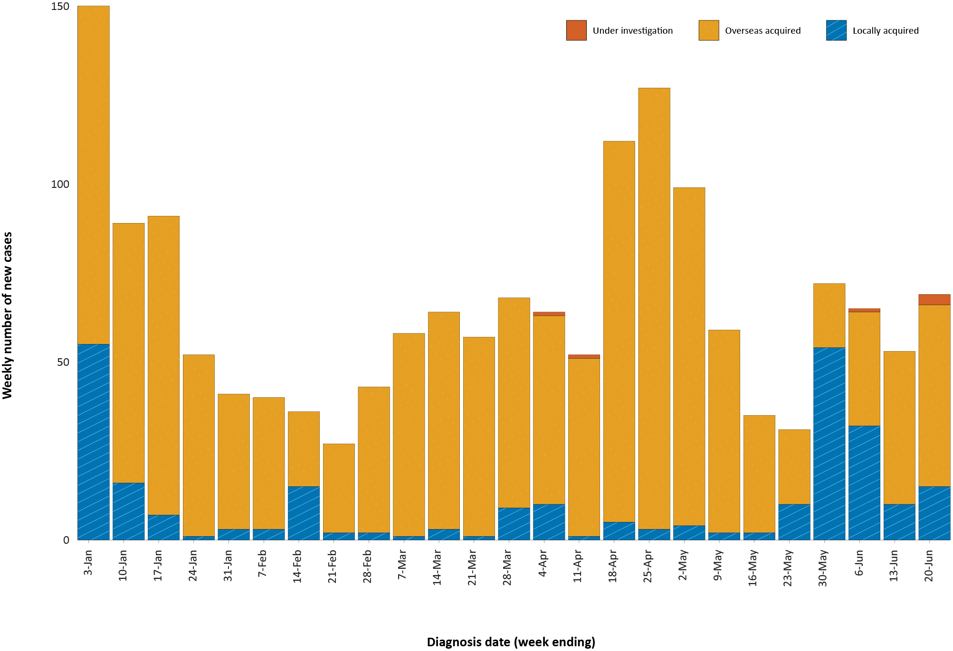
a Source: NNDSS, extract from 22 June 2021 for notifications up to 20 June 2021.

Figure 2: Cumulative COVID-19 notified cases by source of acquisition and diagnosis date, 2 March 2020 – 20 June 2021ª
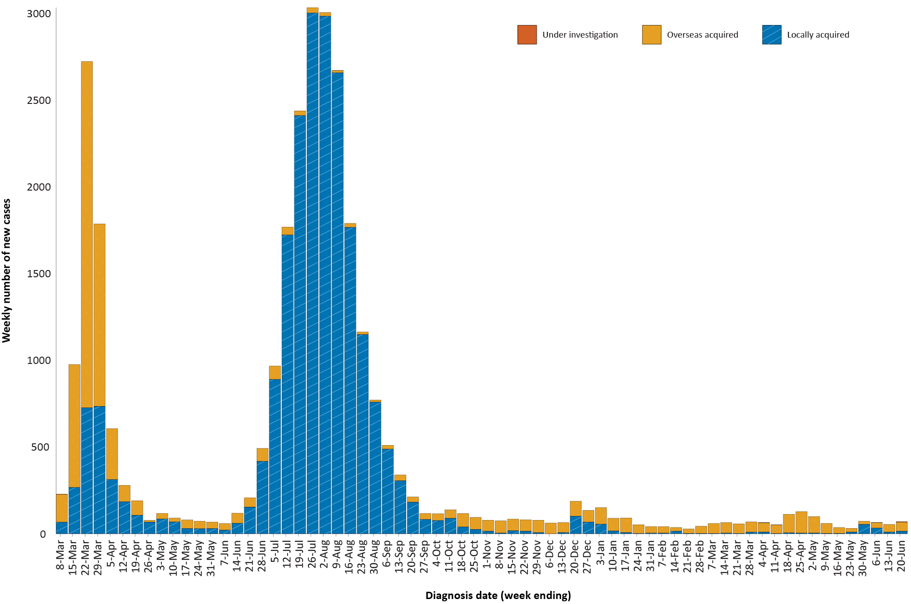
a Source: NNDSS, extract from 22 June 2021 for notifications up to 20 June 2021.

Source of acquisition

(NNDSS)
In this reporting period, 78% (94/121) of cases were acquired overseas, and 21% (25/121) were locally acquired. At the end of this reporting period, there were two cases under investigation (Table 1).
Victoria reported the majority of locally- acquired cases (60%; 15/25) in this fortnight, followed by New South Wales (36%; 9/25) and Queensland (4%; 1/25). Nearly all locally-acquired cases reported during the fortnight had a known contact or link to a cluster. Exceptions were one case in Victoria which had an unknown source, and two cases in New South Wales for which the source of infection was under investigation at the end of this reporting period.
For 2021 to date, Victoria had the highest infection rate for locally-acquired cases with 2.33 infections per 100,000 population, followed by New South Wales with a rate of 0.77 infections per 100,000 population (Table 2). At the end of this reporting period, there had been one day since the last locally-acquired case of known source (Table 3).

Table 2: Locally-acquired COVID-19 case numbers and rates per 100,000 population by jurisdiction and reporting period, Australia, with a diagnosis date from 1 January to 20 June 2021ª
Jurisdiction | Reporting period  7–20 June 2021 | Reporting period  24 May – 6 June 2021 | Cases this year  1 January – 20 June 2021^{b}
 | Number of cases^{b} | Number of cases^{b} | Number of cases^{b} | Rate per 100,000 population^{c}
ACT | 0 | 0 | 0 | —
NSW | 9 | 0 | 63 | 0.77
NT | 0 | 0 | 0 | —
Qld | 1 | 2 | 28 | 0.54
SA | 0 | 0 | 0 | —
Tas. | 0 | 0 | 0 | —
Vic. | 15 | 83 | 156 | 2.33
WA | 0 | 1 | 10 | 0.38
Australia | 25 | 86 | 257 | 1.00
a Source: NNDSS, data extract from 22 June 2021 for notifications up to 20 June 2021.
b This total does not include cases that are under investigation.
c Population data based on Australian Bureau of Statistics (ABS) Estimated Resident Population (ERP) as at June 2020.
Table 3: Days since last locally-acquired COVID-19 case (source unknown and source known), by jurisdiction and diagnosis date, 20 June 2021a
Jurisdiction | Locally acquired — source unknown^{b} |  | Locally acquired — source known^{b}
 | Date of last case | Days since last case | Date of last case | Days since last case
ACT | 21 March 2020 | 456 | 7 July 2020 | 348
NSW | 13 June 2021 | 7 | 18 June 2021 | 2
NT | NA^{c} | NA^{c} | 3 April 2020 | 443
Qld | 23 August 2020 | 301 | 19 June 2021 | 1
SA | 24 March 2020 | 453 | 27 November 2020 | 205
Tas. | 9 August 2020 | 315 | 24 April 2020 | 422
Vic. | 9 June 2021 | 11 | 18 June 2021 | 2
WA | 3 Apr 2020 | 443 | 29 May 2021 | 22
a Source: NNDSS, extract from 22 June 2021 for notifications up to 20 June 2021.
b This does not include locally-acquired cases that were interstate acquired.
c NA: not applicable. The Northern Territory has not reported any locally-acquired cases with an unknown source of infection.

New South Wales reported the largest number of cases (32%; 30/94) that were overseas acquired, followed by Victoria (31%; 29/94) and Queensland (26%; 24/94). In this fortnight, 28 percent (26/94) of overseas-acquired cases reported an unknown country of acquisition. Where country of acquisition was known, Afghanistan was the most commonly-reported country (29%; 20/68). The number of cases acquired in different countries is influenced by travel patterns of returning Australians, travel restrictions, and the prevalence of COVID-19 in the country of travel.

Demographic features

(NNDSS)
In this reporting period, the largest proportion of cases occurred in those aged 20 to 29 years (26%; 32/121 cases). For notifications this year, the highest rate of infection was in those aged 30 to 39 years with a rate of 11.7 infections per 100,000 population (Figure 3; Appendix A, Table A.1). Adults over 80 years of age had the lowest rate of infection this year.
Figure 3: Cumulative COVID-19 cases for the calendar year to date, by age group and sex, Australia, 1 January 2021 – 20 June 2021ª
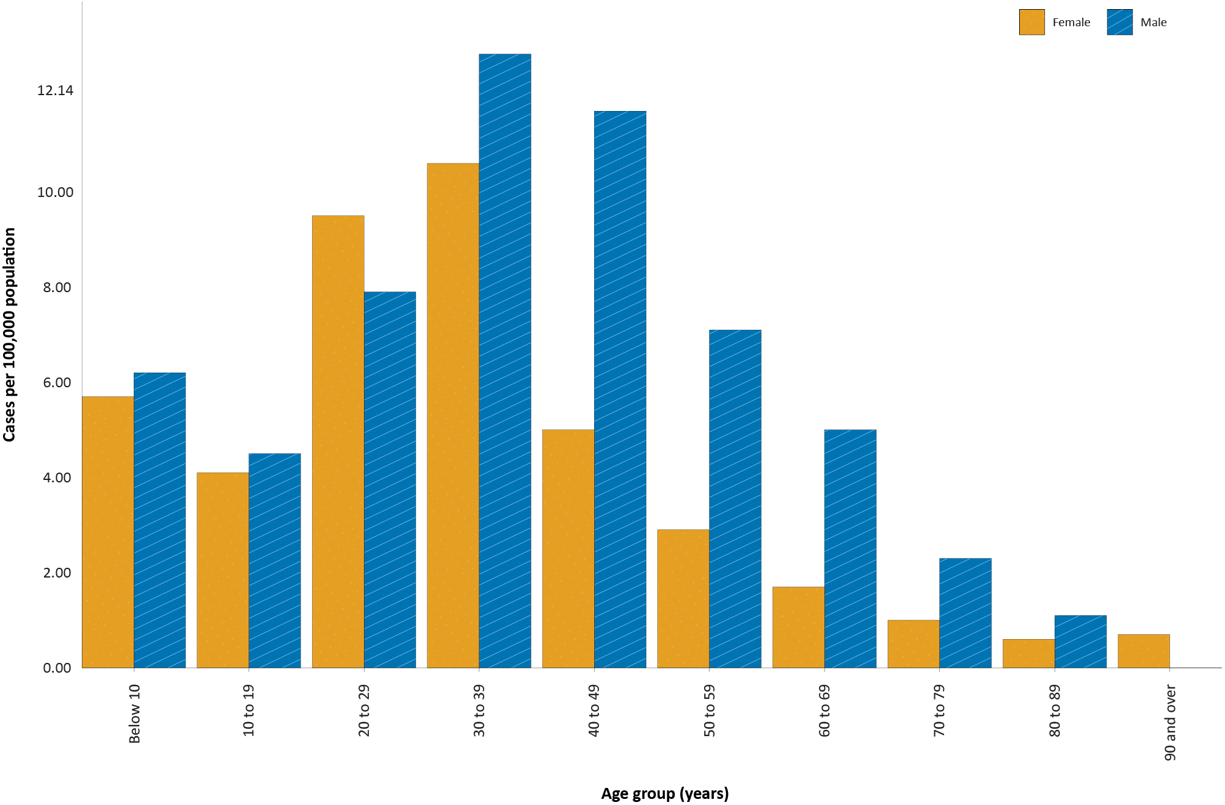
a Source: NNDSS, extract from 22 June 2021 for notifications up to 20 June 2021.

In 2021, notification rates were highest in males for all age groups except those aged 20 to 29 and those aged 90 years and above (Figure 3). The largest difference in rates this year was in the 60 to 69 years age group, where the cumulative rate among males was 5.0 cases per 100,000 population and among females was 1.7 cases per 100,000 population (Appendix A, Table A.1). The median age of cases in this reporting period was 30 years (range: 0 to 80).

Aboriginal and Torres Strait Islander persons

(NNDSS)
Since the beginning of 2021, there have been five confirmed cases of COVID-19 notified in Aboriginal and Torres Strait Islander people, representing 0.33% (5/1,513) of all confirmed cases this year. No new Aboriginal and Torres Strait Islander cases were notified during the reporting period. In 2021, 80% (4/5) of cases in Aboriginal and Torres Strait Islander people were overseas acquired. The age range of COVID-19 cases in Aboriginal and Torres Strait Islander people in 2021 was 20 to 65 years.

Vaccinations

(Department of Health)
As of 20 June 2021, a total of 6,590,741 doses of COVID-19 vaccine had been administered (Table 4), including 414,555 doses provided to aged care and disability residents.
Table 4: Total number of vaccinations administered, by jurisdiction, Australia, 20 June 2021ª
Jurisdiction | Total number of doses administered
ACT | 72,565
NSW | 676,080
NT | 50,879
Qld | 434,281
SA | 181,450
Tas. | 96,781
Vic. | 906,845
WA | 243,127
Aged care and disability facilities^{b} | 414,555
Primary care^{c} | 3,514,178
Total | 6,590,741
a Source: Australian Government Department of Health website.³
b Commonwealth vaccine doses administered in aged care and disability facilities.
c Commonwealth vaccine doses administered in primary care settings.
Recent rare occurrences of thrombosis (blood clotting) and thrombocytopenia (low blood platelet count), in patients who had received the AstraZeneca COVID-19 vaccine, led to temporary suspensions of the vaccine program in Australia to allow for investigation by regulatory bodies. The Australian Technical Advisory Group on Immunisation subsequently recommended that the Pfizer vaccine was the preferred COVID-19 vaccine for adults aged under 60 years.⁴

Clusters and outbreaks
There were 15 locally-acquired cases in Victoria with a notification received date in this two-week reporting period, 14 of which had a known contact or cluster source (Table 1).
In Victoria, all locally-acquired cases reported since 24 May 2021 were due to several ongoing outbreaks in Greater Melbourne. These included outbreaks in a workplace in Port Melbourne; in an aged care facility; in a hospital ward; and in the geographical locations of Whittlesea, Reservoir, West Melbourne and Southbank.
The SARS-CoV-2 strain responsible for most cases’ infections in most of the Victorian outbreaks was the ‘Kappa’ variant (B.1.617.1). Genomic evidence linked these ‘Kappa’ variant cases to a returned traveller notified on 11 May 2021 who had acquired their infection in hotel quarantine in South Australia before returning to Victoria. Investigations into the epidemiological link between this case and the community outbreaks are ongoing.
The West Melbourne outbreak was caused by the ‘Delta’ variant (B.1.617.2) and was genomically matched to a returned traveller testing positive in hotel quarantine in Victoria in early May 2021. The epidemiological link between the traveller and related cases are under investigation. The outbreak included several cases associated with a primary school.
Nearly all locally-acquired cases reported in NSW in the two-week reporting period were part of an outbreak in the Bondi area of Sydney. The first case in the outbreak, reported on 16 June 2021, was a driver transporting international flight crew. The driver was infected with the ‘Delta’ variant of SARS-CoV-2, which matched sequences from the United States of America.
In this period, Queensland reported one locally-acquired case in an international flight crew member who tested positive in the community after completing hotel quarantine. Genomic testing has linked this case to other international aircrew with the ‘Alpha’ variant (B.1.1.7), quarantining in the same hotel quarantine facility.

Four-week reporting period (24 May – 20 June 2021):

Genomic surveillance and virology

(Communicable Disease Genomics Network, AusTrakka and jurisdictional sequencing laboratories)
Nationally, laboratories sequenced SARS-CoV-2 strains from 59% of COVID-19 cases during the pandemic (Table 5, Figure 4).
Table 5: Australian SARS-CoV-2 genome sequences and proportion of positive cases sequenced, 24 May – 20 June 2021 and cumulative to date
Measure | Reporting period  24 May – 20 June 2021 | Cumulative  23 January 2020 – 20 June 2021
SARS-CoV-2 cases sequencedª | 200 | 17,920
Percentage of positive cases sequenced^{b} | 60% | 59%
a Based on individual jurisdictional reports of sequences and case numbers. Calculations of the percentage of cases sequenced based on the number of sequences available in AusTrakka may not always be up-to-date, since this may include duplicate samples from cases and may not represent all available sequence data.
b In most jurisdictions, sequencing has been attempted on all suitable samples (one sample per case). Sequencing of samples from cases identified in the reporting period may be in process at the time of reporting. Remaining unsequenced samples may be due to jurisdictional sequencing strategy, or where samples have been deemed unsuitable for sequencing (typically, because viral loads were too low for sequencing to be successful).

Figure 4: Samples in AusTrakka from 4 January to 20 June 2021, by lineage and date of collectionª
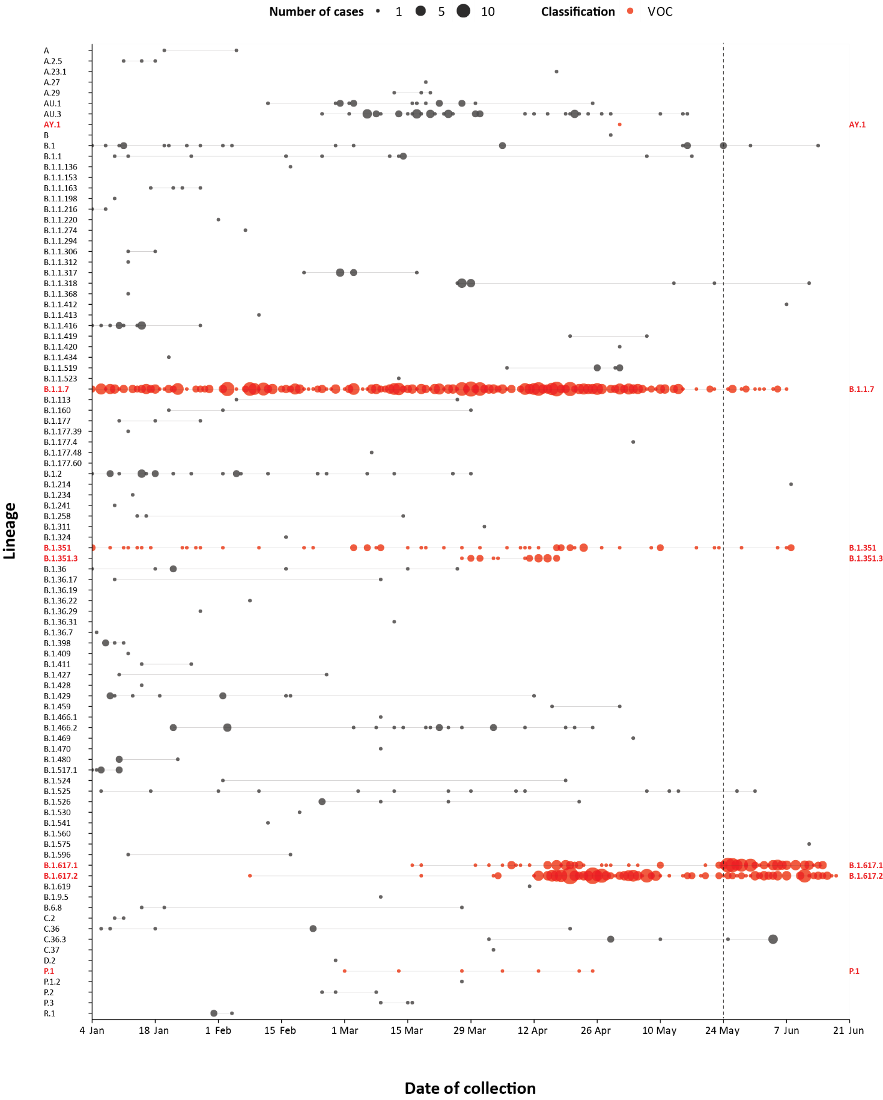
a The start of the current reporting period (24 May – 20 June 2021) is marked by the dotted line, and variant-of-concern samples are coloured red. The size of the circle is proportional to the number of samples in the lineage at each time point.

Variants of concern
AusTrakka actively monitors and reports on SARS-CoV-2 lineages designated Variants of Concern (VOC) by international organisations, including the World Health Organization (WHO): B.1.1.7; B.1.351; P.1; and B.1.617 (and the latter’s sublineages B.1.617.1, B.1.617.2 and B.1.617.3) (Table 6). These variants all display characteristic sets of mutation, including a number of variations in the genomic region encoding the spike protein thought to have the potential to increase transmissibility and/or immune evasion.⁶ On 1 June 2021, WHO announced a new nomenclature system for VOCs, using letters of the Greek alphabet,⁷ to facilitate communication and reduce stigmatisation associated with geography-based colloquial terms.
Further information on variants is available in the Technical Supplement.²
Table 6: Australian SARS-CoV-2 genome sequences in AusTrakka identified as variants of concern, 23 January 2020 – 20 June 2021
VOC lineage | Number of samples
B.1.1.7 (Alpha) | 447
B.1.351 (Beta) | 80
P.1 (Gamma) | 7
B.1.617.1 (Kappa) | 122
B.1.617.2 (Delta) | 202

Testing

(State and territory reporting)
As at 18 June 2021, a cumulative total of 6,953,683 individuals have undergone diagnostic testing for SARS-CoV-2 in Australia this year since 1 January 2021. The cumulative nationwide proportion of positive tests for 2021 remains low at 0.02% (1,526/6,953,683) (Table 7).

Table 7: Individuals undergoing diagnostic tests for SARS-CoV-2,ª by jurisdiction and reporting period, 1 January – 18 June 2021
Jurisdiction | Individuals tested  5–18 June 2021 |  |  | Individuals tested  22 May – 4 June 2021 |  |  | Cumulative individuals tested  in 2021 to 18 June
 | n | Positivity (%) | Per 1,000 population^{b} | n | Positivity (%) | Per 1,000 population^{b} | n | Positivity (%) | Per 1,000 population^{b}
ACT | 8,469 | – | 19.6 | 9,823 | – | 22.8 | 90,681 | < 0.01 | 210.3
NSW | 242,308 | 0.02 | 29.7 | 227,900 | 0.01 | 27.9 | 2,275,711 | 0.02 | 278.7
NT | 9,217 | 0.02 | 37.5 | 11,585 | 0.03 | 47.1 | 98,358 | 0.10 | 399.9
Qld | 82,872 | 0.03 | 16.0 | Not available^{c} | NA^{d} | NA^{d} | 441,396 | 0.07 | 85.3
SA | 52,224 | 0.01 | 29.5 | 67,634 | 0.01 | 38.2 | 528,868 | 0.02 | 298.9
Tas. | 10,374 | – | 19.2 | 11,710 | – | 21.7 | 97,274 | – | 179.9
Vic. | 315,939 | 0.01 | 47.2 | 510,558 | 0.02 | 76.3 | 2,931,040 | 0.01 | 437.8
WA | 34,119 | 0.01 | 12.8 | 43,913 | 0.00 | 16.5 | 490,355 | 0.03 | 184.2
Australia | 755,522 | 0.02 | 29.4 | 883,123 | 0.02 | 34.4 | 6,953,683 | 0.02 | 270.7
a In order to more accurately reflect positivity rates, numbers of individuals tested is presented rather than total number of tests.
b Population data based on Australian Bureau of Statistics (ABS) Estimated Resident Population (ERP) as at June 2020.
c Notifications for Queensland during this period were suspended due to the jurisdiction’s change of surveillance systems.
d NA: not applicable.

During this four-week reporting period, over one and a half million individuals were tested nationally, with a positivity rate of 0.02%. Jurisdictional testing rates are driven by both current case numbers and numbers of people experiencing symptoms. The low national positivity rate, along with high rates of testing, indicates an extremely low incidence of COVID-19 nationally.
Testing rates increased in all age groups in the week ending 4 June 2021, with testing rates the highest they have been all year in those aged 20 to 59. Rates decreased in all age groups in the latter two weeks of this four-weekly reporting period (Figure 5). Even the 80+ age group experienced a small spike in testing rates during this reporting period, despite rates remaining generally low among this age group throughout 2021.
Figure 5: SARS-CoV-2 polymerase chain reaction (PCR) testing rates per 1,000 population per week by age group, Australia, 1 January 2021 – 18 June 2021^{a,b}
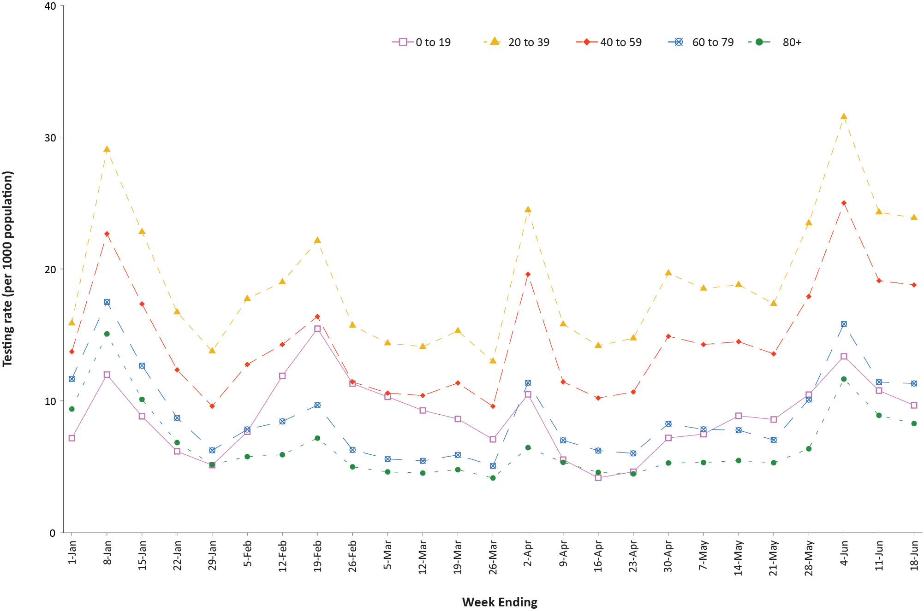
a Source: data provided by jurisdictions to the NIR weekly, current up to 18 June 2021.
b The jurisdictions reporting each week (i.e. the denominator population) may vary.

Acute respiratory illness

(FluTracking and Commonwealth Respiratory Clinics)
Based on self-reported FluTracking data,⁸ prevalence of fever and cough in the community remained at < 1.0%, despite an overall increase in this four-week reporting period compared to the previous four-week reporting period (Figure 6). Runny nose and sore throat symptoms in the community increased again during this reporting period compared to the previous four weeks; however, the prevalence in the community remained low at < 1.1%.

Figure 6: Weekly trends in respiratory illness amongst FluTracking survey participants (age-standardised) compared to the average of the previous five years, Australia, 1 March 2020 – 20 June 2021ª

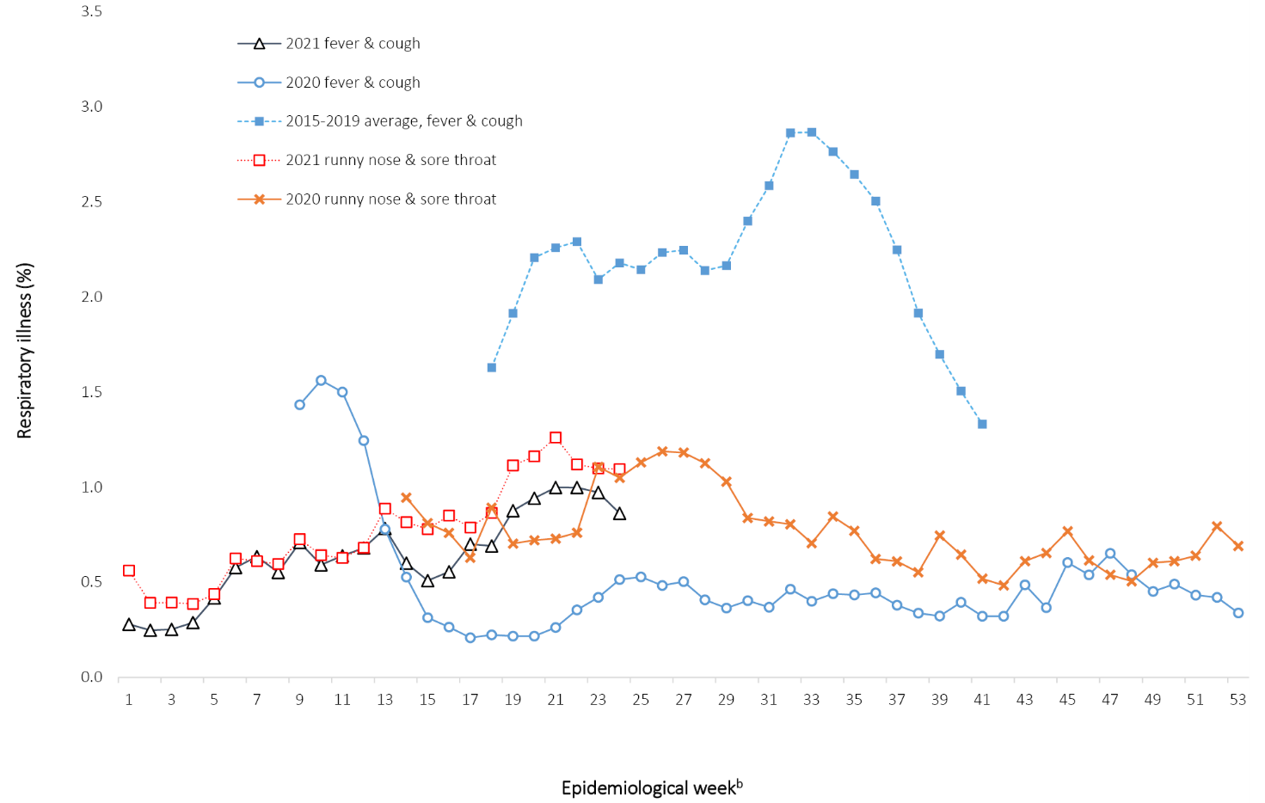
a In years prior to 2020, FluTracking was activated during the main Influenza season from May to October. A historical average beyond the week ending 11 October is therefore not available. In 2020, FluTracking commenced 10 weeks early to capture data for COVID-19. Data on runny nose and sore throat were only collected systematically after 29 March 2020, therefore a historical average for this symptom profile is unavailable.
b Epidemiological weeks are a standardised method for numbering weeks across years, with the first epidemiological week of any year ending on the first Saturday in January.

Table 8: Numbers of COVID-19 case hospitalisations, admissions to ICU, and deaths due to COVID-19, January 2020 – 20 June 2021^{a,b}
Age group | Cases |  | Hospitalisations |  | ICU admission |  | Deaths
 | Total | Cases (with hospital data) | n | Cases hospitalised (%) | n | Cases admitted to ICU (%) | n | Crude CFR (%)
0–9 | 1,509 | 1,463 | 42 | 2.87 | 3 | 0.20 | 0 | 0
10–19 | 2,417 | 2,356 | 32 | 1.36 | 4 | 0.17 | 0 | 0
20–29 | 6,038 | 5,857 | 173 | 2.95 | 20 | 0.33 | 1 | 0.02
30–39 | 4,772 | 4,590 | 212 | 4.62 | 35 | 0.73 | 2 | 0.04
40–49 | 3,435 | 3,292 | 265 | 8.05 | 51 | 1.48 | 1 | 0.03
50–59 | 3,030 | 2,948 | 376 | 12.75 | 107 | 3.53 | 15 | 0.50
60–69 | 2,021 | 1,968 | 434 | 22.05 | 117 | 5.79 | 34 | 1.68
70–79 | 1,348 | 1,317 | 513 | 38.95 | 104 | 7.72 | 148 | 10.98
80–89 | 1,232 | 1,218 | 654 | 53.69 | 33 | 2.68 | 374 | 30.36
90+ | 783 | 772 | 357 | 46.24 | 2 | 0.26 | 315 | 40.23
Total | 26,585 | 25,781 | 3,058 | 11.86 | 476 | 1.79 | 890 | 3.35
a Source: NNDSS, extract from 22 June 2021, based on diagnosis date.
b Data included from four states/territories with the most reliable data across both hospital and ICU data fields: ACT, NSW, Tas. and Vic. This is based on an assessment of data from SPRINT-SARI and NNDSS.
Note that the set of jurisdictions covered in this table differs from the set of jurisdictions discussed within the ‘Hospitalisation’ section text.
In this reporting period, acute respiratory illness was highest in those aged under ten years old, based on both self-reported FluTracking data and presentations to Commonwealth Respiratory Clinics. Females reported respiratory illness more frequently than males. Rates of fever and cough by jurisdiction ranged from 4.7/1,000 FluTracking participants in Victoria to 9.9/1,000 participants in Western Australia.
FluTracking data indicated that 45.1% of those in the community with ‘fever and cough’ and 22.6% of those with ‘runny nose and sore throat’ were tested for SARS-CoV-2. This represented an increase in SARS-CoV-2 testing for both ‘fever and cough’ and ‘sore throat and runny nose’ since the previous reporting period. In the four-week reporting period, testing rates were lowest in Western Australia for both ‘fever and cough’ and ‘sore throat’, and rates were highest in Victoria for both sets of symptoms. It is important to acknowledge that there may be legitimate reasons why people did not get tested, including barriers to accessing testing. Symptoms reported to Flutracking were not specific to COVID-19 and may also be due to chronic diseases.
During this reporting period, there were 92,447 assessments at Commonwealth Respiratory Clinics. Of these, there were 85,169 assessments with consent to share information, with 90.44%(77,026/85,169) tested for SARS-CoV-2. There were two cases reported at these clinics in this reporting period, representing a percent positivity of 0.003% (2/77,026).
Among those tested through the Australian Sentinel Practice Research Network (ASPREN) and Victorian Sentinel Practice Influenza Network (VicSPIN) general practitioner sentinel surveillance systems, rhinovirus was the most common respiratory virus detected in patients presenting with influenza-like illness in this reporting period.

Severity

(NNDSS, FluCAN, SPRINT-SARI)

Hospitalisation
For COVID -19 cases diagnosed to date in 2021 and with hospitalisation status known, the estimated hospitalisation rate was 5.9% (33/591). This is based on data from five states/territories that do not routinely hospitalise cases for isolation purposes and have hospitalisation data that is more than 90% complete (the Australian Capital Territory, South Australia, Tasmania, Victoria and Western Australia). In 2020, approximately 12.6% of cases (2,780/22,021) were hospitalised in these jurisdictions. Cases diagnosed in 2021 were younger and healthier than cases in 2020.

Intensive care admission
The proportion of those hospitalised who were admitted to an intensive care unit (ICU) was estimated from Influenza Complications Alert Network (FluCAN)⁹ sentinel surveillance system data at 19% (based on data for those hospitalised between 29 February 2020 and 28 February 2021).
In the year to date to 20 June 2021, there have been 23 COVID-19 cases admitted to ICUs participating in the sentinel surveillance system, Short Period Incidence Study of Severe Acute Respiratory Infection (SPRINT-SARI),¹⁰ with three of these admitted during this reporting period (24 May – 20 June 2021).

Risk factors for severe disease
The hospitalisation rate for COVID-19 cases in the epidemic to date has generally increased with advancing 10-year age bracket, with the exception of those over the age of 90 years. The management of some cases in residential aged care facilities may be an explanation for the lower rate of hospitalisation in the most elderly.

COVID-19 deaths
In the past four weeks, there have been no deaths due to COVID-19 across Australia (Table 9). Overall, the crude case fatality rate (CFR) remains stable at 3.0%. The ratio of deaths to cases in the year to date has decreased in comparison to this time last year, noting substantially lower case numbers and the difference in age distributions of those infected in 2020 versus 2021.

Table 9: Deaths due to COVID-19 as count and case fatality rates by reporting period, Australia, 1 January 2020 – 20 June 2021ª
 | Number of deaths^{b} | Crude case fatality rate
Reporting period 24 May – 20 June 2021 | 0/259 | 0.0%
Year to date (2021) 1 January – 20 June 2021 | 1/1,566 | 0.1%
Year to date (2020) 1 January – 20 June 2020 | 106/7,760 | 1.4%
Epidemic to date 1 January 2020 – 20 June 2021 | 910/30,034 | 3.0%
a Source: NNDSS, extract from 22 June 2021, based on diagnosis date.
b Expressed as deaths/case numbers.

Public health response measures
Since COVID-19 first emerged internationally, Australia implemented public health measures informed by the disease’s epidemiology (Figure 7). States and territories have decision-making authority in relation to public health measures and have implemented or eased restrictions at their own pace (Appendix A, Table A.2), depending on the local public health and epidemiological situation, and in line with the ‘Framework for National Reopening’.¹¹ Nationwide requirements involving air travel remain, including pre-flight testing for travellers entering Australia; and requirements to wear face masks, when flying domestically or internationally, remain in place. During the current reporting period, there were community transmission cases in New South Wales, Queensland and Victoria.
Figure 7: COVID-19 notifications in Australia by week of diagnosis and jurisdiction, 1 January – 20 June 2021,ª with timing of key public health measures
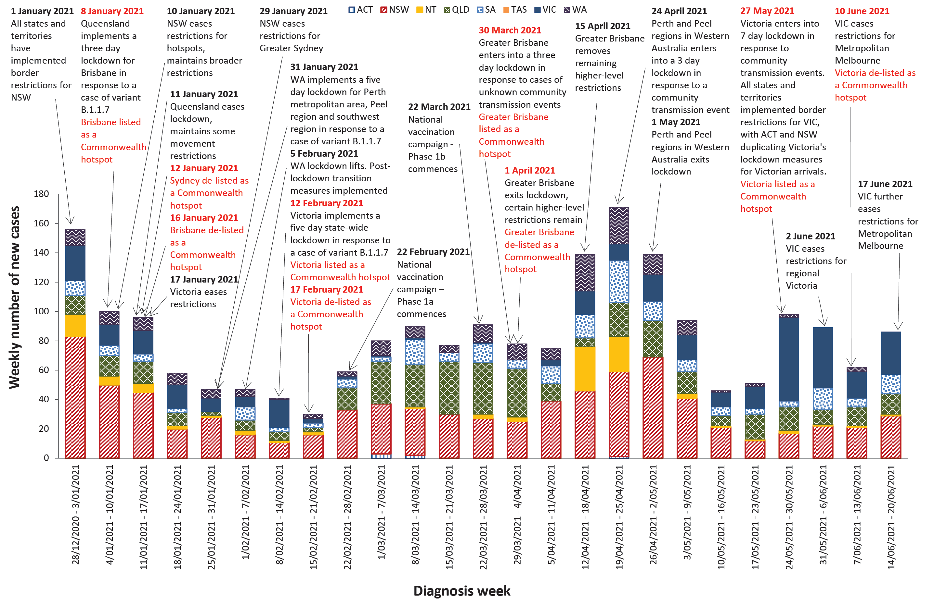

Countries and territories in Australia’s near region
According to WHO, countries and territories in the South East Asian (SEARO) and Western Pacific (WPRO) regions reported 4,562,357 newly-confirmed cases and 110,000 deaths in the four-week period to 20 June 2021, bringing the cumulative cases in the two regions to over 37 million, and cumulative deaths to 523,310.¹² A decreasing trend in case numbers and death incidence in the South East Asian region has been driven by decreasing cases in India, although other countries in the region are now experiencing an increase in cases, notably Myanmar, Bangladesh and Indonesia.¹³
Table 10 outlines the current transmission classification set by WHO for Australia’s near region. Under WHO’s classification, Australia’s transmission classification remains at ‘clusters of cases’.
Table 10: Transmission patterns for countries in Australia’s near region according to WHO, 20 June 2021^{a,b}
Category | Country
No cases  Countries/territories/areas with no cases | American Samoa, Cook Islands, Democratic People’s Republic of Korea, Kiribati, Marshall Islands, Federated States of Micronesia, Nauru, Niue, Palau, Pitcairn Islands, Samoa, Solomon Islands, Tokelau, Tonga, Tuvalu and Vanuatu
Sporadic cases  Countries/territories/areas with one or more cases, imported or locally detected | Brunei Darussalam, Cambodia, Fiji, French Polynesia, Lao PDR, New Caledonia, New Zealand, Singapore, Wallis and Futuna
Clusters of cases  Countries/territories/areas experiencing cases, clustered in time, geographic location and/or by common exposures | Australia, Bhutan, China, Guam, India, Japan, Maldives, Mongolia, Myanmar, Republic of Korea, Sri Lanka, Thailand and Vietnam
Community transmission  Countries /territories/areas experiencing larger outbreaks of local transmission defined through an assessment of factors including, but not limited to:  - large numbers of cases not linkable to transmission chains  - large numbers of cases from sentinel lab surveillance or increasing positive tests through sentinel samples (routine systematic testing of respiratory samples from established laboratories)  - multiple unrelated clusters in several areas of the country/territory/area. | Bangladesh, Indonesia, Malaysia, Nepal, Papua New Guinea, the Philippines and Timor-Leste
a Source: World Health Organization Coronavirus (COVID-19) Dashboard,¹² accessed 28 June 2021.
b Classifications according to WHO.

As of 20 June 2021, over 177 million COVID-19 cases and 3.8 million deaths have been reported globally, with a global CFR of 2.2%. The two regions reporting the largest burden of disease over the past four weeks were the Region of the Americas (40.3%) and the South East Asian region (32.7%).

Acknowledgements
We thank public health staff from incident emergency operations centres and public health units in state and territory health departments, and the Australian Government Department of Health, along with state and territory public health laboratories. We thank those who have provided data from surveillance systems, such as Commonwealth respiratory clinics, ASPREN, Flutracking, FluCAN, SPRINT-SARI, Communicable Disease Genomics Network, AusTrakka and jurisdictional sequencing laboratories.

Author details

Corresponding author
COVID-19 National Incident Room Surveillance Team
Australian Government Department of Health, GPO Box 9484, MDP 14, Canberra, ACT 2601.
Email: epi.coronavirus@health.gov.au

References
COVID-19 National Incident Room Surveillance Team. COVID-19 Australia: Epidemiology Report 43: Reporting period ending 6 June 2021. Commun Dis Intell (2018). 2021;45. doi: https://doi.org/10.33321/cdi.2021.45.33.
COVID-19 National Incident Room Surveillance Team. Technical supplement. COVID-19 Australia: Epidemiology reporting. Commun Dis Intell (2018). 2021;45. doi: https://doi.org/10.33321/cdi.2021.45.2.
Australian Government Department of Health. Getting vaccinated for COVID-19: Australia’s vaccine rollout. [Internet.] Canberra: Australian Government Department of Health; 2021. [Accessed on 21 June 2021.] Available from: https://www.health.gov.au/initiatives-and-programs/covid-19-vaccines/getting-vaccinated-for-covid-19#australias-vaccine-rollout.
Australian Government Department of Health. ATAGI statement on revised recommendations on the use of COVID-19 Vaccine AstraZeneca, 17 June 2021. [Internet.] Canberra: Australian Government Department of Health, Australian Technical Advisory Group on Immunisation; 17 June 2021. [Accessed 25 June 2021.] Available from: https://www.health.gov.au/news/atagi-statement-on-revised-recommendations-on-the-use-of-covid-19-vaccine-astrazeneca-17-june-2021.
Communicable Diseases Genomics Network (CDGN). AusTrakka. [Website.] Melbourne: CDGN; 2020. Available from: https://www.cdgn.org.au/austrakka.
World Health Organization (WHO). Coronavirus disease (COVID-19) Weekly Epidemiological Update and Weekly Operational Update. [Internet.] Geneva: WHO; June 2021. [Accessed on 25 June 2021.] Available from: https://www.who.int/emergencies/diseases/novel-coronavirus-2019/situation-reports/.
WHO. Tracking SARS-CoV-2 variants. [Internet.] Geneva: WHO; 15 June 2021. [Accessed on 25 June 2021.] Available from: https://www.who.int/en/activities/tracking-SARS-CoV-2-variants/.
Dalton C, Durrheim D, Fejsa J, Francis L, Carlson S, d’Espaignet ET et al. Flutracking: a weekly Australian community online survey of influenza-like illness in 2006, 2007 and 2008. Commun Dis Intell Q Rep. 2009;33(3):316–22.
Monash Health. FluCAN (Influenza surveillance): FluCAN (The Influenza Complications Alert Network). [Internet.] Melbourne: Monash Health; 2020. Available from: https://monashhealth.org/services/monash-infectious-diseases/research/influenza-research/flucan-influenza-surveillance-2/.
Australian and New Zealand Intensive Care Society (ANZICS). SPRINT-SARI: Short period incidence study of severe acute respiratory infection. [Internet.] Camberwell: ANZICS; 2020. Available from: https://www.anzics.com.au/current-active-endorsed-research/sprint-sari/.
Australian Government Department of Health. Framework for national reopening – October 2020. [Internet.] Canberra: Australian Government Department of Health; 23 October 2020. [Accessed on 10 November 2020.] Available from: https://www.health.gov.au/resources/publications/framework-for-national-reopening-october-2020.
WHO. WHO Coronavirus Disease (COVID-19) dashboard. [Internet.] Geneva: WHO; 2021. Available from: https://covid19.who.int/.
WHO. Weekly epidemiological update on COVID-19 – 22 June 2021. [Internet.] Geneva: WHO; 22 June 2021. [Accessed on 28 June 2021.] Available from: https://www.who.int/publications/m/item/weekly-epidemiological-update-on-covid-19---22-june-2021.
Australian Capital Territory Government. COVID-19: ACT updated travel advice for Victoria. [Internet.] Canberra: Australian Capital Territory Government; 24 May 2021. [Accessed on 23 June 2021.] Available from: https://www.covid19.act.gov.au/news-articles/act-updated-travel-advice-for-victoria.
Australian Capital Territory Government. COVID-19: New COVID-19 exposure locations added outside Greater Melbourne. [Internet.] Canberra: Australian Capital Territory Government; 26 May 2021. [Accessed on 23 June 2021.] Available from: https://www.covid19.act.gov.au/news-articles/new-covid-19-exposure-locations-added-outside-greater-melbourne.
Australian Capital Territory Government. COVID-19: New ‘stay at home’ requirement in ACT if travelling from Victoria. [Internet.] Canberra: Australian Capital Territory Government; 27 May 2021. [Accessed on 23 June 2021.] Available from: https://www.covid19.act.gov.au/news-articles/new-stay-at-home-requirement-in-act-if-travelling-from-victoria.
Australian Capital Territory Government. COVID-19: ACT travel requirements for NSW exposure locations. [Internet.] Canberra: Australian Capital Territory Government; 2 June 2021. [Accessed on 23 June 2021.] Available from: https://www.covid19.act.gov.au/news-articles/act-travel-requirements-for-nsw-exposure-locations.
Australian Capital Territory Government. COVID-19: Latest news – COVID-19 vaccine. [Internet.] Canberra: Australian Capital Territory Government; 3 June 2021. [Accessed on 23 June 2021.] Available from: https://www.covid19.act.gov.au/news-articles/latest-news-covid-19-vaccine.
Australian Capital Territory Government. COVID-19: Update on ACT travel requirements from New South Wales and Victoria. [Internet.] Canberra: Australian Capital Territory Government; 3 June 2021. [Accessed on 23 June 2021.] Available from: https://www.covid19.act.gov.au/news-articles/update-on-act-travel-requirements-from-new-south-wales-and-victoria.
Australian Capital Territory Government. COVID-19: Update on new COVID-19 case in QLD. [Internet.] Canberra: Australian Capital Territory Government; 9 June 2021. [Accessed on 23 June 2021.] Available from: https://www.covid19.act.gov.au/news-articles/update-on-new-covid-19-case-in-qld.
Australian Capital Territory Government. COVID-19: Stay-at-home order lifted in the ACT. [Internet.] Canberra: Australian Capital Territory Government; 10 June 2021. [Accessed on 23 June 2021.] Available from: https://www.covid19.act.gov.au/news-articles/stay-at-home-order-lifted-in-the-act.
Australian Capital Territory Government. COVID-19: Update on travel requirements for Victoria. [Internet.] Canberra: Australian Capital Territory Government; 17 June 2021. [Accessed on 23 June 2021.] Available from: https://www.covid19.act.gov.au/news-articles/update-on-travel-requirements-for-victoria.
Australian Capital Territory Government. COVID-19: Exposure locations in the ACT. [Internet.] Canberra: Australian Capital Territory Government; 18 June 2021. [Accessed on 23 June 2021.] Available from: https://www.covid19.act.gov.au/news-articles/exposure-locations-in-the-act.
Australian Capital Territory Government. COVID-19: Updated advice for COVID-19 exposure locations in the ACT. [Internet.] Canberra: Australian Capital Territory Government; 19 June 2021. [Accessed on 23 June 2021.] Available from: https://www.covid19.act.gov.au/news-articles/updated-advice-for-covid-19-exposure-locations-in-the-act.
Government of New South Wales, NSW Health. Public health alert - Melbourne. [Internet.] Sydney: Government of New South Wales; 24 May 2021. [Accessed on 24 June 2021.] Available from: https://www.health.nsw.gov.au/news/pages/20210524_01.aspx.
Government of New South Wales, NSW Health. Public Health Alert - Melbourne cases. [Internet.] Sydney: Government of New South Wales; 26 May 2021. [Accessed on 24 June 2021.] Available from: https://www.health.nsw.gov.au/news/pages/20210526_02.aspx.
Government of New South Wales, NSW Health. Public Health Alert - new event of concern. [Internet.] Sydney: Government of New South Wales; 26 May 2021. [Accessed on 24 June 2021.] Available from: https://www.health.nsw.gov.au/news/pages/20210526_03.aspx.
Government of New South Wales, NSW Health. Public health alert - stay at home order. [Internet.] Sydney: Government of New South Wales; 27 May 2021. [Accessed on 24 June 2021.] Available from: https://www.health.nsw.gov.au/news/pages/20210527_01.aspx.
Government of New South Wales, NSW Health. Public Health Alert - Jervis Bay. [Internet.] Sydney: Government of New South Wales; 1 June 2021. [Accessed on 24 June 2021.] Available from: https://www.health.nsw.gov.au/news/pages/20210601_01.aspx.
Government of New South Wales, NSW Health. Public Health Alert - Further venues. [Internet.] Sydney: Government of New South Wales; 2 June 2021. [Accessed on 24 June 2021.] Available from: https://www.health.nsw.gov.au/news/pages/20210602_01.aspx.
Government of New South Wales, NSW Health. Public health alert- Advice for people who have been in Victoria since 4pm 27 May. [Internet.] Sydney: Government of New South Wales; 3 June 2021. [Accessed on 24 June 2021.] Available from: https://www.health.nsw.gov.au/news/pages/20210603_01.aspx.
Government of New South Wales, NSW Health. Stay-at-home order to be lifted for people who have been in Victoria. [Internet.] Sydney: Government of New South Wales; 10 June 2021. [Accessed on 24 June 2021.] Available from: https://www.health.nsw.gov.au/news/pages/20210610_01.aspx.
Government of New South Wales, NSW Health. NSW Health investigating source of COVID-19 case. [Internet.] Sydney: Government of New South Wales; 15 June 2021. [Accessed on 24 June 2021.] Available from: https://www.health.nsw.gov.au/news/pages/20210615_01.aspx.
Government of New South Wales, NSW Health. Public health alert - COVID-19 case. [Internet.] Sydney: Government of New South Wales; 16 June 2021. [Accessed on 24 June 2021.] Available from: https://www.health.nsw.gov.au/news/pages/20210616_01.aspx.
Government of New South Wales, NSW Health. Public health alert - further venues. [Internet.] Sydney: Government of New South Wales; 16 June 2021. [Accessed on 24 June 2021.] Available from: https://www.health.nsw.gov.au/news/pages/20210616_03.aspx.
Government of New South Wales, NSW Health. Public health alert - further venues. [Internet.] Sydney: Government of New South Wales; 20 June 2021. [Accessed on 24 June 2021.] Available from: https://www.health.nsw.gov.au/news/pages/20210620_01.aspx.
Northern Territory Government. Coronavirus (COVID-19): COVID-19 Australian hotspots and travel restrictions. [Internet.] Darwin: Northern Territory Government; June 2021. [Accessed on 23 June 2021.] Available from: https://coronavirus.nt.gov.au/travel/quarantine/hotspots-covid-19.
Queensland Health. Quarantine direction triggered for Victorian venues. [Internet.] Brisbane: Queensland Government, Queensland Health; 24 May 2021. [Accessed on 24 June 2021.] Available from: https://www.health.qld.gov.au/news-events/doh-media-releases/releases/quarantine-direction-triggered-for-victorian-venues.
Queensland Health. Queensland to declare Victorian local government area a hotspot. [Internet.] Brisbane: Queensland Government, Queensland Health; 25 May 2021. [Accessed on 24 June 2021.] Available from: https://www.health.qld.gov.au/news-events/doh-media-releases/releases/queensland-to-declare-victorian-local-government-area-a-hotspot.
Queensland Health. Statement regarding Victoria cases. [Internet.] Brisbane: Queensland Government, Queensland Health; 27 May 2021. [Accessed on 24 June 2021.] Available from: https://www.health.qld.gov.au/news-events/doh-media-releases/releases/statement-regarding-victoria-cases2.
Queensland Health. COVID-19 case identified in Sunshine Coast. [Internet.] Brisbane: Queensland Government, Queensland Health; 9 June 2021. [Accessed on 24 June 2021.] Available from: https://www.health.qld.gov.au/news-events/doh-media-releases/releases/covid-19-case-identified-in-sunshine-coast.
Queensland Health. Queensland quarantine measures kick in as Sydney records one case of COVID-19. [Internet.] Brisbane: Queensland Government, Queensland Health; 16 June 2021. [Accessed on 24 June 2021.] Available from: https://www.health.qld.gov.au/news-events/doh-media-releases/releases/queensland-health-statement-regarding-further-increase-of-exposure-venues.
Queensland Health. Hotspot declared for Waverley Council area in Sydney. [Internet.] Brisbane: Queensland Government, Queensland Health; 18 June 2021. [Accessed on 24 June 2021.] Available from: https://www.health.qld.gov.au/news-events/doh-media-releases/releases/hotspot-declared-for-waverley-council-area-in-sydney.
Queensland Government. Travelling to Queensland. [Internet.] Brisbane: Queensland Government; June 2021. [Accessed on 24 June 2021.] Available from: https://www.qld.gov.au/health/conditions/health-alerts/coronavirus-covid-19/current-status/public-health-directions/travelling-to-queensland.
Queensland Health. Community case in Brisbane. [Internet.] Brisbane: Queensland Government, Queensland Health; 20 June 2021. [Accessed on 24 June 2021.] Available from: https://www.health.qld.gov.au/news-events/doh-media-releases/releases/community-case-in-brisbane.
SA Health. COVID-19 update 267. Victoria border update. [Internet.] Adelaide: Government of South Australia, SA Health; 25 May 2021. [Accessed on 24 June 2021.] Available from: https://www.sahealth.sa.gov.au/wps/wcm/connect/public+content/sa+health+internet/conditions/infectious+diseases/covid-19/about+covid-19/latest+updates/covid-19+round+up+reports/covid-19+update+267.
SA Health. COVID-19 update 268. Victoria border update. [Internet.] Adelaide: Government of South Australia, SA Health; 26 May 2021. [Accessed on 24 June 2021.] Available from: https://www.sahealth.sa.gov.au/wps/wcm/connect/public+content/sa+health+internet/conditions/infectious+diseases/covid-19/about+covid-19/latest+updates/covid-19+round+up+reports/covid-19+update+268.
SA Health. COVID-19 update 272. NSW exposure locations. [Internet.] Adelaide: Government of South Australia, SA Health; 2 June 2021. [Accessed on 24 June 2021.] Available from: https://www.sahealth.sa.gov.au/wps/wcm/connect/public+content/sa+health+internet/conditions/infectious+diseases/covid-19/about+covid-19/latest+updates/covid-19+round+up+reports/covid-19+update+272.
SA Health. COVID-19 update 273. COVID-19 vaccine update. [Internet.] Adelaide: Government of South Australia, SA Health; 3 June 2021. [Accessed on 24 June 2021.] Available from: https://www.sahealth.sa.gov.au/wps/wcm/connect/public+content/sa+health+internet/conditions/infectious+diseases/covid-19/about+covid-19/latest+updates/covid-19+round+up+reports/covid-19+update+273.
SA Health. COVID-19 update 276. COVID-19 vaccine update. [Internet.] Adelaide: Government of South Australia, SA Health; 8 June 2021. [Accessed on 24 June 2021.] Available from: https://www.sahealth.sa.gov.au/wps/wcm/connect/public+content/sa+health+internet/conditions/infectious+diseases/covid-19/about+covid-19/latest+updates/covid-19+round+up+reports/covid-19+update+276.
SA Health. COVID-19 update 277. Interstate COVID-19 exposure locations. [Internet.] Adelaide: Government of South Australia, SA Health; 9 June 2021. [Accessed on 24 June 2021.] Available from: https://www.sahealth.sa.gov.au/wps/wcm/connect/public+content/sa+health+internet/conditions/infectious+diseases/covid-19/about+covid-19/latest+updates/covid-19+round+up+reports/covid-19+update+277.
SA Health. COVID-19 update 282. NSW border update. [Internet.] Adelaide: Government of South Australia, SA Health; 17 June 2021. [Accessed on 24 June 2021.] Available from: https://www.sahealth.sa.gov.au/wps/wcm/connect/public+content/sa+health+internet/conditions/infectious+diseases/covid-19/about+covid-19/latest+updates/covid-19+round+up+reports/covid-19+update+282.
SA Health. COVID-19 update 20 June 2021. [Internet.] Adelaide: Government of South Australia, SA Health; 20 June 2021. [Accessed on 24 June 2021.] Available from: https://www.sahealth.sa.gov.au/wps/wcm/connect/public+content/sa+health+internet/about+us/news+and+media/all+media+releases/covid-19+update+20+june+2021.
Tasmanian Government. Coronavirus disease (COVID-19). Media releases: Victorian COVID-19 cases. [Internet.] Hobart: Tasmanian Government; 24 May 2021. [Accessed on 24 June 2021.] Available from: https://coronavirus.tas.gov.au/media-releases/victorian-covid-19-cases.
Tasmanian Government. Coronavirus disease (COVID-19). Media releases: Victorian COVID-19 cases. [Internet.] Hobart: Tasmanian Government; 25 May 2021. [Accessed on 24 June 2021.] Available from: https://coronavirus.tas.gov.au/media-releases/victorian-covid-19-cases2.
Tasmanian Government. Coronavirus disease (COVID-19). Media releases: Victoria declared a high-risk area. [Internet.] Hobart: Tasmanian Government; 27 May 2021. [Accessed on 24 June 2021.] Available from: https://coronavirus.tas.gov.au/media-releases/victoria-declared-a-high-risk-area.
Tasmanian Government. Coronavirus disease (COVID-19). Media releases: COVID-19 update: NSW high-risk locations. [Internet.] Hobart: Tasmanian Government; 2 June 2021. [Accessed on 24 June 2021.] Available from: https://coronavirus.tas.gov.au/media-releases/covid-19-update-nsw-high-risk-locations.
Tasmanian Government. Coronavirus disease (COVID-19). Media releases: Victoria travel restrictions. [Internet.] Hobart: Tasmanian Government; 3 June 2021. [Accessed on 24 June 2021.] Available from: https://coronavirus.tas.gov.au/media-releases/victoria-travel-restrictions.
Tasmanian Government. Coronavirus disease (COVID-19). Media releases: COVID-19 update. [Internet.] Hobart: Tasmanian Government; 9 June 2021. [Accessed on 24 June 2021.] Available from: https://coronavirus.tas.gov.au/media-releases/covid-19-update4.
Tasmanian Government. Coronavirus disease (COVID-19). Media releases: Changes to Victorian travel restrictions. [Internet.] Hobart: Tasmanian Government; 10 June 2021. [Accessed on 24 June 2021.] Available from: https://coronavirus.tas.gov.au/media-releases/changes-to-victorian-travel-restrictions.
Victoria State Government Department of Health and Human Services (DHHS). Coronavirus update for Victoria - 24 May 2021. [Internet.] Melbourne: Victoria State Government, DHHS; 24 May 2021. [Accessed on 24 June 2021.] Available from: https://www.dhhs.vic.gov.au/coronavirus-update-victoria-24-may-2021.
DHHS. Coronavirus update for Victoria - 25 May 2021. [Internet.] Melbourne: Victoria State Government, DHHS; 25 May 2021. [Accessed on 24 June 2021.] Available from: https://www.dhhs.vic.gov.au/coronavirus-update-victoria-25-may-2021.
Premier of Victoria. Statement from the Acting Premier. [Internet.] Melbourne: Victoria State Government, Office of the Premier; 27 May 2021. [Accessed on 24 June 2021.] Available from: https://www.premier.vic.gov.au/statement-acting-premier-1.
Australian Government Department of Health. Greater Melbourne declared a hotspot for Commonwealth support. [Internet.] Canberra: Australian Government Department of Health; 27 May 2021. [Accessed on 24 June 2021.] Available from: https://www.health.gov.au/news/greater-melbourne-declared-a-hotspot-for-commonwealth-support.
DHHS. Coronavirus update for Victoria - 29 May 2021. [Internet.] Melbourne: Victoria State Government, DHHS; 29 May 2021. [Accessed on 24 June 2021.] Available from: https://www.dhhs.vic.gov.au/coronavirus-update-victoria-29-may-2021.
DHHS. Coronavirus update for Victoria 30 May 2021. [Internet.] Melbourne: Victoria State Government, DHHS; 30 May 2021. [Accessed on 24 June 2021.] Available from: https://www.dhhs.vic.gov.au/coronavirus-update-victoria-30-may-2021.
DHHS. Coronavirus update for Victoria 31 May 2021. [Internet.] Melbourne: Victoria State Government, DHHS; 31 May 2021. [Accessed on 24 June 2021.] Available from: https://www.dhhs.vic.gov.au/coronavirus-update-victoria-31-may-2021.
Premier of Victoria. Statement from the Acting Premier. [Internet.] Melbourne: Victoria State Government, Office of the Premier; 2 June 2021. [Accessed on 24 June 2021.] Available from: https://www.premier.vic.gov.au/statement-acting-premier-2.
DHHS. Coronavirus update for Victoria - 4 June 2021. [Internet.] Melbourne: Victoria State Government, DHHS; 4 June 2021. [Accessed on 24 June 2021.] Available from: https://www.dhhs.vic.gov.au/coronavirus-update-victoria-4-june-2021.
DHHS. Media release - coronavirus update for Victoria - 5 June 2021. [Internet.] Melbourne: Victoria State Government, DHHS; 5 June 2021. [Accessed on 24 June 2021.] Available from: https://www.dhhs.vic.gov.au/coronavirus-update-victoria-5-june-2021.
Australian Government Department of Health. Declaration of Greater Melbourne Area a hotspot for Commonwealth support extended. [Internet.] Canberra: Australian Government Department of Health; 4 June 2021. [Accessed on 24 June 2021.] Available from: https://www.health.gov.au/news/declaration-of-greater-melbourne-area-a-hotspot-for-commonwealth-support-extended.
DHHS. Coronavirus update for Victoria - 9 June 2021. [Internet.] Melbourne: Victoria State Government, DHHS; 9 June 2021. [Accessed on 24 June 2021.] Available from: https://www.dhhs.vic.gov.au/coronavirus-update-victoria-9-june-2021.
Premier of Victoria. Statement from the Acting Premier. [Internet.] Melbourne: Victoria State Government, Office of the Premier; 9 June 2021. [Accessed on 24 June 2021.] Available from: https://www.premier.vic.gov.au/statement-acting-premier-3.
Australian Government Department of Health. Greater Melbourne hotspot for Commonwealth support lifted. [Internet.] Canberra: Australian Government Department of Health; 10 June 2021. [Accessed on 24 June 2021.] Available from: https://www.health.gov.au/news/greater-melbourne-hotspot-for-commonwealth-support-lifted.
DHHS. Coronavirus update for Victoria - 11 June 2021. [Internet.] Melbourne: Victoria State Government, DHHS; 11 June 2021. [Accessed on 24 June 2021.] Available from: https://www.dhhs.vic.gov.au/coronavirus-update-victoria-11-june-2021.
Premier of Victoria. Statement from the Acting Premier. [Internet.] Melbourne: Victoria State Government, Office of the Premier; 16 June 2021. [Accessed on 24 June 2021.] Available from: https://www.premier.vic.gov.au/statement-acting-premier-4.
DHHS. Coronavirus update for Victoria - 17 June 2021. [Internet.] Melbourne: Victoria State Government, DHHS; 17 June 2021. [Accessed on 24 June 2021.] Available from: https://www.dhhs.vic.gov.au/coronavirus-update-victoria-17-june-2021.
Government of Western Australia. WA introduces hard border with Victoria. [Internet.] Perth: Government of Western Australia; 27 May 2021. [Accessed on 23 June 2021.] Available from: https://www.wa.gov.au/government/announcements/wa-introduces-hard-border-victoria.
Government of Western Australia. Public health advice issued for recent arrivals from New South Wales and the Australian Capital Territory. [Internet.] Perth: Government of Western Australia; 2 June 2021. [Accessed on 23 June 2021.] Available from: https://www.wa.gov.au/government/announcements/public-health-advice-issued-recent-arrivals-new-south-wales-and-the-australian-capital-territory.
Government of Western Australia. Health advice about previous positive COVID-19 case. [Internet.] Perth: Government of Western Australia; 6 June 2021. [Accessed on 23 June 2021.] Available from: https://www.wa.gov.au/government/announcements/health-advice-about-previous-positive-covid-19-case.
Government of Western Australia. All Western Australians over 30 eligible for COVID-19 vaccinations. [Internet.] Perth: Government of Western Australia; 8 June 2021. [Accessed on 23 June 2021.] Available from: https://www.wa.gov.au/government/announcements/all-western-australians-over-30-eligible-covid-19-vaccinations.
Government of Western Australia. Public health advice issued for recent arrivals from Queensland. [Internet.] Perth: Government of Western Australia; 9 June 2021. [Accessed on 23 June 2021.] Available from: https://www.wa.gov.au/government/announcements/public-health-advice-issued-recent-arrivals-queensland.
Government of Western Australia. Victoria to transition to a ‘low risk’ state. [Internet.] Perth: Government of Western Australia; 11 June 2021. [Accessed on 23 June 2021.] Available from: https://www.wa.gov.au/government/announcements/victoria-transition-low-risk-state.
Government of Western Australia. Public health advice issued for recent arrivals from New South Wales. [Internet.] Perth: Government of Western Australia; 16 June 2021. [Accessed on 23 June 2021.] Available from: https://www.wa.gov.au/government/announcements/public-health-advice-issued-recent-arrivals-new-south-wales.
Government of Western Australia. Changes to WA’s COVID-19 vaccine rollout. [Internet.] Perth: Government of Western Australia; 17 June 2021. [Accessed on 23 June 2021.] Available from: https://www.wa.gov.au/government/announcements/changes-was-covid-19-vaccine-rollout.
Government of Western Australia. Changes to WA entry conditions for New South Wales travellers. [Internet.] Perth: Government of Western Australia; 19 June 2021. [Accessed on 23 June 2021.] Available from: https://www.wa.gov.au/government/announcements/changes-wa-entry-conditions-new-south-wales-travellers.

Appendix A: Supplementary figures and tables
Table A.1: COVID-19 cases diagnosed and rates per 100,000 population, by age group and sex, Australia, 20 June 2021^{a,b}
Age group | This reporting period  24 May – 20 June 2021 |  |  |  |  |  | This year^{c}  1 January 2021 – 20 June 2021
 | Cases |  |  | Rate per 100,000 population |  |  | Cases |  |  | Rate per 100,000 population
 | Male | Female | People | Male | Female | People | Male | Female | People | Male | Female | People
0 to 9 | 21 | 11 | 32 | 1.3 | 0.7 | 1.0 | 102 | 88 | 190 | 6.2 | 5.7 | 6.0
10 to 19 | 13 | 18 | 31 | 0.8 | 1.2 | 1.0 | 71 | 62 | 133 | 4.5 | 4.1 | 4.3
20 to 29 | 35 | 31 | 66 | 1.9 | 1.7 | 1.8 | 145 | 169 | 314 | 7.9 | 9.5 | 8.7
30 to 39 | 33 | 33 | 66 | 1.8 | 1.7 | 1.8 | 239 | 201 | 440 | 12.9 | 10.6 | 11.7
40 to 49 | 25 | 16 | 41 | 1.5 | 1.0 | 1.2 | 191 | 84 | 275 | 11.7 | 5.0 | 8.3
50 to 59 | 18 | 6 | 24 | 1.2 | 0.4 | 0.8 | 108 | 46 | 154 | 7.1 | 2.9 | 4.9
60 to 69 | 9 | 6 | 15 | 0.7 | 0.4 | 0.6 | 65 | 24 | 89 | 5.0 | 1.7 | 3.3
70 to 79 | 3 | 4 | 7 | 0.3 | 0.4 | 0.4 | 21 | 10 | 31 | 2.3 | 1.0 | 1.7
80 to 89 | 2 | 0 | 2 | 0.5 | 0.0 | 0.2 | 4 | 3 | 7 | 1.1 | 0.6 | 0.8
90 and over | 0 | 1 | 1 | 0.0 | 0.7 | 0.5 | 0 | 1 | 1 | 0.0 | 0.7 | 0.5
a Source: NNDSS, extract from 22 June 2021 for notifications up to 20 June 2021.
b Population data based on Australian Bureau of Statistics (ABS) Estimated Resident Population (ERP) as at June 2020.
c Note the change to focus on rates in this year only. For cumulative rates since the beginning of the epidemic in Australia, readers are encouraged to consult previous reports.

Table A.2: State and territory changes to COVID-19 restrictions, Australia, 24 May – 20 June 2021
Jurisdiction | Summary of changes to COVID-19 restrictions
Australian Capital Territory | From 24 May, Australian Capital Territory (ACT) stated that individuals arriving from Greater Melbourne, and defined as a close contact, must get tested immediately and self-quarantine for 14 days from date of exposure, regardless of whether the result is negative. Non-residents defined as a ‘close contact’ cannot enter the territory.¹⁴  From 25 May, ACT declared Greater Melbourne a Geographical Area of Risk and stated that individuals that arrived within the last 14 days must complete a declaration form and should not visit or attend work at high-risk settings.¹⁴  From 26 May, ACT extended close and casual contact advice to locations in Bendigo and Axedale.15  From 27 May, ACT introduced a ‘stay-at-home’ requirement for all individuals arriving from Victoria in response to the 7 day lockdown, including the requirement for individuals over 12 years to wear a mask if leaving the premises for essential purposes.¹⁶  From 2 June, ACT stated that individuals arriving from New South Wales exposure locations and defined as a ‘close contact’, must get tested immediately and self-quarantine for 14 days from date of exposure, regardless of whether the result is negative. Non-residents that visited exposure locations cannot enter the territory without an exemption.^{14,17}  From 3 June, ACT stated that individuals between 40 and 49 years are eligible for the Pfizer COVID-19 vaccine.¹⁸ ACT extended the Victorian stay-at-home requirement.¹⁹  From 9 June, ACT stated that individuals arriving from Queensland must get tested immediately and self-quarantine until further advice is provided by ACT Health, in response to a case travelling from Victoria through New South Wales into Queensland.²⁰  From 10 June, ACT lifted the Victorian stay-at-home requirement.²¹  From 17 June, ACT extended current Victorian arrival requirements to 24 June.²²  From 18 June, ACT stated that individuals defined as a close contact of ACT exposure sites must get tested immediately and self-quarantine for 14 days from date of exposure. Individuals defined as a casual contact must get tested immediately and self-quarantine until a negative result is returned and continue monitoring symptoms for at least 14 days.²³  From 19 June, Australian Capital Territory classified Bondi Junction Westfield as a casual contact site.²⁴
New South Wales | From 24 May, New South Wales (NSW) stated individuals arriving from the Greater Melbourne area, and defined as a close contact, get tested immediately and isolate for 14 days. Individuals defined as a casual contact must get tested and isolate until a negative result is returned.²⁵  From 26 May, NSW stated individuals that attended venues of concern in Greater Melbourne and Bendigo must contact NSW Health. Individuals must get tested immediately and should not visit residential aged care facilities or healthcare facilities. Individuals that attended the Whittlesea LGA must monitor for symptoms and limit their exposure in public venues for 14 days.26 Individuals that attended venues of concern at a sporting event in Cohuna, Victoria must isolate immediately and contact NSW Health.²⁷  From 27 May, NSW stated individuals arriving from Victoria must follow stay-at-home measures that apply in Victoria.²⁸  From 1 June, NSW stated individuals that attended venues of concern in Jervis Bay, Hyams Beach and Vincentia must get tested immediately and isolate until they receive further advice from NSW Health.²⁹  From 2 June, NSW expanded advice to venues of concern in Gundagai, Huskisson and Goulbourn.30  From 3 June, NSW extended Victorian stay-at-home measures for a further 7 days.³¹  From 9 June, NSW expanded advice to venues of concern in Gillenbah, Forbes, Dubbo and Moree, in response to a case travelling from Melbourne to Queensland through NSW.  From 11 June, NSW lifted the Victorian stay-at-home measures. Individuals arriving from Victoria and attended a close-contact venue must get tested immediately and self-quarantine for 14 days from date of exposure. Individuals that attended a casual-contact venue must get tested immediately and isolate until a negative result is returned.³²  From 15 June, NSW stated all staff who worked on the fourth floor of the Radisson Blu quarantine hotel between 1-5 June, must get tested immediately and isolate pending further advice from NSW Health.³³  From 16 June, NSW stated individuals that attended Bondi Junction Westfield venues of concern must get tested immediately and self-quarantine for 14 days from date of exposure, regardless of whether the result is negative.³⁴  NSW expanded health advice to venues of concern in Zetland and Redfern in connection with the Bondi Junction case. Individuals that attended venues of concern must get tested immediately and isolate pending further advice from NSW Health.³⁵  From 17-20 June, NSW expanded health advice to venues of concern in Leichhardt, Northmead, Macquarie Park, City of Sydney, Shellharbour, Tempe, Drummoyne, Castle Hill, Merrylands and Hurstville.³⁶
Northern Territory | From 5 June, Northern Territory (NT) stated individuals arriving from Queensland, and defined as a ‘close contact’, must get tested immediately and self-quarantine for 14 days from date of exposure, regardless of whether the result is negative. Individuals defined as a ‘casual contact’ must get tested immediately and self-quarantine until a negative result is returned.³⁷  From 7 June, NT declared Victoria a hotspot. Individuals arriving from Tier 1 exposure sites, as defined by Victoria Health, must get tested immediately and quarantine in a Territory-approved place for 14 days. Individuals arriving from Tier 2 exposure sites must get tested immediately and self-quarantine until a negative result is returned. Individuals arriving from Tier 3 exposure sites must monitor for symptoms.³⁷  From 11 June, NT stated that individuals arriving from New South Wales, and defined as a close contact, must get tested immediately and self-quarantine for 14 days from date of exposure, regardless of whether the result is negative. Individuals defined as a casual contact must get tested immediately and self-quarantine until a negative result is returned.³⁷  From 14 June, Northern Territory stated that individuals arriving from the Australian Capital Territory must get tested immediately and self-quarantine until a negative result is returned.³⁷
Queensland | From 24 May, Queensland required arriving from Victorian exposure sites to be tested immediately, and quarantine in a government facility.³⁸  From 26 May, Queensland stated individuals that attended the City of Whittlesea LGA since May 11 will go into hotel quarantine unless they have a valid exemption.³⁹  From 27 May, Queensland stated individuals arriving from Victoria will be required to complete a border pass. Queensland residents or those given an exemption to enter the state will go into hotel quarantine.³⁹  From 28 May, Queensland declared Victoria as a hotspot. Individuals arriving between 1am 27 May and 1am 28 May must follow the same lockdown requirements as Victoria.⁴⁰  From 11 June, Queensland stated Victoria will no longer be declared a hotspot, excluding Greater Melbourne.⁴¹  From 16 June, Queensland stated that individuals arriving from New South Wales exposure sites must get tested immediately, and travel directly to their home or accommodation and quarantine.⁴²  From 19 June, Queensland declared the Waverley Council LGA a hotspot.43 Individuals arriving from the Waverley LGA cannot enter Queensland unless they are a returning resident.  Queensland announced all travellers from anywhere in Australia or New Zealand must complete a Queensland Travel Declaration.⁴⁴  From 20 June, Queensland stated that individuals that attended Brisbane exposure sites must isolate immediately, and complete a contact tracing form.⁴⁵
South Australia | From 24 May, South Australia (SA) stated individuals that attended Tier 1 or Tier 2 locations in Victoria cannot enter South Australia. Individuals already in South Australia must get tested immediately, quarantine for 14 days, wear a mask when in contact with the public during the 14 day period, and get tested again on day 5 and 13. Individuals that attended the City of Whittlesea LGA must get tested and quarantine until a negative result is returned.⁴⁶  From 26 May, SA stated individuals that attended Greater Melbourne cannot enter SA with advice for individuals already in SA unchanged.⁴⁷  From 2 June, SA stated individuals that attended exposure locations in New South Wales must get tested immediately, quarantine for 14 days, wear a mask when in contact with the public during the 14 day period, and get tested again on day 5 and 13.⁴⁸  From 3 June, SA stated individuals working in a residential aged care facility are eligible for the Pfizer vaccine.⁴⁹  From 8 June, SA stated that individuals 40 to 49 years, and NDIS participants and their carers 16 years and older are eligible for COVID-19 vaccination.⁵⁰  From 9 June, SA stated individuals that attended exposure locations in Queensland must get tested immediately, quarantine for 14 days, wear a mask when in contact with the public during the 14 day period, and get tested again on day 5 and 13.⁵¹  From 15 June, SA stated individuals arriving from regional Victoria (excluding Greater Melbourne) will be permitted entry into South Australia. All arrivals must get tested and quarantine until a negative result is returned.⁴⁶  From 17 June, SA stated that individuals that attended exposure locations in New South Wales cannot enter SA with advice for individuals already in SA unchanged.⁵²  From 19 June, SA stated individuals that attended the Waverley Council LGA from 11 June cannot enter South Australia.⁵³
Tasmania | From 24 May, Tasmania (TAS) stated individuals that attended high-risk areas in Victoria must isolate immediately and contact the public health hotline for further advice regarding testing and quarantine arrangements.⁵⁴  From 26 May, TAS declared the City of Whittlesea LGA as a high-risk area.⁵⁵  From 27 May, TAS declared Victoria as a high-risk area.⁵⁶ All TAS e-travel passes were cancelled and individuals were asked to reapply through the G2G system. All travellers are required to complete 14 days self-quarantine.  From 2 June, TAS stated that individuals that attended high-risk areas in New South Wales must isolate immediately and contact the public health hotline for further advice.⁵⁷  From 3 June, TAS extended Victorian declaration in response to the extension of the Victorian lockdown.⁵⁸  From 7 June, TAS stated that individuals 40 to 49 years, First Nations people 16 years and older, and NDIS participants and their carers 16 years and older are eligible for COVID-19 vaccination.  From 9 June, TAS stated individuals that attended high-risk areas in Queensland must isolate immediately and contact the public health hotline for further advice.⁵⁹  From 11 June, TAS declared Victoria as a low-risk area, with Metropolitan Melbourne remaining high-risk.⁶⁰
Victoria | From 24 May, Victoria stated individuals that attended the Highpoint exposure site to get tested immediately and isolate until further notice.⁶¹  From 25 May, Victoria announced further advice for the City of Whittlesea outbreak – individuals that attended the Highpoint exposure site must isolate for 14 days, with individuals attending floor 2 and 3 isolating until a negative result is returned, and individuals attending the centre but not the exposure site asked to monitor for symptoms.⁶²  Elective surgeries (non-urgent) were paused in response to this outbreak.  Within Metropolitan Melbourne:  - private gatherings in the home limited to five visitors per day  - public gatherings limited to 30 people  - face masks need to be worn indoors, unless an exemption applies. The face mask requirement applies to everyone aged 12 years and older, and includes indoor workplaces and secondary schools.  From 27 May, Victoria announced stay-at-home restrictions from 11:59pm to 11:59pm 3 June. Victoria announced 5 reasons to leave home:⁶³  - Food and supplies. Authorised work. Care and caregiving. Exercise, for up to two hours and with one other person. Being vaccinated against CoVID-19.  - Exercise and shopping limited to five kilometres from home. If there’s no shops in 5km radius, travel allowed to those closest. Shopping limited to one person per day, per household.  - Face masks inside and outdoors – everywhere except at home.  - Private and public gatherings not be permitted. Single person bubbles will be allowed.  - Childcare and kindergarten will remain open, but schools will need to close other than for the children of authorised workers and vulnerable students.  - Shops like supermarkets, food stores, bottle shops, banks, petrol stations and pharmacies will also remain open. Cafes and restaurants will be able to offer take-away only. Gyms, hairdressers, community facilities and entertainment venues will all close. Non-essential retail may only open for click and collect.  - Hotels and accommodation can only stay open to support guests already staying onsite. No new bookings can be made – unless it’s for one a permitted purpose, like authorised work.  The Australian Government Chief Medical Officer, Professor Paul Kelly, declared the Greater Melbourne a COVID-19 hotspot for the purposes of Commonwealth support, for an initial period of 7 days from 27 May 2021.⁶⁴  From 28 May, Victoria announced 5 new high-risk exposure sites at nightclubs and bars.65 Individuals required to be tested immediately and isolate for 14 days from date of exposure, regardless of whether the result is negative.⁶⁵  From 30 May, Victoria announced a positive case at a residential aged care facility, with residents confined to rooms, staff wearing Tier 3 PPE throughout, and staff cohorting enhanced among those not declared Primary Close Contacts.⁶⁶  The Western Public Health Unit has assessed that the following definitions will be applied within this outbreak:⁶⁶  - Tier 1 - Primary Close Contact for staff/contractors/visitors  - Any staff member, contractor or visitor in or to the facility that attended the Magnolia Unit at Arcare Maidstone Aged Care between 7am and 1:30pm on 26 May or 27 May (including handovers for staff, etc)  - Any staff member, contractor or visitor in/to the facility who shared communal facilities (e.g. tearoom or office space) with a confirmed case between 7am and 1:30pm on 26 May or 27 May.  - Tier 1 – Primary Close Contact for residents  - Any resident who has attended or who was at Arcare Maidstone Aged Care in any part of the facility from 26 May to present.  - Tier 2  - Any other attendance at Arcare Maidstone Aged Care since 7am on 26 May 2021  From 31 May, the Victorian Aged Care Response Centre has been re-established for three months. 100 Australian Defence Staff also joined the Victorian Department of Health and Human Services’ compliance and enforcement efforts, with a further 60 joining from 1 June.67  More than 100 new exposure sites were added to the Victorian outbreak list.⁶⁸  From 2 June, Victoria extended stay-at-home restrictions for a further 7 days from 11:59pm 3 June for Metropolitan Melbourne and eased in regional Victoria.⁶⁹  - For Metropolitan Melbourne, five reasons to leave home remain people able to travel further for exercise and shopping, with an expanded 10km radius.  - Students in Year 11 and 12 return to face-to-face learning. That includes students in other year levels who are doing a Unit 3/4 VCE or VCAL subject, while that class is being taught.  - A number of outdoor jobs will be added to the authorised list – e.g. landscaping, painting.  - Other restrictions – including mask wearing – will stay the same.  - For regional Victoria, the travel restrictions and five reasons to leave home lifted. All year levels and all students return to face-to-face schooling. Public gatherings increased to ten people and restaurants and cafés can reopen to a maximum of 50 patrons.⁷⁰  From 4 June, the Commonwealth declaration of the Victorian hotspot extended for another seven days until 11:59pm on 10 June 2021, with further review on or before 9 June 2021.71  From 6 June, Victoria announced 3 cases with an unknown acquisition source. The acquisition source of the Whittlesea outbreak, the acquisition source of the aged care outbreak and the acquisition source of the West Melbourne outbreak which is associated with the Delta variant.  A construction site where a positive case worked has been added to the public exposure list as a Tier 1.  From 9 June, Victoria announced exposure sites had reduced to 161.⁷²  Victoria announced wastewater detection in Bendigo suburbs of California Gully, Eaglehawk, Epsom, Huntly, Jackass Flat, Maiden Gully, Marong, North Bendigo and Sailors Gully, with residents urged to monitor for symptoms of COVID-19 and get tested if any symptoms develop.⁷²  From 10 June, Victoria announced easing of restrictions in Metropolitan Melbourne.⁷³  - The five reasons to leave home will no longer apply, and the existing 10-kilometre limit will be increased to 25 kilometres.  - The only reasons to go further than 25 km will be work, education, care and caregiving, and getting vaccinated.  - No visitors to homes but outdoor gatherings will be increased to a maximum of ten people. And mask rules will be eased slightly – required inside, and outdoors when 1.5 metres isn’t possible.  - Schools will resume face-to-face learning for all students from Friday.  - Cafes, restaurants and pubs will open – with strict safety measures like density limits, seated service and QR codes in place. Remaining retail will also open. Hairdressing, beauty and personal care can resume, but only for services where masks can be kept on.  - Weddings will be limited to 10 people, and funerals no more than 50. Fifty will also be the limit on religious gatherings. Swimming pools, entertainment venues and community facilities will also open subject to density limits. And community sport training allowed.  - Work from home preferred.  The Commonwealth lifted the declaration of Greater Melbourne as a hotspot from 11:59pm on 10 June 2021.⁷⁴  From 11 June, Victoria announced the resumption of all non-urgent elective surgeries from 15 June.⁷⁵  From 17 June, Victoria announced further easing of restrictions in Metropolitan Melbourne.⁷⁶  - The 25km travel limit will be removed and travel between metropolitan Melbourne and regional Victoria will resume.  - Two visitors per day (plus dependants) will be permitted to gather inside the home in metro Melbourne, and up to five people (plus dependants) in regional Victoria.  - Twenty people can gather outside in Melbourne, and 50 in regional Victoria. Masks will continue to be required indoors but they are no longer required outdoors  - In Melbourne, funerals can be held with up to 75 mourners, and weddings no more than 20 – and 100 mourners and 50 wedding guests in regional Victoria.  - Gyms can open across Melbourne, with density limits and COVIDSafe plans in place. And hair and beauty services can now operate without masks during service.  Victoria designated the New South Wales LGAs of City of Sydney, Waverley and Woollahra as orange zones under Victoria’s travel permit system. Individuals arriving into Victoria from City of Sydney, Waverley and Woollahra LGAs from 11 June must isolate, get tested, and stay isolated until they receive a negative result.⁷⁷  From 20 June, Victoria expanded its New South Wales orange zone declaration to Bayside, Canada Bay, Inner West and Randwick LGAs from 11:59pm 20 June.
Western Australia | From 25 May, Western Australia (WA) stated individuals arriving from Victoria must get tested immediately and self-quarantine until a negative result is returned. Individuals must wear a mask when in transit to get tested or in transit to their premises and cannot use public transport until a negative result is returned. Individuals arriving from Victorian exposure sites must get tested immediately and self-quarantine for 14 days from date of exposure. Individuals must also get tested on day 2 and 11 of self-quarantine. Quarantine requirements apply irrespective of whether the exposure site is considered a Tier 1 or Tier 2 by Victoria Health.  From 27 May, WA categorised Victoria as medium risk and introduced a hard border, excluding exemptions.⁷⁸  From 2 June, WA stated individuals arriving from the Australian Capital Territory and New South Wales, and had visited an exposure site, must get tested immediately and self-quarantine for 14 days.⁷⁹  From 6 June, WA announced a previous positive case in community and issued cautionary advice that individuals who had visited an exposure site must get tested immediately and monitor for symptoms.⁸⁰  From 8 June, WA stated individuals between 30 and 49 years are eligible for the Pfizer COVID-19 vaccine.⁸¹  From 9 June, WA stated individuals arriving from Queensland, and had visited an exposure site, must get tested within 48 hours and self-quarantine for 14 days from date of exposure.⁸²  From 11 June, WA categorised Victoria from ‘medium risk’ to ‘low risk’. All travellers must complete a G2G PASS declaration, self-quarantine for 14 days and present for a day 11 test, and travellers arriving via Perth Airport must undergo health screening and temperature check on arrival and be prepared to be tested at the airport clinic if deemed necessary.⁸³  From 16 June, WA stated that individuals arriving from New South Wales, and had visited an exposure site, must get tested immediately and self-quarantine for 14 days from date of exposure.⁸⁴  From 18 June, WA announced that individuals between 50 and 59 years are eligible for the Pfizer COVID-19 vaccine.⁸⁵  From 19 June, WA stated that all arrivals from New South Wales must get tested immediately and self-quarantine until a negative result is returned. Individuals must wear a mask when in transit to get tested or in transit to their premises.⁸⁶  WA stated that individuals arriving from Queensland, and had visited an exposure site, must get tested within 48 hours, self-quarantine for 14 days from date of exposure and wear a mask when in transit to get tested or in transit to their premises. Individuals arriving from the Brisbane area must get tested if they develop symptoms.⁸²

Communicable Diseases Intelligence
ISSN: 2209-6051 Online

Communicable Diseases Intelligence (CDI) is a peer-reviewed scientific journal published by the Office of Health Protection and Response, Department of Health. The journal aims to disseminate information on the epidemiology, surveillance, prevention and control of communicable diseases of relevance to Australia.

Editor: Jennie Hood
Deputy Editor: Simon Petrie
Design and Production: Kasra Yousefi
Editorial Advisory Board: David Durrheim, Mark Ferson, John Kaldor, Martyn Kirk and Linda Selvey

Website: http://www.health.gov.au/cdi

Contacts
CDI is produced by Environmental Health and Health Protection Policy Branch, Office of Health Protection and Response, Australian Government Department of Health, GPO Box 9848, (MDP 6) CANBERRA ACT 2601

Email: cdi.editor@health.gov.au

Submit an Article
You are invited to submit your next communicable disease related article to the Communicable Diseases Intelligence (CDI) for consideration. More information regarding CDI can be found at: http://health.gov.au/cdi.
Further enquiries should be directed to: cdi.editor@health.gov.au.

This journal is indexed by Index Medicus and Medline.

Creative Commons Licence - Attribution-NonCommercial-NoDerivatives CC BY-NC-ND
© 2021 Commonwealth of Australia as represented by the Department of Health
This publication is licensed under a Creative Commons Attribution-NonCommercial-NoDerivatives 4.0 International Licence from https://creativecommons.org/licenses/by-nc-nd/4.0/legalcode (Licence). You must read and understand the Licence before using any material from this publication.

Restrictions
The Licence does not cover, and there is no permission given for, use of any of the following material found in this publication (if any):
- the Commonwealth Coat of Arms (by way of information, the terms under which the Coat of Arms may be used can be found at www.itsanhonour.gov.au);
- any logos (including the Department of Health’s logo) and trademarks;
- any photographs and images;
- any signatures; and
- any material belonging to third parties.

Disclaimer
Opinions expressed in Communicable Diseases Intelligence are those of the authors and not necessarily those of the Australian Government Department of Health or the Communicable Diseases Network Australia. Data may be subject to revision.

Enquiries
Enquiries regarding any other use of this publication should be addressed to the Communication Branch, Department of Health, GPO Box 9848, Canberra ACT 2601, or via e-mail to: copyright@health.gov.au

Communicable Diseases Network Australia
Communicable Diseases Intelligence contributes to the work of the Communicable Diseases Network Australia.
http://www.health.gov.au/cdna

SARS-CoV-2 testing (to 18 June 2021) does not align precisely with the epidemiology report’s stated effective date, consistent with the regular reporting arrangements for those data sources.
These data are provided by the national pathogen genomic sequence and analysis platform, AusTrakka,⁵ and from jurisdictional pathogen sequencing laboratories to summarise the genomic epidemiology of SARS-CoV-2 in Australia. Numbers are subject to change retrospectively and sequences are not able to be obtained from all samples (see Technical Supplement).²
SARS-CoV-2 testing (to 18 June 2021) does not align precisely with the epidemiology report’s stated effective date, consistent with the regular reporting arrangements for those data sources.

