Communicable Diseases Intelligence, Year 2023, Volume 47
https://doi.org/10.33321/cdi.2023.47.55
Publication date: 21/09/2023
http://health.gov.au/cdi

First documented gymnasium cluster of COVID-19 with whole genome sequencing in Australia
Bhavi Ravindran, Elizabeth Gatens, Naru Pal, Vicky Sheppeard, Anna Calik, Kate Alexander, Khizar Ashraf, Alicia Arnott, Vitali Sintchenko, Craig B Dalton

Abstract

Background
Transmission of coronavirus disease 2019 (COVID-19) has been demonstrated in fitness settings internationally. We report the first documented case of transmission of COVID-19 in a gymnasium in Australia in 2020.

Methods
Case finding and case interviews were conducted among attendees in a Western Sydney gymnasium, Australia. Whole genome sequencing using an amplicon-based approach was performed on all SARS CoV-2 polymerase chain reaction positive samples detected through surveillance.

Results
We show that five cases of COVID-19 were linked to the gymnasium, with transmission occurring on 7 July 2020, when the index case transmitted the infection to four other gymnasium attendees through the sharing of an enclosed space.

Conclusions
There is an ongoing risk of transmission of COVID-19 within gymnasium environments and they are justifiably classified as a ‘high-risk’ venue. There may be a need to expand ventilation and space requirements to prevent transmission of COVID-19 in such settings in the context of severe COVID-19 variants or to prevent respiratory disease transmission in general.
Keywords: SARS virus; risk factors; gymnasium; coronavirus disease 2019 (COVID-19); Australia; public health; severe acute respiratory syndrome coronavirus 2 (SARS-CoV-2); outbreak; fitness; whole genome sequencing

Introduction
Transmission of coronavirus disease 2019 (COVID-19) occurs mainly during close contact between people, via airborne transmission and through respiratory droplets produced during the symptomatic and pre-symptomatic phase.¹
High-risk settings that have been associated with superspreading events in the COVID-19 pandemic include cruise ships, aged care facilities, restaurants, bars, night clubs, ski resorts, places of worship, meat processing facilities, and gymnasiums.²
Further, outbreaks of COVID-19 have been documented in group fitness classes in South Korea,³ a squash court in Slovenia,⁴ and reported in gymnasiums in New South Wales and the United States of America.^{5–9}
Here we describe the first documented gymnasium-associated transmission cluster in Australia, and outline the epidemiological methods used to elucidate the cluster of five COVID-19 cases linked to attendance at a gymnasium in Western Sydney in July 2020.

Methods
After recognition of a case of COVID-19 in a regular gymnasium attendee, all attendees of a Western Sydney gymnasium during the period 6–10 July 2020 were followed up by the local public health unit through an attendance log provided by the gymnasium. A cluster case was defined as a person who attended the gymnasium during 6–10 July and who tested positive by a SARS-CoV-2-specific real-time reverse transcription-polymerase chain reaction (RT-PCR) assay within 14 days of their last attendance date. No serological investigations were undertaken. This investigation was conducted under the New South Wales Public Health Act 2010 as part of routine public health follow-up, hence no ethics committee approval was required.
All positive cases had an initial standardised case interview that was completed by the local public health unit to ascertain other potential acquisition sources. Following this, a secondary interview was completed one month later, seeking further information regarding locations and timings within the gymnasium; activities undertaken at the gymnasium; potential risk activities; and protective behaviours such as handwashing or disinfecting equipment. All data was secured on an electronic password-protected database.
Attendees were identified through contact tracing interviews with the cases; through an attendance list provided by the gymnasium; and through media messaging which encouraged all attendees to to test and isolate. Close contacts were defined as those people who attended the gymnasium when the index case was in attendance. Public health units actively monitored all close contacts for symptoms of COVID-19, and they were tested if they became symptomatic.
Whole genome sequencing was performed on SARS-CoV-2 PCR-positive samples using an amplicon-based approach.¹⁰

Results
The index patient (Case 1) (male, 26 years of age [M26]) was notified to New South Wales Health on 11 July 2020. An interview revealed that he had been exposed to a known case in a workplace during 3–5 July 2020 and had developed a mild headache on 10 July; he had visited the gymnasium daily during his infectious period from 6 to 10 July 2020.
The gymnasium spans two levels and contains a variety of exercise spaces. The ground level consists of one large room which includes the main area, weights area and a stretching area, with the majority of the weight machines in the main area and free weights in the weights area. The upstairs area contains treadmills, exercise bikes and elliptical machines.
We describe the attendance on 7 July 2020 as there was a clear overlap between Case 1 and the remaining four cases in time, place and activities completed at the gymnasium on this date. We could not identify any further transmission on the other infectious-period days on which Case 1 attended the gymnasium. The attendance by Case 1 on 6 July and on 8–10 July 2020 was transient, mostly at times of low gymnasium attendance, and with exercises completed far away from other gym attendees.
All five cases linked to this cluster were males aged 22–35 years. Case 1 attended the gymnasium on 7 July 2020 from 19:30, using a variety of weight machines in the main area, and then used a variety of free weights in the weights area. He concluded his session by doing push-ups and stretches in the stretching area. Throughout his gymnasium attendance, he chatted several times with Case 2. Four cases (Cases 2, 3, 4, and 5) all reported spending 20–30 minutes in the weights area of the gymnasium at the same time as the index case on 7 July 2020.
Case 2 (M35) was a family friend of Case 1 but had no contact with Case 1 outside of the gymnasium throughout his infectious period. Case 2 signed into the gymnasium at 19:55 on 7 July and commenced his workout in the stretching area before joining Case 1 in the weights area. He then used a variety of gymnasium equipment including cable machines in the main area, before using free weights in the weights area. After the conclusion of his activities, he joined Case 1 in the stretching area (Table 1).
Table 1: Movements of all cases during their 7 July attendance at the Western Sydney gymnasium
7/7/2020 | Case 1 | Case 2 | Case 3 |  | Case 4 | Case 5
1850 |  |  |  |  |  | Upstairs
1900
1910
1920 | Bathroom |  | Mix of  and  area | Weights  main
1930 | Main area
1940
1950 |  | Stretching area |  |  |  | Weights area
2000 | Weights area | Weights area
2010 |  |  |  |  | Weights area
2020 |  | Main area |  |  | Main area | Main area
2030
2040 |  | Weights area |  |  | Weights area | Shower
2050 | Stretching area | Stretching area |  |  | Main area
2100

Case 3 (M24) signed into the gymansium at 19:20 and reported an equal amount of time spent moving between the weights area and the main area (Table 1).
Case 4 (M22) signed into the gymansium at 20:10. He started with free weights in the weights area before moving to the main area to use the bench press and the shoulder press. He then returned to the weights area before returning to the main area to use the cable machines (Table 1).
Case 5 (M24) signed into the gymnasium at 18:50. He started with a cardio workout using the treadmill, exercise bike and elliptical machine in the upstairs cardio area before using free weights in the weights area for 20–30 minutes. He then used an abdominal exercise machine before going home (Table 1).
There was no obvious overlap between cases in use of the bathroom amenities or in filling up their water bottles. Apart from Cases 1 and 2, the other three cases (Cases 3 to 5) reported maintaining at least a one-metre gap from other gymnasium users. All cases reported that they did not consistently clean gymnasium equipment before or after each use.
The gymnasium was reported to be busier than usual on the evening of 7 July 2020 between 5 pm and 10 pm, with 615 people attending in that time period. This attendance was 31% higher than the attendance averaged over the evenings of 6 July and 8–10 July.

Symptom onset
Case 2, Case 4 and Case 5 developed symptoms on 10 July, three days after exposure to Case 1, and Case 3 developed symptoms on 11 July, four days after exposure (Figure 1).
Figure 1: Chronology of onset and diagnosis of COVID-19 cases linked to the gymnasium, Western Sydney, July 2020
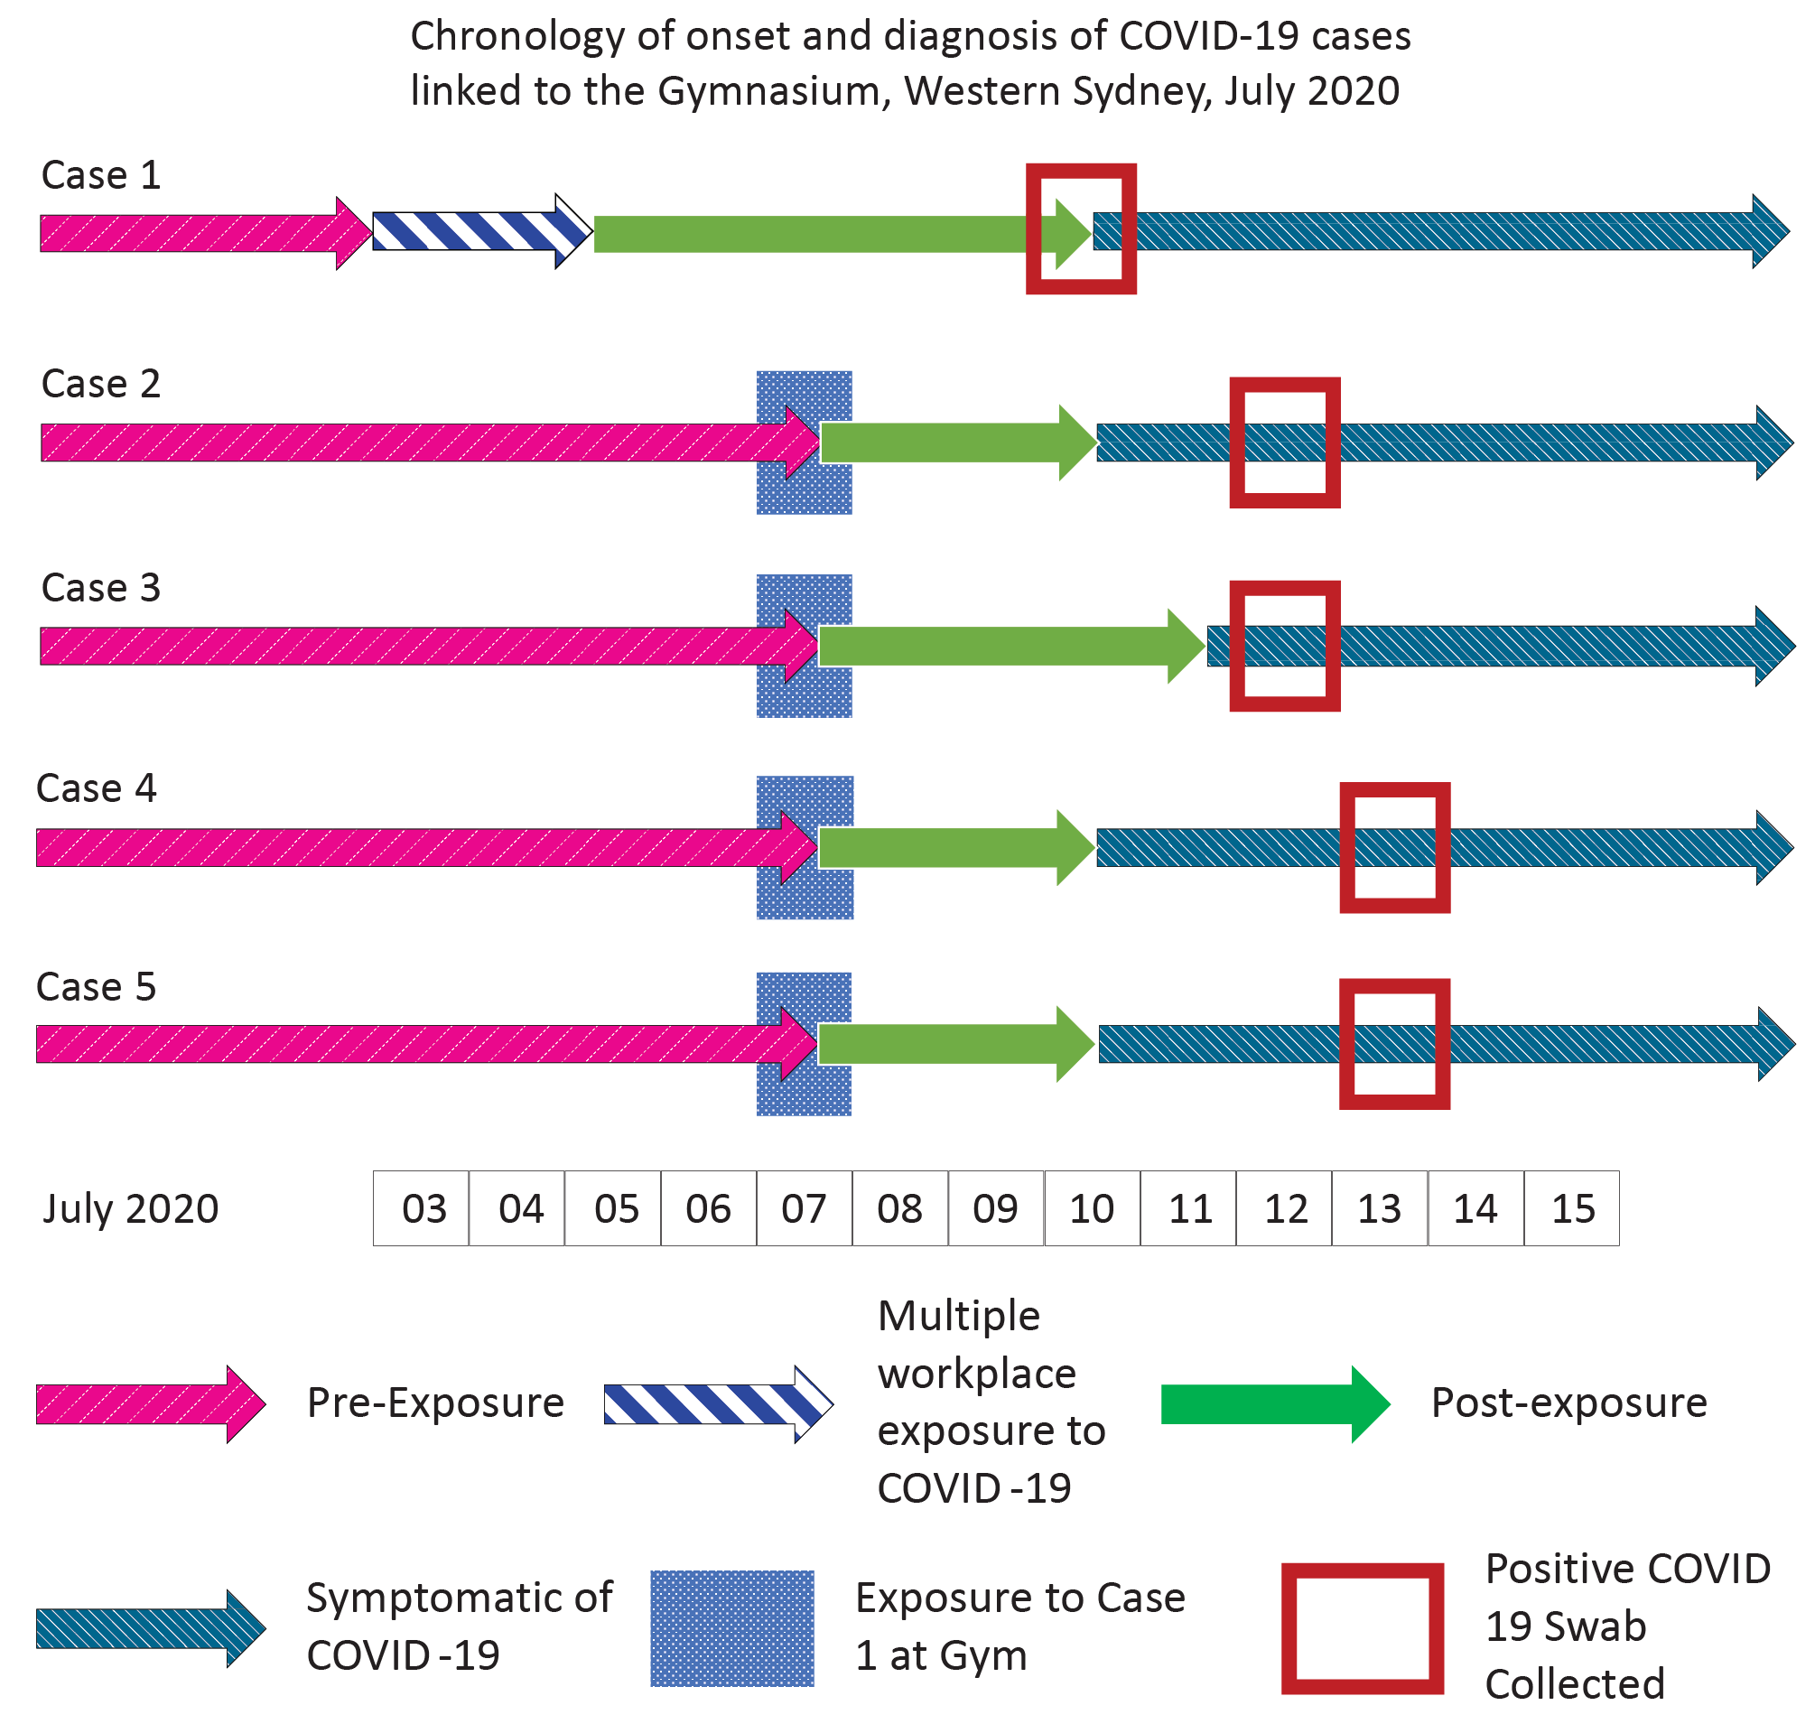

Genome sequence analysis
The index case was found to belong to a large active NSW genomic cluster (NSW33.0) consisting of 201 sequences at the time of the outbreak. Whole genome sequencing of SARS-CoV-2 for Case 1 to Case 5 revealed that whilst all five sequences were closely related and classified as SARS-CoV-2 Pangolin lineage D2, cluster membership was split across two closely related genomic clusters. Cases 1, 2 and 3 were found to belong to NSW33.0, and Cases 4 and 5 to NSW33.1. This occurred because the definition of a genomic cluster was that member sequences cannot differ by more than 2 SNPs from the index sequence. The sequence obtained from Case 1 was already two single nucleotide polymorphisms (SNPs) from the NSW33.0 cluster index sequence. Upon infection, Cases 4 and 5 each acquired an additional SNP, which in turn meant that Cases 4 and 5 were classified as members of local cluster NSW33.1. This is demonstrated in table 2, which maps out the SNP distances between each of the cases that were included in this outbreak.
Table 2: Pairwise SNP differences between cases involved in this cluster
 | Case 1 (NSW33.0) | Case 2 (NSW33.0) | Case 3 (NSW33.0) | Case 4 (NSW33.1) | Case 5 (NSW33.1)
Case 1 (NSW33.0) | 0 | 0 | 1 | 1 | 2
Case 2 (NSW33.0) | 0 | 0 | 1 | 1 | 2
Case 3 (NSW33.0) | 1 | 1 | 0 | 2 | 3
Case 4 (NSW33.1) | 1 | 1 | 2 | 0 | 1
Case 5 (NSW33.1) | 2 | 2 | 3 | 1 | 0

Discussion
While there were other areas of overlap in the gymnasium, transmission between Case 1 and the four subsequent cases (Case 2 to Case 5) likely occurred while all cases were doing weight-based training, which involved both increased depth and velocity of respiratory effort, which is a well-acknowledged risk for transmission.¹¹ Given the limited role of fomite transmission, it is unlikely that transmission occurred through the incomplete cleaning of free weight equipment between use.¹² While cases were genomically classified into two clusters, these clusters represented the same phylogenetic lineage and were closely related. Indeed, initial sequences belonging to NSW33.1 are thought to have evolved from those belonging to NSW33.0, as described. The demonstrated epidemiological links further strengthened the conclusion about their relationship.
We note that four cases (Case 2 to Case 5) spent more than 15 minutes at the same time as the index case in the free weights area, and shared common equipment. We were unable to calculate how many people per square metres were present and we were unable to ascertain if they were spread equally throughout the space. The implicated evening of transmission was the busiest of the five evenings the case attended while potentially infectious.
The transmission chain is dependent upon a 72-hour pre-symptomatic infectious period between Case 1 and the remaining cases. We note case reports of transmission up to 72 hours prior to symptom onset,¹³ and the Australian Federal COVID-19 control guidelines (SoNG) permitted an infectious period of up to 72 hours prior to symptom onset in high-risk settings.¹⁴ While a majority of cases developed symptoms on the same day as reported by Case 1, none of Cases 2–5 reported any high-risk exposures or contact with any persons known to have COVID-19 prior to the their attendance at the gymnasium. While there was an active genomic cluster in Western Sydney at the time, there was not widespread community transmission; there were 62 known locally acquired cases in the week ending 18 July and 90% of cases in New South Wales were linked to known transmission sources in this time period, with all cases in Western Sydney linked to known transmission networks.¹⁵
The cases were re-interviewed to obtain further information related to their activity at the gymnasium, approximately one month after the initial gymnasium exposure, which may have affected recall. Only one case had phone location data available to validate attendance times.
Not everyone who attended the gymnasium during Case 1’s infectious period responded to calls from contact tracers, potentially resulting in other undetected COVID-19 cases. Messaging from New South Wales Health advised all gymnasium attendees to quarantine and get tested if they develop any symptoms; however, many may not have sought testing.
In a gymnasium environment, with people vigorously exercising, they could be breathing deeply and therefore propelling droplets beyond the 1.5 metre safety buffer.¹⁶ We note the index case (Case 1) spent many hours at the gymnasium and describes himself as fit, which may be associated with a larger vital capacity with the potential to exhale a higher viral quanta, potentially explaining his infectiousness 72 hours prior to onset of symptoms. Reducing patron density through a one person per four square metre rule was not protective in the Korean outbreaks,³ and several outbreaks occurred in New South Wales since the requirement for COVIDSafe plans based on enhanced hygiene and a four square metre density rule were introduced.^{5–7} Victoria temporarily implemented a one person per eight square metre requirement in gymnasiums.¹⁷ New variants, which may be more transmissible, may require additional measures to be implemented to prevent spread of COVID-19 within the gymnasium environment.

Conclusion
Our epidemiological and laboratory findings suggest probable transmission of COVID-19 through infectious aerosols in the weights room of a gymnasium. Our findings support caution in similar settings and are important to inform infection control policies for gymnasiums and other indoor sports facilities. Further research is warranted to improve risk mitigation and control measures to prevent COVID-19 transmission within gymnasiums, particularly with the emergence of new variants.^{18,19}

Acknowledgements
The authors thank staff of NSW Health Pathology laboratories for COVID-19 testing and SARS-CoV-2 genome sequencing and bioinformatic analysis.

Author details
Dr Bhavi Ravindran, Public Health Medical Officer,¹
Dr Elizabeth Gatens, Public Health Medical Officer,¹
Dr Naru Pal, Director,²
Dr Vicky Sheppeard, Deputy Director,³
Dr Anna Calik, Public Health Medicine Registrar,²
Dr Kate Alexander, Public Health Physician,²
Dr Khizar Ashraf,²
Dr Alicia Arnott,⁴
Prof. Vitali Sintchenko,⁴
Dr Craig B Dalton, Public Health Physician,^{1,5}
- Hunter New England Population Health, Hunter New England Local Health District, Wallsend, New South Wales, Australia
- Public Health Unit, Population Health, South Western Sydney Local Health District, New South Wales, Australia
- South Eastern Sydney Public Health Unit, New South Wales, Australia
- Institute of Clinical Pathology and Medical Research, NSW Health Pathology, Westmead, New South Wales, Australia
- Hunter Medical Research Institute, New Lambton Heights, New South Wales, Australia

Corresponding author
Dr Khizar Ashraf
Address: L4, 203 Northumberland St, Liverpool, 2170, NSW (P O Box 38, Liverpool, 2170 NSW)
Phone: +61 (0) 408 602 247

References
- de Crane D’Heysselaer S, Parisi G, Lisson M, Bruyère O, Donneau A-F, Fontaine S et al. Systematic review of the key factors influencing the indoor airborne spread of SARS-CoV-2. Pathogens. 2023;12(3):382. doi: https://doi.org/10.3390/pathogens12030382.
- Wong NS, Lee SS, Kwan TH, Yeoh EK. Settings of virus exposure and their implications in the propagation of transmission networks in a COVID-19 outbreak. Lancet Reg Health West Pac. 2020;4:100052. doi: https://doi.org/10.1016/j.lanwpc.2020.100052.
- Jang S, Han SH, Rhee JY. Cluster of coronavirus disease associated with fitness dance classes, South Korea. Emerg Infect Dis. 2020;26(8):1917–20. doi: https://doi.org/10.3201/eid2608.200633.
- Brlek A, Vidovič Š, Vuzem S, Turk K, Simonović Z. Possible indirect transmission of COVID-19 at a squash court, Slovenia, March 2020: case report. Epidemiol Infect. 2020;148:e120. doi: https://doi.org/10.1017/S0950268820001326.
- Government of New South Wales Department of Health (NSW Health). Public health alert - Royal Hospital for Women at Randwick, City Tattersalls, Virgin Gym Zetland, bus routes in Blacktown, Rouse Hill and Mt Druitt. [Internet.] Sydney: NSW Health; 26 August 2020. [Accessed on 12 October 2020.] Available from: https://www.health.nsw.gov.au/news/Pages/20200826_01.aspx.
- Suhs T, Gerlach D, Garfin J, Lorentz A, Firestone M, Sherden M et al. COVID-19 outbreak associated with a fitness center—Minnesota, September–November 2020. Clin Infect Dis. 2022;74(7):1265–7. doi: https://doi.org/10.1093/cid/ciab653.
- Shin SH, Park E, Kim S, Jang M, Park S, Kim DH et al. COVID-19 outbreak and risk factors for infection in a taekwondo gym in the Republic of Korea. Osong Public Health Res Perspect. 2022;13(2):162–70. doi: https://doi.org/10.24171/j.phrp.2021.0295.
- Lendacki FR, Teran RA, Gretsch S, Fricchione MJ, Kerins JL. COVID-19 outbreak among attendees of an exercise facility—Chicago, Illinois, August–September 2020. MMWR Morb Mortal Wkly Rep. 2021;70(9):321–5. doi: https://doi.org/10.15585/mmwr.mm7009e2.
- Groves LM, Usagawa L, Elm J, Low E, Manuzak A, Quint J et al. Community transmission of SARS-CoV-2 at three fitness facilities—Hawaii, June–July 2020. MMWR Morb Mortal Wkly Rep. 2021;70(9):316–20. doi: https://doi.org/10.15585/mmwr.mm7009e1.
- Rockett RJ, Arnott A, Lam C, Sadsad R, Timms V, Gray KA et al. Revealing COVID-19 transmission in Australia by SARS-CoV-2 genome sequencing and agent-based modeling. Nat Med. 2020;26(9):1398–404. doi: https://doi.org/10.1038/s41591-020-1000-7.
- Sturm R. Bioaerosols in the lungs of subjects with different ages—part 1: deposition modeling. Ann Transl Med. 2016;4(11):211. doi: https://doi.org/10.21037/atm.2016.05.62.
- Meyerowitz EA, Richterman A, Gandhi RT, Sax PE. Transmission of SARS-CoV-2: a review of viral, host, and environmental factors. Ann Intern Med. 2021;174(1):69–79. doi: https://doi.org/10.7326/M20-5008.
- Wei WE, Li Z, Chiew CJ, Yong SE, Toh MP, Lee VJ. Presymptomatic transmission of SARS-CoV-2 — Singapore, January 23 – March 16, 2020. MMWR Morb Mortal Wkly Rep. 2020;69(14):411–15. doi: https:// doi.org/10.15585/mmwr.mm6914e1.
- Australian Government Department of Health. Coronavirus Disease 2019 (COVID-19) CDNA National Guidelines for Public Health Units. [Internet.] Canberra: Australian Government Department of Health; 2020. [Accessed on 13 October 2020.] Available from: https://www1.health.gov.au/internet/main/publishing.nsf/Content/cdna-song-novel-coronavirus.htm.
- NSW Health. COVID-19 weekly surveillance in NSW: epidemiological week 30, ending 25 July 2020. Sydney: NSW Health; 30 July 2020. [Accessed on 25 October 2020.] Available from: https://www.health.nsw.gov.au/Infectious/covid-19/Documents/covid-19-surveillance-20200730.pdf.
- Johnson GR, Morawska L. The mechanism of breath aerosol formation. J Aerosol Med Pulm Drug Deliv. 2009;22(3):229–37. doi: https://doi.org/10.1089/jamp.2008.0720.
- Li M, Dunstan J. Victorian coronavirus rules support masks in gyms as yoga, fitness classes push for lower density limits. Sydney: Australian Broadcasting Corporation, ABC News online; 28 October 2020. [Accessed on 30 October 2020.] Available from: https://www.abc.net.au/news/2020-10-28/victoria-coronavirus-rules-gyms-fitness-centres/12818472.
- Allen JG, Ibrahim AM. Indoor air changes and potential implications for SARS-CoV-2 transmission. JAMA. 2021;325(20):2112–3. doi: https://doi.org/10.1001/jama.2021.5053.
- Morawska L, Tang JW, Bahnfleth W, Bluyssen PM, Boerstra A, Buonanno G et al. How can airborne transmission of COVID-19 indoors be minimised? Environ Int. 2020;142:105832. doi: https://doi.org/10.1016/j.envint.2020.105832.

Communicable Diseases Intelligence
ISSN: 2209-6051 Online

Communicable Diseases Intelligence (CDI) is a peer-reviewed scientific journal published by the Office of Health Protection, Department of Health and Aged Care. The journal aims to disseminate information on the epidemiology, surveillance, prevention and control of communicable diseases of relevance to Australia.

Editor: Christina Bareja
Deputy Editor: Simon Petrie
Design and Production: Kasra Yousefi
Editorial Advisory Board: David Durrheim, Mark Ferson, Clare Huppatz, John Kaldor, Martyn Kirk, Meru Sheel and Steph Williams

Website: http://www.health.gov.au/cdi

Contacts
CDI is produced by the Office of Health Protection, Australian Government Department of Health and Aged Care, GPO Box 9848, (MDP 6) CANBERRA ACT 2601

Email: cdi.editor@health.gov.au

Submit an Article
You are invited to submit your next communicable disease related article to the Communicable Diseases Intelligence (CDI) for consideration. More information regarding CDI can be found at: http://health.gov.au/cdi.
Further enquiries should be directed to: cdi.editor@health.gov.au.

This journal is indexed by Index Medicus and Medline.

Creative Commons Licence - Attribution-NonCommercial-NoDerivatives CC BY-NC-ND
© 2023 Commonwealth of Australia as represented by the Department of Health and Aged Care
This publication is licensed under a Creative Commons Attribution-NonCommercial-NoDerivatives 4.0 International Licence from https://creativecommons.org/licenses/by-nc-nd/4.0/legalcode (Licence). You must read and understand the Licence before using any material from this publication.

Restrictions
The Licence does not cover, and there is no permission given for, use of any of the following material found in this publication (if any):
- the Commonwealth Coat of Arms (by way of information, the terms under which the Coat of Arms may be used can be found at www.itsanhonour.gov.au);
- any logos (including the Department of Health and Aged Care’s logo) and trademarks;
- any photographs and images;
- any signatures; and
- any material belonging to third parties.

Disclaimer
Opinions expressed in Communicable Diseases Intelligence are those of the authors and not necessarily those of the Australian Government Department of Health and Aged Care or the Communicable Diseases Network Australia. Data may be subject to revision.

Enquiries
Enquiries regarding any other use of this publication should be addressed to the Communication Branch, Department of Health and Aged Care, GPO Box 9848, Canberra ACT 2601, or via e-mail to: copyright@health.gov.au

Communicable Diseases Network Australia
Communicable Diseases Intelligence contributes to the work of the Communicable Diseases Network Australia.
http://www.health.gov.au/cdna

