Flutracking: Weekly online community-based surveillance of influenza-like illness in Australia, 2017 Annual Report
Sarah Moberley, Sandra Carlson, David Durrheim and Craig Dalton

Abstract
Flutracking participation continued to grow, with a total of 33,947 participants in 2017 (a 9.5% increase from 2016). The majority of participants completed their survey within 24 hours of the email being sent (average 72.5% responses received in 24 hours).
Overall, the rate of influenza-like illness (ILI) in 2017 was higher and remained elevated for a longer period compared to previous years except for the 2009 pandemic.
Flutracking placed the severity and magnitude of the influenza season into historical context. Following the highest number of laboratory-notified influenza cases on record (2.8-fold increase from 2016), Flutracking data demonstrated a large increase in the percent of participants with fever and cough that were tested for influenza (2.9% to 5.0% for 2016 and 2017 respectively) and thus determined it was increased laboratory testing that contributed to the substantial increase in influenza notifications.
Flutracking participants with fever and cough that were tested for influenza have increased each year from 2013 to 2017 at the national level, with a large increase from 2016 (2.9%) to 2017 (5.0%).
The peak weekly fever and cough attack rate occurred in mid-August, with 4.1% ILI in the unvaccinated, compared to 3.1% in vaccinated Flutrackers. In the peak four weeks of ILI, 12.3% of participants experienced an episode of fever and cough. Divergence between the vaccinated and unvaccinated participants’ ILI percentages was highest during the week ending 6 August 2017 (4.1% in the unvaccinated group and 2.7% in the vaccinated group).
The timing of the ILI peak amongst Flutracking participants was consistent with peak notifications of laboratory-confirmed influenza.
Keywords: Community-based surveillance, Influenza-like illness, Citizens in science, Influenza surveillance

Introduction
Flutracking provides weekly community-level influenza-like illness (ILI) surveillance that is not biased by health-seeking behaviour, clinician testing practices or differences in jurisdictional surveillance methods.^{1–5} Flutracking provides an indication of the differential ILI rates by age and geography, and the impact of illness in the community. The Flutracking surveillance system has been incorporated into the weekly Australian Influenza Surveillance Report since 2009.⁶
The main aims of Flutracking are to provide:
- Community-level ILI surveillance in Australia;
- Consistent surveillance of influenza activity across all jurisdictions and over time; and
- Year-to-year comparison of the timing, attack rates, and seriousness of influenza in the community.
In this report, we:
- Describe the epidemiology of ILI in the community;
- Describe the coverage of influenza vaccination and testing among participants;
- Describe the performance characteristics of the Flutracking system; and
- Compare Flutracking estimates with notifications of laboratory-confirmed influenza.

Methods
The Flutracking surveillance system commenced in the week ending Sunday 30 April and was in operation for 25 weeks, until the week ending Sunday 15 October 2017. The recruitment drive ran from 19 April to mid-May, although participants were able to join at any time during the year. Recruitment methods were similar to those used in 2007–2017, with the weekly survey questions having evolved from 2007–2012.^{2,4,5,7,8}
Descriptive statistics were tabulated and summarised for each state and territory, by age group, gender, education level, Aboriginal and Torres Strait Islander status, and vaccination status.
A ‘participant’ was defined as anyone who had a survey submitted by themselves or on their behalf. A ‘respondent’ was anyone who submitted a survey either for themselves or on behalf of a household member.
The participation rate for the variables of state and territory, age group, and gender was calculated using the Australian Bureau of Statistics June 2017 Estimated Resident Population.⁹ The participation rate for education level was calculated using the 2011 Australian Census data, and the 2016 Australian Census data for Aboriginal and Torres Strait Islander status.^{10,11}
We analysed the percentage of vaccinated participants aged less than 10 years of age by whether there was at least one participant in their household who was a healthcare worker with patient contact.
The mean percentage of participants who responded within 24 hours of survey distribution was calculated across all 25 weeks of surveillance. This calculation was also stratified by age group. Response time was calculated for respondents. For participants in Western Australia, two hours were subtracted from their time to respond, and in the Northern Territory and South Australia 30 minutes was subtracted from their time to respond, to account for differences in time zones.
Survey responses submitted less than four hours after the surveys were sent each Monday (5.11 am at the location of the respondents) were excluded from this analysis. This exclusion adjusted for state and territory time zone differences in earliest response times on a Monday morning, and removed 3.1% of all surveys for this particular analysis.
Unless otherwise stated, a participant with ILI was defined as having both self-reported fever and cough. For all ILI analyses any responses of ‘don’t know’ for the ‘fever’ or ‘cough’ or ‘influenza vaccination status’ variables were removed from analysis. This removed 0.7% of all surveys for these analyses.
For ILI percentage calculations, the numerator was all participants who completed a survey for the current week and reported new ILI symptoms, and the denominator was all participants who completed a survey for that week. New symptoms were defined as the first week of reporting ILI symptoms (where there were consecutive weeks of reporting ILI symptoms).
A participant was considered to be effectively vaccinated two weeks after they reported being vaccinated. This delay was not applied to participants who were already vaccinated at the time of the first Flutracking survey.
Weekly ILI percentages were compared by self-reported vaccination status for participants. The un-stratified (by vaccination status) ILI percentages were also compared with national laboratory-confirmed influenza notifications for 2009 to 2017.
We compared the weekly percentage of participants from 2011 to 2017 who had fever and cough and 1) two or more days off work or normal duties; and 2) visited a general practitioner or emergency department, or were admitted to hospital.
The average weekly percentage of Flutracking participants with ILI that were tested for influenza was compared across states and territories from 2013 to 2017.

Results

Recruitment
An additional 7,785 Flutracking participants were recruited in 2017, which was lower than the previous two years (8,609 and 9,987 new participants for the years 2016 and 2015 respectively).
For 2017, the most successful recruitment strategies were the email asking existing participants to invite two friends, followed by the first Flutracking survey, followed by the Life Matters radio interview (with 2,754, 1,222 and 749 new participants respectively having signed up in the seven days following each of these events, Figure 1).
Figure 1: Significant Flutracking recruitment events and impact, 2017
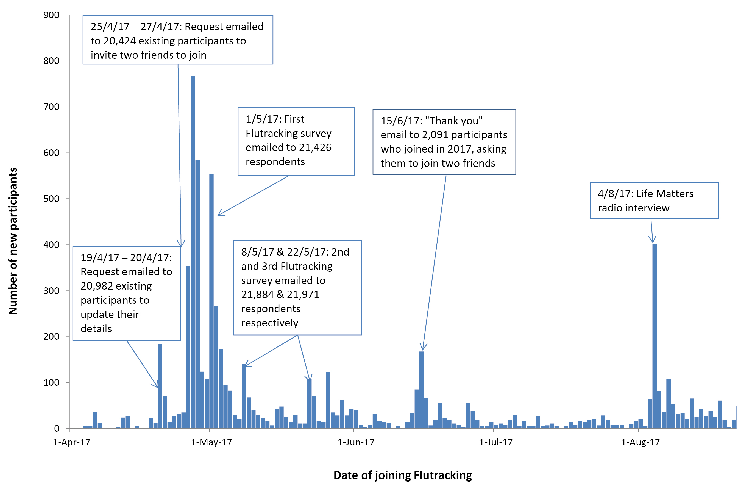

Additional activities to improve representation of Aboriginal and Torres Strait Islander participation in Flutracking were undertaken in 2017, including a story on Indigenous X and The Guardian,¹² Facebook and Twitter promotions. These activities only resulted in approximately 30 extra Indigenous participants. Likewise, a paid Facebook advertisement targeting seniors had very limited impact, with five to ten participants aged greater than 60 years signing up in the week following.
The number of “likes” on the Flutracking facebook page increased from 4422 (17 April 2017) to 5097 by the end of the Flutracking surveillance period.

Participation
At least one survey was completed by 19,759 respondents and 14,188 household members for a total of 33,947 participants. This represented a 9.5% increase in the number of participants who completed at least one survey in 2017, compared with 30,998 in 2016 (Figure 2). Of the 30,195 participants who completed a survey during the first four survey weeks, 68.6 % completed all available surveys, and 82.1 % completed more than 90% of available surveys. A total of 25,501 of the 2016 participants (82.3%) completed at least one survey during 2017 and comprised 75.1% of the 2017 participants.
Figure 2: Number of participants who completed at least one survey, 2006 to 2017
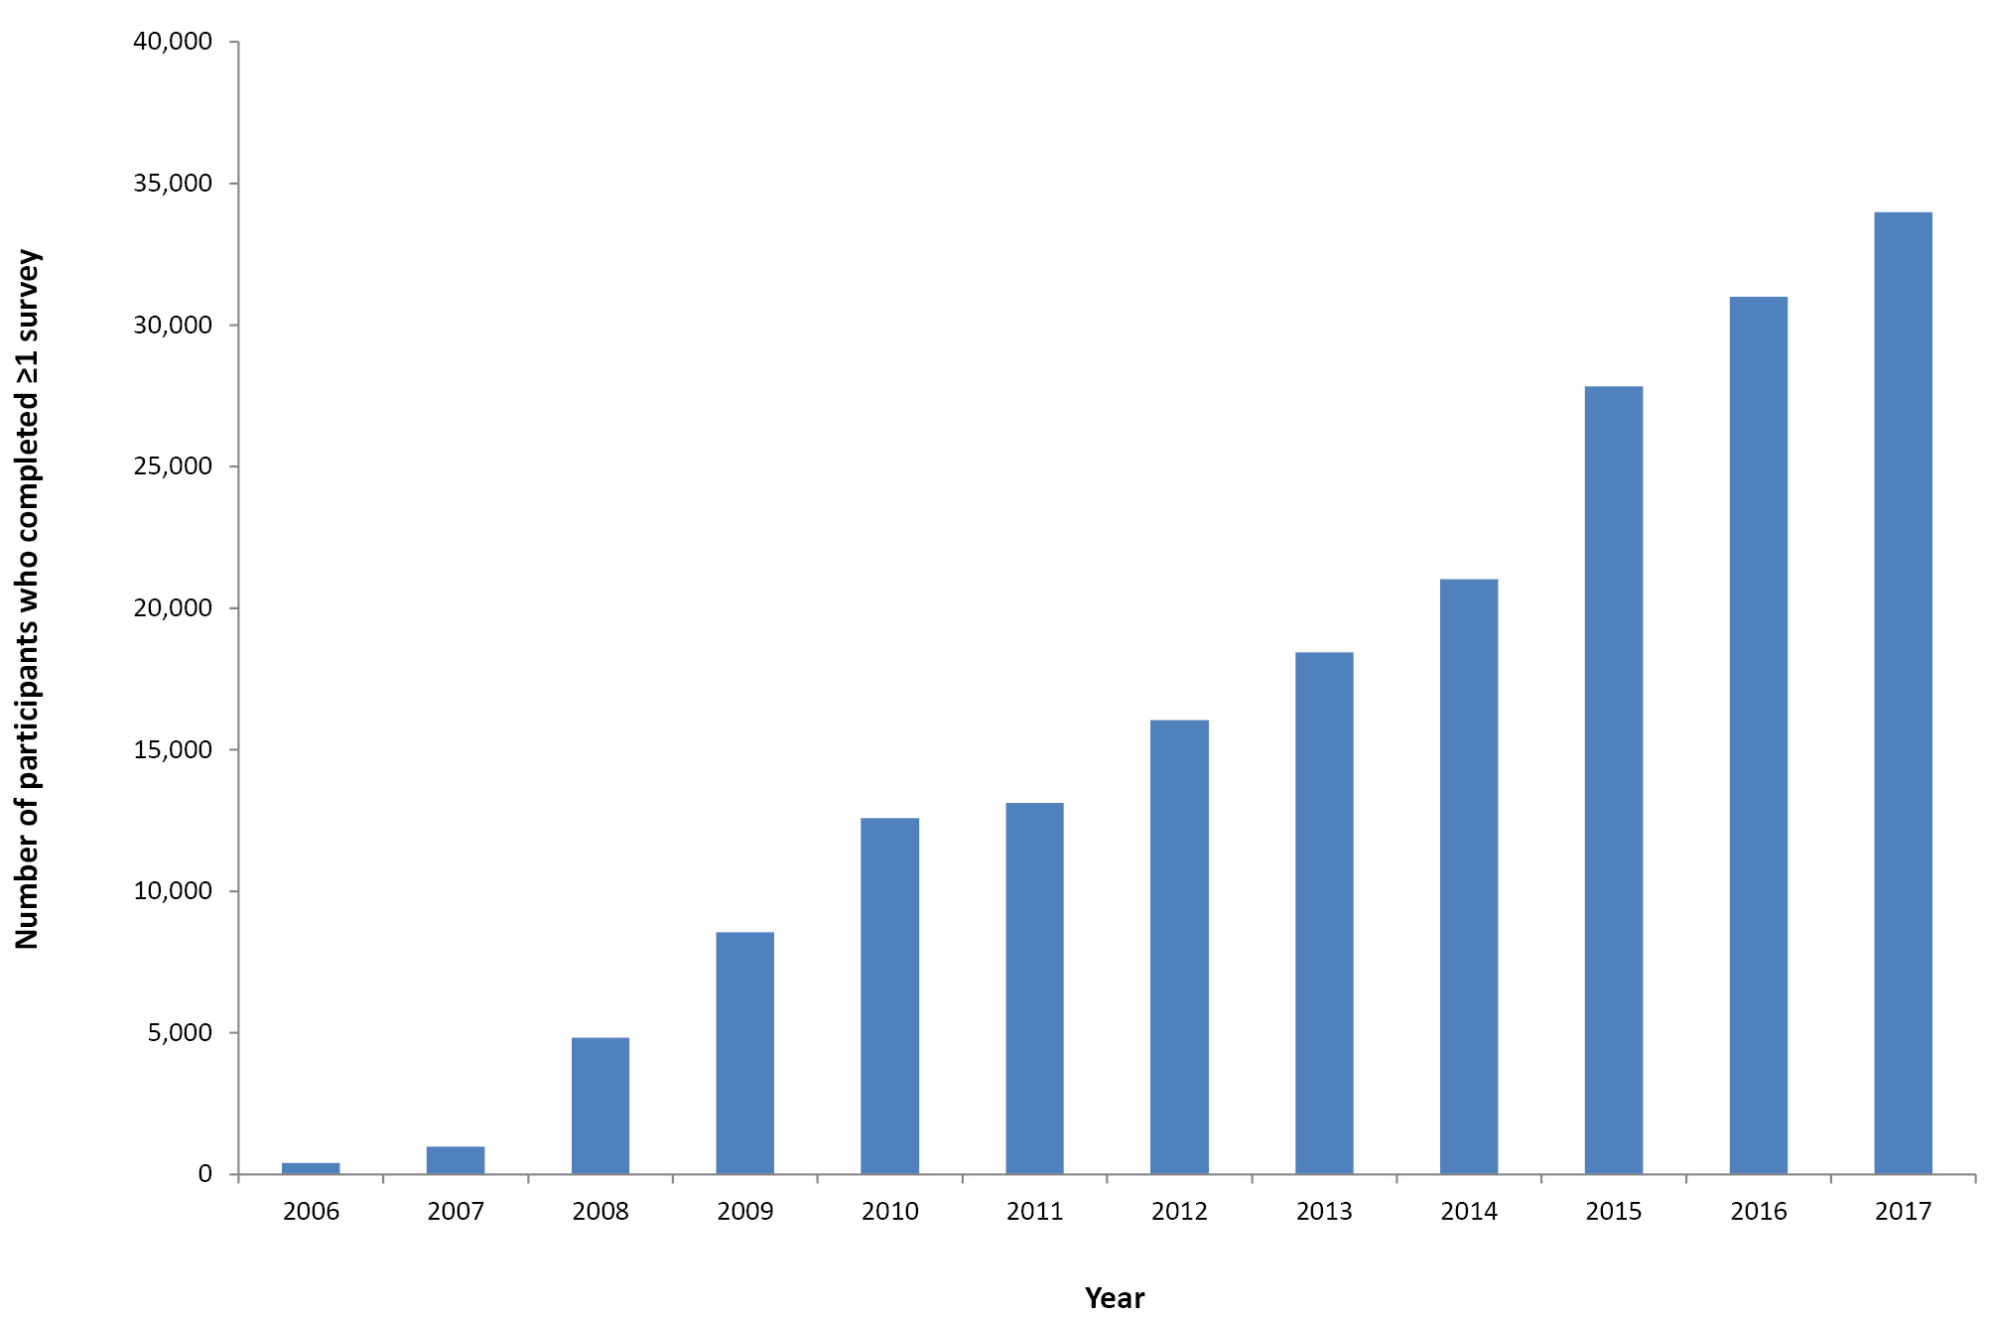
At state and territory level, increases in peak weekly participation were most marked in Victoria, Queensland and the Australian Capital Territory; however, Victoria and Queensland continued to have less than 100 participants per 100,000 population (Appendix A). Tasmania continued to have the highest rate of Flutracking participation per 100,000 persons (Figure 3, further details in Appendix A).

Figure 3. Flutracking participation per 100,000 population, by jurisdiction, 2017
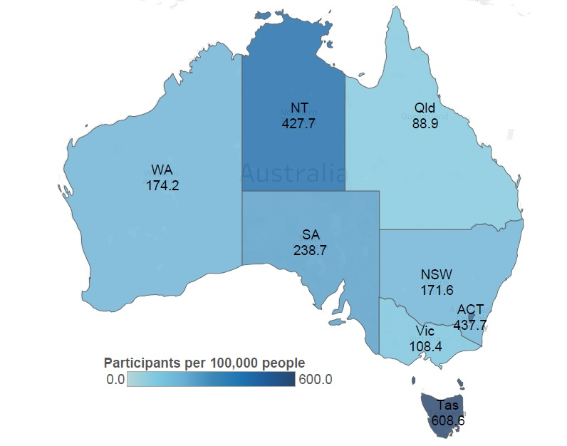

Socio-demographic characteristics
Of the participants who completed at least one survey in 2017, complete demographic details were available for 92.3% (these participants would have signed up prior to these data being collected). The largest proportion of participants were aged 50 to 64 years (32.9%), followed by participants aged 35 to 49 years (23.8%), 16 to 34 years (15.7%), 65 and over (14.5%) and zero to 15 years (13.1%, Appendix B). Most participants were female (60.2%), and a high percentage had completed a postgraduate degree (24.9%). In 2017, 1.6% of participants identified as being Aboriginal or Torres Strait Islander (compared to 2.6% of the Australian population).

Time to respond to survey each week
Most participants responded within 24 hours of the survey being sent, with a mean 24 hour response of 72.5% over the 25 weeks. The 65 years or over age group had a mean 24 hour response of 79.1% over the 25 weeks, which was the highest of all age groups.

Percentage of participants vaccinated
By the final survey for 2017, 60.2% (20,421/33,947) of participants had received the 2017 seasonal vaccine, compared with 58.4% (18,088/30,998) of participants vaccinated by the end of 2016. Of the 6,311 participants who identified as working face-to-face with patients in 2017, 5,060 (80.2%) received the vaccine compared with 79.2% by the end of 2016. Vaccination coverage at the end of the 2017 season was 21.4% (565/2,641) in participants less than 10 years of age and 84.2% (4,140/4,916) in participants aged 65 years, compared to 17.8% and 83% in 2016 (Figure 4).
Figure 4: Percentageª of participants vaccinated with the seasonal influenza vaccine at the final survey of each participant, by participant characteristics, Australia, 2007 to 2017, by year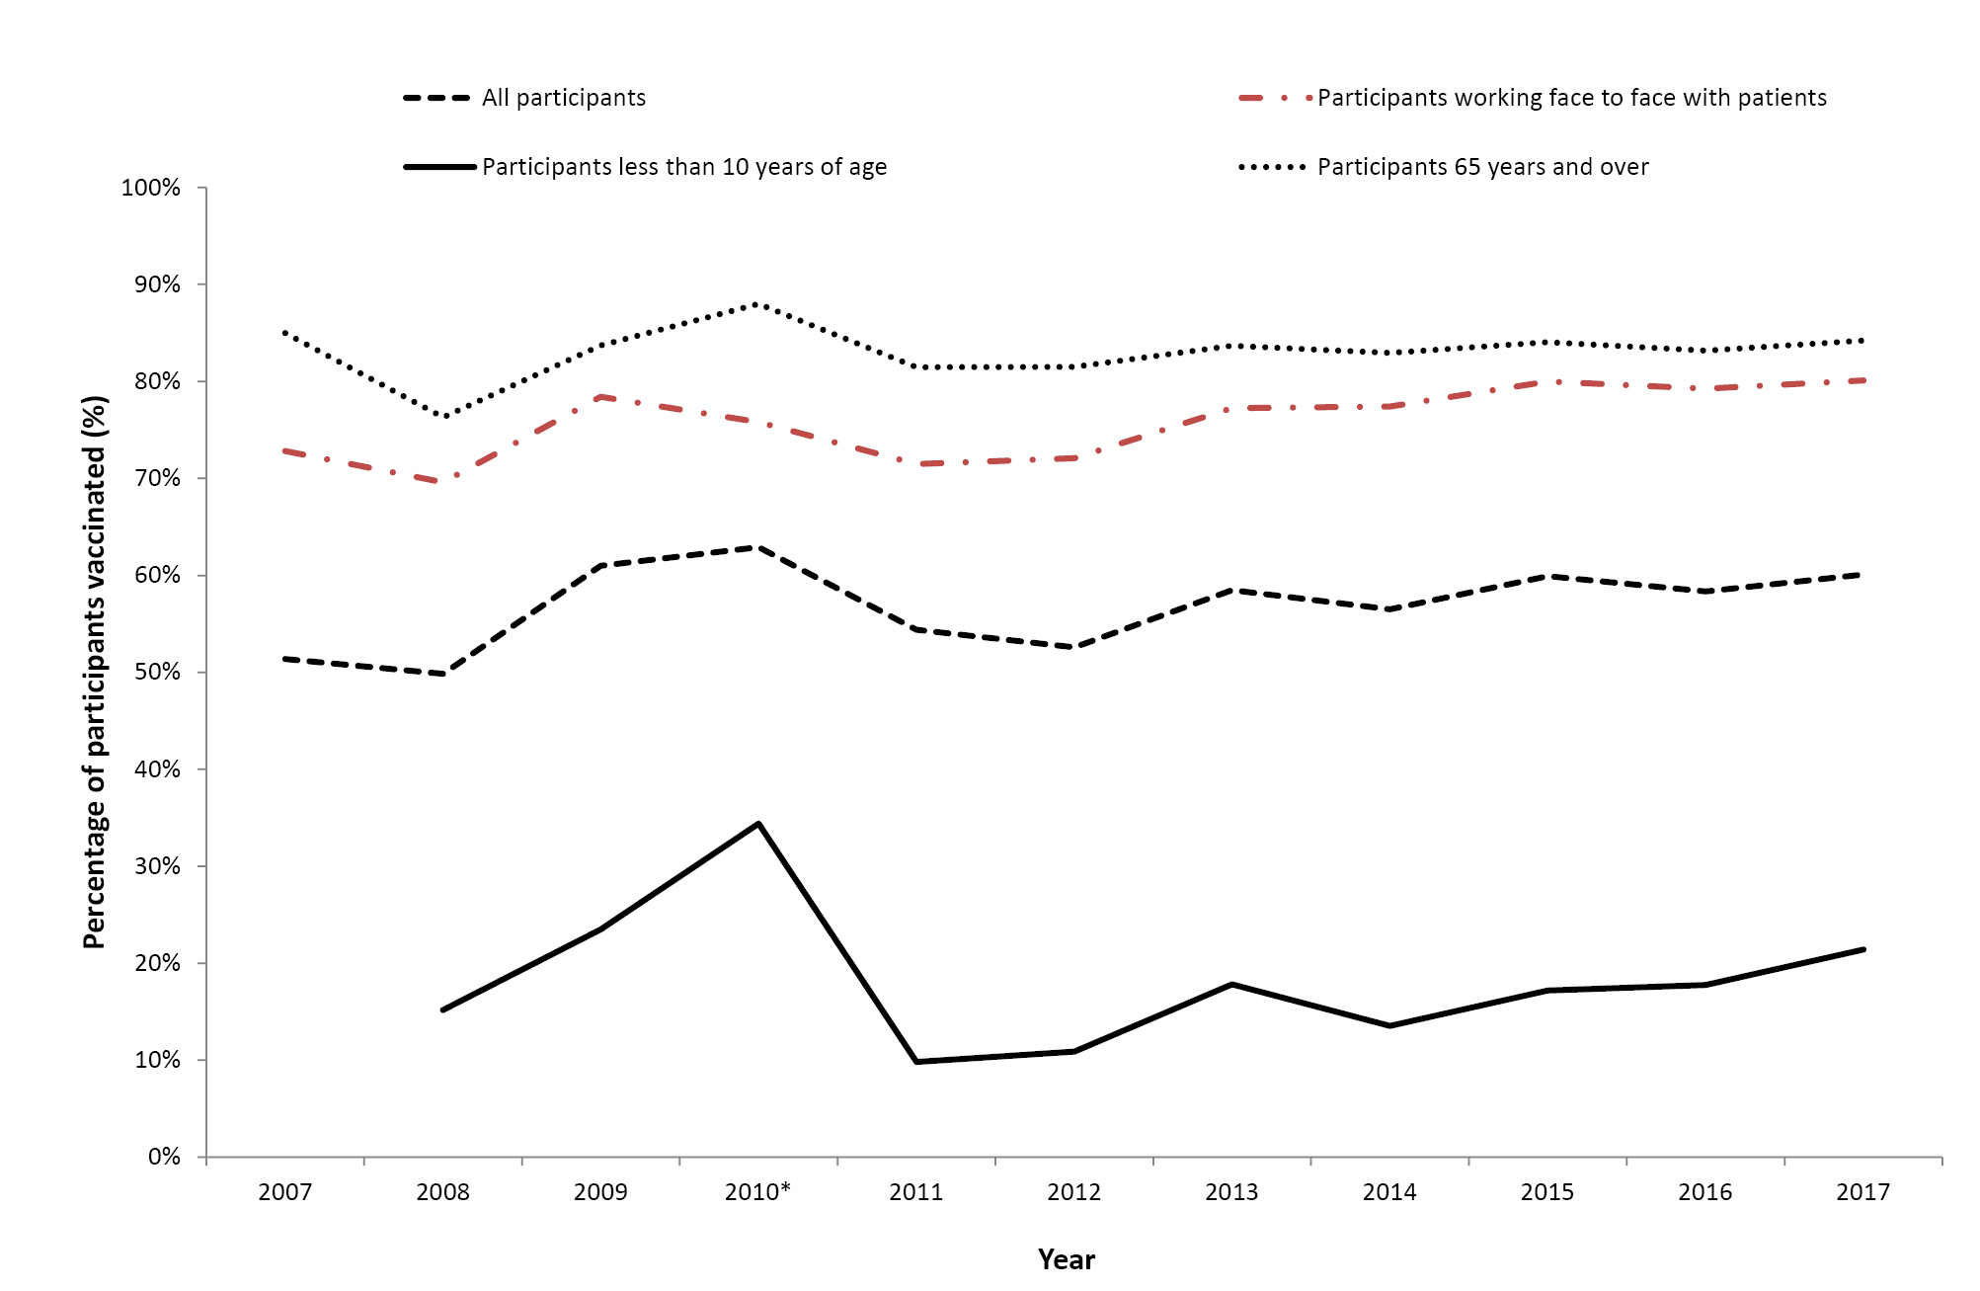
a This percentage calculation included participants who received either the monovalent H1N109 influenza vaccine in 2009 or 2010, or received the 2010 seasonal influenza vaccine.
Apart from higher coverage during 2010, the percentage of Flutracking participants vaccinated appears to have remained fairly consistent over the previous 10 years.

Percentage of participants with influenza-like illness symptoms
Of participants who completed a survey in the national peak week of ILI for 2017, 3.4% reported fever and cough, compared with 2.7% in 2016 and 3.1% in 2015. Of participants who completed at least one survey in the national peak four weeks of ILI for 2017, 12.3% reported fever and cough, compared with 9.6% in 2016 and 10.7% in 2015 (Appendix C).

Detection of influenza-like illness
Figure 5 shows the 2009 to 2017 weekly ILI percentages by vaccination status. The peak in ILI activity for 2017 occurred during the weeks ending 13 August and 20 August for the unvaccinated (4.1%) and vaccinated (3.1%) participants, respectively. Divergence between the vaccinated and unvaccinated participants’ ILI percentages was highest during the week ending 6 August 2017 (1.4% difference; 4.1% in the unvaccinated group and 2.7% in the vaccinated group).
Figure 5: Percent of participants with fever and cough stratified by vaccination status, Australia, 2009 to 2017, by week
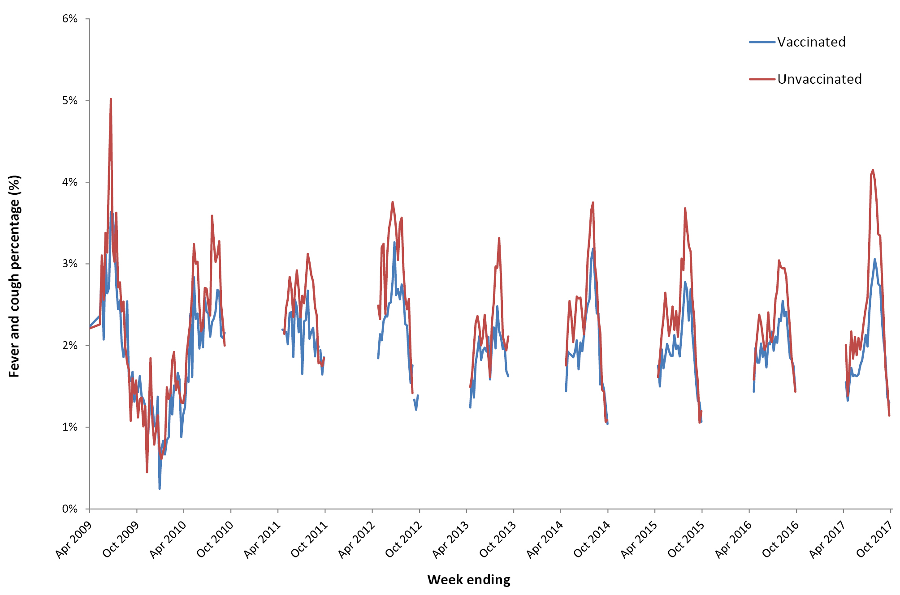

Comparison with national laboratory influenza notifications
Nationally there was a 2.8-fold increase in the number of laboratory-confirmed cases of influenza in 2017 (n=250,165) compared to 90,534 notifications in 2016 (Figure 6). In 2017, the peak Flutracking ILI level was 3.4% (week ending 20 August), which was the same as the peak week of laboratory notifications of influenza.

Figure 6: Fever and cough percentage, 1 April to 31 Octoberª compared with national influenza laboratory notifications, Australia, 2009 to 2017, by week

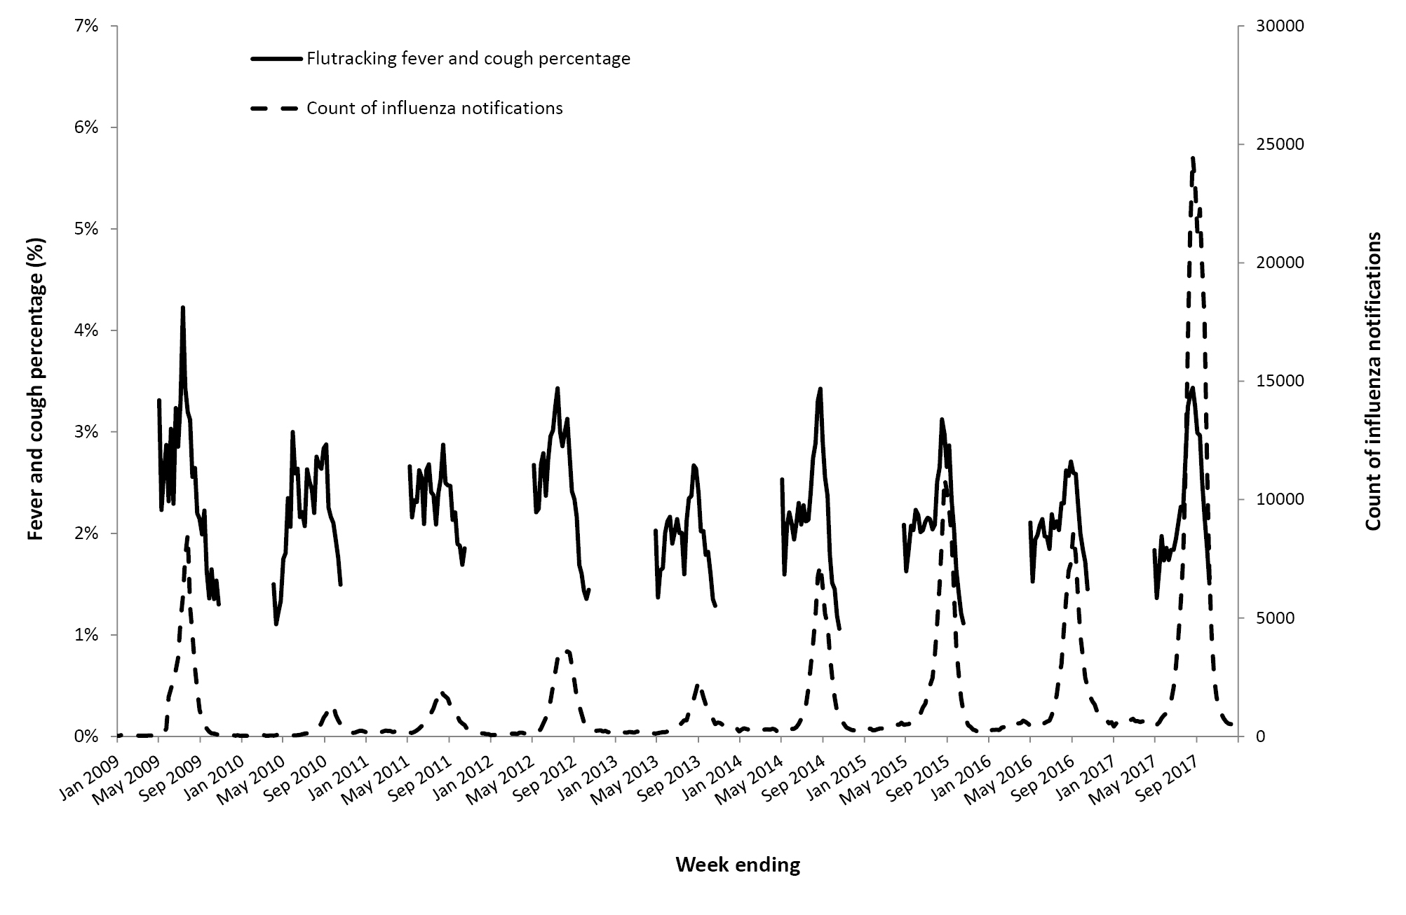
a Not stratified by vaccination status.

Percent of self-reported laboratory influenza tests
There was considerable diversity of rates of influenza laboratory testing across jurisdictions. The average weekly percent of Flutracking participants with fever and cough that were tested for influenza has increased each year from 2013 to 2017 at the national level, with a large increase from 2016 (2.9%) to 2017 (5.0%). This trend was also seen across most jurisdictions, although only a small increase in testing was noted in Western Australia, which had the lowest rate of testing in 2017 at 2.4% of ILI cases (Figure 7).

Figure 7. Average weekly percentage of Flutracking participants with fever and cough that were tested for influenza, by state/territory, 2013–2017
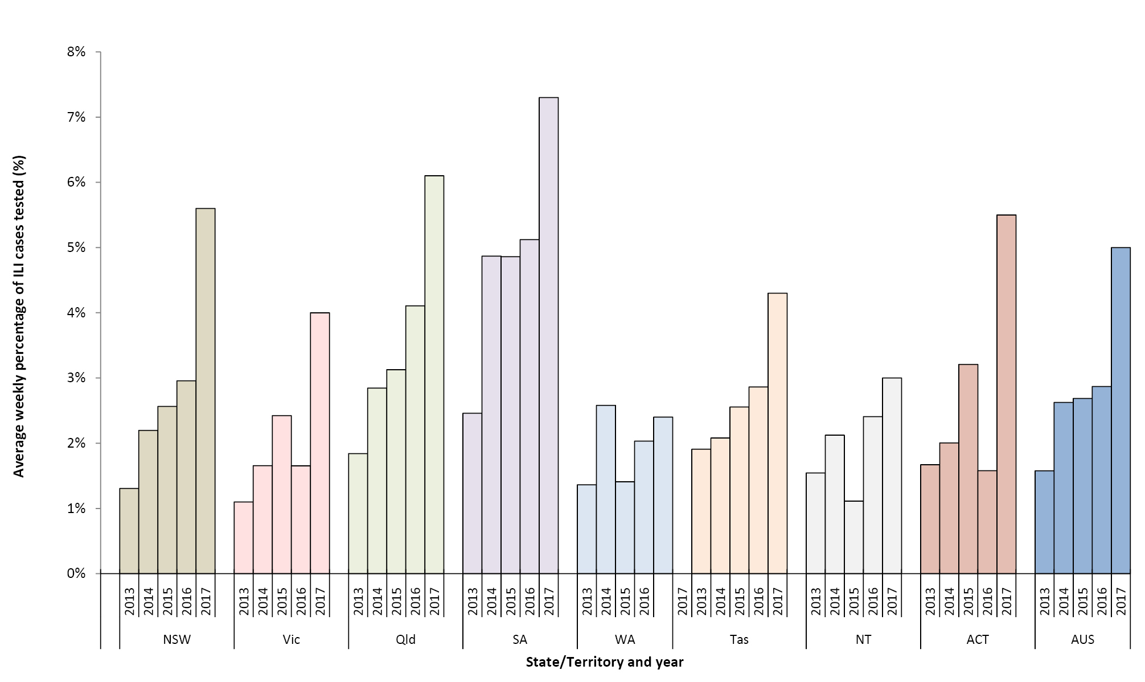

Time off work or normal duties and health-seeking behaviour
The peak weekly percentage of participants taking time off work or normal duties was 2.4% in 2017 and 1.6% in 2016, while the peak weekly percentage of participants seeking health care was 1.4% in 2017 and 1.0% in 2016 (Figure 8).

Figure 8: Weekly influenza-like illness severity,ªAustralia, 2011 to 2017
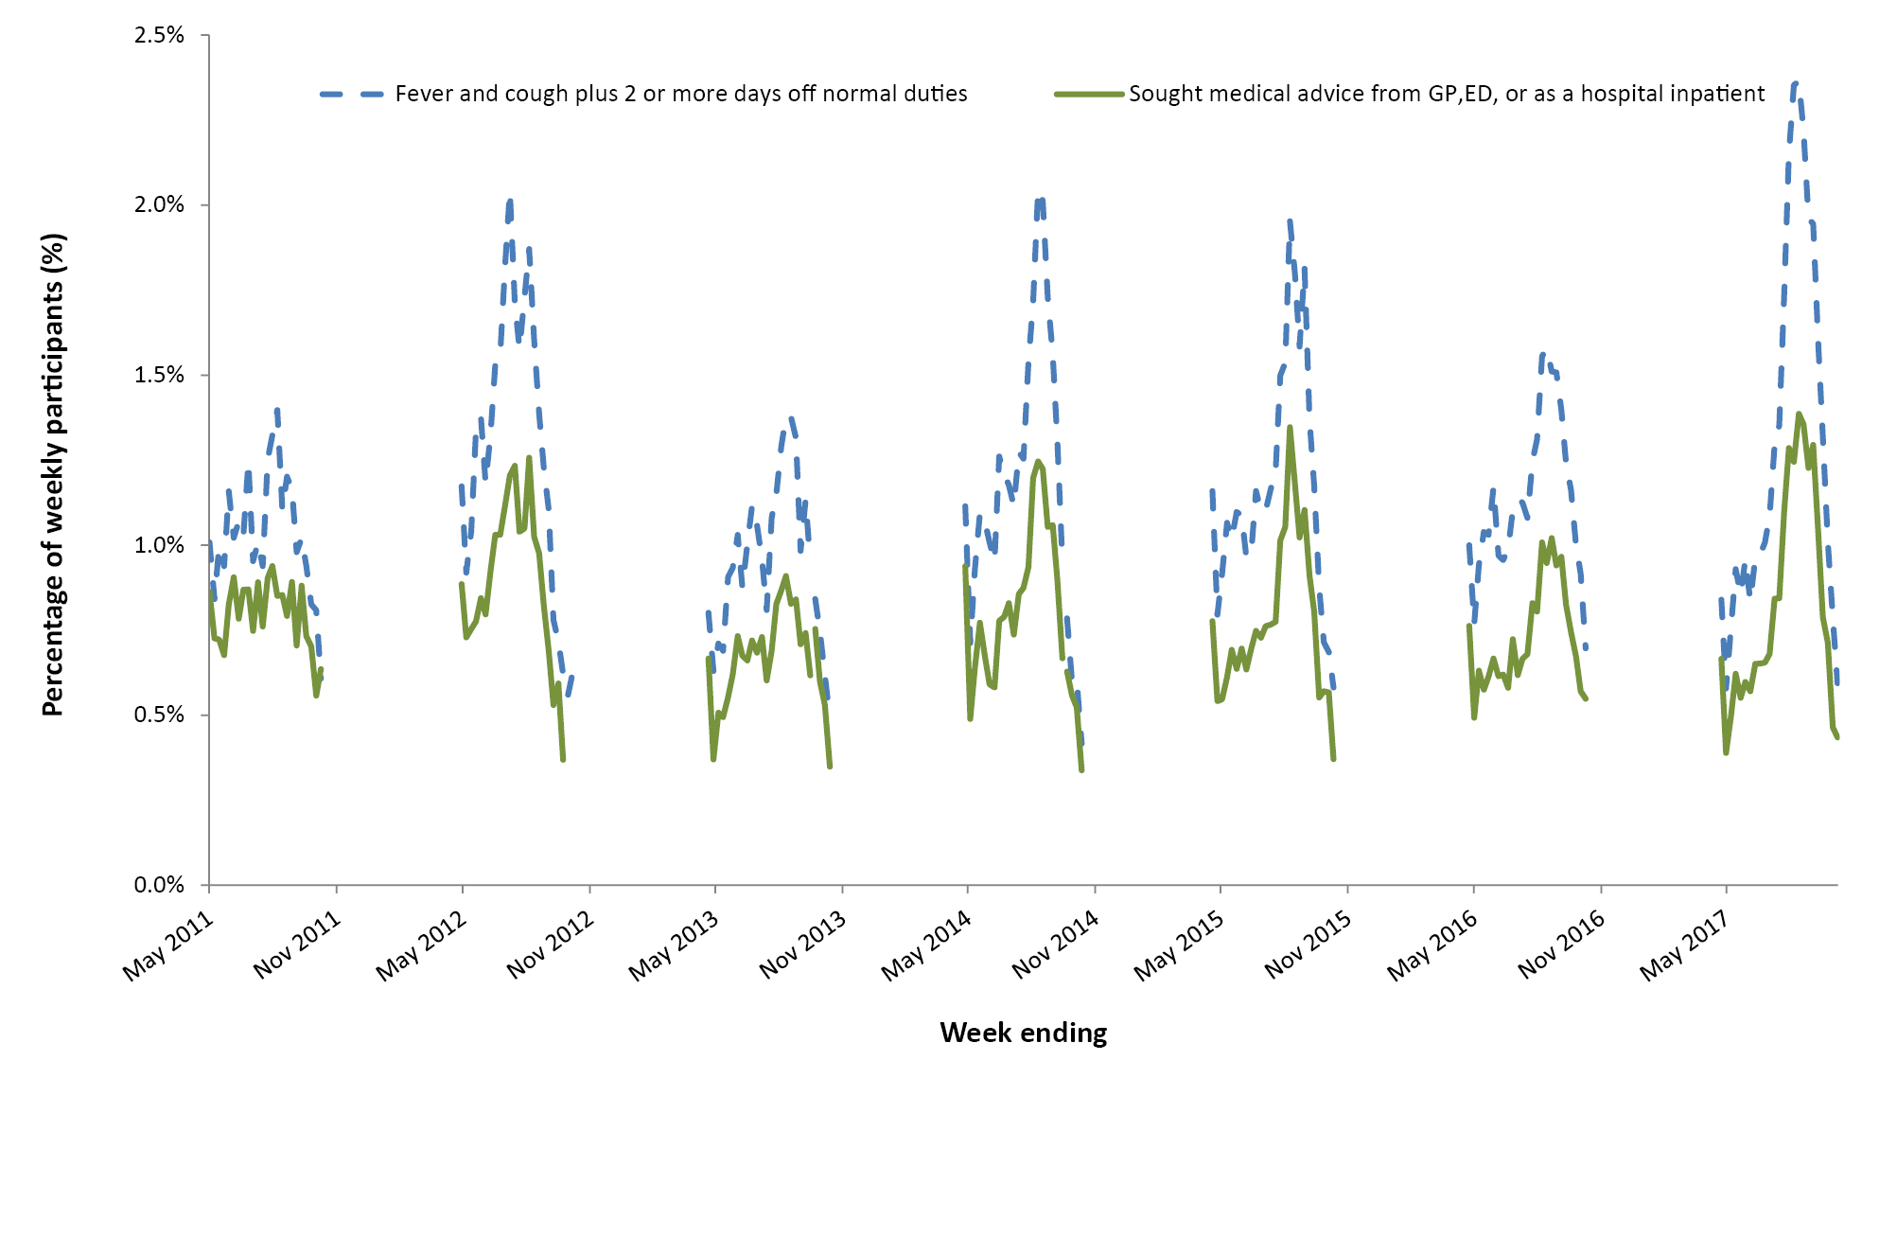
a The denominator is the number of weekly participants.

Burden of illness pyramid
The proportion of Flutracking participants with ILI that tested positive for influenza in the peak four weeks of influenza activity in 2017 was double the proportion that tested positive in 2016. The proportion of Flutracking participants seeking care for ILI was also higher in 2017 than in 2016 (Figure 9).
Figure 9. Burden of Illness pyramid for the peak four weeks of influenza activity in 2016 (weeks ending 15 August – 5 September 2016) and 2017 (weeks ending 6 August – 27 August 2017).
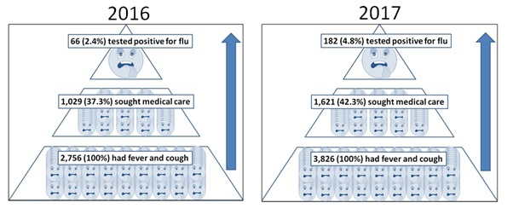

Percentage of participants with influenza-like illness by age group
The highest percentage of Flutracking participants with cough and fever was in the youngest age group, declining to the oldest age group (Figure 10). This trend was consistently observed in 2017, 2009 (pandemic year) and the five-year average.
Figure 10: Percentage of participants with fever and cough episodes, for 2009, 2017, and the 2013–2017 five-year averageª
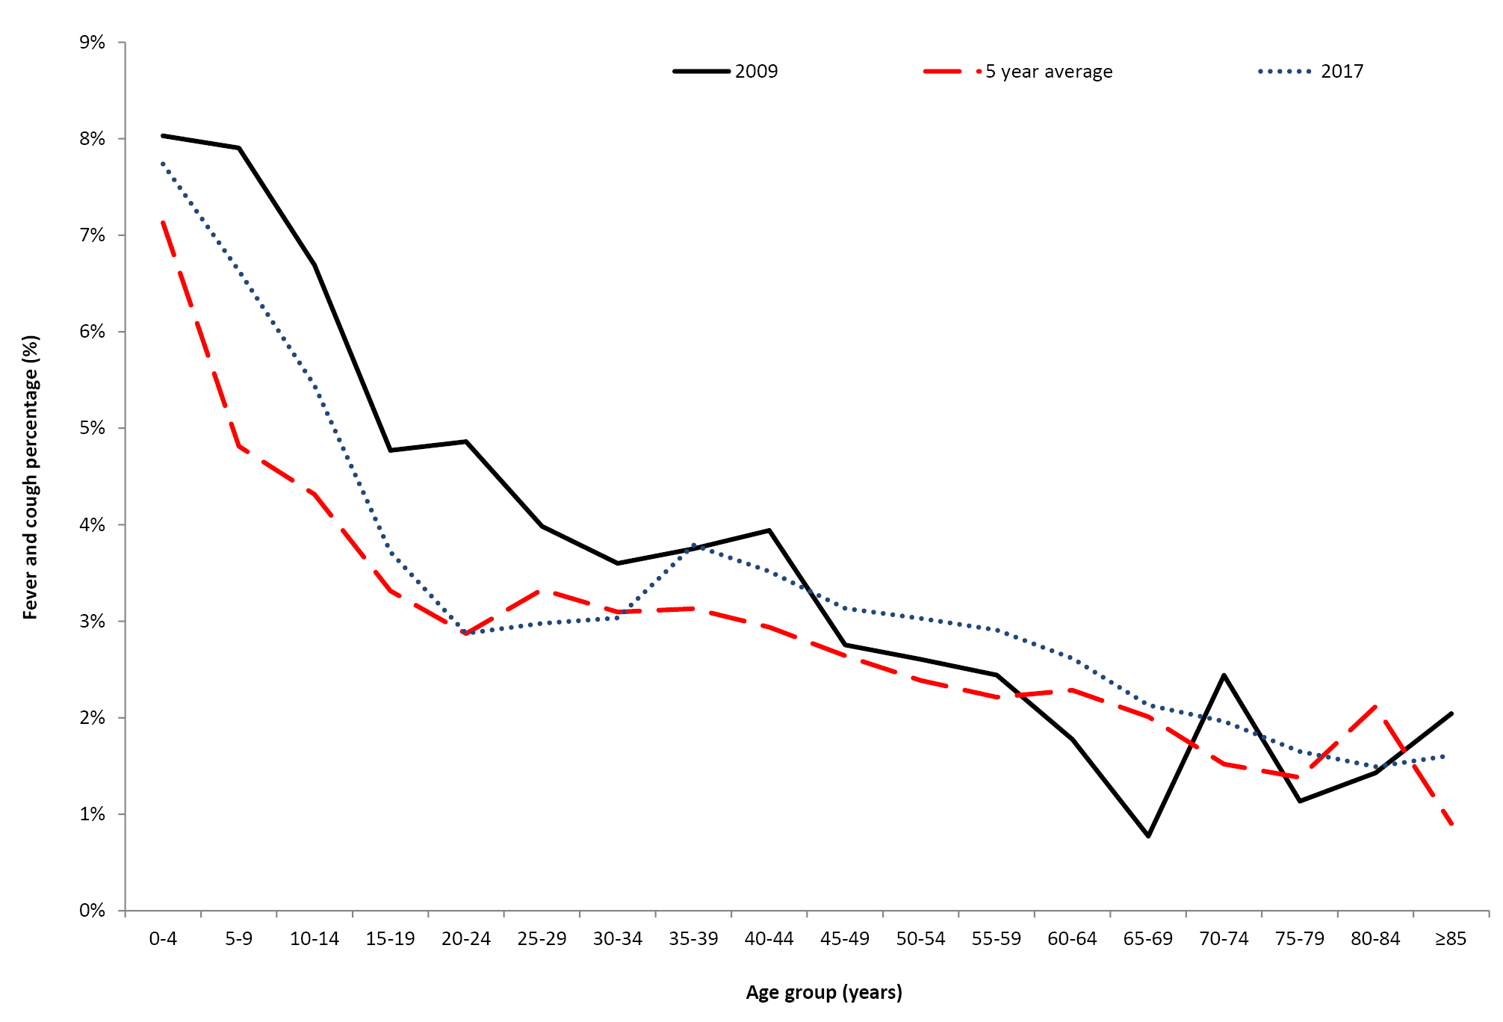
a Only the 4 peak weeks of fever and cough in Australia for each year were included.

Discussion
During 2017, Flutracking continued to engage large numbers of community members to participate in surveillance. We also provided context to the severity and magnitude of the influenza season and provided insight into the community burden of ILI as a complement to other surveillance systems.
Data was shared with health authorities on a weekly basis, showing a later and higher ILI burden in the community compared to previous years. We were able to demonstrate a near doubling of laboratory testing in Flutracking participants over time and the highest burden of ILI in the community since the 2009 pandemic, but not the worst on record (as standard laboratory surveillance suggested). This finding was relatively consistent with other surveillance systems regarding the peak and duration of the influenza season.
Whist recruitment continued to increase in numbers, we appear to be recruiting the same demographic of persons. The profile of Flutracking participants continued to have higher education, more females and fewer younger and Indigenous Australians (in comparison to the Australian population).
The commitment of the surveillance cohort of Flutracking participants was demonstrated by the large proportion of participants that completed their surveys within 24 hours (average 72.5%) and the high completion rate, with 68.5% and 82.1% of participants completing all and greater than 90% of surveys, respectively.
These completion rates are much higher than other community-based surveillance systems internationally. Flu Near You, the community-based surveillance system in the United States of America reported a median of four and five surveys completed per participant per year for the 2012–13 and 2013–14 seasons respectively. Higher completion rates were even less common, with 10.4% and 21.9% of participants submitted between 16 and 33 reports for the 2012–13 and 2013–14 seasons respectively.¹³ The reasons for the difference in these completion rates are unclear, but may be due to the user experience and brevity of the Flutracking survey.
Seasonal influenza vaccination coverage of Flutracking participants has remained stable over the past ten years. Vaccination coverage among Flutracking participants was higher than other available data sources.^{14,15} Flutracking participants are more likely to be vaccinated than the general population based on motives to participate in the survey and because unvaccinated participants are asked about their vaccination status each week. However, year to year trends in Flutracking vaccination coverage provide a rapid and important contribution to understanding vaccination coverage given the potential bias of other systems (such as limited numbers and generalisability of the adult vaccination survey and under-reporting to the Australian Immunisation Register).
The low ILI burden in the 65 years and over age group is inconsistent with the high burden of illness seen in this age group in the national laboratory-confirmed influenza notifications.¹⁶ It is unclear which surveillance data source best describes the burden of ILI in the elderly residing in the community. A fever and cough case definition may have lower sensitivity in the elderly, as there is evidence suggesting the elderly are less likely to experience fever as an influenza symptom.¹⁷ Also, Flutracking participants aged 65 years and older may be of high socio-economic status and retaining their immune competence. Additionally, there could be a bias towards more testing for influenza in the elderly, inflating the number of confirmed influenza notifications in this group, compared to other age groups.
The timing of the peak percent of ILI in Flutracking appeared to be largely consistent with the peak in the notification of laboratory-confirmed influenza cases. Nationally, the number of laboratory-confirmed influenza notifications in 2017 was the highest on record. Flutracking data showed that this may be due to an increase in testing, due to a large increase in the percent of participants with ILI having a test for influenza (1.7-fold increase in 2017 compared to 2016).
During 2018, we aim to continue expanding Flutracking participation in Australia and our near neighbours.

Author Details
Dr Sarah Moberley,¹ Epidemiologist
Ms Sandra J Carlson,¹ Senior Analyst
Dr David N Durrheim,^{1,2,3} Public Health Physician, Conjoint Professor of Public Health Medicine, University of Newcastle
Dr Craig B Dalton,^{1,2} Public Health Physician
- Hunter New England Population Health, NSW, Australia
- University of Newcastle, Callaghan, NSW, Australia
- Hunter Medical Research Institute, Newcastle, NSW, Australia

Corresponding author
Dr Craig B Dalton craig.dalton@health.nsw.gov.au

Acknowledgements
We acknowledge the University of Newcastle for their continued support, and the Australian Government Department of Health and the Hunter Medical Research Institute for their funding and support. We also acknowledge Stephen Clarke for software and database development, and John Fejsa for his contribution to the design of the project, and the many thousands of Flutracking participants who freely give their time each week to contribute to influenza surveillance.

References
- Carlson SJ, Dalton CB, Tuyl FA, Durrheim DN, Fejsa J, Muscatello DJ, et al. Flutracking surveillance: comparing 2007 New South Wales results with laboratory-confirmed influenza notifications. Commun Dis Intell Q Rep. 2009;33(3):323–7.
- Dalton CB, Durrheim DN, Fejsa J, Francis L, Carlson SJ, d’Espaignet E, et al. Flutracking: a weekly Australian community online survey of influenza-like illness in 2006, 2007 and 2008. Commun Dis Intell Q Rep. 2009;33(3):316–22.
- Parrella A, Dalton CB, Pearce R, Litt JC, Stocks N. ASPREN surveillance system for influenza-like illness – A comparison with FluTracking and the National Notifiable Diseases Surveillance System. Aust Fam Physician. 2009;38(11):932–6.
- Carlson SJ, Dalton CB, Durrheim DN, Fejsa J. Online Flutracking survey of influenza-like illness during pandemic (H1N1) 2009, Australia. Emerg Infect Dis. 2010;16(12):1960–2.
- Dalton CB, Carlson SJ, Durrheim DN, Butler MT, Cheng AC, Kelly HA. Flutracking weekly online community survey of influenza-like illness annual report, 2015. Commun Dis Intell Q Rep. 2016;40(4):E512–20.
- The Australian Government Department of Health. Australian influenza report 2009. 2009.
- Carlson SJ, Dalton CB, Butler MT, Fejsa J, Elvidge E, Durrheim DN. Flutracking weekly online community survey of influenza-like illness annual report 2011 and 2012. Commun Dis Intell Q Rep. 2013;37(4):E398–406.
- Dalton CB, Carlson SJ, Cassano D, Butler MT, Durrheim DN. Flutracking weekly online community survey of influenza-like illness annual report. Commun Dis Intell (2018) 2019;43. doi: 10.33321/cdi.2019.43.15.
- Australian Bureau of Statistics. 3101.0 Australian Demographic Statistics, June 2017. 2017 [cited 2018 February 2018]. Available from: http://www.abs.gov.au/ausstats/abs@.nsf/mf/3101.0 .
- Australian Bureau of Statistics. 2011 Census QuickStats 2011 [cited 2018 28 Feb 2018]. Available from: http://www.censusdata.abs.gov.au/census_services/getproduct/census/2011/quickstat/0?opendocument .
- Australian Bureau of Statistics. 2016 Census: Aboriginal and/or Torres Strait Islander Peoples QuickStats 2016 [28 Feb 2018]. Available from: http://www.censusdata.abs.gov.au/census_services/getproduct/census/2016/quickstat/IQS036 .
- Crooks K. Kristy Crooks: If we can beat the flu it will go a long way to beating other Indigenous health problems too @INDIGENOUSX2017 [25 May 2017]. Available from: https://indigenousx.com.au/if-we-can-beat-the-flu-it-will-go-a-long-way-to-beating-other-indigenous-health-problems-too/.
- Smolinski MS, Crawley AW, Baltrusaitis K, Chunara R, Olsen JM, Wójcik O, et al. Flu Near You: crowdsourced symptom reporting following two influenza seasons. Am J Public Health. 2015;105(10):2124–30.
- Australian Institute of Health and Welfare. 2009 Adult Vaccination Survey. Canberra: 2011.
- Hull B, Hendry A, Dey A, Beard F, Brotherton J, McIntyre P. Annual Immunisation Coverage Report. Annual immunisation coverage report 2016. Commun Dis Intell (2018). 2019;in press.
- The Australian Government Department of Health. Australian Influenza Surveillance Report No.12, 2017. [9 April 2018].
- Falsey AR, Baran A, Walsh EE. Should clinical case definitions of influenza in hospitalized older adults include fever? Influenza Other Respir Viruses. 2015;9(S1):23–29.

Appendix A: Recruitment to and participation in Flutracking, 2016 and 2017, by jurisdiction
State or Territory | 2016 |  |  | 2017 |  |  | Percent distribution of Australian population | Percent change 2016 to 2017
 | Number of participants (peak week) | Flutracking participation per 100,000 population | Percent of participants (peak week) | Number of participants (peak week) | Flutracking participation per 100,000 population | Percent of participants (peak week)
NSW | 8,643 | 109.9 | 31.9 | 9,782 | 124.4 | 32.8 | 32.0 | 13.2
Vic | 4,002 | 63.3 | 14.8 | 4,935 | 78.0 | 16.6 | 25.7 | 23.3
Qld | 2,594 | 52.6 | 9.6 | 2,989 | 60.6 | 10.0 | 20.0 | 15.2
SA | 3,471 | 201.4 | 12.8 | 3,400 | 197.3 | 11.4 | 7.0 | -2.0
WA | 3,604 | 139.7 | 13.3 | 3,583 | 138.9 | 12.0 | 10.5 | -0.6
Tas | 2,635 | 505.9 | 9.7 | 2,750 | 527.9 | 9.2 | 2.1 | 4.4
NT | 921 | 374.2 | 3.4 | 986 | 400.7 | 3.3 | 1.0 | 7.1
ACT | 1,224 | 298.3 | 4.5 | 1,387 | 338.0 | 4.7 | 1.7 | 13.3
Total | 27,094 | 110.1 | 100 | 29,814 | 121.2 | 100 | 100 | 10.0

Appendix B: Socio-demographic characteristics of Flutracking participants who completed at least one survey during 2016 and 2017
 | 2016 |  |  | 2017 |  |  | % Distribution of the Australian population
 | Frequency | % | Rate per 100,000 | Frequency | % | Rate per 100,000
Age (years)
0–15 | 4,100 | 12.9 | 83.4 | 4,454 | 13.1 | 90.6 | 20.0
16–34 | 5,479 | 17.3 | 83.0 | 5,335 | 15.7 | 80.8 | 26.8
35–49 | 7,877 | 24.9 | 160.4 | 8,075 | 23.8 | 164.5 | 20.0
50–64 | 10,576 | 33.4 | 241.5 | 11,167 | 32.9 | 255.0 | 17.8
65 and over | 3,635 | 11.5 | 95.8 | 4,916 | 14.5 | 129.5 | 15.4
Total participants | 31,667 | 100 | 128.7 | 33,947 | 100 | 138.0 | 100
Gender
Male | 11,683 | 39.3 | 97.4 | 13,155 | 39.7 | 107.8 | 49.6
Female | 18,015 | 60.7 | 148.5 | 19,935 | 60.2 | 160.8 | 50.4
Total reported | 29,698 | 100 | 120.7 | 33,095 | 100 | 134.5 | 100
Highest level of education completed by participant
Year 11 or below (or equiv) or Certificate I/II/III/IV | 5,224 | 21.1 | 68.3 | 5,612 | 20.4 | 73.3 | 44.1
Year 12 (or equivalent) | 2,016 | 8.2 | 69.9 | 2,241 | 8.1 | 77.7 | 16.6
Advanced Diploma/Diploma | 2,311 | 9.3 | 165.9 | 2,544 | 9.2 | 182.6 | 8.0
Completed Bachelor Degree | 5,866 | 23.7 | 250.6 | 6,600 | 23.9 | 282.0 | 13.5
Grad Diploma/Grad Certificate | 3,296 | 13.3 | 1,108.7 | 3,688 | 13.4 | 1240.6 | 1.7
Postgraduate Degree | 6,013 | 24.3 | 952.7 | 6,875 | 24.9 | 1,089.3 | 3.6
Total who nominated an ABS equivalent education level (15 years and over only) | 24,726 | 100 | 142.4 | 27,560 | 100 | 158.7 | 100
Aboriginal and/or Torres Strait Islander
Yes | 412 | 1.5 | 63.5 | 492 | 1.6 | 75.8 | 2.6
No | 27016 | 98.5 | 112.8 | 30,897 | 98.4 | 129.0 | 97.4
Total reported | 27428 | 100 | 111.5 | 31,389 | 100 | 127.6 | 100.0

Appendix C: Percentage of participants with influenza-like illness symptoms who completed a survey either in the national peak influenza-like illness week, or completed at least one survey in the national peak 4 weeks of influenza-like illness, Australia, 2015 to 2017
ILI symptoms | Participants who completed a survey in the peak week of ILI nationally |  |  |  |  |  | Participants who completed at least one survey during the peak 4 weeks of ILI nationally
 | 2015ª |  | 2016^{b} |  | 2017^{c} |  | 2015^{d} |  | 2016e |  | 2017^{f}
 | n | % | n | % | n | % | n | % | n | % | n | %
Fever | 1,232 | 5.2 | 1,223 | 4.7 | 1,703 | 5.8 | 3,544 | 14.1 | 3,637 | 13.1 | 4,954 | 16.0
Cough | 3,635 | 15.2 | 3,878 | 14.8 | 4,821 | 16.4 | 7,612 | 30.3 | 8,267 | 29.8 | 10,009 | 32.2
Fever & cough | 747 | 3.1 | 705 | 2.7 | 1,008 | 3.4 | 2,689 | 10.7 | 2,665 | 9.6 | 3,826 | 12.3
Fever, cough & sore throat | 586 | 2.5 | 567 | 2.2 | 766 | 2.6 | 2,110 | 8.4 | 2,128 | 7.7 | 2,965 | 9.6

a Week ending 16 August 2015, N=23,913
b Week ending 28 August 2016, N=26,117
c Week ending 20 August 2017, N=29,355
d Weeks ending 16 August to 6 September 2015, N=25,129
e Weeks ending 14 August to 4 September 2016, N= 27,765
f Weeks ending 6 August to 27 August 2017, N=31,047

Communicable Diseases Intelligence
ISSN: 2209-6051 Online

Communicable Diseases Intelligence (CDI) is a peer-reviewed scientific journal published by the Office of Health Protection, Department of Health. The journal aims to disseminate information on the epidemiology, surveillance, prevention and control of communicable diseases of relevance to Australia.

Editor: Cindy Toms
Deputy Editor: Simon Petrie
Design and Production: Kasra Yousefi
Editorial Advisory Board: David Durrheim, Mark Ferson, John Kaldor, Martyn Kirk and Linda Selvey

Website: http://www.health.gov.au/cdi

Contacts
Communicable Diseases Intelligence is produced by:
Health Protection Policy Branch, Office of Health Protection, Australian Government Department of Health
GPO Box 9848, (MDP 6) CANBERRA ACT 2601

Email: cdi.editor@health.gov.au

Submit an Article
You are invited to submit your next communicable disease related article to the Communicable Diseases Intelligence (CDI) for consideration. More information regarding CDI can be found at: http://health.gov.au/cdi.
Further enquiries should be directed to: cdi.editor@health.gov.au.

This journal is indexed by Index Medicus and Medline.

Creative Commons Licence - Attribution-NonCommercial-NoDerivatives CC BY-NC-ND
© 2019 Commonwealth of Australia as represented by the Department of Health
This publication is licensed under a Creative Commons Attribution-NonCommercial-NoDerivatives 4.0 International Licence from https://creativecommons.org/licenses/by-nc-nd/4.0/legalcode (Licence). You must read and understand the Licence before using any material from this publication.

Restrictions
The Licence does not cover, and there is no permission given for, use of any of the following material found in this publication (if any):
- the Commonwealth Coat of Arms (by way of information, the terms under which the Coat of Arms may be used can be found at www.itsanhonour.gov.au);
- any logos (including the Department of Health’s logo) and trademarks;
- any photographs and images;
- any signatures; and
- any material belonging to third parties.

Disclaimer
Opinions expressed in Communicable Diseases Intelligence are those of the authors and not necessarily those of the Australian Government Department of Health or the Communicable Diseases Network Australia. Data may be subject to revision.

Enquiries
Enquiries regarding any other use of this publication should be addressed to the Communication Branch, Department of Health, GPO Box 9848, Canberra ACT 2601, or via e-mail to: copyright@health.gov.au

Communicable Diseases Network Australia
Communicable Diseases Intelligence contributes to the work of the Communicable Diseases Network Australia.
http://www.health.gov.au/cdna

