Report on influenza viruses received and tested by the Melbourne WHO Collaborating Centre for Reference and Research on Influenza in 2017
Merryn Roe, Matthew Kaye, Pina Iannello, Hilda Lau, Iwona Buettner, M Ximena Tolosa, Tasoula Zakis, Vivian K Leung and Michelle K Chow

Abstract
As part of its role in the World Health Organization’s (WHO) Global Influenza Surveillance and Response System (GISRS), the WHO Collaborating Centre for Reference and Research on Influenza in Melbourne received a record total of 5866 human influenza positive samples during 2017. Viruses were analysed for their antigenic, genetic and antiviral susceptibility properties and were propagated in qualified cells and hens’ eggs for use as potential seasonal influenza vaccine virus candidates. In 2017, influenza A(H3) viruses predominated over influenza A(H1)pdm09 and B viruses, accounting for a total of 54% of all viruses analysed. The majority of A(H1)pdm09, A(H3) and influenza B viruses analysed at the Centre were found to be antigenically similar to the respective WHO recommended vaccine strains for the Southern Hemisphere in 2017. However, phylogenetic analysis indicated that the majority of circulating A(H3) viruses had undergone genetic drift relative to the WHO recommended vaccine strain for 2017. Of 3733 samples tested for susceptibility to the neuraminidase inhibitors oseltamivir and zanamivir, only two A(H1)pdm09 viruses and one A(H3) virus showed highly reduced inhibition by oseltamivir, while just one A(H1)pdm09 virus showed highly reduced inhibition by zanamivir.
Keywords: GISRS, influenza, vaccines, surveillance, laboratory, annual report, WHO

Introduction
The WHO Collaborating Centre for Reference and Research on Influenza in Melbourne (the Centre) is part of the World Health Organization Global Influenza Surveillance and Response System (WHO GISRS). GISRS is a worldwide network of laboratories that was established in 1952 to monitor changes in influenza viruses circulating in the human population, with the aim of reducing its impact through the use of vaccines and antiviral drugs.^{1,2} The Centre in Melbourne is one of five such Collaborating Centres (the others being in Atlanta, Beijing, London and Tokyo) that monitor the antigenic and genetic changes in circulating human influenza viruses, and makes bi-annual recommendations on which influenza strains should be included in the influenza vaccine for the upcoming influenza season in either the northern or southern hemisphere. This report summarises the results of virological surveillance activities undertaken at the Centre in Melbourne during 2017.
Two types of influenza cause significant disease in humans: types A and B. Influenza A viruses are further classified into subtypes, based on their haemagglutinin (HA) and neuraminidase (NA) surface proteins. Globally, there are currently two influenza A subtypes circulating in the human population: A(H1N1)pdm09 and A(H3N2). Influenza B viruses are not classified into subtypes; however, there are two distinct co-circulating lineages of influenza B viruses – B/Victoria/2/87 (B/Victoria lineage) and B/Yamagata/16/88 (B/Yamagata lineage). In addition, each year influenza C viruses are detected from humans, but these viruses do not cause severe disease and are not a major focus of influenza surveillance.

Methods

Virus isolation
All A(H1)pdm09 and all influenza B viral isolates received at the Centre were re-passaged in cell culture (Madin-Darby Canine Kidney (MDCK) cells), whilst all A(H3) viral isolates were re-passaged in MDCK-SIAT1 cells.³ Virus isolation in cell culture was also attempted from a selection of original clinical specimens received. A smaller subset of influenza positive original clinical samples was directly inoculated into eggs and a qualified cell line as potential candidate vaccine viruses.

Antigenic analysis
The antigenic properties of influenza viral isolates were analysed using the haemagglutination inhibition (HI) assay as previously described.⁴ The majority of the HI assays were performed using the TECAN Freedom EVO200 robot platform which incorporates a camera (SciRobotics, Kfar Saba, Israel) and imaging software (FluHema™) for automated analysis. In HI assays, viruses were tested for their ability to agglutinate turkey (A(H1N1)pdm09 and B viruses) or guinea pig (A(H3N2) viruses) red blood cells (RBC) in the presence of ferret antisera previously raised against several reference viruses. Isolates were identified as antigenically similar to the reference strain if the test samples had a titre that was no more than 4-fold different from the titre of the homologous reference strain. During 2017, results were reported with reference to the A/Michigan/45/2009 (H1N1pdm09)-like, A/Hong Kong/4801/2014 (H3N2)-like, B/Brisbane/60/2008-like (Victoria lineage), and B/Phuket/3073/2013-like (Yamagata lineage) viruses that were recommended for inclusion in the southern hemisphere 2017 influenza vaccine. In recent years (including 2017), HI assays involving A(H3) viruses have been performed in the presence of oseltamivir carboxylate (OC) in order to reduce non-specific binding of the NA protein.⁵ The addition of OC reduces the number of influenza virus isolates that can be tested by HI as around 40% of viruses lose the ability to bind RBC. Hence other methods such as the Focus Reduction Assay (FRA) or Microneutralisation assays (MNT) have been employed to test a subset of these viruses.

Genetic analysis
For influenza-positive samples that failed to grow in MDCK cells, real-time RT-PCR was performed to determine the influenza type/subtype/lineage using kits obtained through the International Reagent Resource, Influenza Division, WHO Collaborating Centre for Surveillance, Epidemiology and Control of Influenza, Centers for Disease Control and Prevention (CDC), Atlanta, GA, USA. The CDC Influenza Virus Real-Time RT-PCR kits were used to identify influenza A, influenza B, A(H1)pdm09, A(H3), B/Yamagata and B/Victoria viruses.
A substantial subset of all influenza viruses analysed at the Centre underwent genetic analysis by sequencing of viral RNA genes, usually HA and NA genes as well as the matrix gene for influenza A viruses and non-structural protein gene (NS) for influenza B viruses. The full genomes (all eight gene segments) of a smaller subset of viruses were also sequenced.
For sequencing, RNA was extracted from isolates or original clinical specimens using either a manual QIAGEN QIAamp Viral RNA kit or the automated QIAGEN QIAXtractor platform, followed by reverse transcription PCR using the BIOLINE MyTaq one step reverse transcription PCR kit according to the manufacturer’s recommendations, with gene specific primers (primer sequences available on request). Conventional Sanger sequencing was carried out on PCR products using an Applied Biosystems 3500XL Genetic Analyzer (Applied Biosystems, Foster City, CA, USA). Sequence assembly was performed using the SeqMan Pro module of DNASTAR Lasergene version 13 software (DNASTAR, Madison, WI, USA). Next generation sequencing (NGS) was also performed on a selection of viruses using an Applied Biosystems Ion Torrent™ Personal Genome Machine™ (PGM) System according to the manufacturer’s recommendations. These sequences were analysed using a proprietary pipeline, FluLINE.⁶ Phylogenetic analysis was performed using Geneious 9.0.4 (Biomatters Ltd, Auckland, New Zealand) and FigTree v1.3.1 software.

Antiviral drug resistance testing
Circulating viruses were tested for their sensitivity to the currently used neuraminidase inhibitors oseltamivir (Tamiflu) and zanamivir (Relenza). The neuraminidase inhibition (NAI) assay used was a functional fluorescence-based assay using the substrate 20-(4-methylumbelliferyl)-a-D-N-acetylneuraminic acid (MUNANA), in which the susceptibility of test viruses to the antiviral drugs was measured in terms of the drug concentration needed to reduce the neuraminidase enzymatic activity by 50% (IC₅₀), and compared to values obtained with sensitive reference viruses of the same subtype or lineage. NAI assays were performed as previously described⁷ with the incorporation of a robotic platform by TECAN EVO200 and Infinite 200Pro for liquid handling and plate reading (Tecan Australia). For the purposes of reporting, reduced inhibition of influenza A viruses has been defined by WHO as a 10–99 fold increase in IC₅₀, while highly reduced inhibition is defined as a ≥ 100-fold increase in IC₅₀ in an NAI assay. For influenza B viruses, these figures have been defined as 5–49 fold and ≥50 fold increases, respectively. However, it should be noted that the relationship between the IC₅₀ value and the clinical effectiveness of a neuraminidase inhibitor is not well understood and a reduction in inhibition may not be clinically significant.
Viruses found to have highly reduced inhibition by either oseltamivir or zanamivir underwent genetic analysis using pyrosequencing, Sanger sequencing or NGS to determine the presence of amino acid substitutions in the neuraminidase protein that were associated with the reduction of inhibition by NAIs. For example, a change from histidine to tyrosine at position 275 (H275Y) of the neuraminidase protein of A(H1N1)pdm09 viruses is known to reduce inhibition by oseltamivir, as does the H273Y neuraminidase mutation in B viruses.⁸ Pyrosequencing was also performed on original clinical specimens of selected viruses which may have contained a known mutation such as H275Y but for which no isolate was available. Pyrosequencing was performed as previously described⁹ using the MyTaq One-Step RT-PCR Kit (QIAGEN, Hilden, Germany) for virus amplification, with pyrosequencing reactions performed using the PyroMark instrument (QIAGEN, Hilden, Germany).

Candidate vaccine strains
The viruses used to produce human influenza vaccines are required to be isolated and passaged in embryonated hens’ eggs or qualified cell lines.^{10–12} The Centre undertook primary isolation of selected viruses from clinical samples directly into eggs, using previously described methods,¹³ with the following modifications. First, the viruses were inoculated only into the amniotic cavity. Once growth was established, the isolates were passaged in the allantoic cavity. Egg incubation conditions differed slightly with A(H1)pdm09 and A(H3) viruses incubated at 35ºC for three days, and influenza B viruses incubated at 33ºC for three days. In addition, selected clinical samples were inoculated into the qualified cell line MDCK 33016PF and incubated at 35ºC for 3 days and viral growth was monitored by haemagglutination of turkey or guinea pig RBC. These isolates were then analysed by HI assay, real time RT-PCR and genetic sequencing using the methods described above.

Results
During 2017, the Centre received 5866 clinical specimens and/or virus isolates from 41 laboratories in 14 countries (Figure 1). As in previous years, most samples were submitted by laboratories in the Asia-Pacific region, including Australian laboratories¹⁴ and were received during the Southern Hemisphere influenza season (June-October). Figure 2 shows the weekly temporal distribution of samples sent to the Centre by type/subtype and lineage. During 2017, influenza A(H3) was the predominant circulating strain, although a significant proportion of influenza B viruses co-circulated. For samples received from Australia and where lineage could be confirmed, B/Yamagata viruses predominated extensively over B/Victoria viruses. Overall, isolation was attempted for 5167 (88%) of the samples received and yielded 3761 isolates (overall isolation rate of 73%). Of the viruses for which type and subtype could be confirmed, isolation rates of 86% (581/675) for A(H1)pdm09, 84% (1984/2360) for A(H3) and 84% (1196/1424) for influenza B were obtained. However, amongst these viruses, 39% (781/1984 isolated) of A(H3) isolates did not reach sufficient titres for antigenic analysis. A total of 2744 viral isolates were successfully characterised by HI assay in comparison to the 2017 vaccine-like reference viruses (Table 1).
Figure 1. Geographic spread of influenza laboratories sending viruses to the Centre during 2017.
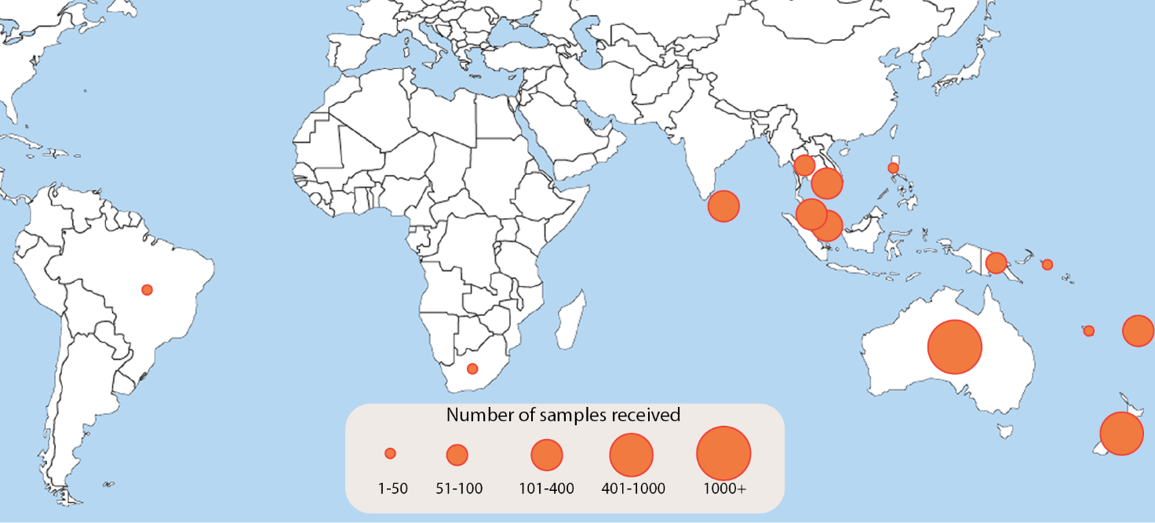

Table 1. Antigenic analysis of viruses received by the Centre in 2017, by geographic region of origin.
 | A(H1N1)pdm09 reference strain: |  | A(H3N2)* reference strain: |  | B/Victoria reference strain: |  | B/Yamagata reference strain:
 | A/Michigan/45/2015 (cell) |  | A/Hong Kong/4801/2014 (cell) |  | B/Brisbane/60/2008 (cell) |  | B/Phuket/3073/2013 (cell)
Region | Like | Low reactor (%) | Like | Low reactor (%) | Like | Low reactor (%) | Like | Low reactor (%)
Australasia | 395 | 2 | 677 | 164 | 51 | 2 | 871 | 0
South East Asia | 114 | 3 | 62 | 13 | 138 | 0 | 55 | 0
Pacific | 30 | 0 | 15 | 21 | 3 | 0 | 62 | 0
Africa | 3 | 0 | 10 | 2 | 0 | 0 | 3 | 0
South Asia | 31 | 0 | 7 | 0 | 3 | 0 | 2 | 0
South America | 0 | 0 | 3 | 0 | 0 | 0 | 2 | 0
Total | 573 | 5 (0.9%) | 774 | 200 (20.5%) | 195 | 2 (1.0%) | 995 | 0 (0%)
* Note that many A(H3) virus isolates that were obtained could not be analysed by HI assay due to low haemagglutination assay (HA) titre in the presence of oseltamivir

In addition, 884 samples were characterised by real-time RT-PCR to determine their type/subtype or lineage. Sanger sequencing and NGS techniques were used to sequence the haemagglutinin genes of 1965 viruses. The full genomes of 109 viruses were sequenced using either Sanger sequencing or NGS. Of the samples for which results could be obtained via antigenic or genetic analysis (n=4663), influenza A(H3) viruses predominated, comprising 54% (2514/4663) of viruses analysed. The remaining portion of viruses were mostly influenza B viruses (32% of viruses analysed; comprising 5% B/Victoria (209/4663) and 27% B/Yamagata (1274/4663)), followed by 14% A(H1)pdm09 (666/4663 of viruses analysed).
Figure 2. Number of samples received at the Centre by week of sample collection, 2017.
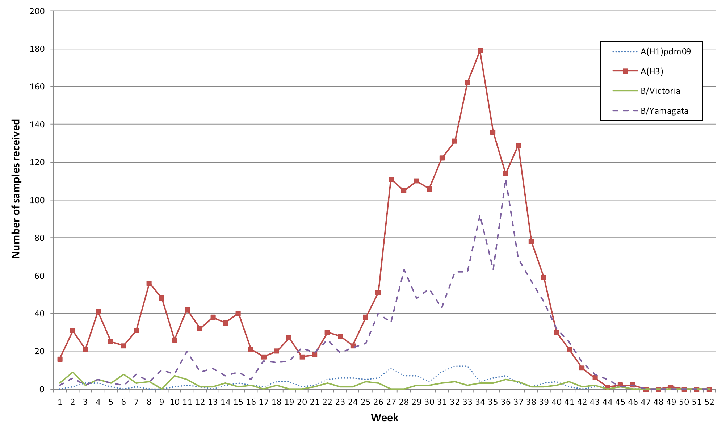

A(H1N1)pdm09
Of the 578 A(H1)pdm09 isolates analysed by HI assay using ferret antisera in 2017, the majority (99%) were antigenically similar to the vaccine reference strain A/Michigan/45/2015 (Table 1).
Sequencing and phylogenetic analysis of HA genes from 175 viruses showed that A(H1)pdm09 viruses sent to the Centre during 2017 fell mainly into the 6B.1 subclade with a smaller number of viruses in subclade 6B.2 (Figure 3). No antigenic differences were detectable between viruses from the 6B, 6B.1 or 6B.2 genetic clades in HI assays using ferret antisera and the majority of viruses reacted in a similar manner to the reference and 2017 vaccine virus A/Michigan/45/2015.

Figure 3. Phylogenetic tree of haemagglutinin genes of A(H1)pdm09 viruses received by the Centre during 2017.
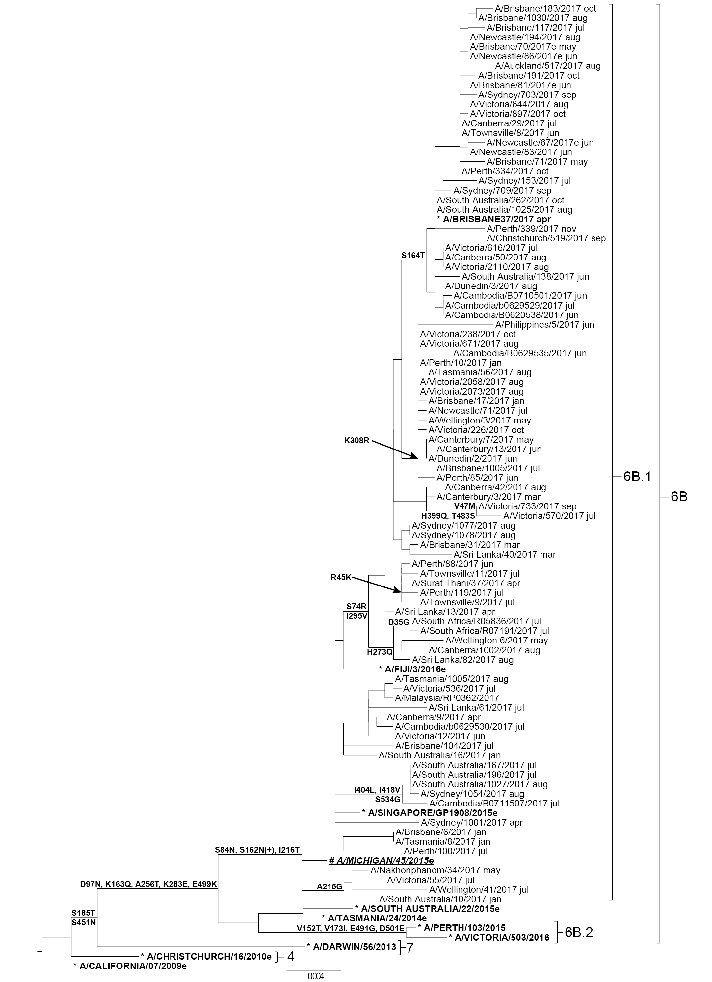
Legend:
# 2017 SOUTHERN HEMISPHERE VACCINE STRAIN
* REFERENCE VIRUS
e: egg isolate
Scale bar represents 0.4% nucleotide sequence difference between viruses
Amino acid changes relative to the outgroup sequence (A/CALIFORNIA/07/2009e) are shown
(+/-) indicates gain/loss of a potential glycosylation site
] Braces indicate clades
Five viruses were inoculated into eggs for isolation of candidate vaccine strains. Of these, four (80%) were successfully isolated, all of which fell into subclade 6B.1.
Of 578 A(H1)pdm09 viruses tested, two viruses exhibited highly reduced inhibition by oseltamivir. Both of these viruses—one from Singapore and one from Sydney—were confirmed to contain the H275Y mutation in their NA genes, a known mutation that is associated with reduced inhibition of oseltamivir. Another virus from Queensland had highly reduced inhibition by zanamivir and contained a Q136R mutation in its NA gene. Pyrosequencing of the original specimens of an additional four viruses from Perth revealed that they all contained the H275Y mutation in their NA gene.

A(H3N2)
Antigenic analysis of 974 A(H3) subtype isolates using the HI assay showed that 20.5% were low reactors to the ferret antisera prepared against the cell-propagated reference strain A/Hong Kong/4801/2014 (Table 1). However, 40.5% of viruses were low reactors to the ferret antisera prepared against the egg-propagated strain A/Hong Kong/4801/2014 (data not shown). An additional 781 A(H3) viruses were inoculated and isolated by cell culture but did not reach sufficient titres for antigenic analysis, whilst a further 229 were successfully isolated but did not reach sufficient titres when tested by HI assay in the presence of oseltamivir carboxylate.
The HA genes of 1582 A(H3) viruses were sequenced. Phylogenetic analysis indicated that the majority of circulating viruses fell into subclade 3C.2a1 based on their HA genes, which is genetically different to the 2017 vaccine strain A/Hong Kong/4801/2014 (clade 3C.2a) (Figure 4). A smaller proportion of A(H3) viruses fell into the 3C.2a2, 3C.2 a3 and 3C.2a4 clades.

Figure 4. Phylogenetic tree of haemagglutinin genes of A(H3) viruses received by the Centre during 2017.
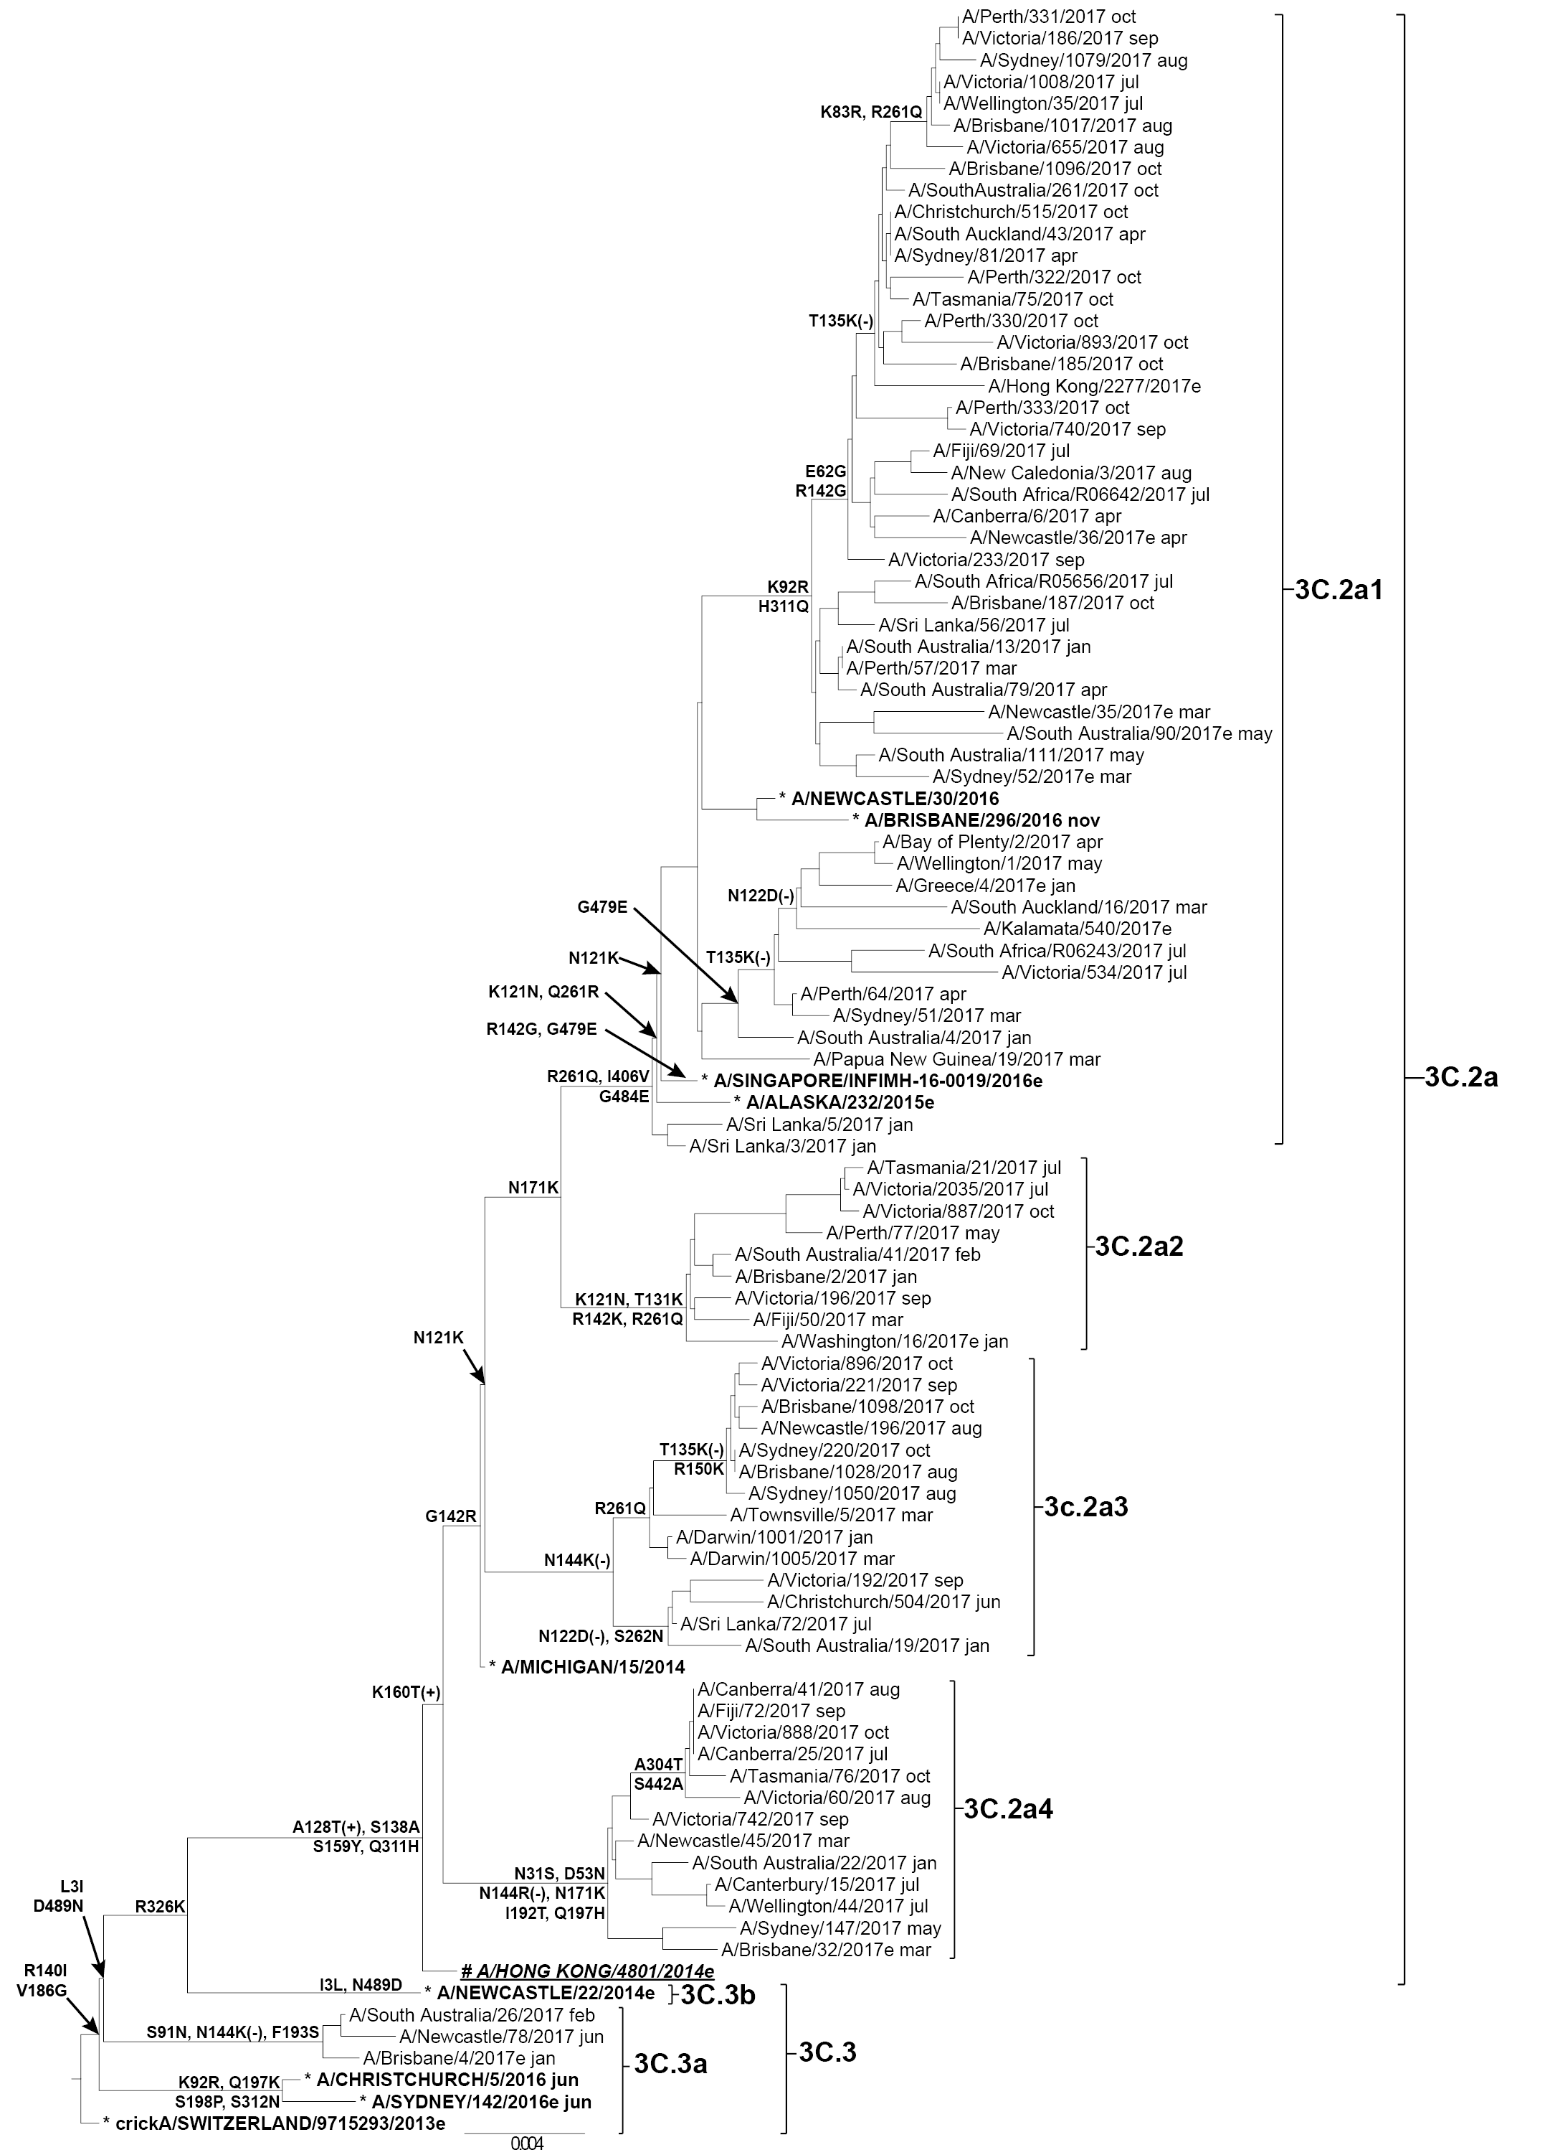
Legend:
# 2017 SOUTHERN HEMISPHERE VACCINE STRAIN
* REFERENCE VIRUS
e: egg isolate
Scale bar represents 0.4% nucleotide sequence difference between viruses
Amino acid changes relative to the outgroup sequence (crickA/SWITZERLAND/9715293/2013e) are shown
(+/-) indicates gain/loss of a potential glycosylation site
] Braces indicate clades
In total 80 viruses were inoculated into eggs, of which 30 (38%) grew successfully. These consisted of 17 viruses from clade 3C.2a, which included seven from subclade 3C.2a1. Additionally, three viruses were isolated from subclade 3C.2a2, three from 3C.2a3, five from 3C.2a4 and two from 3C.3a.
Of the 1960 A(H3) viruses tested by NAI assay, only one virus from Sydney showed highly reduced inhibition by oseltamivir and was found to contain a R292K mutation in its NA gene.

Influenza B
Amongst influenza B viruses received at the Centre during 2017, B/Yamagata lineage viruses were predominant over B/Victoria lineage viruses (Figure 2). A total of 1192 influenza B viruses were characterised by HI assay and almost all were antigenically similar to the B/Brisbane/60/2008-like and B/Phuket/3073/2013-like vaccine viruses for the B/Victoria and B/Yamagata lineages respectively (Table 1).
Sequencing was performed on HA genes from 208 B viruses, with the majority being B/Yamagata viruses. All of the viruses of B/Victoria lineage were genetically similar to the B/Brisbane/60/2008 reference virus (Figure 5). B/Victoria viruses bearing a two amino acid deletion in the HA protein at positions 162-163 have been increasing in frequency in many countries,¹⁵ however, only one such virus was detected (B/Victoria/3/2017) amongst viruses received at the Centre. The majority of B/Yamagata lineage viruses belonged to Clade 3, which is the same genetic clade as the 2017 vaccine virus B/Phuket/3073/2013 (Figure 6).

Figure 5. Phylogenetic tree of haemagglutinin genes of B/Victoria viruses received by the Centre during 2017.
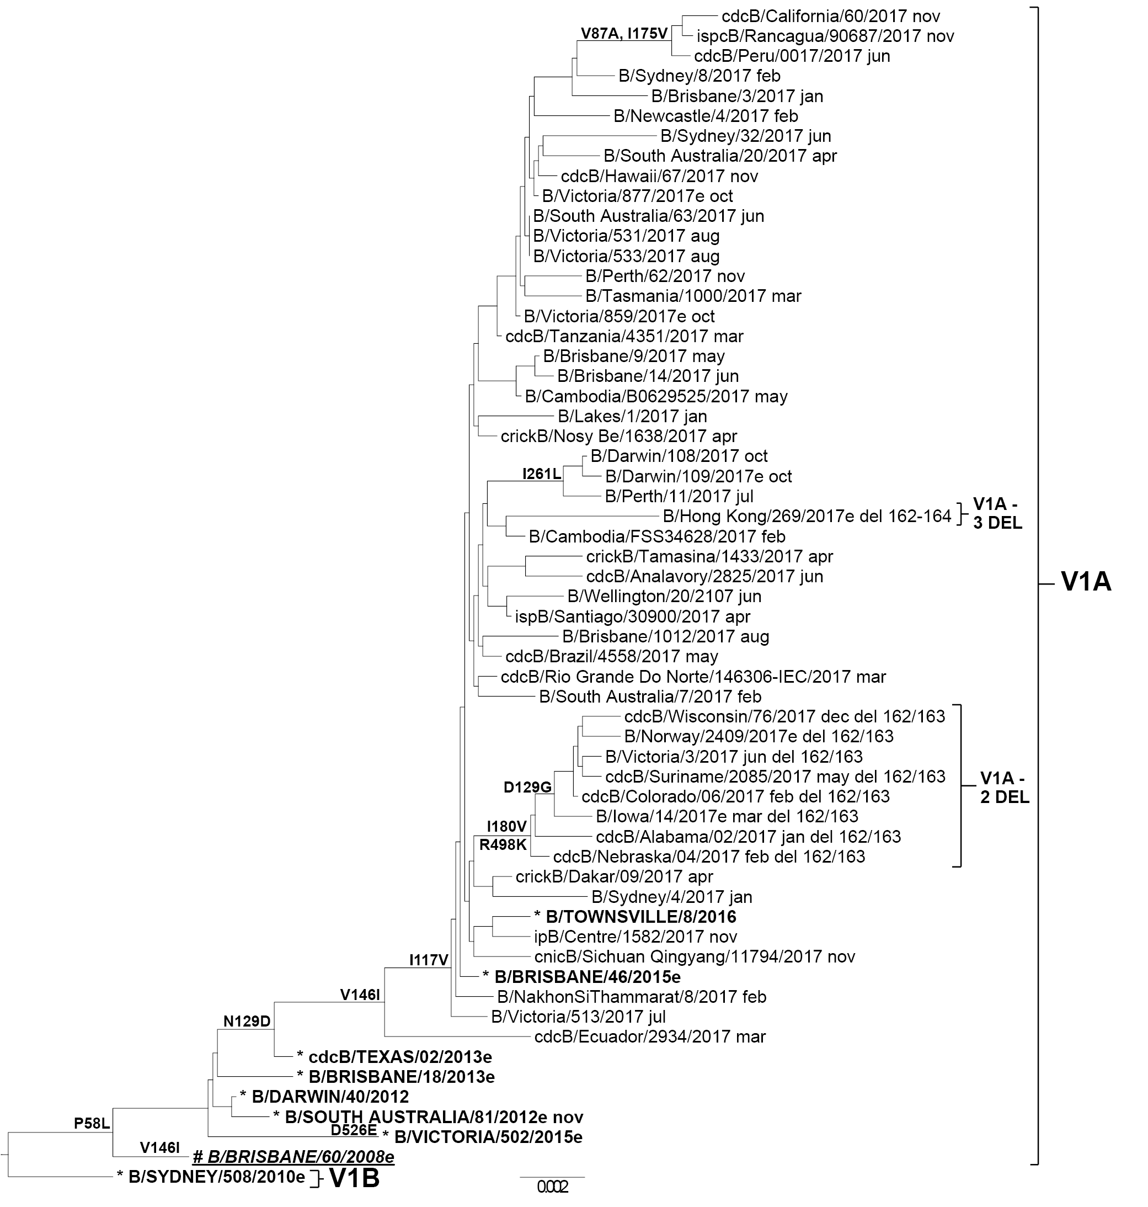
Legend:
# 2017 SOUTHERN HEMISPHERE VACCINE STRAIN
* REFERENCE VIRUS
e: egg isolate
Scale bar represents 0.2% nucleotide sequence difference between viruses
Amino acid changes relative to the outgroup sequence (B/SYDNEY/508/2010e) are shown
V1A - 3 DEL and V1A - 2 DEL indicate amino acid deletions at the positions indicated
] Braces indicate clades

Figure 6. Phylogenetic tree of haemagglutinin genes of B/Yamagata viruses received by the Centre during 2017.
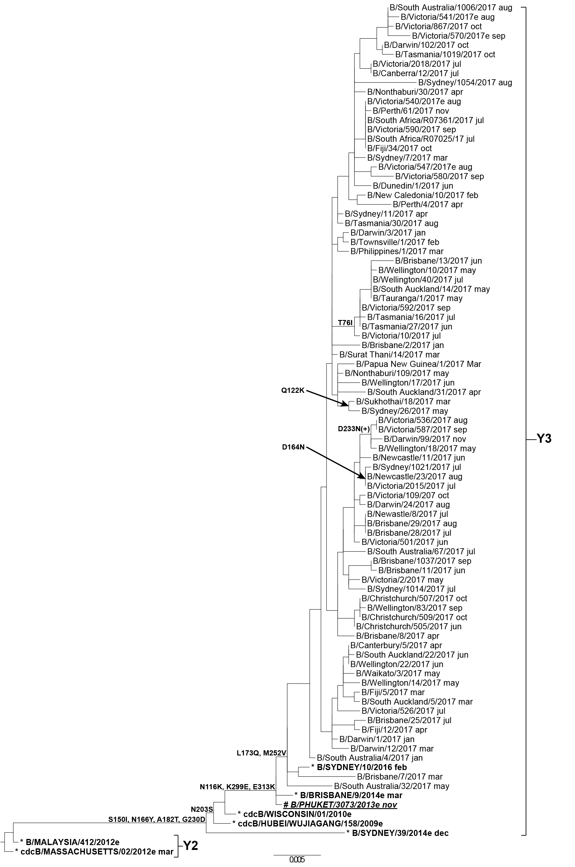
Legend:
# 2017 SOUTHERN HEMISPHERE VACCINE STRAIN
* REFERENCE VIRUS
e: egg isolate
Scale bar represents 0.5% nucleotide sequence difference between viruses
Amino acid changes relative to the outgroup sequence (cdcB/MASSACHUSETTS/02/2012e mar) are shown
(+/-) indicates gain/loss of a potential glycosylation site
] Braces indicate clades

Egg isolation was attempted for five B/Victoria and six B/Yamagata viruses, resulting in the successful isolation of four (80%) B/Victoria viruses and six (100%) B/Yamagata viruses. At least one representative from the major clades of both B lineages was amongst the successful egg isolates. Of 200 B/Victoria and 995 B/Yamagata viruses tested, none displayed highly reduced inhibition by oseltamivir or zanamivir.

Discussion
In 2017 the majority of samples received at the Centre were from Australia (76%), which was similar to previous years.^{14,16,17} Furthermore, during 2017, the Centre received the largest number of samples since the pandemic in 2009. This correlated with record notifications of laboratory-confirmed influenza during the 2017 Australian influenza season (over 250,000 cases), and was the highest recorded influenza activity since influenza became a notifiable disease in 2001, surpassing notifications both during the 2009 pandemic and the previous annual high in 2015.¹⁸ The geographical spread of influenza around the country in 2017 was uneven, as Western Australia experienced lower levels of activity compared to elevated levels in southern and eastern jurisdictions.¹⁹ The large increase in reported influenza activity during 2017 has been partly attributed to the early onset and prolonged length of the influenza season as well as increased use of diagnostic testing in clinical settings. However low vaccine effectiveness, in particular for the A(H3) subtype, has also been identified as a likely contributor to the high influenza activity in 2017.^{19,20} For the entire season, influenza A(H3) was the predominant circulating strain, followed by influenza B viruses, of which B/Yamagata viruses predominated over B/Victoria viruses. This pattern was also reflected in the relative proportions of samples received at the Centre during 2017.
Elderly populations are disproportionately affected in years when A(H3) viruses are predominant.²¹ In 2017 this was consistent with the fact that notification rates were highest for adults aged 80 years and older compared to younger age groups (2,974 notifications per 100,000 population for adults ≥85 years, 1,894 notifications per 100,000 population for adults aged 80–84 years).¹⁸ This is unsurprising given the predominance of A(H3) viruses during the season and the increase in influenza notifications and samples received by the Centre. A secondary smaller peak in young children aged 5 to 9 years (1,696 notifications per 100,000 population) has been largely attributed to influenza B.¹⁸
Due to this demographic, an increased number of deaths associated with influenza and pneumonia were reported in 2017, with 745 influenza associated deaths notified to the NNDSS by the end of November 2017. The median age of patients who died was 86 years (range 3 to 107 years),¹⁹ with the majority of deaths being attributed to influenza A.²²
The extended duration of elevated influenza activity observed during the 2017 Australian influenza season and dominance of A(H3) viruses is consistent with low interim vaccine effectiveness (VE) estimates, particularly for the A(H3) subtype.²³ The interim overall VE for 2017 was 33% (95% CI: 17 to 46%) with the lowest VE estimated for the A(H3) subtype (VE 10%, 95% CI: -16 to 31). Interim northern hemisphere VE estimates for the 2017–2018 season, which contained the same A(H3) vaccine strain component (A/Hong Kong/4801/2014) as the southern hemisphere in 2017, also reflected markedly lower VE estimates for A(H3) compared to A(H1)pdm09 and influenza B.^{24–26}
HI assays performed at the Centre showed that approximately 80% of A(H3) viruses tested were antigenically similar to the cell-propagated reference strain A/Hong Kong/4801/2014. However, almost half of the viruses analysed at the Centre were low reactors to the egg-derived A/Hong Kong/4801/2014 reference strain (data not shown). Adaptive changes acquired by A(H3) candidate viruses in their HA gene during propagation in eggs may alter their antigenicity and consequently produce lower VE. While every effort is made to obtain A(H3) egg isolates which retain the antigenic characteristics of their cell-derived counterparts, the A(H3) component included in vaccines in recent years have been affected by such adaptations.^{27,28} Interim VE estimates reported by the United States Department of Defense (DoD) during the northern hemisphere 2017–2018 season indicated a higher VE for A(H3) compared to VE calculated for civilian populations (27–52% VE for DoD populations versus 25% VE in civilian populations),²⁹ although the age structure and health status of these populations, as well as the type of vaccines used, are likely to be different. The components for the northern hemisphere 2017–2018 influenza vaccine were the same as those for the southern hemisphere 2017 vaccine. However, more than half of the vaccines administered by the US DoD contained an A(H3) component that was propagated in cell culture instead of eggs, and it is possible the higher VE in this population may be partly attributable to the inclusion of cell-based vaccine components that do not contain the same adaptations as egg-based vaccine components. Analysis of data from the United States Medicare program also indicated VE for preventing influenza-related hospital encounters and inpatient stays in individuals aged ≥ 65 years was higher for cell-based vaccine compared to egg-based vaccines.³⁰ At this time only egg-based influenza vaccines are available in Australia and as such these adaptations to egg-based components remain an ongoing concern in vaccine production and for VE.
In addition, there are ongoing difficulties in the antigenic characterisation of A(H3) viruses. Evolutionary changes in this subtype continue to create challenges in detecting antigenic changes using the HI assay.^{5,31} A large number of A(H3) viruses isolated in MDCK-SIAT-1 cells cannot be assayed by HI in the presence of oseltamivir carboxylate. After taking into account viruses that had insufficient titre for antigenic analysis following cell culture, as well as viruses that had insufficient titres when tested by HI assay in the presence of oseltamivir carboxylate, overall only 49% of all A(H3) viruses received by the Centre during 2017 and isolated in cell culture were successfully analysed by the HI assay. The Centre has developed Microneutralisation assays and the Focus Reduction Assay to characterise the antigenicity of circulating A(H3) viruses that cannot be run in HI assays. At this time, however, such assays remain time- and labour-intensive and complement rather than replace the HI assay. Genetic analysis has therefore become an increasingly important tool for detecting both minor and major changes in circulating A(H3) viruses.
Genetic data from the Centre indicated that many viruses in 2017 fell into clade 3C.2a1, a growing subclade of 3C.2a in which the 2017 vaccine strain, A/Hong Kong/4801/2014 sits. Although viruses in the subclade 3C.2a1 remain antigenically similar to other viruses in 3C.2a, the genetic drift of 3C.2a1 viruses and/or unwanted egg adaptations appear to have affected the effectiveness of the A(H3) vaccine component. Taken together, low VE estimates, genetic drift and poor HI reactivity resulted in the decision to change the H3 vaccine component in the 2018 vaccine to A/Singapore/INFIMH-16–0019/2016.³²
The majority of circulating A(H1)pdm09 viruses were antigenically similar to the cell-derived A/Michigan/45/2015 reference strain in the vaccine. Genetic analysis showed that almost all of the A(H1)pdm09 viruses received by the Centre in 2017 fell into the same clade (6B.1) as A/Michigan/45/2015. Moderate interim VE estimates (50%, 95% CI: 8 to 24%) were reported for the A(H1)pdm09 component of the 2017 Australian vaccine.²³
Finally, antigenic and genetic data indicated that both influenza B lineage viruses analysed by the Centre were a good match with the recommended vaccine strains, B/Brisbane/60/2008 (Victoria lineage) and B/Phuket/3073/2013 (Yamagata lineage). This was also reflected in moderate VE estimates for adults for the Australian 2017 influenza season (VE 57%, 95% CI: 22–62%).²³
With the continual change and evolution in influenza viruses and the absence of an effective universal vaccine, there remains a need for ongoing influenza surveillance and considered decision-making around influenza vaccine updates. The work performed by the Centre in Melbourne is crucial to the efforts of the global surveillance community to ensure that viruses recommended for the influenza vaccine remain updated and as closely matched to the future circulating viruses as possible.

Acknowledgements
The authors would like to thank all of the National Influenza Centres and other contributing laboratories who sent influenza positive samples to the Centre during 2017. We thank Ms Sook Kwan Brown for technical advice, and thank Dr Kanta Subbarao and Dr Ian Barr for their comments and input to this report. The FluLINE was developed by October Sessions and Uma Kamaraj from Duke-NUS Medical School, Singapore. The Melbourne WHO Collaborating Centre for Reference and Research on Influenza is supported by the Australian Government Department of Health. MXT was supported by an Australian Government Research Training Program Scholarship.

Author details
Ms Merryn Roe, Medical Scientist¹
Dr Matthew Kaye, Medical Scientist¹
Mrs Pina Iannello, Medical Scientist¹
Ms Hilda Lau, Medical Scientist¹
Mrs Iwona Buettner, Medical Scientist¹
Dr M Ximena Tolosa, Epidemiologist^{1,2}
Mrs Tasoula Zakis, Medical Scientist¹
Ms Vivian K Leung, Epidemiologist¹
Dr Michelle K Chow, Communications Officer¹
- WHO Collaborating Centre for Reference and Research on Influenza
- National Centre for Epidemiology and Population Health, Australian National University

Corresponding author:
Dr Michelle Chow
WHO Collaborating Centre for Reference and Research on Influenza
Peter Doherty Institute for Infection and Immunity
792 Elizabeth St
Melbourne 3000
Email: michelle.chow@influenzacentre.org

References
- Hay AJ, McCauley JW. The WHO global influenza surveillance and response system (GISRS)-A future perspective. Influenza Other Respir Viruses. 2018; https://doi.org/10.1111/irv.12565.
- Monto AS. Reflections on The Global Influenza Surveillance and Response System (GISRS) at 65 years: an expanding framework for influenza detection, prevention and control. Influenza Other Respir Viruses. 2018;12(1):10–2.
- Oh DY, Barr IG, Mosse JA, Laurie KL. MDCK-SIAT1 cells show improved isolation rates for recent human influenza viruses compared to conventional MDCK cells. J Clin Microbiol. 2008;46(7):2189–94.
- Hobson D, Curry RL, Beare AS, Ward-Gardner A. The role of serum haemagglutination-inhibiting antibody in protection against challenge infection with influenza A2 and B viruses. J Hyg (Lond). 1972;70(4):767–77.
- Lin YP, Gregory V, Collins P, Kloess J, Wharton S, Cattle N, et al. Neuraminidase receptor binding variants of human influenza A(H3N2) viruses resulting from substitution of aspartic acid 151 in the catalytic site: a role in virus attachment? J Virol. 2010;84(13):6769–81.
- Zhou B, Deng YM, Barnes JR, Sessions OM, Chou TW, Wilson M, et al. Multiplex reverse transcription-PCR for simultaneous surveillance of influenza A and B viruses. J Clin Microbiol. 2017;55(12):3492–501.
- Hurt AC, Okomo-Adhiambo M, Gubareva LV. The fluorescence neuraminidase inhibition assay: a functional method for detection of influenza virus resistance to the neuraminidase inhibitors. Methods Mol Biol. 2012;865:115–25.
- Hurt AC, Besselaar TG, Daniels RS, Ermetal B, Fry A, Gubareva L, et al. Global update on the susceptibility of human influenza viruses to neuraminidase inhibitors, 2014–2015. Antiviral Res. 2016;132:178–85.
- Deng YM, Caldwell N, Barr IG. Rapid detection and subtyping of human influenza A viruses and reassortants by pyrosequencing. PLoS One. 2011;6(8):e23400.
- Gerdil C. The annual production cycle for influenza vaccine. Vaccine. 2003;21(16):1776–9.
- Stohr K, Bucher D, Colgate T, Wood J. Influenza virus surveillance, vaccine strain selection, and manufacture. Methods Mol Biol. 2012;865:147–62.
- Weir JP, Gruber MF. An overview of the regulation of influenza vaccines in the United States. Influenza Other Respir Viruses. 2016;10(5):354–60.
- WHO Global Influenza Surveillance Network. Manual for the laboratory diagnosis and virological surveillance of influenza. Geneva: World Health Organization; 2011.
- Sullivan SG, Chow MK, Barr IG, Kelso A. Influenza viruses received and tested by the Melbourne WHO Collaborating Centre for Reference and Research on Influenza annual report, 2014. Commun Dis Intell Q Rep. 2015;39(4):E602–11.
- Questions and Answers: Recommended composition of influenza virus vaccines for use in the 2018–2019 northern hemisphere influenza season and development of candidate vaccine viruses for pandemic preparedness. 2018 February 2018. Available from: https://www.who.int/influenza/vaccines/virus/recommendations/201802_qanda_recommendation.pdf?ua=1
- Leung VK, Spirason N, Lau H, Buettner I, Leang SK, Chow MK. Influenza viruses received and tested by the Melbourne WHO Collaborating Centre for Reference and Research on Influenza annual report, 2015. Commun Dis Intell Q Rep. 2017;41(2):E150-E60.
- Leung VK, Deng YM, Kaye M, Buettner I, Lau H, Leang SK, et al. Report on influenza viruses received and tested by the Melbourne WHO Collaborating Centre for Reference and Research on Influenza in 2016. Commun Dis Intell (2018) 2019; 43: https://doi.org/10.33321/cdi.2019.43.3.
- Australian Government Department of Health. National Notifiable Diseases Surveillance System Canberra: Australian Government Department of Health; 2018 Accessed 20 August 2018. Available from: http://www9.health.gov.au/cda/source/cda-index.cfm
- Australian Government Department of Health. Australian Influenza Surveillance Report - 2017 Season Summary. Available from: http://www.health.gov.au/internet/main/publishing.nsf/Content/ozflu-surveil-2017-final.htm
- Grant KA, Carville K, Sullivan SG, Strachan J, Druce J, Fielding J. A severe 2017 influenza season dominated by influenza A(H3N2), Victoria, Australia. Western Pac Surveill Response J. 2018;9(Suppl 1):1–9.
- Thompson WW, Shay DK, Weintraub E, Brammer L, Bridges CB, Cox NJ, et al. Influenza-associated hospitalizations in the United States. JAMA. 2004;292(11):1333–40.
- Australian Government Department of Health. Australian Influenza Surveillance Report, No. 12 2017, 14–27 October 2017. Available from: http://www.health.gov.au/internet/main/publishing.nsf/Content/ozflu-surveil-no12-17.htm
- Sullivan SG, Chilver MB, Carville KS, Deng YM, Grant KA, Higgins G, et al. Low interim influenza vaccine effectiveness, Australia, 1 May to 24 September 2017. Euro Surveill. 2017;22(43). https://doi.org/10.2807/1560-7917.ES.2017.22.43.17-00707
- Flannery B, Chung JR, Thaker SN, Monto AS, Martin ET, Belongia EA, et al. Interim Estimates of 2016–17 Seasonal Influenza Vaccine Effectiveness—United States, February 2017. MMWR Morb Mortal Wkly Rep. 2017;66(6):167–71.
- Rondy M, Kissling E, Emborg HD, Gherasim A, Pebody R, Trebbien R, et al. Interim 2017/18 influenza seasonal vaccine effectiveness: combined results from five European studies. Euro Surveill. 2018;23(9): https://doi.org/10.2807/1560-7917.ES.2018.23.9.18-00086
- Skowronski DM, Chambers C, De Serres G, Dickinson JA, Winter AL, Hickman R, et al. Early season co-circulation of influenza A(H3N2) and B(Yamagata): interim estimates of 2017/18 vaccine effectiveness, Canada, January 2018. Euro Surveil.l 2018;23(5):https://doi.org//10.2807/1560-7917.ES.2018.23.5.18-00035
- Skowronski DM, Janjua NZ, De Serres G, Sabaiduc S, Eshaghi A, Dickinson JA, et al. Low 2012–13 influenza vaccine effectiveness associated with mutation in the egg-adapted H3N2 vaccine strain not antigenic drift in circulating viruses. PloS One. 2014;9(3):e92153.
- Zost SJ, Parkhouse K, Gumina ME, Kim K, Diaz Perez S, Wilson PC, et al. Contemporary H3N2 influenza viruses have a glycosylation site that alters binding of antibodies elicited by egg-adapted vaccine strains. Proc Natl Acad Sci USA. 2017;114(47):12578–83.
- Shoubaki L, Eick-Cost AA, Hawksworth A, Hu Z, Lynch L, Myers CA, et al. Brief report: Department of Defense midseason vaccine effectiveness estimates for the 2017–2018 influenza season. MSMR. 2018;25(6):26–8.
- Izurieta HS, Chillarige Y, Kelman J, Wei Y, Lu Y, Xu W, et al. Relative effectiveness of cell-cultured and egg-based influenza vaccines among the U.S. elderly, 2017–18. J Infect Dis. 2019; https://doi.org/10.1093/infdis/jiy716
- Barr IG, Russell C, Besselaar TG, Cox NJ, Daniels RS, Donis R, et al. WHO recommendations for the viruses used in the 2013–2014 Northern Hemisphere influenza vaccine: Epidemiology, antigenic and genetic characteristics of influenza A(H1N1)pdm09, A(H3N2) and B influenza viruses collected from October 2012 to January 2013. Vaccine. 2014;32(37):4713–25.
- World Health Organisation. Recommended composition of influenza virus vaccines for use in the 2018 southern hemisphere influenza season. 28 September 2017. Accessed 28 August 2018. Available from: http://www.who.int/influenza/vaccines/virus/recommendations/2018_south/en/.

Communicable Diseases Intelligence
ISSN: 2209-6051 Online

Communicable Diseases Intelligence (CDI) is a peer-reviewed scientific journal published by the Office of Health Protection, Department of Health. The journal aims to disseminate information on the epidemiology, surveillance, prevention and control of communicable diseases of relevance to Australia.

Editor: Cindy Toms
Deputy Editor: Simon Petrie
Design and Production: Kasra Yousefi
Editorial Advisory Board: David Durrheim, Mark Ferson, John Kaldor, Martyn Kirk and Linda Selvey

Website: http://www.health.gov.au/cdi

Contacts
Communicable Diseases Intelligence is produced by:
Health Protection Policy Branch, Office of Health Protection, Australian Government Department of Health
GPO Box 9848, (MDP 6) CANBERRA ACT 2601

Email: cdi.editor@health.gov.au

Submit an Article
You are invited to submit your next communicable disease related article to the Communicable Diseases Intelligence (CDI) for consideration. More information regarding CDI can be found at: http://health.gov.au/cdi.
Further enquiries should be directed to: cdi.editor@health.gov.au.

This journal is indexed by Index Medicus and Medline.

Creative Commons Licence - Attribution-NonCommercial-NoDerivatives CC BY-NC-ND
© 2019 Commonwealth of Australia as represented by the Department of Health
This publication is licensed under a Creative Commons Attribution-NonCommercial-NoDerivatives 4.0 International Licence from https://creativecommons.org/licenses/by-nc-nd/4.0/legalcode (Licence). You must read and understand the Licence before using any material from this publication.

Restrictions
The Licence does not cover, and there is no permission given for, use of any of the following material found in this publication (if any):
- the Commonwealth Coat of Arms (by way of information, the terms under which the Coat of Arms may be used can be found at www.itsanhonour.gov.au);
- any logos (including the Department of Health’s logo) and trademarks;
- any photographs and images;
- any signatures; and
- any material belonging to third parties.

Disclaimer
Opinions expressed in Communicable Diseases Intelligence are those of the authors and not necessarily those of the Australian Government Department of Health or the Communicable Diseases Network Australia. Data may be subject to revision.

Enquiries
Enquiries regarding any other use of this publication should be addressed to the Communication Branch, Department of Health, GPO Box 9848, Canberra ACT 2601, or via e-mail to: copyright@health.gov.au

Communicable Diseases Network Australia
Communicable Diseases Intelligence contributes to the work of the Communicable Diseases Network Australia.
http://www.health.gov.au/cdna

https://www.internationalreagentresource.org/

