Distribution of Bacillus Calmette–Guérin (BCG) Vaccine in Victoria 2013-2015
N.X. Wong, N. Crawford, J. Lawrie, J. Hickman, S. Elia, J. Buttery

Abstract

Background
The Bacillus Calmette–Guérin (BCG) vaccine has an important role mitigating tuberculosis (TB) disease in high risk children. In Victoria, immunisation services at the Royal Children’s Hospital (RCH) and Monash Health (MH) have been funded as the major providers of BCG vaccine since 2013.

Methods
In this article, we performed retrospective analysis of patients who attended RCH and MH for BCG between 1st November 2013- 30th November 2015. This was compared with local birth data in order to portray the distribution of BCG vaccine across various cohorts.

Outcomes
A total of 3,975 patients received BCG vaccine (1,775 at Monash, 2,200 from RCH). Detailed data is only available on 830 RCH patients. The median age of the study population was 6.9 months (IQR 3.9-11.3). The majority of children (98.9%, 2,575/2,604) received BCG vaccine prior to overseas travel. Of these, 96.0% (2,474/2,575) were travelling to countries in Asia. Only 13/2,604 (0.5%) were given BCG vaccine prior to travel to a country with low incidence of TB. Most infants were of Asian descent (93.3% mothers [2,425/2,604], 90.4% [2,346/2,604] fathers). A much smaller proportion was African (1.4% mothers [35/2,604], 1.5% [39/2,604] fathers). This contrasts with 2012 Victorian birth data, which showed that 82.2% (7,508/ 9,134) babies born to mothers from high TB prevalence countries were of Asian descent, whereas 8.9% (816/ 9,134) were of African descent. These results highlight scope to improve awareness and equity of BCG vaccine service, particularly to infants of African background.

Introduction
The Bacillus Calmette–Guérin vaccine (BCG), a live attenuated strain of Mycobacterium bovis, is administered to reduce the incidence and severity of Mycobacterium tuberculosis (MTB) disease in children. BCG vaccination of young children reduces the risk of severe and disseminated disease by 60-80%, although its role in adults and limiting transmission is controversial.¹⁻³ Over recent years, universal BCG vaccination has been phased out in many countries with low incidence of TB, with varying selective strategies adopted. In certain European countries (the United Kingdom, Netherlands and Norway), BCG vaccination is targeted at children born to parents originating from countries with a high incidence of TB.⁴⁻⁶ By comparison, other countries such as Denmark, the United States and Canada limit vaccination to children who are travelling to high prevalence regions for prolonged periods.⁷
In Australia, TB is a disease of low incidence – most cases occur in people born overseas in high-risk countries in Asia, north and sub-Saharan Africa, Eastern Europe and the Pacific. Higher rates of disease are also documented in Aboriginal and Torres Strait Islander (hereafter referred to as Indigenous) populations in Northern Australia.⁸ As such, BCG vaccine has been administered on a targeted basis to at-risk groups since the 1980s. Current national recommendations^{9, 10} indicate that BCG should be administered in:
- Aboriginal and Torres Strait Islander neonates in communities with a high incidence of TB (Northern Territory, Far North Queensland, northern areas of Western Australia and South Australia).
- Neonates and children under five years of age who will be travelling to or living in countries with a high prevalence of TB for extended periods (2-3 months prior to travel).¹¹
- Neonates born to parents with leprosy or a family history of leprosy.
Although incidence of TB disease is higher in overseas-born Australians for up to 20 years following migration¹², national guidelines do not recommend vaccination to children of migrants from high incidence countries.¹⁰ However, local Victorian guidelines suggest that BCG should be considered in children living with immigrants who have recently arrived from countries of high TB incidence. BCG vaccine is not delivered under the National Immunisation Programme.¹³ Within Australia, there is considerable variation between state guidelines for BCG vaccine.
In the state of Victoria, Australia, BCG is distributed through specialist vaccination clinics at the Royal Children’s (RCH) and Monash Health (MH). Since 2013, these clinics have received government funding for BCG vaccination, and thus provide the bulk of state-wide delivery in Victoria. The vaccine can also be obtained through private clinics in Melbourne and a regional clinic (Geelong). At risk children under the age of five years can be referred to these services via a general practitioner or a specialist service (including neonatal units). The vaccine is administered according to national guidelines, as recommended in the Australian Immunisation Handbook.¹⁰
In this study, we sought to describe the characteristics of the children who receive BCG vaccination in Victoria. In doing so, we aimed to assess how equitably and effectively the vaccine is accessed by potentially at-risk populations.

Methods
We performed a retrospective cohort analysis of patients who received BCG vaccine through MH and RCH immunisation clinics from the 1st November 2013 to 30th November 2015. Information was extracted from an existing database, which included information on patient ethnicity, indication for BCG vaccine and details about planned travel. All patients who received BCG vaccine during the study period were included. Distribution of BCG vaccine was assessed initially by using postcodes of vaccinees. The incidence of vaccinees per postcode was mapped geographically to depict the distribution of delivery across the state.
This data was compared with local birth and population data to provide estimation of the potential at-risk population. Local birth data was extracted from the Birthing Outcome System (BOS) database of Monash Health. This database documents all births that occur (public and private) within Monash Health Data pertaining to babies born within the study period was extracted from the database, including maternal country of birth. We approximated this at-risk population as babies born to mothers from overseas regions of high TB incidence (defined as >20 cases per 100,000 population¹⁴).
Population data on TB burden in Victoria was obtained from the Department of Health and Human Services (DHHS). In Australia, notification of confirmed cases of TB to the National Notifiable Diseases Surveillance System (NNDSS) is mandatory. Data for all children in Victoria aged 0-19 who had a confirmed case of TB from 2013-2015 were included in the study analysis. De-identified data on country of birth, parental country of birth and type of TB disease was analysed to provide illustration of disease burden in a population similar to the study population.

Statistical analysis
Continuous data are presented as mean and standard deviation/ median and interquartile range as appropriate for data distribution. Categorical variables are reported as frequencies and percentages. The proportion of children of Asian and African descent in the study population was compared to the at-risk population, as defined by local registry data, using chi-squared testing. A p-value of < 0.05 was considered statistically significant. The data was analysed with Stata / SE V.13.0.
Ethics approval for the study was obtained from the Human Research and Ethics Committee at Monash Health.

Results

Study population: demographic data
A total of 3,975 patients received BCG vaccine during the study period (1,775 at MH, 2,200 from RCH). Detailed data was available for only 829 RCH patients. The median age of the study population was 6.9 months (3.9 – 11.3). Almost all (2,603/2,604) vaccinees were born in Australia, with one born in New Zealand. No children were identified as Indigenous. Patient characteristics from the two clinics are summarised in Table 1.
Table 1: Demographics of children receiving BCG vaccine from MH and RCH Immunisation Clinics between November 2013-November 2015
 | MCH | RCH
Number of patients | 1,775 (68.2%) | 829 (31.8%)
Median age | 8 months (IQR 4.2-16.7) | 5.4 months (IQR 3.4-8.0)
Born in Australia | 1,774 /1,775 (99.9%) | 829/ 829 (100%)
Planned travel | 1,659 /1,775 (93.5%) | 817/ 829 (98.6%)
Planned travel to Asia | 1,705 / 1,775 (96.1%) | 769/ 829 (92.8%)
Planned travel to Africa | 18/ 1,775 (1.0%) | 11/ 829 (1.3%)

Parental demographics and travel plans
Complete details on parental country of birth was available for 2,595 vaccinees. Maternal country of birth was not available for 5 patients and paternal country of birth was not available for 9 patients. The majority of the study population were of Asian descent (96.6%, 2,516/2,604). A much smaller group was of African descent (2.0%, 52/2,604). These characteristics are summarised in Table 2. Most children were brought to the clinic prior to planned travel to a country with high TB incidence (2,476/2,604, 95.1%). The median time from vaccination to proposed travel date was 41 days (IQR 22-72).

Table 2: Parental region of birth and planned travel destination of children receiving BCG vaccination
 | One or both parents born in region | Planned travel destination
Africa | 52/2,604 (2.0%) | 29/2,604 (1.1%)
Asia | 2,516/2,604 (96.6%) | 2,474/2,604 (95.0%)
Eastern Europe | 13/2,604 (0.50%) | 10/2,604 (0.38%)
Western Europe | 37/2,604 (1.4%) | 7/2,604 (0.27%)
Middle East | 36/2,604 (1.4%) | 18/2,604 (0.69%)
Pacific (excluding Australia) | 10/2,604 (0.4%) | 4/2,604 (0.15%)
South America | 30/2,604 (1.2%) | 24/2,604 (0.92%)
US/ Canada | 8/2,604 (0.31%)
Australia / NZ | 133/2,604 (5.1%)

Postcode data was available for 2,560 patients. The number of vaccines administered per postcode was mapped in proportion to suburb population, as per the latest census data. Greatest coverage was seen in the suburbs of Clayton, Dandenong, Casey South and Wyndham regions. Vaccine coverage by referral number is shown in Figure 1. Figure 2 depicts vaccine provision in the south eastern suburbs of Melbourne.
Figure 1: BCG vaccine delivery across greater Melbourne. Solid red circles represent more than 30 individual vacinees for that postcode, less solid circles represent less referrals. Blue markers denote major tertiary hospitals
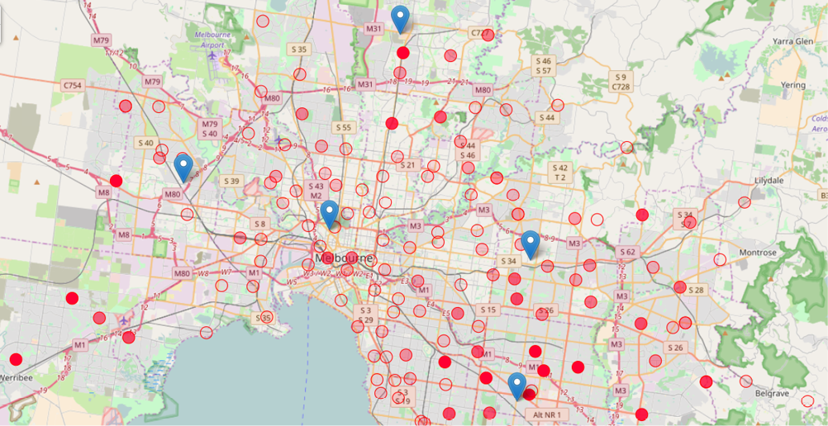

Figure 2: Distribution of BCG vaccine in the south eastern suburbs of Melbourne
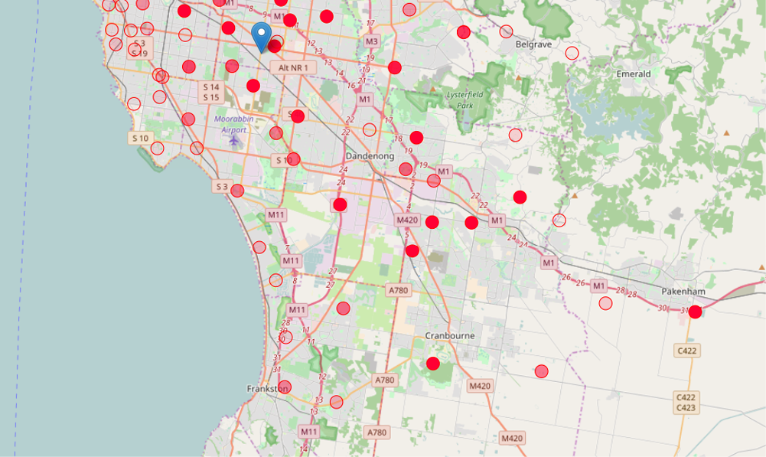

Comparison with local population data
During the study period, there were 17,048 babies born within the Monash Health network. Data on maternal county of birth is summarised in Table 3. 44.0% (7,508/17,048) mothers were of Asian descent and 4.7% (816/17,048) mothers were of African descent. There were a total of 9,134/17,048 (53.6%) babies born to mothers originating from high prevalence TB regions – Africa, Asia, Eastern European and Middle Eastern countries.
There were 816 children of African descent born at MH during the study period, which accounted for 4.8% of total births, and 8.9% of births to mothers originating from high TB prevalence regions. This was significantly greater than the proportion of children that received BCG vaccine who were of African descent (8.9% vs. 2.0%, p <0.01). By comparison, the proportion of babies born in the local population to mothers of Asian origin was 44.0% (7,508/ 17,048), accounting for 82.2% of babies born to mothers from high TB prevalence regions. The proportion of children who received BCG vaccine who were of Asian descent was significantly greater than this (82.2% vs 96.6%, p < 0.01). A comparison between proportion of local births by maternal region of birth and BCG vaccine delivery during the study period is shown in Figure 3.

Figure 3: Distribution of births from high TB prevalence regions compared to proportion of children who received BCG vaccine in this study cohort
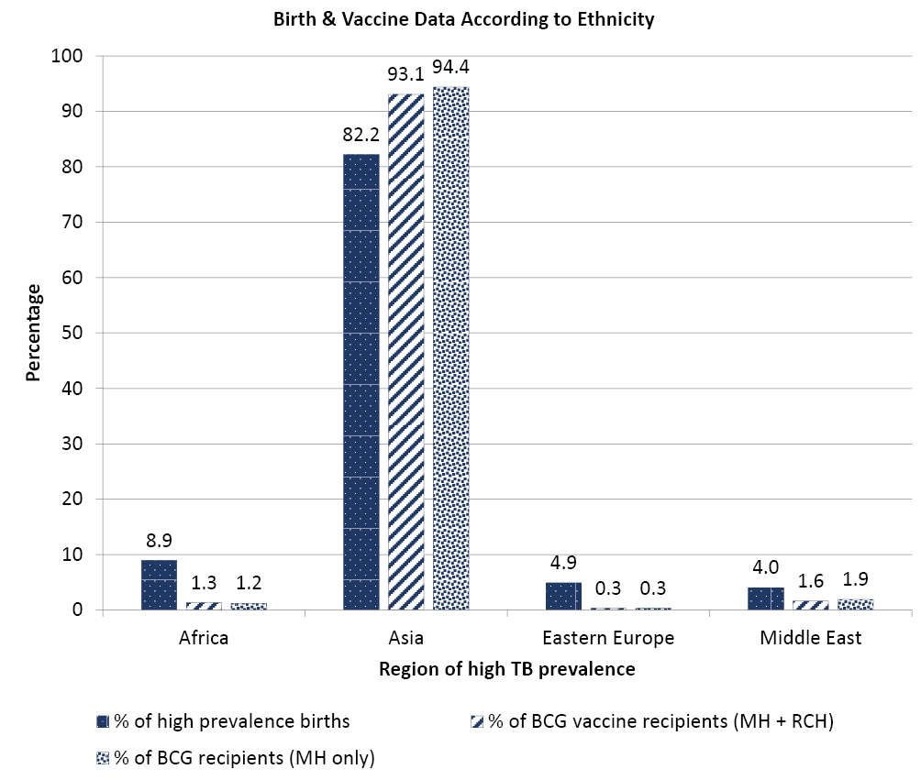
Table 3: Proportion of births at MH by region during the study period
Proportion of total births by region
Africa | 4.7% (816/17,048)
Asia | 44.0% (7,508/17,048)
Eastern Europe | 2.6% (445/17,048)
Western Europe | 2.0% (344/ 17,048)
Middle East | 2.1% (365/17,048)
Pacific (excluding Australia) | 1.7% (295/17,048)
South America | 0.6% (115/17,048)
US/ Canada | 0.4% (66/17,048)
Australia / NZ | 42.9% (7,507/17,048)
Country unspecified | 0.2% (41/17,048)
Table 4: Characteristics of children aged 0-19 diagnosed with TB from 2013-2015
Total number of children diagnosed with TB in Victoria between 2013-2015 | 111
Number of extrapulmonary TB cases | 30/111 (27.0%)
Cases born overseas | 56/111 (50.5%)
Cases in the 0-4 year old group | 26/111 (23.4%)
Cases born overseas | 3/26 (11.5%)
Cases of extrapulmonary disease | 5/26 (19.2%)
African descent | 14/26 (54%)
Asian descent | 10/26 (38.5%)
Cases in the 5-19 year old group | 85/111 (76.6%)
Cases born overseas | 53/85 (62.3%)
Cases of extrapulmonary disease | 26/85 (30.6%)
African descent | 24/85 (28.2%)
Asian descent | 46/85 (54.1%)

Comparison with incident childhood TB disease cases 2013-2015
Between 2013-2015, there were 111 cases of confirmed TB reported in children aged 0-19. 49.5% (55/111) were born in Australia and 50.5% (56/111) were born overseas. 59.5% (66/111) children were born in an Asian country or had one/ both parents originating from an Asian country. 27.0% (30/111) were born in an African country or had one/ both parents originating from an African country.
There were 26 children up to 4 years of age diagnosed with TB in Victoria within the study period. Most of these children were born in Australia (88.5%, 23/26). Ten were of Asian descent and 14 were of African descent.

Discussion
Our study confirms that state-funded Victorian immunisation clinics provide BCG vaccination to a substantial at-risk population. The overwhelming majority of children received BCG prior to travelling to a high-risk country. In our study population, there were no Indigenous children, or children with a family history of leprosy who received BCG. The median time between vaccination and planned travel was shorter than that recommended; however, the study period does include a period of global vaccine shortage.¹⁵
Our comparison with parental demographics of children born at MH indicate that a significantly smaller proportion of children of African descent received BCG vaccine compared to children of Asian descent. Similar discrepancies in vaccine coverage according to parental country of birth and ethnicity has also been noted in two European studies, in countries where selective vaccination is practised.^{5, 6}
Further insight into the differential risk of TB disease according to ethnic origin was obtained from Victorian population data. During the study period, the proportion of TB cases reported in children born overseas (56%) was similar to those born in Australia (54%). This reflects a higher proportion of immigration related disease compared to that seen in New Zealand, the United States and Western Europe.¹⁶ Almost a quarter of cases were reported in children under five born in Australia – the cohort which stands to benefit from local BCG vaccination. The proportion of African children diagnosed in this age group was higher than in the over five group. This adds to the importance of addressing BCG delivery in African populations, especially alongside our previous findings that suggest this group of children may be receiving suboptimal vaccine delivery.
Reduced vaccination rates in the African migrant population may relate to a number of factors. Firstly, geographical access may limit availability of BCG vaccine to some migrant groups. Currently, RCH and MH service large populations in central and south-east Melbourne. However, distance may limit access to migrant communities which are prominent in the western suburbs of Melbourne and rural settings. Limited vaccine distribution to regional and rural areas was cited as a shortcoming of BCG vaccination programmes in Australia in a recent study.¹⁷
Additionally, this group may have less awareness of the need to consider BCG vaccination. A previous Victorian study found that only 10.3% of mothers from high incidence countries were aware of the need to consider BCG vaccine prior to planned travel to their native countries.¹⁸ However, access to vaccine education as not been compared between different ethnic groups. Factors such as language barriers, education and refugee status may all contribute to poor awareness of TB and the indications for BCG vaccination. Moreover, general practitioners and treating specialists may similarly lack awareness of the indications for BCG vaccination in this cohort. As the BCG vaccine is not distributed through the National Immunisation Programme, providers and referrers need to remain cognisant of the indications for BCG vaccination. This may be complicated by changes in guidelines, and variations in recommendations across different state and national guidelines. Accurately identifying target populations has previously been noted as a barrier to other forms of selective vaccination, such as the influenza and pneumococcal vaccines.^{6, 19, 20}
Our findings must be interpreted with acknowledgement of several limitations. Firstly, data on 1,329 patients vaccinated at RCH was not available. This was partly due to cases only being captured with more detailed information if <12-months of age. There was also limited data during this study period on BCG vaccines administered in private clinics where demographic data was not collated. This may introduce potential bias if the private population differed in ethnic demographics as compared to the public patients.
Another limitation to our study is the means by which the potential at-risk population was approximated. We obtained data from a local birth registry to approximate a target population, defined as babies born to mothers from overseas, high-incidence countries. Although state-wide birth data for the study period were not available, the local results obtained showed similar proportions of overseas-born mothers to previous state-wide data reports.²¹ The numbers used for comparison included only information on maternal ethnic background, with paternal ethnicity not available. Additionally, the target vaccine population, according to current recommendations, includes only those children who are travelling to high-incidence countries for a prolonged period of time, whereas we have used proportion of children born to mothers from high incidence countries to approximate the at-risk population. As such, the smaller proportion of vaccination could be attributed to lower incidence of travel amongst different migrant groups. It is plausible that the population of Asian children receiving BCG vaccine is overrepresented compared to African children due to differential travel patterns. A previous cohort study of women born in high TB prevalence countries showed that planned travel to Asia was the most common at 91.3%, compared to that of sub-Saharan Africa at 7.2%.¹⁸ However, even this proportion would suggest that the observed vaccination proportion of African infants in our study of 2.0% underrepresents the potentially at-risk African population in the state of Victoria.

Conclusion
Targeted delivery of BCG vaccine provides an important service to children at-risk of TB infection and disease. The purpose of this study was to analyse the demographics of the children who receive BCG vaccination in Victoria, and assess whether this cohort adequately reflects the at-risk populations. Comparisons with local birth data and population case data are useful in providing estimations of the at-risk population in Victoria and the risk factors for disease. These markers show that the highest burden of TB disease lies with children of Asian and African descent, consistent with previous reports of TB burden in Australia.^{8, 16}
Our findings suggest that there is an unequal delivery of this vaccine amongst these risk groups, with less children of African descent receiving BCG vaccines than their Asian counterparts. Whilst this finding must be interpreted within the limitations of our study, it does highlight potential to improve vaccine delivery to the at-risk African population of Victoria. Further investigation is required to conclude if these observed differences relate to inadequate awareness, access or less travel exposure in the African cohort. Addressing these factors may enable provision of a more equitable and effective vaccination service.

Corresponding author
Dr. Nicole X. Wong Address: Monash Children’s Hospital, Clayton Road, Victoria Phone: 0435113813 Email: nicolexwong@gmail.com

Authors and affiliations
Dr. Nicole X. Wong - Monash Children’s Hospital, Melbourne. General Medicine, Royal Children’s Hospital (RCH), Melbourne. Department of Paediatrics, University of Melbourne.
Dr. Nigel Crawford - General Medicine, RCH, Melbourne. Murdoch Children’s Research Institute (MCRI), Melbourne. Department of Paediatrics, University of Melbourne.
Jock Lawrie - MCRI, Melbourne.
Jo Hickman - Monash Immunisation, Monash Health.
Sonja Elia - Immunisation Service, RCH, Melbourne
Prof Jim Buttery - Department of Infection and Immunity, Monash Children’s Hospital, Melbourne.

References
- Soysal A, Millington KA, Bakir M, Dosanjh D, Aslan Y, Deeks JJ, et al. Effect of BCG vaccination on risk of Mycobacterium tuberculosis infection in children with household tuberculosis contact: a prospective community-based study. Lancet. 2005;366(9495):1443-51.
- Trunz BB, Fine P, Dye C. Effect of BCG vaccination on childhood tuberculous meningitis and miliary tuberculosis worldwide: a meta-analysis and assessment of cost-effectiveness. Lancet. 2006;367(9517):1173-80.
- Eisenhut M, Paranjothy S, Abubakar I, Bracebridge S, Lilley M, Mulla R, et al. BCG vaccination reduces risk of infection with Mycobacterium tuberculosis as detected by gamma interferon release assay. Vaccine. 2009;27(44):6116-20.
- Erkens CG, de Vries G, Keizer ST, Slump E, van den Hof S. The epidemiology of childhood tuberculosis in the Netherlands: still room for prevention. BMC Infect Dis. 2014;14:295.
- Srinivasan R, Menon L, Stevens P, Campbell I, Alfaham M. Ethnic differences in selective neonatal BCG immunisation: white British children miss out. Thorax. 2006;61(3):247-9.
- Feiring B, Laake I, Molden T, Haberg SE, Nokleby H, Seterelv SS, et al. Do selective immunisation against tuberculosis and hepatitis B reach the targeted populations? A nationwide register-based study evaluating the recommendations in the Norwegian Childhood Immunisation Programme. Vaccine. 2016;34(17):2015-20.
- Infuso A, Falzon D, Euro TBn. European survey of BCG vaccination policies and surveillance in children, 2005. Euro Surveill. 2006;11(3):6-11.
- National Tuberculosis Advisory Committee. Tuberculosis notifications in Australia, 2012 and 2013 Communicatication Diseases Intelligence. 2015;39(2).
- National Tuberculosis Advisory Committee. The BCG Vaccine: Information and recommendations for use in Australia Communicable Diseases Intelligence. 2013;37(1):E65-E72.
- Australian Technical Advisory Group On Immunisation. The Australian Immunisation Handbook 10th ed. Canberra: Australian Government Department of Health 2017 August 2017
- Ritz N, Connell TG, Curtis N. To BCG or not to BCG? Preventing travel-associated tuberculosis in children. Vaccine. 2008;26(47):5905-10.
- Barry C, Konstantinos A, National Tuberculosis Advisory C. Tuberculosis notifications in Australia, 2007. Commun Dis Intell Q Rep. 2009;33(3):304-15.
- Department of Health and Human Services V. Management, control and prevention of tuberculosis: Guidelines or health care providers. . 2015.
- World Health Organization. Global Tuberculosis Report 2017.
- World Health Organization Department of Immunizations Vaccines and Biologicals, World Health Organization Global Tuberculosis Programme, UNICEF Supply and Programme Divisions. Guidance on how to prioritize the globally constrained BCG vaccine supply 2015.
- Teo SS, Tay EL, Douglas P, Krause VL, Graham SM. The epidemiology of tuberculosis in children in Australia, 2003-2012. Med J Aust. 2015;203(11):440.
- Khandaker G, Beard FH, Dey A, Coulter C, Hendry AJ, Macartney KK. Evaluation of bacille Calmette-Guerin immunisation programs in Australia. Commun Dis Intell Q Rep. 2017;41(1):E33-E48.
- Gwee A, Rodrigo R, Casalaz D, Ritz N, Curtis N. Infants born in Australia to mothers from countries with a high prevalence of tuberculosis: to BCG or not to BCG? Med J Aust. 2013;199(5):324-6.
- Ames HM, Glenton C, Lewin S. Parents’ and informal caregivers’ views and experiences of communication about routine childhood vaccination: a synthesis of qualitative evidence. Cochrane Database Syst Rev. 2017;2:CD011787.
- Thomas P, Joseph TL, Menzies RI. Evaluation of a targeted immunisation program for Aboriginal and Torres Strait Islander infants in an urban setting. N S W Public Health Bull. 2008;19(5-6):96-9.
- Li Z, Zeki R, Hilder L, Sullivan E. Australia’s mothers and babies 2011. . In: Unit ANPEaS, editor. Canberra2013.
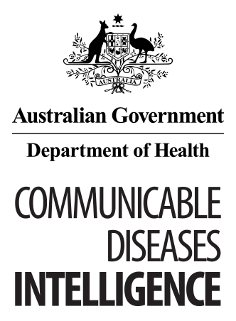
© Commonwealth of Australia 2018 - ISSN: 2209-6051 (Online)
This work is copyright. You may download, display, print and reproduce the whole or part of this work in unaltered form for your own personal use or, if you are part of an organisation, for internal use within your organisation, but only if you or your organisation do not use the reproduction for any commercial purpose and retain this copyright notice and all disclaimer notices as part of that reproduction. Apart from rights to use as permitted by the Copyright Act 1968 or allowed by this copyright notice, all other rights are reserved and you are not allowed to reproduce the whole or any part of this work in any way (electronic or otherwise) without first being given the specific written permission from the Commonwealth to do so. Requests and inquiries concerning reproduction and rights are to be sent to the Online, Services and External Relations Branch, Department of Health, GPO Box 9848, Canberra ACT 2601, or by email to copyright@health.gov.au
Communicable Diseases Intelligence aims to disseminate information on the epidemiology and control of communicable diseases in Australia. Communicable Diseases Intelligence invites contributions dealing with any aspect of communicable disease epidemiology, surveillance or prevention and control in Australia. Submissions can be in the form of original articles, short reports, surveillance summaries, reviews or correspondence. Instructions for authors can be found in Commun Dis Intell 2016;40(1):E189–E193.
Communicable Diseases Intelligence contributes to the work of the Communicable Diseases Network Australia.
http://www.health.gov.au/cdna

This journal is indexed by Index Medicus and Medline.
Disclaimer: Opinions expressed in Communicable Diseases Intelligence are those of the authors and not necessarily those of the Australian Government Department of Health or the Communicable Diseases Network Australia. Data may be subject to revision.

Editor: Cindy Toms
Deputy Editor: Phil Wright
Editorial and Production Staff: Leroy Trapani, Kasra Yousefi
Editorial Advisory Board: Peter McIntyre (Chair), David Durrheim, Mark Ferson, John Kaldor, Martyn Kirk
Website: http://www.health.gov.au/cdi
Communicable Diseases Intelligence is produced by Health Protection Policy Branch, Office of Health Protection, Australian Government, Department of Health, GPO Box 9848, (MDP 6) CANBERRA ACT 2601;
Email: cdi.editor@health.gov.au

