COVID-19 Australia: Epidemiology Report 68
Reporting period ending 20 November 2022
COVID-19 Epidemiology and Surveillance Team
The next report (Epidemiology Report 69) will be released in late January 2023 owing to the summer shutdown.

Summary

Four-week reporting period (24 October – 20 November 2022)
As of report 62 onward, the case data provided in this report includes both confirmed and probable cases reported to the National Notifiable Diseases Surveillance System (NNDSS), unless otherwise specified. Case definitions for confirmed and probable cases are in accordance with the coronavirus disease 2019 (COVID-19) Series of National Guidelines for Public Health Units (SoNG).
On 24 October 2022, Queensland commenced the transmission of all rapid antigen test (RAT) positive cases to NNDSS, which will be completed over the coming weeks; prior to 24 October 2022, Queensland only reported probable cases that had a RAT conducted in a clinical setting; probable cases who tested via RAT outside of a clinical setting were not reported to NNDSS. Therefore, interpretation of historical trends in Queensland should be undertaken with caution until the transmission of all RAT cases is complete. Due to technical difficulties in the Australian Capital Territory, hospitalisation data and testing data from the ACT are unavailable from 12 November 2022.
Trends – Nationally, COVID-19 case notifications have been increasing since late October 2022, reflecting a fourth wave of transmission driven by a combination of existing and newly emerging Omicron subvariants. In the four-week period 24 October – 20 November 2022, there were 88,529 confirmed and 146,554 probable cases of COVID-19 reported in Australia to NNDSS. In the latter reporting fortnight, a total of 152,817 confirmed and probable cases were notified (an average of 10,916 cases per day), compared to 82,266 in the previous fortnight (5,876 cases per day).
Age group – Since late October 2022, there has been an increase in case rates across all age groups, with rates highest in those aged 70 years and over. In the reporting period 24 October – 20 November 2022, the highest case rate was observed among adults aged 80 years and over, whilst the lowest rate was among children aged 5 to 11 years. Children aged 17 years or less continue to experience considerably lower case rates than the adult population. For the entire Omicron wave to date (15 December 2021 – 20 November 2022), the highest case rate has been in adults aged 18 to 29 years.
Aboriginal and Torres Strait Islander persons – In the reporting period 24 October – 20 November 2022, there were 5,287 new cases notified in Aboriginal and Torres Strait Islander people. In the current Omicron wave (15 December 2021 – 20 November 2022) there have been 335,722 cases of COVID-19 notified in Aboriginal and Torres Strait Islander people, representing 3.6% (335,722/9,382,262) of all COVID-19 cases in the Omicron wave to date.
Severity – The notification rate of cases with severe illness (defined as those admitted to ICU or died) has remained relatively stable since early October 2022. The overall crude case fatality rate in the current fourth Omicron wave is 0.11%, which is less than the rate observed during the first (0.14%) and third (0.21%) waves, similar to the rate observed in the second wave (0.10%), and notably less than observed during the Delta (0.70%) wave. Since the start of the pandemic to 20 November 2022, there have been 158 cases of paediatric inflammatory multisystem syndrome temporally associated with SARS-CoV-2 (PIMS-TS) reported to PAEDS, including 124 cases reported in 2022.
Virology – For samples collected in the four-week period 24 October – 20 November 2022, all 5,500 were assigned against Omicron or recombinants consisting of two Omicron lineages. BA.5 is currently the predominant sub-lineage being sequenced, representing 62.6% of sequences collected in the reporting period and available for analysis in AusTrakka. By contrast, recombinant lineages made up 10.0% of sequences available in AusTrakka during the same period. Of the Omicron sequences in AusTrakka to date, 23.99% are BA.1; 39.82% are BA.2; < 0.001% are BA.3; 4.41% are BA.4 and 30.80% are BA.5. Recombinants make up 0.54% of all Omicron sequences to date.
International situation – According to the World Health Organization (WHO), cumulative global COVID-19 cases stood at over 635 million COVID-19 cases and over 6.6 million deaths, as of 20 November 2022. For the South East Asian and Western Pacific regions combined, there were 4,531,896 newly-confirmed cases and 9,122 deaths in the four-week period to 20 November 2022. Compared to the previous four-week reporting period, new cases and new deaths increased in both the Western Pacific and South East Asia regions. In total, since the start of the pandemic, over 157 million cases and over one million deaths have been reported in the two regions.

Keywords: SARS-CoV-2; novel coronavirus; 2019-nCoV; coronavirus disease 2019; COVID-19; acute respiratory disease; epidemiology; Australia
This reporting period covers the four-week period of 24 October – 20 November 2022. Within this period, data for each week is compared. The previous reporting period was the preceding four weeks (26 September – 23 October 2022).¹ The focus of this report is on the epidemiological situation in Australia since the beginning of the current Omicron wave. For the purposes of this report, 15 December 2021 is used as a proxy for the beginning of this wave. This date was chosen as from this date onwards, the majority of sequenced strains from cases were Omicron. Readers are encouraged to consult prior reports in this series for information on the epidemiology of coronavirus disease 2019 (COVID-19) in Australia.
Methods of data analysis used in these reports have periodically changed over the course of this reporting series to date. Please refer to the Technical Supplement for details of such changes, and for definitions of terminology.²
Unless otherwise specified, tabulated data, data within the text, and figures, except those relating to severity, are extracted from the National Notifiable Diseases Surveillance System (NNDSS) based on ‘notification received date’. All tables and figures related to severity data extracted from NNDSS are based on ‘diagnosis date’ to better capture the true onset of severe illness and to enable a more accurate understanding of infection risk and disease severity.
The case data provided includes both confirmed cases and probable cases reported to the NNDSS, as defined in accordance with the COVID-19 series of national guidelines (SoNG).³ For the purposes of this report, only probable cases from 5 January 2022 are included.
Due to the dynamic nature of data in the NNDSS, numbers may be subject to revision and may vary from numbers previously reported and from case notifications released by states and territories.

Background and data sources
See the Technical Supplement for general information on COVID-19 including modes of transmission, common symptoms, and severity.²

Activity

COVID-19 trends

(NNDSS and jurisdictional reporting to the National Incident Centre)
Cumulatively, from the beginning of the pandemic to 20 November 2022, jurisdictions within Australia have reported 10,588,982 COVID-19 cases to the National Incident Centre (Table 1). In the same time period, there were 4,957,726 confirmed and 4,659,164 probable cases of COVID-19 reported to NNDSS nationally. The difference in these case numbers arises because probable cases are not yet systematically reported by all jurisdictions to NNDSS. The analyses in this report include both confirmed and probable cases reported to the NNDSS, unless otherwise specified.
Table 1: Confirmed and probable COVID-19 cases by jurisdiction, 1 January 2020 – 20 November 2022^{a,b}
 | Australia (total) | ACT | NSW | NT | Qld | SA | Tas. | Vic. | WA
Cases – PCR confirmed | 4,979,995 | 124,660 | 1,986,286 | 21,830 | 645,003 | 474,547 | 58,771 | 1,175,877 | 493,021
Cases – RAT probable | 5,608,987 | 87,962 | 1,633,442 | 77,665 | 1,044,086 | 329,616 | 200,381 | 1,526,600 | 709,235
Cases – total | 10,588,982 | 212,622 | 3,619,728 | 99,495 | 1,689,089 | 804,163 | 259,152 | 2,702,477 | 1,202,256
a Source: jurisdictional reporting to the National Incident Centre.
b ACT: Australian Capital Territory; NSW: New South Wales; NT: Northern Territory; Qld: Queensland; SA: South Australia; Tas.: Tasmania; Vic.: Victoria; WA: Western Australia.
Figure 1: Confirmed and probable weekly COVID-19 notified cases by notification date, Australia, 29 November 2021 – 20 November 2022ª
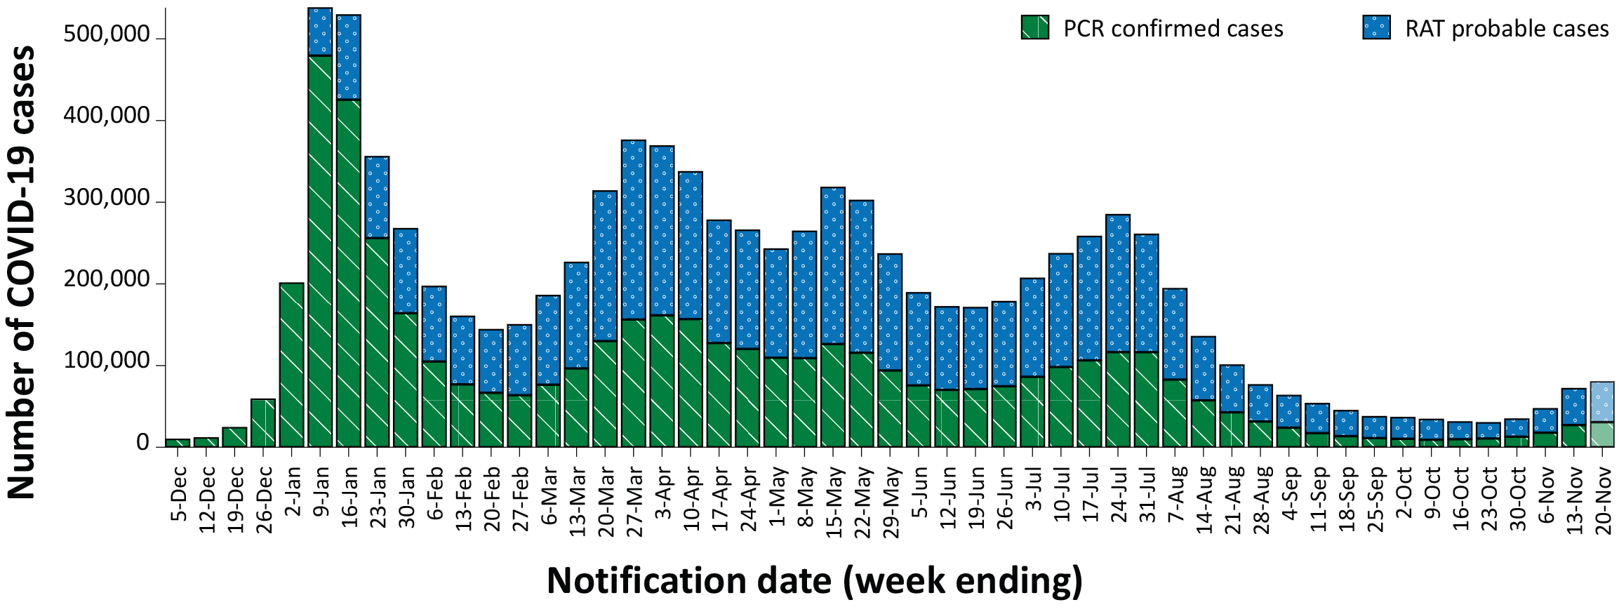
a Source: NNDSS extract from 22 November 2022 for notifications from 29 November 2021 to 20 November 2022. On 24 October 2022, Queensland commenced the transmission of all rapid antigen test (RAT) positive cases to NNDSS, which will be completed over the coming weeks; prior to 24 October 2022, Queensland only reported probable cases that had a RAT conducted in a clinical setting; probable cases who tested via RAT outside of a clinical setting were not reported to NNDSS. Therefore, interpretation of historical trends should be undertaken with caution until the transmission of all RAT cases is complete.
Table 2: Confirmed and probable COVID-19 cases by jurisdiction and date of notification, Australia, 15 December 2021 – 20 November 2022^{a,b}
Jurisdiction | Reporting period |  |  |  |  |  | Current Omicron wave
 | 24 October – 6 November 2022 |  |  | 7–20 November 2022 |  |  | 15 December 2021 – 20 November 2022
 | Confirmed | Probable | Total | Confirmed | Probable | Total | Confirmed | Probable | Total
ACT | 801  (43.0%) | 1,061  (57.0%) | 1,862 | 1,096  (39.1%) | 1,705  (60.9%) | 2,801 | 124,186 (58.3%) | 88,678  (41.7%) | 212,864
NSW | 14,428  (57.3%) | 10,763  (42.7%) | 25,191 | 30,159  (57.1%) | 22,626  (42.9%) | 52,785 | 1,898,430 (56.6%) | 1,453,481 (43.4%) | 3,351,911
NT | 111  (19.1%) | 469  (80.9%) | 580 | 131  (21.8%) | 470  (78.2%) | 601 | 21,63  (21.7%) | 78,017  (78.3%) | 99,652
Qld^{c} | 1,792  (22.8%) | 6,061  (77.2%) | 7,853 | 3,593  (21.3%) | 13,247  (78.7%) | 16,840 | 640,393 (71.9%) | 249,677 (28.1%) | 890,070
SA | 3,839  (45.0%) | 4,684  (55.0%) | 8,523 | 8,110  (47.8%) | 8,845  (52.2%) | 16,955 | 473,787 (59.0%) | 329,701 (41.0%) | 803,488
Tas. | 552  (21.5%) | 2,018  (78.5%) | 2,570 | 1,045  (22.6%) | 3,580  (77.4%) | 4,625 | 58,579  (22.6%) | 200,361 (77.4%) | 258,940
Vic. | 6,398  (28.7%) | 15,863  (71.3%) | 22,261 | 10,402  (25.8%) | 29,915  (74.2%) | 40,317 | 1,026,589 (40.0%) | 1,538,998 (60.0%) | 2,565,587
WA | 2,750  (20.5%) | 10,676  (79.5%) | 13,426 | 3,322  (18.6%) | 14,571  (81.4%) | 17,893 | 479,499 (40.0%) | 720,251 (60.0%) | 1,199,750
Australia | 30,671  (37.3%) | 51,595  (62.7%) | 82,266 | 57,858  (37.9%) | 94,959  (62.1%) | 152,817 | 4,723,098 (50.3%) | 4,659,164 (49.7%) | 9,382,262
a Source: NNDSS extract from 22 November 2022 for notifications from 15 December 2021 to 20 November 2022.
b ACT: Australian Capital Territory; NSW: New South Wales; NT: Northern Territory; Qld: Queensland; SA: South Australia; Tas.: Tasmania; Vic.: Victoria; WA: Western Australia.
c On 24 October 2022, Queensland commenced the transmission of all rapid antigen test (RAT) positive cases to NNDSS, which will be completed over the coming weeks; prior to 24 October 2022, Queensland only reported probable cases that had a RAT conducted in a clinical setting; probable cases who tested via RAT outside of a clinical setting were not reported to NNDSS. Therefore, interpretation of historical trends in Queensland should be undertaken with caution until the transmission of all RAT cases is complete.
Nationally, case notifications have been increasing since late October 2022. In the four-week period 24 October – 20 November 2022, there were 88,529 confirmed and 146,554 probable cases of COVID-19 reported in Australia to NNDSS. In the most recent reporting fortnight, a total of 152,817 confirmed and probable cases were notified (an average of 10,916 cases per day), compared to 82,266 in the previous fortnight (5,876 cases per day).
Since the emergence of the Omicron variant in Australia, there have so far been four distinct waves of transmission, defined by the predominant Omicron subvariant circulating. The first wave, driven by the BA.1 subvariant, occurred from mid-December 2021 to February 2022, with a peak in cases observed in early January 2022. From March 2022, the BA.2 subvariant was the predominant strain; in this second Omicron wave, there was a primary peak in early April and a secondary peak in late May 2022. In early July 2022, BA.5 (including sub-lineages) became the predominant subvariant detected in Australia, driving a third wave of transmission which peaked in the week ending 24 July 2022. Since late October 2022, case numbers have once again started to increase, reflecting a fourth wave of transmission driven by a combination of existing and newly emerging Omicron subvariants.
Case numbers since January 2022 are an underestimate, as probable cases are not yet systematically reported from all jurisdictions. Furthermore, in October 2022, mandatory reporting of positive RATs ceased in several jurisdictions. Therefore, the current data in NNDSS will underestimate the incidence of disease in the community.

Demographic features

(NNDSS)
Since late October 2022, there has been an increase in case rates across all age groups, with rates highest in those aged 70 years and over. In the reporting period 24 October – 20 November 2022, the highest case rate was observed among adults aged 80 years and over, whilst the lowest rate was among children aged 5 to 11 years (Appendix A, Table A.1). Children aged 17 years or less continue to experience considerably lower case rates than the adult population (Figure 2a). For the entire Omicron wave to date (15 December 2021 – 20 November 2022), the highest case rate has been in adults aged 18 to 29 years. For this age group, the weekly notification rate peaked in the week ending 9 January 2022 at 5,605 cases per 100,000 population (not depicted). Case rates have been comparable across all paediatric age groups since late August 2022, with rates increasing slightly in the current reporting period (Figure 2b).

Figure 2: Confirmed and probable COVID-19 case rates for (a) all ages and (b) children, by age group by notification week, Australia, 27 February – 20 November 2022ª
a
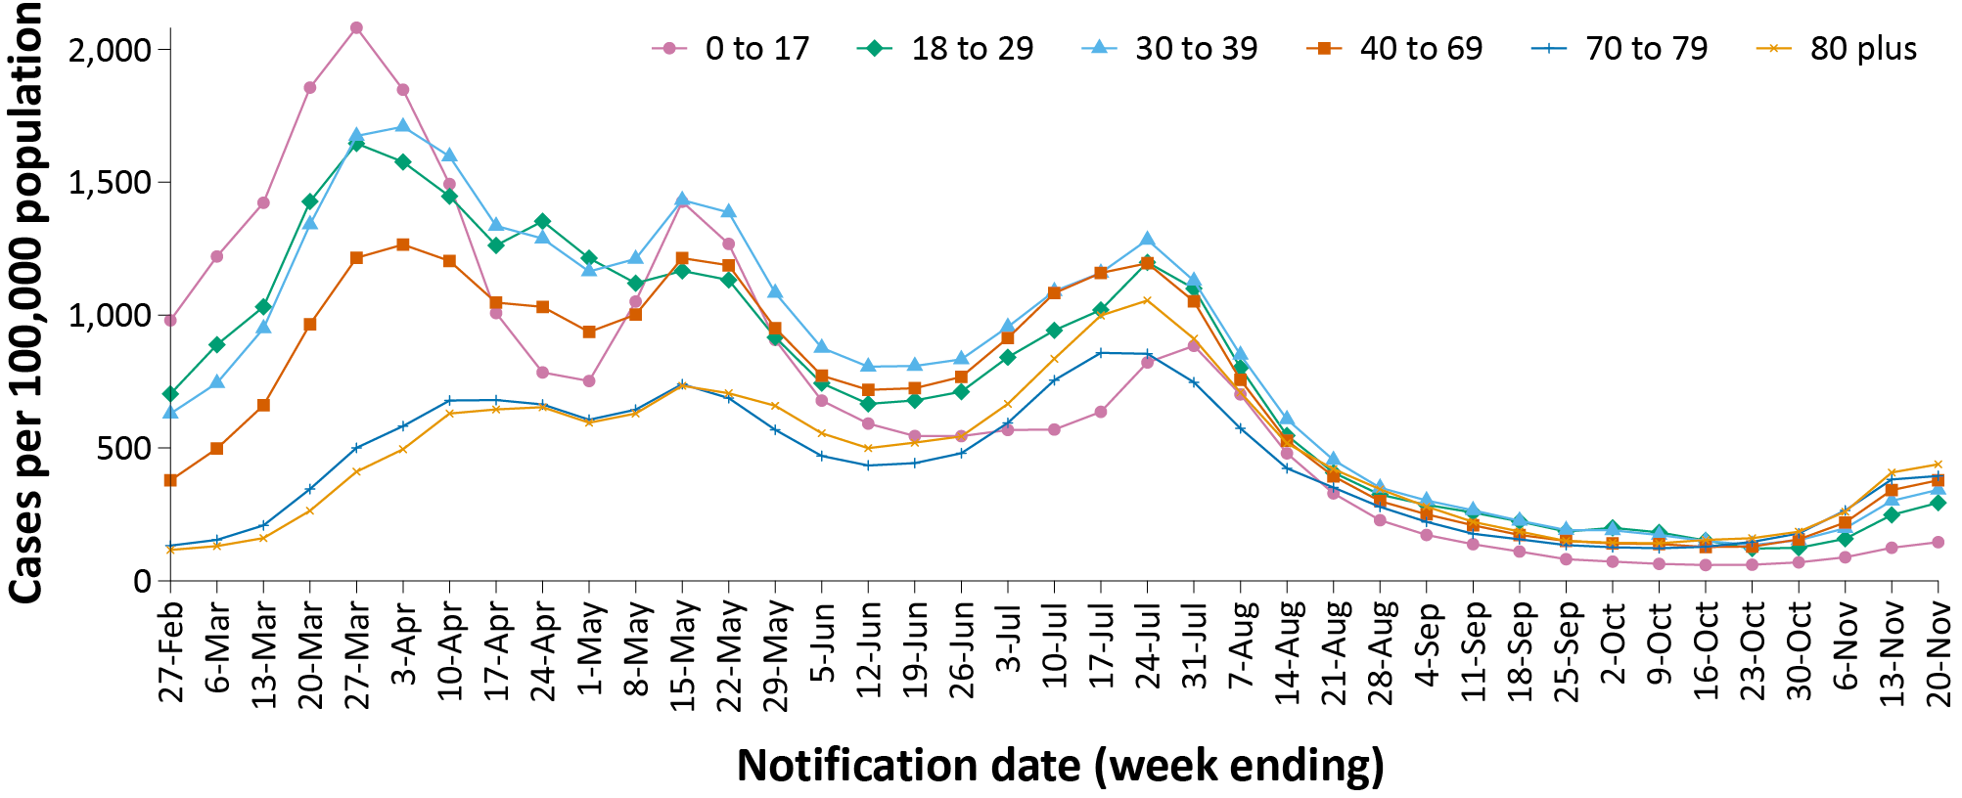
b
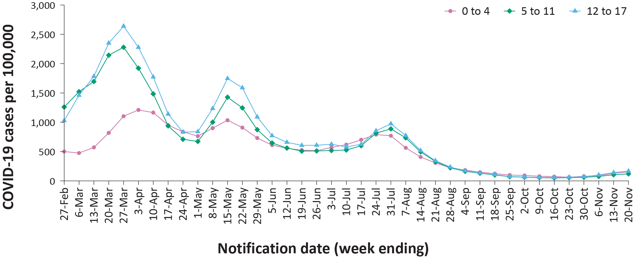
a Source: NNDSS extract from 22 November 2022 for notifications from 21 February to 20 November 2022. On 24 October 2022, Queensland commenced the transmission of all rapid antigen test (RAT) positive cases to NNDSS, which will be completed over the coming weeks; prior to 24 October 2022, Queensland only reported probable cases that had a RAT conducted in a clinical setting; probable cases who tested via RAT outside of a clinical setting were not reported to NNDSS. Therefore, interpretation of historical trends should be undertaken with caution until the transmission of all RAT cases is complete.

Aboriginal and Torres Strait Islander persons

(NNDSS)
Overall, since the start of the pandemic, Indigenous status is unknown for approximately 13% of COVID-19 cases in NNDSS. Therefore, the number of cases classified as Aboriginal and Torres Strait Islander people is likely an under-representation. During the reporting period, there were 5,287 new COVID-19 cases notified in Aboriginal and Torres Strait Islander people (Table 3). In the Omicron wave (15 December 2021 – 20 November 2022) there have been 335,722 cases of COVID-19 notified in Aboriginal and Torres Strait Islander people, representing 3.6% (335,722/9,382,262) of all COVID-19 cases in the Omicron wave to date.
Table 3: Confirmed and probable cases of COVID-19 among Aboriginal and Torres Strait Islander peoples by jurisdiction and date of notification, Australia, 15 December 2021 – 20 November 2022ª
Jurisdiction | 24 –30 October 2022 | 31 October – 6 November 2022 | 7–13 November 2022 | 14–20 November 2022 | 15 December 2021 – 20 November 2022 (Omicron wave)
Australian Capital Territory | 10 | 14 | 18 | 21 | 3,857
New South Wales | 381 | 338 | 467 | 575 | 124,132
Northern Territory | 33 | 56 | 66 | 49 | 24,272
Queensland^{b} | 285 | 230 | 318 | 388 | 57,379
South Australia | 73 | 63 | 104 | 123 | 21,604
Tasmania | 68 | 74 | 102 | 87 | 15,250
Victoria | 132 | 146 | 219 | 209 | 33,596
Western Australia | 149 | 126 | 167 | 196 | 55,632
Total | 1,131 | 1,047 | 1,461 | 1,648 | 335,722
a Source: NNDSS extract from 22 November 2022 for notifications from 15 December 2021 to 20 November 2022.
b On 24 October 2022, Queensland commenced the transmission of all rapid antigen test (RAT) positive cases to NNDSS, which will be completed over the coming weeks; prior to 24 October 2022, Queensland only reported probable cases that had a RAT conducted in a clinical setting; probable cases who tested via RAT outside of a clinical setting were not reported to NNDSS. Therefore, interpretation of historical trends in Queensland should be undertaken with caution until the transmission of all RAT cases is complete.
Of the COVID-19 cases notified in Aboriginal and Torres Strait Islander people from 15 December 2021 to date, and where location of residence was known, 56% (186,288/333,461) lived in a regional or remote area (Table 4). The majority of cases reported in outer regional and remote areas since the start of the Omicron wave were diagnosed using RATs, at 68% and 73%, respectively. It should be noted that the reliance on RATs for diagnosing COVID-19 is greater in regional and remote areas than in major cities, resulting in a larger under-representation of cases in regional and remote areas than in major cities, due to the incomplete capture of probable cases in NNDSS.
Nationally, there have been 287 COVID-19 associated deaths reported in Aboriginal and Torres Strait Islander people from the start of the pandemic to 20 November 2022. This comprises 95 from New South Wales, 88 from Queensland, 42 from the Northern Territory, 30 from Western Australia, 20 from South Australia, 10 from Victoria and two each from the Australian Capital Territory and Tasmania. An additional 532 Aboriginal and Torres Strait Islander cases have been admitted to intensive care units (ICU) nationally. During the Omicron wave to date, the overall notification rate, to NNDSS, of severe cases (measured as those who were admitted to ICU or died) in Aboriginal and Torres Strait Islander people was 78.3 per 100,000 population, compared to 16.7 per 100,000 population during the Delta wave (Table 5). The higher rates of severe illness during the Omicron wave are attributed to the significantly higher levels of disease transmission in the community during the Omicron wave, rather than the Omicron variant inherently causing more severe illness compared to the Delta variant. Note that ICU status in NNDSS is likely incomplete.

Table 4: COVID-19 cases among Aboriginal and Torres Strait Islander people by area of remoteness, Australia, 15 December 2021 – 20 November 2022ª
Jurisdiction^{b,c} | Major city | Inner regional | Outer regional | Remote^{d}
ACT | 3,806 | 36 | 10 | 1
NSW | 66,538 | 40,243 | 13,836 | 2,853
NT | 61 | 17 | 7,581 | 15,934
Qld^{e} | 16,915 | 11,154 | 21,097 | 8,144
SA | 11,618 | 2,326 | 4,589 | 2,960
Tas. | 201 | 9,244 | 5,409 | 265
Vic. | 19,159 | 10,810 | 3,577 | 14
WA | 28,875 | 4,000 | 6,989 | 15,199
Australia | 147,173 | 77,830 | 63,088 | 45,370
a Source: NNDSS extract from 22 November 2022 for notifications from 15 December 2021 to 20 November 2022. Excludes cases with an overseas place of residence, and where place of residence is unknown.
b ACT: Australian Capital Territory; NSW: New South Wales; NT: Northern Territory; Qld: Queensland; SA: South Australia; Tas.: Tasmania; Vic.: Victoria; WA: Western Australia.
c Cases are classified based on jurisdiction of notification, not jurisdiction of residence. Some cases are notified to a different jurisdiction than their location of residence.
d ‘Remote’ here also includes areas classified as ‘very remote’.
e On 24 October 2022, Queensland commenced the transmission of all rapid antigen test (RAT) positive cases to NNDSS, which will be completed over the coming weeks; prior to 24 October 2022, Queensland only reported probable cases that had a RAT conducted in a clinical setting; probable cases who tested via RAT outside of a clinical setting were not reported to NNDSS. Therefore, interpretation of historical trends in Queensland should be undertaken with caution until the transmission of all RAT cases is complete.
Table 5: Confirmed and probable COVID-19 cases in Aboriginal and Torres Strait Islander people by age and highest level of illness severity, Australia, 1 January 2020 to 20 November 2022
Age group (years) | 15 December 2021  – 20 November 2022  (Omicron wave) |  |  |  | 16 June 2021  – 14 December 2021  (Delta wave) |  |  |  | 1 January 2020  – 20 November 2022  (Pandemic to date)
 | ICU^{a,c} | Diedª | ICU or died^{a,c} | Rate ICU or died^{b,c} | ICU^{a,c} | Diedª | ICU or diedª | Rate ICU or died^{b} | ICU^{a,c} | Diedª | ICU or died^{a,c} | Rate ICU or died^{b,c}
0–17 | 55 | 1 | 55 | 16.9 | 8 | 0 | 8 | 2.5 | 63 | 1 | 63 | 19.4
18–59 | 229 | 81 | 296 | 70.9 | 86 | 11 | 90 | 21.6 | 316 | 92 | 387 | 92.7
60+ | 123 | 179 | 274 | 485.5 | 28 | 15 | 35 | 62.0 | 153 | 194 | 311 | 551.1
All | 407 | 261 | 625 | 78.3 | 122 | 26 | 133 | 16.7 | 532 | 287 | 761 | 95.3
a ‘ICU’ and ‘died’ are not mutually exclusive categories; ‘died’ can include cases who died with or without prior admission to ICU. Therefore, the number of cases admitted to ICU or having died will not equal the sum of cases in ICU or died.
b Rate per 100,000 population for the given time period.
c Due to technical difficulties, hospitalisation data from the Australian Capital Territory are unavailable from 12 November 2022.

Severity

(NNDSS, SPRINT-SARI)
Given the delay between illness onset and severe illness, and so as to provide a more accurate assessment of severity, cases with an onset in the last two weeks have been excluded from analyses on the weekly rate of cases with severe illness (defined as cases admitted to ICU or died) and on the proportion of cases admitted to ICU or died.
In the Omicron wave, the notification rate of cases with severe illness peaked in the week ending 16 January 2022, at approximately 4.5 severe cases per 100,000 population per week (Figure 3). Coinciding with overall case trends, there was an increase in severe cases during the third Omicron wave from late June 2022, with a peak occurring during the week ending 24 July 2022. Since the start of the fourth Omicron wave in late October 2022, the notification rate of cases admitted to ICU has been gradually increasing, while weekly notifications of COVID-19-associated deaths have remained relatively stable. Rates of severe cases continue to be greater in older age groups; in the third Omicron wave, those aged 80 years and over experienced a notable peak in severe rates during the week ending 24 July 2022, while this trend was not observed in the other age groups (Figure 4).
Figure 3: COVID-19 cases, deaths and ICU admissions, Australia, by date of onset, Australia, 31 May 2021 to 20 November 2022^{a,b}
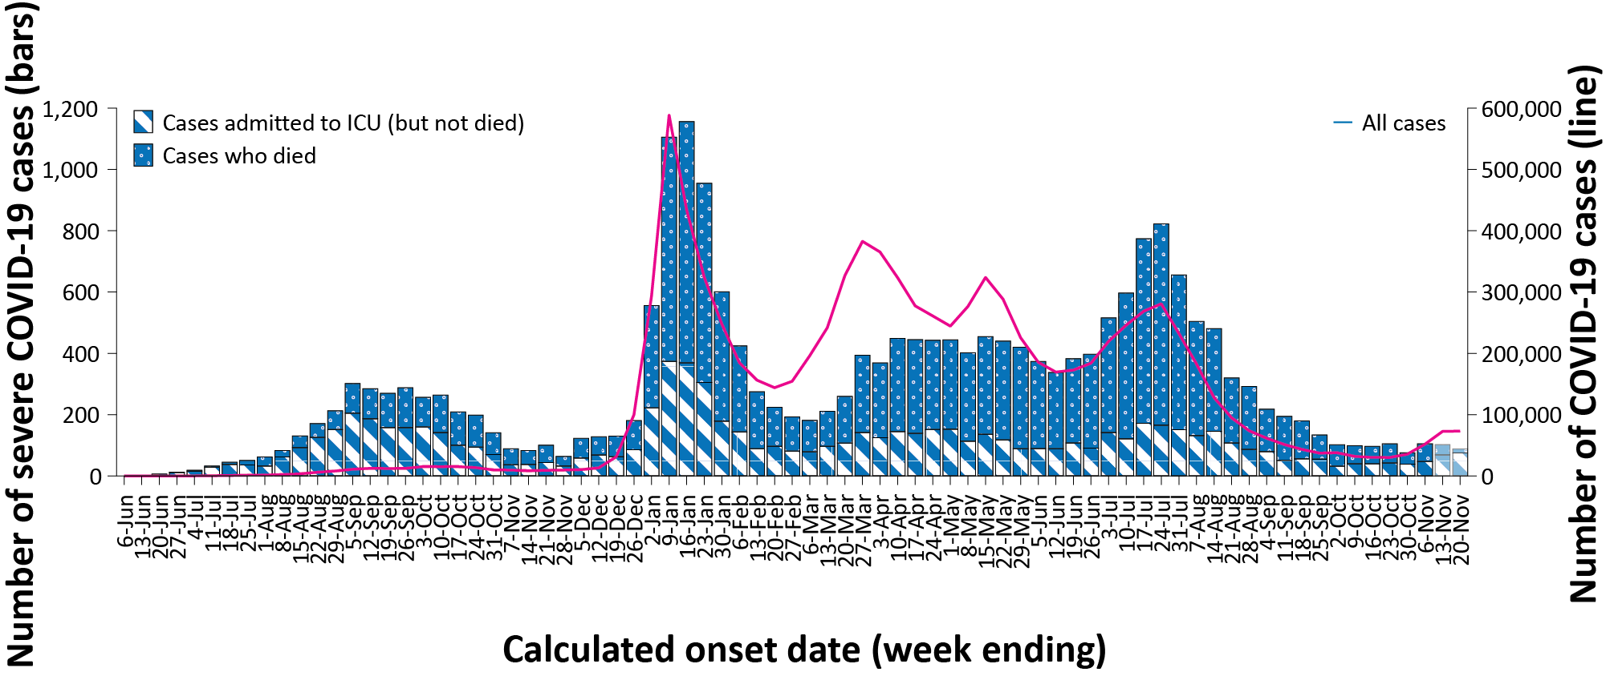
a Source: NNDSS extract from 22 November 2022 for notifications to 20 November 2022. On 24 October 2022, Queensland commenced the transmission of all rapid antigen test (RAT) positive cases to NNDSS, which will be completed over the coming weeks; prior to 24 October 2022, Queensland only reported probable cases that had a RAT conducted in a clinical setting; probable cases who tested via RAT outside of a clinical setting were not reported to NNDSS. Therefore, interpretation of historical trends should be undertaken with caution until the transmission of all RAT cases is complete. Due to technical difficulties, hospitalisation data from the Australian Capital Territory are unavailable from 12 November 2022.
b The shaded bars at the right represent the most recent two reporting weeks and should be interpreted with caution, as cases with an illness onset in these weeks may not have yet developed severe disease.

Figure 4: Age-specific rates of COVID-19 cases admitted to ICU or died, by date of diagnosis, Australia, 31 May 2021 to 6 November 2022ª
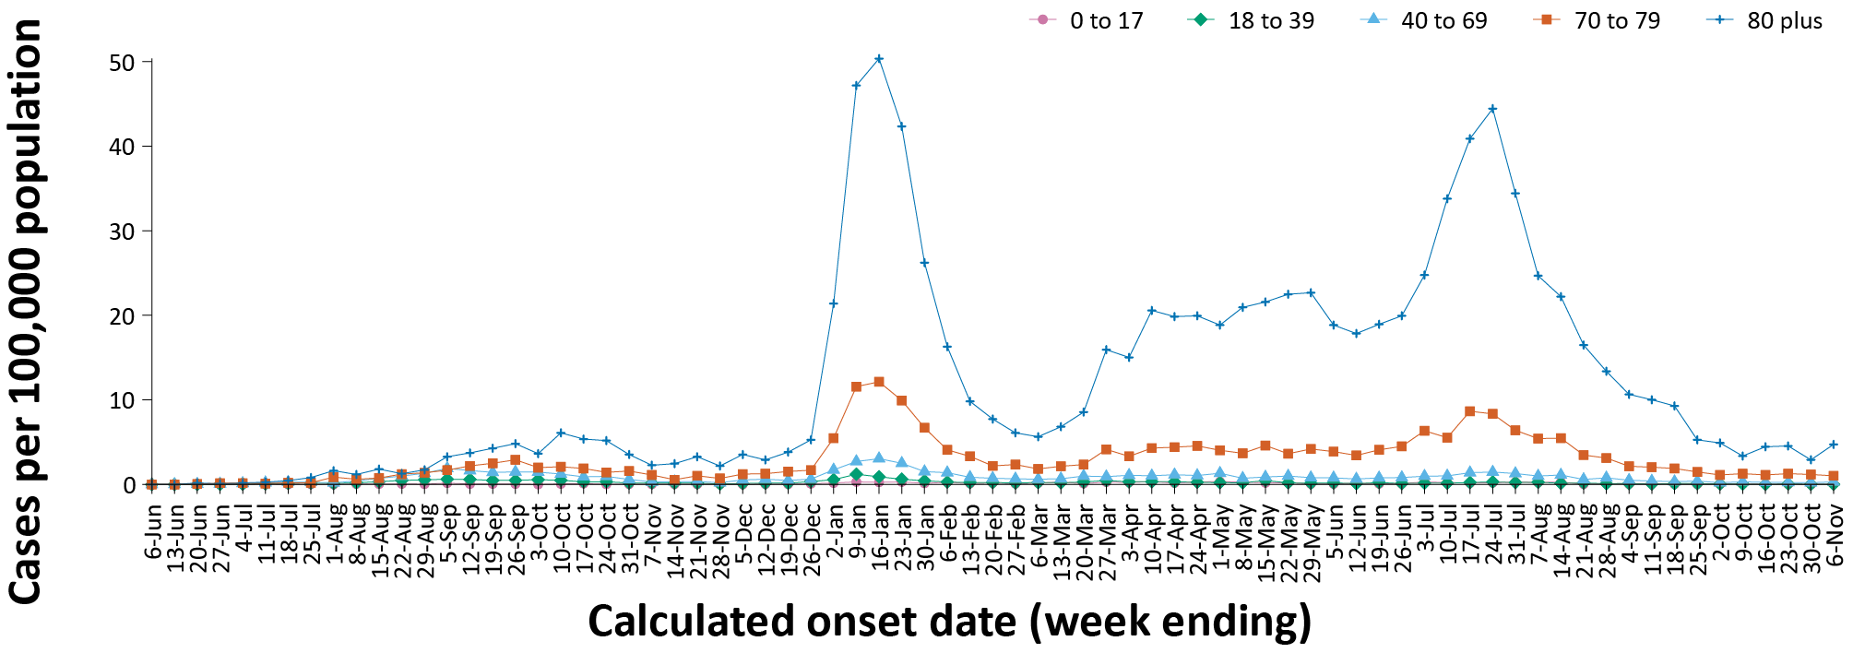
a Source: NNDSS extract from 22 November 2022 for notifications to 20 November 2022. Includes cases with an illness onset from 31 May 2021 to 6 November 2022; cases with an illness onset in the last two weeks (7 – 20 November 2022) were excluded to account for the delay between onset and development of severe illness. Due to technical difficulties, hospitalisation data from the Australian Capital Territory are unavailable from 12 November 2022.

ICU admissions
From the start of the Omicron wave to 20 November 2022, there were 4,408 COVID-19 cases admitted to ICUs participating in the sentinel surveillance system, Short Period Incidence Study of Severe Acute Respiratory Infection (SPRINT-SARI),⁴ with 116 of these admitted during this reporting period (24 October – 20 November 2022).

Risk factors for severe disease
Comorbidity data extracted from SPRINT-SARI reflect the sickest patients with COVID-19 who are managed in ICU; data are therefore not generalisable to all cases (Table 6). In adult patients admitted to ICU with COVID-19 since 15 December 2021, where comorbidity information was available, the most prevalent comorbidity was diabetes, followed by cardiac disease. Of those adult patients admitted to ICU since 15 December 2021 for whom comorbidity data was known, 77% (2,240/2,920) had at least one of the listed comorbidities.

Table 6: Comorbidities for adult COVID-19 cases (aged greater than or equal to 18 years) amongst those admitted to ICU, Australia, 15 December 2021 – 20 November 2022ª
Comorbidity | ICU casesª (n = 2,920) (%)
Cardiac disease (n = 2,889) | 790 (27%)
Chronic respiratory condition (n = 2,890)^{b} | 710 (25%)
Diabetes (n = 2,871) | 976 (34%)
Obesity (n = 2,848) | 644 (23%)
Chronic renal disease (n = 2,874) | 467 (16%)
Chronic neurological condition (n = 2,873) | 217 (8%)
Malignancy (n = 2,886) | 399 (14%)
Chronic liver disease (n = 2,880) | 166 (6%)
Immunosuppression (n = 2,854) | 510 (18%)
Number of specified comorbidities (n = 2,920)^{c}
No comorbidities | 680 (23%)
One or more | 2,240 (77%)
Two or more | 1,433 (49%)
Three or more | 749 (26%)
a Source: SPRINT-SARI. Only includes adult cases (≥ 18 years old) and excludes those with missing data on comorbidities or where comorbidity is unknown.
b Includes asthma.
c Includes chronic respiratory conditions, cardiac disease (excluding hypertension), immunosuppressive condition/therapy, diabetes, obesity, liver disease, renal disease and neurological disorder.
Figure 5: PIMS-TS cases reported to PAEDS, by sample month and level of care required, Australia, 1 June 2020 – 20 November 2022ª
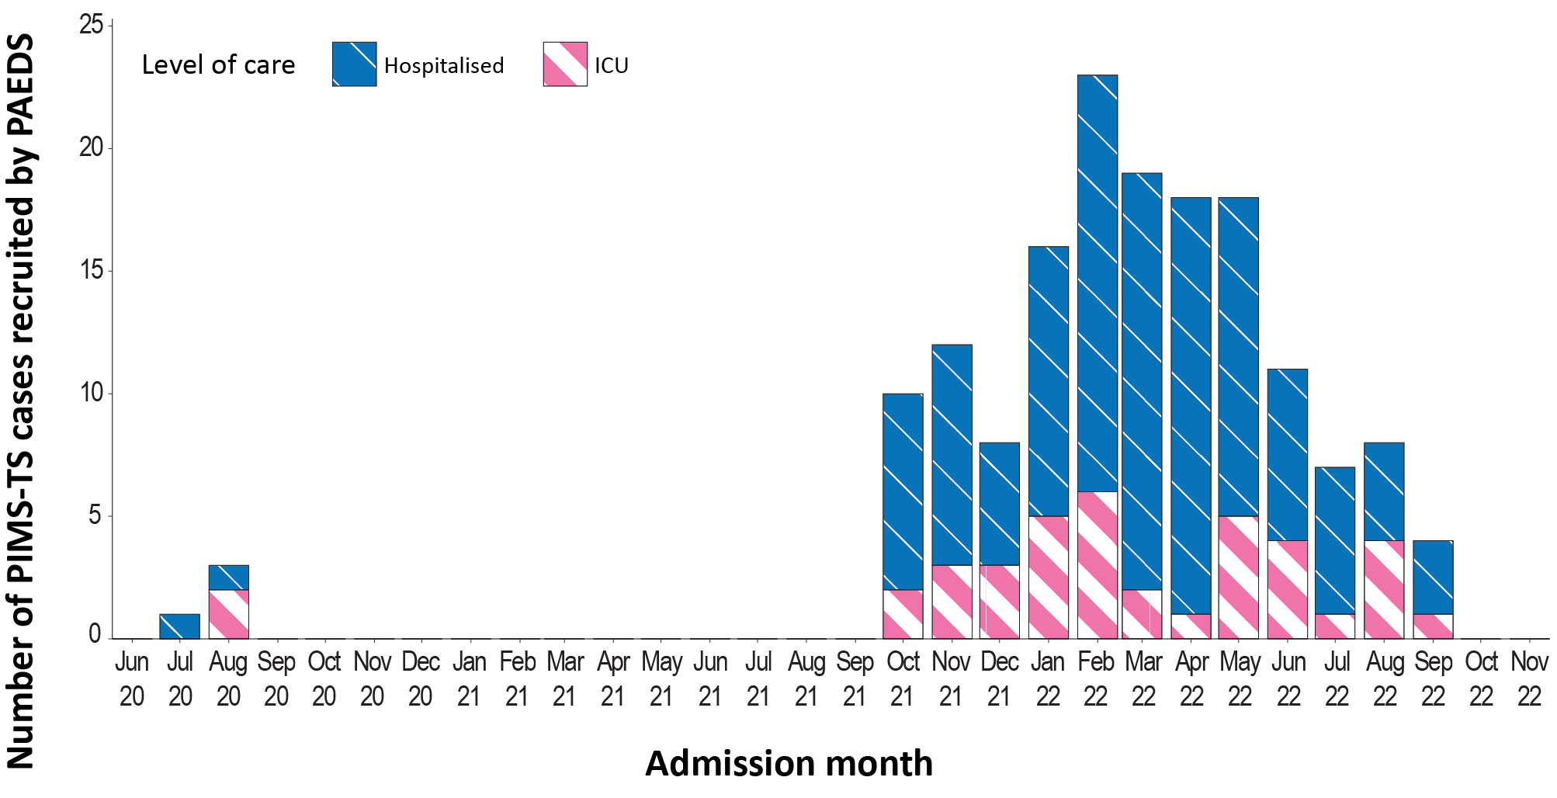
a Source: PAEDS.

PIMS-TS

(PAEDS)
Since the start of the pandemic to 20 November 2022, there have been 158 cases of paediatric inflammatory multisystem syndrome temporally associated with SARS-CoV-2 (PIMS-TS) reported to the Paediatric Active Enhanced Disease Surveillance (PAEDS) network, including 124 cases reported in 2022, no cases from the current reporting period and two new cases from previous reporting periods. The majority of PIMS-TS cases to date have occurred in those aged 5 to < 12 years (53%; 83/158), followed by those aged 6 months to < 5 years (27%; 43/158). To date, there have been no PIMS-TS associated deaths.

COVID-19 deaths
There were 240 COVID-19-associated deaths among COVID-19 cases notified during the reporting period (24 October – 20 November 2022). This brings the total number of COVID-19-associated deaths reported in NNDSS to 15,222 (Table 7). The overall crude case fatality rate in the current fourth Omicron wave is 0.11%, which is less than the rate observed during the first (0.14%) and third (0.21%) waves, similar to the rate observed in the second wave (0.10%), and notably less than observed during the Delta (0.70%) wave (Table 8).
Table 7: Deaths associated with COVID-19 by reporting period, Australia, 1 January 2020 – 20 November 2022^{a,b}
Jurisdiction^{c} | 24 October – 6 November 2022 | 7–20 November 2022 | 15 December 2021 –  20 November 2022  (Omicron wave) | 1 January 2020 –  20 November 2022  (Pandemic to date)
ACTd | 2 (1.4%) | 0 (0.0%) | 115 (0.9%) | 141 (0.9%)
NSW | 36 (25.7%) | 12 (12.0%) | 4,817 (37.1%) | 5,516 (36.2%)
NT | 1 (0.7%) | 0 (0.0%) | 78 (0.6%) | 79 (0.5%)
Qld^{d} | 23 (16.4%) | 3 (3.0%) | 2,335 (18.0%) | 2,342 (15.4%)
SA | 4 (2.9%) | 6 (6.0%) | 1,061 (8.2%) | 1,065 (7.0%)
Tas. | 4 (2.9%) | 3 (3.0%) | 180 (1.4%) | 193 (1.3%)
Vic. | 52 (37.1%) | 63 (63.0%) | 3,661 (28.2%) | 5,154 (33.9%)
WA | 18 (12.9%) | 13 (13.0%) | 732 (5.6%) | 732 (4.8%)
Total | 140 (100.0%) | 100 (100.0%) | 12,979 (100.0%) | 15,222 (100.0%)
a Source: NNDSS, extract from 22 November 2022 for deaths to 20 November 2022.
b Deaths are categorised into time periods using date of death. Deaths with a missing date of death are classified using date of illness onset.
c ACT: Australian Capital Territory; NSW: New South Wales; NT: Northern Territory; Qld: Queensland; SA: South Australia; Tas.: Tasmania; Vic.: Victoria; WA: Western Australia.
d On 24 October 2022, Queensland commenced the transmission of all rapid antigen test (RAT) positive cases to NNDSS, which will be completed over the coming weeks; prior to 24 October 2022, Queensland only reported probable cases that had a RAT conducted in a clinical setting; probable cases who tested via RAT outside of a clinical setting were not reported to NNDSS. Therefore, interpretation of historical trends in Queensland should be undertaken with caution until the transmission of all RAT cases is complete.

Table 8: COVID-19 associated case fatality rates, among cases notified to NNDSS, by age group and date of onset, 1 January 2020 to 6 November 2022^{a,b}
Age group | Fourth Omicron wave  24 October – 6 November 2022 | Third Omicron wave  15 June – 23 October 2022 | Second Omicron wave  1 March - 14 June 2022 | First Omicron wave  15 December 2021 - 28 February 2022 | Omicron  15 December 2021 – 6 November 2022 | Delta  16 June – 14 December 2021 | Pandemic  1 January 2020 – 6 November 2022
0–4 | 0.00% | < 0.05% | < 0.05% | < 0.05% | < 0.05% | 0.00% | < 0.05%
5–11 | 0.00% | 0.00% | 0.00% | < 0.05% | < 0.05% | < 0.05% | < 0.05%
12–15 | 0.00% | < 0.05% | 0.00% | < 0.05% | < 0.05% | < 0.05% | < 0.05%
16–17 | 0.00% | 0.00% | < 0.05% | 0.00% | < 0.05% | 0.00% | < 0.05%
18–29 | 0.00% | < 0.05% | < 0.05% | < 0.05% | < 0.05% | < 0.05% | < 0.05%
30–39 | 0.00% | < 0.05% | < 0.05% | < 0.05% | < 0.05% | 0.06% | < 0.05%
40–49 | < 0.05% | < 0.05% | < 0.05% | < 0.05% | < 0.05% | 0.19% | < 0.05%
50–59 | < 0.05% | < 0.05% | < 0.05% | 0.05% | < 0.05% | 0.65% | 0.05%
60–69 | 0.06% | 0.14% | 0.11% | 0.25% | 0.15% | 1.95% | 0.19%
70–79 | 0.18% | 0.66% | 0.46% | 1.17% | 0.66% | 6.20% | 0.78%
80–89 | 0.93% | 2.53% | 2.09% | 5.08% | 2.75% | 14.94% | 3.16%
90+ | 2.78% | 6.63% | 5.93% | 10.88% | 6.95% | 27.88% | 7.72%
Unknown | 0.00% | 0.00% | 0.00% | 0.00% | 0.00% | 0.00% | 0.00%
Total | 0.11% | 0.21% | 0.10% | 0.14% | 0.14% | 0.70% | 0.16%
a Source: NNDSS, extract from 22 November 2022 for deaths to 20 November 2022. On 24 October 2022, Queensland commenced the transmission of all rapid antigen test (RAT) positive cases to NNDSS, which will be completed over the coming weeks; prior to 24 October 2022, Queensland only reported probable cases that had a RAT conducted in a clinical setting; probable cases who tested via RAT outside of a clinical setting were not reported to NNDSS. Therefore, interpretation of historical trends should be undertaken with caution until the transmission of all RAT cases is complete.
b To account for the lag between illness onset and the development of severe illness, cases with an onset date in the last two weeks have been excluded from calculations of the case fatality rate.

Figure 6: Omicron sub-lineages proportions in Australia, from 1 January 2022 by sample collection date, aggregated by week^{a,b}
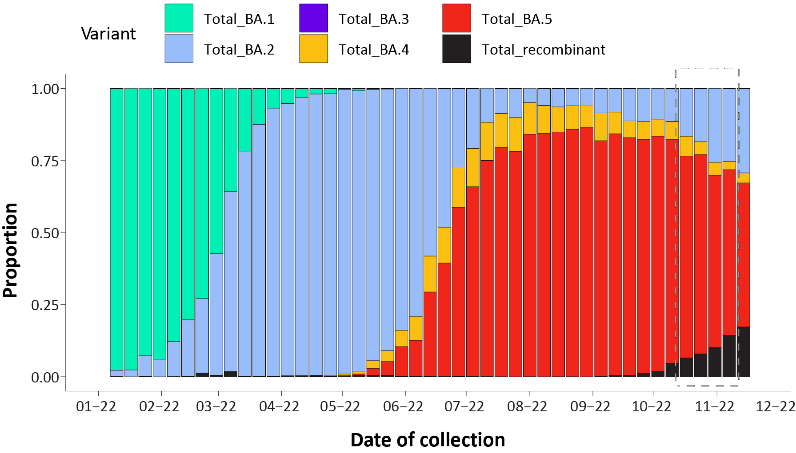
a The current reporting period (24 October to 20 November 2022) is marked by the dashed lines.
b. Proportions in the figure may not be representative when sequence numbers are small. Data may change week-to-week as sequences with older collection dates are uploaded. These numbers are not equivalent to number of cases, as there may be duplicates in the AusTrakka data. Newly designated Omicron sub-lineages have been collapsed into parent lineages BA.1, BA.2, BA.3, BA.4 and BA.5; recombinants are designated by X*.

Figure 7: Samples in AusTrakka in the past 26 weeks, by lineage and date of collectionª
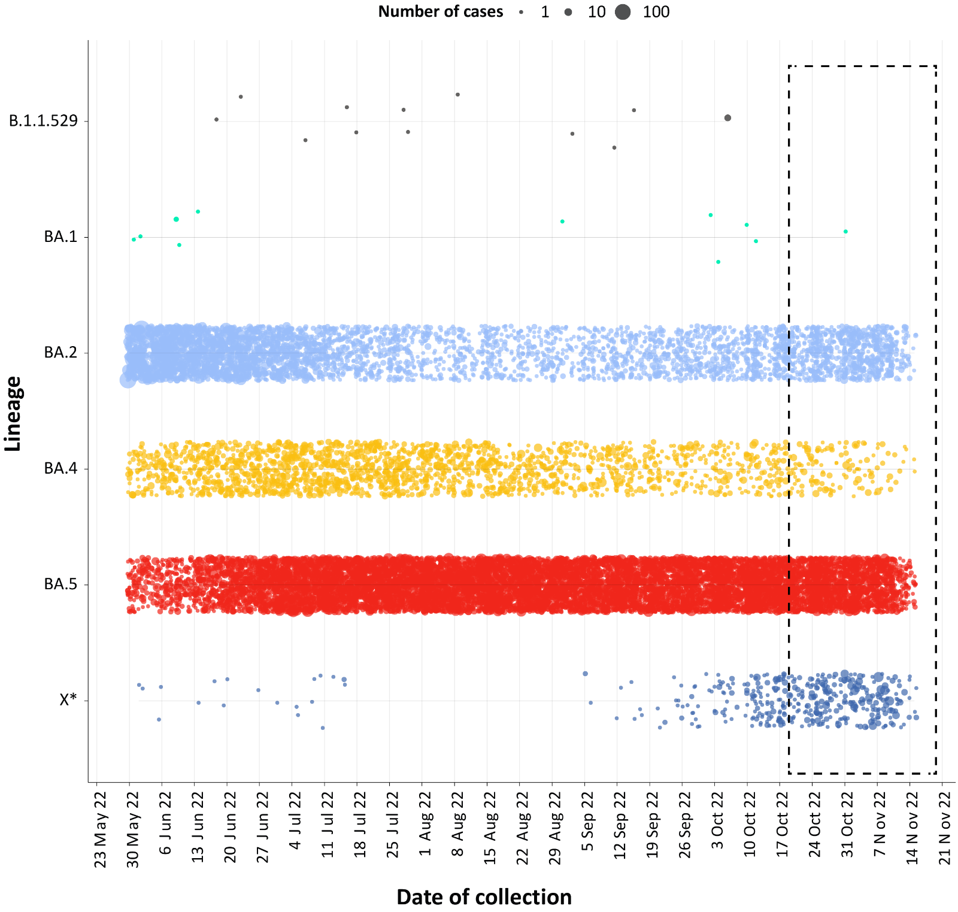
a The current reporting period (24 October to 20 November 2022) is marked by the dashed lines. The size of the dots are proportional to the number of sequences observed in each jurisdiction each day.

Genomic surveillance and virology

(Communicable Disease Genomics Network, AusTrakka and jurisdictional sequencing laboratories)
Nationally, 3.16% of COVID-19 cases have been sequenced since the start of the pandemic in January 2020, based on jurisdictional reporting of confirmed cases (Table 9). Case numbers and sequencing proportion are based on PCR results only, as rapid antigen tests do not allow for sequencing. A significant rise in case numbers nationally at the start of 2022, and a change in the pandemic response across Australia, saw jurisdictional laboratories move towards sequencing for surveillance purposes. This resulted in a drop in the overall sequencing proportion in 2022. However, as the sequencing output has remained steady, any drop in recorded case numbers—such as that observed prior to the start of the fourth Omicron wave—may cause the sequencing proportion to rise again.
Table 9: Australian SARS-CoV-2 genome sequences and proportion of positive cases sequenced, 24 October – 20 November 2022 and cumulative to date
Measure | Reporting period  24 October – 20 November 2022 | Cumulative  23 January 2020 – 20 November 2022
SARS-CoV-2 cases sequencedª | 9,051 | 160,302
Percentage of positive cases sequenced^{b} | 8.53% | 3.16%
a Total SARS-CoV-2 case numbers as reported by jurisdictional laboratories based on PCR results only. Cases identified via rapid antigen testing are reported differently by each jurisdiction and cannot be followed up for sequencing. They are therefore not included in the sequencing proportions reported here. Sequencing of samples from cases identified in the reporting period may be in process at the time of reporting. Remaining unsequenced samples may be due to jurisdictional sequencing strategy, or where samples have been deemed unsuitable for sequencing (typically because viral loads were too low for sequencing to be successful).
b Based on individual jurisdictional reports of sequences and case numbers. Calculations of the percentage of cases sequenced based on the number of sequences available in AusTrakka may not always be up-to-date, since this may include duplicate samples from cases and may not represent all available sequence data.

Variants of concern (VOC)
AusTrakka⁵ is actively monitoring and reporting on one lineage and its associated sub- and sub-sub-lineages, currently designated as a Variant of Concern (VOC) by international organisations, including the World Health Organization (WHO): Omicron (B.1.1.529). The Omicron variant displays a characteristic set of mutations, including a number of variations in the genomic region encoding the spike protein thought to have the potential to increase transmissibility and/or immune evasion. The CDGN VOC working group demoted four previously designated VOCs (Alpha (B.1.1.7); Beta (B.1.351); Gamma (P.1); and Delta (B.1.617)) due to the sustained absence of any cases in Australia, and very limited prevalence globally. Further information on variants is available in the Technical Supplement.²
Unlike previous periods in Australia’s COVID-19 waves, where one or two dominant lineages were the main driver of disease, there is currently significant diversity in the range of sub-sub-lineages circulating within Australia. During this reporting period, more than 200 unique lineages have been identified, and it is likely that there are more that are not being characterised through whole genome sequencing. This diversity of circulating lineages has sometimes been referred to as a ‘variant soup’. Many of these circulating lineages will die out without causing a significant disease burden, but others appear to have stronger growth potential. Lineages such as BQ.1 (sub-sub-lineage of BA.5), BA.2.75 (and associated sub-lineages such as BR), XBB (recombinant of BJ.1/BA.2.10 and BM.1.1.1/BA.2.75.3) and XBF (recombinant of BA.2.75 and BA.5) have emerged with strong signals both within and across different jurisdictions and are being monitored by AusTrakka and the CDGN VOC working group due to their increasing prevalence.
All 5,500 sequences from samples collected within the reporting period were assigned to Omicron or to recombinants consisting of two Omicron lineages. BA.5 is currently the predominant sub-lineage being sequenced, representing 62.6% of sequences collected in the reporting period and available for analysis in AusTrakka. By contrast, recombinant lineages made up 10.0% of sequences available in AusTrakka during the same period.
Of the Omicron sequences in AusTrakka to date, 23.99% are BA.1; 39.82% are BA.2; < 0.001% are BA.3; 4.41% are BA.4 and 30.80% are BA.5. All sub-sub-lineages have been collapsed into respective major sub-lineage. Recombinants make up 0.54% of all Omicron sequences to date.

Testing

(State and territory reporting)
From the commencement of the pandemic to 20 November 2022, over 80 million PCR tests for SARS-CoV-2 have been conducted nationally. Jurisdictional PCR testing rates are driven by current case numbers, testing policies and numbers of people experiencing symptoms. The number, rates and percent positivity of RATs cannot be calculated, as there is currently no reporting of negative RATs. Due to technical difficulties, testing data from the Australian Capital Territory (ACT) is unavailable from 12 November 2022, therefore percent positivity calculations are currently not available for the ACT.
During the four-week reporting period (24 October – 20 November 2022), PCR testing rates increased in New South Wales, South Australia, Tasmania and Victoria, and remained relatively stable in all other jurisdictions. There was an overall increase in percent positivity in all jurisdictions, except in the Northern Territory where percent positivity remained relatively stable over the reporting period. In the week ending 20 November 2022, the highest PCR percent positivity was observed in Western Australia at 17% (Figure 8).

Figure 8: SARS-CoV-2 polymerase chain reaction (PCR) testing rates per 1,000 population and percent positivity by jurisdiction and date of notification, 13 December 2021 – 20 November 2022ª
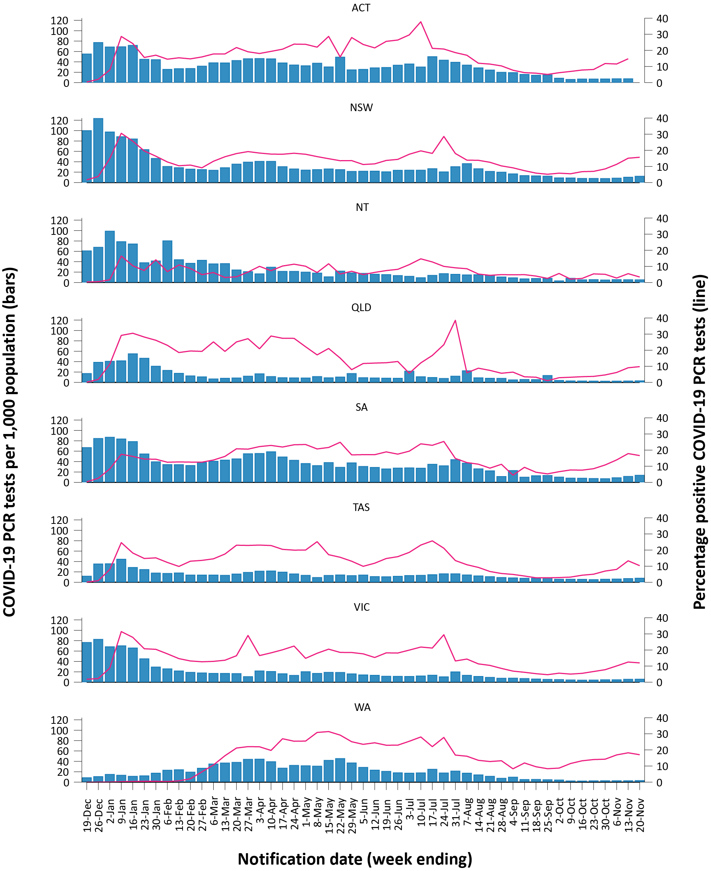
a Source: testing data provided by jurisdictions to the NIR daily, current to 20 November 2022; case data extracted from NNDSS on 22 November 2022 for cases with a notification date up to 20 November 2022; population data based on Australian Bureau of Statistics (ABS) Estimated Resident Population (ERP) as at June 2021. On 24 October 2022, Queensland commenced the transmission of all rapid antigen test (RAT) positive cases to NNDSS, which will be completed over the coming weeks; prior to 24 October 2022, Queensland only reported probable cases that had a RAT conducted in a clinical setting; probable cases who tested via RAT outside of a clinical setting were not reported to NNDSS. Therefore, interpretation of historical trends in Queensland should be undertaken with caution until the transmission of all RAT cases is complete. Due to technical difficulties, testing data from the Australian Capital Territory are unavailable from 12 November 2022.

Acute respiratory illness

(FluTracking, ASPREN, and Commonwealth Respiratory Clinics)
Based on self-reported FluTracking data,⁶ the prevalence of fever and cough in the community increased in the first week of the reporting period, followed by a decrease in the last three weeks of the reporting period (Figure 9). Runny nose and sore throat symptoms fluctuated throughout the reporting period with an initial increase in the first week, followed by a decrease in the middle of the reporting period and another increase in the last week (Figure 10).
Figure 9: Weekly trends in fever and cough amongst FluTracking survey participants (age-standardised) compared to the average of the previous five years, Australia, 1 January 2020 – 20 November 2022ª
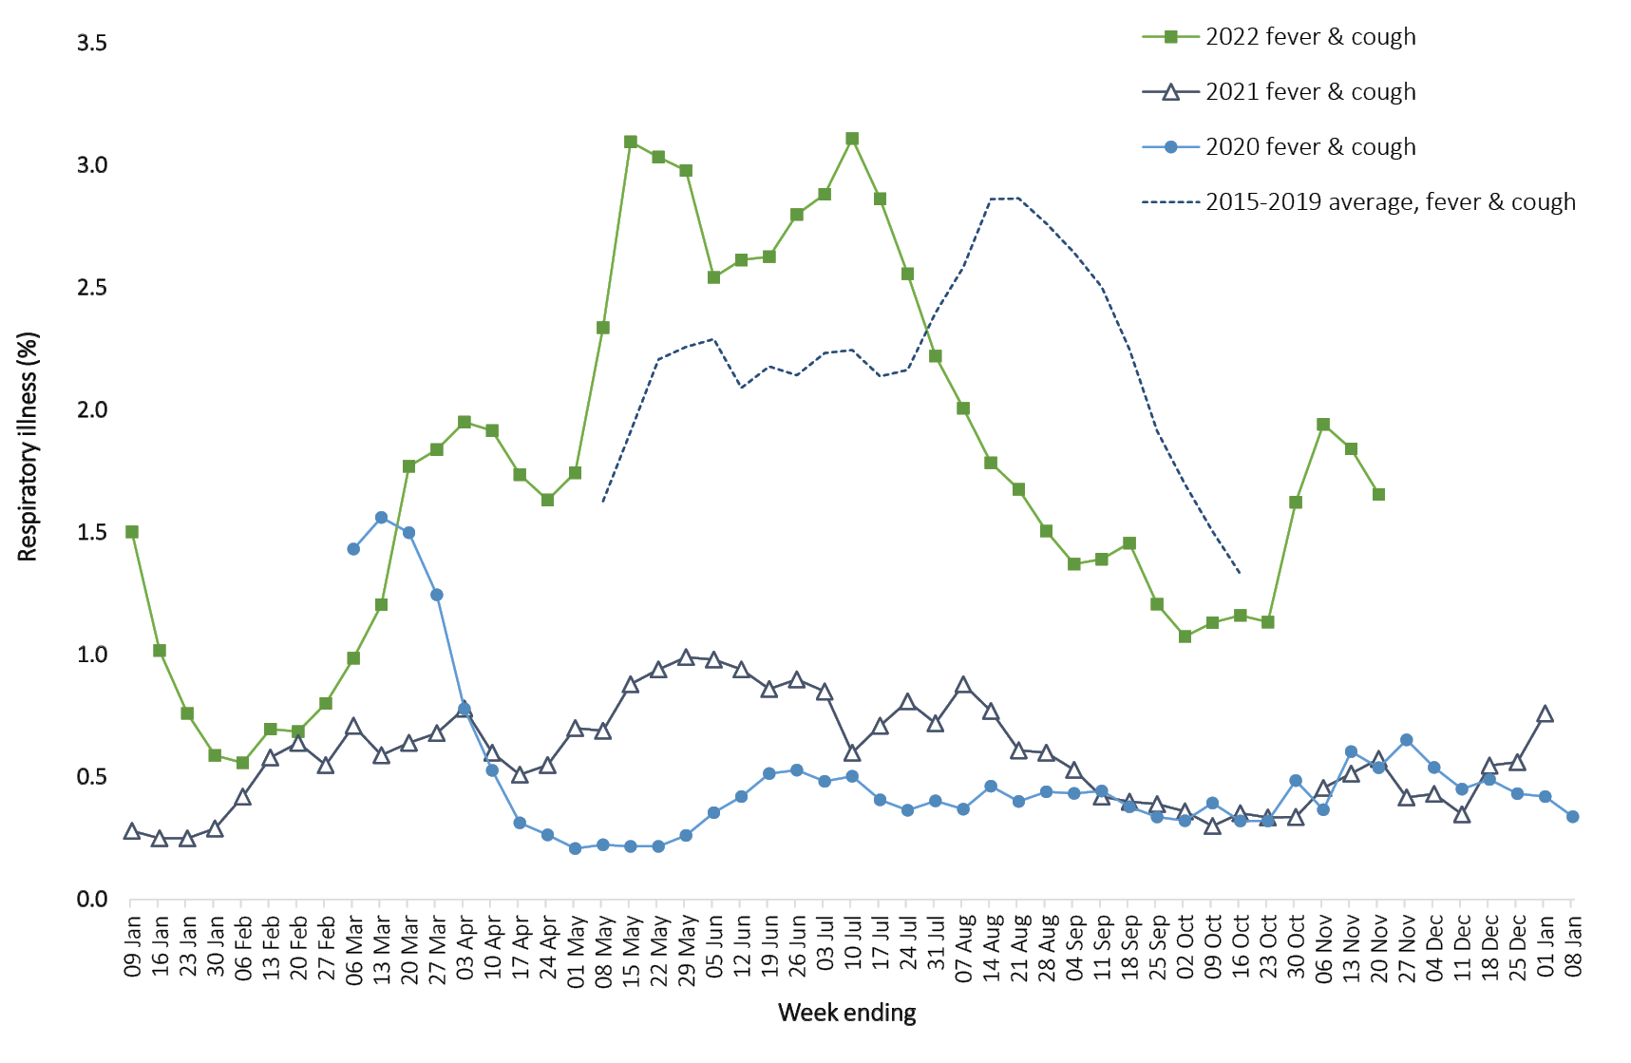
a In years prior to 2020, FluTracking was activated during the main Influenza season from May to October. A historical average beyond the week ending 11 October is therefore not available. In 2020, FluTracking commenced ten weeks early to capture data for COVID-19.
Over the reporting period, FluTracking data indicated that 20.3% of participants with ‘fever and cough’ were tested for SARS-CoV-2 with a PCR test and 83.8% were tested using a RAT (noting that in some instances RATs will be followed up by a PCR test for the same case). Of those with runny nose and sore throat, 7% were tested for SARS-CoV-2 using a PCR test and 63% were tested using a RAT. In the current reporting period, the percent positivity for fever and cough symptoms increased compared to the previous reporting period for both PCR and RAT to 45% and 47%, respectively. For runny nose and sore throat symptoms, the percent positivity increased for PCR and RAT to 14% and 7%, respectively. Note that participants with one set of symptoms are not excluded from having the other. It is important to acknowledge that there may be legitimate reasons why people did not get tested, including barriers to accessing testing. Symptoms reported to FluTracking are not specific to COVID-19 and may also be due to infections with other respiratory pathogens and to chronic diseases, such as asthma.
From 24 October to 20 November 2022, of presentations to Commonwealth Respiratory Clinics that were tested for SARS-CoV-2, 9.7% (2,996/30,734) were found to be positive. Since the start of the pandemic, the most commonly reported symptom amongst presentations that tested positive for COVID-19 was sore throat (57%), followed by cough (56%) and tiredness (44%).
Since the start of 2022, of those presenting to sentinel ASPREN sites with influenza-like illness who were tested for respiratory viruses, 56% (553/981) tested positive. Among those positive, the most common virus detected was influenza A (29%; 161/553), followed by rhinovirus (26%; 142/553); of those testing positive, 13% (70/553) were positive for SARS-CoV-2.
Figure 10: Weekly trends in runny nose and sore throat symptoms amongst FluTracking survey participants (age-standardised), Australia, 29 March 2020 – 20 November 2022ª
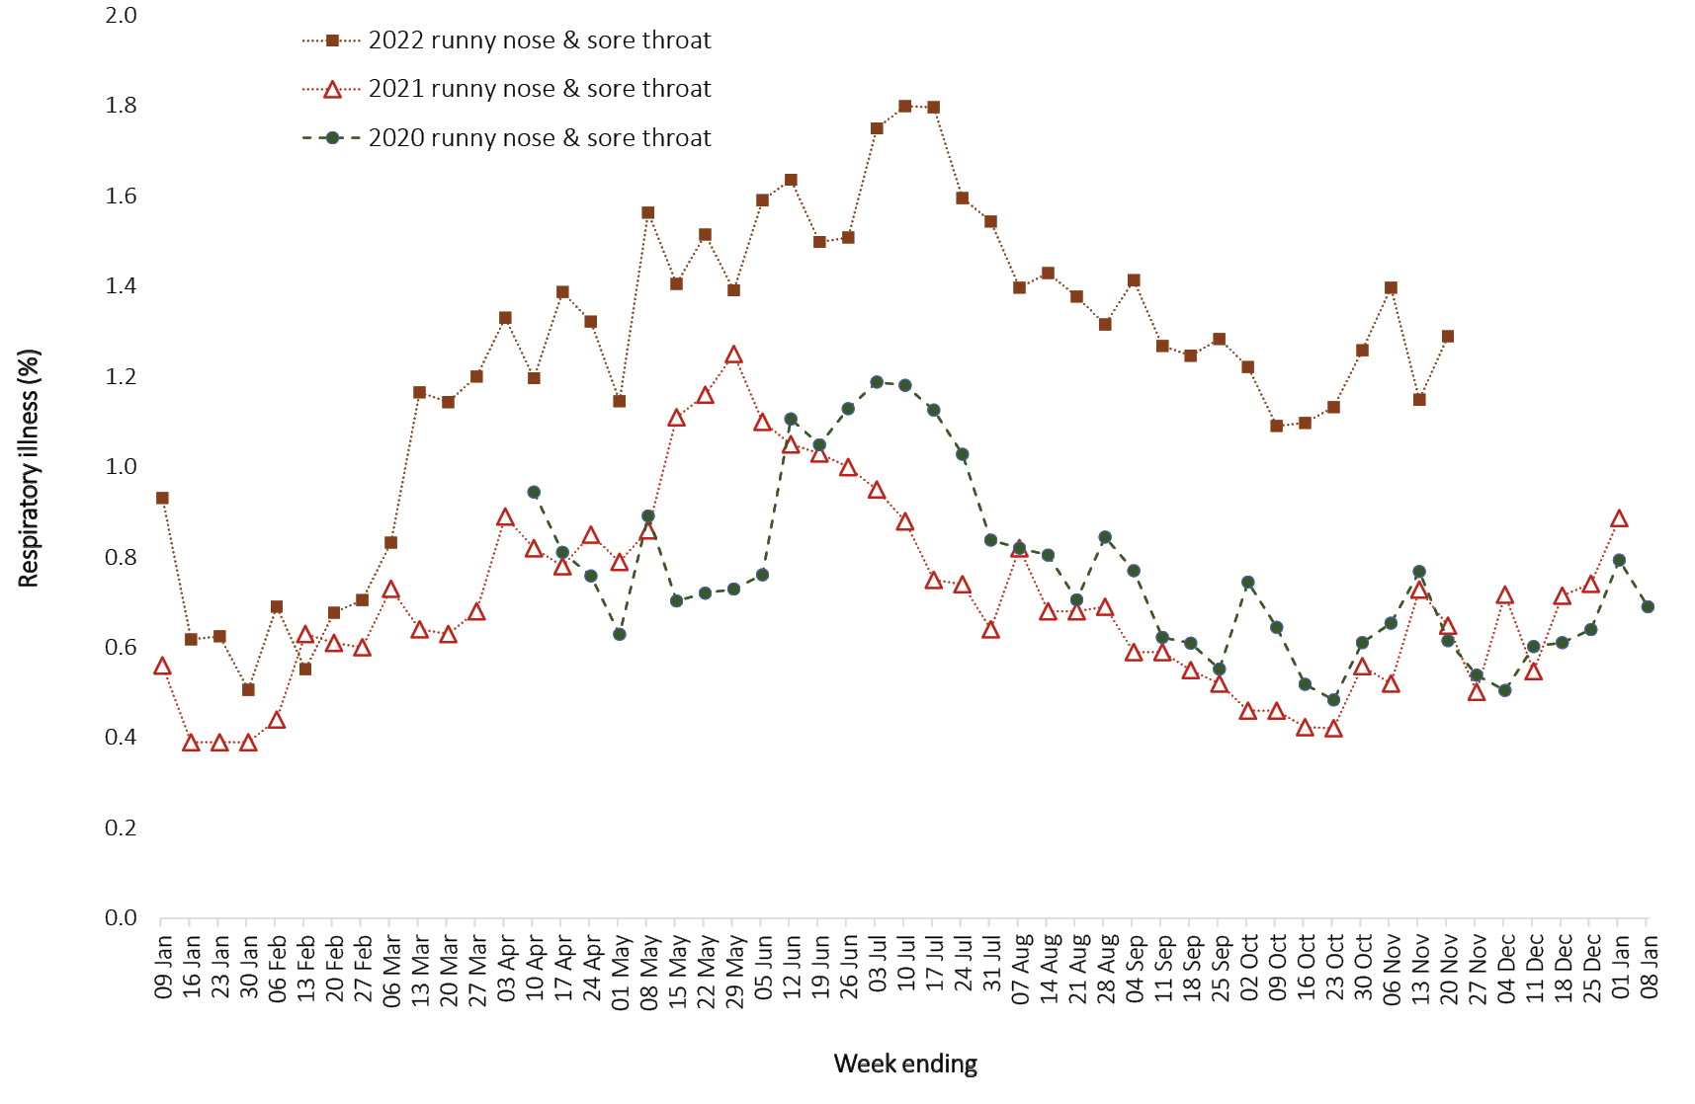
a Data on runny nose and sore throat were only collected systematically after 29 March 2020, therefore a historical average for this symptom profile is unavailable.

Countries and territories in Australia’s near region
According to WHO, countries and territories in the South East Asian and Western Pacific regions reported 4,531,896 newly-confirmed cases and 9,122 deaths in the four-week period to 20 November 2022. Compared to the previous four-week reporting period, new cases and new deaths increased in both the Western Pacific and South East Asia regions; new deaths increased significantly for the latter.⁷ In total, since the start of the pandemic, over 157 million cases and over one million deaths have been reported in the two regions.⁸
Table 10 outlines new cases and deaths in the four-week period to 20 November 2022 and cumulative cases and deaths for the pandemic in selected countries with the highest number of new cases in the South East Asian region and the Western Pacific region.
As of 20 November 2022, over 635 million COVID-19 cases and over 6.6 million deaths have been reported globally since the start of the pandemic, with a global case fatality rate (CFR) of approximately 1.04%. The two regions reporting the largest burden of disease over the past four weeks were the Western Pacific region (43% of total cases) and the European region (38% of total cases).
Table 10: Cumulative cases and deaths, and new cases and deaths reported in the four-week period to 20 November 2022 for selected countries in Australia’s near region according to WHOª
Country | Cumulative cases | New cases reported in the last 4 weeks | Change in new cases in the last 4 weeks^{b} | Cumulative deaths | New deaths reported in the last 4 weeks | Change in new deaths in the last 4 weeks^{b}
South East Asian region
Indonesia | 6,608,367 | 137,406 | +184% | 159,379 | 950 | +129%
India | 44,669,015 | 26,273 | -65% | 530,574 | 1,613 | +258%
Thailand | 4,702,330 | 12,433 | +8% | 33,106 | 184 | -10%
Myanmar | 633,005 | 2,402 | -74% | 19,487 | 11 | -48%
Bangladesh | 2,036,367 | 2,226 | -82% | 29,430 | 17 | -72%
Western Pacific region
Japan | 23,771,785 | 1,780,508 | +84% | 48,281 | 2,007 | +3%
Republic of Korea | 26,558,765 | 1,261,431 | +86% | 30,031 | 1,041 | +34%
China | 9,463,379 | 807,654 | -35% | 29,726 | 1,914 | +14%
Singapore | 2,148,794 | 89,085 | -48% | 1,700 | 40 | -20%
a Source: World Health Organization Coronavirus (COVID-19) Dashboard, accessed 12 December 2022, for data until 20 November 2022.
b Percent change in the number of newly confirmed cases/deaths in the most recent four-week period compared to the four weeks prior.

Acknowledgements
We thank public health staff from incident emergency operations centres and public health units in state and territory health departments, and the Australian Government Department of Health and Aged Care, along with state and territory public health laboratories. We thank those who have provided data from surveillance systems, such as Commonwealth respiratory clinics, ASPREN, FluTracking, FluCAN, SPRINT-SARI, Communicable Disease Genomics Network, AusTrakka and jurisdictional sequencing laboratories.

Author details

Corresponding author
COVID-19 Epidemiology and Surveillance Team
Australian Government Department of Health and Aged Care, GPO Box 9484, MDP 14, Canberra, ACT 2601.
Email: epi.coronavirus@health.gov.au

References
- COVID-19 National Incident Room Surveillance Team. COVID-19 Australia: Epidemiology Report 67: Reporting period ending 23 October 2022. Commun Dis Intell (2018). 2022;46. doi: https://doi.org/10.33321/cdi.2022.46.80.
- COVID-19 National Incident Room Surveillance Team. Technical supplement. COVID-19 Australia: Epidemiology reporting. Commun Dis Intell (2018). 2021;45. doi: https://doi.org/10.33321/cdi.2021.45.2.
- Australian Government Department of Health and Aged Care. Coronavirus (COVID-19) – CDNA National Guidelines for Public Health Units. [Internet.] Canberra: Australian Government Department of Health and Aged Care; 14 October 2022. [Accessed on 9 November 2022.] Available from: https://www.health.gov.au/resources/publications/coronavirus-covid-19-cdna-national-guidelines-for-public-health-units.
- Australian and New Zealand Intensive Care Research Centre (ANZIC-RC). SPRINT-SARI: Short period incidence study of severe acute respiratory infection. [Internet.] Melbourne: Monash University, ANZIC-RC; 2020. Available from: https://www.monash.edu/medicine/sphpm/anzicrc/research/sprint-sari.
- Communicable Diseases Genomics Network (CDGN). AusTrakka. [Website.] Melbourne: CDGN; 2020. Available from: https://www.cdgn.org.au/austrakka.
- Dalton C, Durrheim D, Fejsa J, Francis L, Carlson S, d’Espaignet ET et al. Flutracking: a weekly Australian community online survey of influenza-like illness in 2006, 2007 and 2008. Commun Dis Intell Q Rep. 2009;33(3):316–22.
- World Health Organization (WHO). Weekly epidemiological update on COVID-19 – 23 November 2022. [Internet.] Geneva: WHO; 23 November 2022. [Accessed on 12 December 2022.] Available from: https://www.who.int/publications/m/item/weekly-epidemiological-update-on-covid-19---23-november-2022.
- WHO. WHO Coronavirus Disease (COVID-19) dashboard. [Internet.] Geneva: WHO; 2021. Available from: https://covid19.who.int/.

Appendix A: Supplementary figures and tables
Table A.1: COVID-19 cases and rates per 100,000 population, by age group, sex, and notification received date, Australia, 15 December 2021 – 20 November 2022^{a,b,c}
Age group | Four-week reporting period |  |  |  |  |  | Current ‘Omicron’ wave
 | 24 October – 20 November 2022 |  |  |  |  |  | 15 December 2021 – 20 November 2022
 | Cases |  |  | Rate per 100,000 population |  |  | Cases |  |  | Rate per 100,000 population
 | Male | Female | People^{d} | Male | Female | People^{d} | Male | Female | People^{d} | Male | Female | People^{d}
0–4 | 3,153 | 3,132 | 6,926 | 402.9 | 424.2 | 455.4 | 196,387 | 187,026 | 421,629 | 25,095.6 | 25,329.6 | 27,721.9
5–11 | 3,900 | 3,816 | 8,340 | 332.1 | 342.7 | 364.5 | 388,325 | 369,385 | 843,567 | 33,065.2 | 33,169.2 | 36,868.2
12–15 | 2,605 | 2,671 | 5,787 | 398.9 | 431.8 | 455.1 | 227,500 | 228,839 | 513,424 | 34,838.8 | 36,995.6 | 40,377.3
16–17 | 1,320 | 1,639 | 3,227 | 435.0 | 572.4 | 547.1 | 102,798 | 117,457 | 241,776 | 33,874.3 | 41,019.8 | 40,992.1
18–29 | 11,758 | 19,014 | 33,482 | 567.6 | 955.7 | 824.5 | 807,007 | 946,809 | 1,876,498 | 38,959.7 | 47,591.2 | 46,209.5
30–39 | 13,912 | 20,775 | 37,606 | 746.2 | 1,084.2 | 994.7 | 692,528 | 826,849 | 1,645,923 | 37,145.8 | 43,149.6 | 43,536.2
40–49 | 12,453 | 18,942 | 34,093 | 762.7 | 1,139.5 | 1,034.7 | 564,297 | 682,405 | 1,355,839 | 34,561.8 | 41,051.9 | 41,148.2
50–59 | 12,644 | 19,184 | 34,451 | 823.8 | 1,192.4 | 1,095.9 | 446,953 | 527,955 | 1,051,571 | 29,121.5 | 32,815.2 | 33,450.5
60–69 | 12,687 | 16,930 | 31,992 | 956.6 | 1,199.3 | 1,168.5 | 311,332 | 346,915 | 704,252 | 23,474.4 | 24,575.7 | 25,722.6
70–79 | 10,617 | 11,587 | 23,814 | 1,122.4 | 1,151.0 | 1,219.6 | 186,893 | 187,397 | 394,662 | 19,757.8 | 18,614.8 | 20,211.8
80–89 | 4,803 | 5,294 | 10,778 | 1,239.3 | 1,083.1 | 1,229.9 | 80,299 | 89,335 | 176,669 | 20,719.9 | 18,277.0 | 20,160.1
90 + | 1,099 | 2,101 | 3,402 | 1,412.8 | 1,457.4 | 1,532.8 | 19,952 | 36,359 | 58,047 | 25,649.2 | 25,222.0 | 26,153.9
a Source: NNDSS, extract from 22 November 2022 for notifications to 20 November 2022. On 24 October 2022, Queensland commenced the transmission of all rapid antigen test (RAT) positive cases to NNDSS, which will be completed over the coming weeks; prior to 24 October 2022, Queensland only reported probable cases that had a RAT conducted in a clinical setting; probable cases who tested via RAT outside of a clinical setting were not reported to NNDSS. Therefore, interpretation of historical trends should be undertaken with caution until the transmission of all RAT cases is complete.
b Population data based on Australian Bureau of Statistics (ABS) Estimated Resident Population (ERP) as at June 2021.
c Excludes cases where age was unknown.
d Total cases includes those where sex was unknown and those classified as X, i.e., persons who reported their sex as another term, other than male or female.

Communicable Diseases Intelligence
ISSN: 2209-6051 Online

Communicable Diseases Intelligence (CDI) is a peer-reviewed scientific journal published by the Office of Health Protection and Response, Department of Health and Aged Care. The journal aims to disseminate information on the epidemiology, surveillance, prevention and control of communicable diseases of relevance to Australia.

Editor: Noel Lally
Deputy Editor: Simon Petrie
Design and Production: Kasra Yousefi
Editorial Advisory Board: David Durrheim, Mark Ferson, John Kaldor, Martyn Kirk and Linda Selvey

Website: http://www.health.gov.au/cdi

Contacts
CDI is produced by the Office of Health Protection and Response, Australian Government Department of Health and Aged Care, GPO Box 9848, (MDP 6) CANBERRA ACT 2601

Email: cdi.editor@health.gov.au

Submit an Article
You are invited to submit your next communicable disease related article to the Communicable Diseases Intelligence (CDI) for consideration. More information regarding CDI can be found at: http://health.gov.au/cdi.
Further enquiries should be directed to: cdi.editor@health.gov.au.

This journal is indexed by Index Medicus and Medline.

Creative Commons Licence - Attribution-NonCommercial-NoDerivatives CC BY-NC-ND
© 2022 Commonwealth of Australia as represented by the Department of Health and Aged Care
This publication is licensed under a Creative Commons Attribution-NonCommercial-NoDerivatives 4.0 International Licence from https://creativecommons.org/licenses/by-nc-nd/4.0/legalcode (Licence). You must read and understand the Licence before using any material from this publication.

Restrictions
The Licence does not cover, and there is no permission given for, use of any of the following material found in this publication (if any):
- the Commonwealth Coat of Arms (by way of information, the terms under which the Coat of Arms may be used can be found at www.itsanhonour.gov.au);
- any logos (including the Department of Health and Aged Care’s logo) and trademarks;
- any photographs and images;
- any signatures; and
- any material belonging to third parties.

Disclaimer
Opinions expressed in Communicable Diseases Intelligence are those of the authors and not necessarily those of the Australian Government Department of Health and Aged Care or the Communicable Diseases Network Australia. Data may be subject to revision.

Enquiries
Enquiries regarding any other use of this publication should be addressed to the Communication Branch, Department of Health and Aged Care, GPO Box 9848, Canberra ACT 2601, or via e-mail to: copyright@health.gov.au

Communicable Diseases Network Australia
Communicable Diseases Intelligence contributes to the work of the Communicable Diseases Network Australia.
http://www.health.gov.au/cdna

