Asymptomatic COVID-19 or are we missing something?
Jazmin K Daniells, Helen L MacCallum, David N Durrheim

Abstract
A closer review of the asymptomatic COVID-19 cases recorded during the first pandemic wave in the Hunter New England area found that seven of the 26 ‘asymptomatic’ patients actually had experienced COVID-19-like symptoms, with five reporting symptoms prior to testing on review of all available clinical records. There is a need to delve deeper into the symptom history of ‘asymptomatic’ cases than initially recommended in national guidelines.

Introduction
Coronavirus disease 2019 (COVID-19) is a disease caused by the novel coronavirus SARS-CoV-2, which first emerged in late 2019. Australia recorded its first case on 25 January 2020.¹ The Hunter New England Local Health District (HNELHD) provides health care to 920,370 people in regional New South Wales (NSW), Australia.² As of 30 May 2020, HNELHD recorded 279 confirmed cases of COVID-19. Of the 279 cases recorded in the Hunter New England area, 26 were initially recorded as ‘asymptomatic’. The focus of Australian testing for all cases during the study period was to find symptomatic cases, with strict clinical and epidemiological criteria needing to be met for a swab to be performed.
Internationally the reported percentage of asymptomatic cases of COVID-19 ranges from 6 to 41%.³ Many of the published reports have not used widespread community testing and have calculated the asymptomatic ratio based on small numbers of tests. For example, one report of 565 Japanese citizens evacuated from Wuhan estimated an asymptomatic rate of 30.8%.⁴ However, in this study only 13 people were swabbed using reverse transcription–polymerase chain reaction (RT-PCR) testing and the asymptomatic ratio was calculated based on four of these people being asymptomatic. Another study considering the cohort of patients on the Diamond Princess cruise ship estimated that the total number of asymptomatic cases was 17.9%.⁵
There is currently no strong evidence to suggest that asymptomatic transmission is a major contributor to the spread of COVID-19. A meta-analysis and systematic review of asymptomatic transmission found only two studies that described possible forward transmission from asymptomatic cases.³ There are case reports of presumed asymptomatic transmission, including one family cluster in Wuhan, China where the presumed index case had no symptoms or computed tomography (CT) chest changes.⁶ The evidence is more compelling that patients are infectious in the pre-symptomatic period from 2.3 days (95% CI 0.8–3.0 days) before symptom onset, and that this pre-symptomatic transmission plays a more important transmission role than asymptomatic transmission.⁷

Methods
Ethics approval for this project was not required as COVID-19 is a notifiable disease and this is covered by the NSW Public Health Act 2010. A case line-list from the Notifiable Conditions Information Management System (NCIMS) that was filtered to include asymptomatic cases was created from the original epidemiological line-list of COVID-19 cases. This captured all cases from 5 March to 30 May 2020 who, at their initial case interview, reported to be asymptomatic. Each case identified on the line-list was then audited independently by two public health medical officers. NCIMS and the local hospital Clinical Application Portal (CAP) were both reviewed for each case: these sources contain initial case interviews, any hospital presentations or hospital-based care (including HNELHD’s COVID-19 community outreach service), close contacts and any follow-up documentation for cases. Cases were not re-interviewed. Each case was closely investigated for symptoms or changes to baseline symptom severity pre- or post-COVID-19 testing, as well as for any evidence of transmission to identified close contacts. Evidence of transmission was any close contact returning a positive COVID-19 RT-PCR swab; close contacts who were co-exposed were excluded.

Results
Of 279 cases of COVID-19 in HNELHD during the first pandemic wave, there were 26 cases initially classified as asymptomatic. Of these 26 cases, five were found to have mild symptoms in the two weeks prior to being swabbed, and another two subsequently developed symptoms in the following 2–5 days (Figure 1). Nineteen cases (19/279; 7%) were truly asymptomatic; thus, over a quarter of the initially identified ‘asymptomatic’ cases had been misclassified as asymptomatic. Of the truly asymptomatic cases, 9 were female (47%) (Table 1). The asymptomatic patients ranged from 9 to 83 years of age, with the most prevalent group aged 9–18 years (n = 5; 26%). Patients who were truly asymptomatic had a range of comorbidities, including those that are recognised as risk factors for more severe COVID-19 disease.

Figure 1: Review of HNELHD asymptomatic cases
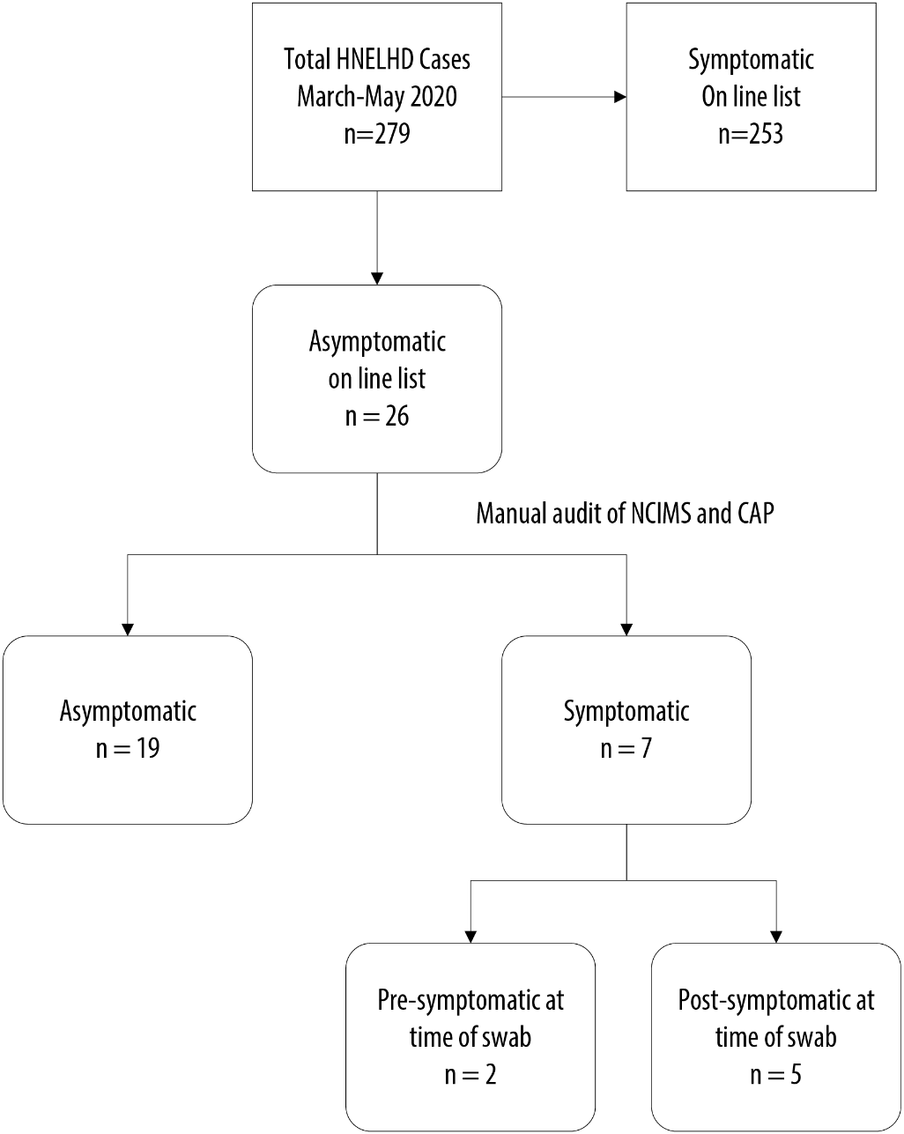

Table 1: Demographics of truly asymptomatic and misclassified asymptomatic COVID-19 cases, Hunter New England Local Health District, NSW, March–May 2020
Characteristic | Truly asymptomatic cases | Percentage (%) | Misclassified asymptomatic cases | Percentage (%)
Age, years
Median | 37 |  | 66
Range | 9–83 |  | 19–86
Age groups
9–18 | 5 | 26 | 0 | 0
19–28 | 2 | 11 | 3 | 43
29–38 | 2 | 11 | 0 | 0
39–48 | 0 | 0 | 0 | 0
49–58 | 0 | 0 | 0 | 0
59–68 | 2 | 11 | 1 | 14
69–78 | 4 | 21 | 1 | 14
79–88 | 4 | 21 | 2 | 29
Sex
Female | 9 | 47 | 4 | 57
Male | 10 | 53 | 3 | 43
Comorbidities
Diabetes | 4 | 21 | 1 | 14
Hypertension | 4 | 21 | 2 | 29
Cardiovascular disease | 2 | 11 | 1 | 14
≥3 Comorbidities | 6 | 32 | 4 | 57
Aboriginal status
Aboriginal or Torres Strait Islander | 3 | 16 | 0 | 0
Non-Indigenous | 16 | 84 | 7 | 100
Of all patients initially thought to be asymptomatic: 15 (58%) were swabbed because they were cruise ship passengers; three (11%) were investigated as a part of a family cluster; three (11%) were tested because they were close contacts of cases; for three (11%) the reason for testing was unclear; one (4%) was tested for international travel clearance; and one (4%) fabricated current symptoms to be tested.
There was no evidence of COVID-19 transmission from an asymptomatic case, though cases were effectively isolated which reduced the potential for transmission.

Discussion
The detection of asymptomatic patients within the first wave of COVID-19 in HNELHD was likely underestimated in the context of strict testing criteria focused on fever and/or respiratory symptoms. Despite this, our findings highlight the need to thoroughly investigate the past history of asymptomatic cases, and to also follow these cases forward, to avoid misclassification as asymptomatic. As of 17 June, the SoNG revision (version 3.2) would capture missed symptomology as it directs thorough investigation of asymptomatic cases.¹⁰
During the initial case interviews emphasis was placed on contact tracing to ensure isolation of cases and close contacts. It is possible that mild symptoms that occurred in the days prior (up to 20 days) may have been missed as our case interview questionnaire only prompted for current symptoms (based on the CDNA National Guidelines at the time). The availability of laboratory testing capacity during this period was limited and the public health focus was appropriately on mitigating the risk of ongoing community spread.
We now know that COVID-19 can cause a prolonged period of viral RNA shedding, with a median time of 20 days reported by a cohort study in Wuhan.^{8,9} Due to this, cases who had mild symptoms in the past (which had subsequently resolved) may be inaccurately labelled as asymptomatic. This distinction is important if there is a suspected difference in infectivity of patients with mild symptoms compared to those with no symptoms at all. It would be interesting to review other studies, such as that conducted by Mizumoto et al,⁵ to determine if asymptomatic cases were in fact post-symptomatic, given the long time-frame in which viral RNA can be detected.
We acknowledge that this is a small sample in northern NSW and not representative of all asymptomatic cases, as these cases were tested and detected during a time that symptomatic testing was directed by national guidelines. Nonetheless, this provides an important insight into disease dynamics within the local community.
There is clear evidence that a significant proportion of infections with SARS-CoV-2 are asymptomatic, including 7% of cases in the HNELHD.³ The implications of this in terms of infectivity and public health risk remain unclear and warrant further investigation. Misclassification of cases as asymptomatic, rather than pre- or post-symptomatic, may warp our understanding of transmission dynamics. To prevent this, the collection of sound surveillance data and thorough investigation of seemingly asymptomatic cases is required. Furthermore, symptom-based screening for COVID-19 — requiring present symptoms at time of testing — may exclude many positive patients; broader testing criteria will be required when the second pandemic wave occurs to accurately capture all cases.

Acknowledgments
Many thanks to the Hunter New England COVID-19 Planning Team and epidemiologist Laura Miles for assisting with data access.
Thanks also to all of the fantastic staff working at the Public Health Unit of Hunter New England, to all of the COVID-19 surge staff for their endless hard work, and to Dr Tony Merritt for his review.

Author details
Dr Jazmin K Daniells^{1,2} Dr Helen L MacCallum^{1,2} Prof David N Durrheim^{1,2}
- Hunter New England Population Health, NSW, Australia
- School of Medicine and Public Health, University of Newcastle, NSW, Australia

Corresponding author
Dr Jazmin K Daniells
Public Health Medical Officer, HNE Population Health, Locked Bag 10, Wallsend NSW 2287 Australia.
phone: (02) 4924 6499
facsimile: (02) 4924 6048
email: Jazmin.Daniells@health.nsw.gov.au

References
- Australian Government Department of Health; Ministers. First confirmed case of novel coronavirus in Australia. [Internet.] Canberra: Australian Government Department of Health, the Hon Greg Hunt MP: 25 January 2020. Available from: https://www.health.gov.au/ministers/the-hon-greg-hunt-mp/media/first-confirmed-case-of-novel-coronavirus-in-australia.
- New South Wales Health. Local health districts: Hunter New England. [Internet.] Sydney: Government of New South Wales; 2018. Available from: https://www.health.nsw.gov.au/lhd/Pages/hnelhd.aspx.
- Byambasuren O, Cardona M, Bell K, Clark J, McLaws ML, Glasziou P. Estimating the extent of true asymptomatic COVID-19 and its potential for community transmission: systematic review and meta-analysis. medRxiv. 2020. doi: https://doi.org/10.1101/2020.05.10.20097543.
- Nishiura H, Kobayashi T, Miyama T, Suzuki A, Jung SM, Hayashi K et al. Estimation of the asymptomatic ratio of novel coronavirus infections (COVID-19). Int J Infect Dis. 2020;94:154–5.
- Mizumoto K, Kagaya K, Zarebski A, Chowell G. Estimating the asymptomatic proportion of coronavirus disease 2019 (COVID-19) cases on board the Diamond Princess cruise ship, Yokohama, Japan, 2020. Euro Surveill. 2020;25(10):2000180.
- Bai Y, Yao L, Wei T, Tian F, Jin DY, Chen L et al. Presumed asymptomatic carrier transmission of COVID-19. JAMA. 2020;323(14):1406–7.
- He X, Lau EHY, Wu P, Deng X, Wang J, Hao X et al. Temporal dynamics in viral shedding and transmissibility of COVID-19. Nat Med. 2020;26(5):672–5.
- Hu Z, Song C, Xu C, Jin G, Chen Y, Xu X et al. Clinical characteristics of 24 asymptomatic infections with COVID-19 screened among close contacts in Nanjing, China. Sci China Life Sci. 2020;63(5):706–11.
- Zhou F, Yu T, Du R, Fan G, Liu Y, Liu Z et al. Clinical course and risk factors for mortality of adult inpatients with COVID-19 in Wuhan, China: a retrospective cohort study. Lancet. 2020;395(10229):1054–62.
- Australian Government Department of Health. Series of National Guidelines (SoNGs): Coronavirus Disease 2019 (COVID-19). CDNA National guidelines for public health units. [Internet.] Canberra: Australian Government Department of Health; 2020. Available from: https://www1.health.gov.au/internet/main/publishing.nsf/Content/cdna-song-novel-coronavirus.htm.
Communicable Diseases Intelligence
ISSN: 2209-6051 Online

Communicable Diseases Intelligence (CDI) is a peer-reviewed scientific journal published by the Office of Health Protection, Department of Health. The journal aims to disseminate information on the epidemiology, surveillance, prevention and control of communicable diseases of relevance to Australia.

Editor: Tanja Farmer
Deputy Editor: Simon Petrie
Design and Production: Kasra Yousefi
Editorial Advisory Board: David Durrheim, Mark Ferson, John Kaldor, Martyn Kirk and Linda Selvey

Website: http://www.health.gov.au/cdi

Contacts
Communicable Diseases Intelligence is produced by:
Health Protection Policy Branch, Office of Health Protection, Australian Government Department of Health
GPO Box 9848, (MDP 6) CANBERRA ACT 2601

Email: cdi.editor@health.gov.au

Submit an Article
You are invited to submit your next communicable disease related article to the Communicable Diseases Intelligence (CDI) for consideration. More information regarding CDI can be found at: http://health.gov.au/cdi.
Further enquiries should be directed to: cdi.editor@health.gov.au.

This journal is indexed by Index Medicus and Medline.

Creative Commons Licence - Attribution-NonCommercial-NoDerivatives CC BY-NC-ND
© 2020 Commonwealth of Australia as represented by the Department of Health
This publication is licensed under a Creative Commons Attribution-NonCommercial-NoDerivatives 4.0 International Licence from https://creativecommons.org/licenses/by-nc-nd/4.0/legalcode (Licence). You must read and understand the Licence before using any material from this publication.

Restrictions
The Licence does not cover, and there is no permission given for, use of any of the following material found in this publication (if any):
- the Commonwealth Coat of Arms (by way of information, the terms under which the Coat of Arms may be used can be found at www.itsanhonour.gov.au);
- any logos (including the Department of Health’s logo) and trademarks;
- any photographs and images;
- any signatures; and
- any material belonging to third parties.

Disclaimer
Opinions expressed in Communicable Diseases Intelligence are those of the authors and not necessarily those of the Australian Government Department of Health or the Communicable Diseases Network Australia. Data may be subject to revision.

Enquiries
Enquiries regarding any other use of this publication should be addressed to the Communication Branch, Department of Health, GPO Box 9848, Canberra ACT 2601, or via e-mail to: copyright@health.gov.au

Communicable Diseases Network Australia
Communicable Diseases Intelligence contributes to the work of the Communicable Diseases Network Australia.
http://www.health.gov.au/cdna

