Australian Meningococcal Surveillance Programme annual report, 2019
Monica M Lahra and Tiffany R Hogan for the National Neisseria Network

Abstract
Invasive meningococcal disease (IMD) is a notifiable disease in Australia, and both probable and laboratory-confirmed cases of IMD are reported to the National Notifiable Diseases Surveillance System (NNDSS). In 2019, there were 206 notifications of IMD. Of these, 202 were laboratory-confirmed cases analysed by the reference laboratories of the Australian National Neisseria Network (NNN). Of the 202 laboratory-confirmed cases of IMD, 167 were confirmed by bacterial culture and 35 by nucleic acid amplification testing, and all had the serogroup determined. Fine typing was available on 146 samples (146/202, 72%). Neisseria meningitidis serogroup B (MenB) infections accounted for 50.0% (101/202); MenW for 26.2% (53/202); MenY for 20.8% (42/202) and MenC for 3.0% of cases (6/202). Of the MenW cases, 88% were PorA antigen type P1.5,2, and 65% of these (24/37) were sequence type 11, the hypervirulent strain reported in recent outbreaks in Australia and overseas.
The primary peaks of IMD notifications in Australia in 2019 were observed in infants less than 1 year of age (36/202, 18%) and in adults aged 65 years or older (39/202, 19%). MenB infections predominated in those aged less than 5 years and those aged 15–19 years, whereas MenW and MenY infections predominated in those aged 45 years or more.
All 167 IMD isolates were tested for antimicrobial susceptibility. One isolate out of these 167 (0.6%) was resistant to penicillin with an MIC ≥ 1mg/L; 154/167 isolates (92%) had decreased susceptibility to penicillin. All isolates were susceptible to ceftriaxone and ciprofloxacin, and one isolate was resistant to rifampicin.
Keywords: antibiotic resistance; disease surveillance; meningococcal disease; Neisseria meningitidis

Introduction
Australia’s National Neisseria Network (NNN) was established in 1979 as a collaborative network of reference laboratories in each state and territory which contribute to the laboratory surveillance of the pathogenic Neisseria: N. meningitidis and N. gonorrhoeae. The NNN has coordinated laboratory data from cases of invasive meningococcal disease (IMD) for the Australian Meningococcal Surveillance Programme (AMSP) since 1994, and is supported by the Australian Government Department of Health and the jurisdictions.¹ The NNN laboratories supply phenotypic and genotypic data to supplement the notification data from the National Notifiable Diseases Surveillance System (NNDSS), which includes cases of probable and laboratory-confirmed IMD.
Notifications of IMD in Australia peaked in 2002 at 3.5 cases per 100,000,² with the majority of disease at that time caused by MenB and MenC. In 2003, the introduction of the conjugate serogroup C meningococcal vaccine to the National Immunisation Program was followed by significant and sustained reductions, in the 10 years that followed, of both the number of serogroup C IMD cases and the overall notifications of IMD, to a rate of only 0.6 cases per 100,000 in 2013.^{3,4} After 2013, however, there followed increases both in IMD notifications and in the proportion of IMD caused by the MenW and MenY serogroups in Australia. The IMD notification rate increased to 1.5 cases per 100,000 in 2017,² when MenACWY immunisation programmes were implemented across jurisdictions in targeted age groups. This was followed by a change in the national immunisation programme in 2018 substituting monovalent MenC vaccine with the 4-valent MenACWY vaccine. In 2018 IMD notifications declined to 1.1 per 100,000, then to 0.8 per 100,000 in 2019.
IMD is a rare disease in Australia, but one of public health concern. Continued monitoring of phenotypic and genotypic features of IMD strains is critical to plan and inform clinical management of cases, case clusters and outbreaks of IMD locally and nationally, and to inform and monitor public health interventions.

Methods

Case confirmation of invasive meningococcal disease
Case confirmation is based on isolation of N. meningitidis, or on a positive nucleic acid amplification testing (NAAT) from a normally sterile site, defined as laboratory-definitive evidence of IMD according to the national case definition.⁵ Information regarding the site of infection, age and sex of the patients is collated by the NNN for the AMSP.
IMD cases are categorised on the basis of the site from which N. meningitidis was isolated, or from which meningococcal DNA was detected (blood, joint fluid, vitreous fluid). When N. meningitidis is detected from both blood and cerebrospinal fluid (CSF) from the same patient, the case is classified as one of meningitis.

Phenotyping and genotyping of Neisseria meningitidis
Phenotyping is limited to the determination of the serogroup by detection of soluble polysaccharide antigens. Genotyping of both isolates and DNA extracts is performed by sequencing of products derived from amplification of the porin genes porA and porB and the outer membrane protein, fetA.

Antibiotic susceptibility testing
Meningococcal isolates are tested to determine their minimum inhibitory concentration (MIC) values to antibiotics used for therapeutic and prophylactic purposes: ceftriaxone, ciprofloxacin, penicillin and rifampicin. This program has historically reported penicillin testing categories as: sensitive (MIC ≤ 0.03 mg/L); less sensitive (MIC 0.06–0.5 mg/L); and resistant (MIC ≥ 1 mg/L). However, to monitor across antimicrobial susceptibility testing methods, a distribution of penicillin MIC values is now reported.

Results
In 2019, there were 202 laboratory-confirmed cases of IMD analysed by the NNN, and 206 cases notified to the NNDSS.² The numbers of notifications has continued to decline following the recent MenACWY vaccination interventions in Australia – from 380 in 2017 to 281 in 2018 and 206 in 2019. Laboratory data were available for 98% of notified cases of IMD in Australia in 2019 (Figure 1). In 2019, the peak incidence for IMD occurred in midwinter and early spring (1 July to 30 September) (Table 1).

Figure 1: Number of invasive meningococcal disease cases reported to the National Notifiable Diseases Surveillance System compared with laboratory-confirmed data from the Australian Meningococcal Surveillance Programme, Australia, 1991–2019
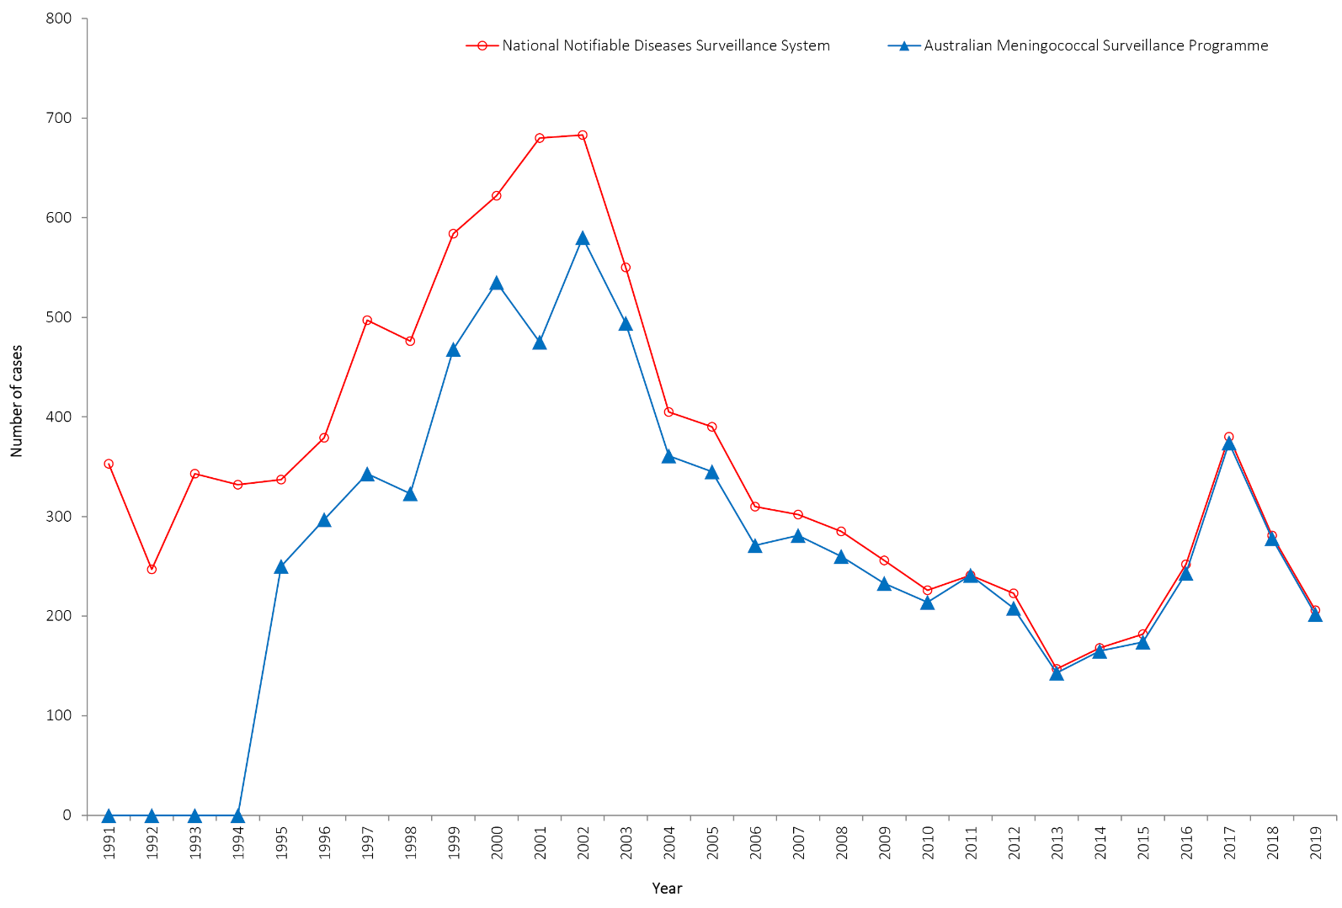
Table 1: Laboratory-confirmed cases of invasive meningococcal disease, Australia 2019
IMD serogroup 2019 | 1 January – 31 March | 1 April – 30 June | 1 July – 30 September | 1 October – 31 December | Total
B | 19 | 25 | 37 | 20 | 101
C | 3 | 2 | 0 | 1 | 6
Y | 4 | 8 | 21 | 9 | 42
W | 11 | 13 | 19 | 10 | 53
Total | 37 | 48 | 77 | 40 | 202

In 2019 there was a decrease in notifications of IMD across jurisdictions compared to 2018. While New South Wales reported the highest number of cases (58 cases), this was a decrease from 70 cases in 2018. Queensland had the second highest number of notifications (45 cases), a decrease from 58 cases in 2018. The number of cases from each jurisdiction for 2019 is shown in Table 2.

Table 2: Number of laboratory-confirmed cases of invasive meningococcal disease, Australia, 2019, by state or territory and serogroup
State/territory | Serogroups
 | B | C | Y | W | Total
ACT | 1 | 0 | 0 | 0 | 1
NSW | 34 | 0 | 14 | 10 | 58
NT | 1 | 0 | 0 | 6 | 7
Qld | 18 | 0 | 18 | 9 | 45
SA | 18 | 0 | 4 | 3 | 25
Tas | 5 | 0 | 0 | 2 | 7
Vic | 16 | 0 | 4 | 14 | 34
WA | 8 | 6 | 2 | 9 | 25
Australia | 101 | 6 | 42 | 53 | 202
 | 50.0 | 3.0 | 20.8 | 26.2 | %

Age distribution
The peak incidence of IMD in 2019 occurred in the extremes of age: in infants of less than one year (18% of cases, 36/202); and adults aged over 65 years or more, comprising 19% of IMD cases (38/202) in 2019 (Table 3). We note also that 25% of IMD occurred in children less than 5 years of age (50/202). Between 2003 and 2014, the proportion of IMD that occurred in children aged less than 5 years ranged from 28% to 36% of cases. Since 2015, in Australia the proportion of IMD in children less than 5 years of age has ranged from 21% to 27%.
Table 3: Laboratory-confirmed cases of invasive meningococcal disease, by age and serogroup; and the proportion of IMD attributable to MenB Australia, 2019
Serogroup | Age group |  |  |  |  |  |  |  |  | Total
 | <1 | 1–4 | 5–9 | 10–14 | 15–19 | 20–24 | 25–44 | 45–64 | 65+
B | 20 | 13 | 3 | 6 | 21 | 10 | 12 | 12 | 4 | 101
C | 1 | 0 | 1 | 0 | 0 | 0 | 3 | 1 | 0 | 6
Y | 4 | 0 | 0 | 1 | 3 | 9 | 0 | 9 | 16 | 42
W | 11 | 1 | 2 | 0 | 2 | 2 | 9 | 7 | 19 | 53
Total | 36 | 14 | 6 | 7 | 26 | 21 | 24 | 29 | 39 | 202
%B of within age group | 55.6 | 92.9 | 50.0 | 85.7 | 80.8 | 47.6 | 50.0 | 41.4 | 10.3

Samples from laboratory-confirmed cases
In 2019, diagnosis was confirmed by a positive bacterial culture in 83% of cases of IMD (167/202); for 17% (35/202) of cases, IMD was confirmed by NAAT testing alone (Table 4).There were 33 diagnoses of meningitis and 164 diagnoses of septicaemia (Table 4). Additionally, there were 5 IMD diagnoses confirmed from other sites comprising joint fluid aspirates (n = 3), ascitic fluid (n = 1), and an unspecified site (n = 1).

Table 4: Number of laboratory-confirmed cases of invasive meningococcal disease, Australia, 2019, by specimen type and method of confirmation
Specimen | Bacterial culture | Nucleic Acid Amplification Test | Total
Blood | 150 | 14 | 164
CSF +/- Blood | 13 | 20 | 33
Other specimensa | 4 | 1 | 5
Total | 167 | 35 | 202
a Other specimens: joint aspirates (3); ascitic fluid (1); and unspecified (1).

Notifications and proportion of MenB, MenC, MenY and MenW
The serogroup was determined for all 202 laboratory-confirmed cases of IMD (Tables 2 and 3). In 2019, MenB accounted for 50% of all IMD in Australia. With respect to serogroup infections by age group, as shown in Table 3, in children aged 1–4 years (13/14, 92.9%) and in older children and adolescents (10–19 years) (27/33, 81.8%) MenB predominated. MenB accounted for the largest proportion of disease in all age groups (range 41.4–92.9%) excepting 65 years and older where MenW and MenY were in the majority.
New South Wales reported the largest number of notifications of MenB IMD (n = 34), accounting for 59% of IMD in this state (34/58) in 2019. South Australia was again the state with the highest proportion of MenB, 72% of statewide IMD cases (18/25). In the years 2006–2012 the proportion of IMD cases caused by MenB was 84–88%, before falling in successive years: in 2013–2014 to 75–80%, in 2015 to 64%, and to 36% in 2016–2017. There was an increase in its attributable proportion in 2018 to 44% and again in 2019 to 50% of IMD cases reported (Figure 2).
Figure 2: Proportion of serogroups of laboratory-confirmed invasive meningococcal disease, Australia, by year
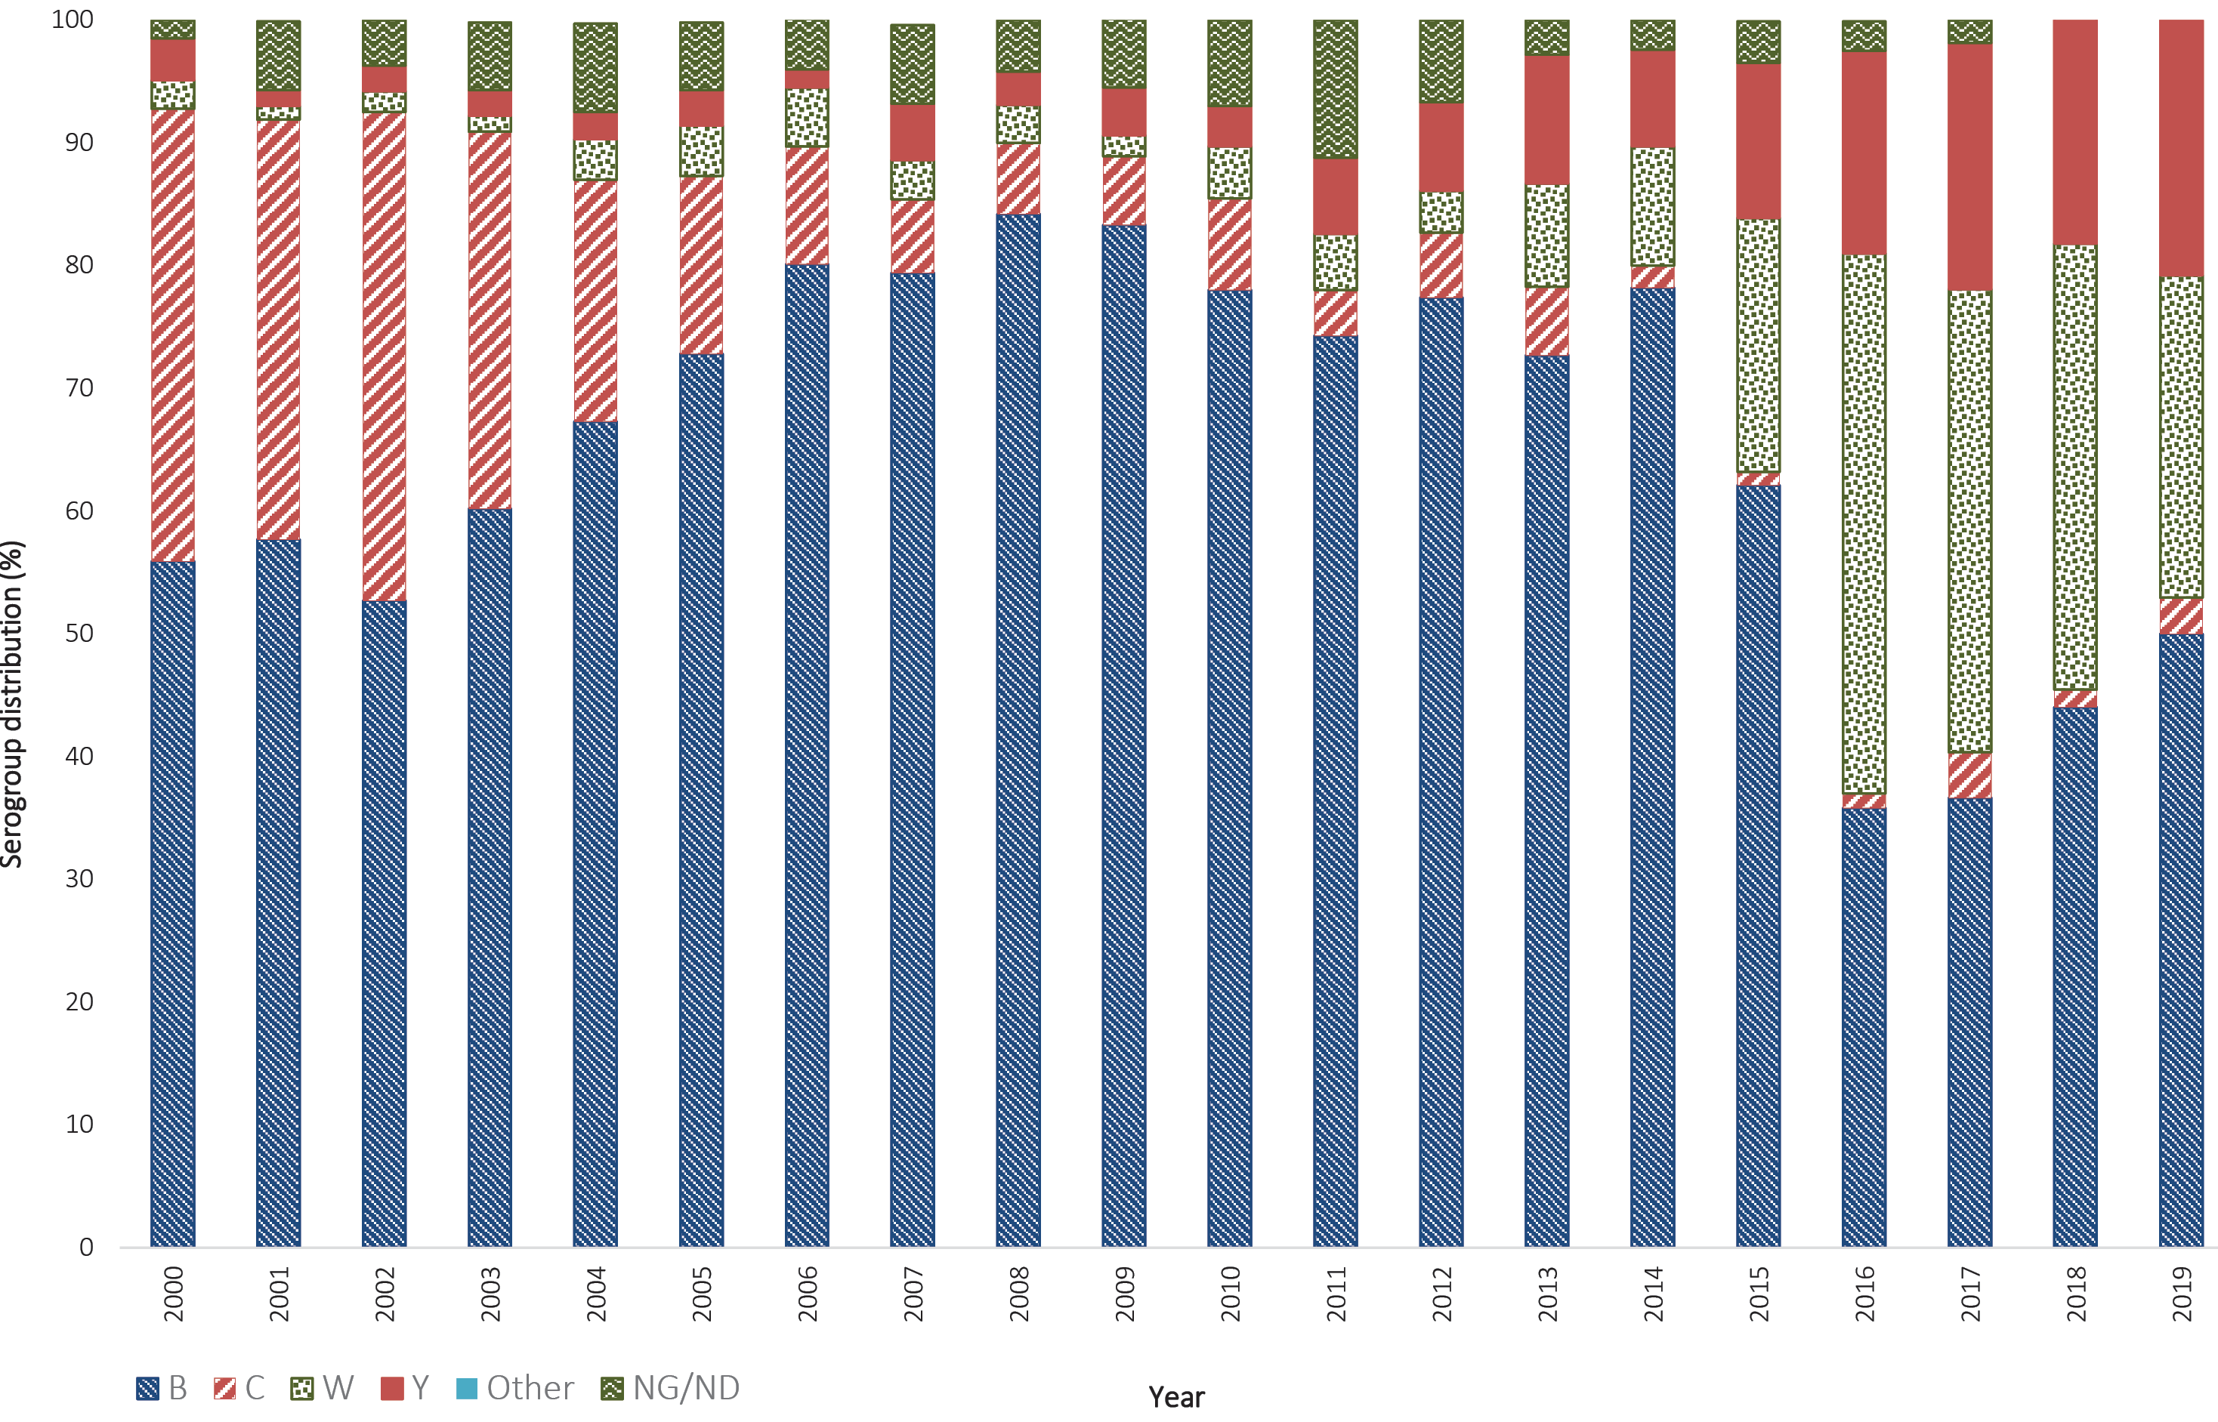
Figure 3: Number of serogroup B, C, Y and W cases of laboratory-confirmed invasive meningococcal disease, Australia, 2019, by age
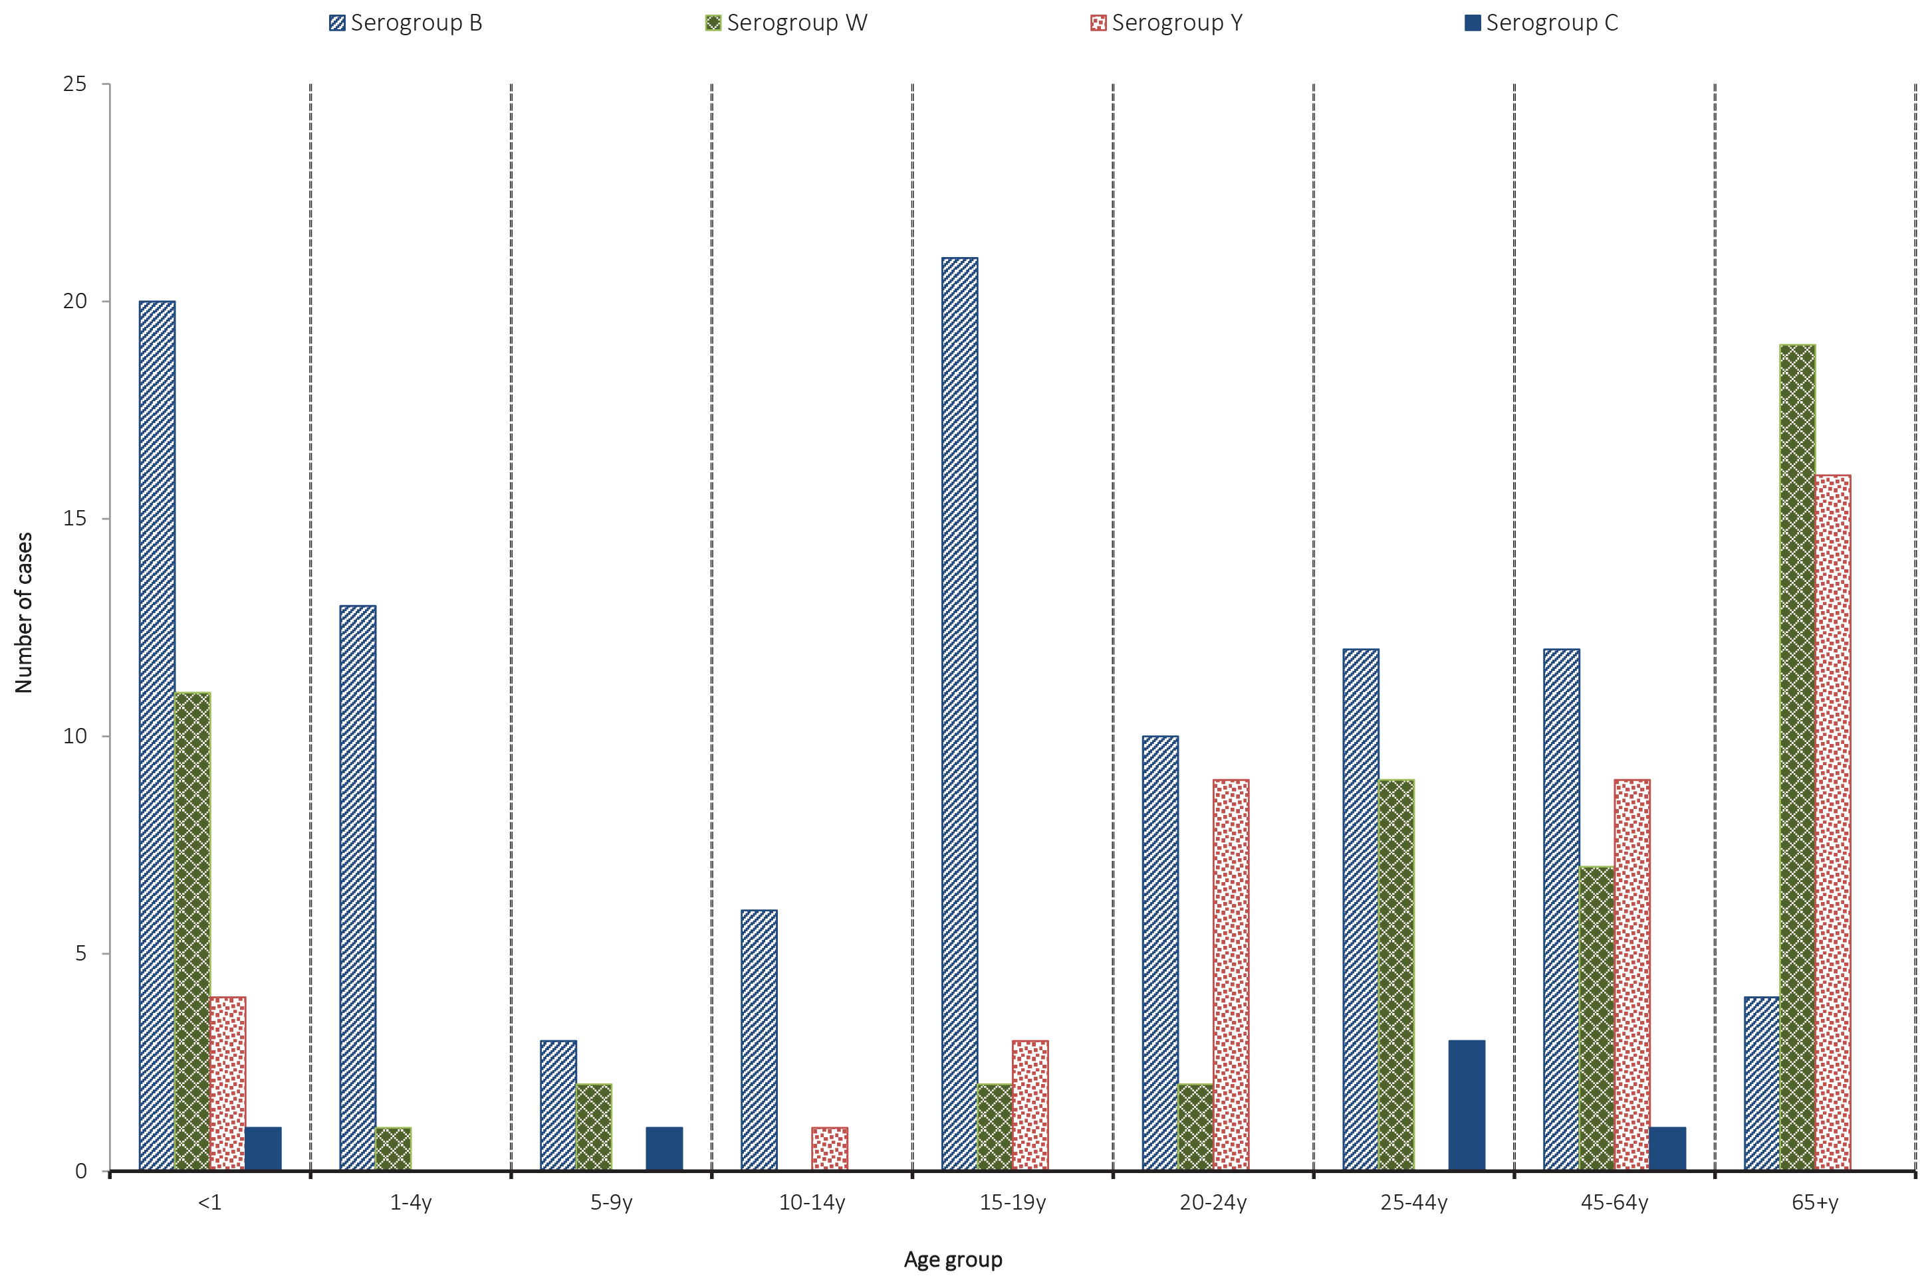
Figure 4: Number of porA genotypes for MenB in laboratory-confirmed cases of invasive meningococcal disease Australia, 2019
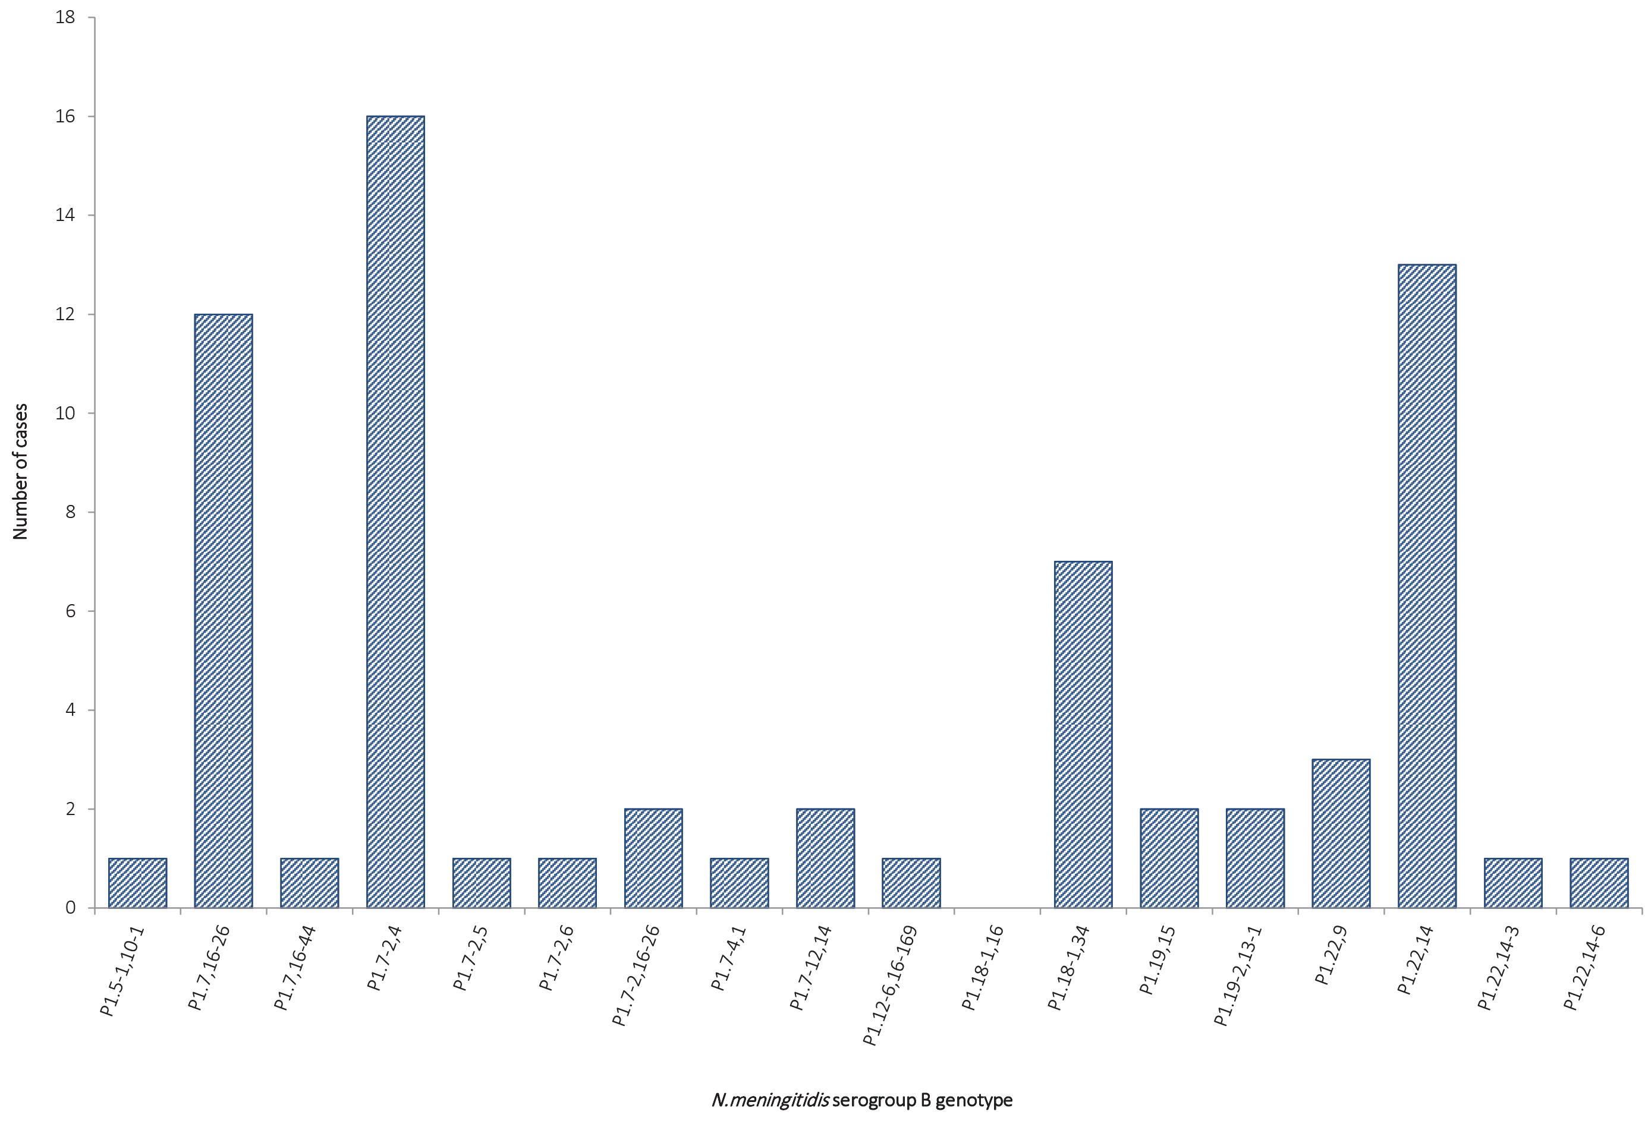
Figure 5: Number of porA genotypes for MenW in laboratory-confirmed cases of invasive meningococcal disease Australia, 2019
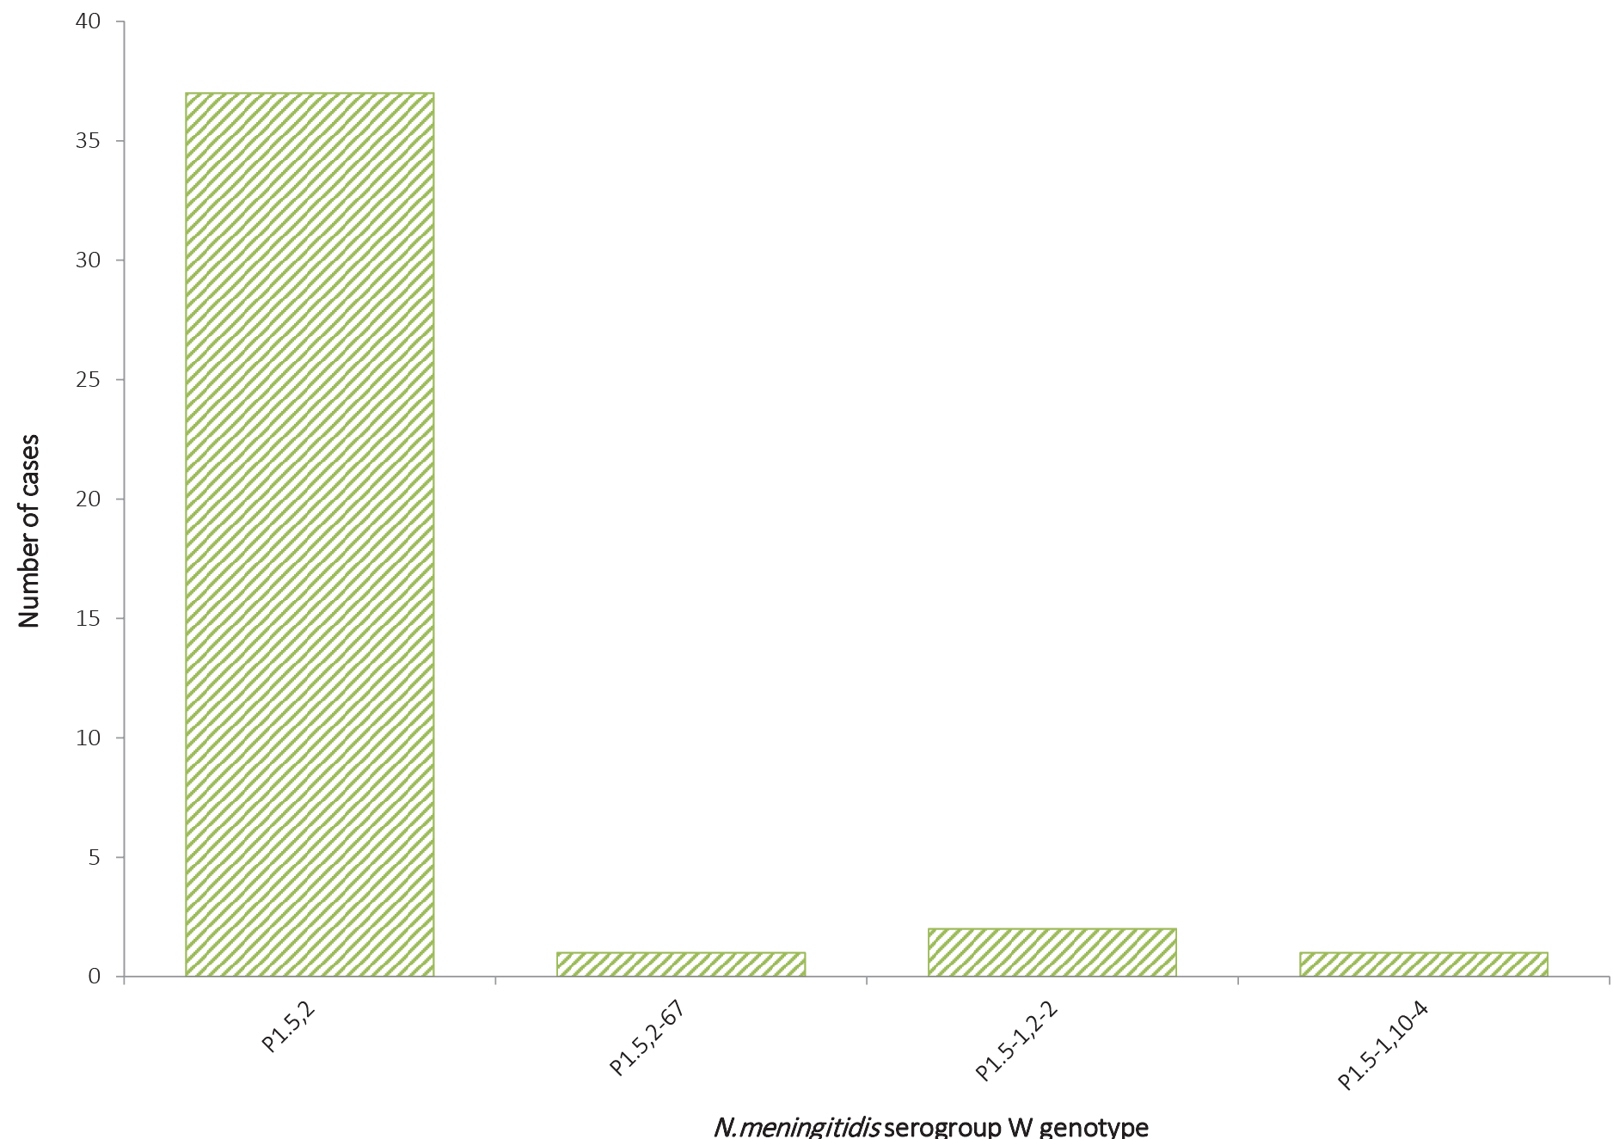
Figure 6: Number of porA genotypes for MenY in laboratory-confirmed cases of invasive meningococcal disease Australia, 2019
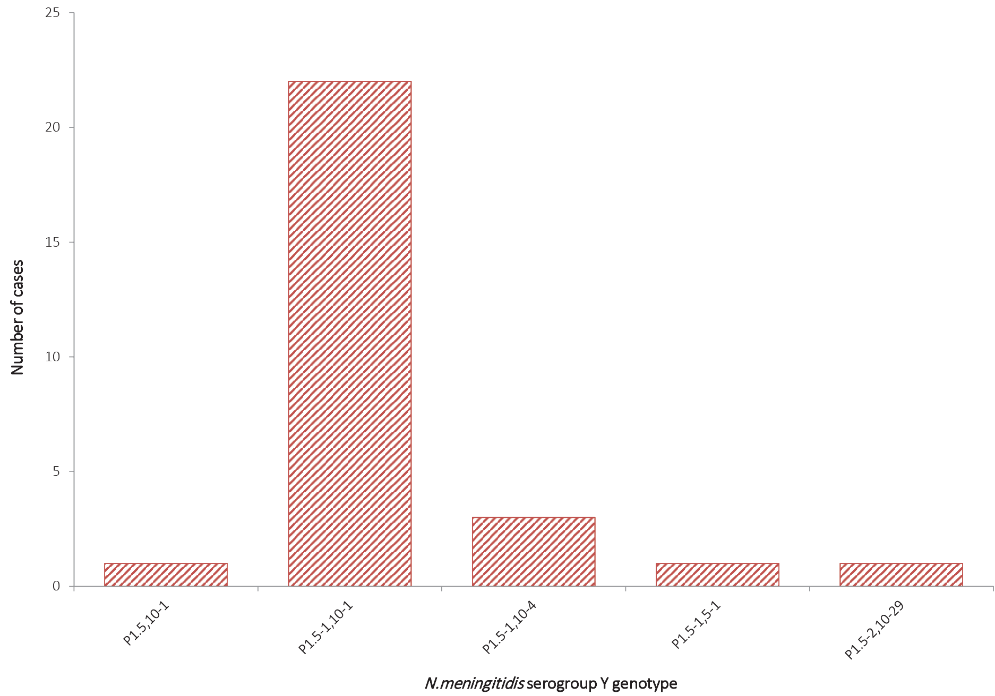
There were 6 notifications of IMD caused by MenC in 2019; this is higher than the number reported in 2018 (n = 4), but similar to annual national case numbers for the period 2014–2016. All MenC IMD cases in 2019 were reported from Western Australia (Table 3, Figure 3).
The rise in IMD notifications in Australia since 2014 is due to a rise in the number of infections of both MenW and MenY, as shown in Figure 1 and Figure 2. Prior to 2015 the proportion of cases of IMD caused by MenW was low, ranging from 1.1–4.8% in 1997–2012, then increasing to 8.4–9.7% in 2013–2014. In 2015 it was 21%, in 2016 it was 44%, in 2017–2018 it was 36–38%, as shown in Figure 2. In 2019 there were 53/202 MenW infections, accounting for 26% of IMD.
IMD caused by MenW was seen in all age groups in 2019 except those aged between 10 to 14 years. We note that this age group has historically had low numbers of IMD cases; in 2019, only 7 cases (6 MenB and 1 MenY) were reported. For those aged less than 5 years, the number and proportion of IMD cases caused by MenW (12 cases, 24%) was lower than that reported in 2018. For those aged over 65 years, MenW was the predominant cause of IMD.
A similar pattern and trend was seen in the number and proportion of IMD caused by MenY in 2019 (n = 42, 21% of total IMD). Prior to 2015, the proportion of cases of IMD caused by MenY ranged from 1.3–4.6% in the period 1997–2010 to 6.2–10.5% in 2011–2014. In 2015 the proportion rose to 12.6%, increasing to 16.5% in 2016 and again to 20% in 2017. The proportion was lower in 2018, at 15.8% (Figure 2).
Of the 42 cases of IMD caused by MenY in 2019, Queensland reported the largest number (18/45 statewide notifications in 2019). MenY was reported in all jurisdictions except the Australian Capital Territory, Northern Territory and Tasmania (Table 2). MenY IMD was reported in all age groups in in 2019 except in those aged between 1 to 9 years and 25 to 44 years, with the highest number and proportion seen in those aged 45 or more years (25/68 of the total IMD notifications for this age group), as in previous years (Table 3, Figure 3).

Genotyping
In 2019, genotyping was possible for 72% of IMD notifications (146/202). Results are shown in Figures 4–6 and Table 5. There were 70 MenB cases typed: the predominant porA type in 2019 continues to be P1.7-2,4 (16/70, 23%). Other prevalent MenB genotypes were P1.22,14 (13 cases, 19%), and P1.7,16-26 (12 cases, 17%), similar to previous years (Table 5). All MenC IMD in 2019 were from Western Australia, and investigation revealed that 5/6 were type P1.5,2 (Table 5). For serogroup W IMD, the predominant genotype remains P1.5,2 (37 cases, 88%) (Figures 4–6 and Table 5). Of these, 24 cases (65%) were clonal complex 11, the same strain type as the hypervirulent serogroup W strain also reported in the UK and South America since 2009 (Table 6).^{6,7} For MenY IMD, the predominant genotype was P1.5-1,10-1 (22 cases, 79%), as has been reported since 2014, when the increase in serogroup Y IMD was first noted in Australia (Figure 6).

Table 5: Distribution of porA genotype laboratory-confirmed cases of invasive meningococcal disease, Australia, 2019, by state or territory
 | Number per serogroup per state / territory
porA genotype | NSW | Qld | Vic | SA | WA | ACT | Tas | NT
P1.5,2 | 3W | 9W | 11W | 2W | 7W, 5C | 0 | 2W | 3W
P1.5,2-67 | 0 | 0 | 0 | 0 | 1W | 0 | 0 | 0
P1.5,10-1 | 0 | 1Y | 0 | 0 | 0 | 0 | 0 | 0
P1.5-1,2-2 | 0 | 0 | 2W | 0 | 0 | 0 | 0 | 0
P1.5-1,5-1 | 0 | 1Y | 0 | 0 | 0 | 0 | 0 | 0
P1.5-1,10-1 | 1Y | 14Y | 3Y, 1B | 2Y | 2Y | 0 | 0 | 0
P1.5-1,10-4 | 0 | 2Y | 1Y, 1W | 0 | 0 | 0 | 0 | 0
P1.5-2,10-29 | 1Y | 0 | 0 | 0 | 0 | 0 | 0 | 0
P1.7,16-26 | 3B | 3B | 4B | 1B | 1B | 0 | 0 | 0
P1.7,16-29 | 0 | 0 | 0 | 0 | 1C | 0 | 0 | 0
P1.7, 16-44 | 1B | 0 | 0 | 0 | 0 | 0 | 0 | 0
P1.7-2,4 | 3B | 1B | 3B | 8B | 1B | 0 | 0 | 0
P1.7-2,5 | 0 | 0 | 0 | 1B | 0 | 0 | 0 | 0
P1.7-2,6 | 0 | 0 | 0 | 1B | 0 | 0 | 0 | 0
P1.7-2,16-26 | 1B | 0 | 0 | 1B | 0 | 0 | 0 | 0
P1.7-4,1 | 0 | 1B | 0 | 0 | 0 | 0 | 0 | 0
P1.7-12,14 | 0 | 2B | 0 | 0 | 0 | 0 | 0 | 0
P1.12-1,16 | 2B | 0 | 0 | 0 | 0 | 0 | 0 | 0
P1.12-6,16-169 | 0 | 1B | 0 | 0 | 0 | 0 | 0 | 0
P1.18-1,16 | 1W | 0 | 0 | 0 | 0 | 0 | 0 | 0
P1.18-1,34 | 0 | 1B | 3B | 0 | 2B | 0 | 1B | 0
P1.19,15 | 0 | 0 | 1B | 0 | 0 | 0 | 1B | 0
P1.19-2,13-1 | 0 | 1B | 0 | 1B | 0 | 0 | 0 | 0
P1.22,9 | 0 | 0 | 1B | 1B | 1B | 0 | 0 | 0
P1.22,14 | 1B | 7B | 3B | 0 | 0 | 1B | 1B | 0
P1.22,14-3 | 0 | 1B | 0 | 0 | 0 | 0 | 0 | 0
P1.22,14-6 | 0 | 0 | 0 | 0 | 1B | 0 | 0 | 0
P1.22-1, 14 | 0 | 0 | 0 | 1B | 0 | 0 | 0 | 0

Table 6: Laboratory-confirmed cases of MenW invasive meningococcal disease, Australia, 2019, by sequence type (ST)
Sequence type | MenW genotype
 | P1.5,2 | P1.5,2-67 | P1.5-1,2-2 | P1.5-1,10-4 | P1.18-1,16 | Total
ST-11 | 24 | 1 | 0 | 1 | 0 | 26
ST-22 | 0 | 0 | 2 | 0 | 0 | 2
ST574 | 0 | 0 | 0 | 0 | 0 | 0
ST1158 | 0 | 0 | 0 | 0 | 0 | 0
ST1287 | 0 | 0 | 0 | 0 | 0 | 0
ST1655 | 0 | 0 | 0 | 0 | 0 | 0
ST2780 | 0 | 0 | 0 | 0 | 0 | 0
ST12351 | 0 | 0 | 0 | 0 | 0 | 0
ST13135 | 0 | 0 | 0 | 0 | 0 | 0
Not determined | 13 | 0 | 0 | 0 | 1 | 14
Total | 37 | 1 | 2 | 1 | 1 | 42

Antibiotic susceptibility testing
Isolates of N meningitidis are tested against both treatment (ceftriaxone and penicillin) and clearance antibiotics (rifampicin and ciprofloxacin). In 2019, 167/202 of laboratory-confirmed IMD had Neisseria meningitidis cultured, and it was therefore possible for antimicrobial susceptibility testing (AST) to be performed. All 167 N. meningitidis isolates had AST performed by the NNN.
Regarding antimicrobial susceptibility to the treatment antibiotics, ceftriaxone susceptibility testing was performed on all 167 isolates in 2019, and all isolates were susceptible. With regards to penicillin, the distribution of penicillin MIC values is shown in Table 7. There were 12/167 strains (7.2%) fully susceptible to penicillin (MIC ≤ 0.03 mg/L).
Table 7: Penicillin MIC distribution of laboratory-confirmed invasive meningococcal disease isolates, Australia, 2019
Penicillin MIC distribution
MIC mg/L | ≤ 0.032 | 0.064 | 0.125 | 0.25 | 0.5 | 1 | 2 | ≥ 4 | Total
Number | 12 | 35 | 25 | 60 | 34 | 1 | 0 | 0 | 167
% | 7.2 | 21.0 | 15.0 | 35.9 | 20.4 | 0.6 | 0 | 0 | 100
There were 154/167 isolates that were categorised as less susceptible to penicillin (MIC value 0.064–0.5 mg/L). Of these, 34 had a penicillin MIC of 0.5mg/L, which is close to the MIC breakpoint for resistance; 26/34 (76%) with this penicillin MIC were Men W. In recent years MenW has demonstrated higher penicillin MIC values and higher proportions of resistance. In 2019, one of 167 IMD isolates (0.6%) was resistant to penicillin (MIC ≥ 1 mg/L): this isolate was a MenW IMD, diagnosed in Victoria. The proportion of IMD isolates resistant to penicillin was lower than reported in 2018 (1.4%) and continues to decline from 2016 (5.8%) and 2017 (5.1%) as shown in Figure 7. Regarding the clearance antibiotics for IMD, all 167 isolates were susceptible to ciprofloxacin; one MenW isolate from Victoria was resistant to rifampicin with a MIC value ≥ 32 mg/L.

Figure 7: Proportion of penicillin-susceptible, less susceptible and resistant invasive meningococcal disease isolates, Australia, by year
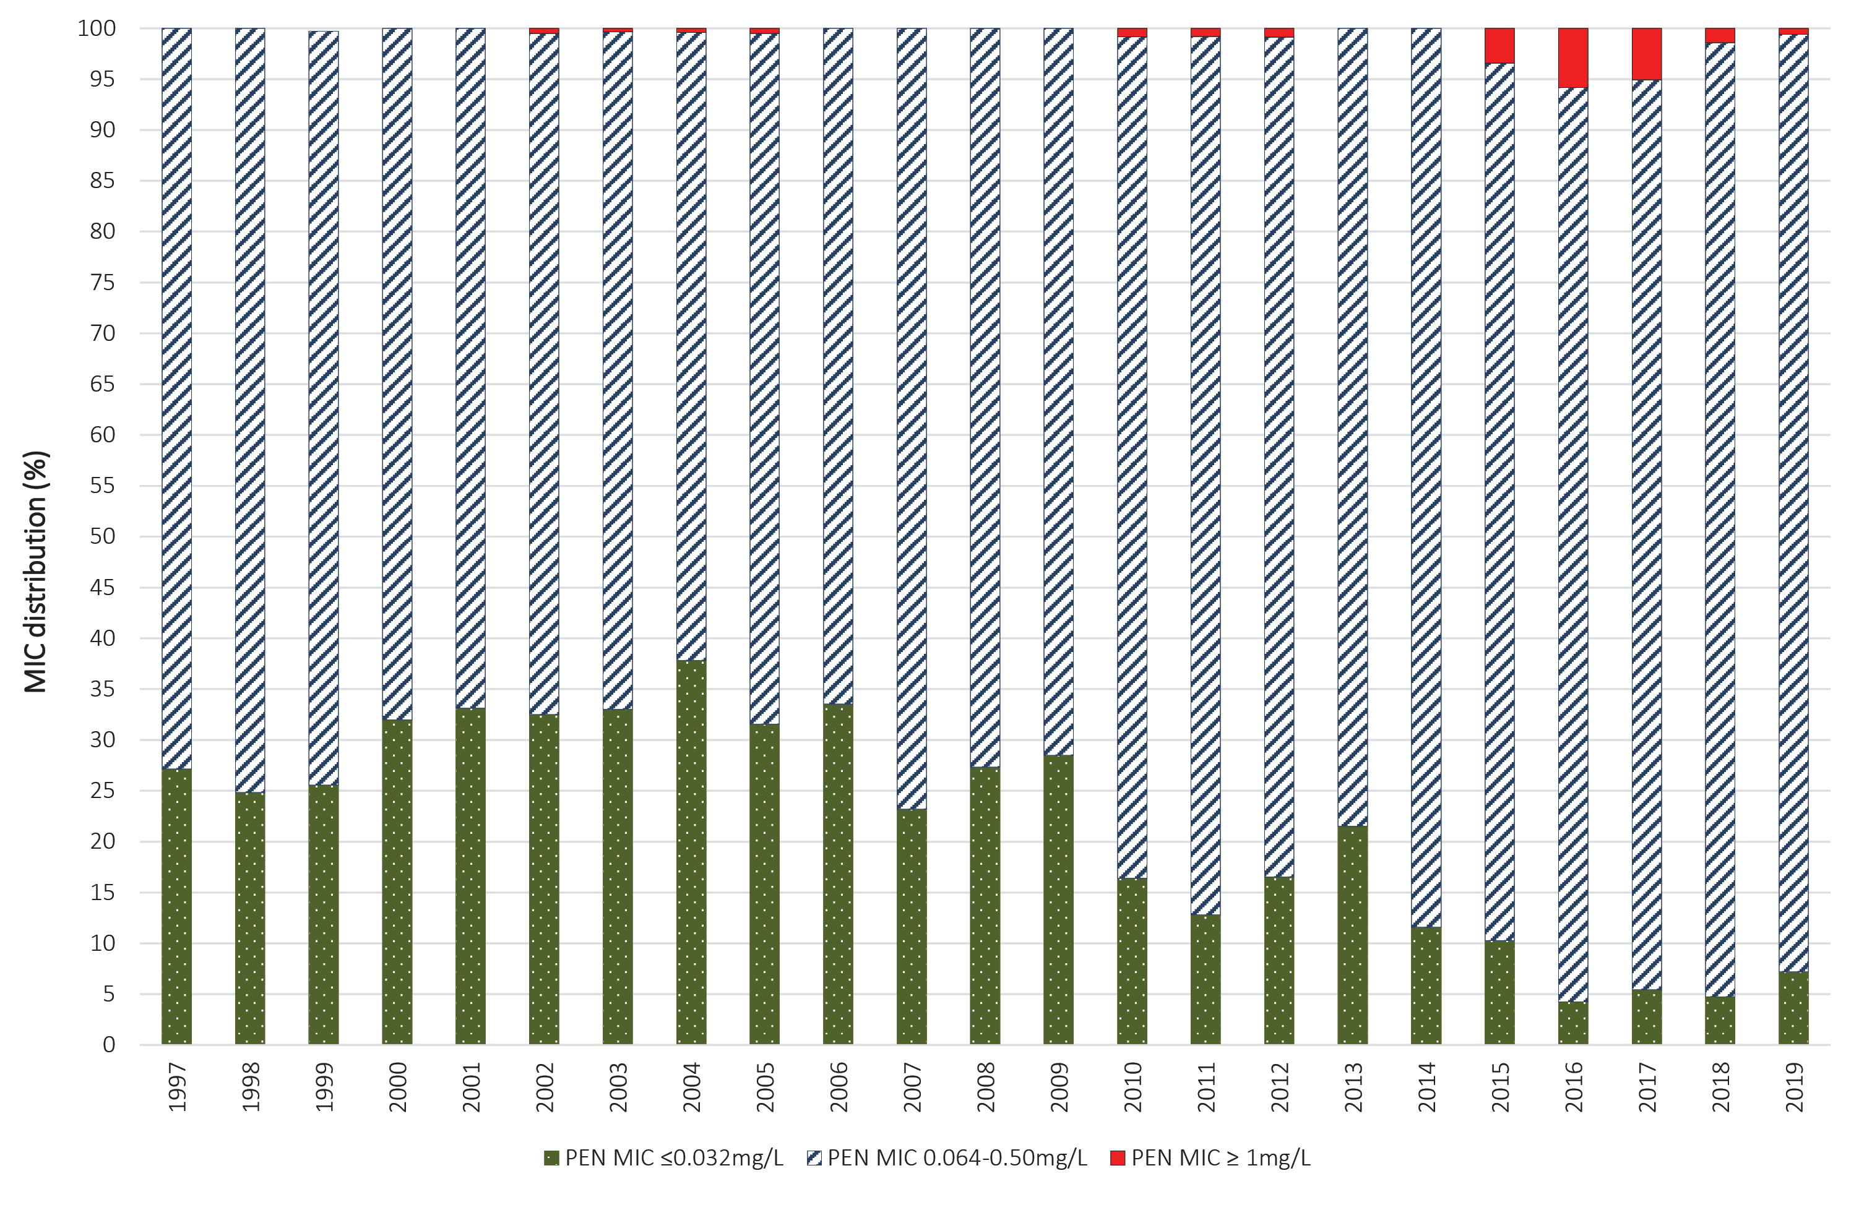

Discussion
In 2019, 98% of IMD notifications (202/206) were laboratory confirmed.³ Overall there was a 27% decrease in notifications of IMD in Australia in 2019 compared to 2018. Following the increases in MenW and MenY disease in Australia during 2016–2017, there were jurisdictional, time-limited MenACWY vaccination programs for target age groups in 2017 and 2018.⁸ From 1 July 2018, a change to the National Immunisation Program (NIP) was implemented, where MenC vaccine at 12 months of age was replaced with a quadrivalent ACWY vaccine. This change in the NIP in 2018 has been followed by a decrease in both notifications and proportion of MenW and MenY disease, and also an increase in the proportion of disease caused by MenB from 36% in 2016–2017 to 50% in 2019. We note that, following the introduction of the MenC vaccine in 2003 in Australia, the proportion of MenB IMD was 84–88% in the years 2006–2012 then declining, along with disease notifications until the emergence of MenW and MenY disease since 2014 in Australia.⁸ In 2019 MenB accounted for 66% of IMD (33/50) notifications in those less than 5 years of age; 81% of IMD (21/26) in 15–19 year olds; 48% of IMD (10/21) in 20–24 year olds; 50% of IMD (12/24) in 25–44 year olds; and 41% of IMD (12/29) in 45–64 year olds. A recombinant multi-component meningococcal B vaccine has been available in Australia since 2014,⁹ however this vaccine is not currently on the NIP.
In 2019, with regards to serogroup infections by age group, as shown in Table 3, MenB predominated in children aged 1–4 years of age (13/14, 92.9%) and in older children and adolescents (10–19 years) (27/33, 81.8%). MenB accounted for the greatest proportion of IMD in all age groups (range 41.4–92.9%) excepting 65 years and older where MenW and MenY were predominant.
MenW caused 26.1% of IMD (53/202) in Australia, a decrease from 36% in 2018. MenW IMD was reported in all age groups, except those between 10 to 14 years. MenW infections accounted for 30.6% of IMD in babies less than one year of age (11/36 notifications), and 49% of IMD notifications in those aged over 65 years (19/39 notifications). MenY IMD in 2019 (n = 42/202) accounted for 20.8% of IMD nationally; it was reported in babies less than one year of age (4/42, 9.5%); in 15–19 year olds (3/26, 11.5%); in 20–24 year olds (9/21, 43%); in 45–64 year olds (9/29, 31%); and in those aged 65 and older (16/39, 41%).
The primary peaks of IMD notifications were observed in infants less than 1 year of age (36/202, 18%) and in adults aged 65 years or older (39/202, 19%). In infants, IMD was predominately caused by MenB (20/36) and MenW (11/36), whereas in those aged 65 and older, IMD was attributable to MenW and MenY predominantly (35/39 notifications amongst those aged 65 and older were MenW or MenY). Secondary disease peaks were observed in adolescents 15–19 years of age, due primarily to MenB (81%).
With regards to the prevailing IMD serogroups and genotypes, the number of IMD cases caused by MenB in 2019 was less than in 2018, but the proportion was higher (101/202, 50% in 2019 compared with 123/278, 44% in 2018). New South Wales reported the largest number of MenB notifications. However, South Australia continues to report the highest proportion of MenB. The predominant genotypes of Men B in Australia continue to be P1.7-2,4 (16/70), followed by genotype P1.22,14 (13/70) and genotype P1.7,16-26 (12/70).
The predominant circulating strain of MenW continues to be genotype P1.5,2 sequence type (ST)-11. This MenW strain emerged in the United Kingdom and South America in 2009; it has spread to account for 25% of IMD in the UK in 2014/15 and 59% of all cases in Chile in 2012.^{6,7} MenW ST11 is hypervirulent and associated with atypical clinical presentations, more severe disease, and a higher case fatality rate.⁷ The initial increase in MenW overseas, and in Australia, was seen in older adults; it was subsequently reported in all age groups, particularly in adolescents and infants.¹⁰
The predominant MenY genotype since 2014 continues to be P1.5-1,10-1; previously, MenY genotype distribution was more heterogeneous. The emergence of MenY IMD has also been reported recently in Europe.¹¹ The phenotypic and genotypic characterization of the MenY isolates is ongoing by the NNN.
Antimicrobial susceptibility testing of IMD isolates in 2019 showed that penicillin resistance has reduced compared with recent years (one isolate, 0.6%). The incidence of penicillin resistance in N. meningitidis in Australia was less than 1% annually among IMD isolates tested in 1996–2014, rising to 3.4% in 2015 and 5.8% in 2016; it has fallen from 5.1% in 2017 through 1.4% in 2018. However the proportion of IMD isolates less sensitive to penicillin has been increasing from 62–75% in 1996–2006; 67–79% in 2007–2009; 78–88% in 2010–2015; to 90–94% in 2016–2019. The majority of penicillin-resistant meningococcal isolates are MenW. All IMD isolates tested in 2019 were susceptible to ceftriaxone and ciprofloxacin, while one isolate was resistant to rifampicin.
There has been a year-on-year decrease in IMD notifications from 1.5 cases per 100,000 in 2017; to 1.1 per 100,000 in 2018; to 0.8 cases per 100,000 in 2019. There has also been a decrease in the proportion of isolates attributable to MenW and MenY following changes in the National Immunisation Programme. The NNN is continuing to lead further investigations with the Commonwealth Department of Health and is closely monitoring the phenotypic and genotypic features of N. meningitidis causing IMD in Australia. Additional investigations including whole genome sequencing are in place to enhance IMD surveillance. The AMSP data are used for informing treatment guidelines and disease prevention strategies; and to monitor the effect of interventions.

Acknowledgements
Meningococcal isolates were received in the reference centres from many laboratories throughout Australia. The considerable time and effort involved in forwarding these isolates is recognised and these efforts are greatly appreciated. These data could not have been provided without this assistance and the help of clinical colleagues and public health personnel. The Australian Government Department of Health provided funding for the National Neisseria Network.
Members of the AMSP in 2019, to whom isolates and samples should be referred, and enquiries directed, are listed below.

Australian Capital Territory
P Collignon, S Bradbury Microbiology Department, The Canberra Hospital, Gilmore Crescent, Garran ACT 2605 Telephone: +61 2 6244 2510 Email: peter.collignon@act.gov.au

New South Wales
MM Lahra, EA Limnios, TR Hogan, RL Kundu, J El Nasser, S Ray, M Shoushtari Microbiology Department, New South Wales Health Pathology, The Prince of Wales Hospital Barker Street, Randwick NSW 2031 Telephone: +61 2 9382 9084 Facsimile: +61 2 9382 9310 Email: monica.lahra@health.nsw.gov.au
M Maley, R Porritt Department of Microbiology and Infectious Diseases, New South Wales Health Pathology, Liverpool Hospital, Locked Mail Bag 7090, Liverpool BC NSW 1871 Telephone: +61 8738 5124 Facsimile: +61 2 8738 5129 Email: Joanne.Mercer@sswahs.nsw.gov.au or Robert.Porritt@sswahs.nsw.gov.au

Northern Territory
R Baird, K Freeman Microbiology Department, Territory Pathology, Royal Darwin Hospital, Rocklands Drive, Tiwi NT 0810 Telephone: +61 8 8922 8167 Facsimile: +61 8 8922 7788 Email: rob.baird@nt.gov.au

Queensland
G Robertson, H Smith, V Hicks, A. Jennison Public Health Microbiology, Queensland Health Forensic and Scientific Services, 39 Kessels Road, Coopers Plains Qld 4108 Telephone: +61 7 3096 2825 Facsimile: +61 7 3096 2973; +61 7 3274 9175 Email: Amy.Jennison@health.qld.gov.au

South Australia
I Bastian, A Lawrence, J Holds SA Pathology, Royal Adelaide Hospital Site, Microbiology and Infectious Diseases, Royal Adelaide Hospital, North Terrace, Adelaide, SA 5000 Telephone: +61 8 8222 3335 Facsimile: +61 8 2223543 Email: andrew.lawrence@health.sa.gov.au

Tasmania
L Cooley, B McEwan Department of Microbiology and Infectious Diseases, Royal Hobart Hospital, 48 Liverpool Street, Hobart Tasmania 7000 Telephone: +61 3 6222 8656 Email: belinda.mcewan@dhhs.tas.gov.au

Victoria
B Howden, K Stevens Microbiological Diagnostic Unit Public Health Laboratory, Department of Microbiology and Immunology, The Peter Doherty Institute, The University of Melbourne, Parkville Victoria 3052 Telephone: +61 3 8344 5713 Facsimile: +61 3 8344 7833 Email: kerries@unimelb.edu.au

Western Australia
D Speers, J Bew Department of Microbiology, QEII Medical Centre, PP Block Level 5, PathWest Laboratory Medicine WA, Hospital Avenue, Nedlands, WA 6009 Telephone: +61 8 6383 4501 Facsimile: +61 8 9382 8046 Email: jane.bew@health.wa.gov.au

Author details
Monica M Lahra^{1, 2} Tiffany R Hogan¹
- Neisseria Reference Laboratory and World Health Organisation Collaborating Centre for STI and AMR, Sydney. Department of Microbiology, New South Wales Health Pathology, The Prince of Wales Hospital, Randwick, 2031, NSW Australia.
- School of Medical Sciences, Faculty of Medicine, The University of New South Wales, NSW, 2052 Australia

Corresponding author
Professor Monica Lahra,
Director, Microbiology Department, Neisseria Reference Laboratory and WHO Collaborating Centre for STI and AMR, New South Wales Health Pathology, Level 4, Campus Centre, The Prince of Wales Hospital, Randwick NSW, 2031.
Email: monica.lahra@health.nsw.gov.au

References
- National Neisseria Network. Meningococcal isolate surveillance Australia 1994. Commun Dis Intell. 1995;19:286–9.
- Australian Government Department of Health. National Notifiable Disease Surveillance System. [Internet.] Canberra: Australian Government Department of Health; 2019. Available from: http://www9.health.gov.au/cda/source/cda-index.cfm .
- National Notifiable Diseases Surveillance System (NNDSS). Number of notifications of Meningococcal disease (invasive), received from state and territory health authorities in the period of 1991 to 2012 and year-to-date notifications for 2014. [Internet.] Canberra: Australian Government Department of Health; 2014.
- Australian Government Department of Health. Invasive meningococcal disease. [Internet.] Canberra: Australian Government Department of Health; 2019. Available from: https://www.health.gov.au/internet/main/publishing.nsf/Content/ohp-meningococcal-W.htm .
- Communicable Diseases Network Australia (CDNA). Invasive meningococcal disease: CDNA national guidelines for public health units. [Internet.] Canberra: Australian Government Department of Health; 2015. Available from: http://www.health.gov.au/internet/main/publishing.nsf/content/cdna-song-imd.htm .
- Abad R, López EL, Debbag R, Vázquez JA. Serogroup W meningococcal disease: global spread and current affect on the Southern Cone in Latin America. Epidemiol Infect. 2014;142(12):2461–70.
- Ladhani SN, Beebeejaun K, Lucidarme J, Campbell H, Gray S, Kaczmarski E. Increase in endemic Neisseria meningitidis capsular group W sequence type 11 complex associated with severe invasive disease in England and Wales. Clin Infect Dis. 2015;60(4):578–85.
- Chiu C, Dey A, Wang H, Menzies R, Deeks S, Mahajan D et al. Vaccine preventable diseases in Australia, 2005 to 2007. Commun Dis Intell Q Rep. 2010;34(Suppl):S1–167.
- Australian Government Department of Health. Australian Immunisation Handbook: Meningococcal disease. [Internet.] Canberra: Australian Government Department of Health; 2015. Available from: http://www.health.gov.au/internet/immunise/publishing.nsf/Content/immunise-meningococcal
- Araya P, Fernández J, Del Canto F, Seoane M, Ibarz-Pavón AB, Barra G et al. Neisseria meningitidis ST-11 clonal complex Chile, 2012. Emerg Infect Dis. 2015;21(2):339–41.
- Bröker M, Jacobsson S, Kuusi M, Pace D, Simões MJ, Skoczynska A et al. Meningococcal serogroup Y emergence in Europe: update 2011. Hum Vaccin Immunother. 2012;8(12):1907–11.
Communicable Diseases Intelligence
ISSN: 2209-6051 Online

Communicable Diseases Intelligence (CDI) is a peer-reviewed scientific journal published by the Office of Health Protection, Department of Health. The journal aims to disseminate information on the epidemiology, surveillance, prevention and control of communicable diseases of relevance to Australia.

Editor: Tanja Farmer
Deputy Editor: Simon Petrie
Design and Production: Kasra Yousefi
Editorial Advisory Board: David Durrheim, Mark Ferson, John Kaldor, Martyn Kirk and Linda Selvey

Website: http://www.health.gov.au/cdi

Contacts
Communicable Diseases Intelligence is produced by:
Health Protection Policy Branch, Office of Health Protection, Australian Government Department of Health
GPO Box 9848, (MDP 6) CANBERRA ACT 2601

Email: cdi.editor@health.gov.au

Submit an Article
You are invited to submit your next communicable disease related article to the Communicable Diseases Intelligence (CDI) for consideration. More information regarding CDI can be found at: http://health.gov.au/cdi.
Further enquiries should be directed to: cdi.editor@health.gov.au.

This journal is indexed by Index Medicus and Medline.

Creative Commons Licence - Attribution-NonCommercial-NoDerivatives CC BY-NC-ND
© 2020 Commonwealth of Australia as represented by the Department of Health
This publication is licensed under a Creative Commons Attribution-NonCommercial-NoDerivatives 4.0 International Licence from https://creativecommons.org/licenses/by-nc-nd/4.0/legalcode (Licence). You must read and understand the Licence before using any material from this publication.

Restrictions
The Licence does not cover, and there is no permission given for, use of any of the following material found in this publication (if any):
- the Commonwealth Coat of Arms (by way of information, the terms under which the Coat of Arms may be used can be found at www.itsanhonour.gov.au);
- any logos (including the Department of Health’s logo) and trademarks;
- any photographs and images;
- any signatures; and
- any material belonging to third parties.

Disclaimer
Opinions expressed in Communicable Diseases Intelligence are those of the authors and not necessarily those of the Australian Government Department of Health or the Communicable Diseases Network Australia. Data may be subject to revision.

Enquiries
Enquiries regarding any other use of this publication should be addressed to the Communication Branch, Department of Health, GPO Box 9848, Canberra ACT 2601, or via e-mail to: copyright@health.gov.au

Communicable Diseases Network Australia
Communicable Diseases Intelligence contributes to the work of the Communicable Diseases Network Australia.
http://www.health.gov.au/cdna

