Australian mumps serosurvey 2012–2013: any cause for concern?
Cyra Patel, Frank Beard, Alexandra Hendry, Helen Quinn, Aditi Dey, Kristine Macartney, Linda Hueston, Dominic E Dwyer, Peter McIntyre

Abstract

Objective
To determine population-level immunity to mumps in Australia.

Methods
We tested randomly selected specimens from people aged 1–49 years using the Enzygnost anti-parotitis IgG enzyme immunoassay from an opportunistically collected serum bank in 2012–2013. Weighted estimates of the proportion seropositive and equivocal for mumps-specific IgG antibody were determined by age group and compared with two previous national serosurveys conducted in 2007–2008 and 1997–1998.

Results
Overall, 82.1% (95% CI 80.6–83.5%) of 2,729 specimens were positive or equivocal for mumps-specific IgG antibodies (71.1% positive [95% CI 69.4–72.9%]; 10.9% equivocal [95% CI 9.8–12.2%]). The proportion positive or equivocal was higher in 2012–2013 (82.1%) than in 2007–2008 (75.5%) and 1997–1998 (72.5%), but varied by age. The proportion positive or equivocal in 2012-2013 was above 80% for all age groups older than 1 year except for 30–34 year olds, corresponding to the 1978–1982 birth cohort previously identified as most likely to have missed out on a second MMR vaccine dose.

Conclusions
Seropositivity to mumps in 2012–2013 was well-maintained compared with previous serosurveys. Low mumps notifications over this period in Australia suggest an absence of community-based transmission of mumps infection in the general population, but recent outbreaks among Aboriginal adolescents and young adults in close-contact settings, despite high 2-dose MMR coverage, suggest that seroprotection may be insufficient in other similar settings in Australia.
Keywords: mumps, vaccine preventable disease, surveillance, serosurveillance, immunity

Abbreviations
ELISA – enzyme-linked immunosorbent assay
GMC – geometric mean concentration
MMR – measles, mumps, rubella (vaccine)
MMRV – measles, mumps, rubella, varicella (vaccine)

Introduction
Mumps is an acute viral illness caused by an RNA virus belonging to the family Paramyxoviridae, with transmission typically occurring via respiratory secretions, including aerosolisation.¹ Infected individuals usually present with respiratory symptoms, parotitis and non-specific symptoms such as fever, malaise, headache and/or myalgia.^{1–5} Complications occur in a minority of cases. Clinical meningitis can develop in up to 10% of cases and encephalitis in 0.1%, although permanent neurological sequelae are rare.⁴ Fatalities due to mumps are very rare, with the case fatality rate associated with mumps encephalitis reported at 1.5%.⁴ While long-term sequelae are rare, orchitis occurs in approximately 15–30% of unvaccinated adult male cases, although it is less common (< 10%) in the post-vaccine era.^{4,6–10}
Mumps-containing vaccines have been offered routinely in Australia since 1983 through the government-funded National Immunisation Program (NIP), although several changes to the immunisation schedule have occurred (summarised in Appendix A, Table A.1).¹¹ Briefly, a single dose of measles-mumps vaccine was introduced at 12 months of age in 1983, changing to measles-mumps-rubella (MMR) from 1989. From 1993, a second dose of MMR vaccine was funded for children aged 10–14 years old, delivered through a school-based program. In 1998, the second MMR vaccine dose was moved to age 4–5 years, accompanied by a national school-based campaign targeting ages 5 to 12 years. A subsequent national campaign in 2001 aimed to increase MMR vaccination coverage in young adults, but uptake was poor.³ In 2013, the second dose of MMR was moved to 18 months and given as measles-mumps-rubella-varicella (MMRV) vaccine.
MMR vaccine coverage has been high in Australia since the early 2000s, with 2-dose coverage above 90% from 2010 onwards.^{12–16} However, the mumps component of MMR vaccine is known to generate a weaker immune response than the measles and rubella components, with evidence that it has a lower seroconversion rate (especially following 1 dose of MMR vaccine); shows faster declines in seropositivity and in concentration of mumps-specific antibodies over time; and generates mumps-specific antibodies that are of lower avidity.^{1,17} All mumps-containing vaccines used in Australia have contained the Jeryl Lynn strain, with effectiveness of two doses in preventing laboratory‐confirmed mumps estimated between 83% and 88% in children and adolescents.¹⁸
Data on notifications of mumps cases are available at a national level from 1995, although mumps was not notifiable in all jurisdictions, nor captured by the National Notifiable Diseases Surveillance System, until 2001.¹⁹ Over time, the overall incidence of mumps has greatly reduced, with residual cases shifting from children to young adults,^{3,20} but large regional outbreaks have occurred in 2007–2008 and 2015–2017 among adolescents and young adults in remote Aboriginal communities in the north and west of Australia.^{3,6,21–24} The great majority (89%) of notified cases in the outbreak in 2015–2017 had documented receipt of two doses of mumps-containing vaccine.⁶ Similar outbreaks in highly vaccinated populations have also been reported in close contact settings in other countries, including the United States of America and Europe.^{25–29}
Serosurveillance allows for assessment of population immunity and identification of age cohorts with lower levels of seroprotection and potential susceptibility to infection. The aim of this study was to determine the age-specific prevalence of levels of immunoglobulin G (IgG) antibody against mumps in a representative serosurvey and to compare trends with similar national serosurveys previously conducted in 1997–1998 and 2007–2008.

Methods

Population and study design
We randomly sampled 2,729 residual serum and plasma specimens from a bank of 12,411 specimens collected opportunistically from 32 diagnostic laboratories in all states and territories around Australia during 2012 and 2013. The collection method was the same as that used previously, although the number of contributing laboratories varied.^{30,31} The opportunistic sampling method used has been validated by an Australian study comparing opportunistic and random cluster sampling for estimation of measles immunity.³² Information available for each specimen included sex, age or date of birth, residential postcode and date of collection. Vaccination status or Aboriginal and Torres Strait Islander status was not collected: this is not routinely provided on diagnostic laboratory request forms, and was thus unavailable. Known infection with human immunodeficiency virus; any other immunocompromising condition; and transfusion of blood products within the past three months were exclusion criteria for specimen use.
Ethical approval for this national study was obtained from the Western Sydney Human Research Ethics Committee, the South Australian Department of Health Human Research Ethics Committee, the Melbourne Health Human Research Ethics Committee and the Government of Western Australia Child and Adolescent Health Service Research Ethics Committee.

Sample size calculations
The specimens collected for this study were representative of the age, gender and ratio of the population in metropolitan versus rural areas within each specific age group and across each of the eight Australian states and territories. Sample sizes were calculated for children aged one and 2–4 years, then 5-year age groups up to 49 years. Children under one year of age were excluded as MMR vaccination is not routinely offered to infants under Australia’s NIP. Sample sizes were based on the expected proportion seropositive for mumps-specific antibodies in each age group for Australia as a whole with at least 5% precision (i.e. the estimate to fall within five percentage points of the true proportion) with 95% confidence. The number of specimens sampled from the specimen bank was representative of the age distribution across each of the eight Australian states and territories, with equal numbers of males and females tested.

Mumps-specific IgG antibody assay
Specimens were tested at the New South Wales Health Pathology’s Institute of Clinical Pathology and Medical Research, Westmead, and interpreted according to the manufacturer’s instructions using the Enzygnost (Behring Diagnostics, Marburg, Germany) anti-parotitis IgG enzyme immunoassay, the same assay used in the previous national mumps serosurveys. Mumps IgG levels were evaluated using the difference in absorbance between the antigen-positive and control antigen wells (ΔA), and were interpreted as follows: ΔA < 0.100 negative, ΔA 0.100–0.200 equivocal, and ΔA > 0.200 positive. All sera for which the result was equivocal were retested using the same method and reclassified as negative or positive if appropriate. Further details about the assay are as previously published.³³

Data analysis
Estimates of the proportion of specimens that were either positive or equivocal and negative for the Australian population aged 1–49 years and age-group-specific estimates were calculated, weighted by age group, sex and state/territory of residence as appropriate to match the required sample size. Positive and equivocal samples were examined together as they were assumed to represent evidence of immunity against mumps. Analyses were also completed to determine estimates of the proportion of specimens that were positive, equivocal or negative. Binomial 95% confidence intervals were calculated for the proportion estimates. Differences between age groups were examined using logistic regression. Statistical comparisons between states and territories were not made as the study was not adequately powered to do so.
Comparisons with serosurveys conducted in 2007–2008 and 1997–1998, which used the same immunoassay and cut-off values for mumps-specific IgG levels, were made using chi square tests. While the data on demographic variables (age, sex and state/territory) was complete for the 2007–2008 serosurvey, only data on age was available for the 1997–1998 serosurvey. A birth cohort analysis was also conducted, with cohort cut-off years selected based on when changes to the NIP mumps vaccination schedule occurred (similar to cut-offs used in a birth cohort analysis of a previous mumps serosurvey in Australia),³⁴ so as to assess potential impacts of changing vaccination policies and practices over time.
P-values less than 0.05 were considered statistically significant. All analyses were performed using Stata 13.1.

Results
A total of 2,729 specimens were tested: 53.1% female and 46.9% male using a weighted sample distribution representative of census data for the 2012 Australian population (metropolitan: 70.7% of samples vs 70.3%; regional/remote locations: 29.3% of samples vs 29.6%).³⁵
Overall, 82.1% (95% CI 80.6–83.5%) of the specimens were positive or equivocal for mumps-specific antibodies, with 71.1% (95% CI 69.4–72.9%) meeting the criteria for mumps-specific-IgG seropositivity, 10.9% (95% CI 9.8–12.2%) equivocal, and 17.9% (95% CI 16.5–19.4%) negative. The proportion seropositive or equivocal was similar among females (82.1%, 95% CI 80.0–84.0%) and males (82.0%, 95% CI 79.2–84.1%). The point estimate of proportion positive or equivocal varied by state/territory, but was greater than 80% in all states/territories except Tasmania (73.2%) (Appendix A, Table A.2).

Age-specific immunity
The proportion of specimens positive or equivocal for mumps-specific antibodies varied by age group (Table 1, Figure 1), and was lowest among 1-year olds (66.1%) and highest among 45–49 year olds (87.3%). Seropositivity was lower between the ages of 10 and 24 years compared with children aged 5–9 years (88.5%), significantly so for the age groups 10–14 years (81.2%; p = 0.037) and 20–24 years (80.6%; p = 0.029). Among adults, seropositivity was lower among 30–34 year olds, both compared with 25–29 year olds (75.6% vs 86.4%, p = 0.002) and with 35–39 year olds (75.6% vs 85.1%, p = 0.011). Findings were similar when limited to being seropositive only (Figure 2).

Table 1: Proportion of specimens positive or equivocal, positive only, equivocal only or negative for mumps-specific antibodies, by age group, 2012–2013 serosurvey
Age group (years) | n | Positive or equivocal |  | Positive |  | Equivocal |  | Negative
 |  | % | 95% CI | % | 95% CI | % | 95% CI | % | 95% CI
1 | 183 | 66.1% | 58.4–73.1% | 50.8% | 43.0–58.5% | 15.4% | 10.2–22.6% | 33.9% | 26.9–41.6%
2–4 | 287 | 80.8% | 75.8–84.9% | 72.6% | 67.1–77.5% | 8.2% | 5.5–12.1% | 19.2% | 15.1–24.2%
5–9 | 199 | 88.3% | 83.1–92.1% | 79.9% | 73.7–84.9% | 8.5% | 5.3–13.2% | 11.7% | 7.9–16.9%
10–14 | 270 | 81.2% | 76.1–85.4% | 65.0% | 59.2–70.5% | 16.1% | 12.2–21.0% | 18.8% | 14.6–23.9%
15–19 | 270 | 82.6% | 77.6–86.7% | 69.2% | 63.4–74.5% | 13.4% | 9.7–18.1% | 17.4% | 13.3–22.4%
20–24 | 250 | 80.6% | 75.0–85.1% | 68.6% | 62.4–74.2% | 11.9% | 8.4–16.7% | 19.4% | 14.9–25.0%
25–29 | 320 | 86.4% | 82.2–89.8% | 72.3% | 67.1–77.0% | 14.1% | 10.6–18.5% | 13.6% | 10.2–17.8%
30–34 | 205 | 75.6% | 69.1–81.1% | 61.2% | 54.1–67.9% | 14.4% | 10.2–20.0% | 24.4% | 18.9–30.9%
35–39 | 285 | 85.1% | 80.3–88.9% | 76.8% | 71.5–81.4% | 8.3% | 5.6–12.0% | 14.9% | 11.1–19.7%
40–44 | 255 | 84.0% | 78.8–88.1% | 79.9% | 74.4–84.5% | 4.1% | 2.3–7.2% | 16.0% | 11.9–21.2%
45–49 | 205 | 87.3% | 82.0–91.3% | 81.4% | 75.4–86.2% | 5.9% | 3.4–10.1% | 12.7% | 8.7–18.0%
All ages | 2,729 | 82.1% | 80.6–83.5% | 71.1% | 69.4–72.9% | 10.9% | 9.8–12.2% | 17.9% | 16.5–19.4%

The proportion of equivocal results was highest in age groups between 10 and <35 years, ranging from 11.9–16.1%, and lowest among 35–49 year olds (p < 0.001 compared with younger age groups except 2–9 year olds) (Appendix A, Table A.3).

Comparison with previous serosurveys
Among all 1,915 and 3,396 specimens tested in the 1997–1998 and 2007–2008 serosurveys, a greater proportion of specimens were positive or equivocal for mumps-specific antibodies in 2012–2013 (82.1%) than in 2007–2008 (75.5%, p < 0.001) or 1997–1998 (72.5%, p < 0.001). Although age-specific proportions seropositive or equivocal differed across the three serosurveys (Figures 1 and 2), the proportion positive or equivocal was higher in 2012–2013 for each age group with the exception of 30–34 year olds. However, differences were statistically significant only in some age groups (2007–2008 serosurvey: 1 year, 25–29 years and 35–39 years; 1997–1998 serosurvey: 2–4 years, 5–9 years and 15–19 years) (Figure 1, details in Appendix A, Table A.3). The proportion positive or equivocal was significantly lower for 30–34 year olds in 2012–2013 (75.6%) than in 2007–2008 (83.4%, p = 0.009). Subjects aged 30-34 years in 2012–2013 roughly correspond to the 1978–1982 birth cohort, which had lower proportions positive or equivocal compared with other birth cohorts across all three serosurveys (2012–2013: 77.6%; 2007–2008: 70.5%; 1997–1998: 67.2%) (Figure 3).

Figure 1: Proportion of specimens positive or equivocal for mumps-specific antibodies, by age group and year of serosurvey
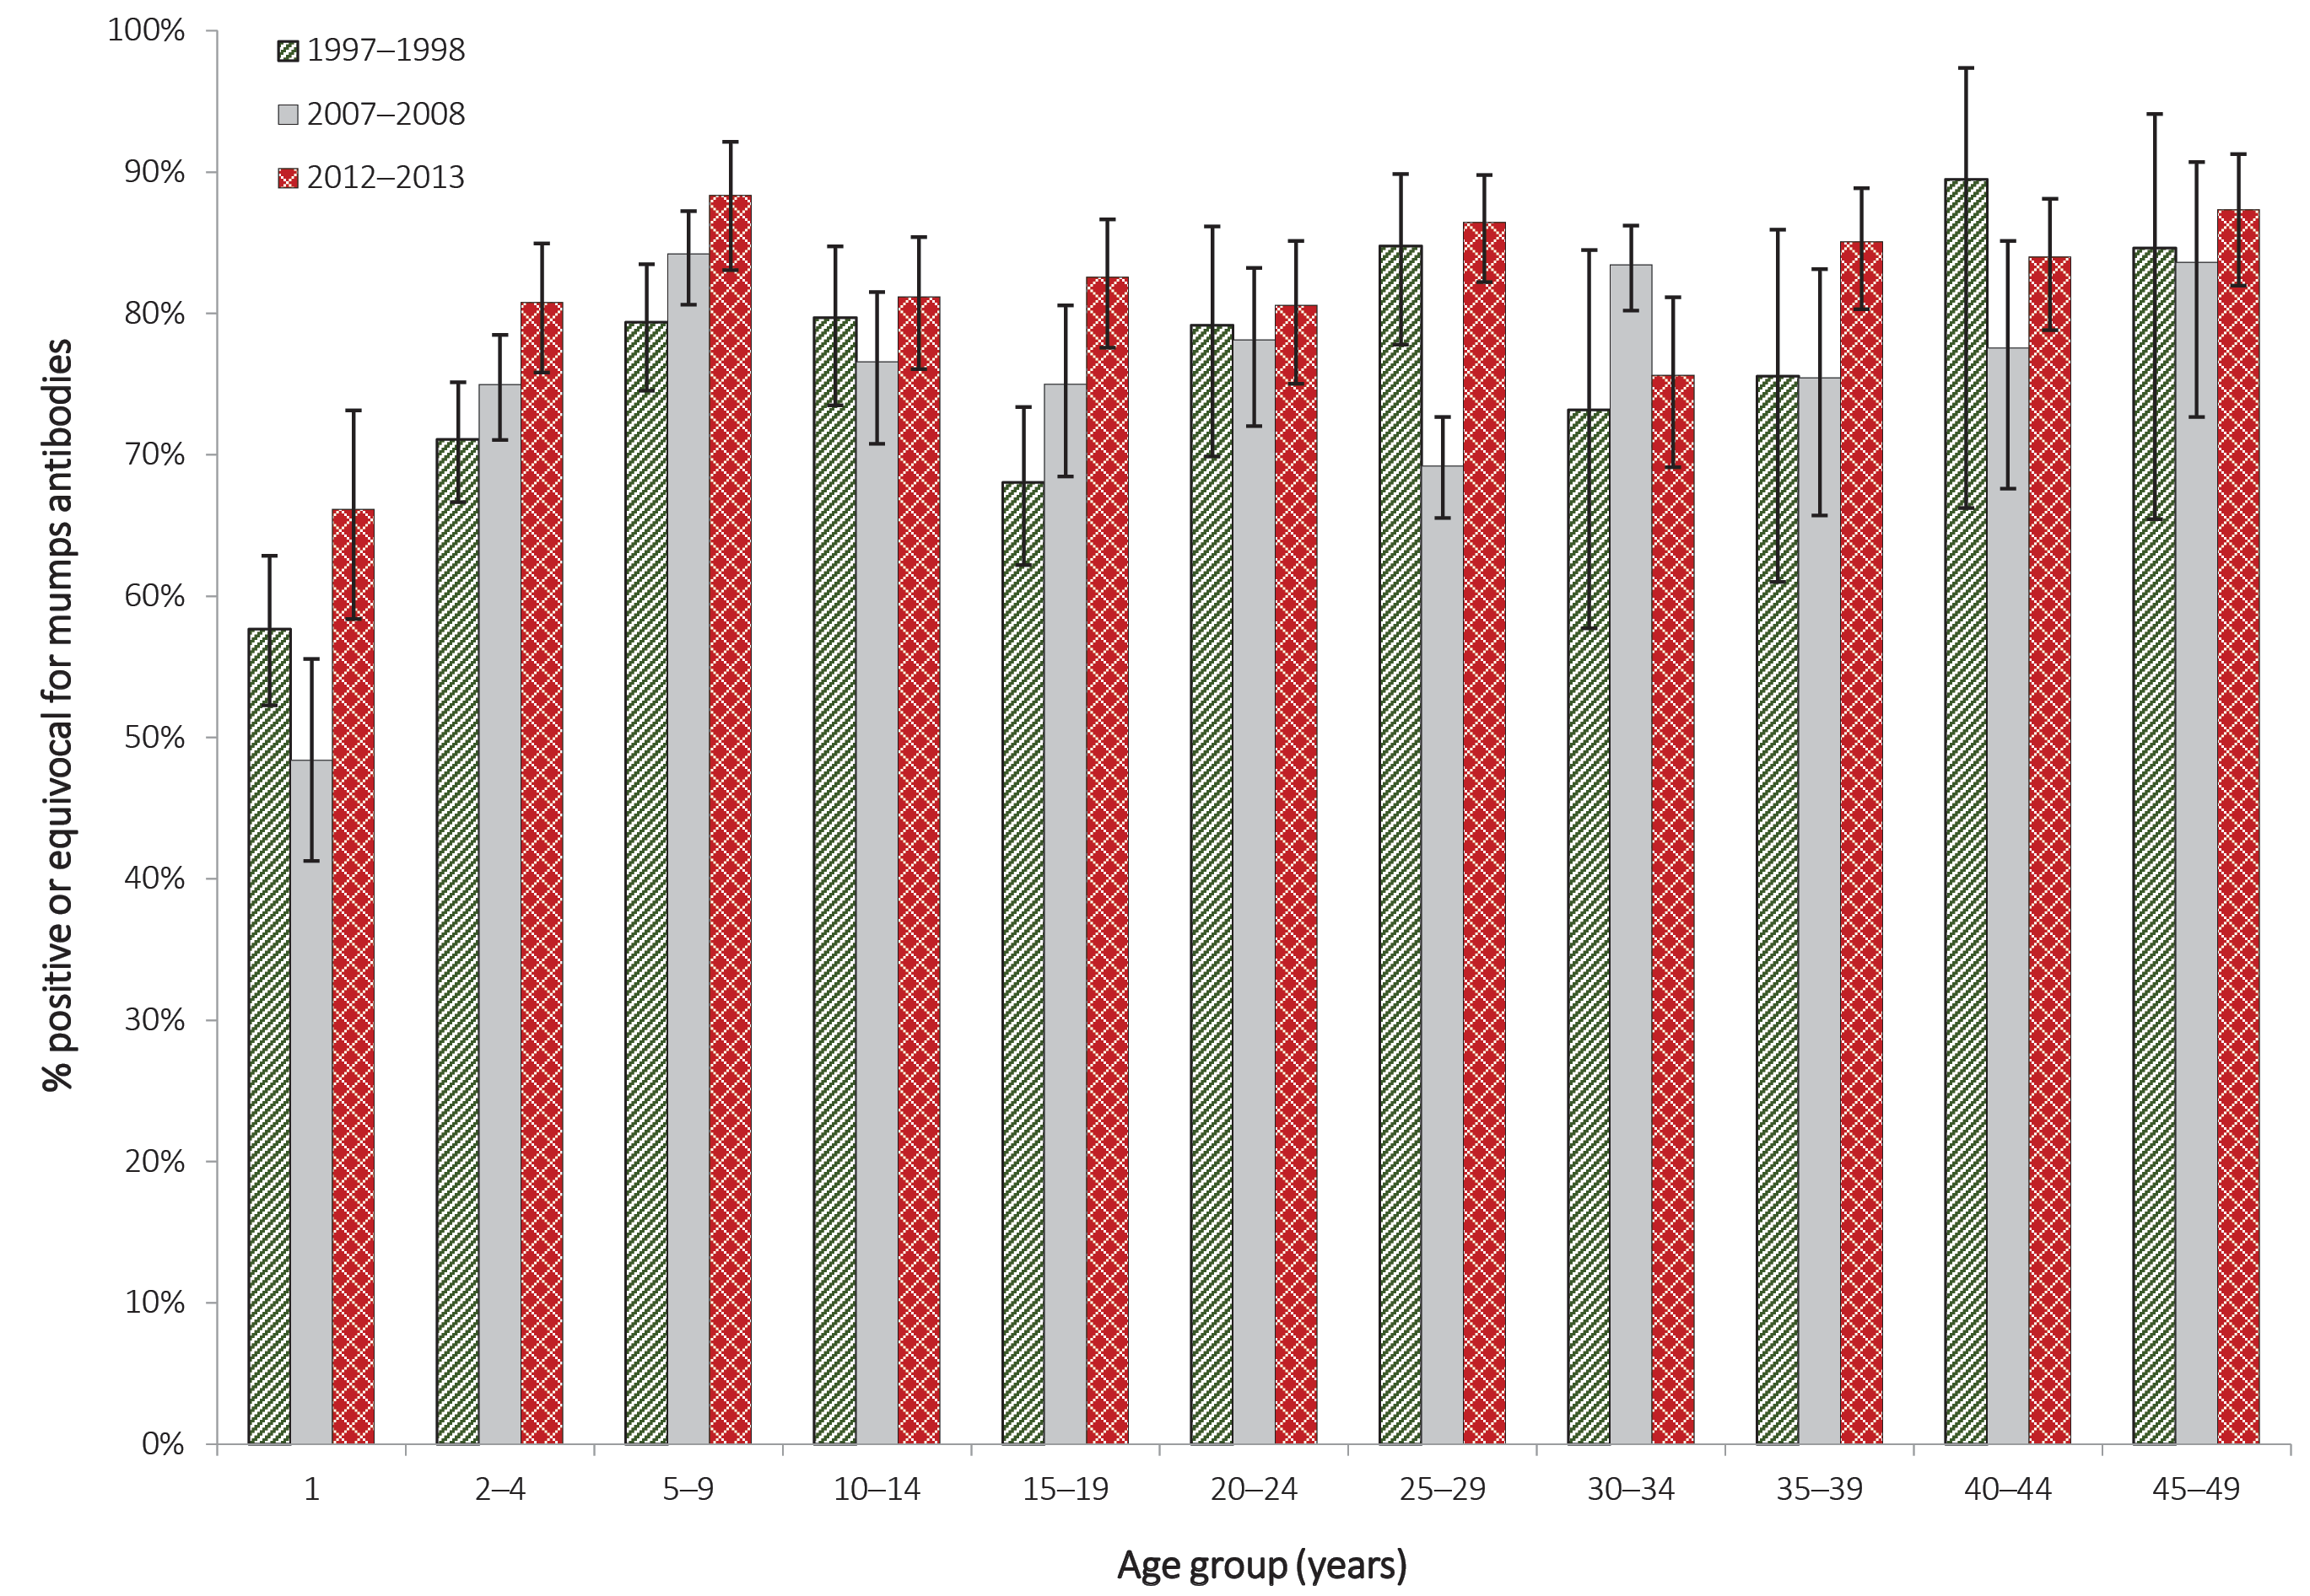

Figure 2: Proportion of specimens positive only for mumps-specific antibodies, by age group and year of serosurvey
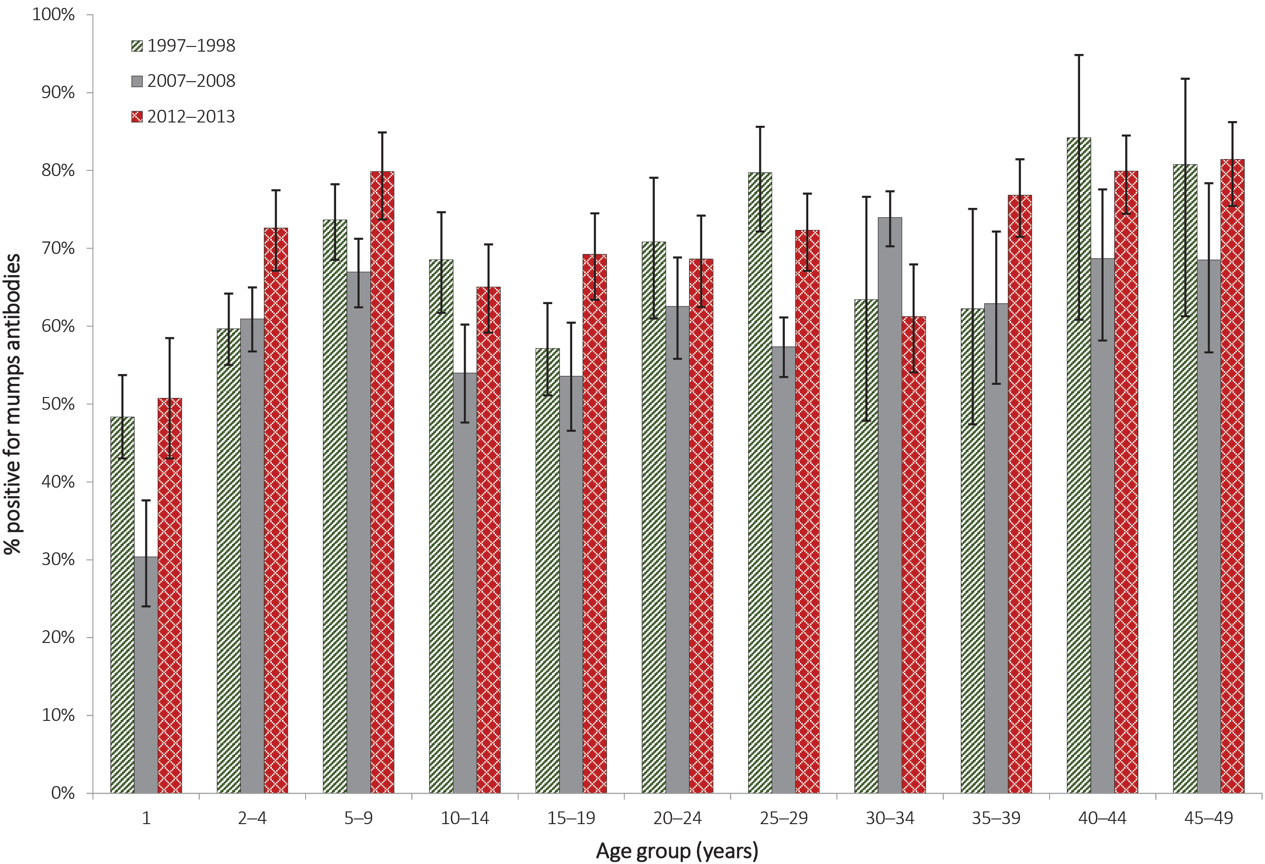

Figure 3: Proportion of specimens positive or equivocal for mumps-specific antibodies, by year of birth and year of serosurvey
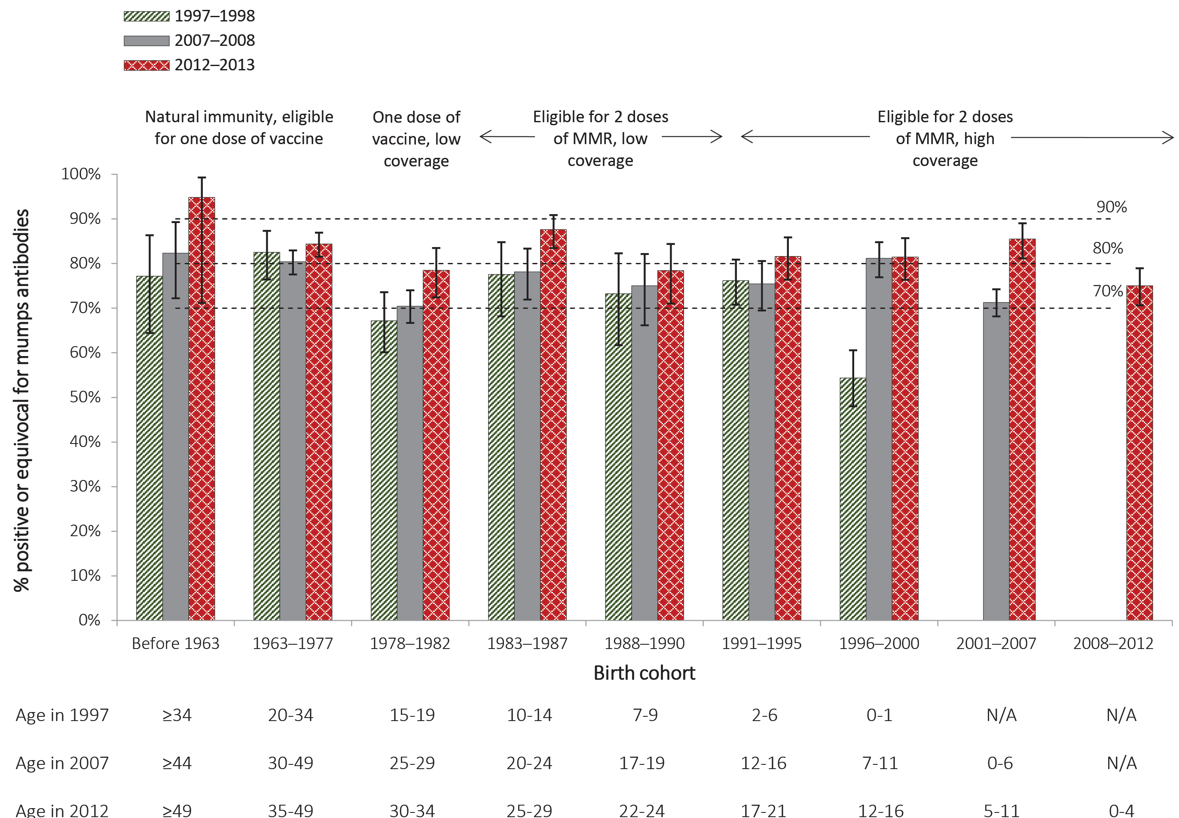

Discussion
In 2012–2013, there was evidence of moderate to high immunity against mumps in the Australian population, with mumps-specific IgG antibodies detected in 82% of a representative sample. This is lower than similar estimates reported for measles (89.7%)³⁶ and rubella (98.8%),³⁷ the other components of the MMR vaccine. Our findings are consistent with evidence that a lower seroconversion rate (especially following 1 dose of MMR vaccine), faster declines in seropositivity and antibody concentrations, and antibodies of lower avidity are observed with the mumps component of MMR vaccine compared to the other two components.^{1,17,38,39}
The proportion with evidence of immunity against mumps (i.e. either positive or equivocal for mumps-specific antibodies) varied by age and was highest among cohorts aged 35 years or more (84–87%), who would be expected to have had higher rates of mumps infection in childhood. The proportion positive or equivocal was greater than 80% for all age groups except 1-year olds (66.1%), who do not complete the vaccination course until 18 months of age, and those aged 30–34 years (75.6%), corresponding to the birth cohort with historically lower mumps seropositivity and having missed the second dose of MMR vaccine.³⁴ Marginally higher proportions with equivocal results were observed among people aged 10–34 years (11–16%) compared with those aged 2–9 (8–8.5%) years and 35–49 years (4–8%). This is likely due to a combination of lower 2-dose coverage and waning immunity among those completing the MMR vaccination schedule ten or more years prior.
Seropositivity in the 2007–2008 and 1997–1998 serosurveys also varied by age, which may be attributable to a number of factors including changes in the rate of past mumps infection, changes to vaccination schedules, supplementary vaccination campaigns, and changes in age-related vaccine coverage over time.^{3,11–16,20} The higher overall proportion positive or equivocal in 2012–2013 (82.1%) compared to the 1997–1998 and 2007–2008 serosurveys (75.5% and 72.5%, respectively) likely reflects improving 2-dose coverage of MMR vaccine, especially in children. While coverage of the first dose of MMR vaccine has been consistently above 90% since 2000,⁴⁰ 2-dose MMR vaccine coverage among 5-year olds increased from 80.3% in 2008 to 91.6% in 2012.¹⁴ However, the differences in age-specific mumps seroprevalence across the serosurveys were marginal, in contrast to clear evidence of increasing equivocal results observed in the same age cohorts for measles.³⁶
The lower proportion positive or equivocal for mumps-specific antibodies observed for 30–34 year olds in the 2012–2013 serosurvey is consistent with results of the previous serosurveys documenting lower immunity against mumps in the 1978–1982 birth cohort compared with the rest of the Australian population.³⁴ Circulation of mumps virus was declining in the 1980s³⁴ and vaccination was not routinely offered to infants until 1983. Although this age cohort was targeted in a 2001 MMR vaccination campaign for young adults aged 18–30 years, uptake was low so it is likely that many remained both unvaccinated and uninfected.^{41,42}
The overall estimates of seropositivity in our study are slightly lower than population-level seropositivity reported in other countries with high coverage of mumps-containing vaccine, including the USA (90.0% in 1999–2004⁴³ and 87.6% in 2009–2010),⁴⁴ the Netherlands (90.9% in 2006–2007)⁴⁵ and Spain (88.3% in 2007–2010).⁴⁶ However the variations and trends in seropositivity to mumps by age group observed in our study are broadly similar to these other international serosurveys.^{38,45,46} Our lower observed seroprevalance rates overall may be attributable to differences in the sensitivity of test assays used in different studies,³³ rather than to lower immunity in Australia.
Although the proportion of the population with evidence of immunity against mumps in our study is below the estimated threshold for herd immunity for mumps of 90–92%,⁴⁷ there is no current evidence of widespread community transmission of mumps in Australia. A recent analysis of mumps notifications in Australia,⁴⁸ reproduced in Figure 4, showed that incidence has remained low overall. The exception is two outbreaks among Aboriginal and Torres Strait Islander people reported in 2007–2008²¹ and 2015–2017.^{49,50} These outbreaks predominantly occurred in close contact settings in remote Aboriginal communities and mainly affected adolescents and young adults up to age 30 years, despite 52% (80/153)²¹ and 89% (371/419)⁶ of cases having received 2 doses of mumps vaccine in the 2007–2008 and 2015–2017 outbreaks. A matched case-control analysis of the mumps outbreak in Western Australia in 2015 found low 2-dose vaccine effectiveness among Aboriginal people.⁴⁹ Multiple outbreaks have also occurred among close contact groups of adolescents and young adults in other countries despite high 2-dose vaccine coverage,^{21,25,26,28,29,51–57} with lower vaccine effectiveness reported in outbreaks for individuals with increasing time since vaccination.^{52,58} In the absence of data on seroprevalence in the affected population immediately prior to an outbreak, it is unclear whether population-level mumps seropositivity lower than 90% is predictive of future outbreaks. However, the evidence cumulatively suggests that populations with moderate levels of immunity, particularly those who completed vaccination more than 10 years prior to disease exposure, are vulnerable to mumps outbreaks in settings with a high force of infection, consistent with data over the past two decades in Australia.

Figure 4: Mumps notification rates, all jurisdictions, 2006 to 2015, by Aboriginal and Torres Strait Islander statusª
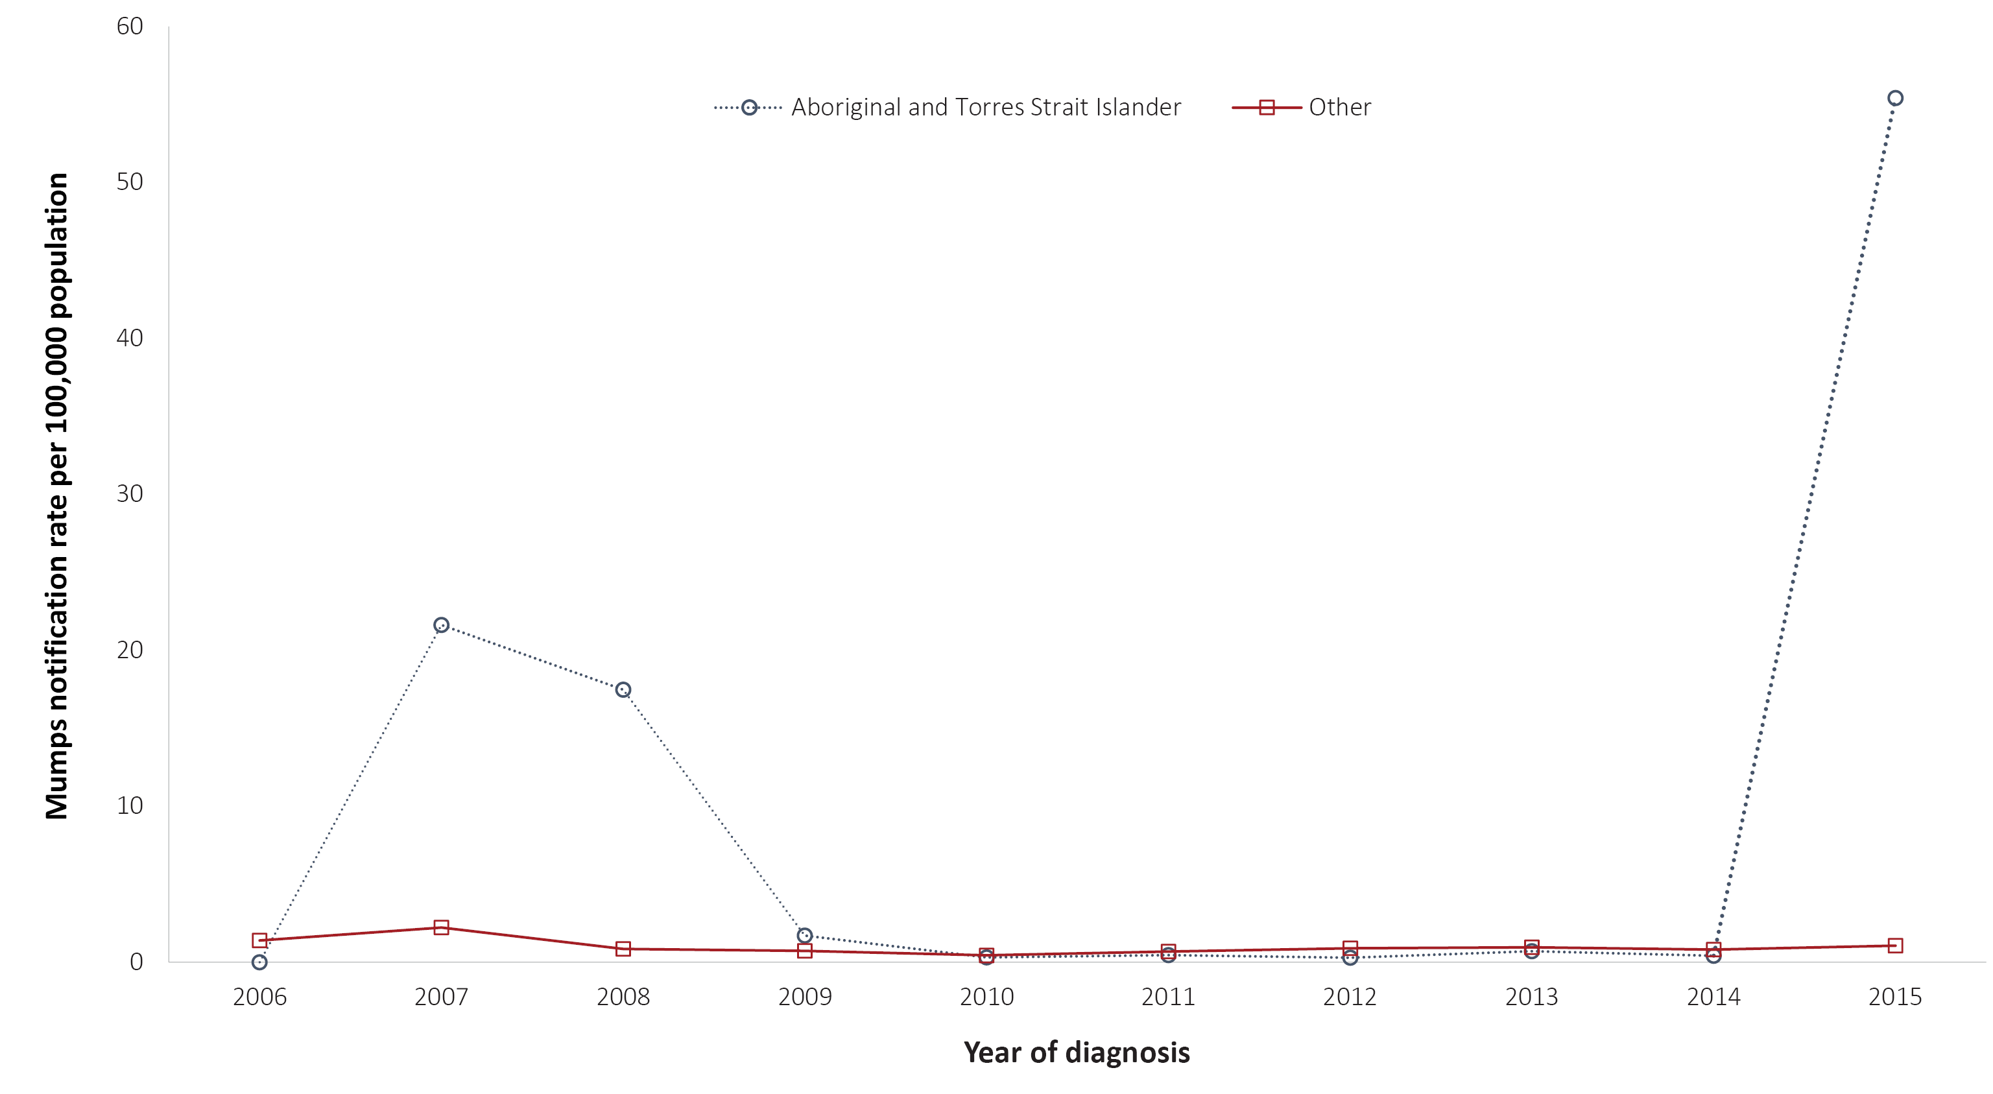
a Reproduced from reference 48.

Limitations of our study include the absence of data on vaccination status; on time since vaccination; and on Aboriginal and Torres Strait Islander status. Our data may underestimate true seroprevalence in Australia, with the moderate seropositivity and relatively high proportion of equivocal results related to the immunoassay used. The commercial assay Enzygnost ELISA was used in all three serosurveys we have conducted, and has been previously shown to be significantly less sensitive than the Microimmune ELISA.³³ The MicroImmune ELISA currently commercially available is more appropriate for testing mumps-specific IgM rather than IgG. Establishing a correlate of protection for mumps has been problematic,¹ in contrast to measles and rubella. While plaque reduction neutralisation tests are considered to be the gold standard for mumps serology,^{59,60} they are cumbersome and time-consuming, and unsuitable for testing thousands of samples for the purpose of serosurveillance. Furthermore, while the frequency of mumps-specific B cells appears to be low,⁵⁹ the possibility of immunity through B cell memory or cellular immunity cannot be excluded in people negative for mumps antibodies. We have attempted to address the limitations of the test assay by presenting positive and equivocal results together, as well as positive results only.
In conclusion, this 2012–2013 serosurvey provides evidence of moderate to high population level immunity against mumps, marginally higher than, but similar to, estimates from past national serosurveys. Despite mumps-specific seroprevalence below the presumptive herd immunity threshold of 92%, seropositivity was > 80% in most age groups. Given the absence of widespread mumps transmission in Australia, indicated by the low notification rates of acute mumps infection (0.9 per 100,000 in 2012),³ our findings imply that there is adequate population-level protection afforded by the vaccination program in Australia. In close contact settings where there is a high force of infection, there is a risk of outbreaks every ten or so years. The long-term effectiveness of mumps vaccination and the potential value of a third dose of mumps-containing vaccine, particularly in selected populations, is being examined internationally.^{58,61–64} While a third dose of mumps-containing vaccine is not currently warranted at a population level for any age or regional group, its use in outbreak settings would likely be effective in limiting case numbers. Ongoing monitoring of population-level seroprevalence of mumps-specific antibodies and more detailed examination of seroprevalence among high-risk populations, such as Aboriginal and Torres Strait Islander people in some regions, could further inform consideration of this issue in Australia.

Acknowledgements
We wish to thank the staff of all the laboratories that have contributed sera/plasma to our national serosurvey program for their valuable contribution.
The National Centre for Immunisation Research and Surveillance is supported by the Australian Government Department of Health, the NSW Ministry of Health and The Sydney Children’s Hospitals Network. The opinions expressed in this paper are those of the authors, and do not necessarily represent the views of these agencies.

Author details
Cyra Patel¹ Frank Beard^{1,2} Alexandra Hendry¹ Helen Quinn^{1,2} Aditi Dey^{1,2} Kristine Macartney^{1,2} Linda Hueston³ Dominic E Dwyer³ Peter McIntyre¹
- National Centre for Immunisation Research and Surveillance, Children’s Hospital at Westmead, Sydney, Australia
- University of Sydney, Sydney, Australia
- Institute of Clinical Pathology and Medical Research, NSW Health Pathology, Westmead, Sydney, Australia

Corresponding author
Cyra Patel National Centre for Immunisation Research and Surveillance Kids Research, The Children’s Hospital at Westmead Locked Bag 4001, Westmead NSW 2145, Australia Phone: +61 2 9845 1407 / +61 466 345 248 Email: cyra.patel@health.nsw.gov.au

References
- ﻿Rubin SA. 40 – Mumps vaccines. In: Plotkin SA, Orenstein WA, Offit PA, Edwards KM, eds. Vaccines. 7th ed. Philadeliphia, PA: Elsevier Saunders; 2018. p. 663–88.e11.
- Dey A, Knox S, Wang H, Beard FH, McIntyre PB. Summary of national surveillance data on vaccine preventable diseases in Australia, 2008–2011. Commun Dis Intell Q Rep. 2016;40(Suppl):S1–70.
- Bag SK, Dey A, Wang H, Beard F. Australian vaccine preventable disease epidemiological review series: mumps 2008–2012. Commun Dis Intell Q Rep. 2015;39(1):E10–18.
- Hviid A, Rubin S, Muhlemann K. Mumps. Lancet. 2008;371(9616):932–44.
- Australian Technical Advisory Group on Immunisation (ATAGI). The Australian Immunisation Handbook, 10th ed: Mumps. [Internet.] Canberra: Australian Government Department of Health; 2019. [Accessed on 12 July 2019.] Available from: https://immunisationhandbook.health.gov.au/vaccine-preventable-diseases/mumps.
- Westphal DW, Eastwood A, Levy A, Davies J, Huppatz C, Gilles M et al. A protracted mumps outbreak in Western Australia despite high vaccine coverage: a population-based surveillance study. Lancet Infect Dis. 2019;19(2):177–84.
- Donahue M, Schneider A, Ukegbu U, Shah M, Riley J, Weigel A et al. Notes From the field: complications of mumps during a university outbreak among students who had received 2 doses of measles-mumps-rubella vaccine – Iowa, July 2015–May 2016. MMWR Morb Mortal Wkly Rep. 2017;66(14):390–391.
- Zamir CS, Schroeder H, Shoob H, Abramson N, Zentner G. Characteristics of a large mumps outbreak: clinical severity, complications and association with vaccination status of mumps outbreak cases. Hum Vaccin Immunother. 2015;11(6):1413–7.
- Yung CF, Andrews N, Bukasa A, Brown KE, Ramsay M. Mumps complications and effects of mumps vaccination, England and Wales, 2002–2006. Emerg Infect Dis. 2011;17(4):661–7.
- Kutty PK, Lawler J, Rausch-Phung E, Ortega-Sanchez IR, Goodell S, Schulte C et al. Epidemiology and the economic assessment of a mumps outbreak in a highly vaccinated population, Orange County, New York, 2009–2010. Hum Vaccin Immunother. 2014;10(5):1373–81.
- National Centre for Immunisation Research & Surveillance (NCIRS). Significant events in measles, mumps and rubella vaccination practice in Australia. Sydney: NCIRS; 2019. [Accessed on 20 July 2020.] Available from: http://ncirs.org.au/sites/default/files/2019-12/Measles-mumps-rubella-history-Dec%202019.pdf.
- Hull B, Dey A, Menzies R, McIntyre P. Annual immunisation coverage report, 2010. Commun Dis Intell Q Rep. 2013;37(1):E21–39.
- Hull BP, Dey A, Menzies RI, Brotherton JM, McIntyre PB. Immunisation coverage annual report, 2011. Commun Dis Intell Q Rep. 2013;37(4):E291–312.
- Hull BP, Dey A, Menzies RI, Brotherton JM, McIntyre PB. Immunisation coverage, 2012. Commun Dis Intell Q Rep. 2014;38(3):E208–31.
- Hull BP, Dey A, Beard FH, Menzies RI, Brotherton JM, McIntyre PB. Immunisation coverage annual report, 2013. Commun Dis Intell Q Rep. 2016;40(1):E146–69.
- Hull BP, Hendry AJ, Dey A, Beard FH, Brotherton JM, McIntyre PB. Immunisation coverage annual report, 2014. Commun Dis Intell Q Rep. 2017;41(1):E68–90.
- Kontio M, Jokinen S, Paunio M, Peltola H, Davidkin I. Waning antibody levels and avidity: implications for MMR vaccine-induced protection. J Infect Dis. 2012;206(10):1542–8.
- Demicheli V, Rivetti A, Debalini MG, Di Pietrantonj C. Vaccines for measles, mumps and rubella in children. Cochrane Database Syst Rev. 2012;2012(2):CD004407.
- Australian Government Department of Health. Australian national notifiable diseases and case definitions. [Internet.] Canberra: Australian Government Department of Health; 2019. Available from: https://www1.health.gov.au/internet/main/publishing.nsf/Content/cdna-casedefinitions.htm.
- McIntyre P, Amin J, Gidding H, Hull B, Torvaldsen S, Tucker A et al. Vaccine preventable diseases and vaccination coverage in Australia, 1993–1998. Commun Dis Intell. 2000;24(Suppl):v–83.
- Bangor-Jones RD, Dowse GK, Giele CM, van Buynder PG, Hodge MM, Whitty MM. A prolonged mumps outbreak among highly vaccinated Aboriginal people in the Kimberley region of Western Australia. Med J Aust. 2009;191(7):398–401.
- Australian Government Department of Health. National Notifiable Diseases Surveillance System: summary tables for selected single disease. [Internet.] Canberra: Australian Government Department of Health; 2017. Available from: http://www9.health.gov.au/cda/source/cda-index.cfm.
- Naidu L, Chiu C, Habig A, Lowbridge C, Jayasinghe S, Wang H et al. Vaccine preventable diseases and vaccination coverage in Aboriginal and Torres Strait Islander people, Australia 2006–2010. Commun Dis Intell Q Rep. 2013;37(Suppl):S1–95.
- Queensland Health. Notifiable conditions annual reporting. Brisbane: Queensland Government, Queensland Health; 2019. Available from: https://www.health.qld.gov.au/clinical-practice/guidelines-procedures/diseases-infection/surveillance/reports/notifiable/annual.
- Centers for Disease Control and Prevention (CDC). Mumps cases and outbreaks. [Internet.] Atlanta, GA: United States Government Department of Health and Human Services, CDC; 2017. Available from: https://www.cdc.gov/mumps/outbreaks.html.
- Eriksen J, Davidkin I, Kafatos G, Andrews N, Barbara C, Cohen D et al. Seroepidemiology of mumps in Europe (1996–2008): why do outbreaks occur in highly vaccinated populations? Epidemiol Infect. 2013;141(3):651–66.
- Levine H, Zarka S, Ankol OE, Rozhavski V, Davidovitch N, Aboudy Y et al. Seroprevalence of measles, mumps and rubella among young adults, after 20 years of universal 2-dose MMR vaccination in Israel.Hum Vaccin Immunother. 2015;11(6):1400–5.
- Nedeljković J, Kovačević-Jovanović V, Milošević V, Šeguljev Z, Petrovic V, Muller CP et al. A mumps outbreak in Vojvodina, Serbia, in 2012 underlines the need for additional vaccination opportunities for young adults. PloS One. 2015;10(10):e0139815.
- Schwarz NG, Bernard H, Melnic A, Bucov V, Caterinciuc N, an der Heiden M et al. Mumps outbreak in the Republic of Moldova, 2007–2008. Pediatr Infect Dis J. 2010;29(8):703–6.
- Song N, Gao Z, Wood JG, Hueston L, Gilbert GL, MacIntyre CR et al. Current epidemiology of rubella and congenital rubella syndrome in Australia: progress towards elimination. Vaccine. 2012;30(27):4073–8.
- Gilbert GL, Escott RG, Gidding HF, Turnbull FM, Heath TC, McIntyre PB et al. Impact of the Australian Measles Control Campaign on immunity to measles and rubella. Epidemiol Infect. 2001;127(2):297–303.
- Kelly H, Riddell MA, Gidding HF, Nolan T, Gilbert GL. A random cluster survey and a convenience sample give comparable estimates of immunity to vaccine preventable diseases in children of school age in Victoria, Australia. Vaccine. 2002;20(25–26):3130–6.
- Backhouse JL, Gidding HF, McIntyre PB, Gilbert GL. Evaluation of two enzyme immunoassays for detection of immunoglobulin G antibodies to mumps virus. Clin Vaccine Immunol. 2006;13(7):764–7.
- Aratchige PE, McIntyre PB, Quinn HE, Gilbert GL. Recent increases in mumps incidence in Australia: the “forgotten” age group in the 1998 Australian Measles Control Campaign. Med J Aust. 2008;189(8):434–7.
- Australian Bureau of Statistics. 3238.0 – Estimates and Projections, Aboriginal and Torres Strait Islander Australians, 2001 to 2026. [Internet.] Canberra: Australian Government, Australian Bureau of Statistics; 30 April 2014. Available from: http://www.abs.gov.au/ausstats/abs@.nsf/mf/3238.0.
- Gidding HF, Quinn HE, Hueston L, Dwyer DE, McIntyre PB. Declining measles antibodies in the era of elimination: Australia’s experience. Vaccine. 2018;36(4):507–13.
- Edirisuriya C, Beard FH, Hendry AJ, Dey A, Gidding HF, Hueston L et al. Australian rubella serosurvey 2012–2013: on track for elimination? Vaccine. 2018;36(20):2794–8.
- Davidkin I, Jokinen S, Broman M, Leinikki P, Peltola H. Persistence of measles, mumps, and rubella antibodies in an MMR-vaccinated cohort: a 20-year follow-up. J Infect Dis. 2008;197(7):950–6.
- Johnson CE, Kumar ML, Whitwell JK, Staehle BO, Rome LP, Dinakar C et al. Antibody persistence after primary measles-mumps-rubella vaccine and response to a second dose given at four to six vs. eleven to thirteen years. Ped Infect Dis J. 1996;15(8):687–92.
- Hull BP, Mahajan D, Dey A, Menzies RI, McIntyre PB. Immunisation coverage annual report, 2008. Commun Dis Intell Q Rep. 2010;34(3):241–58.
- Gidding HF, Wood J, MacIntyre CR, Kelly H, Lambert SB, Gilbert GL et al. Sustained measles elimination in Australia and priorities for long term maintenance. Vaccine. 2007;25(18):3574–80.
- Kelly HA, Gidding HF, Karapanagiotidis T, Leydon JA, Riddell MA. Residual susceptibility to measles among young adults in Victoria, Australia following a national targeted measles-mumps-rubella vaccination campaign. BMC Public Health. 2007;7:99.
- Kutty PK, Kruszon-Moran DM, Dayan GH, Alexander JP, Williams NJ, Garcia PE et al. Seroprevalence of antibody to mumps virus in the US population, 1999–2004. J Infect Dis. 2010;202(5):667–74.
- Lebo EJ, Kruszon-Moran DM, Marin M, Bellini WJ, Schmid S, Bialek SR et al. Seroprevalence of measles, mumps, rubella and varicella antibodies in the United States population, 2009–2010. Open Forum Infect Dis. 2015;2(1):ofv006.
- Smits G, Mollema L, Hahné S, de Melker H, Tcherniaeva I, Waaijenborg S et al. Seroprevalence of mumps in the Netherlands: dynamics over a decade with high vaccination coverage and recent outbreaks. PloS One. 2013;8(3):e58234.
- González-Escalada A, García-García L, Viguera-Ester P, Marín-García P, García J, Gil-de-Miguel A et al. Seroprevalence of antibodies against measles, rubella, mumps, varicella-zoster, and B. pertussis in young adults of Madrid, Spain. Hum Vaccin Immunother. 2013;9(9):1918–25.
- Anderson RM. The concept of herd immunity and the design of community-based immunization programmes. Vaccine. 1992;10(13):928–35.
- Ioannides S, Beard F, Larter N, Clark K, Wang H, Hendry A et al. Vaccine preventable diseases and vaccination coverage in Aboriginal and Torres Strait Islander people, Australia, 2011–2015. Commun Dis Intell (2018). 2019;43. doi: https://doi.org/10.33321/cdi.2019.43.36.
- Westphal D, Quinn HE, Effler P, eds. Vaccine effectiveness during a large mumps outbreak in Western Australia. 15th National Immunisation Conference. 7–9 June 2016. [Conference proceedings.] Brisbane: Public Health Association of Australia; 2016.
- Queensland Health. Notifiable conditions reports: summary information. [Internet.] Brisbane: Queensland Government, Queensland Health; 2017. Available from: https://www.health.qld.gov.au/clinical-practice/guidelines-procedures/diseases-infection/surveillance/reports/notifiable/summary.
- Albertson JP, Clegg WJ, Reid HD, Arbise BS, Pryde J, Vaid A et al. Mumps outbreak at a university and recommendation for a third dose of measles-mumps-rubella vaccine – Illinois, 2015–2016. MMWR Morb Mortal Wkly Rep. 2016;65(29):731–4.
- Vygen S, Fischer A, Meurice L, Mounchetrou Njoya I, Gregoris M, Ndiaye B et al. Waning immunity against mumps in vaccinated young adults, France 2013. Euro Surveill. 2016;21(10). doi: https://doi.org/10.2807/1560-7917.ES.2016.21.10.30156.
- Fields VS, Safi H, Waters C, Dillaha J, Capelle L, Riklon S et al. Mumps in a highly vaccinated Marshallese community in Arkansas, USA: an outbreak report. Lancet Infect Dis. 2019;19(2):185–92.
- Indenbaum V, Hübschen JM, Stein-Zamir C, Mendelson E, Sofer D, Hindiyeh M et al. Ongoing mumps outbreak in Israel, January to August 2017. Euro Surveill. 2017;22(35). doi: https://doi.org/10.2807/1560-7917.ES.2017.22.35.30605.
- Shah M, Quinlisk P, Weigel A, Riley J, James L, Patterson J et al. Mumps outbreak in a highly vaccinated university-affiliated setting before and after a measles-mumps-rubella vaccination campaign—Iowa, July 2015 – May 2016. Clin Infect Dis. 2018;66(1):81–8.
- Willocks LJ, Guerendiain D, Austin HI, Morrison KE, Cameron RL, Templeton KE et al. An outbreak of mumps with genetic strain variation in a highly vaccinated student population in Scotland. Epidemiol Infect. 2017;145(15):3219–25.
- Deeks SL, Lim GH, Simpson MA, Gagne L, Gubbay J, Kristjanson E et al. An assessment of mumps vaccine effectiveness by dose during an outbreak in Canada. CMAJ. 2011;183(9):1014–20.
- Cardemil CV, Dahl RM, James L, Wannemuehler K, Gary HE, Shah M et al. Effectiveness of a third dose of MMR vaccine for mumps outbreak control. N Engl J Med. 2017;377(10):947–56.
- Latner DR, McGrew M, Williams NJ, Sowers SB, Bellini WJ, Hickman CJ. Estimates of mumps seroprevalence may be influenced by antibody specificity and serologic method. Clin Vaccine Immunol. 2014;21(3):286–97.
- Ravault S, Friel D, Di Paolo E, Caplanusi A, Gillard P, Povey M et al. Assessment of mumps virus-specific antibodies: comparison of plaque reduction neutralization test and enzyme-linked immunosorbent assay estimates. J Infect Dis. 2019;220(9):1462–8.
- Nelson GE, Aguon A, Valencia E, Oliva R, Guerrero ML, Reyes R et al. Epidemiology of a mumps outbreak in a highly vaccinated island population and use of a third dose of measles-mumps-rubella vaccine for outbreak control – Guam 2009 to 2010. Ped Infect Dis J. 2013;32(4):374–80.
- Ogbuanu IU, Kutty PK, Hudson JM, Blog D, Abedi GR, Goodell S et al. Impact of a third dose of measles-mumps-rubella vaccine on a mumps outbreak. Pediatrics. 2012;130(6):e1567–74.
- Marin M, Marlow M, Moore KL, Patel M. Recommendation of the Advisory Committee on Immunization Practices for use of a third dose of mumps virus–containing vaccine in persons at increased risk for mumps during an outbreak. MMWR Morb Mortal Wkly Rep. 2018;67(1):33–8.
- Hamami D, Cameron R, Pollock KG, Shankland C. Waning immunity Is associated with periodic large outbreaks of mumps: a mathematical modeling study of Scottish data. Front Physiol. 2017;8:233.

Appendix A: Supplementary tables
Table A.1: Significant changes to mumps vaccination programs and policy in Australiaª
Year | Changes to mumps vaccination program and/or policy
1981 | Monovalent mumps vaccine recommended for children 12 months of age, not funded
1983 | Combined measles-mumps vaccine funded under NIP for children 12 months of age
1993–94 | School-based delivery of second dose of MMR vaccine to children 10–14 years of age (typically offered in last year of primary or first year of secondary school to children 12–13 years of age)
1998 | National Measles Control Campaign targeting children 5-12 years of age; second MMR vaccine dose moved to 4–5 years from 10–14 years
2001 | Funded young adult (18–30 years) MMR vaccination campaign
2013 | Second dose of mumps-containing vaccine provided (as MMRV) at 18 months of age under NIP, bringing forward age of second childhood vaccination from 4 years
a MMR: measles-mumps-rubella vaccine; MMRV: measles-mumps-rubella-varicella vaccine; NIP: National Immunisation Program. Summarised from ref. 11.
Table A.2: Proportion of specimens positive, equivocal or negative for mumps-specific antibodies, by state/territory, 2012–2013
State/ territory | n | Positive or equivocal |  | Positive |  | Equivocal |  | Negative
 |  | % | 95% CI | % | 95% CI | % | 95% CI | % | 95% CI
ACT | 54 | 81.5% | 68.9–89.7% | 64.8% | 51.3–76.3% | 16.7% | 8.9–29.0% | 18.5% | 10.3–31.1%
NSW | 872 | 80.7% | 77.9–83.2% | 68.6% | 65.4–71.6% | 12.1% | 10.1–14.4% | 19.3% | 16.8–22.1%
NT | 49 | 80.2% | 65.7–89.6% | 75.2% | 60.1–85.9% | 5.0% | 1.3–18.0% | 19.8% | 10.4–34.3%
Qld | 558 | 83.5% | 80.1–86.3% | 73.4% | 69.6–77.0% | 10.0% | 7.7–12.9% | 16.5% | 13.7–19.9%
SA | 194 | 81.8% | 75.7–86.6% | 70.7% | 63.9–76.7% | 11.0% | 7.3–16.3% | 18.2% | 13.4–24.3%
Tas | 56 | 73.2% | 60.2–83.2% | 57.1% | 44.0–69.4% | 16.1% | 8.6–28.1% | 26.8% | 16.8–39.8%
Vic | 674 | 83.0% | 79.9–85.6% | 73.4% | 69.9–76.6% | 9.6% | 7.6–12.0% | 17.0% | 14.4–20.1%
WA | 272 | 83.7% | 77.9–88.2% | 72.8% | 66.2–78.5% | 10.9% | 7.2–16.2% | 16.3% | 11.8–22.1%
Australia | 2,729 | 82.1% | 80.6–83.5% | 71.1% | 69.4–72.9% | 10.9% | 9.8–12.2% | 17.9% | 16.5–19.4%

Table A.3: Proportion of specimens positive, equivocal (or both) or negative for mumps-specific antibodies, by age group and year of serosurvey
Age group (years) | 1997–1998 (N = 1,915) |  |  | 2007–2008 (N = 3,396) |  |  | 2012–2013 (N = 2,729)
 | Number tested | % | 95% CI | Number tested | % | 95% CI | Number tested | % | 95% CI
Positive or equivocal
1 | 333 | 57.7% | 52.3–62.9% | 208 | 48.4% ª | 41.3–55.6% | 183 | 66.1% | 58.4–73.1%
2–4 | 439 | 71.1% ª | 66.6–75.1% | 601 | 74.9% | 71.0–78.5% | 287 | 80.8% | 75.8–84.9%
5–9 | 315 | 79.4% ª | 74.5–83.5% | 464 | 84.2% | 80.6–87.2% | 199 | 88.3% | 83.1–92.1%
10–14 | 197 | 79.7% | 73.5–84.7% | 239 | 76.6% | 70.8–81.5% | 270 | 81.2% | 76.1–85.4%
15–19 | 266 | 68.0% ª | 62.2–73.4% | 196 | 75.0% | 68.5–80.6% | 270 | 82.6% | 77.6–86.7%
20–24 | 96 | 79.2% | 69.9–86.2% | 210 | 78.1% | 72.0–83.2% | 250 | 80.6% | 75.0–85.1%
25–29 | 138 | 84.8% | 77.8–89.9% | 640 | 69.2% ª | 65.5–72.7% | 320 | 86.4% | 82.2–89.8%
30–34 | 41 | 73.2% | 57.7–84.5% | 591 | 83.4% ª | 80.2–86.2% | 205 | 75.6% | 69.1–81.1%
35–39 | 45 | 75.6% | 61.0–85.9% | 93 | 75.4% ª | 65.7–83.1% | 285 | 85.1% | 80.3–88.9%
40–44 | 19 | 89.5% | 66.2–97.4% | 84 | 77.6% | 67.6–85.1% | 255 | 84.0% | 78.8–88.1%
45–49 | 26 | 84.6% | 65.4–94.1% | 70 | 83.6% | 72.7–90.7% | 205 | 87.3% | 82.0–91.3%
All ages | 1,915 | 72.5% ª | 70.4–74.4% | 3,396 | 75.5% ª | 74.0–76.9% | 2,729 | 82.1% | 80.6–83.5%
Positive
1 | 333 | 48.3% | 43.0–53.7% | 208 | 30.4% ª | 24.0–37.6% | 183 | 50.8% | 43.0–58.5%
2–4 | 439 | 59.7% ª | 55.0–64.2% | 601 | 60.9% ª | 56.7–65.0% | 287 | 72.6% | 67.1–77.5%
5–9 | 315 | 73.7% | 68.5–78.2% | 464 | 67.0% ª | 62.4–71.2% | 199 | 79.9% | 73.7–84.9%
10–14 | 197 | 68.5% | 61.7–74.6% | 239 | 54.0% ª | 47.6–60.2% | 270 | 65.0% | 59.2–70.5%
15–19 | 266 | 57.1% ª | 51.1–63.0% | 196 | 53.6% ª | 46.6–60.4% | 270 | 69.2% | 63.4–74.5%
20–24 | 96 | 70.8% | 61.0–79.0% | 210 | 62.5% | 55.8–68.8% | 250 | 68.6% | 62.4–74.2%
25–29 | 138 | 79.7% | 72.2–85.6% | 640 | 57.3% ª | 53.5–61.1% | 320 | 72.3% | 67.1–77.0%
30–34 | 41 | 63.4% | 47.9–76.6% | 591 | 73.9% ª | 70.2–77.3% | 205 | 61.2% | 54.1–67.9%
35–39 | 45 | 62.2% ª | 47.4–75.1% | 93 | 62.9% ª | 52.6–72.1% | 285 | 76.8% | 71.5–81.4%
40–44 | 19 | 84.2% | 60.8–94.8% | 84 | 68.7% ª | 58.2–77.6% | 255 | 79.9% | 74.4–84.5%
45–49 | 26 | 80.8% | 61.3–91.8% | 70 | 68.5% ª | 56.6–78.4% | 205 | 81.4% | 75.4–86.2%
All ages | 1,915 | 63.2% ª | 61.1–65.4% | 3,396 | 61.0% ª | 59.3–62.7% | 2,729 | 71.1% | 69.4–72.9%
Equivocal
1 | 333 | 9.3% | 6.6–12.9% | 208 | 18.0% | 13.2–24.0% | 183 | 15.4% | 10.2–22.6%
2–4 | 439 | 11.4% | 8.7–14.7% | 601 | 14.0% ª | 11.5–17.0% | 287 | 8.2% | 5.5–12.1%
5–9 | 315 | 5.7% | 3.6–8.9% | 464 | 17.2% ª | 14.0–21.1% | 199 | 8.5% | 5.3–13.2%
10–14 | 197 | 11.2% | 7.5–16.4% | 239 | 22.6% | 17.7–28.3% | 270 | 16.1% | 12.2–21.0%
15–19 | 266 | 10.9% | 7.7–15.3% | 196 | 21.4% ª | 16.2–27.7% | 270 | 13.4% | 9.7–18.1%
20–24 | 96 | 8.3% | 4.2–15.8% | 210 | 15.6% | 11.3–21.1% | 250 | 11.9% | 8.4–16.7%
25–29 | 138 | 5.1% ª | 2.4–10.3% | 640 | 11.9% | 9.6–14.6% | 320 | 14.1% | 10.6–18.5%
30–34 | 41 | 9.8% | 3.7–23.3% | 591 | 9.5% ª | 7.4–12.1% | 205 | 14.4% | 10.2–20.0%
35–39 | 45 | 13.3% | 6.1–26.7% | 93 | 12.6% | 7.2–21.0% | 285 | 8.3% | 5.6–12.0%
40–44 | 19 | 5.3% | 0.7–29.4% | 84 | 8.9% | 4.5–16.9% | 255 | 4.1% | 2.3–7.2%
45–49 | 26 | 3.8% | 0.5–22.8% | 70 | 15.1% ª | 8.5–25.4% | 205 | 5.9% | 3.4–10.1%
All ages | 1,915 | 9.2% | 8.0–10.6% | 3,396 | 14.5% | 13.3–15.7% | 2,729 | 10.9% | 9.8–12.2%
Negative
1 | 333 | 42.3% | 37.1–47.7% | 208 | 51.6% | 44.4–58.7% | 183 | 33.9% | 26.9–41.6%
2–4 | 439 | 28.9% | 24.9–33.4% | 601 | 25.1% | 21.5–29.0% | 287 | 19.2% | 15.1–24.2%
5–9 | 315 | 20.6% | 16.5–25.5% | 464 | 15.8% | 12.8–19.4% | 199 | 11.7% | 7.9–16.9%
10–14 | 197 | 20.3% | 15.3–26.5% | 239 | 23.4% | 18.5–29.2% | 270 | 18.8% | 14.6–23.9%
15–19 | 266 | 32.0% | 26.6–37.8% | 196 | 25.0% | 19.4–31.5% | 270 | 17.4% | 13.3–22.4%
20–24 | 96 | 20.8% | 13.8–30.1% | 210 | 21.9% | 16.8–28.0% | 250 | 19.4% | 14.9–25.0%
25–29 | 138 | 15.2% | 10.1–22.2% | 640 | 30.8% | 27.3–34.5% | 320 | 13.6% | 10.2–17.8%
30–34 | 41 | 26.8% | 15.5–42.3% | 591 | 16.6% | 13.8–19.8% | 205 | 24.4% | 18.9–30.9%
35–39 | 45 | 24.4% | 14.1–39.0% | 93 | 24.6% | 16.9–34.3% | 285 | 14.9% | 11.1–19.7%
40–44 | 19 | 10.5% | 2.6–33.8% | 84 | 22.4% | 14.9–32.4% | 255 | 16.0% | 11.9–21.2%
45–49 | 26 | 15.4% | 5.9–34.6% | 70 | 16.4% | 9.3–27.3% | 205 | 12.7% | 8.7–18.0%
All ages | 1,915 | 27.5% | 25.6–29.6% | 3,396 | 24.5% | 23.1–26.0% | 2,729 | 17.9% | 16.5–19.4%
a Indicates that the difference in the proportion seropositive, equivocal or combined (either seropositive or equivocal), compared to the 2012 serosurvey, is significant (p < 0.05) for that age group.

Communicable Diseases Intelligence
ISSN: 2209-6051 Online

Communicable Diseases Intelligence (CDI) is a peer-reviewed scientific journal published by the Office of Health Protection, Department of Health. The journal aims to disseminate information on the epidemiology, surveillance, prevention and control of communicable diseases of relevance to Australia.

Editor: Tanja Farmer
Deputy Editor: Simon Petrie
Design and Production: Kasra Yousefi
Editorial Advisory Board: David Durrheim, Mark Ferson, John Kaldor, Martyn Kirk and Linda Selvey

Website: http://www.health.gov.au/cdi

Contacts
Communicable Diseases Intelligence is produced by:
Health Protection Policy Branch, Office of Health Protection, Australian Government Department of Health
GPO Box 9848, (MDP 6) CANBERRA ACT 2601

Email: cdi.editor@health.gov.au

Submit an Article
You are invited to submit your next communicable disease related article to the Communicable Diseases Intelligence (CDI) for consideration. More information regarding CDI can be found at: http://health.gov.au/cdi.
Further enquiries should be directed to: cdi.editor@health.gov.au.

This journal is indexed by Index Medicus and Medline.

Creative Commons Licence - Attribution-NonCommercial-NoDerivatives CC BY-NC-ND
© 2020 Commonwealth of Australia as represented by the Department of Health
This publication is licensed under a Creative Commons Attribution-NonCommercial-NoDerivatives 4.0 International Licence from https://creativecommons.org/licenses/by-nc-nd/4.0/legalcode (Licence). You must read and understand the Licence before using any material from this publication.

Restrictions
The Licence does not cover, and there is no permission given for, use of any of the following material found in this publication (if any):
- the Commonwealth Coat of Arms (by way of information, the terms under which the Coat of Arms may be used can be found at www.itsanhonour.gov.au);
- any logos (including the Department of Health’s logo) and trademarks;
- any photographs and images;
- any signatures; and
- any material belonging to third parties.

Disclaimer
Opinions expressed in Communicable Diseases Intelligence are those of the authors and not necessarily those of the Australian Government Department of Health or the Communicable Diseases Network Australia. Data may be subject to revision.

Enquiries
Enquiries regarding any other use of this publication should be addressed to the Communication Branch, Department of Health, GPO Box 9848, Canberra ACT 2601, or via e-mail to: copyright@health.gov.au

Communicable Diseases Network Australia
Communicable Diseases Intelligence contributes to the work of the Communicable Diseases Network Australia.
http://www.health.gov.au/cdna

