Australian vaccine preventable disease epidemiological review series: invasive Haemophilus influenzae type b disease, 2000–2017
Julia E Maguire, Frank Beard, Kelley Méder, Aditi Dey, Kristine Macartney, Peter McIntyre

Abstract

Introduction
Invasive Haemophilus influenzae type b (Hib) disease is rare in Australia following vaccine introduction in 1993. Two deaths in vaccinated children in 2017, and the Hib booster dose moving from age 12 months to 18 months in 2018, prompted this review.

Methods
Hib Case Surveillance Scheme 2000–2017 data were used to calculate incidence, incidence rate ratios (IRR) and vaccine failure (VF) trends. We used denominators from the Australian Immunisation Register to calculate incidence in immunised and unimmunised children.

Results and Discussion
All-age national invasive Hib disease incidence halved from 0.13 per 100,000 population in 2000 to 0.06 in 2017. Of 345 cases notified in 2000–2017, 153 were born post-2000, with 51 (33%) Aboriginal and Torres Strait Islander (Indigenous), and compared with non-Indigenous children IRR was 8.34 (95% CI: 5.83–11.79), with no evidence of decrease. Overall case fatality rate was 12.4% (19/153); 6 cases had underlying medical conditions. The overall incidence of invasive Hib disease was over 8 times higher (16.6 per 100,000) in children with no recorded doses than in children with ≥1 vaccine dose (1.9 per 100,000). VF criteria were met in 65/145 (45%) cases aged >8 weeks, of whom 7 (11%) were immunocompromised and 6 (9%) died, with no evidence of VF increase over time.

Conclusion
Overall, invasive Hib disease incidence declined by 55% from 2000 to 2017, but marked disparity persists between Indigenous and non-Indigenous children. Following moving the fourth dose from 12 to 18 months in 2018, monitoring of 3-dose VFs will be important, especially in Indigenous children.
Keywords: Haemophilus influenzae type b, vaccine failure, immunisation, vaccine preventable disease, epidemiology, surveillance

Introduction
Haemophilus influenzae type b (Hib) is a gram-negative bacterium transmitted via the inhalation of respiratory droplets.¹ Hib can cause invasive disease which may present clinically as meningitis, epiglottitis, cellulitis, pneumonia, septicaemia or septic arthritis.¹ The case fatality rate (CFR) for Hib meningitis in developed countries is at least 3%, and 15–30% of survivors are left with permanent neurological sequelae.^{1,2}
Hib vaccine was funded for young children under the National Immunisation Program (NIP) in April 1993 and extended to include catch-up for all children less than 5 years of age in July 1993. Hib vaccines had been available for private purchase from 1992. The Hib vaccine does not protect against non-type b Haemophilus influenzae serotypes (a, c, d, e and f) or non-typeable strains. In the pre-vaccine era, Hib was the most common cause of bacterial meningitis in children aged <5 years and responsible for almost all cases of epiglottitis, a life-threatening airway obstruction, with more than 500 invasive Hib cases in children aged <5 years each year.³ The incidence of invasive Hib disease in children aged <5 years was up to ten times higher (up to 580 per 100,000 population) in Aboriginal and Torres Strait Islander children than non-Indigenous children (40–60 per 100,000).⁴ By 2010, all-age invasive Hib disease incidence decreased to 1.4 per 100,000 population for Aboriginal and Torres Strait Islander people and 0.07 per 100,000 population for non-Indigenous people.⁵
In non-Indigenous children, the Hib vaccine initially used in the NIP was HbOC (PRP [capsular polysaccharide polyribosyl-ribitol phosphate] conjugated to a mutant diphtheria toxin carrier protein) administered at 2, 4, 6 and 18 months of age. In Aboriginal and Torres Strait Islander children, who had a high incidence before 6 months of age, PRP-OMP (PRP conjugated to the outer membrane protein [OMP] of Neisseria meningitidis serogroup B) was given at 2, 4 and 12 months, as it yielded potentially protective antibody levels from the first dose onwards.^{4,6,7} Following introduction of universal hepatitis B vaccine to the NIP from early 2000, a combination PRP-OMP/hepatitis B vaccine was used for all children. From late 2005, PRP-T (PRP conjugated to tetanus toxoid carrier protein) vaccine replaced PRP-OMP in some states in a hexavalent formulation (Infanrix hexa® at 2, 4 and 6 months of age with a booster at 12 months), and since late 2009 has been the sole Hib vaccine used in the NIP. Further detail on Hib vaccine schedules over time is provided in Appendix 1.
In 2017, two deaths from invasive Hib disease in vaccinated children prompted this review of age-specific invasive Hib disease incidence and vaccine failures. This was also timely due to the changed timing of the Hib booster dose on the NIP from 12 months to 18 months of age, required to accommodate new vaccines at the 12 month schedule point. This is the first comprehensive review since the widespread use of PRP-T vaccine commenced in 2005, except for limited data to 2013.^{4,7}

Methods

Data sources
Invasive Hib disease is notifiable in Australia under state and territory public health legislation, with notifications of confirmed invasive Hib disease reported to state and territory health departments and then to the National Notifiable Diseases Surveillance System (NNDSS). National enhanced surveillance data on NNDSS cases are collected via the Hib Case Surveillance Scheme (HCSS), managed by the National Centre for Immunisation Research and Surveillance. Cases notified between 1 January 2000 and 31 December 2017 were extracted from the HCSS enhanced dataset (including all NNDSS data fields) on 31 October 2018. Population-level Hib vaccination coverage data were extracted from the Australian Immunisation Register (AIR).

Data definitions

Notifications
Case definitions for confirmed invasive Hib disease differed slightly over the period studied. Pre-2004, a confirmed case required a clinically compatible illness as well as isolation of Hib from blood, or detection in a specimen from a sterile site of Hib antigen, or of bacteria of compatible appearance which failed to grow in culture. From 2004 to 30 June 2014, a confirmed case required laboratory definitive evidence, defined as isolation of Hib from a normally sterile site with typing confirmed at an approved reference laboratory, or detection of Hib antigen in cerebrospinal fluid with other laboratory parameters consistent with meningitis. This was amended from 1 July 2014 to isolation or detection of Hib from a normally sterile site with typing confirmed at a jurisdictional or regional reference laboratory.^{8,9} The full case definitions used over the period are provided in Appendix 2﻿.

Vaccination status
To be considered valid, doses of vaccine had to be given at least 14 days before disease onset. A case was defined as ‘unimmunised’ if no doses of Hib vaccine had been received ≥14 days prior to onset. A case aged <12 months was defined (in accordance with the age specific immunisation schedule requirement) as ‘fully immunised’ if they had received a full primary course of the relevant vaccine i.e. 2 doses of PRP-OMP or 3 doses of PRP-T or HbOC ≥14 days prior to disease onset. A case aged ≥12 months was defined as ‘fully immunised’ if they had received any of the following schedules ≥14 days prior to disease onset: (a) a full primary course and a booster dose at ≥12 months of age (3 doses of PRP-OMP or 4 doses of HbOC or PRP-T); (b) 1 dose of any Hib vaccine at 12–14 months of age with a booster dose ≥2 months later; or (c) 1 dose of any Hib vaccine at ≥16 months of age. All other cases, where vaccination status was known, were classified as ‘partially immunised’.⁴

Vaccine failures
Vaccine failures were assessed using a simplified case definition below (Box 1).
Box 1. Haemophilus influenzae type b (Hib) vaccine failure case definition
First Hib vaccine doses before 16 months:
Confirmed case who has received 3 doses of PRP-T or HbOC-containing vaccine, or 2 doses of PRP-OMP-containing vaccine, the first at ≥6 weeks of age, with minimum interval of ≥28 days between doses and last dose ≥14 days prior to disease onset.
OR
First Hib vaccine dose after 16 months:
Confirmed case who has received 1 dose of any Hib-containing vaccine at ≥16 months of age and ≥14 days prior to disease onset.

Data analysis
Notification rates were calculated using the mid-year estimated resident populations released by the Australian Bureau of Statistics (ABS) for 2000–2016 and population projections for 2017.¹⁰ Aboriginal and Torres Strait Islander population estimates for 2001–2016 and projections for 2017 were also provided by the ABS. Data on Hib cases of any age notified between 1 January 2000 and 31 December 2017 were analysed, with more detailed sub-analyses focusing on cases who were born from 1 January 2000 onwards i.e. in the PRP-OMP and PRP-T vaccine eras, and those aged 12–17 months due to the vaccine schedule change. Time between the last vaccine dose received by a case and the date of disease onset was also analysed.
Notification rates and incidence rate ratios (IRR) were calculated by age, vaccine era (as per Appendix 1: Era 1 [2000–2005], Era 2 [2006–2009] and Era 3 [2010–2017]), vaccine type, number of doses received, jurisdiction and Aboriginal and Torres Strait Islander status. Calculation of IRR and confidence intervals (CIs) used the Poisson distribution for counts. Case fatality rates were also calculated. Medical risk factors were categorised into groups: immunocompromised (combining cases reported to have immunosuppressive conditions and/or receiving immunosuppressive drugs); splenectomy; congenital abnormality; premature birth; and other; with all combined into an ‘any risk factor’ category.
The number of Hib cases born from 1 January 2000 onwards who had received ≥1 dose of PRP-OMP, ≥1 dose of PRP-T, or no doses of Hib vaccine, was calculated by Aboriginal and Torres Strait Islander status. To provide a crude estimate of relative incidence by vaccination status, cases were divided by the number of individuals born from 1 January 2000 onwards recorded on the AIR as having received ≥1 dose of PRP-OMP, ≥1 dose of PRP-T, or no doses of Hib vaccine, by 31 December 2017.
Vaccine failures were analysed by vaccine type, dose number, age and jurisdiction. Statistical analyses were performed using Stata (version 14.2; StataCorp, College Station, Texas, USA).
Ethics approval was not required as de-identified aggregated population-based data were used for routine public health surveillance purposes only, in accordance with requirements of all relevant data custodians.

Results

Cases of any age notified from 2000 to 2017
In the 18 years from 2000 to 2017, 345 invasive Hib cases of any age were notified nationally. The all-age notification rate decreased by 55% from 0.13 cases per 100,000 (n=24) in 2000 to 0.06 cases per 100,000 (n=14) in 2017 (IRR 0.45, 95% CI: 0.21–0.90, p=0.016), with 2017 having the lowest annual incidence recorded during the study period (Figure 1). The decrease in cases was also significant comparing vaccine Era 1 (2000–2005), where PRP-OMP was predominantly used (average annual incidence of 20.5), to vaccine Era 3 (2010–2017), where PRP-T was predominantly used (17.5; p<0.01) (Appendix 3).
During 2000–2017, just over half of total cases were male (174/345, 50.4%) and 76 (22.0%) were recorded as Aboriginal and Torres Strait Islander with a notification rate of 0.66 per 100,000, compared to 0.07 per 100,000 for non-Indigenous cases (IRR 9.46, 95% CI: 7.17–12.34, p<0.001). In cases aged <5 years, there was no significant difference in IRR by vaccine era: 8.1 (95% CI: 4.1–15.4), 11.6 (95% CI: 5.4–24.4) and 9.1 (95% CI: 5.1–15.8), for Era 1 (2000–2005), Era 2 (2006–2009) and Era 3 (2010–2017), respectively.
The median age at notification was 8 years, with 45% aged <5 years and 11% aged ≥70 years. Notification rates for 2000–2017 were similar in children aged 0–6 months and 7–12 months at 1.61 and 1.68 per 100,000, respectively. The lowest age-specific notification rate was in adults aged 20–49 years (Appendix 4). Aboriginal and Torres Strait Islander cases were substantially younger (median 14 months) than non-Indigenous cases (14 years), with 46% aged <1 year compared to 18% of non-Indigenous cases. A detailed summary of demographic and clinical characteristics is in Appendix 3.

Cases born from 1 January 2000 onwards
Of the total 345 notified Hib cases, 153 (44.3%) were born from 1 January 2000 onwards. Most data fields for these cases were 100% complete; data fields with lower completeness are indicated in Table 1. The notification rate decreased by 70% from 0.75 cases per 100,000 (n=40) in Era 1 to 0.22 cases per 100,000 (n=75) in Era 3, with 2017 having the lowest annual incidence (n=9; 0.16 per 100,000) recorded during the study period (Figure 7).

Figure 1: All-age Hib notifications by vaccine era and notification year, Australia, 2000–2017
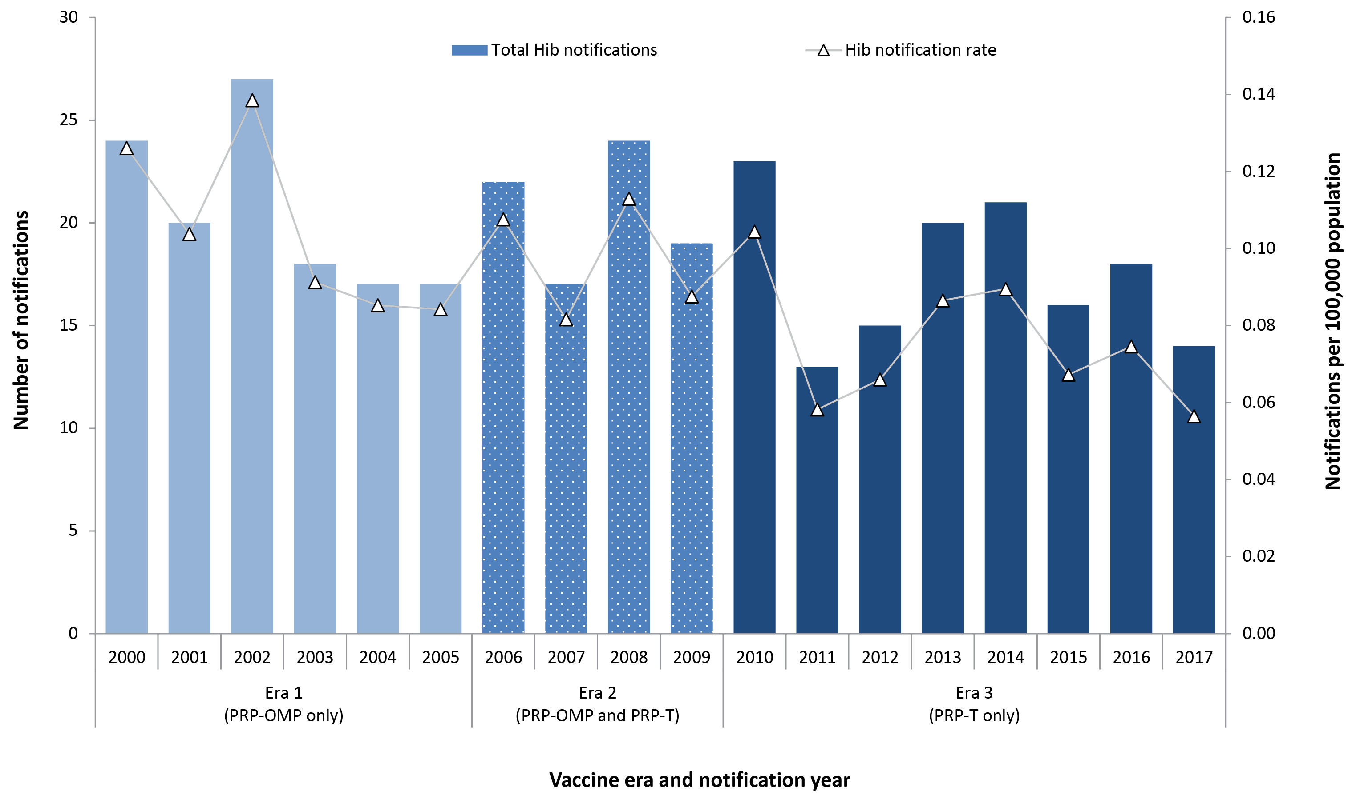

Table 1: Characteristics of Hib cases born from 1 January 2000 onwards, Australia, 2000–2017
Characteristics | Notifications  N=65 (%)
Age, median in months (range) | 24 (5–167)
Sex
Female  Male | 31 (48%)  34 (52%)
Aboriginal and Torres Strait Islander
No  Yes | 46 (71%)  19 (29%)
State or territory
Australian Capital Territory  New South Wales  Northern Territory  Queensland  South Australia  Tasmania  Victoria  Western Australia | 0 (0%)  23 (35%)  9 (14%)  14 (22%)  5 (8%)  0 (0%)  9 (14%)  5 (8%)
Hib vaccine era
Era 1 (PRP-OMP): 2000–2005  Era 2 (PRP-OMP and PRP-T): 2006–2009  Era 3 (PRP-T): 2010–2017 | 15 (23%), 2.5 annually  12 (18%), 3.0 annually  38 (58%), 4.8 annually
Clinical illness
Meningitis  Epiglottitis  Unlocalised/sepsis  Pneumonia  Otherª | 17 (26%)  13 (20%)  12 (18%)  14 (22%)  9 (14%)
Outcome
Survived  Died  Unknown | 54 (83%)  8 (12%)  3 (5%)
Risk factors
Immunocompromised  Congenital abnormality  Premature birth  Any risk factor^{b}  Missing | 7 (11%)  5 (8%)  2 (3%)  17 (26%)  2 (3.1%)
a Includes Blue Book and Northern Territory and Central Australian Childhood Immunisation Databases.
b Includes cellulitis (17), pharyngitis (4), septic arthritis (4), tonsillitis (2), otitis media (1), febrile illness (1), submandibular abscess (1), combinations of conditions (8) and unspecified (8).
c Includes a range of conditions, as reported by notifiers, including alcoholism, anaemia, cardiomyopathy, cerebral palsy, chronic respiratory disease, congenital heart disease, cyanotic heart disease, diabetes and renal failure. 26 (7.5%) had multiple reported risk factors.

Age distribution
Among cases born from 1 January 2000 onwards, children aged 0–6 months and 7–11 months had the highest notification rates, annual average 1.5 cases per 100,000 for both age groups (Figure 2). The median age was 11 months (range 10 days – 13 years), with 86.9% (n=133) aged ≤5 years. There were 17 (11.1%) cases aged 12–17 months and only eight cases were aged <8 weeks at onset.

Aboriginal and Torres Strait Islander status
Among cases born from 1 January 2000 onwards, 51 (33.3%) were recorded as Aboriginal and Torres Strait Islander (Table 1). Notification rates in both Aboriginal and Torres Strait Islander and non-Indigenous children decreased over the study period (Figure 3).

Figure 2: Number and rate of Hib notifications in individuals born from 1 January 2000 onwards, by year of birth, age group and notification year, Australia, 2000–2017
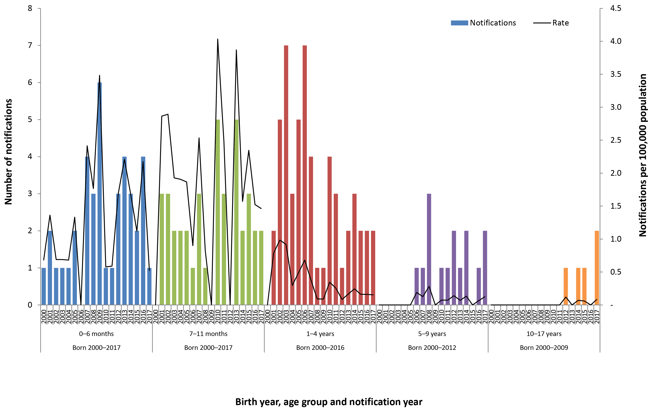

Figure 3: Hib notifications and rate for individuals born from 1 January 2000 onwards, by Aboriginal and Torres Strait Islander status, vaccine era and year, Australia, 2001–2017
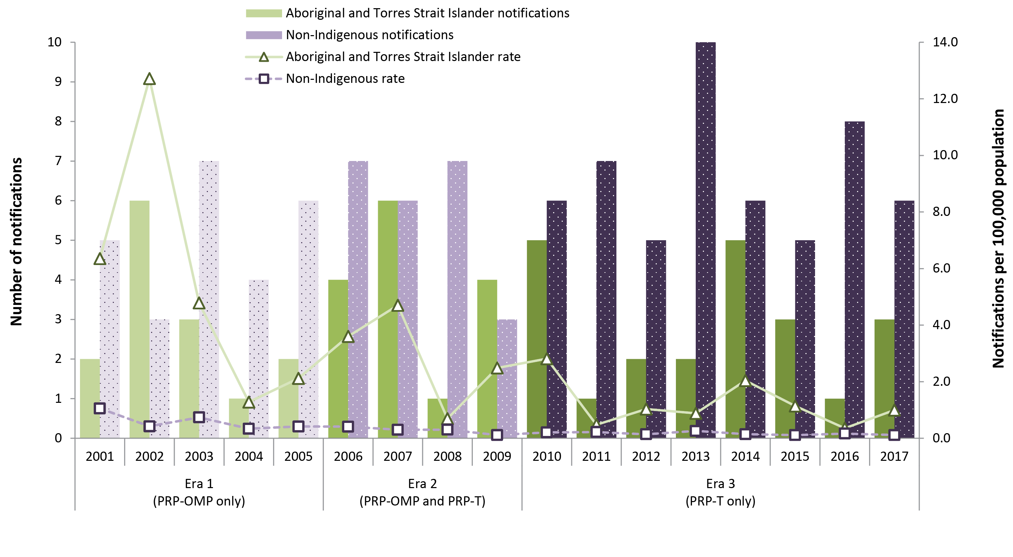

Figure 4: Hib notifications and notification rate in individuals born from 1 January 2000 onwards, by Aboriginal and Torres Strait Islander status and age group (<5 years only), Australia, 2001–2017
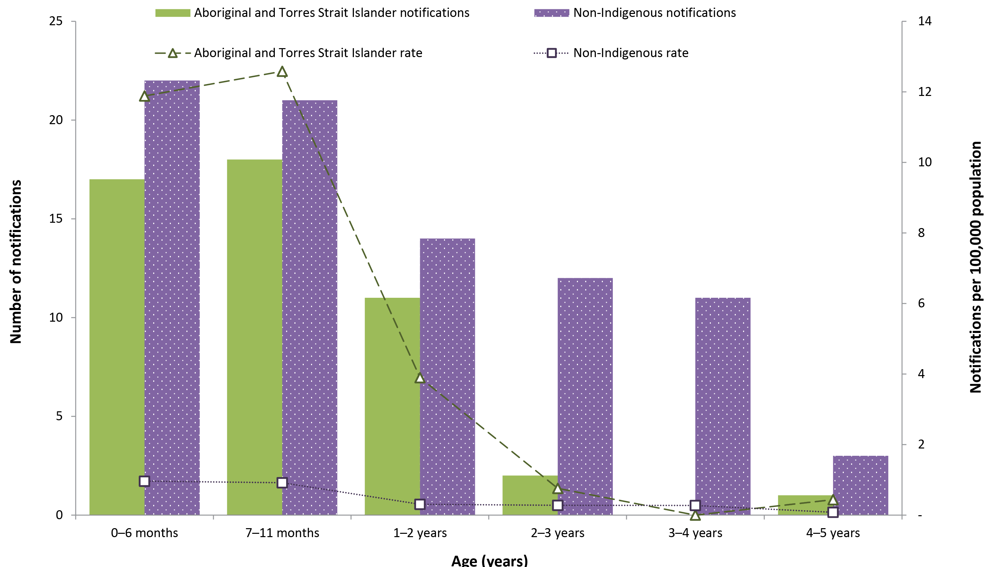

IRRs for Aboriginal and Torres Strait Islander children compared to non-Indigenous children were 8.50 (95% CI: 4.09–17.00) for Era 1, 10.34 (95% CI: 5.02–20.69) for Era 2, 7.05 (95% CI: 4.09–11.80) for Era 3, and 8.36 (95% CI: 5.85–11.82) for all eras combined. Aboriginal and Torres Strait Islander cases were younger (median age 9 months; range 52 days–5 years) than non-Indigenous cases (median 17 months; range 10 days–13 years), with the rate disparity much higher in children aged <1 year, decreasing with age so that rates in children aged 2–5 years are similar (Figure 4).

Figure 5: Hib cases and deaths in children born from 1 January 2000 onwards by age group, Australia, 2000–2017
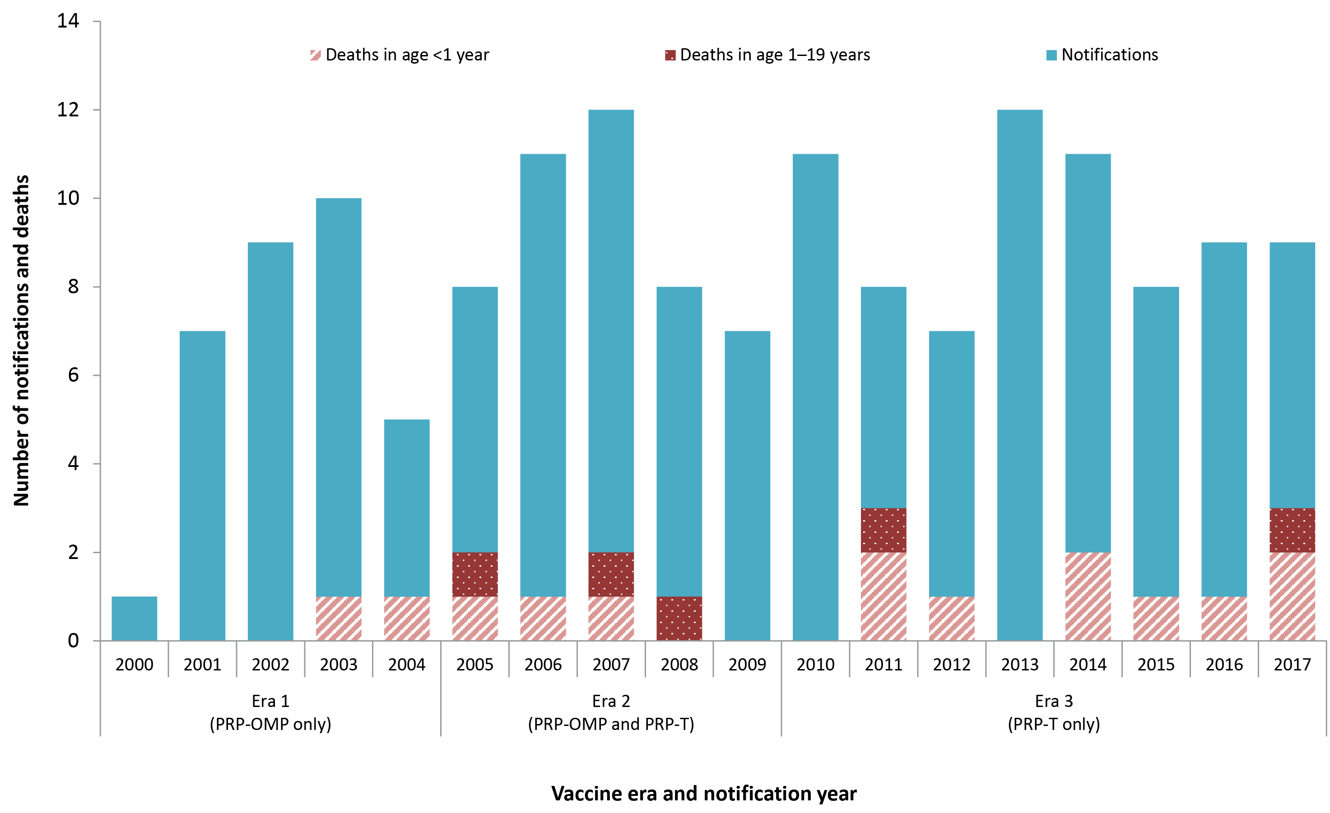

State and territory variation
Among cases born from 1 January 2000 onwards, cases were reported in six of the eight jurisdictions with no cases reported in the Australian Capital Territory and Tasmania. The highest proportion of cases was in New South Wales (35.3%) followed by Queensland (24.2%), Western Australia (12.4%), Victoria (11.1%), the Northern Territory (10.5%) and South Australia (6.5%). However, the highest notification rate was in the Northern Territory (2.60 per 100,000), which was at least seven times higher than in any other jurisdiction (Appendix 5).
The notification rate in the Northern Territory decreased from 9.36 per 100,000 in Era 1 (PRP-OMP only) to 2.48 per 100,000 in Era 2 (PRP-OMP and PRP-T) and to 1.43 per 100,000 in Era 3 (PRP-T only). Notification rates decreased from Era 1 to Era 3 and remained low in all other jurisdictions.

Clinical presentation and case fatality
For cases born from 1 January 2000 onwards, information about clinical presentation was available for 99% (152/153) of cases. Meningitis was the most common presentation reported (35%) followed by septicaemia (22%) and epiglottitis (12%). In Era 1 (2000–2005), septicaemia was the most common presentation (38.5%), however meningitis was the most common in Era 2 (2006–2009; 44.4%) and Era 3 (2010–2017; 38.0%). There was a higher proportion of meningitis presentations in Aboriginal and Torres Strait Islander cases (49%) than in non-Indigenous cases (28%).
Nineteen of the 153 cases born from 1 January 2000 onwards were reported to have died, including two children aged <8 weeks, with an overall CFR of 12.4% (11 in New South Wales, 5 in Queensland and 1 in each of the Northern Territory, South Australia and Victoria). The CFR for cases who presented with septicaemia, meningitis, epiglottitis and other presentations were 18.2% (6/33), 16.7% (9/54), 10.5% (2/19) and 4.3% (2/46), respectively. The CFR was 9.8% (5/51, includes 1 with underlying medical conditions) for Aboriginal and Torres Strait Islander cases and 13.7% (14/102, includes 5 with underlying medical conditions) for non-Indigenous cases. Overall six (35.3%, includes 3 vaccine failures) of the 17 deaths aged ≥8 weeks had recorded one or more underlying conditions, including immunocompromise, cerebral palsy and chronic lung disease.
The median age among cases who died was 7 months (range 37 days–10 years), with small numbers in individual years and no consistent trend (Figure 5). All five Aboriginal and Torres Strait Islander and nine (64%) non-Indigenous deaths were aged <1 year. The death field was not completed for 13.1% of cases (20/153) overall, with data completeness fluctuating over the study period.

Vaccination status
Of the 153 cases born from 1 January 2000 onwards, 145 were aged ≥8 weeks at notification and eligible to have received at least one vaccine dose. Of the 145, 28% had no recorded vaccine doses, 30% were partially immunised for age and 43% fully immunised (Table 2). Approximately half the cases who had received PRP-T were fully immunised and half partially immunised, while approximately three-quarters of cases who had received PRP-OMP were fully immunised.
Of the 145 cases aged ≥8 weeks, the proportion partially immunised among Aboriginal and Torres Strait Islanders (42%, 21/50) was almost double that of non-Indigenous cases (23%, 22/95), but the proportion fully immunised was higher in non-Indigenous cases (48%, 46/95) (Figure 6). Although the overall proportion of unimmunised cases was similar among Aboriginal and Torres Strait Islander (26%, 13/50) and non-Indigenous cases (28%, 27/95), significantly more (54%, 7/13) unimmunised Aboriginal and Torres Strait Islander children were aged 2–6 months, compared to non-Indigenous children (15%; 4/27 p=0.008) (Figure 6).

Table 2: Number of Hib cases born from 1 January 2000 onwards and aged ≥8 weeks, by vaccine type and vaccination status, Australia, 2000–2017
Vaccine type | Vaccination status |  |  |  |  |  | Total | Deaths
 | Unimmunised |  | Partially immunised |  | Fully immunised
 | n | % | n | % | n | % | n | n | %
PRP-T | 0 | 0 | 28 | 48.3 | 30 | 51.7 | 58 | 8 | 13.8
PRP-OMP | 0 | 0 | 10 | 23.8 | 32 | 76.2 | 42 | 5 | 11.9
HbOC | 0 | 0 | 3 | 100.0 | 0 | 0 | 3 | 0 | 0
Unknown | 0 | 0 | 2 | 100.0 | 0 | 0 | 2 | 0 | 0
No recorded doses | 40 | 100.0 | 0 | 0 | 0 | 0 | 40 | 4 | 10.0
Total | 40 | 27.6 | 43 | 29.7 | 62 | 42.8 | 145 | 17 | 11.7
Deaths | 4 | 10.0 | 6 | 14.0 | 7 | 11.3 | 17 | N/A | N/A

Figure 6: Number of Hib cases born from 1 January 2000 onwards and aged ≥8 weeks, by age group, vaccination status and Aboriginal and Torres Strait Islander status, Australia, 2000–2017
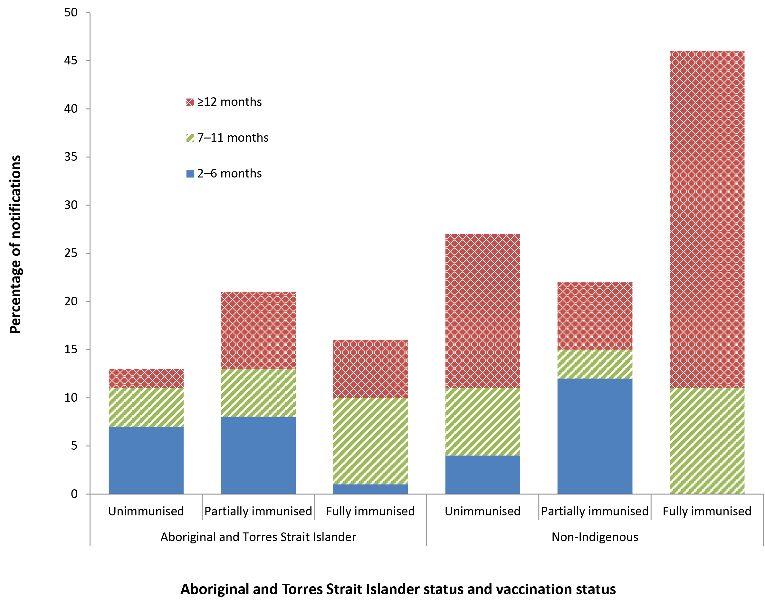

Table 3: Estimated Hib incidenceª and incidence rate ratio in children born after 1 January 2000 by vaccine type and Aboriginal and Torres Strait Islander status, Australia, 2000–2017
Vaccine type received | Aboriginal and Torres Strait Islander |  | Non-Indigenous |  | Total |  | IRR (95% CI)
 | n | Rate (95% CI) | n | Rate (95% CI) | n | Rate (95% CI)
PRP-T or PRP-OMP (≥1 dose) | 36 | 13.3 (9.3–18.4) | 64 | 1.3 (1.0–1.6) | 100 | 1.9 (1.5–2.3) | 10.5 (6.8–16.0)
PRP-T (≥1 dose) | 22 | 12.3 (7.7–18.6) | 36 | 1.1 (0.8–1.5) | 58 | 1.7 (1.3–2.2) | 11.3 (6.3–19.7)
PRP-OMP (≥1 dose) | 14 | 15.2 (8.3–25.5) | 28 | 1.6 (1.1–2.3) | 42 | 2.3 (1.7–3.1) | 9.5 (4.6–18.6)
No recorded vaccine doses | 14 | 479.6 (262.5–803.4) | 34 | 11.8 (8.2–16.6) | 48 | 16.6 (12.2–22.0) | 40.5 (20.1–77.5)
Total | 51 | 19.5 (14.5–25.6) | 102 | 1.9 (1.6–2.3) | 153 | 2.8 (2.3–3.2) | 10.1 (7.1–14.3)
a Crude estimated rate per 100,000 population and 95% confidence interval, calculated as the number of cases who received ≥1 dose of relevant vaccine (or no doses) divided by the number recorded on AIR as having received ≥1 dose of relevant vaccine (or no doses) multiplied by 100,000.

The incidence of invasive Hib disease per 100,000 in unimmunised and immunised children was calculated using cases born from 1 January 2000 as the numerator and vaccination status as at 31 December 2017, with all individuals on the AIR born since 1 January 2000 and ≥1 dose (for immunised rate) or no recorded doses (for unimmunised rate) as the denominator. For unimmunised non-Indigenous children, incidence of Hib was 11.8 per 100,000 versus 1.6 per 100,000 in children with ≥1 dose of PRP-OMP and 1.1 per 100,000 with ≥1 dose of PRP-T vaccine (Table 3). In Aboriginal and Torres Strait Islander children who had received at least one vaccine dose, estimated incidence was approximately 10 times higher than non-Indigenous, and for unimmunised Aboriginal and Torres Strait Islander children, estimated incidence was 40 times higher.

Vaccine failures
Of the 153 invasive Hib cases born from 1 January 2000 onwards, 145 were at least 8 weeks of age, and 100 had received ≥1 dose of either PRP-T or PRP-OMP (Table 3), of whom 65 met our definition for vaccine failure (see Box 1). Eight of the 65 vaccine failures died (CFR 12.3%), similar to the CFR among cases ≥8 weeks who were not vaccine failures (9/80; 11.3%). The median age of vaccine failures was considerably older than for cases overall (24 months compared to 11 months), just over half (52%) were male and 29% were Aboriginal and Torres Strait Islander (Table 4). Seven (11%) vaccine failures were immunocompromised, with all fully vaccinated.

Table 4: Overall summary of demographic and clinical characteristics of Hib vaccine failures in individuals born from 1 January 2000 onwards, Australia, 2000–2017
Characteristics | Notifications  N=65 (%)
Age, median in months (range) | 24 (5–167)
Sex
Female  Male | 31 (48%)  34 (52%)
Aboriginal and Torres Strait Islander
No  Yes | 46 (71%)  19 (29%)
State or territory
Australian Capital Territory  New South Wales  Northern Territory  Queensland  South Australia  Tasmania  Victoria  Western Australia | 0 (0%)  23 (35%)  9 (14%)  14 (22%)  5 (8%)  0 (0%)  9 (14%)  5 (8%)
Hib vaccine era
Era 1 (PRP-OMP): 2000–2005  Era 2 (PRP-OMP and PRP-T): 2006–2009  Era 3 (PRP-T): 2010–2017 | 15 (23%), 2.5 annually  12 (18%), 3.0 annually  38 (58%), 4.8 annually
Clinical illness
Meningitis  Epiglottitis  Unlocalised/sepsis  Pneumonia  Otherª | 17 (26%)  13 (20%)  12 (18%)  14 (22%)  9 (14%)
Outcome
Survived  Died  Unknown | 54 (83%)  8 (12%)  3 (5%)
Risk factors
Immunocompromised  Congenital abnormality  Premature birth  Any risk factor^{b}  Missing | 7 (11%)  5 (8%)  2 (3%)  17 (26%)  2 (3.1%)
a Includes cellulitis (3), pharyngitis (2), septic arthritis (1), combinations of conditions (2) and unspecified (1).
b Includes a range of conditions, as reported by notifiers, including cerebral palsy, chronic respiratory disease and cyanotic heart disease. 6 (9%) had multiple reported risk factors. There were no cases with congenital asplenia or splenectomy reported.
The number and proportion of Hib cases classified as vaccine failures fluctuated by individual year, with small annual numbers (Figure 7). The proportion of vaccine failures amongst total cases decreased from 38% in Era 1 to 32% in Era 2 and increased to 51% in Era 3; noting the shorter population person-time in Era 1, which incorporates children born from 2000–2005 and cases notified over the same 6-year period, compared to Era 3, which incorporates children born over the entire 2000–2017 period but only includes cases notified in 2010–2017. The vaccine failure rate decreased from 0.28 in Era 1 (PRP-OMP) to 0.13 in Era 2 (PRP-OMP/PRP-T) and 0.11 per 100,000 in Era 3 (PRP-T). The vaccine failure rate in children aged <1 year decreased from 0.27 in Era 1 (PRP-OMP) to 0.18 in Era 2 (PRP-OMP/PRP-T) and increased to 0.53 per 100,000 in Era 3 (PRP-T); not statistically significant. The proportion of vaccine failures by year, excluding year 2000 where there was only one notification, varied from a low of 20% (2/10) in 2003 to a high of 75% (6/8) in 2011.

Figure 7: Total number and rate of Hib notifications and vaccine failures in individuals born from 1 January 2000 onwards, by vaccine era and year, Australia, 2000–2017
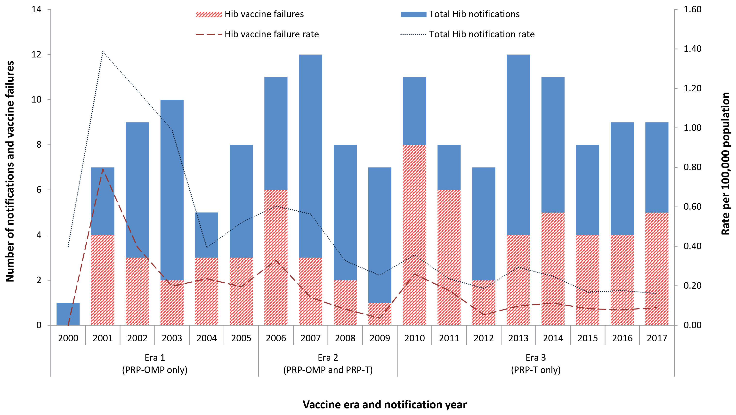

Vaccination status
The majority of cases of vaccine failure were fully immunised for age (n=57, 88%), as defined in Methods; of whom 53% had received PRP-OMP and 47% PRP-T vaccine (Table 5, Table 6). The median age was higher, and time from last Hib vaccine dose to disease onset was longer, among PRP-OMP vaccine failures than among those of PRP-T; noting that children who received PRP-OMP (in Era 1 and Era 2) have a longer person-time included the study than children who received PRP-T (in Era 2 and Era 3).

Table 5: Characteristics of Hib vaccine failures born from 1 January 2000 onwards by vaccine type, Australia, 2000–2017
Characteristic | Vaccine type |  | Totalª
 | PRP-OMP | PRP-T
Number (%) | 33 (52%) | 31 (48%) | 65
Vaccination status^{b}  Fully immunised  Partially immunised | 30 (91%)  3 (9%) | 27 (87%)  4 (13%) | 57 (88%)  8 (12%)
Hib vaccine era  Era 1 (PRP-OMP): 2000–2005  Era 2 (PRP-OMP and PRP-T): 2006–2009  Era 3 (PRP-T): 2010–2017 | 14 (42%)  11 (33%)  8 (24%) | 0 (0%)  1 (3%)  30 (97%) | 15 (23%)  12 (18%)  38 (58%)
Age, median (range) | 36 months  (5 months–14 years) | 15 months  (7 months–7 years) | 24 months  (5 months–13 years)
Last vaccine dose to onset, median (range) | 23 months  (37 days–11 years) | 6 months  (34 days–6 years) | 13 months  (34 days–11 years)
Aboriginal and Torres Strait Islander | 8 (24%) | 11 (35%) | 19 (29%)
Died | 4 (aged 1, 3, 7 and 10 years) | 4 (aged 7–12 months) | 8 (12%)
Clinical illness  Meningitis  Pneumonia  Epiglottitis  Unlocalised/sepsis  Other^{c} | 7 (21%)  11 (33%)  6 (18%)  6 (18%)  3 (9%) | 10 (32%)  3 (10%)  7 (23%)  5 (16%)  6 (19%) | 17 (26%)  14 (22%)  13 (20%)  12 (18%)  9 (14%)
a Includes 1 vaccine failure that was partially immunised with HbOC vaccine
b As described in Methods (Vaccination status):
‘Fully immunised’:
A case aged <12 months that received full primary course of the relevant vaccine; i.e. 2 doses of PRP-OMP or 3 doses of PRP-T or HbOC;
A case aged ≥12 months that received a full primary course of the relevant vaccine and a booster dose at ≥12 months of age; i.e. total of 3 doses of PRP-OMP or 4 doses of HbOC or PRP-T;
A case that received 1 dose of any Hib vaccine at 12–14 months of age with a booster dose ≥2 months later;
A case that received 1 dose of any Hib vaccine at ≥16 months of age.
‘Partially immunised’: All other cases, where immunisation status was known
c Includes cellulitis, pharyngitis, septic arthritis and combinations of conditions.

Table 6: Number of Hib vaccine failures in individuals born from 1 January 2000 onwards, by age and vaccine type, Australia, 2000–2017
Age group | Vaccine type |  | Totalª | Deaths
 | PRP-OMP | PRP-T |  | n | %
6 weeks–6 months | 1 | 0 | 1 | 0 | 0
7–11 months | 5 | 13 | 18 | 4 | 22
12–17 months | 6 | 4 | 11 | 1 | 9
18 months–4 years | 12 | 10 | 22 | 1 | 5
5–9 years | 5 | 4 | 9 | 1 | 11
10–19 years | 4 | 0 | 4 | 1 | 25
Total | 33 | 31 | 65 | 8 | 12
a Includes 1 vaccine failure partially vaccinated with HbOC vaccine

Age distribution
The median age for notifications assessed as Hib vaccine failures was 24 months (range 5 months–13 years), with 80% (52/65) aged ≤5 years and 29% (19/65) aged <1 year (Table 6).
All vaccine failures in infants aged <1 year were fully immunised, of whom 13 (68%) had received 3 doses of PRP-T and 6 (32%) had received 2 doses of PRP-OMP. Over half (10/19) of the infant vaccine failures were Aboriginal and Torres Strait Islander. The median age at onset was 9 months (range 5–11 months) and median time between administration of the last dose and disease onset 3 months (range 34 days–7 months). Eleven of the 19 cases had meningitis and eight had other clinical presentations.
Of the 11 vaccine failures aged 12–17 months, six received PRP-OMP (three received a third dose), four received PRP-T (two received a fourth dose) and one received three doses of HbOC; overall 6/11 met the definition for fully immunised and 5/11 for partially immunised.

Aboriginal and Torres Strait Islander status
Of the 65 vaccine failures, 19 (29%) were Aboriginal and Torres Strait Islander children, 11 (58%) of whom received PRP-T and eight (42%) PRP-OMP vaccine, as opposed to the 46 non-Indigenous vaccine failures of whom 20 (43%) received PRP-T vaccine, 25 (54%) had received PRP-OMP and 1 (2%) HbOC vaccine.
Of the 19 vaccine failures in Aboriginal and Torres Strait Islander children, 18/19 (95%) were aged <5 years, compared to 34/46 (74%) of vaccine failures in non-Indigenous children (Table 7). The median age at onset was lower in Aboriginal and Torres Strait Islander children (11 months [range 5 months – 5 years] versus 3 years [range 7 months – 13 years] in non-Indigenous; p=0.001), with 73% aged <18 months compared to 35% of non-Indigenous children.

Table 7: Number and proportion of Hib vaccine failures in individuals born from 1 January 2000 onwards, by age and Aboriginal and Torres Strait Islander status, Australia, 2000–2017
Age group | Vaccine failure |  |  |  | Total
 | Aboriginal and Torres Strait Islander |  | Non-Indigenous
 | n | % | n | %
6 weeks–6 months | 1 | 5 | 0 | 0 | 1
7–11 months | 9 | 47 | 9 | 20 | 18
12–17 months | 4 | 21 | 7 | 15 | 11
18 months–4 years | 4 | 21 | 18 | 39 | 22
5–9 years | 1 | 5 | 8 | 17 | 9
10–19 years | 0 | 0 | 4 | 9 | 4
Total | 19 | 100 | 46 | 100 | 65

The median number of days between administration of the last dose of Hib vaccine and disease onset for vaccine failures was 5 months (range 34 days – 5 years) in Aboriginal and Torres Strait Islander people and 24 months (range 38 days – 11 years) in non-Indigenous.

State and territory variation
Vaccine failures were reported in all jurisdictions that reported Hib notifications in the study period. The largest proportion of cases classified as vaccine failures was in the Northern Territory (9/16, 56%) followed by Victoria (9/17, 53%).

Clinical presentation and mortality
Meningitis accounted for 17/65 (26%) vaccine failures; children aged <1 year had the highest proportion (58%, 11/19) compared to children aged 1–4 years (6%, 2/33) and children aged >5 years (31%, 4/13). A higher proportion of vaccine failures presented with pneumonia and epiglottitis than unimmunised cases, 22% versus 8% and 20% versus 7%, respectively. A higher proportion of Aboriginal and Torres Strait Islander children with vaccine failure had meningitis (42% [8/19] versus 20% [9/46] in non-Indigenous).
There were eight deaths (CFR 12%) among Hib vaccine failure cases, the oldest 10 years of age, one reported to be Aboriginal and Torres Strait Islander (Figure 8). Deaths occurred in 2017 (2), 2015 (1), 2011 (3), 2008 (1) and 2007 (1). Half of the deaths had received PRP-T and half PRP-OMP vaccine. The CFR in vaccine failure cases who presented with meningitis, epiglottitis and pneumonia was 29% (5/17), 15% (2/13) and 7% (1/14), respectively and CFR was higher in cases with a reported underlying medical condition (3/17, 18% versus 5/40, 13%).

Figure 8: Number of Hib (a) vaccine failures and (b) others born from 1 January 2000 onwards, by clinical outcome, Aboriginal and Torres Strait Islander status and age group, Australia, 2000–2017
(a)
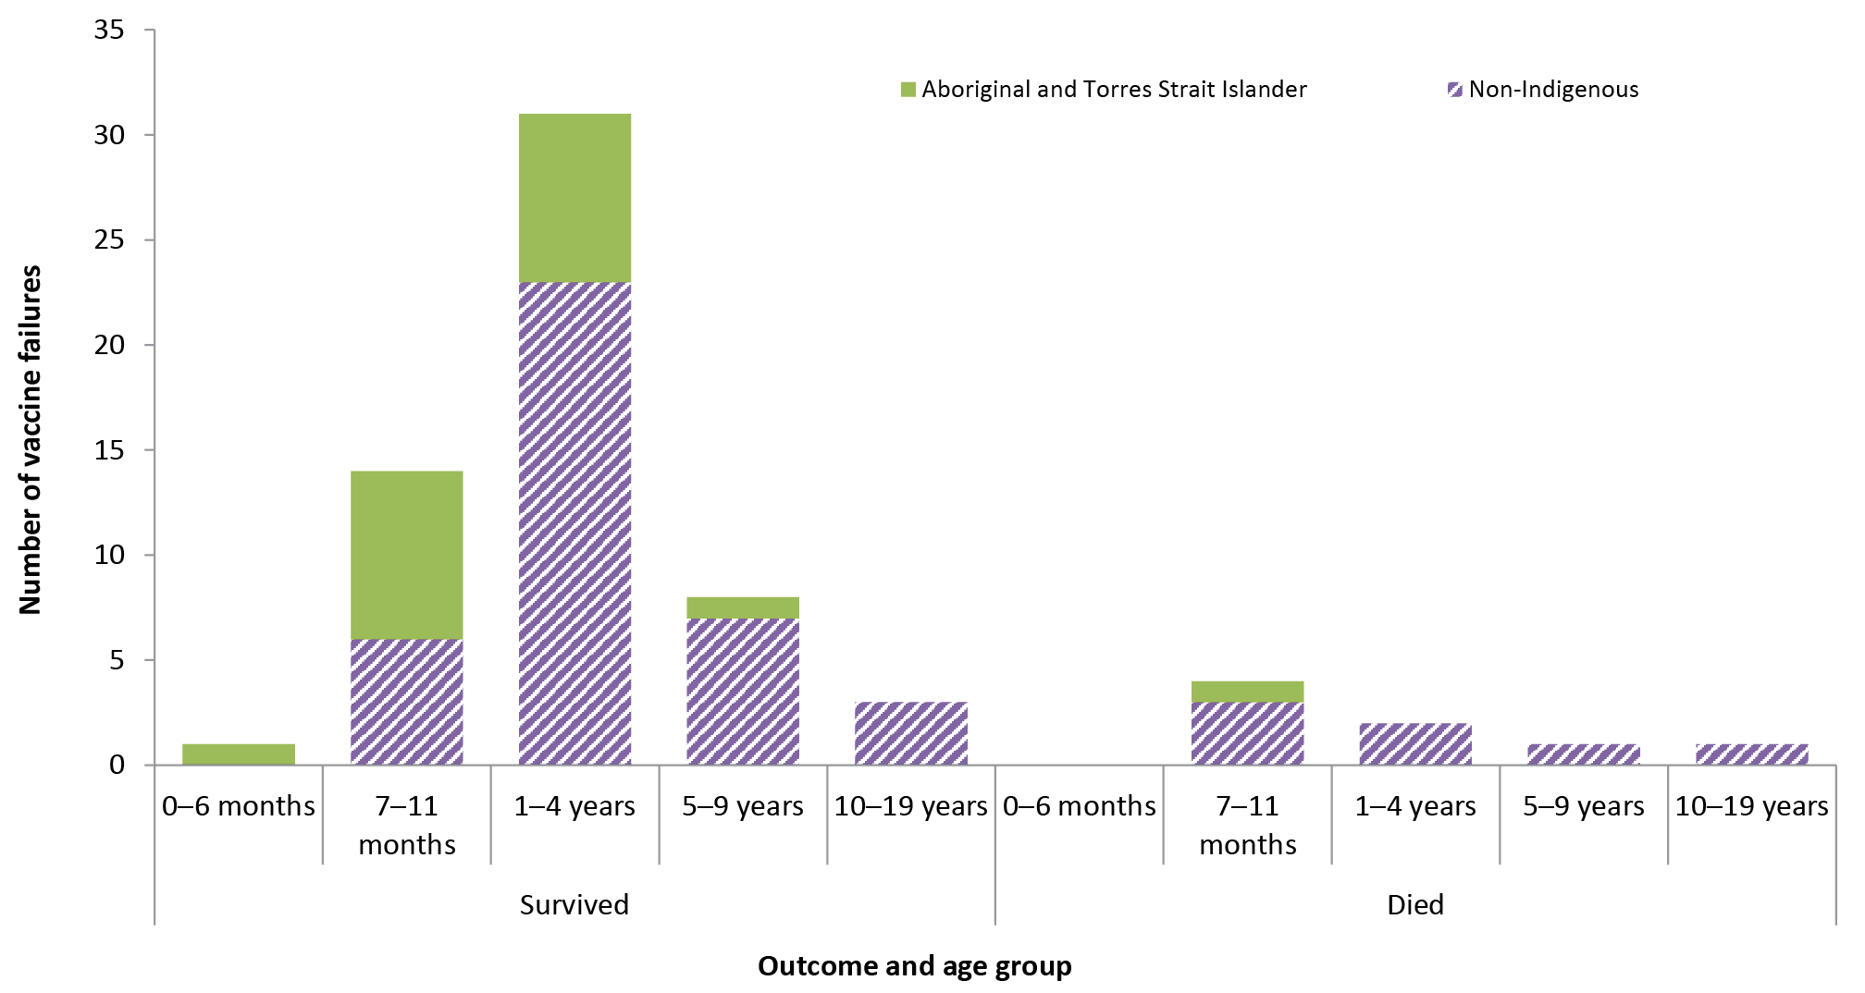
(b)
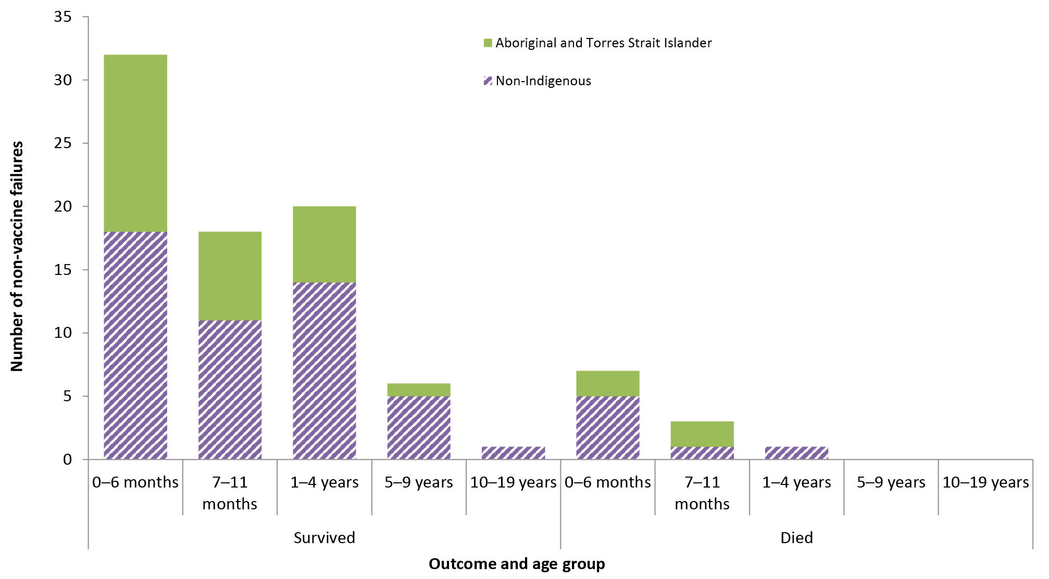

Discussion
We identified 345 cases of invasive Hib disease in Australia over the 2000–2017 period, with the annual all-age notification rate decreasing significantly, by 55%, from 0.13 per 100,000 population in 2000 to 0.06 per 100,000 population in 2017.
We focused our analyses on the 153 cases born from 1 January 2000 onwards. This includes individuals vaccinated in the PRP-OMP and PRP-T vaccine eras rather than vaccinated with HbOC vaccine, which is no longer in use worldwide, and data for this period has a high level of completeness. In this 18-year birth cohort, the notification rate decreased by 70% from Era 1 (PRP-OMP vaccine only) to Era 3 (PRP-T vaccine only). The highest age-specific notification rate over the study period was in infants aged <1 year, with 87% of cases aged ≤5 years. The highest jurisdictional notification rate over the study period was in the Northern Territory, the jurisdiction with the highest proportion of Aboriginal and Torres Strait Islander people. Although the incidence rate in the Northern Territory decreased from Era 1 to Era 3, it was at least seven times higher than in other jurisdictions.
One-third of cases born from 1 January 2000 onwards (51/153) were Aboriginal and Torres Strait Islander children, with a significantly younger median age than non-Indigenous cases (9 months compared to 17 months). While the Hib notification rate decreased over the study period in both Aboriginal and Torres Strait Islander and non-Indigenous children, disparity in rates remained high, with a small non-significant decrease in IRR (Aboriginal and Torres Strait Islander: non-Indigenous) from 8.50 in Era 1 to 7.02 in Era 3. The IRR in children aged <10 years was 1.5 in the early years of the Hib vaccination program (1993–1996), but increased significantly in subsequent years due to much larger declines in incidence among non-Indigenous children.⁴ Similar disparities have previously been documented in Australia.⁷ Disparities between First Nations and non-Indigenous populations have also been reported in Canada (IRR 4.4 in 2003–2005 for all ages) and the United States of America (7.1 in 1994–1995 for Native American children aged <4 years and 18.0 for Alaska Native children aged <5 years), driven by factors that promote transmission, including higher rates of nasopharyngeal carriage of Hib, overcrowded living conditions and environmental tobacco smoke exposure.^{11–17}
This rate disparity is particularly high, IRR 12–14, in children aged <2 years, consistent with the known issues of vaccine delay in younger Aboriginal and Torres Strait Islander children.¹⁸ In 2018, Hib vaccine coverage in Aboriginal and Torres Strait Islander children was slightly lower than non-Indigenous children at 12 months of age (primary course; 92.5% versus 94.6%), but higher at 24 months of age (for booster dose then scheduled at 12 months; 95.2% versus 94.7%) and even higher at 60 months of age (98.3% versus 95.8%).¹⁹ The high proportion of unimmunised Aboriginal and Torres Strait Islander Hib cases aged 2–6 months (54% compared to 15% in unimmunised non-Indigenous cases) emphasises potential benefits from improving vaccine coverage, and especially timeliness, to further reduce disparity. However, much of the 40-fold higher risk of Hib disease in unimmunised versus immunised Aboriginal and Torres Strait Islander children is attributable to higher nasopharyngeal carriage and social and environmental determinants of health, which also need to be addressed in order to reduce this persistent disparity.¹⁸
There is evidence of increased incidence of invasive non-type b Haemophilus influenzae disease in international settings post-Hib vaccine introduction, such as type a disease in Indigenous populations of North America.²⁰ However, previous research conducted in South Australia (where non-type b invasive disease is notifiable) and the Northern Territory found no significant evidence of an increase amongst the Aboriginal and Torres Strait Islander population through to 2011.²¹ Assessing potential disparity of non-type b invasive Haemophilus influenzae disease between Aboriginal and Torres Strait Islander and non-Indigenous children would be facilitated by making non-type b Haemophilus influenzae disease nationally notifiable with laboratory typing coordinated similarly to that currently occurring for invasive pneumococcal disease.²²
Among the 153 cases born from 1 January 2000 onwards, meningitis and septicaemia were the most common presentations and the CFR was 12.4%, one third of whom had an underlying medical condition. The CFR is higher than previously reported in Australia in the early vaccine period (1993–1996, 5%), but could be attributable to both improved reporting and an increased proportion of cases with reported medical comorbidities (20%).^{3, 7} Although based on small numbers, the CFR was similar for Aboriginal and Torres Strait Islander and non-Indigenous cases: 9.8% and 13.7% respectively. All deaths among Aboriginal and Torres Strait Islander cases were aged <1 year, but deaths among other cases occurred up to 10 years of age.
Among cases born from 1 January 2000 onwards, 31% were unimmunised, 41% fully immunised and 28% partially immunised. Approximately three-quarters of cases that had received PRP-OMP were fully immunised compared to half of those who had received PRP-T. This, along with the higher median time from last vaccine dose to disease onset in PRP-OMP recipients, could be consistent with longer protective effect of PRP-OMP and/or a longer period of usage of PRP-OMP and would require more detailed analysis to delineate. The higher proportion of partially immunised Aboriginal and Torres Strait Islander than of non-Indigenous cases (21% versus 41%) may reflect reduced vaccination timeliness in this population as a result of logistical and accessibility issues.
We estimated incidence of Hib in children who had received at least one dose of PRP-OMP (2.3 per 100,000), or PRP-T (1.7 per 100,000), to be around 90% lower than in unimmunised children (16.6 per 100,000). This is consistent with estimates of Hib vaccine effectiveness (VE) in Australia in the 1990s (83–90%), but also emphasises that even at a time when Hib disease has become rare, unimmunised children remain at a tenfold higher risk of disease.²³ It is notable that almost all unimmunised cases older than 12 months occurred in non-Indigenous children; this may be due to vaccine refusal, although we have no specific data on this. In Aboriginal and Torres Strait Islander children, incidence in those who had received at least one vaccine dose was 97% lower than unimmunised children irrespective of vaccine, consistent with a strong protective effect. However, disease risk in unimmunised Aboriginal and Torres Strait Islander children was about 40-fold higher than in unimmunised non-Indigenous children, with a rate similar to that in the pre-vaccine era, which is consistent with high circulation of Hib and documented higher levels of nasopharyngeal colonisation.²⁴ More precisely, delineation of relative VE for PRP-OMP and PRP-T and between Aboriginal and Torres Strait Islander and non-Indigenous children would require a more robust analysis such as a matched case-control study.²⁵
Approximately 45% of cases born from 1 January 2000 onwards were classified as vaccine failures, with 88% fully immunised. Although the proportion of cases meeting the definition of vaccine failure increased from 32% in Era 1 (PRP-OMP) to 51% in Era 3 (PRP-T), this was in the context of lower overall incidence during Era 3. The overall vaccine failure rate decreased more than twofold from 0.28 per 100,000 in the PRP-OMP vaccine era (Era 1) to 0.11 per 100,000 in the PRP-T vaccine era (Era 3), however the vaccine failure rate in children aged <1 year almost doubled from 0.27 per 100,000 in Era 1 to 0.53 per 100,000 in Era 3. This could be related to the more rapid immunogenic effects achieved in infants using PRP-OMP vaccine than in those using PRP-T-containing vaccines, but could also be due to the improved ascertainment of immunisation status or an artefact of the very small numbers involved.²⁶ Fully-immunised immunocompromised children accounted for 7 vaccine failures; immunocompromise is an established risk factor for Hib disease.^{27–29} Cases in children aged 12–17 months are of particular interest, given the 2018 NIP schedule change from a Hib booster dose at 12 months (given as combined Hib-meningococcal C vaccine) to 18 months of age (given as monovalent Hib vaccine). Of the 17 (11%) cases in this age group, 11 were classified as vaccine failures of whom 6 had received the booster dose then scheduled at 12 months. Of the 6 not classified as vaccine failures, 4 were unimmunised and 2 partially immunised. It will be important to monitor any evidence of an increase in 3-dose vaccine failures in this age group, especially in Aboriginal and Torres Strait Islander children, given their higher proportion of cases and vaccine failures aged <18 months of age.
Strengths of our study include the high completeness of most data fields in this enhanced surveillance dataset, and likely high case ascertainment, due to high likelihood of microbiologic testing in this severe disease and the reliability of laboratory notification. Although the Hib case definition changed over the study period to strengthen the level of laboratory evidence required, it is unlikely these changes would have had any major impact on case ascertainment.
Overall our study shows that rates of invasive Hib disease in Australia, already very low prior to 2000 following vaccine introduction in 1993, have continued to decline steadily. Despite the success of the immunisation program, vaccine failures continue to occur, although at a very low rate. This analysis also emphasises the importance of timely vaccination according to the recommended infant schedule, especially in Aboriginal and Torres Strait Islander infants who continue to be disproportionately affected by invasive Hib disease. It will be important to continue to monitor invasive Hib disease epidemiology and vaccine failures, particularly following the 2018 change in timing of the booster dose on the NIP schedule.

Acknowledgements
We would like to acknowledge Anna Glynn-Robinson and Kaitlyn Vette (Communicable Diseases Epidemiology and Surveillance Section, Office of Health Protection, Australian Government Department of Health) for preliminary vaccine failure analyses; state and territory public health staff for collecting data and submitting enhanced surveillance reports to the HCSS; Han Wang (National Centre for Immunisation Research and Surveillance) for database management; and Brynley Hull (National Centre for Immunisation Research and Surveillance) for population immunisation data.

Author details
Ms Julia E Maguire, Communicable Disease Epidemiologist and Lecturer^{1,2}
Dr Frank Beard, Staff Specialist, Public Health Physician and Senior Lecturer^{1,2}
Ms Kelley Méder, Communicable Disease Epidemiologist¹
Dr Aditi Dey, Senior Research Fellow and Senior Lecturer^{1,2}
Prof Kristine Macartney, Director of NCIRS and Staff Specialist^{1,2}
Prof Peter McIntyre, Senior Professorial Fellow^{1,2}

- National Centre for Immunisation Research and Surveillance, Westmead, New South Wales, Australia
- The University of Sydney, New South Wales, Australia

Corresponding author
Ms Julia Maguire
National Centre for Immunisation Research and Surveillance, Locked Bag 4001, Westmead NSW 2145, Australia
Julia.Maguire@health.nsw.gov.au
+61 2 9845 0191

References
- Nanduri SA, Sutherland AR, Gordon LK, Santosham M. Haemophilus influenzae type b vaccines. In: Plotkin SA, Orenstein WA, Offit PA, Edwards KM, editors. Plotkin’s vaccines. 7th ed. Philadelphia, PA: Elsevier; 2018.
- American Public Health Association. Control of Communicable Diseases Manual. Washington, DC. 2008.
- Herceg A. The decline of Haemophilus influenzae type b disease in Australia. Commun Dis Intell. 1997;21(13):173–6.
- Menzies RI, Bremner KM, Wang H, Beard FH, McIntyre PB. Long-term trends in invasive Haemophilus influenzae type B disease among indigenous Australian children following use of PRP-OMP and PRP-T vaccines. Pediatr Infect Dis J. 2015;34(6):621–6.
- NNDSS Annual Report Writing Group, Milton A, Stirzaker S, Trungove M, Knuckey D, Martin N et al. Australia’s notifiable disease status, 2010: annual report of the National Notifiable Diseases Surveillance System. Commun Dis Intell Q Rep. 2012;36(1):1–69.
- National Centre for Immunisation Research and Surveillance. Significant events in Haemophilus influenzae type b (Hib) vaccination practice in Australia 2018. [Accessed: 19 March 2019.] Available from: http://www.ncirs.org.au/sites/default/files/2018-11/Haemophilus-influenzae-type-b-history-July-2018.pdf.
- Wang H, Deeks S, Glasswell A, McIntyre P. Trends in invasive Haemophilus influenzae type B disease in Australia, 1995-2005. Commun Dis Intell Q Rep. 2008;32(3):316–25.
- Australian Government Department of Health. Haemophilus influenzae type B (Hib) infection (invasive) case definition 2014. [Internet.] [Accessed: 8 April 2019.] Available from: http://www.health.gov.au/internet/main/publishing.nsf/Content/cda-surveil-nndss-casedefs-cd_hib.htm.
- Chiu C, Dey A, Wang H, Menzies R, Deeks S, Mahajan D et al. Vaccine preventable diseases in Australia, 2005 to 2007. Commun Dis Intell Q Rep. 2010;34(Supp):S1–167.
- The Australian Bureau of Statistics. Australian Demographic Statistics, Sep 2016. [Internet.] [Accessed: 13 September 2017.] Available from: http://www.abs.gov.au/AUSSTATS/abs@.nsf/DetailsPage/3101.0Sep%202016?OpenDocument.
- Bisgard KM, Kao A, Leake J, Strebel PM, Perkins BA, Wharton M. Haemophilus influenzae invasive disease in the United States, 1994–1995: near disappearance of a vaccine-preventable childhood disease. Emerg Infect Dis. 1998;4(2):229–37.
- Millar EV, O’Brien KL, Levine OS, Kvamme S, Reid R, Santosham M. Toward elimination of Haemophilus influenzae type B carriage and disease among high-risk American Indian children. Am J Public Health. 2000;90(10):1550–4.
- Degani N, Navarro C, Deeks SL, Lovgren M. Invasive bacterial diseases in northern Canada. Emerg Infect Dis. 2008;14(1):34–40.
- Singleton R, Holve S, Groom A, McMahon BJ, Santosham M, Brenneman G et al. Impact of immunizations on the disease burden of American Indian and Alaska native children. Arch Pediatr Adolesc Med. 2009;163(5):446–53.
- Galil K, Singleton R, Levine OS, Fitzgerald MA, Bulkow L, Getty M et al. Reemergence of invasive Haemophilus influenzae type b disease in a well-vaccinated population in remote Alaska. J Infect Dis. 1999;179(1):101–6.
- Kovesi T, Creery D, Gilbert NL, Dales R, Fugler D, Thompson B, et al. Indoor air quality risk factors for severe lower respiratory tract infections in Inuit infants in Baffin Region, Nunavut: a pilot study. Indoor Air. 2006;16(4):266–75.
- Singleton R, Hammitt L, Hennessy T, Bulkow L, DeByle C, Parkinson A et al. The Alaska Haemophilus influenzae type b experience: lessons in controlling a vaccine-preventable disease. Pediatrics. 2006;118(2):e421–9.
- Hull B, Hendry A, Dey A, Beard F, Brotherton J, McIntyre P. Immunisation coverage annual report, 2015. Commun Dis Intell (2018). 2019;43. https://doi.org/ https://doi.org/10.33321/cdi.2019.43.11.
- Hull B, Hendry A, Dey A, McIntyre P, Macartney K, Beard F. Immunisation coverage annual report 2018. In preparation.
- Tsang RSW, Ulanova M. The changing epidemiology of invasive Haemophilus influenzae disease: Emergence and global presence of serotype a strains that may require a new vaccine for control. Vaccine. 2017;35(33):4270–5.
- Menzies RI, Markey P, Boyd R, Koehler AP, McIntyre PB. No evidence of increasing Haemophilus influenzae non-b infection in Australian Aboriginal children. Int J Circumpolar Health. 2013;72. https://doi.org/ https://doi.org/10.3402/ijch.v72i0.20992.
- Toms C, de Kluyver R, Enhanced Invasive Pneumococcal Disease Surveillance Working Group for the Communicable Diseases Network Australia. Invasive pneumococcal disease in Australia, 2011 and 2012. Commun Dis Intell Q Rep. 2016;40(2):E267–84.
- Horby P, Gilmour R, Wang H, McIntyre P. Progress towards eliminating Hib in Australia: an evaluation of Haemophilus influenzae type b prevention in Australia, 1 July 1993 to 30 June 2000. Commun Dis Intell Q Rep. 2003;27(3):324–41.
- Jacups SP, Morris PS, Leach AJ. Haemophilus influenzae type b carriage in Indigenous children and children attending childcare centers in the Northern Territory, Australia, spanning pre- and post-vaccine eras. Vaccine. 2011;29(16):3083–8.
- Jayasinghe S, Chiu C, Quinn H, Menzies R, Gilmour R, McIntyre P. Effectiveness of 7- and 13-valent pneumococcal conjugate vaccines in a schedule without a booster dose: a 10-year observational study. Clin Infect Dis. 2018;67(3):367–74.
- Monge S, Hahne SJ, de Melker HE, Sanders EA, van der Ende A, Knol MJ. Effectiveness of the DTPa-HBV-IPV/Hib vaccine against invasive Haemophilus influenzae type b disease in the Netherlands (2003–16): a case-control study. Lancet Infect Dis. 2018;18(7):749–57.
- Holmes SJ, Granoff DM. The biology of Haemophilus influenzae type b vaccination failure. J Infect Dis. 1992;165(Suppl 1):S121–8.
- Scheifele D, Gold R, Marchessault V, Duclos P. Failures after immunization with Haemophilus influenzae type b vaccines—1991–1995. Can Commun Dis Rep. 1996;22(3):17–20, 23.
- Scheifele D, Halperin S, Law B, King A, Halperin S, Morris R, et al. Invasive Haemophilus influenzae type b infections in vaccinated and unvaccinated children in Canada, 2001–2003. CMAJ. 2005;172(1):53–6.

Appendices
Appendix 1: Recommended Haemophilus influenzae type b vaccination schedule under the National Immunisation Program, Australia
Date | Vaccine (immunisation age) | Target population
Era 1
1993 Jan – 2000 Mar | PRP-OMP^{a,b}  (2, 4, 12 months) | All Aboriginal and Torres Strait Islander children  All children in the NT
 | HbOC^{c}  (2, 4, 6, 18 months) | Non-Indigenous children
2000 Mar – 2005 Nov | PRP-OMPª  (2, 4, 12 months) | All children
Era 2
2005 Nov – 2008 Feb | PRP-OMPª  (2, 4, 12 months) | All children in Vic, Qld, SA, NT  Aboriginal and Torres Strait Islander children in WA
 | PRP-T^{b,d}  (2, 4, 6, 12 months) | All children in ACT, NSW, Tas  Non-Indigenous children in WA
2008 Mar – 2009 Feb | PRP-OMPª  (2, 4, 12 months) | All children in NT  Aboriginal and Torres Strait Islander children in WA
 | PRP-T^{b,d}  (2, 4, 6, 12 months) | All children in ACT, NSW, Tas, Vic, SA and Qld  Non-Indigenous children in WA
2009 Feb – 2009 Oct | PRP-OMPª  (2, 4, 12 months) | All children in NT
 | PRP-T^{b,d}  (2, 4, 6, 12 months) | All children in ACT, NSW, Tas, Vic, SA, Qld and WA
Era 3
2009 Oct – 2013 Jul | PRP-T^{b,d}  (2, 4, 6, 12 months) | All children
2013 Jul – 2018 Jun | PRP-T^{e}  (2, 4, 6, 12 months) | All children
2018 Jul onward | PRP-T^{d,f}  (2, 4, 6, 18 months) | All children
a Liquid PedvaxHIB Haemophilus influenzae type b (PRP-OMP)
b Infanrix hexa Diphtheria-tetanus-acellular pertussis (DTPa), hepatitis B, inactivated poliovirus, Haemophilus influenzae type b (PRP-T)
c HibTITER Haemophilus influenzae type b (HbOC)
d Hiberix Haemophilus influenzae type b (PRP-T)
e Menitorix Haemophilus influenzae type b (PRP-T) and meningococcal group C
f Act-HIB Haemophilus influenzae type b (PRP-T)
Source: Significant events in Haemophilus influenzae type b (Hib) vaccination practice in Australia 2018 by the National Centre for Immunisation Research and Surveillance.⁶
ACT – Australian Capital Territory, NT – Northern Territory, Qld – Queensland, SA – South Australia, Tas – Tasmania, Vic – Victoria, WA – Western Australia

Appendix 2: The evolution of reporting Hib infection using NNDSS case definitions
Pre-2004
An invasive clinically compatible illness (meningitis, epiglottitis, cellulitis, septic arthritis, osteomyelitis, pneumonia, pericarditis or septicaemia) and either:
- The isolation of Haemophilus influenzae type b (Hib) from blood, or
- Detection of Hib antigen (in a clinically compatible case), or
- Detection of Gram-negative bacteria where the organism fails to grow in a clinical case
OR
A confident diagnosis of epiglottitis by direct vision, laryngoscopy or X-ray.
2004 – 30 June 2014
Confirmed case
Laboratory definitive evidence
Laboratory definitive evidence
Isolation of Haemophilus influenzae type b (Hib) from a normally sterile site where typing has been confirmed at an approved reference laboratory.
OR
Detection of Hib antigen in cerebrospinal fluid when other laboratory parameters are consistent with meningitis.
Post-1 July 2014
Confirmed case
Laboratory definitive evidence
Laboratory definitive evidence
Isolation or detection of Haemophilus influenzae type b (Hib) from a normally sterile site where typing has been confirmed at a jurisdictional or regional reference laboratory.
Source: Vaccine preventable diseases in Australia, 2005 to 2007 by Chiu C, Dey A, Wang H, Menzies R, Deeks S, Mahajan D and Haemophilus influenzae type B (Hib) infection (invasive) case definition by the Australian Government Department of Health.^{8, 9}

Appendix 3: Characteristics of notified Hib cases for all ages, Australia, 2000–2017
Characteristics | Notifications
 | Born prior to 1 January 2000  N=192 (%) | Total  N=345 (%)
Age, median in years (range) | 41 (0–93) | 8 (0–93)
Sex
Female  Male | 100 (52.1%)  92 (47.9%) | 171 (49.6%)  174 (50.4%)
Aboriginal and/or Torres Strait Islander
No  Yes | 167 (87.0%)  25 (13.0%) | 269 (78.0%)  76 (22.0%)
Source of vaccination information
Australian Immunisation Register  Verbally from parent or provider  Other  Missing | 5 (2.6%)  11 (5.7%)  12 (6.3%)  164 (85.4%) | 96 (27.8%)  24 (7.0%)  33 (9.6%)ª  192 (55.7%)
State or territory
Australian Capital Territory  New South Wales  Northern Territory  Queensland  South Australia  Tasmania  Victoria  Western Australia | 0 (0%)  67 (34.9%)  14 (7.3%)  63 (32.8%)  8 (4.2%)  3 (1.6%)  32 (16.7%)  5 (2.6%) | 0 (0%)  121 (35.1%)  30 (8.7%)  100 (29.0%)  18 (5.2%)  3 (0.9%)  49 (14.2%)  24 (7.0%)
Hib vaccine era
Era 1 (PRP-OMP & HbOC): 2000–2005  Era 2 (PRP-OMP & PRP-T): 2006–2009  Era 3 (PRP-T): 2010–2017 | 83 (43%), 13.8 annually  44 (23%), 11.0 annually  65 (34%), 8.13 annually | 123 (36%), 20.5 annually  82 (24%), 20.5 annually  140 (41%), 17.5 annually
Clinical illness
Unlocalised/sepsis  Meningitis  Pneumonia  Epiglottitis  Other  Missing | 61 (31.8%)  16 (8.3%)  34 (17.7%)  29 (15.1%)  26 (13.5%)  35 (18.2%) | 99 (27.2%)  70 (20.3%)  55 (15.9%)  48 (13.9%)  46 (13.3%)^{b}  27 (7.8%)
Outcome
Survived  Died  Missing | 142 (74.0%)  18 (9.4%)  32 (16.7%) | 256 (74.2%)  37 (10.7%)  52 (15.1%)
Risk factors
Immunocompromised  Splenectomy  Congenital abnormality  Premature birth  Any risk factor  Missing | 17 (8.9%)  2 (1.0%)  6 (3.1%)  1 (0.5%)  64 (33.3%)  65 (33.9%) | 39 (11.3%)  2 (0.6%)  16 (4.6%)  19 (5.5%)  135 (39.1)^{c}  83 (24.1)
a Includes Blue Book and Northern Territory and Central Australian Childhood Immunisation Databases.
b Includes cellulitis (17), pharyngitis (4), septic arthritis (4), tonsillitis (2), otitis media (1), febrile illness (1), submandibular abscess (1), combinations of conditions (8) and unspecified (8).
c Includes a range of conditions, as reported by notifiers, including alcoholism, anaemia, cardiomyopathy, cerebral palsy, chronic respiratory disease, congenital heart disease, cyanotic heart disease, diabetes and renal failure. 26 (7.5%) had multiple reported risk factors.

Appendix 4: Number and rate of Hib notifications by notification year and age group (years) for all ages excluding those aged <8 weeks, Australia, 2000–2017
Year | Notifications and rate per 100,000 |  |  |  |  |  |  |  |  |  |  | Total
 | <1 year | 1–4 years |  | 5–9 years |  | 10–19 years | 20–49 years |  | 50–69 years | ≥70 years
 | n | rate | n |  | rate | n | rate | n | rate | n | rate | n | rate | n | rate | n | rate
2000 | 6 | 2.39 | 4 |  | 0.39 | 3 | 0.22 | 1 | 0.03 | 5 | 0.06 | 3 | 0.08 | 2 | 0.12 | 24 | 0.13
2001 | 4 | 1.59 | 7 |  | 0.68 | 3 | 0.22 | 2 | 0.07 | 1 | 0.01 | 1 | 0.03 | 1 | 0.06 | 20 | 0.10
2002 | 4 | 1.61 | 6 |  | 0.59 | 3 | 0.22 | 2 | 0.07 | 4 | 0.05 | 3 | 0.08 | 5 | 0.28 | 27 | 0.14
2003 | 2 | 0.80 | 7 |  | 0.69 | 0 | 0.00 | 2 | 0.07 | 3 | 0.04 | 2 | 0.05 | 1 | 0.06 | 18 | 0.09
2004 | 2 | 0.79 | 4 |  | 0.39 | 2 | 0.15 | 4 | 0.13 | 1 | 0.01 | 3 | 0.07 | 1 | 0.05 | 17 | 0.09
2005 | 3 | 1.17 | 5 |  | 0.49 | 0 | 0 | 2 | 0.07 | 3 | 0.04 | 0 | 0 | 4 | 0.22 | 17 | 0.08
Era 1 total | 21 | 1.39 | 33 |  | 0.54 | 11 | 0.14 | 13 | 0.08 | 17 | 0.03 | 12 | 0.05 | 14 | 0.13 | 123 | 0.10
2006 | 3 | 1.12 | 7 |  | 0.68 | 2 | 0.15 | 1 | 0.03 | 3 | 0.04 | 4 | 0.09 | 2 | 0.11 | 22 | 0.11
2007 | 7 | 2.47 | 4 |  | 0.38 | 1 | 0.08 | 2 | 0.06 | 0 | 0 | 3 | 0.07 | 0 | 0 | 17 | 0.08
2008 | 4 | 1.37 | 1 |  | 0.09 | 3 | 0.22 | 0 | 0 | 7 | 0.08 | 3 | 0.07 | 6 | 0.30 | 24 | 0.11
2009 | 5 | 1.69 | 1 |  | 0.09 | 0 | 0 | 5 | 0.16 | 5 | 0.06 | 1 | 0.02 | 1 | 0.05 | 19 | 0.09
Era 2 total | 19 | 1.67 | 13 |  | 0.30 | 6 | 0.11 | 8 | 0.07 | 15 | 0.04 | 11 | 0.06 | 9 | 0.11 | 82 | 0.10
2010 | 6 | 2.02 | 4 |  | 0.35 | 1 | 0.07 | 0 | 0 | 5 | 0.05 | 6 | 0.12 | 1 | 0.05 | 23 | 0.10
2011 | 4 | 1.38 | 3 |  | 0.26 | 1 | 0.07 | 0 | 0 | 1 | 0.01 | 4 | 0.08 | 0 | 0 | 13 | 0.06
2012 | 3 | 0.98 | 1 |  | 0.08 | 2 | 0.14 | 1 | 0.03 | 4 | 0.04 | 3 | 0.06 | 1 | 0.05 | 15 | 0.07
2013 | 8 | 2.58 | 2 |  | 0.17 | 1 | 0.07 | 1 | 0.03 | 1 | 0.01 | 2 | 0.04 | 4 | 0.18 | 20 | 0.09
2014 | 5 | 1.63 | 3 |  | 0.24 | 2 | 0.13 | 1 | 0.03 | 3 | 0.03 | 4 | 0.07 | 3 | 0.13 | 21 | 0.09
2015 | 5 | 1.63 | 2 |  | 0.16 | 0 | 0 | 1 | 0.03 | 3 | 0.03 | 3 | 0.06 | 2 | 0.08 | 16 | 0.07
2016 | 5 | 1.59 | 2 |  | 0.16 | 1 | 0.07 | 0 | 0 | 3 | 0.03 | 4 | 0.07 | 2 | 0.08 | 18 | 0.07
2017 | 3 | 0.91 | 2 |  | 0.15 | 2 | 0.13 | 2 | 0.06 | 2 | 0.02 | 1 | 0.02 | 2 | 0.08 | 14 | 0.06
Era 3 total | 39 | 1.59 | 19 |  | 0.20 | 10 | 0.09 | 2 | 0.03 | 22 | 0.03 | 27 | 0.06 | 15 | 0.08 | 140 | 0.08
Total | 79 | 1.55 | 65 |  | 0.23 | 27 | 0.11 | 27 | 0.05 | 54 | 0.03 | 50 | 0.06 | 38 | 0.10 | 345 | 0.09

Appendix 5: Number and rate of Hib notifications in individuals born from 1 January 2000 onwards, by year and jurisdiction,ª Australia, 2000–2017
Year | Notifications and rate per 100,000
 | NSW |  | NT |  | Qld |  | SA |  | Vic |  | WA
 | n | rate | n | rate | n | rate | n | rate | n | rate | n | rate
2000 | 1 | 1.15 | 0 | 0.00 | 0 | 0.00 | 0 | 0.00 | 0 | 0.00 | 0 | 0.00
2001 | 3 | 1.73 | 2 | 27.19 | 1 | 1.03 | 1 | 2.81 | 0 | 0.00 | 0 | 0.00
2002 | 1 | 0.39 | 1 | 9.21 | 0 | 0.00 | 2 | 3.74 | 0 | 0.00 | 5 | 6.68
2003 | 3 | 0.87 | 2 | 13.96 | 2 | 1.01 | 1 | 1.41 | 1 | 0.41 | 1 | 1.00
2004 | 1 | 0.23 | 1 | 5.67 | 2 | 0.79 | 1 | 1.12 | 0 | 0.00 | 0 | 0.00
2005 | 4 | 0.78 | 1 | 4.76 | 1 | 0.32 | 0 | 0.00 | 2 | 0.54 | 0 | 0.00
Era 1 total | 13 | 0.72 | 7 | 9.36 | 6 | 0.57 | 5 | 1.34 | 3 | 0.23 | 6 | 1.14
2006 | 4 | 0.66 | 0 | 0.00 | 5 | 1.35 | 0 | 0.00 | 2 | 0.46 | 0 | 0.00
2007 | 4 | 0.57 | 2 | 7.07 | 2 | 0.46 | 1 | 0.68 | 1 | 0.20 | 2 | 0.92
2008 | 4 | 0.50 | 1 | 3.10 | 1 | 0.20 | 0 | 0.00 | 2 | 0.34 | 0 | 0.00
2009 | 2 | 0.22 | 0 | 0.00 | 2 | 0.34 | 0 | 0.00 | 0 | 0.00 | 3 | 1.03
Era 2 total | 14 | 0.46 | 3 | 2.48 | 10 | 0.53 | 1 | 0.16 | 5 | 0.23 | 5 | 0.53
2010 | 4 | 0.40 | 1 | 2.52 | 2 | 0.31 | 1 | 0.47 | 1 | 0.14 | 2 | 0.61
2011 | 4 | 0.36 | 1 | 2.33 | 1 | 0.14 | 0 | 0.00 | 1 | 0.12 | 1 | 0.28
2012 | 1 | 0.08 | 0 | 0.00 | 1 | 0.13 | 2 | 0.79 | 2 | 0.22 | 1 | 0.25
2013 | 5 | 0.38 | 0 | 0.00 | 6 | 0.69 | 0 | 0.00 | 1 | 0.10 | 0 | 0.00
2014 | 3 | 0.21 | 1 | 1.86 | 4 | 0.43 | 0 | 0.00 | 2 | 0.19 | 1 | 0.20
2015 | 2 | 0.13 | 2 | 3.49 | 2 | 0.20 | 0 | 0.00 | 0 | 0.00 | 2 | 0.38
2016 | 2 | 0.12 | 1 | 1.65 | 3 | 0.28 | 1 | 0.29 | 1 | 0.08 | 1 | 0.18
2017 | 6 | 0.34 | 0 | 0.00 | 2 | 0.17 | 0 | 0.00 | 1 | 0.07 | 0 | 0.00
Era 3 total | 27 | 0.25 | 6 | 1.43 | 21 | 0.29 | 4 | 0.17 | 9 | 0.11 | 8 | 0.21
Total | 54 | 0.34 | 16 | 2.60 | 37 | 0.36 | 10 | 0.30 | 17 | 0.14 | 19 | 0.36
a Note there were no cases in Tasmania or the Australian Capital Territory during the study period.
NSW - New South Wales, NT – Northern Territory, Qld – Queensland, SA – South Australia, Vic – Victoria, WA – Western Australia

Communicable Diseases Intelligence
ISSN: 2209-6051 Online

Communicable Diseases Intelligence (CDI) is a peer-reviewed scientific journal published by the Office of Health Protection, Department of Health. The journal aims to disseminate information on the epidemiology, surveillance, prevention and control of communicable diseases of relevance to Australia.

Editor: Cindy Toms
Deputy Editor: Simon Petrie
Design and Production: Kasra Yousefi
Editorial Advisory Board: David Durrheim, Mark Ferson, John Kaldor, Martyn Kirk and Linda Selvey

Website: http://www.health.gov.au/cdi

Contacts
Communicable Diseases Intelligence is produced by:
Health Protection Policy Branch, Office of Health Protection, Australian Government Department of Health
GPO Box 9848, (MDP 6) CANBERRA ACT 2601

Email: cdi.editor@health.gov.au

Submit an Article
You are invited to submit your next communicable disease related article to the Communicable Diseases Intelligence (CDI) for consideration. More information regarding CDI can be found at: http://health.gov.au/cdi.
Further enquiries should be directed to: cdi.editor@health.gov.au.

This journal is indexed by Index Medicus and Medline.

Creative Commons Licence - Attribution-NonCommercial-NoDerivatives CC BY-NC-ND
© 2019 Commonwealth of Australia as represented by the Department of Health
This publication is licensed under a Creative Commons Attribution-NonCommercial-NoDerivatives 4.0 International Licence from https://creativecommons.org/licenses/by-nc-nd/4.0/legalcode (Licence). You must read and understand the Licence before using any material from this publication.

Restrictions
The Licence does not cover, and there is no permission given for, use of any of the following material found in this publication (if any):
- the Commonwealth Coat of Arms (by way of information, the terms under which the Coat of Arms may be used can be found at www.itsanhonour.gov.au);
- any logos (including the Department of Health’s logo) and trademarks;
- any photographs and images;
- any signatures; and
- any material belonging to third parties.

Disclaimer
Opinions expressed in Communicable Diseases Intelligence are those of the authors and not necessarily those of the Australian Government Department of Health or the Communicable Diseases Network Australia. Data may be subject to revision.

Enquiries
Enquiries regarding any other use of this publication should be addressed to the Communication Branch, Department of Health, GPO Box 9848, Canberra ACT 2601, or via e-mail to: copyright@health.gov.au

Communicable Diseases Network Australia
Communicable Diseases Intelligence contributes to the work of the Communicable Diseases Network Australia.
http://www.health.gov.au/cdna

