Identifying early changes in influenza vaccination uptake following a government funded immunisation program using a participatory community surveillance program
Sarah A Moberley, Sandra J Carlson, David N Durrheim and Craig B Dalton

Background/methods
Following Australia’s severe influenza season in 2017, the health departments of the states and territories commenced funding in 2018 of influenza vaccine for all children aged six months to five years. As the national immunisation register has recently been extended to include recording of vaccination for all age groups, Australia’s community-based influenza-like illness (ILI) surveillance system, Flutracking, was used to explore influenza vaccine coverage in participants.
Flutracking participants respond to a weekly survey about ILI from April to October each year. Participants report their influenza vaccine status with the current year’s vaccine in the first weekly survey, and if unvaccinated (or unknown), participants are prompted with the question weekly until the end of the Flutracking season. Detailed methods for Flutracking are available elsewhere.¹
Self-reported vaccine coverage by age group (<5 years, 5 to 17 years, 18 to 64 years and ≥65 years) was calculated at 21 October (timing of the final 2018 Flutracking survey) for participants who had completed at least one survey in 2018. The five-year average was calculated for the percentage vaccinated at the end of the Flutracking survey for the years 2013 to 2017, and compared to 2018.
Flutracking received ethics approval from the University of Newcastle (# 06/03/22.403) in 2006. In 2009 the program applied to the University of Newcastle to exit the ethics committee review as Flutracking had been incorporated into the national influenza surveillance system.
The total number of participants completing at least one survey increased from 18,437 in 2013 to 45,532 in 2018. Flutracking participants are more likely to be female (59.8% compared to 50.4%) and more likely to have completed a postgraduate degree (22.6% compared to 3.6%) than the general Australian population.² A relatively large proportion of Flutracking participants are health care workers, working face to face with patients (17.5%).
Keywords: flutracking, vaccine coverage, influenza vaccine, influenza like illness, community based surveillance

Results
Flutracking participants reported higher vaccine coverage for each age group in 2018 than in each of the previous five years (Figure 1). For participants aged less than five years, 55.6% (852/1,532) of participants reported vaccination compared to the five-year average of 18.7% (762/4077), a threefold increase. Participants aged 5 to 17 years also reported higher vaccine coverage, with 32.5% (1,713/5,274) vaccinated in 2018 compared to the 2013 to 2017 five-year average of 19.0% (2,828/14,911). Participants aged 18 to 64 years reported only slightly higher coverage in 2018, at 66.5% (20,496/30,835) compared to the five-year average (62.9%, 61,943/98,538). Participants aged 65 years and over also reported a slightly higher coverage rate of 86.6% (6,830/7,890), compared to the five-year average (83.7%).
Figure 1. Influenza vaccine coverage in Flutracking participants by age category, 2013 to 2018.
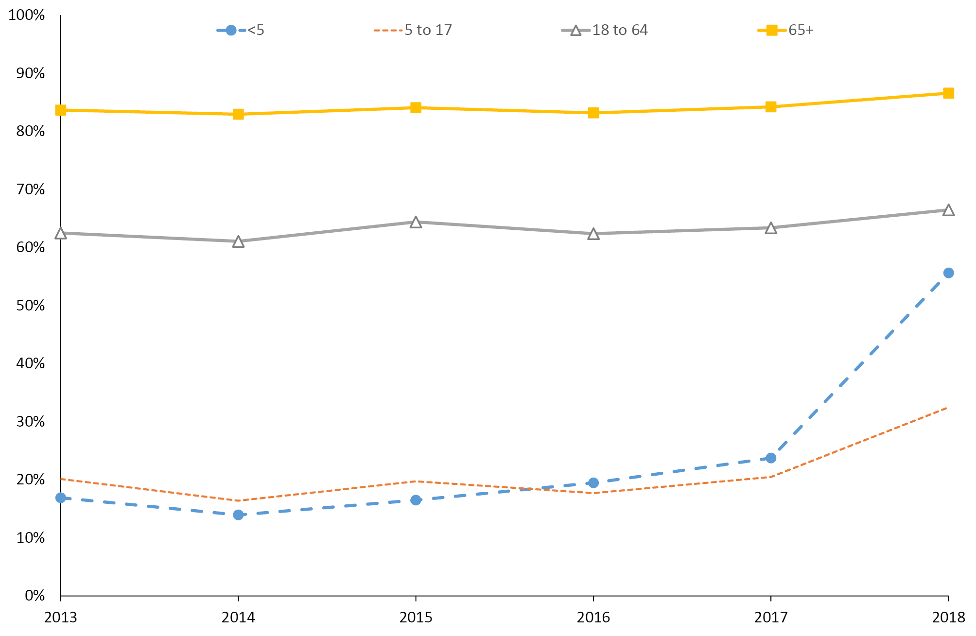
Between 2013 and 2017, vaccine coverage within each age category remained relatively stable (Figure 1): from 13.9 to 23.7% for participants aged less than five years; from 16.4 to 20.5% for participants aged 5 to 17 years; from 61.1 to 64.4% for participants aged 18 to 64 years and from 82.9 to 84.2% for participants aged 65 years and over.
To examine whether the increasing number of participants influenced the vaccine coverage in 2018, an additional analysis was conducted to assess coverage for those Flutrackers who had completed at least one survey in 2018, 2017 and 2016. The trend of increased coverage was unchanged (data not shown). Vaccine coverage in participants who joined in 2018 was also very similar to participants who had joined prior to 2018 (3.6% higher in new 2018 participants aged less than five years).

Discussion
Our data suggests substantial coverage gains in the target population and a flow-on effect to children aged 5 to 17 years. This may be due to both the funding of influenza vaccine in children and a motivated cohort following a severe influenza season in 2017. Coverage in adult participants was also at a record high. These findings were shared with Australia’s jurisdictions and the Department of Health to provide an early indication of the impact of the funded program.
In Australia, the main source of data for vaccine coverage is the Australian Immunisation Register (AIR). A report by the National Centre for Immunisation Research and Surveillance³ based on data from the AIR also demonstrated an increase in influenza vaccine coverage in 2018 for children aged six months to five years (25.6% and 29.5% coverage overall and in Indigenous children respectively) compared to data from 2017 (5% and 14.9% in overall and in Indigenous children respectively).⁴
The AIR data suggested lower 2018 influenza vaccine coverage in each age group compared to Flutracking participants who likely have a bias toward increased vaccination uptake. However, the AIR is known to provide an underestimation of influenza coverage, largely due to underreporting.⁵
We acknowledge the bias within the Flutracking data, including: the motivation to participate in community based surveillance; the high level of education; and the high proportion of health workers within the Flutracking population. We were also unable to confirm that all children who reported to be vaccinated received two doses of vaccine in their first year of vaccine receipt.
Flutracking allows monitoring of near-real-time trends in seasonal influenza vaccine coverage and can rapidly assess impacts of changes in influenza immunisation policies within our cohort. These early signals can then be investigated and confirmed through other less timely, but potentially less biased data sources.

Author details
Dr Sarah A Moberley¹
Ms Sandra J Carlson²
Prof David N Durrheim³
Assoc Prof Craig B Dalton⁴
- Epidemiologist, Hunter New England Population Health, New South Wales, Australia
- Senior Analyst, Hunter New England Population Health, New South Wales, Australia
- Director, Hunter New England Population Health, New South Wales, Australia; University of Newcastle, Callaghan, Australia; Hunter Medical Research Institute, Newcastle, Australia
- Public Health Physician, Hunter New England Population Health, New South Wales, Australia; University of Newcastle, Callaghan, Australia

Corresponding author
Craig B Dalton
Hunter New England Population Health, New South Wales, Australia
University of Newcastle, Callaghan, Australia
Craig.dalton@health.nsw.gov.au

References
- Carlson SJ, Dalton CB, Tuyl FA, Durrheim DN, Feisa J, Muscatello DJ et al. Flutracking surveillance: comparing 2007 New South Wales results with laboratory confirmed influenza notifications. Commun Dis Intell Q Rep. 2009;33(3):323–7.
- Carlson SJ, Dalton CB, Butler MT, Fejsa J, Elvidge E, Durrheim DN. Flutracking weekly online community survey of influenza-like illness annual report 2011 and 2012. Commun Dis Intell Q Rep. 2013;37(4):E398–E406.
- Beard FH, Hendry AJ, Macartney K. Early success with room for improvement: influenza vaccination of young Australian children. Med J Aust. 2019;210(11):484–6.
- Hull B, Hendry A, Dey A, Brotherton J, Macartney K, Beard F. Annual Immunisation Coverage Report, 2017. Commun Dis Intell (2108). 2019;43. https://doi.org/10.33321/cdi.2019.43.47.
- Hendry A, Hull B, Dey A, Beard F. Influenza vaccination coverage as recorded on the Australian Immunisation Register. National Centre for Immunisation Research and Surveillance. [Accessed on 13 September 2018.]
Communicable Diseases Intelligence
ISSN: 2209-6051 Online

Communicable Diseases Intelligence (CDI) is a peer-reviewed scientific journal published by the Office of Health Protection, Department of Health. The journal aims to disseminate information on the epidemiology, surveillance, prevention and control of communicable diseases of relevance to Australia.

Editor: Cindy Toms
Deputy Editor: Simon Petrie
Design and Production: Kasra Yousefi
Editorial Advisory Board: David Durrheim, Mark Ferson, John Kaldor, Martyn Kirk and Linda Selvey

Website: http://www.health.gov.au/cdi

Contacts
Communicable Diseases Intelligence is produced by:
Health Protection Policy Branch, Office of Health Protection, Australian Government Department of Health
GPO Box 9848, (MDP 6) CANBERRA ACT 2601

Email: cdi.editor@health.gov.au

Submit an Article
You are invited to submit your next communicable disease related article to the Communicable Diseases Intelligence (CDI) for consideration. More information regarding CDI can be found at: http://health.gov.au/cdi.
Further enquiries should be directed to: cdi.editor@health.gov.au.

This journal is indexed by Index Medicus and Medline.

Creative Commons Licence - Attribution-NonCommercial-NoDerivatives CC BY-NC-ND
© 2019 Commonwealth of Australia as represented by the Department of Health
This publication is licensed under a Creative Commons Attribution-NonCommercial-NoDerivatives 4.0 International Licence from https://creativecommons.org/licenses/by-nc-nd/4.0/legalcode (Licence). You must read and understand the Licence before using any material from this publication.

Restrictions
The Licence does not cover, and there is no permission given for, use of any of the following material found in this publication (if any):
- the Commonwealth Coat of Arms (by way of information, the terms under which the Coat of Arms may be used can be found at www.itsanhonour.gov.au);
- any logos (including the Department of Health’s logo) and trademarks;
- any photographs and images;
- any signatures; and
- any material belonging to third parties.

Disclaimer
Opinions expressed in Communicable Diseases Intelligence are those of the authors and not necessarily those of the Australian Government Department of Health or the Communicable Diseases Network Australia. Data may be subject to revision.

Enquiries
Enquiries regarding any other use of this publication should be addressed to the Communication Branch, Department of Health, GPO Box 9848, Canberra ACT 2601, or via e-mail to: copyright@health.gov.au

Communicable Diseases Network Australia
Communicable Diseases Intelligence contributes to the work of the Communicable Diseases Network Australia.
http://www.health.gov.au/cdna

