COVID-19, Australia: Epidemiology Report 17: Fortnightly reporting period ending 24 May 2020
COVID-19 National Incident Room Surveillance Team
Notified cases of COVID-19 and associated deaths reported to the National Notifiable Diseases Surveillance System (NNDSS) to 24 May 2020.
Confirmed cases in Australia notified up to 24 May 2020^{i}
Notifications | 7,135
Deaths | 102

Summary
The incidence of COVID-19 has markedly reduced since a peak in mid-March. There have been no cases reported in SA, the NT or the ACT in the last four weeks. The numbers of new cases reported from other jurisdictions continue to be very low. Testing rates have been higher across all jurisdictions, with Victoria reporting an 85% testing rate increase and NSW a 40% increase over this period. The positivity rate nationally continues to remain very low at less than 0.1% over the reporting period. Continued high rates of testing are necessary to detect and mitigate the spread of COVID-19 in the community.
Over the past fortnight, 45% of cases acquired their infection overseas. Of cases considered to be locally-acquired over this period, most were associated with contacts of confirmed cases or were associated with known outbreaks.
The highest rate of COVID-19 continues to be among people aged 65–79 years. Three-quarters of all cases in this age group have been associated with overseas travel, including several outbreaks linked to cruise ships. The lowest rate of disease is in children under 18, a pattern reflected in international reports. A small proportion of cases overall have experienced severe disease, requiring hospitalisation or intensive care with some fatalities. The crude case fatality rate amongst Australian cases is 1.4%. People who are older and have one or more comorbidities are more likely to experience severe disease.
A combination of early case identification, physical distancing, public health measures and a reduction in international travel have likely been effective in slowing the spread of the disease in Australia. In addition, the median number of days between symptom onset and diagnostic testing has improved considerably from 7 days in the early phase of the outbreak to 1 day in the latest phase of the epidemic.
Internationally, as at 24 May 2020, there have been recent increases in the number of daily cases reported globally. The largest numbers of both cases and deaths have been reported in the United States. Of the confirmed cases reported globally, the case fatality rate is approximately 6.5%. Countries in South America are starting to see rapid growth in case numbers, while the United States is seeing a very slow decline in its daily new case numbers. In the South East Asia region, India and Bangladesh are seeing accelerating epidemics, compounded by the recovery from Cyclone Amphan. Increasing numbers of cases are also being reported in Africa, although the numbers are much smaller. In the Pacific there are very few daily new cases reported.
Keywords: SARS-CoV-2; novel coronavirus; 2019-nCoV; coronavirus disease 2019; COVID-19; acute respiratory disease; epidemiology; Australia
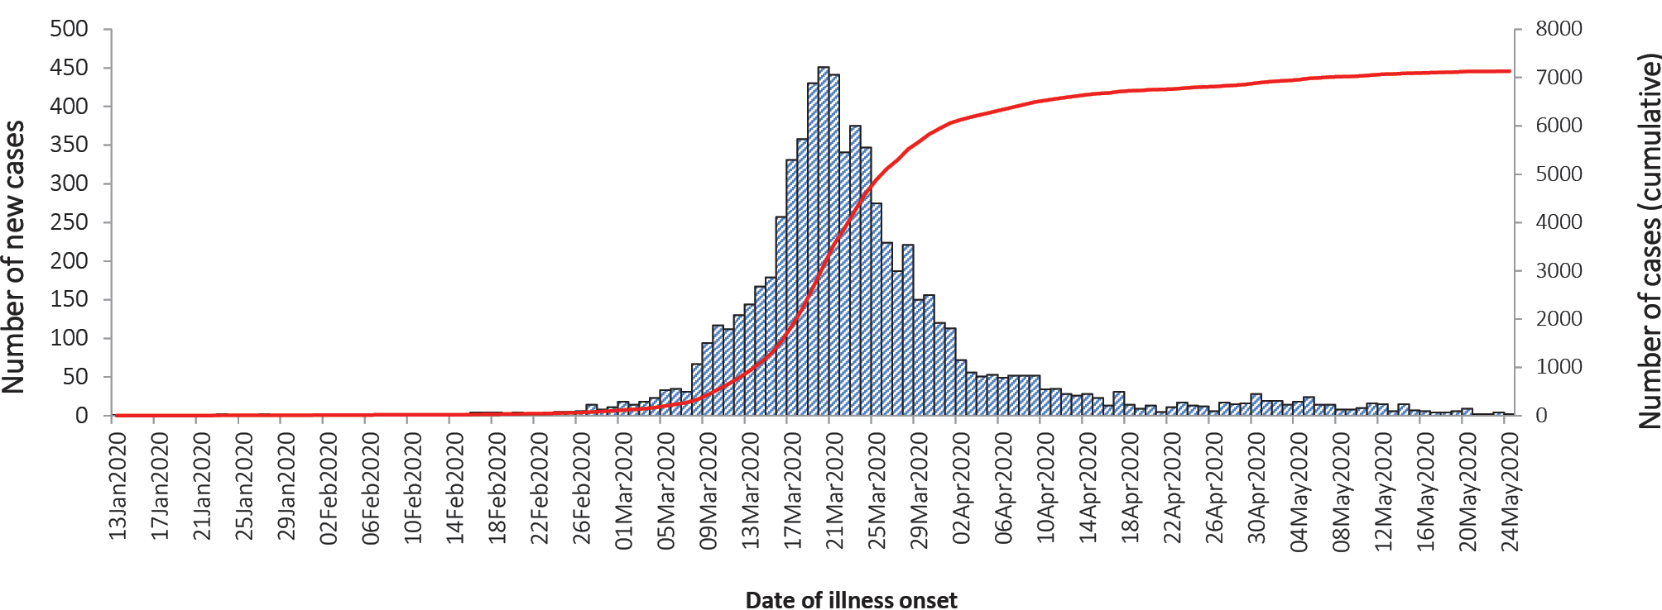
Source: NNDSS

Australian cases: descriptive epidemiology

National trends and geographical distribution
The incidence of COVID-19 continues to be low with very few cases reported by most jurisdictions, indicative of a steady reduction in transmission (Figure 1). Compared to the previous fortnight period, the number of total cases has dropped from 224 to 99. Over the past four weeks there were no cases reported in SA, the NT or the ACT.
Figure 1: Fortnightly COVID-19 new case notifications per 100,000 population,ª as at 24 May 2020, by jurisdiction
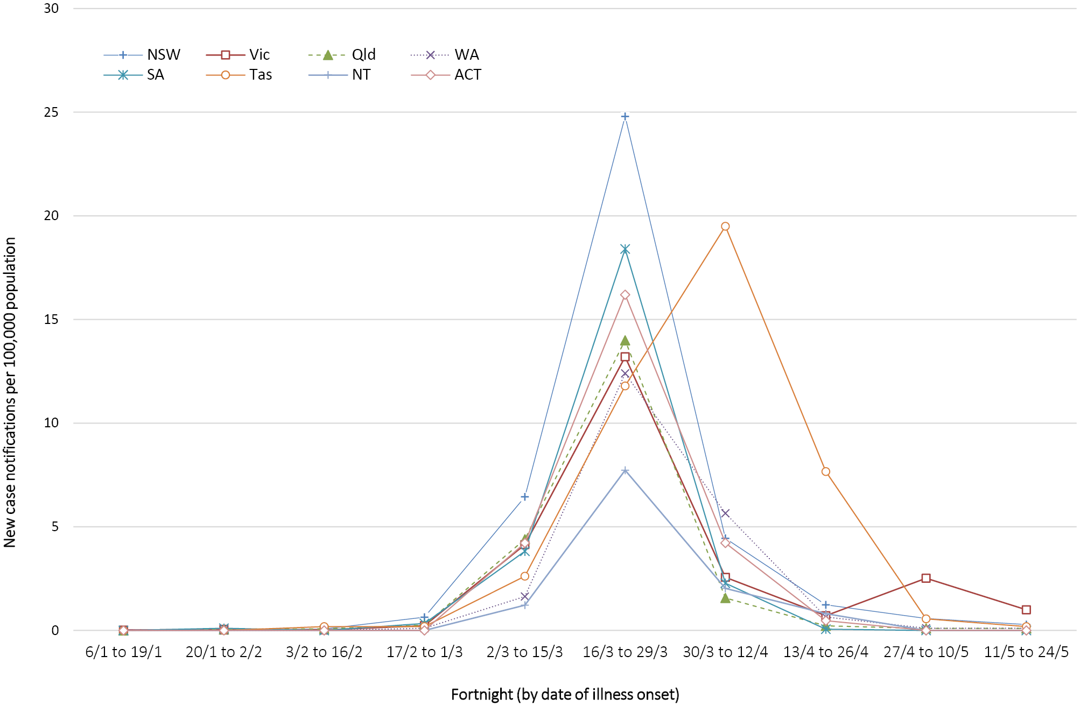
a Source: NNDSS.

Since the epidemic began, the highest cumulative rates per of COVID-19 per population have been reported from NSW and Tasmania (Table 1). This appears to be driven by the cruise-ship-related outbreaks in NSW and by a large outbreak in hospitals in North West Tasmania.
Table 1: Fortnightly notifications and cumulative total cases of COVID-19,ª Australia, by jurisdiction
Jurisdiction | New cases |  | Total cases
 | 27 April–10 May | 11–24 May | Number of cases | Rates per 100,000 population
NSW | 47 | 23 | 3,117 | 38.5
Vic | 166 | 67 | 1,616 | 24.5
Qld | 5 | 5 | 1,058 | 20.8
WA | 3 | 3 | 541 | 20.6
SA | 0 | 0 | 439 | 25.1
Tas | 3 | 1 | 228 | 42.7
NT | 0 | 0 | 29 | 11.8
ACT | 0 | 0 | 107 | 25.1
Australia | 224 | 99 | 7,135 | 28.1
a Source: NNDSS.
In this reporting period, the number of locally-acquired cases reported who reside within a cluster of statistical area level 3 (SA3) has decreased across all jurisdictions (Figure 2). This suggests that the spread of COVID-19 cases in the affected areas has been contained successfully. Between 11 and 24 May, the SA3s with the highest number of cases that were considered to be locally-acquired resided in Moreland-North, Casey-South, and Tullamarine-Broadmeadows. Each of these SA3s reported fewer than 10 cases.

Figure 2: Number of COVID-19 case notifications, Australia, by location of usual residence and selected areas,ª 14-day heat maps for the four most recent fortnightly reporting periods^{b}
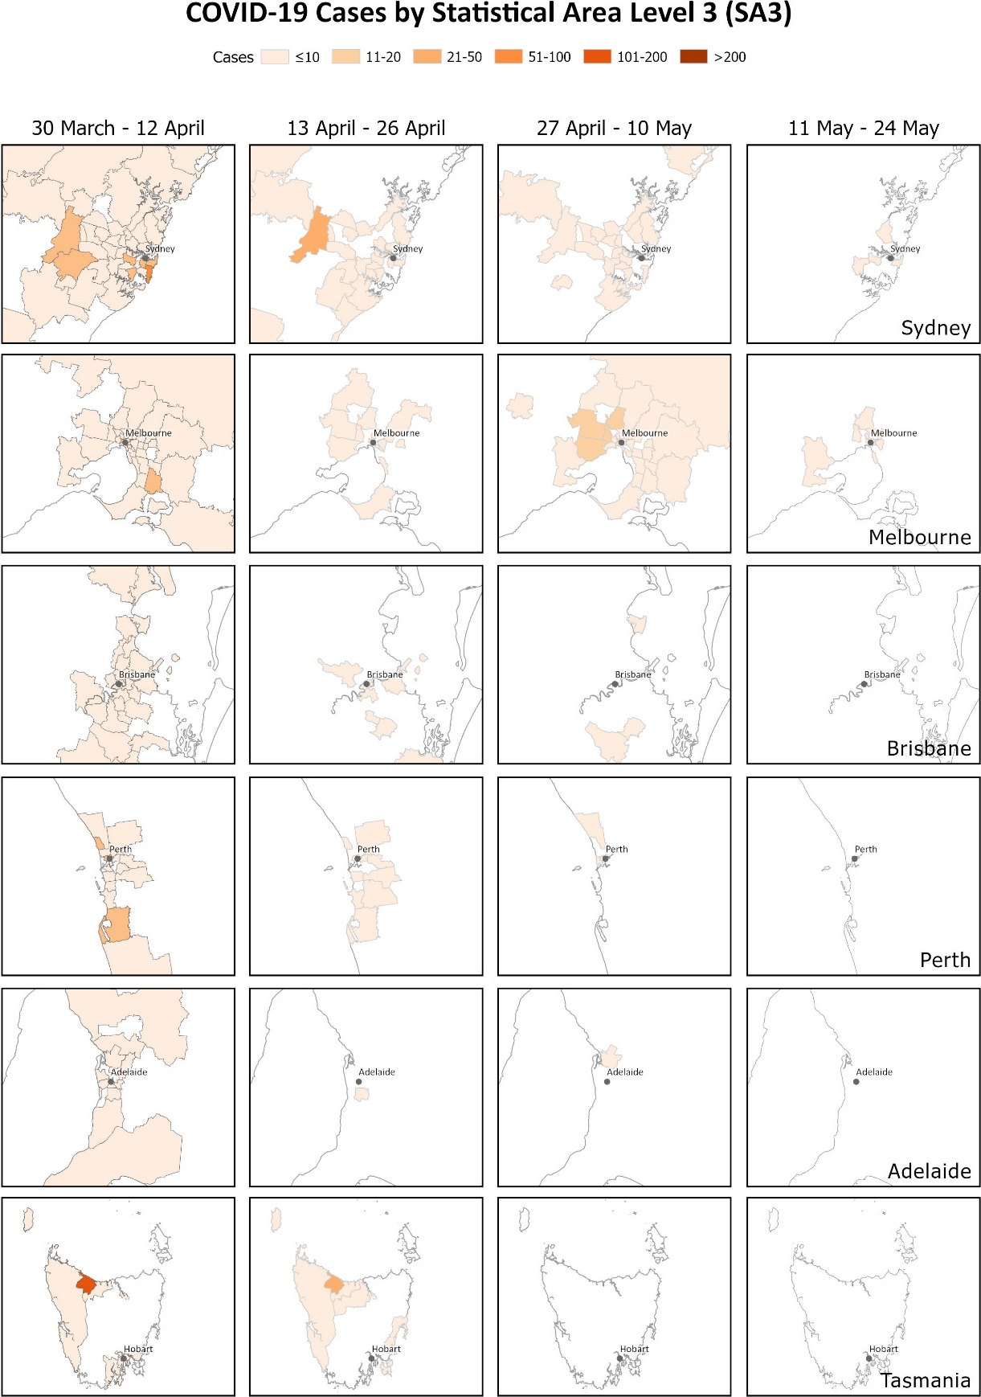
a This map requires caution especially when drawing inferences about areas of current transmission. The allocation of a cases to an SA3 area represents the usual location of residence of a case, which does not necessarily mean that this is the place where they acquired their infection or were diagnosed. For example, the figure includes cases that acquired their infection overseas and were detected in hotel quarantine. Overseas residents who do not have a usual place of residence in Australia are not shown.
b Source: NNDSS.
The Series of National Guidelines recommendation on testing criteria has been modified during this reporting period of 11–24 May.¹ The modifications were mainly on the clinical criteria of testing, which now include presence of fatigue as well as a lower fever threshold from 38 ºC to 37.5 ºC. In addition, jurisdictions may also test asymptomatic international or interstate travellers.
At the conclusion of the reporting period a total of 1,224,795 tests have been conducted in Australia. The proportion of positive tests has continued to decline across all states and territories, with each of the jurisdictions reporting less than 1% positivity rate cumulatively (Table 2). Nationally the positivity rate over the current fortnight reporting period was less than 0.1%. The lower positivity rate is a good indication of widespread testing in a community and supports the low levels of disease being observed.
Table 2: Diagnostic tests performed as at 24 May 2020, Australia, by jurisdiction
Jurisdiction | Cumulative number of tests performed  (proportion of tests positive %) | Cumulative tests/100,000 population ^{a,b}
NSW | 418,427 (0.7) | 5,172
Vic | 420,246 (0.4) | 6,371
Qld | 173,864 (0.6) | 3,413
WA | 76,644 (0.7) | 2,924
SA | 88,446 (0.5) | 5,048
Tas | 24,191 (0.9) | 4,526
NT | 7,217 (0.4) | 2,935
ACT | 15,760 (0.7) | 3,693
Australia | 1,224,795 (0. 6) | 4,829
a Population data based on Australian Bureau Statistics (ABS) Estimated Resident Population (ERP) as at 30 June 2019.
b Data in this table are based on reports of notification by states and territories.

Comparison with international data
Australia’s epidemic scale and trajectory appears to be consistent with countries which were able to effect large-scale public health measures early to enable a flattening of their epidemic curves following an initially rapid phase of exponential growth.
Testing criteria have been different between countries, making direct comparison difficult. For example, the United Kingdom is only testing symptomatic presentations with likely transmission routes as well as specific workforces,² while others including New Zealand have been testing anyone who is displaying cold- or flu-like symptoms.³ In New Zealand the testing rate per population is consistent across each of the District Health Boards with an average of 5,000 tests per 100,000 population and the national cumulative positivity rate is at 0.5%. The similarities between Australia and New Zealand in the number of tests per population, and in positivity rate, suggest that both Australia and New Zealand have very low levels of transmission.

Source of Infection
Of the total 7,135 cases, approximately two-thirds are considered to have acquired their infection overseas (62%). Cruise-ship-related travel and travel history to the European region accounted for the majority of overseas-acquired infections (Figure 3). Over a quarter of cases (28%) are considered to be locally-acquired and linked to a confirmed case, many of these are associated with large interconnected clusters, with a small proportion (10%) of locally-acquired cases unable to be linked to back to a confirmed case. The remaining cases were under investigation.
Figure 3: Number of new case notifications in Australia, by source of acquisition^{.a}
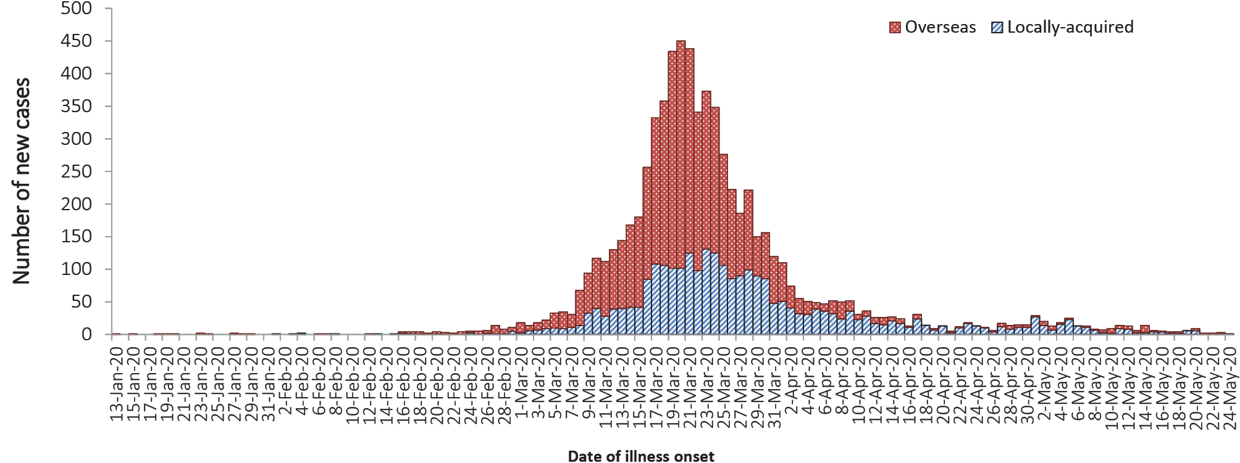
a Source: NNDSS. ‘Locally-acquired’ comprises all cases without an overseas place of acquisition.
Over the fortnight period 11–24 May, 45% of cases acquired their infection overseas, which was higher than in the previous fortnight (23%). Most overseas-acquired cases in the last four weeks have been from Southern and Central Asia. In the previous fortnight (27 April – 10 May) the majority of cases were reported as being locally-acquired and associated with known outbreaks, such as a meat processing facility outbreak (Vic) and an aged care facility outbreak (NSW).

Demographics of cases
The highest rate of disease is among those in the 65–79 years age group with 42.3 cases per 100,000 population (see Appendix B, Figure B.1). The higher rate of cases in this age group is largely driven by outbreaks on cruise ships and by overseas travel, with 75% of cases acquiring their infection outside Australia (44% at sea, 31% in other countries).
Notifications are similar by gender among those aged under 65 years, however among those aged 65 years and over there is a higher rate of cases for males than for females (Table B.1).
The lowest rate of disease is among children and young adults, with 3.6 cases per 100,000 population aged 5–17 and 3.8 cases per 100,000 aged under 5 years. This is consistent with international reports from China and the United States of America, which indicate a low rate of infection among children. A similar pattern has been observed with other coronaviruses such as SARS and MERS with low rates of infection in children.⁵

Severity
Higher disease severity, as indicated by hospitalisation, admission to ICU, and death, has been associated with increased age and comorbidities.¹² The median age of cases who have been hospitalised (61 years, interquartile range (IQR): 42–72 years), admitted to ICU (64 years, IQR: 53–73) and died (80 years, IQR: 74–86) is higher than for cases overall (47 years, IQR: 29–62). Of total cases of COVID-19 notified in Australia, 947 (13%) were admitted to hospital, compared with 16% of cases reported as requiring hospitalisation in Canada⁶ and 36% of cases in the EU/EEA.⁷ It is noted that the higher proportion reported by EU/EEA is affected by each country’s testing strategies, with some European countries now only testing hospitalised individuals for COVID-19.⁷ The crude case fatality rate (CFR) and the proportion of cases requiring hospitalisation in Australia both remain substantially lower than the corresponding values reported from many other comparable high-income countries.
Among Australian cases, the CFR for males aged 65–79 years is slightly elevated compared with females of the same age (Table 3). However, this is reversed in the population aged 80 years and over. Overall fatality rates by age group are similar to those observed in China and Italy as of 17 March 2020,^{8,9} but lower than that observed for the European region when aggregated.¹⁰ The CFR for males aged 80 years and over in the ICU is high at 75.0% (6 deaths from 8 cases in ICU). By comparison, the CFR for Canadian males meeting the same criteria was 46.3% (19 deaths from 41 cases in ICU), based on data up until 13 May 2020 (30,500 cases).¹¹ However, the Australian results are based on a small number of cases and may not be directly comparable to the results in other countries.
Table 3: Number and Case Fatality Rate (CFR) of all cases, hospitalised cases and cases admitted to ICU,ª by age and gender, Australia
 | All cases |  |  | Hospitalisation |  |  | ICU
 | Male | Female | Persons | Male | Female | Persons | Male | Female | Persons
 | Number
Total | 3,618 | 3,513 | 7,135 | 517 | 430 | 947 | 128 | 74 | 202
 | Case Fatality Rate (%)
Under 50 | 0.1 | 0.0 | 0.03 | 0.6 | 0.00 | 0.3 | 0.00 | 0.00 | 0.00
50–64 | 0.5 | 0.3 | 0.4 | 3.3 | 1.6 | 2.4 | 11.4 | 0.00 | 6.8
65–79 | 3.6 | 2.6 | 3.1 | 11.3 | 9.1 | 10.4 | 17.5 | 13.8 | 16.3
80 and over | 21.3 | 24.3 | 22.7 | 31.6 | 39.0 | 34.7 | 75.0 | 33.3 | 57.1
All age groups | 1.6 | 1.3 | 1.4 | 8.3 | 6.7 | 7.6 | 15.6 | 8.1 | 12.9
a Source: NNDSS.
Of the hospitalised COVID-19 cases, 21% (n = 202) were admitted to ICU, with 56 cases receiving ventilation. Fewer than 2% of hospitalised cases were aged under 18 years. Canada has reported similar proportions, with 22% of those hospitalised being admitted to ICU and fewer than 3% of hospitalised cases aged under 20.¹¹ Within the European region, the overall severe hospitalisation rate (cases admitted to ICU and/or requiring respiratory support) from all hospitalised cases was approximately 11% across 14 countries; however large variation was seen between these countries.¹⁰ The European region also reported a decrease in both the hospitalisation and severe hospitalisation rate as age increases beyond 70 years, which is not seen in the Australian data.

Comorbidities
Of all cases, 29% reported one or more comorbid conditions. The proportion of COVID-19 cases who reported one or more comorbid conditions increased with disease severity. Having one or more comorbid conditions was found to be significantly associated with increased odds of hospitalisation and death among COVID-19 cases aged 50 and over.
Cardiac disease, diabetes and chronic respiratory conditions are the most common comorbid conditions among COVID-19 cases (Table 4). Asthma is the most commonly reported comorbidity across all cases, but shows little correlation with increasing disease severity.

Table 4: COVID-19 comorbidities for all cases, hospitalised cases, cases admitted to ICU and deaths (number of cases, proportion of cases),ª Australia
Rank | All cases  (n=5,354) | Hospitalised cases  (n=682) | ICU cases  (n=162) | Deaths  (n=80)
 | Common comorbidities
1 | Asthma  (451, 8%) | Cardiac disease^{b}  (128, 19%) | Diabetes  (39, 24%) | Cardiac disease^{b}  (28, 35%)
2 | Cardiac disease^{b}  (435, 8%) | Diabetes  (119, 17%) | Cardiac disease^{b}  (32, 20%) | Diabetes  (21, 26%)
3 | Diabetes  (381, 7%) | Chronic respiratory condition^{c}  (84, 12%) | Obesity  (19, 12%) | Chronic respiratory condition^{c}  (17, 21%)
4 | Obesity  (202, 4%) | Asthma  (64, 12%) | Chronic respiratory condition^{c}  (18, 11%) | Immunosuppressive condition/therapy  (16, 20%)
5 | Chronic respiratory condition^{c}  (190, 4%) | Obesity  (46, 7%) | Immunosuppressive condition/therapy  (17, 10%) | Neurological disorder  (14, 18%)
6 | Immunosuppressive condition/therapy  (155, 3%) | Immunosuppressive condition/therapy  (43, 6%) | Asthma  (13, 8%) | Obesity  (6, 8%)
7 | Neurological disorder  (92, 2%) | Renal disease  (27, 4%) | Renal disease  (11, 7%) | Asthma  (5, 6%)
8 | Renal disease  (62, 1%) | Neurological disorder  (20, 3%) | Neurological disorder  (6, 4%) | Renal disease  (5, 6%)
9 | Liver disease  (41, 1%) | Liver disease  (11, 2%) | Liver disease  (2, 1%) | Liver disease  (2, 3%)
 | No comorbidities
 | 2,951 (55%) | 198 (29%) | 40 (25%) | 7 (9%)
 | One or more specified comorbidities^{d}
 | 1,556 (29%) | 375 (55%) | 101 (62%) | 78%)
a Source: NNDSS. Excludes those with missing data on comorbidities or where comorbidity is unknown.
b Excluding hypertension.
c Excluding asthma.
d Includes asthma, chronic respiratory conditions (excluding asthma), cardiac disease (excluding hypertension), immunosuppressive condition/therapy, diabetes, obesity, liver disease, renal disease and neurological disorder.

Data on hospitalised cases from the Influenza Complications Alert Network (FluCAN)¹² found a higher prevalence of comorbid conditions in a sample of COVID-19 patients aged 16 years and over (n = 73), likely due to more comprehensive data obtained from patients’ medical records. Among those for which the existence of a comorbidity was known, 37% were identified as obese, suggesting this may be a key risk factor for more severe disease. Diabetes (34%), cardiac disease (32%) and chronic respiratory illness (30%) were also common. A history of smoking (being either a current or past smoker) was identified in 36% of cases.
International investigations report similar results to that of the Australian data. The United States CDC has published data on comorbidities for a small proportion of cases for which complete chart reviews have been conducted, which showed similar comorbidities within cases examined.¹³ The most common comorbidities in the CDC dataset, among hospitalised adults with at least one reported comorbidity, included hypertension (57.9%), obesity (49.7%), metabolic disease (42.4%), and cardiovascular disease (43.9%). Those with no known comorbid condition comprised only 8.3% of the population examined.
Within the European region, analysis of comorbidities of hospitalised patients has shown 38.7% of the population had no comorbidity. The most common types of comorbidity included cardiac disorder (excluding hypertension) (13.4%), diabetes (12.1%), and chronic lung disease (8.9%), similar to the proportions seen within the Australian data.¹⁰

Symptom profile
The symptoms reported by COVID-19 cases in Australia are consistent with a mild respiratory infection in the majority of cases. The most common symptoms reported (see Appendix B, Figure B.2) were cough (69%), fever (47%), sore throat (40%) and headache (36%). Loss of smell or taste was reported in 12% of cases, noting that this is currently not a standard field in NNDSS, and is likely to under-represent those presenting with these symptoms. A small number of cases reported more severe symptoms, with pneumonia and/or acute respiratory disease (ARD) reported in 3% of cases with symptoms.
Adults and children reported similar symptoms, with cough and fever the most commonly reported symptoms across all age groups. Shortness of breath was more commonly reported among older cases, particularly those aged 80 and over (32%).
The symptom profile of Australian cases is broadly similar to the symptoms reported by COVID-19 cases internationally. Among EU/EEA countries and the UK, fever/chills and dry or productive cough were the most commonly reported symptoms.¹⁴ Cough, headaches and fever and chills were the most commonly reported symptoms among cases in Canada.¹⁵ Differences in reported symptoms will be influenced by differences in surveillance strategies and symptom reporting across countries.

Populations of Interest

Aboriginal and Torres Strait Islander persons
Fifty-nine cases (0.8%) have been reported in Aboriginal and Torres Strait Islander persons since the start of the epidemic in Australia. Approximately half of these cases acquired their infection overseas. Whilst cases were reported across several jurisdictions, of the locally-acquired cases the majority were reported in areas classified as ‘Major cities of Australia’ based on the case’s usual place of residence (Table 5). No cases among Aboriginal and Torres Strait Islander persons have been notified from remote or very remote areas of Australia.

Table 5: COVID-19 cases,ª notified among Aboriginal and Torres Strait Islander persons by remoteness classification and source of acquisition
Locally-acquired^{b} |  |  |  | Overseas-acquired | Total
Major cities of Australia | Inner regional Australia | Outer regional Australia | Remote/very remote Australia
21 | 4 | 6 | 0 | 28 | 59
a Source: NNDSS.
b ‘Locally-acquired’ comprises all cases without an overseas place of acquisition.
Across all Australian cases, completeness of the Indigenous status field was approximately 95%.
The median age of COVID-19 cases among Aboriginal and Torres Strait Islander persons is 34 years (IQR: 21–56 years), which is lower than the median age of non-Indigenous COVID-19 cases (47, IQR: 29–62 years).
Of the cases notified amongst Aboriginal and Torres Strait Islander persons, 10% were admitted to hospital, which is similar to the proportion of all cases hospitalised (all cases = 13%). Of cases in Aboriginal and Torres Strait Islander persons, none were reported as being admitted to ICU, with no fatalities reported.

School-aged children and older population
The peak period of illness onset for COVID-19 cases among school-aged children and older populations in Australia was between 16 and 29 March 2020. The epidemic curve (Figure 3) shows new cases declining in the following fortnight after the introduction of overseas travel restrictions, implemented on 20 March 2020 (see Appendix B, Table B.2). This decline in new cases indicates that the measures were effective in preventing the spread of COVID-19 in Australia.
There have been 145 case notifications in total among school-aged children (5–17 years old), accounting for 2.0% of all cases. Nine new cases within this age group were reported in this reporting period. Of the 145 cases, 72% reported no recent overseas travel history (Figure 4 As at 24 May 2020, the median days between symptoms onset and diagnostic test among school-aged children is 2 days (IQR: 1–4), whereas in older populations the median days is 3 days (IQR: 1–7). The European region has reported comparatively few cases in people aged 19 or below.¹⁰

Figure 4: Number of COVID-19 case notifications in Australia by date of illness onset for selected age groups, from 13 January to 24 May 2020, by source of acquisitionª
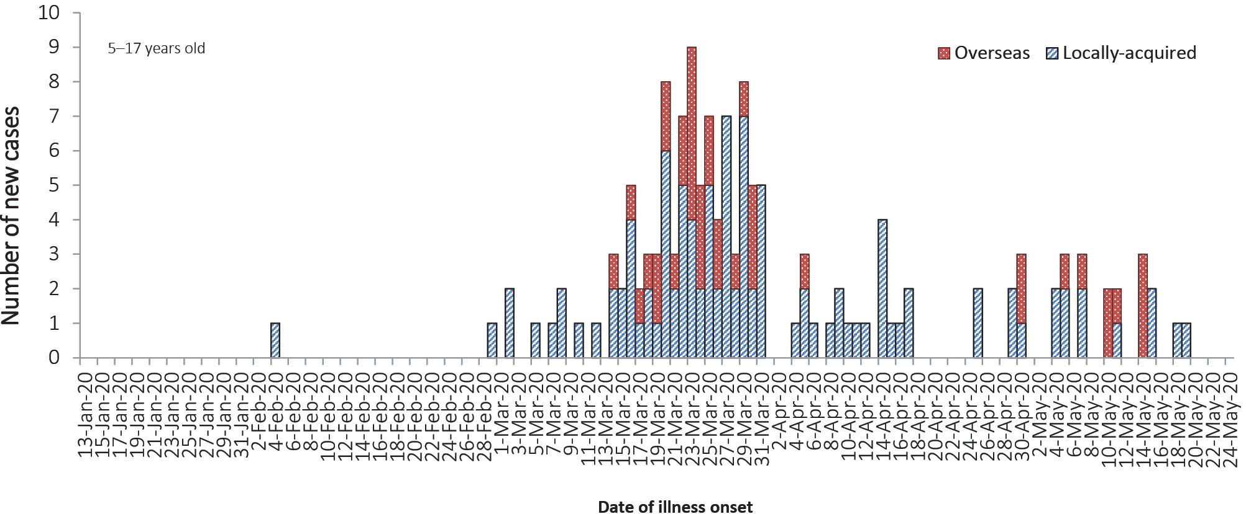
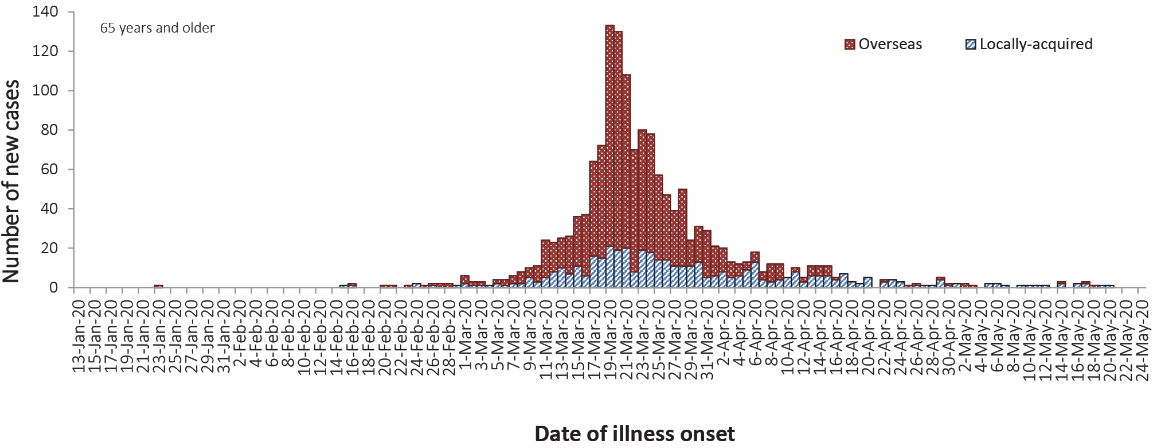
a. Source: NNDSS Locally-acquired comprises all cases without an overseas place of acquisition.
Older people aged 65 years and over are at an increased risk for severe disease from COVID-19. In Australia, there have been 1,517 cases notified among older people. The majority of these cases (62.7%) reported recent overseas travel history. Of the overseas-acquired infection cases in older populations, cruise-ship-acquired infection makes up 62.4% of the cases, with approximately 1 in 2 of the cruise-ship-acquired cases among those aged 70–79 years old.

Cluster and outbreak investigations
Cluster:
The term ‘cluster’ in relation to COVID-19 refers to two or more cases (who do not reside in the same household) that are epidemiologically related in time, place or person where a common source (such as an event or within a community) of infection is suspected but not yet established.
Outbreak:
The term ‘outbreak’ in relation to COVID-19 refers to two or more cases (who do not reside in the same household) among a specific group of people and/or over a specific period of time where illness is associated with a common source (such as an event or within a community). Some states and territories may report a single case associated with a residential aged care facility as an outbreak.

To date the largest outbreaks of COVID-19 in Australia have been associated with cruise ships, with some other large domestic clusters associated with aged care and healthcare facilities, workplaces and private functions.
In the week ending 24 May 2020, states and territories reported 10 open clusters and outbreaks of COVID-19, a decrease compared to the preceding week. Open clusters and outbreaks are defined as those where a new case was identified in the last 14 days as at the end of the reporting period. Of the open clusters and outbreaks, four were in residential aged care facilities, three in various other settings, two in health care facilities, and one associated with a cruise ship. Those in various other settings included an outbreak in a meat processing facility and an outbreak in a fast food restaurant. The number of open clusters and outbreaks may be revised as a result of ongoing investigations in states and territories.
Meat and animal processing facilities have been identified as settings with increased risk for SARS-CoV-2 transmission. Outbreaks have been reported in meat and animal processing facilities in at least eight countries including Australia.¹⁸ To date, there has been only one outbreak reported in a meat processing facility in Australia. A report on COVID-19 cases among workers in meat and poultry processing facilities in the Unites States identified 115 meat or poultry processing facilities associated with 4,913 cases of COVID-19 in workers.¹⁹ The high rate of transmission these settings is considered to be related to difficulties in workplace physical distancing in production line settings, hygiene, and crowded living and transportation conditions.¹⁹
Residents of aged care facilities are at increased risk of COVID-19 infection due to the environment of communal living facilities, and are more vulnerable to serious complications if they do become infected. As of 24 May 2020, there have been 129 cases of COVID-19 associated with 31 residential aged care facilities, with 72 recoveries and 27 deaths. Sixty-six of these cases occurred in aged care residents, with the remaining 63 cases occurring in care staff. In addition, there have been 42 cases associated with 30 in-home Commonwealth funded aged care services providing support to older Australians who live at home, with 37 recoveries and 3 deaths. Thirty-one of these cases occurred in care recipients, with the remaining 11 cases occurring in care staff. The Commonwealth is actively supporting services with reported incidents and outbreaks of COVID-19, providing access to personal protective equipment and additional staffing resources where required. Advice and guidelines have been provided to aged care services,²⁰ including the release of an outbreak management guide.²¹

In-focus analysis

Comparison of first and most recent 500 cases
Understanding the characteristics of COVID-19 cases between the early and later phases of the epidemic provides useful insights on the effectiveness of public health measures as well as on the pattern of disease transmission. A review of the first and most recent 500 COVID-19 cases in NNDSS data found that during the early phase of COVID-19 epidemic in Australia, overseas-acquired cases made up the majority of cases notified, with about 2 in 3 cases (64%) reporting recent overseas travel history compared to 1 in 5 cases (20%) in the most recent phase of the epidemic (Table 6). The distribution of cases was highest among those aged 18–64 years in the early phase whereas in the later phase, the rate was highest among those aged 80 years and older. This reflects that the driver of early spread of the disease was mostly from overseas travel whereas in the most recent phase of the epidemic, the spread has been largely driven by local clusters and outbreaks.
Table 6: The demographic characteristics of the first 500 and most recent last COVID-19 casesª
Characteristics | First 500 cases | Most recent 500 cases
Date of illness onset period | 13 Jan – 10 Mar | 14 Apr – 24 May
Median age (IQR) | 44 (31–58) | 40 (27–58)
Female (N/%) | 234 (46.8%) | 252 (50.4%)
Overseas-acquired (N/%) | 321 (64.2%) | 104 (20.8%)
At sea (cruise ships) | 25/321 (7.8%) | 20/104 (19.2%)
Europe | 116/321 (36.1%) | 12/104 (11.5%)
Southern and Central Asia | 1/321 (0.3%) | 47/104 (45.2%)
Aboriginal and Torres Strait Islander persons (N/%) | 1 (0.22%) | 10 (2%)
Median time between symptoms onset and laboratory testing (days) | 7 (3–12) | 1 (0–3)
Rate of cases per 100,000
Under 5 | 0.03 | 0.54
5–17 | 0.11 | 0.38
18–64 | 1.34 | 1.15
65–79 | 0.97 | 1.01
80 and over | 0.54 | 1.46
Source: NNDSS
Early identification of cases is an important strategy for containing the spread of COVID-19. In Australia, the time between onset of symptoms and laboratory testing has improved from a median of 7 days in the early phase to a median of 1 day in the most recent phase of the epidemic. A shorter time between symptoms onset and diagnosis is essential for early isolation of cases and quarantining of close contacts, therefore preventing the further spread of COVID-19.

Public health response measures
Since COVID-19 first emerged internationally, Australia has implemented public health measures in response to the disease’s epidemiology, both overseas and in Australia (Figure 5). Key aspects of Australia’s evolving public health response are summarised in Appendix B (Table B.2).

Figure 5: COVID-19 notifications in Australia by date of illness onset, from 13 January to 24 May 2020,ª with timing of key public health measures
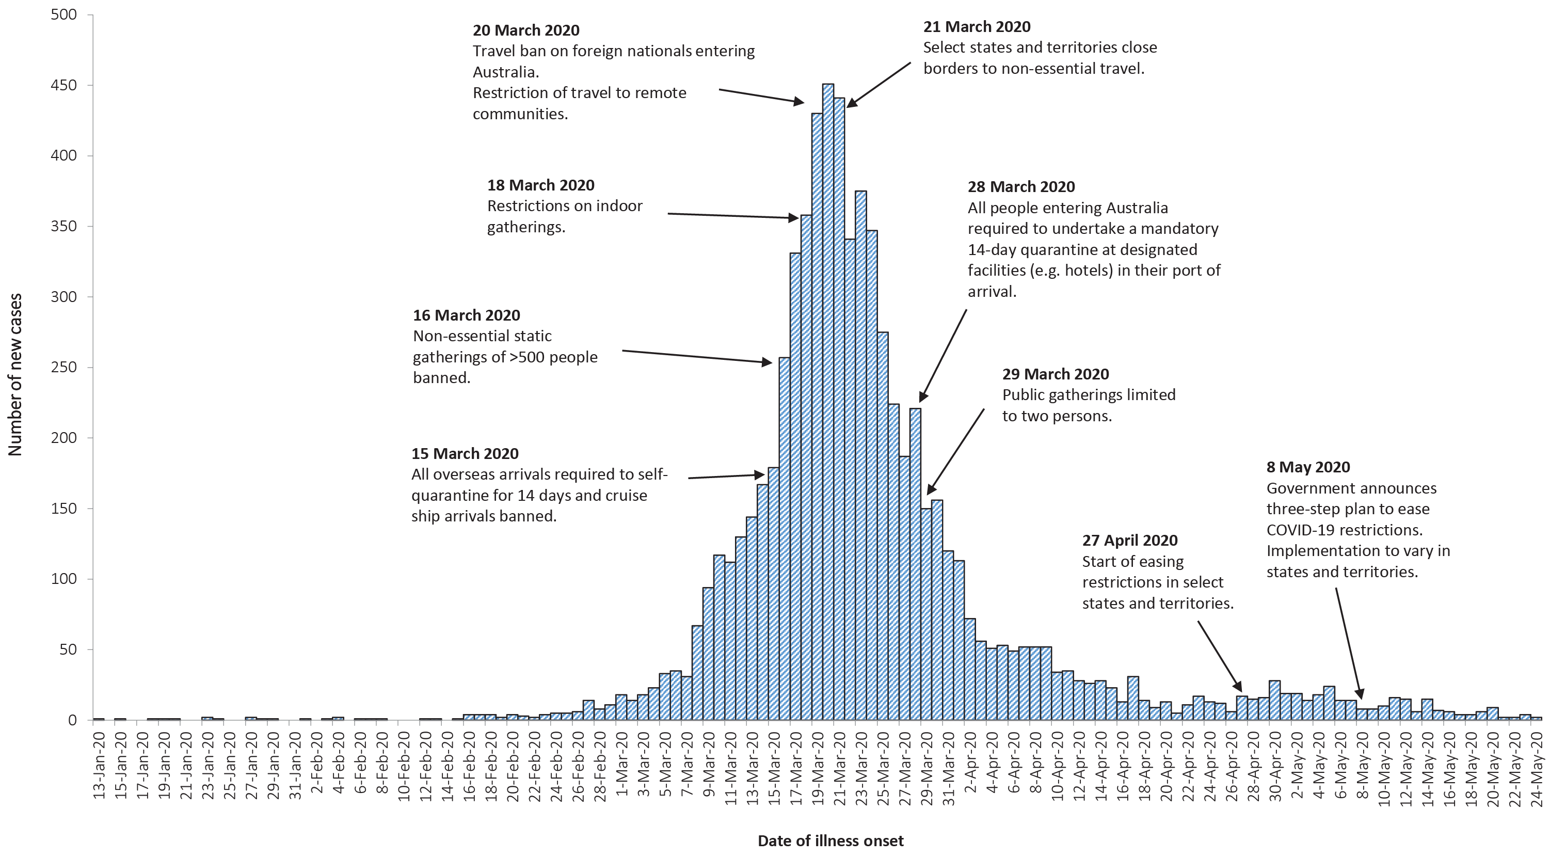
a Source: NNDSS. Due to reporting delays, interpret the latest days’ new cases with caution

On Friday 8 May, the Australian Government announced a three-step framework for easing COVID-19 restrictions, with states and territories easing restrictions at their own pace depending on the current public health situation and local epidemiology. A summary of the restrictions that have been eased is listed at Table 7.
Table 7: State and territory actions for easing COVID-19 restrictions, from 11 May to 24 May 2020a
Jurisdiction | Summary of restrictions which have been eased
New South Wales | Step 1: from 15 May the following restrictions were eased:²³  - Public gatherings of up to 10 people permitted outdoors  - Gatherings of 5 permitted in households  - Restrictions on weddings and funerals eased  - Outdoor sports and recreation reopened with restrictions
Victoria | Step 1: from 12 May the following restrictions were eased:²⁴  - Gatherings of 5 permitted in households  - Gatherings of 10 permitted for sports and in places of worship
Queensland | Step 1: from 16 May the following restrictions were eased:²⁵  - Up to 5 visitors may gather in a household  - Public gatherings of up to 10 people permitted outdoors  - Intrastate travel restrictions eased  - Restrictions on weddings and funerals eased  - Schools to recommence fact-to-face teaching  - Additional concessions for outback Queensland
Western Australia | Step 2: from 18 May the following restrictions will be eased:²⁶  - Public gatherings of up to 20 people permitted  - Restrictions on weddings and funerals eased  - Regional travel restrictions relaxed  - Individuals permitted to return to work (face-to-face)
South Australia | Step 1: from 11 May the following restrictions were eased:^{27,28}  - Public gatherings of up to 10 people permitted  - Regional travel permitted  - Universities and TAFEs recommenced face-to-face learning  - Restrictions on weddings and funerals eased
Tasmania | Step 1: from 18 May the following restrictions were eased:²⁹  - Up to 5 visitors may gather in a household  - Public gatherings of up to 10 people permitted  - Community sports and pools open to up to 10 people  - Tasmanian residents permitted to quarantine in their primary residence (rather than hotel)
Australian Capital Territory | Step 1: from 16 May the following restrictions were eased:^{30,31}  - Public gatherings of up to 10 people permitted  - Public schools to progressively reopen over a four week period commencing 18 May
Northern Territory | Step 2/3: from 15 May the following restrictions were eased:³²  - All businesses permitted to reopen  - People permitted to undertake all recreational, sporting and social activities in public places for up to two hours
a For a history of Australia’s COVID-19 public health response activities see Appendix B (Table B.2).

International situation³³

Global
On 24 May 2020, more than 216 countries, regions and areas had reported 5,204,508 COVID-19 cases and 337,687 deaths to the WHO.³³ Europe and the United States of America continue to be the epicentres of the pandemic; however, some South American countries and India are emerging as new hotspots (Figure 6). By region, approximately 45% of all global cases and 41% of all global deaths are from the Americas, while 39% of cases and 51% of deaths are from the European Region. By country, the largest numbers of cases are from the United States of America, the Russian Federation and Brazil and the largest numbers of deaths are from the United States of America, the United Kingdom and Italy. The global case fatality rate (CFR) is approximately 6.5%. The differing epidemics being experienced by each country are aligned to the phase of the epidemic that they are currently in and the relevant local public health responses, as well as broader health system capacity.

Figure 6: Number of COVID-19 cases (logarithmic scale) by selected country and days since passing 100 cases, up to 24 May 2020
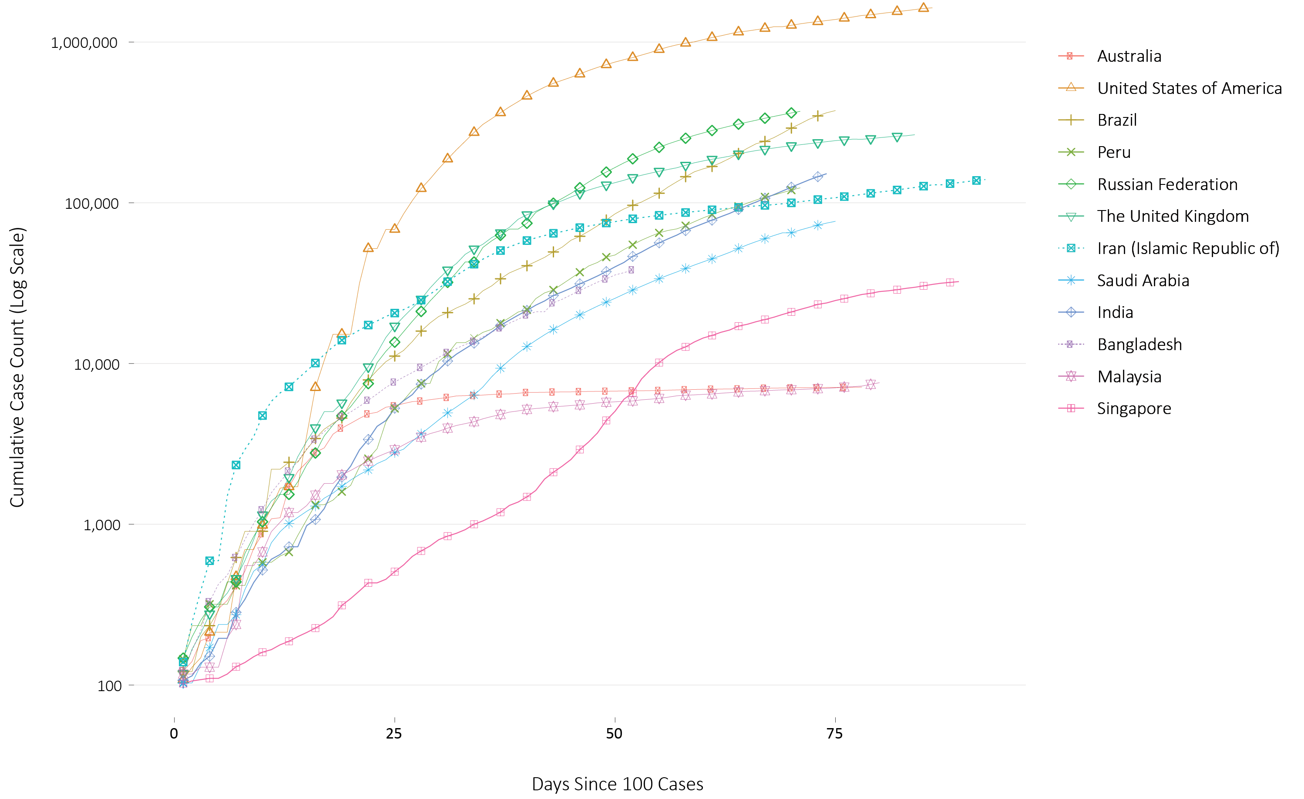

Americas
The United States of America reports almost 1.6 million cases (30% of global cases) and is experiencing a slow decline in new daily case numbers shown in Figure 5. Despite this, the number of new cases over the previous week were the highest in the world. The country is experiencing large outbreaks in several workplace and community settings, such as animal processing plants, correctional facilities and residential aged care facilities.
Brazil’s epidemic is accelerating (Figure 5) and the country has now reported over 330,000 cases, with an average of 15,000 new cases reported daily over the past week. The situation in Peru is also rapidly worsening (Figure 5), with the country reporting a daily increase in the number of cases of greater than 2.5%. Despite early success against the virus through mandatory self-quarantine and border closures, the current epidemic may be attributed to an inability of the population to adhere to public health measures.

Europe
Russia has the greatest number of COVID-19 cases in Europe, although its epidemic appears to be slowing (seen in the flattening on the curve in Figure 5). Whilst it has one of the lowest CFRs in the world (1.0%), this is likely because it is reporting only deaths that are considered to be exclusively due to COVID-19. Effects of Russia’s easing lockdown will likely start to be seen from the end of May through to mid-June. Turkey, which is reporting more than 150,000 cases, also has a lower CFR than most European countries (2.8%).³⁴ This may be related to underreporting of COVID-19 deaths, as the country is reporting more excess deaths than COVID-19 deaths.³⁵ The number of new daily cases continue to decline in many of the other significantly affected European nations, with the United Kingdom being the main exception. Several countries in eastern Europe,³⁶ including Kazakhstan, Armenia and Tajikistan, are showing strong growth in the number of new cases. Many countries are planning to allow travel in the coming months, and some countries have negotiated ‘travel bubbles’; Estonia, Latvia and Lithuania being one example.

Eastern Mediterranean
Saudi Arabia passed their epidemic peak and are intending to fully lift restrictions by 21 June 2020. Iran is experiencing a resurgence of the epidemic,³⁷ and on 23 May 2020 announced additional measures against the outbreak.
A large majority of the outbreaks in Arab countries have been within the migrant worker and prison populations. Population migration, as a result of jobless workers returning to their home countries, has distributed the disease and the restricted testing capacity of several countries in the region may be masking the true scale of the epidemic. Most countries in the region are reporting a CFR lower than the global average. However, Yemen is reporting a CFR of approximately 20%.

Africa
Of cases in the African region (1.5% of global cases), more than a quarter have been in South Africa (28%), while more than a quarter of deaths in this region have occurred in Algeria (29%). South Africa has reported three times as many deaths over the previous week.³⁸ COVID testing is available in more than 40 African countries, noting it is essentially one laboratory per country. However, obtaining test kits has proved to be problematic for smaller nations. Africa CDC is coordinating bulk orders of testing supplies to improve the continent’s negotiating power.

South East Asia
This region has seen the highest week-on-week increase of newly reported cases of any region in the globe. Case numbers in India and Bangladesh are accelerating with the virus circulating in the poorest populations (seen in Figure 5). India reports a testing positivity rate of approximately 4% and is testing travellers, close contacts and symptomatic people. Although Indonesia reports approximately 24,000 cases and 1,500 deaths, media reports suggest the numbers may be much higher and many cases remain undetected. Malaysia, Vietnam and Thailand all have a very low positivity rate and have likely contained the outbreak in their respective countries. Malaysia’s cumulative case trajectory is shown in Figure 5.

Pacific
There has been limited growth in the number of new cases in this region over the past week, with the majority of new cases still being reported by Singapore (61%). Its epidemic trajectory is shown in Figure 5. Approximately 93% of all cases in Singapore are dormitory workers; 9.5% of the dormitory worker population has been diagnosed with COVID-19. The Philippines reports a CFR of 6.0% which is similar to the global CFR but high for the region. The country’s testing data shows a positivity rate of 7.6%. Of the Pacific Island Nations which have reported at least one case, there have been no new cases or deaths reported in the past 21 days. The Commonwealth of the Northern Mariana Islands reported 2 new cases on 17 May 2020.

Background
The current estimates on epidemiological parameters including severity, transmissibility and incubation period are uncertain. Estimates are likely to change as more information becomes available.

Transmission
Human-to-human transmission of SARS-CoV-2 is via droplets and fomites from an infected person to a close contact.³⁹ Several studies have detected that viral RNA levels peak in the first week of illness, suggesting transmission is most likely to occur early in the illness with infectivity gradually decreasing over time.⁴⁰ In a Taiwanese study examining over 2,500 close contacts of 100 patients with COVID-19, all 22 secondary cases had their first exposure to the index case within six days of symptom onset. No infections were documented in the 850 contacts whose exposure was after six days.⁴¹
Viral RNA has been identified in respiratory track specimens 1–2 days prior to symptom onset, and has been observed after symptom cessation.⁴⁰ In 50% of the patients, seroconversion occurred after seven days with a range of up to 14 days; this seroconversion was not followed by a rapid decline in viral load.⁴⁰ However, the detection of viral RNA does not always correlate with transmission risk. A study of nine patients with mild COVID-19 infection found infectious virus was not able to be isolated from naso/oropharyngeal and sputum samples after the first 8 days of illness, despite continued high viral RNA levels.⁴⁰ Recent analysis from the Korea Centres for Disease Control and Prevention of cases who tested positive after previously being cleared from isolation found live virus was unable to be cultured from any cases selected for testing (n = 108).⁴²
Several studies suggests that children do not play a key role in transmission and are unlikely to be the primary source of infections.⁴³ Studies out of the EU have suggested that child to adult transmission is uncommon.^{44,45}
Current evidence does not support airborne or faecal-oral spread as major factors in transmission.³⁹

Incubation period
Estimates of median incubation period, based on seven published studies, are 5 to 6 days (ranging from 1 to 14 days). Patients with long incubation periods do occasionally occur; however, they are likely to be ‘outliers’ who should be studied further but who are unlikely to represent a change in epidemiology of the virus.^{46,47}

Molecular epidemiology
Since December 2019, the virus has diversified into multiple lineages as it has spread globally, with some degree of geographical clustering. The whole genome sequences currently available from Australian cases are dispersed across these lineages, reflecting multiple concurrent introductions into Australia.^{48–50} Multiple genomic clusters, closely related sequences reflecting local transmission chains, have also been identified in Australia.^{48,49} Genomic epidemiology has successfully been used to link many cases that were epidemiologically classified as ‘locally-acquired – contact not identified’ to known genomic clusters, highlighting the utility of virus sequencing to informing the public health response.^{48, 49}

Clinical features
COVID-19 presents as mild illness in the majority of cases, with cough and fever being the most commonly reported symptoms. Severe or fatal outcomes are more likely to occur in the elderly or those with comorbid conditions.^{39,51}
Some COVID-19 patients show neurological signs such as headache, nausea and vomiting. There is evidence that SARS-CoV-2 viruses are not always confined to the respiratory tract and may invade the central nervous system inducing neurological symptoms. As such, it is possible that invasion of the central nervous system is partially responsible for the acute respiratory failure of COVID-19 patients.⁵²
There is some evidence to suggest that impairment or loss of the sense of smell (hyposmia/anosmia) or taste (hypoguesia/aguesia) is associated with COVID-19.^{53,54} This is supported by research finding a biological mechanism for the SARS-CoV-2 virus to cause olfactory dysfunction.^{55,56}
Several studies have identified cardiovascular implications resulting from COVID-19.^{57–59} Vascular inflammation has been observed in a number of cases and may be a potential mechanism for myocardial injury which can result in cardiac dysfunction and arrhythmias.
COVID-19 disease in children is more likely to be mild and self-limiting, compared to adults. Internationally children make up a small proportion of confirmed COVID-19 cases, with those shown to be infected either presenting with milder symptoms then adults or remaining asymptomatic, a similar pattern has been observed with SARS and MERS. However, the greater likelihood of mild clinical presentation in children may result lower testing and case detection in this cohort. Studies have also shown that hospital admission is inversely related to age. From European reporting death associated with COVID-19 has been rare among those aged less than 15 years, with 4 deaths reported from 44,695 cases, as at 13 May 2020.
There have been reports of a rare clinical presentation of paediatric inflammatory multisystem syndrome resembling Kawasaki disease temporally associated with SARS-CoV-2 infection in children. This presentation remains rare with evidence of the association between COVID-19 and the development of a Kawasaki like disease is currently inconclusive and further investigation is needed due to variability in clinical presentations in reported paediatric cases.^{60,61}

Treatment
Current clinical management of COVID-19 cases focuses on early recognition, isolation, appropriate infection control measures and provision of supportive care.⁶² Whilst there is no specific antiviral treatment currently recommended for patients with suspected or confirmed SARS-CoV-2 infection, multiple clinical trials are underway to evaluate a number of therapeutic agents, including remdesivir, lopinavir/ritonavir, and chloroquine or hydroxychloroquine. ^{63,64}
A open-label randomised controlled trial did not find a significant impact of hydroxychloroquine treatment on disease progression for hospitalised patients with mild to moderate COVID-19, with those receiving treatment also reporting a higher number of adverse events.⁶⁵ Similarly, an open-label randomised controlled trial of lopinavir/ritonavir among hospitalised patients found no benefit for time to clinical improvement.⁶⁶
Results for remdesivir treatment have been mixed, with one randomised double-blind placebo-controlled trial finding patients recovered 31% faster and a lower mortality rate (8.0% compared with 11.6% among placebo patients),⁶⁷ while another found no effect.⁶⁸ Taiwan Food and Drug Administration (TFDA) has recently approved remdesivir for the treatment of patients with severe SARS-CoV-2 infection based on preliminary evidence on its safety and effectiveness. Further trials are required to assess the effectiveness of these treatments on COVID-19. Multiple COVID-19 vaccines have commenced clinical trials.

Data considerations
Data were extracted from the NNDSS on 28 May 2020, including notifications received up to 24 May 2020. Due to the dynamic nature of the NNDSS, data in this extract are subject to retrospective revision and may vary from data reported in published NNDSS reports and reports of notification data by states and territories.
Date of illness onset definition: Date of illness onset was based on diagnosis date data in NNDSS. Diagnosis date represents either the onset date or, where the date of onset was not known, the earliest of the specimen collection date, the notification date, or the notification received date.

Acknowledgements
This report represents surveillance data reported through CDNA as part of the nationally-coordinated response to COVID-19. We thank public health staff from incident emergency operations centres in state and territory health departments, and the Australian Government Department of Health, along with state and territory public health laboratories. We also thank Professor Allen Cheng of FluCAN for providing data for the FluCAN analyses.

Author details

Corresponding author
COVID-19 National Incident Room Surveillance Team, Australian Government Department of Health, GPO Box 9484, MDP 14, Canberra, ACT 2601. Email: epi.coronavirus@health.gov.au

References
- Australian Government Department of Health. Series of National Guidelines (SoNGs): Coronavirus Disease 2019 (COVID-19). CDNA National guidelines for public health units. [Internet.] Canberra: Australian Government Department of Health; 29 May 2020. [Accessed on 2 June 2020.] Available from: https://www1.health.gov.au/internet/main/publishing.nsf/Content/cdna-song-novel-coronavirus.htm.
- Government of the United Kingdom. Guidance: Coronavirus (COVID-19): getting tested. [Internet.] London: Government of the United Kingdom; 15 April 2020. [Accessed on 1 June 2020.] Available from: https://www.gov.uk/guidance/coronavirus-covid-19-getting-tested.
- New Zealand Government. COVID-19 testing: Information about COVID-19 testing in New Zealand. [Internet.] Wellington: New Zealand Government; 18 April 2020. [Accessed on 1 June 2020.] Available from: https://covid19.govt.nz/covid-19/about-covid-19/covid-19-testing/.
- Ludvigsson JF. Systematic review of COVID‐19 in children shows milder cases and a better prognosis than adults. Acta Paediatr. 2020. doi: https://doi.org/10.1111/apa.15270.
- Zimmermann P, Curtis N. Coronavirus infections in children including COVID-19: an overview of the epidemiology, clinical features, diagnosis, treatment and prevention options in children. Pediatr Infect Dis J. 2020;39(5):355–368. doi: https://doi.org/10.1097/INF.0000000000002660.
- Public Health Agency of Canada (PHAC). Coronavirus disease 2019 (COVID-19). Daily epidemiology update. Updated: 19 May 2020, 11:00 ET. Ottawa: Government of Canada, PHAC; 2020. Available from: https://www.canada.ca/content/dam/phac-aspc/documents/services/diseases/2019-novel-coronavirus-infection/surv-covid19-epi-update-eng.pdf.
- European Centre for Disease Prevention and Control (ECDC) COVID-19 surveillance report: Week 2020-19. 4: Severity. [Internet.] Solna: ECDC; 14 May 2020. [Accessed on 19 May 2020.] Available from: https://covid19-surveillance-report.ecdc.europa.eu/#4_severity.
- Zheng Z, Peng F, Xu B, Zhao J, Liu H, Peng J et al. Risk factors of critical & mortal COVID-19 cases: a systematic literature review and meta-analysis. J Infect. 2020. doi: https://doi.org/10.1016/j.jinf.2020.04.021.
- Onder G, Rezza G, Brusaferro S. Case-fatality rate and characteristics of patients dying in relation to COVID-19 in Italy. JAMA. 2020;323(18):1775-1776. doi: https://doi.org/10.1001/jama.2020.4683.
- ECDC. COVID-19 surveillance report: Week 21, 2020. [Internet.] Solna: ECDC; 2 June 2020. [Accessed on 3 June 2020.] Available from: https://covid19-surveillance-report.ecdc.europa.eu/.
- Statistics Canada. Table 13-10-0775-01. Detailed preliminary information on cases of COVID-19: 4 Dimensions (Aggregated data), Public Health Agency of Canada. [Internet.] Ottawa: Statistics Canada; 2020. [Accessed on 3 June 2020.] Available from: https://www150.statcan.gc.ca/t1/tbl1/en/tv.action?pid=1310077501.
- COVID-19 National Incident Room Surveillance Team. COVID-19, Australia: Epidemiology Report 16: Reporting week ending 23:59 AEST 17 May 2020. Commun Dis Intell (2018). 2020;44. doi: https://doi.org/10.33321/cdi.2020.44.45.
- Centers for Disease Control and Prevention (CDC). COVID-Net: a weekly summary of U.S. COVID-19 hospitalization data. COVID-19 laboratory-confirmed hospitalizations: preliminary data as of May 23, 2020. [Internet.] Atlanta: United States Government Department of Health and Human Services, CDC; 2020. [Accessed on 3 June 2020.] Available from: https://gis.cdc.gov/grasp/COVIDNet/COVID19_5.html.
- ECDC. COVID-19 surveillance report: Week 2020-19. 6: Other epidemiological characteristics. [Internet.] Solna: ECDC; 14 May 2020. [Accessed on 19 May 2020.] Available from: https://covid19-surveillance-report.ecdc.europa.eu/#6_other_epidemiological_characteristics.
- Government of Canada. Epidemiological summary of COVID-19 cases in Canada: last data update May 19, 2020, 11:00 ET. [Internet.] Ottawa: Government of Canada; 2020. [Accessed on 19 May 2020.] Available from: https://health-infobase.canada.ca/covid-19/epidemiological-summary-covid-19-cases.html.
- Government of Canada. Coronavirus (COVID-19) and Indigenous communities. [Internet.] Ottawa: Government of Canada; 2020. [Accessed on 3 June 2020.] Available from: https://www.sac-isc.gc.ca/eng/1581964230816/1581964277298.
- Ministry of Health. COVID-19 testing in Alert Levels 3 and 2 to support New Zealand’s elimination strategy. Wellington: New Zealand Government Ministry of Health; 28 April 2020. [Accessed on 2 June 2020.] Available from: https://www.health.govt.nz/system/files/documents/pages/testing_approach_to_eliminate_covid-19-28april2020.pdf.
- Centre for Evidence-Based Medicine (CEBM). What explains the high rate of SARS-CoV-2 transmission in meat and poultry facilities? [Internet.] Oxford: University of Oxford, CEBM; 27 May 2020. [Accessed on 3 June 2020.] Available from: https://www.cebm.net/covid-19/what-explains-the-high-rate-of-sars-cov-2-transmission-in-meat-and-poultry-facilities/.
- Dyal JW, Grant MP, Broadwater K, Bjork A, Waltenburg, MA, Gibbins JD et al. COVID-19 among workers in meat and poultry processing facilities – 19 states, April 2020. MMWR Morb Mortal Wkly Rep. 2020;69(18):557–61. doi: http://dx.doi.org/10.15585/mmwr.mm6918e3.
- Australian Government Department of Health. Coronavirus (COVID-19) advice for the health and aged care sector. [Internet.] Canberra: Australian Government Department of Health; 2020. [Accessed 3 June 2020.] Available from: https://www.health.gov.au/news/health-alerts/novel-coronavirus-2019-ncov-health-alert/coronavirus-covid-19-advice-for-the-health-and-aged-care-sector.
- Communicable Diseases Network Australia (CDNA). Coronavirus disease 2019 (COVID-19) outbreaks in residential care facilities: CDNA national guidelines for the prevention, control and public health management of COVID-19 outbreaks in residential care facilities in Australia. Canberra: Australian Government Department of Health, CDNA; 13 March 2020. [Accessed on 3 June 2020.] Available from: https://www.health.gov.au/sites/default/files/documents/2020/03/coronavirus-covid-19-guidelines-for-outbreaks-in-residential-care-facilities.pdf.
- Australian Health Protection Principal Committee (AHPPC). Coronavirus (COVID-19) in Australia – pandemic health intelligence plan. Canberra: Australian Government Department of Health, AHPPC; 2020. [Accessed on 29 May 2020.] Available from: https://www.health.gov.au/sites/default/files/documents/2020/05/coronavirus-covid-19-in-australia-pandemic-health-intelligence-plan_1.pdf.
- Government of New South Wales. What you can and can’t do under the rules. [Internet.] Sydney: Government of New South Wales; 2020. [Accessed on 3 June 2020.] Available from: https://www.nsw.gov.au/covid-19/what-you-can-and-cant-do-under-rules.
- Department of Health and Human Services (DHHS). Your coronavirus (COVID-19) questions answered. [Internet.] Melbourne: Victoria State Government, DHHS; 2020. [Accessed on 19 May 2020.] Available from: https://www.dhhs.vic.gov.au/your-coronavirus-covid-19-questions-answered.
- Queensland Department of Health. Home Confinement, Movement and Gathering Direction (No. 6): Understanding this direction. [Internet.] Brisbane: Queensland Government, Department of Health; 2020. [Accessed on 192 May 2020.] Available from: https://www.health.qld.gov.au/system-governance/legislation/cho-public-health-directions-under-expanded-public-health-act-powers/home-confinement-movement-gathering-direction/help.
- Department of the Premier and Cabinet. COVID-19 coronavirus: WA Roadmap. [Internet.] Perth: Government of Western Australia, Department of the Premier and Cabinet; 2020. [Accessed on 12 May 2020.] Available from: https://www.wa.gov.au/organisation/department-of-the-premier-and-cabinet/covid-19-coronavirus-wa-roadmap.
- Government of South Australia. South Australian Roadmap for Easing COVID-19 Restrictions. Adelaide: Government of South Australia; 2020. [Accessed on 20 May 2020.] https://www.covid-19.sa.gov.au/__data/assets/pdf_file/0012/195879/200059.4-COVID-19-RoadMap_FINAL.PDF.
- Government of South Australia. Latest news: COVID restrictions to ease from Monday. [Internet.] Adelaide: Government of South Australia; 2020. [Accessed on 20 May 2020.] https://www.covid-19.sa.gov.au/latest-news/covid-restrictions-to-ease-from-monday.
- Department of Premier and Cabinet. Restrictions to ease from tomorrow. [Internet.] Hobart: Tasmanian Government, Department of Premier and Cabinet; 2020. [Accessed on 19 May 2020.] Available from: http://www.premier.tas.gov.au/releases/restrictions_to_ease_from_tomorrow.
- Australian Capital Territory Government. Some easing of COVID-19 restrictions begins. [Internet.] Canberra: Australian Capital Territory Government; 2020. [Accessed on 12 May 2020.] Available from: https://www.act.gov.au/our-canberra/latest-news/2020/may/some-easing-of-covid-19-restrictions-begins.
- Australian Capital Territory Government (ACT Government). Canberra’s recovery plan: COVID-19 easing of restrictions roadmap. Canberra: ACT Government; 26 May 2020. [Accessed on 29 May 2020.] Available from: https://www.covid19.act.gov.au/__data/assets/pdf_file/0007/1551778/CV_Roadmap_Recovery-plan_ease-of-restrictions_0.4.1.pdf.
- Northern Territory Government. Roadmap to the new normal. [Internet.] Darwin: Northern Territory Government; 2020. [Accessed on 12 May 2020.] Available from: https://coronavirus.nt.gov.au/steps-to-restart/roadmap-new-normal.
- World Health Organization (WHO). Coronavirus disease 2019 (COVID-19) situation report – 125. [Internet.] Geneva: WHO; 2020. [Accessed on 3 June 2020.] Available from: https://www.who.int/docs/default-source/coronaviruse/situation-reports/20200524-covid-19-sitrep-125.pdf.
- Gall C. Istanbul death toll hints Turkey is hiding a wider coronavirus calamity. [Internet.] New York: The New York Times; 20 April 2020. [Accessed on 1 June 2020.] Available from: https://www.nytimes.com/2020/04/20/world/middleeast/coronavirus-turkey-deaths.html.
- Wu J, McCann A, Katz J, Peltier E. 87,000 missing deaths: tracking the true toll of the coronavirus outbreak. [Internet.] New York: The New York Times; 21 April 2020. [Accessed on 1 June 2020.] Available from: https://www.nytimes.com/interactive/2020/04/21/world/coronavirus-missing-deaths.html.
- WHO. COVID-19 sitation in the WHO European Region. [Internet.] Geneva: WHO; 2020. [Accessed on 1 June 2020.] Available from: https://who.maps.arcgis.com/apps/opsdashboard/index.html#/ead3c6475654481ca51c248d52ab9c61.
- United Nations Office for the Coordination of Humanitarian Affairs (OCHA). Islamic Republic of Iran: flash update - as of 28 May 2020. [Internet.] New York: United Nations, OCHA; 28 May 2020. [Accessed on 1 June 2020.] Available from: https://reliefweb.int/report/iran-islamic-republic/islamic-republic-iran-flash-update-28-may-2020.
- WHO. WHO Africa dashboard (Covid-19). [Internet.] Brazzaville: WHO Regional Office for Africa; 2020. [Accessed on 1 June 2020.] Available from: https://www.afro.who.int/node/12360.
- WHO. Report of the WHO-China joint mission on coronavirus disease 2019 (COVID-19). [Internet.] Geneva: WHO; 2020. [Accessed 1 Mar 2020.] Available from: https://www.who.int/docs/default-source/coronaviruse/who-china-joint-mission-on-covid-19-final-report.pdf.
- Wölfel R, Corman VM, Guggemos W, Seilmaier M, Zange S, Müller MA et al. Virological assessment of hospitalized patients with COVID-2019. Nature. 2020. doi: https://doi.org/10.1038/s41586-020-2196-x.
- Cheng HY, Jian SW, Liu DP, Ng TC, Huang WT, Lin HH. Contact tracing assessment of COVID-19 transmission dynamics in Taiwan and risk at different exposure periods before and after symptom onset. JAMA Intern Med. 2020. doi: https://doi.org/10.1001/jamainternmed.2020.2020.
- Korea Centers for Disease Control and Prevention (KCDC). Division of risk assessment and international cooperation. Findings from investigation and analysis of re-positive cases. [Internet.] Cheongju: Government of South Korea, KCDC; 2020. [Accessed on 24 May 2020.] Available from: https://www.cdc.go.kr/board/board.es?mid=a30402000000&bid=0030&act=view&list_no=367267&nPage=1.
- Zhu Y, Bloxham CJ, Hulme KD, Sinclair JE, Tong ZW, Steele LE et al. Children are unlikely to have been the primary source of household SARS-CoV-2 infections. medRxiv. 2020. doi: https://doi.org/10.1101/2020.03.26.20044826.
- Gudbjartsson DF, Helgason A, Jonsson H, Magnusson OT, Melsted P, Norddahl GL et al. Spread of SARS-CoV-2 in the Icelandic population. N Engl J Med. 2020. doi: https://doi.org/10.1056/NEJMoa2006100.
- European Centre for Disease Prevention and Control (ECDC). Rapid risk assessment: Paediatric inflammatory multisystem syndrome and SARS-CoV-2 infection in children – 15 May 2020. Solna: ECDC; 2020. [Accessed on 19 May 2020.] Available from: https://www.ecdc.europa.eu/sites/default/files/documents/covid-19-risk-assessment-paediatric-inflammatory-multisystem-syndrome-15-May-2020.pdf.
- WHO. Coronavirus disease 2019 (COVID-19) situation report – 29. [Internet.] Geneva: WHO; 2020. [Accessed 22 Feb 2020.] Available from: https://www.who.int/docs/default-source/coronaviruse/situation-reports/20200218-sitrep-29-covid-19.pdf.
- Pung R, Chiew CJ, Young BE, Chin S, Chen M, Clapham HE. Investigation of three clusters of COVID-19 in Singapore: implications for surveillance and response measures. Lancet. 2020;395(10229):1039–46.
- Rockett RJ, Arnott A, Lam C, Sadsad R, Timms V, Gray KA et al. Revealing COVID-19 transmission by SARS-CoV-2 genome sequencing and agent based modelling. bioRxiv. doi: https://doi.org/10.1101/2020.04.19.048751.
- Nextstrain team. Genomic epidemiology of novel coronavirus – Oceania-focused subsampling. [Internet.] [Accessed on 5 May 2020.] Available online: https://nextstrain.org/ncov/oceania?c=division&f_country=Australia&l=radial.
- Seemann T, Lane C, Sherry N, Duchene S, Goncalves da Silva A, Caly L et al. Tracking the COVID-19 pandemic in Australia using genomics. medRxiv. 2020 doi: https://doi.org/10.1101/2020.05.12.20099929.
- Sun P, Qiu S, Liu Z, Ren J, Xi JJ. Clinical characteristics of 50466 patients with 2019-nCoV infection. medRxiv. 2020. doi: https://doi.org/10.1101/2020.02.18.20024539.
- Li B, Bai W, Hashikawa T. The neuroinvasive potential of SARS-CoV-2 may be at least partially responsible for the respiratory failure of COVID-19 patients. J Med Virol. 2020. doi: https://doi.org/10.1002/jmv.25728.
- Mao L, Jin H, Wang M, Hu Y, Chen S, He Q et al. Neurological manifestations of hospitalized patients with coronavirus disease 2019 in Wuhan, China. JAMA Neurol. 2020;e201127. doi: https://doi.org/10.1001/jamaneurol.2020.1127.
- Drew DA, Nguyen LH, Steves CJ, Wolf J, Spector TC, Chan AT. Rapid implementation of mobile technology for real-time epidemiology of COVID-19. medRxiv. 2020. doi: https://doi.org/10.1101/2020.04.02.20051334.
- Venkatakrishnan AJ, Puranik A, Anand A, Zemmour D, Yao X, Wu X et al. Knowledge synthesis from 100 million biomedical documents augments the deep expression profiling of coronavirus receptors. bioRxiv. 2020. doi: https://doi.org/10.1101/2020.03.24.005702.
- Brann DH, Tsukahara T, Weinreb C, Logan DW, Datta SR. Non-neural expression of SARS-CoV-2 entry genes in the olfactory epithelium suggests mechanisms underlying anosmia in COVID-19 patients. bioRxiv. 2020. doi: https://doi.org/10.1101/2020.03.25.009084.
- Inciardi RM, Lupi L, Zaccone G, Italia L, Raffo M, Tomasoni D et al. Cardiac involvement in a patient with coronavirus disease 2019 (COVID-19). JAMA Cardiol. 2020. doi: https://doi.org/10.1001/jamacardio.2020.1096.
- Guo T, Fan Y, Chen M, Wu X, Zhang L, He T et al. Cardiovascular implications of fatal outcomes of patients with coronavirus disease 2019 (COVID-19). JAMA Cardiol. 2020. doi: https://doi.org/10.1001/jamacardio.2020.1017.
- Madjid M, Safavi-Naeini P, Solomon SD, Vardeny O. Potential effects of coronaviruses on the cardiovascular system: a review. JAMA Cardiol. 2020. doi: https://doi.org/10.1001/jamacardio.2020.1286.
- Riphagen S, Gomez X, Gonzalez-Martinez C, Wilkinson N, Theocharis P. Hyperinflammatory shock in children during COVID-19 pandemic. Lancet. 2020. doi: https://doi.org/10.1016/S0140-6736(20)31094-1.
- Morand A, Urbina D, Fabre A. COVID-19 and Kawasaki like disease: the known-known, the unknown-known and the unknown-unknown. Preprints. 2020;2020050160. doi: https://doi.org/10.20944/preprints202005.0160.v1.
- WHO. Clinical management of severe acute respiratory infection when novel coronavirus (nCoV) infection is suspected. [Internet.] Geneva: WHO; 2020. [Accessed 23 Feb 2020.] Available from: https://www.who.int/publications-detail/clinical-management-of-severe-acute-respiratory-infection-when-novel-coronavirus-(ncov)-infection-is-suspected.
- Harrison C. Coronavirus puts drug re-purposing on the fast track. Nat Biotechnol. 2020. doi: https://doi.org/10.1038/d41587-020-00003-1.
- Wang M, Cao R, Zhang L, Yang X, Liu J, Xu M et al. Remdesivir and chloroquine effectively inhibit the recently emerged novel coronavirus (2019-nCoV) in vitro. Cell Research. 2020;30;269–71.
- Tang W, Cao Z, Han M, Wang Z, Chen W, Sun W et al. Hydroxychloroquine in patients with mainly mild to moderate coronavirus disease 2019: open label, randomised controlled trial. BMJ. 2020. doi: https://doi.org/10.1136/bmj.m1849.
- Cao B, Wang Y, Wen D, Liu W, Wang J, Fan G et al. A trial of lopinavir–ritonavir in adults hospitalized with severe Covid-19. N Engl J Med. 2020;382:1787–99.
- National Institute of Allergy and Infectious Diseases (NIAID). NIH Clinical Trial Shows Remdesivir Accelerates Recovery from Advanced COVID-19. [Internet.] Bethesda: Government of the United States of America, National Institutes of Heath, NIAID; 2020. [Accessed on 19 May 2020.] Available from: https://www.niaid.nih.gov/news-events/nih-clinical-trial-shows-remdesivir-accelerates-recovery-advanced-covid-19.
- Wang Y, Zhang D, Du G, Du R, Zhao J, Jin Y et al. Remdesivir in adults with severe COVID-19: a randomised, double-blind, placebo-controlled, multicentre trial. Lancet. 2020;395(10236);1569–78.

Appendix A: Frequently asked questions
Q: Can I request access to the COVID-19 data behind your CDI fortnightly reports?
A: National notification data on COVID-19 confirmed cases is collated in the National Notifiable Disease Surveillance System (NNDSS) based on notifications made to state and territory health authorities under the provisions of their relevant public health legislation.
Normally, requests for the release of data from the NNDSS requires agreement from states and territories via the Communicable Diseases Network Australia, and, depending on the sensitivity of the data sought and proposed, ethics approval may also be required.
Due to the COVID-19 response, unfortunately, specific requests for NNDSS data have been put on hold. We are currently looking into options to be able to respond to data requests in the near future.
We will continue to publish regular summaries and analyses of the NNDSS dataset and recommend the following resources be referred to in the meantime:
- NNDSS summary tables: http://www9.health.gov.au/cda/source/cda-index.cfm
- Daily case summary of cases: https://www.health.gov.au/news/health-alerts/novel-coronavirus-2019-ncov-health-alert/coronavirus-covid-19-current-situation-and-case-numbers
- Communicable Diseases Intelligence COVID-19 epidemiology report: https://www1.health.gov.au/internet/main/publishing.nsf/Content/novel_coronavirus_2019_ncov_weekly_epidemiology_reports_australia_2020.htm
- State and territory public health websites.

Q: Why have the reports changed from weekly to fortnightly?
A: With the number of new cases in Australia slowing, this report has moved from a weekly to a fortnightly release schedule. The change to fortnightly reporting is to allow more time for an in-depth analysis of the NNDSS data, therefore enhancing the contents of the report.
Q: Can I request access to data at post-code level of confirmed cases?
A: Data at this level cannot be released without ethics approval and permission would need to be sought from all states and territories via the Communicable Diseases Network Australia. As noted above, specific requests for NNDSS data are currently on hold.
A GIS/mapping analysis of cases will be included in each Communicable Diseases Intelligence COVID-19 epidemiology report. In order to protect privacy of confirmed cases, data in this map will be presented at SA3 level.
Q: Where can I find more detailed data on COVID-19 cases?
A: We are currently looking into ways to provide more in-depth epidemiological analyses of COVID-19 cases, with regard to transmission and severity, including hospitalisation. These analyses will continue to be built upon in future iterations of the Communicable Diseases Intelligence report.

Appendix B: Supplementary figures and tables
Table B.1: COVID-19 case notifications and rate per 100,000 population in Australia, by age group and gender
 |  |  | Cases |  |  | Rate (per 100,000 population)
 | Male | Female |  | Persons | Male |  | Female | Persons
Under 5 | 34 | 26 |  | 60 | 4.2 |  | 3.4 | 3.8
5 to 17 | 73 | 71 |  | 145 | 3.5 |  | 3.6 | 3.6
18 to 64 | 2690 | 2720 |  | 5413 | 34.5 |  | 34.4 | 34.4
65 to 79 | 694 | 581 |  | 1275 | 47.4 |  | 37.4 | 42.3
80 and over | 127 | 115 |  | 242 | 29.8 |  | 19.3 | 23.7
Notes: The age group 5–17 years was selected to broadly represent school students in Australia. The cut-off of 17 years was selected due to a sharp increase in cases seen among those aged 18 and 19 that is associated with overseas travel and likely to be people who have left school.

Figure B.1: COVID-19 rates per 100,000 population of all cases notified in Australia, by age group and gender
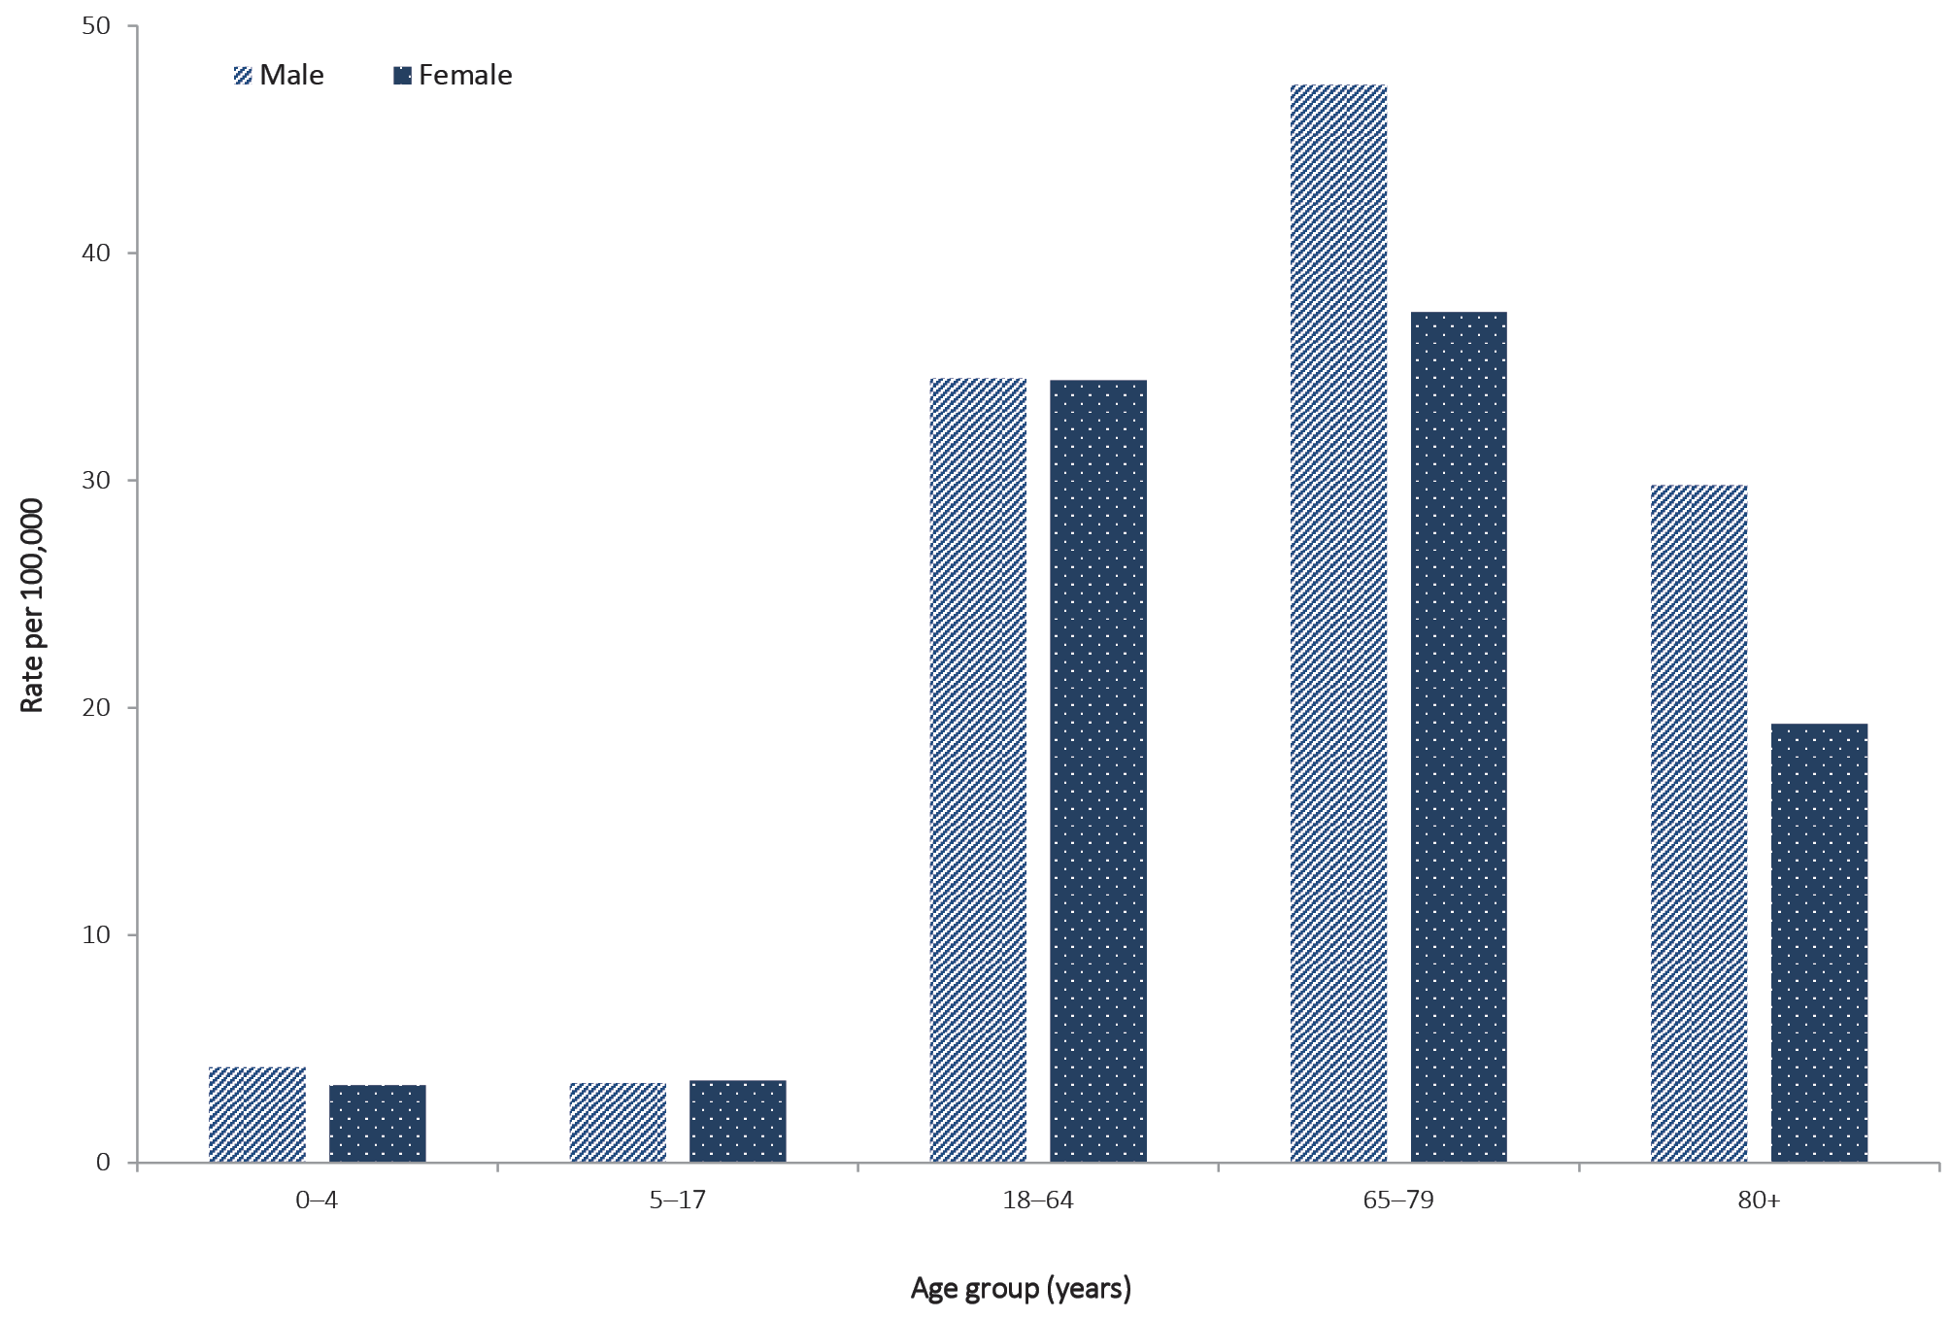

Figure B.2: Variation in combinations of COVID-19 symptoms in confirmed cases, Australiaª
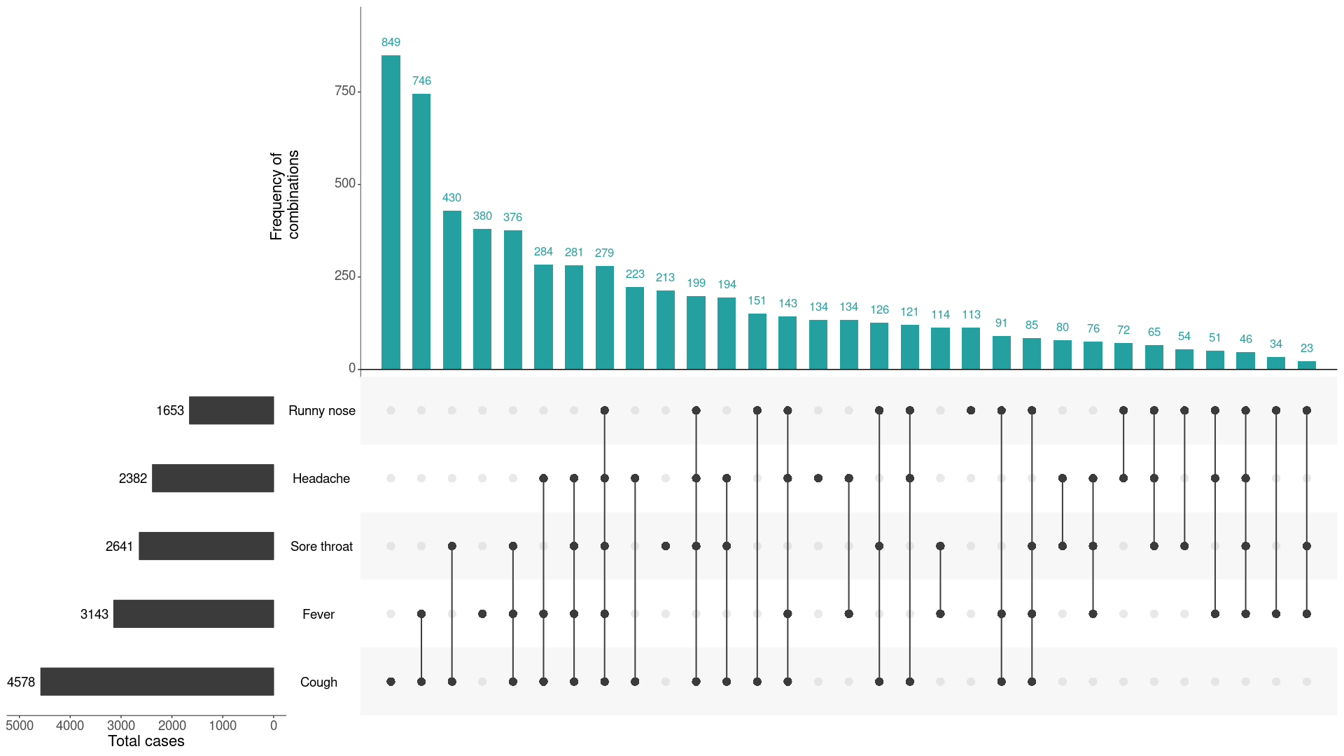
a This figure shows the variation in combinations of symptoms observed in reported cases (n = 6,657) for the five most frequently observed symptoms (cough, fever, sore throat, headache, runny nose). The horizontal bars on the left show the frequency of symptom occurrence in any combination with other symptoms. The circles and lines indicate particular combinations of symptoms observed in individual patients. The vertical green bars indicate the frequency of occurrence of the corresponding combination of symptoms.
Table B.2: Timeline of key COVID-19 related events, including Australian public health response activitiesª
Date | Event / response activity
8 May 2020 | The Australian Government announces a three-step plan to ease COVID-19 restrictions.
1 May 2020 | AHPPC releases a statement on risk management for re-opening boarding schools and school-based residential colleges.
26 April 2020 | The Australian Government launches a new voluntary coronavirus app, COVIDSafe.
24 April 2020 | AHPPC provides statements on the recommencement of kidney transplantation, updated advice regarding schools, and use of PPE in hospital with patients with COVID-19.
21 April 2020 | AHPPC provides advice for residential aged care facilities about minimising the impact of COVID-19 with information on entry restrictions, managing illness in visitors and staff, and hygiene measures.
21 April 2020 | The Australian Government announces the gradual ease of restrictions on elective surgery from Tuesday 28 April 2020.
16 April 2020 | AHPPC provides advice on reducing the potential risk of COVID-19 transmission in schools.
9 April 2020 | Air crew on international flights will be required to self-isolate at their place of residence (or hotel if not in their local city) between flights or for 14 days, whichever is shorter.
30 March 2020 | Special provisions be applied to vulnerable people in the workplace and application of additional regional social distancing measures to combat COVID-19.
29 March 2020 | Both indoor and outdoor public gatherings limited to two persons only.
28 March 2020 | All people entering Australia required to undertake a mandatory 14-day quarantine at designated facilities (e.g. hotels) in their port of arrival.
26 March 2020 | Restricted movement into certain remote areas to protect community members from COVID-19.
24 March 2020 | - Temporary suspension of all non-urgent elective procedures in both the public and private sector;  - Progressive scale up of social distancing measures with stronger measures in relation to non-essential gatherings, and considerations of further more intense options; and  - Aged care providers limit visits to a maximum of two visitors at one time per day.
25 March 2020 | - School-based immunisation programs, with the exception of the delivery of meningococcal ACWY vaccine, are paused; and  - Australian citizens and Australian permanent residents are restricted from travelling overseas.
21 March 2020 | Qld, WA, NT and SA close borders to non-essential travellers.
20 March 2020 | - Travel ban on foreign nationals entering Australia;  - Restriction of travel to remote communities; and  - Tasmania closes borders to non-essential travellers.
18 March 2020 | - DFAT raises travel advice for all overseas destinations to Level 4 ‘Do Not Travel’;  - Continuation of a 14-day quarantine requirement for all returning travellers; and  - Restrictions on indoor gatherings.
16 March 2020 | Non-essential static gatherings of > 500 people banned.
15 March 2020 | All overseas arrivals required to self-isolate for 14 days and cruise ship arrivals banned.
8 March 2020 | Restrictions on COVID-19 contacts and travellers from listed higher risk countries.
5 March 2020 | Restrictions on travel from Republic of Korea.
1 March 2020 | Restrictions on travel from Islamic Republic of Iran.
a | References for this table are as identified in reference 12.

Communicable Diseases Intelligence
ISSN: 2209-6051 Online

Communicable Diseases Intelligence (CDI) is a peer-reviewed scientific journal published by the Office of Health Protection, Department of Health. The journal aims to disseminate information on the epidemiology, surveillance, prevention and control of communicable diseases of relevance to Australia.

Editor: Tanja Farmer
Deputy Editor: Simon Petrie
Design and Production: Kasra Yousefi
Editorial Advisory Board: David Durrheim, Mark Ferson, John Kaldor, Martyn Kirk and Linda Selvey

Website: http://www.health.gov.au/cdi

Contacts
Communicable Diseases Intelligence is produced by:
Health Protection Policy Branch, Office of Health Protection, Australian Government Department of Health
GPO Box 9848, (MDP 6) CANBERRA ACT 2601

Email: cdi.editor@health.gov.au

Submit an Article
You are invited to submit your next communicable disease related article to the Communicable Diseases Intelligence (CDI) for consideration. More information regarding CDI can be found at: http://health.gov.au/cdi.
Further enquiries should be directed to: cdi.editor@health.gov.au.

This journal is indexed by Index Medicus and Medline.

Creative Commons Licence - Attribution-NonCommercial-NoDerivatives CC BY-NC-ND
© 2020 Commonwealth of Australia as represented by the Department of Health
This publication is licensed under a Creative Commons Attribution-NonCommercial-NoDerivatives 4.0 International Licence from https://creativecommons.org/licenses/by-nc-nd/4.0/legalcode (Licence). You must read and understand the Licence before using any material from this publication.

Restrictions
The Licence does not cover, and there is no permission given for, use of any of the following material found in this publication (if any):
- the Commonwealth Coat of Arms (by way of information, the terms under which the Coat of Arms may be used can be found at www.itsanhonour.gov.au);
- any logos (including the Department of Health’s logo) and trademarks;
- any photographs and images;
- any signatures; and
- any material belonging to third parties.

Disclaimer
Opinions expressed in Communicable Diseases Intelligence are those of the authors and not necessarily those of the Australian Government Department of Health or the Communicable Diseases Network Australia. Data may be subject to revision.

Enquiries
Enquiries regarding any other use of this publication should be addressed to the Communication Branch, Department of Health, GPO Box 9848, Canberra ACT 2601, or via e-mail to: copyright@health.gov.au

Communicable Diseases Network Australia
Communicable Diseases Intelligence contributes to the work of the Communicable Diseases Network Australia.
http://www.health.gov.au/cdna

