COVID-19 Australia: Epidemiology Report 33
Fortnightly reporting period ending 17 January 2021
COVID-19 National Incident Room Surveillance Team
Trends – There has been a decrease in new COVID-19 cases this fortnight, with decreases seen in both locally-acquired and overseas-acquired cases. There were 164 cases and no deaths this fortnight, bringing Australia’s cumulative total to 28,696 cases and 909 deaths.
Demographics – Demographic trends have remained unchanged this reporting period: persons aged ≥ 90 years have the highest cumulative rate of infection; children aged 0–9 years have the lowest rate of infection; and cases in Aboriginal and Torres Strait Islander persons account for less than 1% of all confirmed cases.
Local cases – Locally-acquired cases accounted for 14% (23/164) of all cases reported this fortnight.
Overseas cases – The majority of cases this fortnight were overseas-acquired (85%; 140/164), all of which were in managed quarantine. The most common countries of origin were the United States of America, Lebanon, the United Kingdom and India.
Virology – There were eight cases of the UK variant (B.1.1.7 variant) and two of the B.1.351 South African variant (B.1.351 lineage) uploaded to GISAID in Australia as at the end of the reporting period, noting there may be delays between jurisdictional reporting and uploads to GISAID. No cases of the Brazilian variant (B.1.1.28 lineage) were reported in Australia.
Severity – For all cases since the beginning of the pandemic, 13% have been admitted to hospital, noting that cases may be hospitalised for isolation purposes and not severe disease. No deaths were reported this fortnight; the cumulative case fatality rate remains at 3.2% this reporting period.
Testing – Testing rates increased by 13% compared to the previous fortnight, largely due to an increase in testing rates in Queensland and Victoria. The positivity rate remained low at 0.02%.
Keywords: SARS-CoV-2; novel coronavirus; 2019-nCoV; coronavirus disease 2019; COVID-19; acute respiratory disease; epidemiology; Australia

Key messages for the fortnight
This reporting period covers the last two weeks (4 January to 17 January 2021). The previous reporting period is the preceding two weeks (21 December 2020 to 3 January 2021). As Australia continues to experience low numbers of COVID-19, this report is transitioning to a brief update on case numbers each fortnight and a more detailed analysis every four weeks. Acute respiratory illness, severity, clusters and outbreaks, public health response measures and the international situation are reported in detail on a four-weekly basis. The latest information on these topics can be found in Epidemiology Report 32,¹ state and territory health websites, the World Health Organization’s weekly situation reports, and the Department of Health’s current situation and case numbers webpage.

Background and data sources
See the Technical Supplement for information on coronavirus disease 19 (COVID-19) including modes of transmission, common symptoms and severity. The Technical Supplement also details the data sources used for routine surveillance reports on COVID-19.

Activity

Transmission trends of confirmed COVID-19

(NNDSS and jurisdictional reporting to NIR)
As at 17 January 2021, there were 28,696 COVID-19 cases including 909 deaths reported nationally, with two distinct peaks in March and July (Figure 1). In this reporting period, there were 164 cases and no deaths reported. On average, 12 cases were notified each day over this reporting period, a decrease from the average of 20 cases reported per day over the previous reporting period. The largest number of cases diagnosed this fortnight was from New South Wales (49%; 81/164), followed by Victoria (19%; 31/164), Queensland (15%; 24/164), South Australia (6%; 10/164), Western Australia (6%; 10/164) and the Northern Territory (5%; 8/164). No cases were reported in the Australian Capital Territory or Tasmania.

Source of acquisition

(NNDSS)
In this reporting period, the majority of cases were reported as overseas acquired (85%; 140/164). Locally-acquired cases accounted for 14% (23/164) of cases, and the contact was not identified for one of these cases, which is less than the previous reporting period (7%; 16/233). In total, 1% (1/164) of cases reported this fortnight were under investigation at the time of reporting (Table 1).
In this reporting period, the largest number of locally-acquired cases was reported in New South Wales (74%; 17/23), followed by Queensland and Victoria. Of the locally-acquired cases reported this fortnight, almost all have been linked to three main clusters in New South Wales (Avalon, Inner West and Berala). Queensland reported four locally-acquired cases this reporting period, associated with a cluster linked to a Brisbane quarantine hotel.
Cumulatively, the infection rate to date for all locally-acquired cases was highest in Victoria with 294 infections per 100,000 population (Table 2). The rate of infection in Tasmania was 27.9 infections per 100,000 population, largely as a result of an outbreak in North West Tasmanian hospitals in April 2020, which represented half of all their cases. At the time of writing this report, it was two days since a locally-acquired case of unknown source in Australia, notified on 15 January. This was the only locally-acquired case of unknown source this reporting period.
In this reporting period, the largest number of overseas-acquired cases was reported in New South Wales (46%; 64/140), followed by Victoria (21%; 29/140) and Queensland (14%; 19/140). The higher number of overseas-acquired cases reported in New South Wales reflects the number of returned travellers managed there.
In this reporting period, the largest numbers of overseas-acquired cases were from the United States of America (20%; 28/140) followed by Lebanon (8%; 11/140), India (6%; 9/140) and the United Kingdom (6%; 9/140). The number of cases by country is influenced by travel patterns of returning Australians as well as by the prevalence of COVID-19 in the country the person is arriving from.
Figure 1: COVID-19 notified cases by source of acquisition and diagnosis date, Australia, week ending 17 January 2021ª
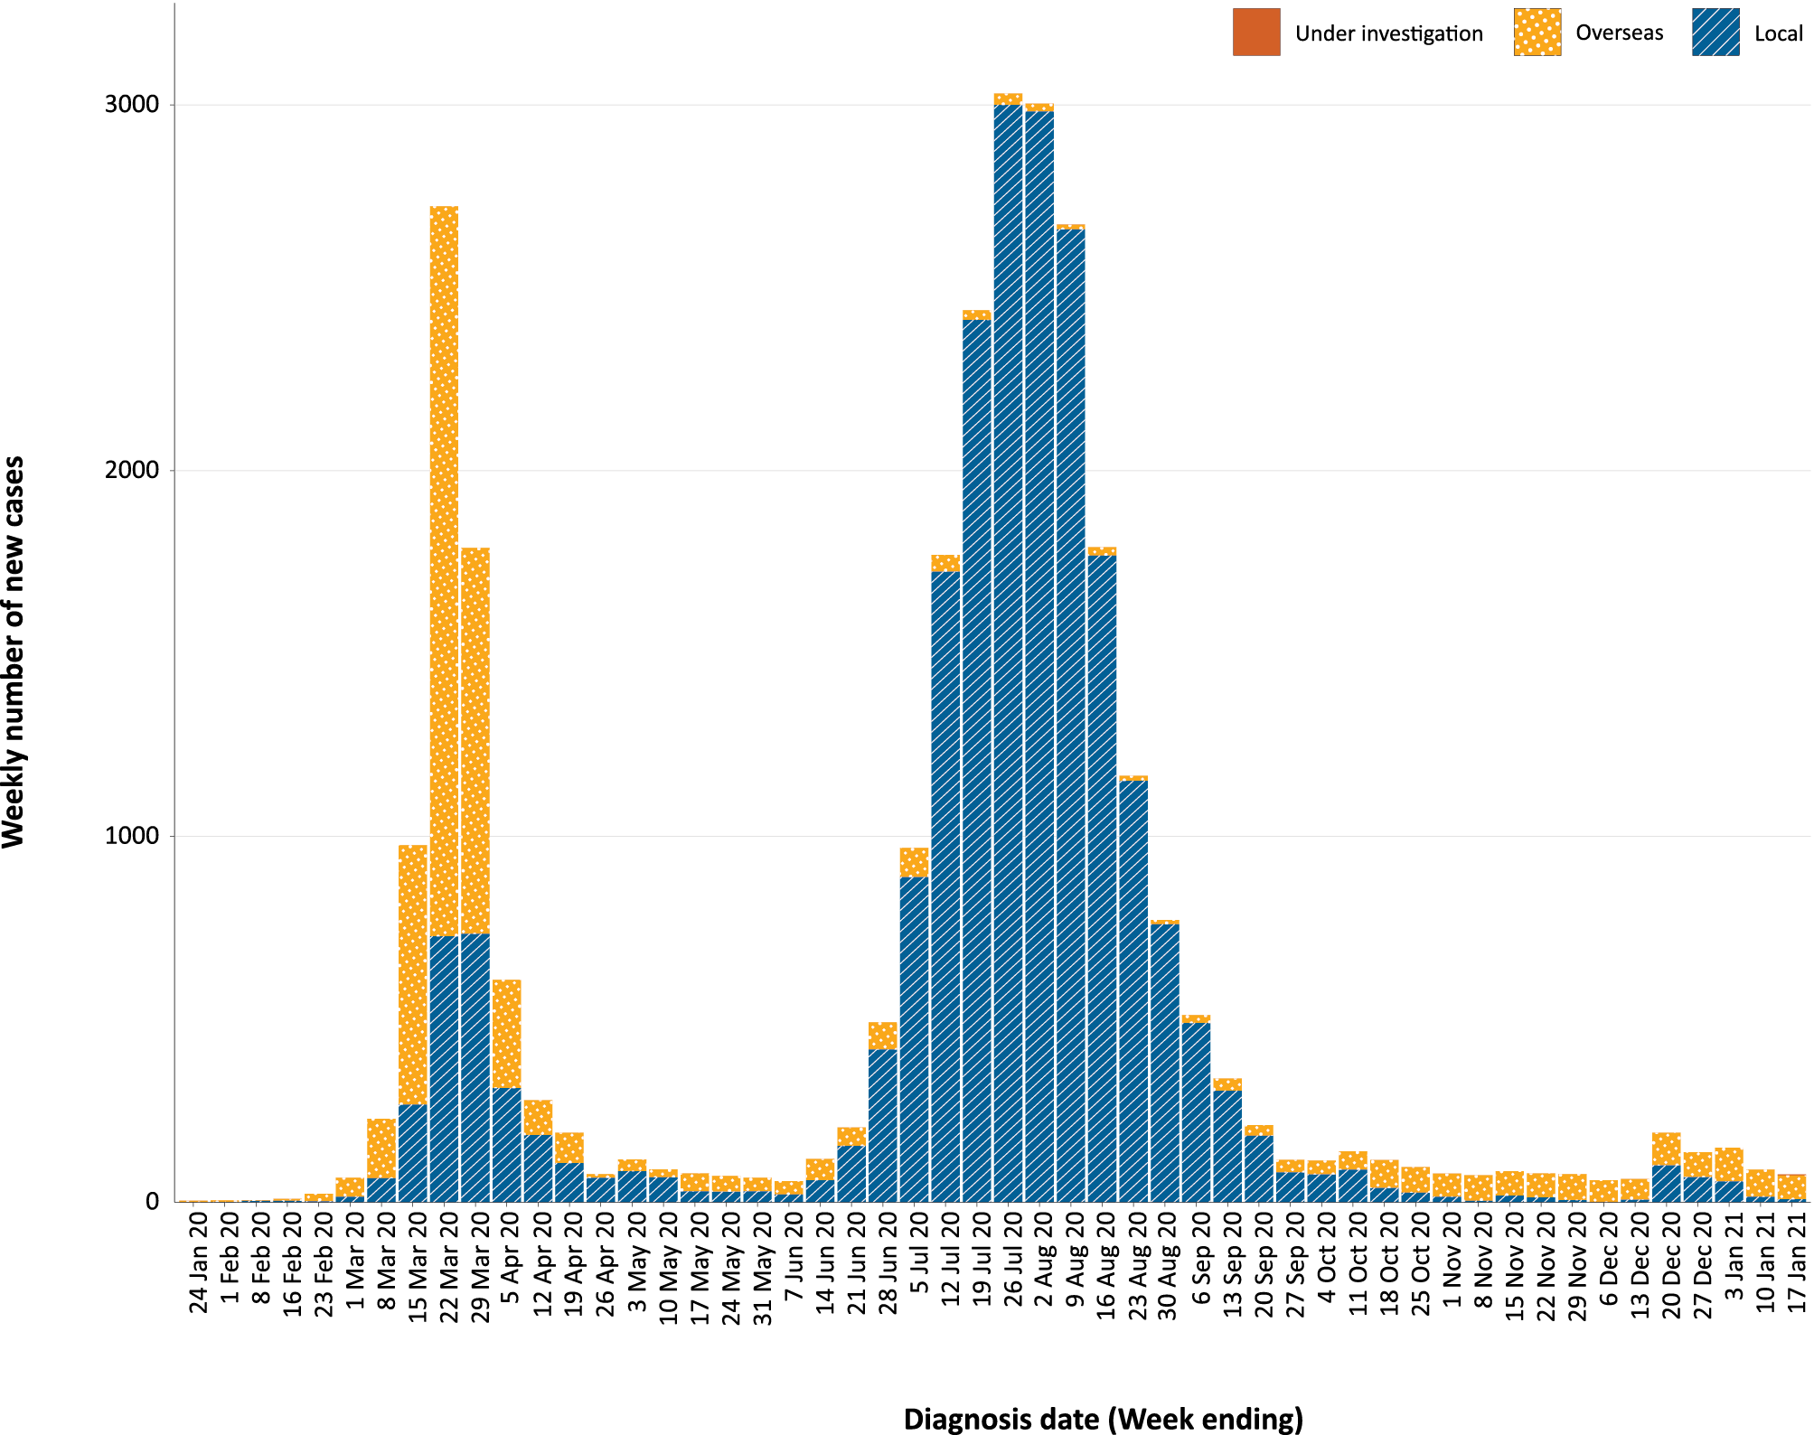
a Source: NNDSS.

Table 1: COVID-19 notifications by jurisdiction and source of acquisition, Australia, 4–17 January 2021
Source | NSW | Vic. | Qld | WA | SA | Tas. | NT | ACT | Australia
Overseas | 64 | 29 | 19 | 10 | 10 | 0 | 8 | 0 | 140
Local — source known | 16 | 2 | 4 | 0 | 0 | 0 | 0 | 0 | 22
Local — source unknown | 1 | 0 | 0 | 0 | 0 | 0 | 0 | 0 | 1
Local — interstate | 0 | 0 | 0 | 0 | 0 | 0 | 0 | 0 | 0
Under investigation | 0 | 0 | 1 | 0 | 0 | 0 | 0 | 0 | 1
Total | 81 | 31 | 24 | 10 | 10 | 0 | 8 | 0 | 164
Table 2: Locally-acquired COVID-19 case numbers and rates per 100,000 population by jurisdiction and reporting period, Australia, 17 January 2021
Jurisdiction | Reporting period | Reporting period | Cumulative cases  23 January 2020 – 17 January 2021
 | 21 December – 3 January | 4–17 January
 | Number of cases | Number of cases | Number of cases | Rates per 100,000 population
NSW | 203 | 17 | 2,179 | 26.9
Vic. | 27 | 2 | 19,388 | 294.0
Qld | 0 | 4 | 302 | 5.9
WA | 3 | 0 | 98 | 3.7
SA | 1 | 0 | 184 | 10.5
Tas. | 0 | 0 | 149 | 27.9
NT | 0 | 0 | 6 | 2.4
ACT | 0 | 0 | 29 | 6.8
Australia | 234 | 23 | 22,335 | 88.1

Demographic features

(NNDSS)
In this reporting period, the largest number of cases occurred in those aged 30 to 39 years (26%, 42/164 cases). For all notifications to date, the highest rate of infection was in those aged 90 and over with a rate of 386.8 per 100,000 population (Appendix A, Table A.1). Children under 10 years old had the lowest rate of infection (47.2 cases per 100,000 population). This age group also reported the lowest testing rate in the reporting period, which was approximately half that of those aged 30–39 years old.
Cumulatively, the male-to-female rate ratio of cases was approximately 1:1 in most age groups. Notification rates were higher among females than males in the 20–29 years age group and those aged ≥ 80 years old, and higher among males than among females in the 70–79 years age group (Figure 2). The largest difference in cumulative rates was in the 90 years and over age group, where the cumulative rate among males was 333.7 cases per 100,000 population and among females 413.3 cases per 100,000 population (Appendix A, Table A.1).
Figure 2: Cumulative COVID-19 cases, by age group and sex, Australia, 23 January 2020 to 17 January 2021
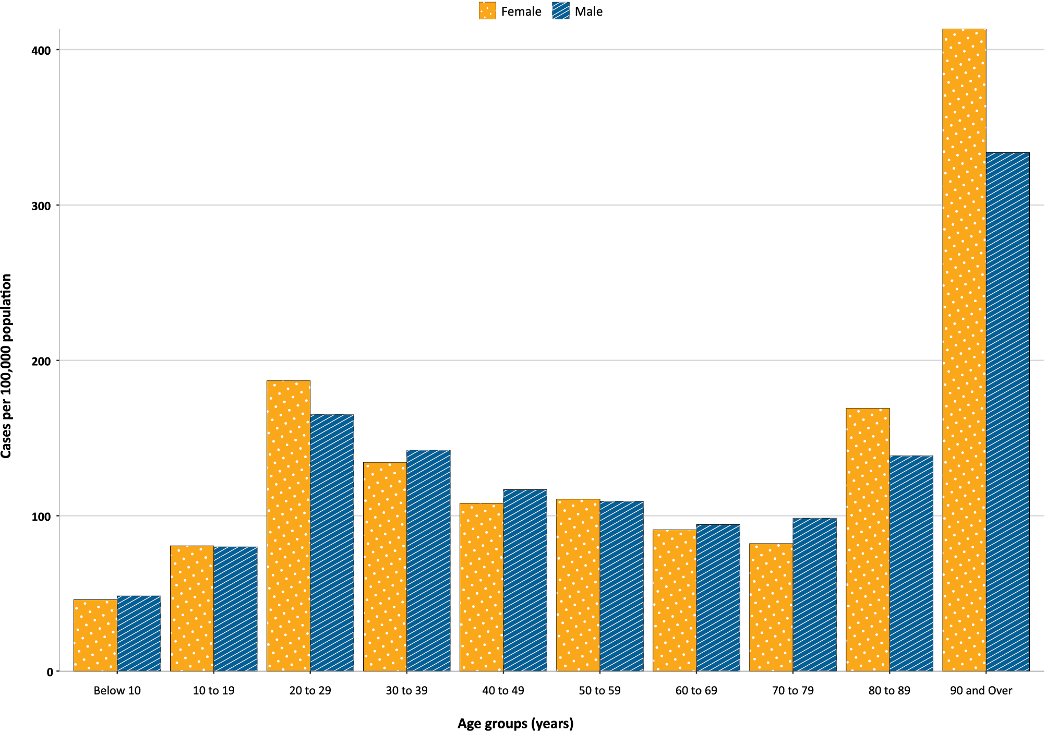
Since the beginning of the epidemic in Australia, the median age of all cases was 37 years old (interquartile range, IQR: 25–56) which has not changed since the beginning of August. Prior to 1 June 2020, COVID-19 cases were slightly older, with a median age of 46 years old (IQR: 29–62), associated with a high proportion of cases having a recent travel history or acquisition on a cruise ship. In cases reported after 1 June 2020, the median age was 34 years old (IQR: 23–53) reflecting transmission in the community and across a range of settings, especially in Victoria. The median age of cases in this reporting period was 33 years old (IQR: 22–45).

Aboriginal and Torres Strait Islander people

(NNDSS)
There have been 148 confirmed cases of COVID-19 notified in Aboriginal and Torres Strait Islander people since the beginning of the epidemic, which has not changed since the last report. This represents approximately 0.5% of all confirmed cases. No new overseas-acquired cases have been reported among Aboriginal and Torres Strait Islander people since the end of August and only one locally-acquired case has been reported since the start of September. The notification rate across all age groups is higher in Non-Indigenous people than in Aboriginal and Torres Strait Islander people (Figure 3). Other demographic features of cases remain the same as reported in the previous epidemiology report.¹
Figure 3: National COVID-19 notification rate per 100,000 population by age group, Aboriginal and Torres Strait Islander people and Non-Indigenous people, Australia, 23 January 2020 – 17 January 2021
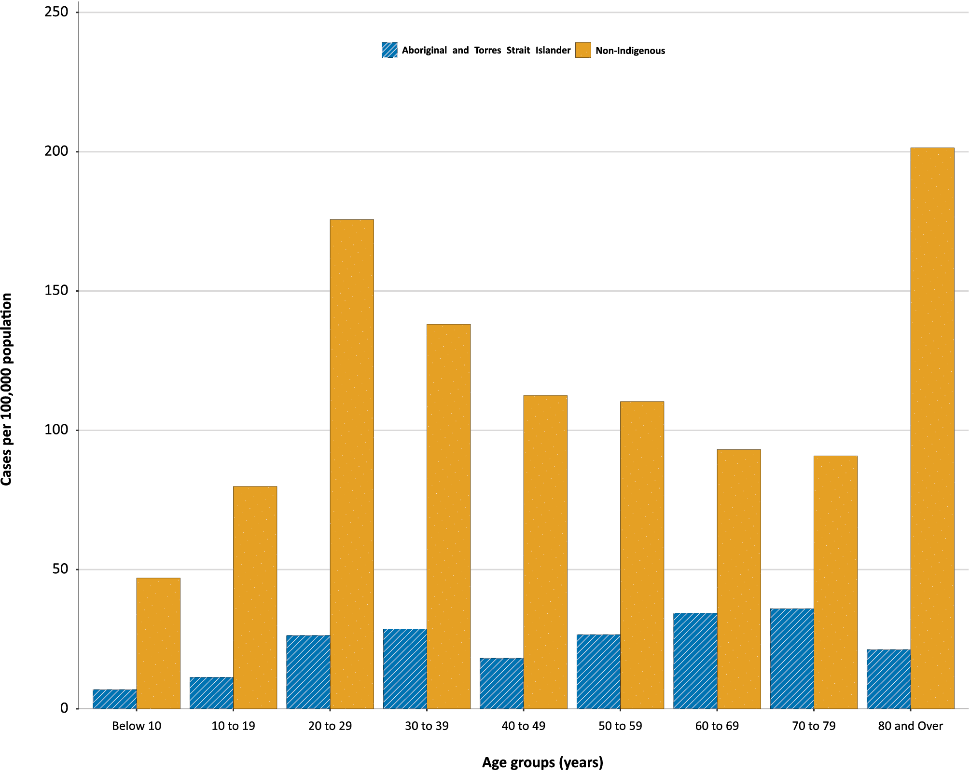

COVID-19 deaths

(NNDSS and jurisdictional reporting to NIR)
There have been no deaths reported this fortnight, with the total number of deaths remaining unchanged since the last report at 909. The crude case fatality rate remained unchanged this fortnight at 3.2%. Further severity measures were reported in the previous Epidemiology Report 32.¹

Virology

(GISAID)
At the time of this report, there were 17,108 SARS-CoV-2 genome sequences available from Australian cases on the global sequence repository, GISAID.² These sequences were dispersed throughout the global lineages, reflecting multiple concurrent introductions into Australia.^{3–5} In the last fortnight, there were 29 new Australian sequences uploaded to GISAID, which was a decrease from the previous two-week period (151), largely reflective of case numbers in Australia. In the past two-week period there were 11 different sequences uploaded to GISAID, reflecting the shift from locally-acquired cases to overseas-acquired cases in Australia. New South Wales (3), Victoria (2), Western Australia (2) and South Australia (1) uploaded sequences of the United Kingdom (UK) variant of concern (B.1.1.7 lineage) to GISAID, noting there may be delays between jurisdictional reporting and uploads. New South Wales had reported two cases of the South African variant of concern (B.1.351) to GISAID. All cases of these variants of concern have been linked to overseas arrivals in mandatory hotel quarantine. Australia has reported no cases of the B.1.1.28 Brazilian variant of concern. National genomic surveillance of SARS-CoV-2 has been implemented and laboratories across Australia are routinely monitoring sequences for variant strains.

Testing

(State and territory reporting)
As at 17 January 2021, a cumulative total of 12,405,954 tests were conducted in Australia. The cumulative nationwide proportion of positive tests remained low at 0.23% (Table 3). With the exception of Victoria, the cumulative testing positivity in individual jurisdictions was < 0.2%.

Table 3: Diagnostic tests performed, by jurisdiction, Australia, 17 January 2021
Jurisdiction | Tests performed  21 December – 3 January |  |  | Tests performed  4–17 January |  |  | Cumulative tests performed  23 January 2020 – 17 January 2021
 | n | Positivity (%)ª | Per 1,000 population^{b} | n | Positivity (%)ª | Per 1,000 population^{b} | n | Positivity (%)ª | Per 1,000 population^{b}
NSW | 477,619 | 0.04 | 59.1 | 302,550 | 0.04 | 37.4 | 4,472,916 | 0.11 | 553.2
Vic | 182,052 | 0.02 | 27.6 | 322,323 | 0.01 | 48.9 | 4,252,138 | 0.48 | 644.9
Qld | 71,181 | 0.03 | 14.0 | 193,106 | 0.02 | 37.9 | 1,681,421 | 0.08 | 330.2
WA | 30,076 | 0.07 | 11.5 | 56,875 | 0.04 | 21.7 | 683,322 | 0.13 | 260.6
SA | 66,196 | 0.02 | 37.8 | 71,460 | 0.02 | 40.8 | 918,249 | 0.06 | 524.0
Tas | 7,227 | 0.00 | 13.5 | 8,518 | 0.00 | 15.9 | 153,438 | 0.15 | 287.0
NT | 5,310 | 0.23 | 21.6 | 10,023 | 0.12 | 40.7 | 93,274 | 0.10 | 379.0
ACT | 9,659 | 0.01 | 22.7 | 12,369 | 0.00 | 29.0 | 151,196 | 0.08 | 354.8
Australia | 849,320 | 0.04 | 33.5 | 977,224 | 0.02 | 38.5 | 12,405,954 | 0.23 | 489.2
a Testing positivity is calculated using case numbers notified by jurisdictions to the NIR, rather than NNDSS.
b Population data based on Australian Bureau of Statistics (ABS) Estimated Resident Population (ERP) as at 30 December 2019.

During this reporting period, 977,224 tests were conducted nationally, with a positivity rate of 0.02%. This represented a 13% increase in tests conducted compared to the previous fortnight. Queensland reported a 170% increase in tests conducted, consistent with increased public health messaging in the jurisdiction in response to the detection of four linked cases of the UK variant B.1.1.7 from hotel quarantine, which resulted in a three day lockdown during the reporting period. Testing rates increased from the previous reporting period to an average of 19.3 tests per 1,000 population per week during this reporting period, a marginally lower testing rate than the peak of 19.4 tests per 1,000 population per week in early August. All jurisdictions except the Northern Territory reported a positivity rate of < 0.10% in this reporting period. The Northern Territory reported a positivity rate of 0.12%, associated with overseas-acquired cases linked with repatriation flights. The positivity rate in New South Wales remained at 0.04% in this reporting period, despite a decrease in locally-acquired cases and overseas-acquired cases. The low national positivity rate, along with high rates of testing, indicates a low prevalence of COVID-19 nationally.
For the reporting period ending 15 January 2021, testing rates increased among all age groups in the first week of January, then declined sharply (Figure 4). Testing rates among children and young adults aged 0–19 years have the lowest testing rates for the reporting period. Testing rates are highest in major cities and urban areas of Australia; lower testing rates, with little variation between classification areas, are seen across regional and remote areas across Australia.

Figure 4: SARS-CoV-2 polymerase chain reaction (PCR) testing rates per 1,000 population per week by age group, Australia, 1 May 2020 – 15 January 2021^{a,b}
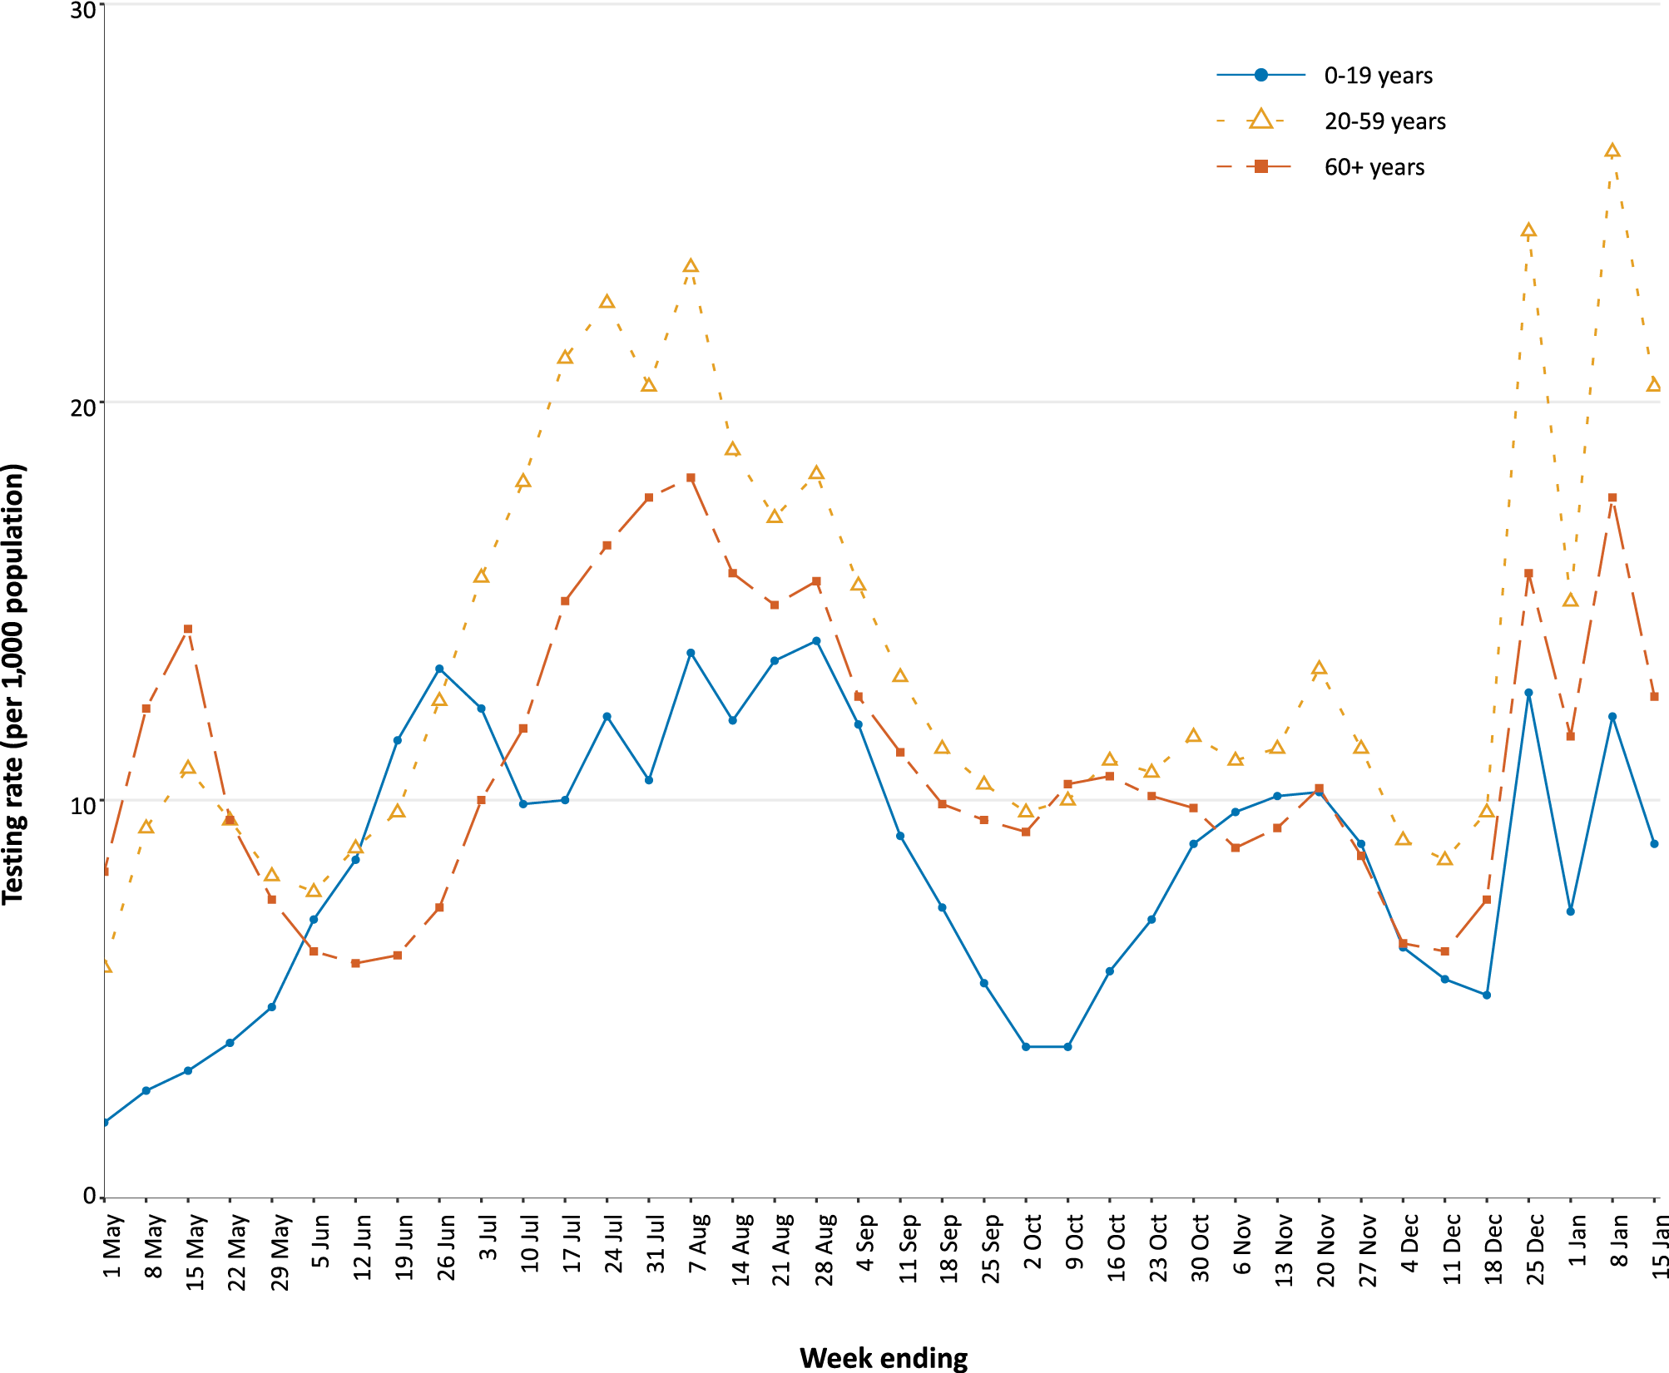
a Data provided by jurisdictions to the NIR weekly.
b The jurisdictions reporting each week (i.e. the denominator population) may vary.

Acknowledgements
We thank public health staff from incident emergency operations centres and public health units in state and territory health departments, and the Australian Government Department of Health, along with state and territory public health laboratories. We thank those who have provided data from surveillance systems, such as Commonwealth respiratory clinics, Flutracking, SPRINT-SARI and FluCAN.

Author details

Corresponding author
COVID-19 National Incident Room Surveillance Team Australian Government Department of Health, GPO Box 9484, MDP 14, Canberra, ACT 2601. Email: epi.coronavirus@health.gov.au

References
- COVID-19 National Incident Room Surveillance Team. COVID-19 Australia: Epidemiology Report 32: Four-week reporting period ending 3 January 2021. Commun Dis Intell (2018). 2021;45. doi: https://doi.org/10.33321/cdi.2021.45.1.
- Global Initiative on Sharing All Influenza Data (GISAID). [Website.] Berlin: Federal Republic of Germany, Freunde von GISAID e.V.; 2020. [Accessed on 20 January 2021.] Available from: https://www.gisaid.org/.
- Rockett RJ, Arnott A, Lam C, Sadsad R, Timms V, Gray KA et al. Revealing COVID-19 transmission in Australia by SARS-CoV-2 genome sequencing and agent-based modeling. Nat Med. 2020. doi: https://doi.org/10.1038/s41591-020-1000-7.
- Seemann T, Lane CR, Sherry NL, Duchene S, Goncalves da Silva A, Caly L et al. Tracking the COVID-19 pandemic in Australia using genomics. Nat Commun. 2020;11(1):4376. doi: https://doi.org/10.1038/s41467-020-18314-x.
- Eden JS, Rockett R, Carter I, Rahman H, de Ligt J, Hadfield J et al. An emergent clade of SARS-CoV-2 linked to returned travellers from Iran. Virus Evol. 2020;6(1):veaa027. doi: https://doi.org/10.1093/ve/veaa027.

Appendix A: Supplementary figures and tables
Table A.1: COVID-19 case notifications and rates per 100,000 population, by age group and sex, Australia, 4–17 January 2021
Age group | This reporting period |  |  |  |  |  | Cumulative: 23 January 2020 – 17 January 2021
 | Cases |  |  | Rate per 100,000 population |  |  | Cases |  |  | Rate per 100,000 population
 | Male | Female | People | Male | Female | People | Male | Female | People | Male | Female | People
0 to 9 | 5 | 10 | 15 | 0.3 | 0.6 | 0.5 | 792 | 711 | 1,503 | 48.4 | 45.9 | 47.2
10 to 19 | 13 | 8 | 21 | 0.8 | 0.5 | 0.7 | 1,254 | 1,197 | 2,451 | 79.9 | 80.6 | 80.2
20 to 29 | 11 | 17 | 28 | 0.6 | 0.9 | 0.8 | 3,067 | 3,366 | 6,455 | 165.1 | 186.9 | 176.4
30 to 39 | 23 | 19 | 42 | 1.3 | 1.0 | 1.1 | 2,587 | 2,493 | 5,095 | 142.2 | 134.3 | 138.6
40 to 49 | 21 | 10 | 31 | 1.3 | 0.6 | 0.9 | 1,890 | 1,788 | 3,706 | 116.8 | 108 | 113.2
50 to 59 | 10 | 7 | 17 | 0.7 | 0.4 | 0.6 | 1,647 | 1,741 | 3,396 | 109.2 | 110.7 | 110.2
60 to 69 | 5 | 3 | 8 | 0.4 | 0.2 | 0.3 | 1,199 | 1,220 | 2,421 | 94.3 | 90.9 | 92.6
70 to 79 | 1 | 0 | 1 | 0.1 | 0.0 | 0.1 | 856 | 756 | 1,612 | 98.4 | 82 | 90
80 to 89 | 0 | 1 | 1 | 0.0 | 0.2 | 0.1 | 495 | 780 | 1,275 | 138.5 | 169.1 | 155.7
90 and over | 0 | 0 | 0 | 0.0 | 0.0 | 0.0 | 229 | 552 | 782 | 333.7 | 413.3 | 386.8

Communicable Diseases Intelligence
ISSN: 2209-6051 Online

Communicable Diseases Intelligence (CDI) is a peer-reviewed scientific journal published by the Office of Health Protection and Response, Department of Health. The journal aims to disseminate information on the epidemiology, surveillance, prevention and control of communicable diseases of relevance to Australia.

Editor: Tanja Farmer
Deputy Editor: Simon Petrie
Design and Production: Kasra Yousefi
Editorial Advisory Board: David Durrheim, Mark Ferson, John Kaldor, Martyn Kirk and Linda Selvey

Website: http://www.health.gov.au/cdi

Contacts
CDI is produced by Environmental Health and Health Protection Policy Branch, Office of Health Protection and Response, Australian Government Department of Health, GPO Box 9848, (MDP 6) CANBERRA ACT 2601

Email: cdi.editor@health.gov.au

Submit an Article
You are invited to submit your next communicable disease related article to the Communicable Diseases Intelligence (CDI) for consideration. More information regarding CDI can be found at: http://health.gov.au/cdi.
Further enquiries should be directed to: cdi.editor@health.gov.au.

This journal is indexed by Index Medicus and Medline.

Creative Commons Licence - Attribution-NonCommercial-NoDerivatives CC BY-NC-ND
© 2021 Commonwealth of Australia as represented by the Department of Health
This publication is licensed under a Creative Commons Attribution-NonCommercial-NoDerivatives 4.0 International Licence from https://creativecommons.org/licenses/by-nc-nd/4.0/legalcode (Licence). You must read and understand the Licence before using any material from this publication.

Restrictions
The Licence does not cover, and there is no permission given for, use of any of the following material found in this publication (if any):
- the Commonwealth Coat of Arms (by way of information, the terms under which the Coat of Arms may be used can be found at www.itsanhonour.gov.au);
- any logos (including the Department of Health’s logo) and trademarks;
- any photographs and images;
- any signatures; and
- any material belonging to third parties.

Disclaimer
Opinions expressed in Communicable Diseases Intelligence are those of the authors and not necessarily those of the Australian Government Department of Health or the Communicable Diseases Network Australia. Data may be subject to revision.

Enquiries
Enquiries regarding any other use of this publication should be addressed to the Communication Branch, Department of Health, GPO Box 9848, Canberra ACT 2601, or via e-mail to: copyright@health.gov.au

Communicable Diseases Network Australia
Communicable Diseases Intelligence contributes to the work of the Communicable Diseases Network Australia.
http://www.health.gov.au/cdna

https://www.health.gov.au/news/health-alerts/novel-coronavirus-2019-ncov-health-alert#local-outbreak-information.
https://www.who.int/emergencies/diseases/novel-coronavirus-2019/situation-reports/.
https://www.health.gov.au/news/health-alerts/novel-coronavirus-2019-ncov-health-alert/coronavirus-covid-19-current-situation-and-case-numbers.
https://doi.org/10.33321/cdi.2021.45.2 .

