COVID-19, Australia: Epidemiology Report 16: Reporting week ending 23:59 AEST 17 May 2020
COVID-19 National Incident Room Surveillance Team
Please note: future editions of this report will be published on a fortnightly basis.
Notified cases of COVID-19 and associated deaths reported to the National Notifiable Diseases Surveillance System (NNDSS) to 17 May 2020.

Summary
Confirmed cases in Australia notified up to 17 May 2020
Notifications | 7,075
Deaths | 100
The incidence of new cases of COVID-19 has reduced dramatically since a peak in mid-March. Social distancing measures, public health action and the reduction in international travel have likely been effective in slowing the spread of the disease, in the Australian community.
Testing rates over the past week have increased markedly, with a continued very low proportion of people testing positive. These low rates of detection are indicative of low levels of COVID-19 transmission. It is important that testing rates and community adherence to public health measures remain high to support the continued suppression of the virus, particularly in vulnerable high-risk groups and settings.
New cases of COVID-19 are currently being reported by only some jurisdictions, albeit at relatively low rates. Although case numbers are low, new cases tend to still be a mix of overseas-acquired and locally-acquired infections. Most locally-acquired cases can be linked back to a known case or cluster. Although the proportion of locally-acquired cases has increased, the overall rate of new cases, regardless of place of acquisition, continues to decrease.
The crude case fatality rate in Australia remains low (1.4%), compared with the WHO reported global rate (6.8%). The low case fatality rate is likely reflective of high case detection and high quality of health care services in Australia. Deaths from COVID-19 in Australia have occurred predominantly among the elderly and those with comorbidities, with no deaths occurring in those under 40 years.
The highest rate of COVID-19 continues to be among people aged 60–79 years. One third of all cases in this age group have been associated with several outbreaks linked to cruise ships. The lowest rate of disease is in young children, a pattern reflected in international reports.
Internationally, while the number of new cases each day remains relatively stable at the global level, some areas such as Brazil and India are showing a dramatic rise in reported cases. Although some low-income countries have so far reported few cases, it is possible that this is due to limited diagnostic and public health capacity, and may not be reflective of true disease incidence.
Keywords: SARS-CoV-2; novel coronavirus; 2019-nCoV; coronavirus disease 2019; COVID-19; acute respiratory disease; epidemiology; Australia
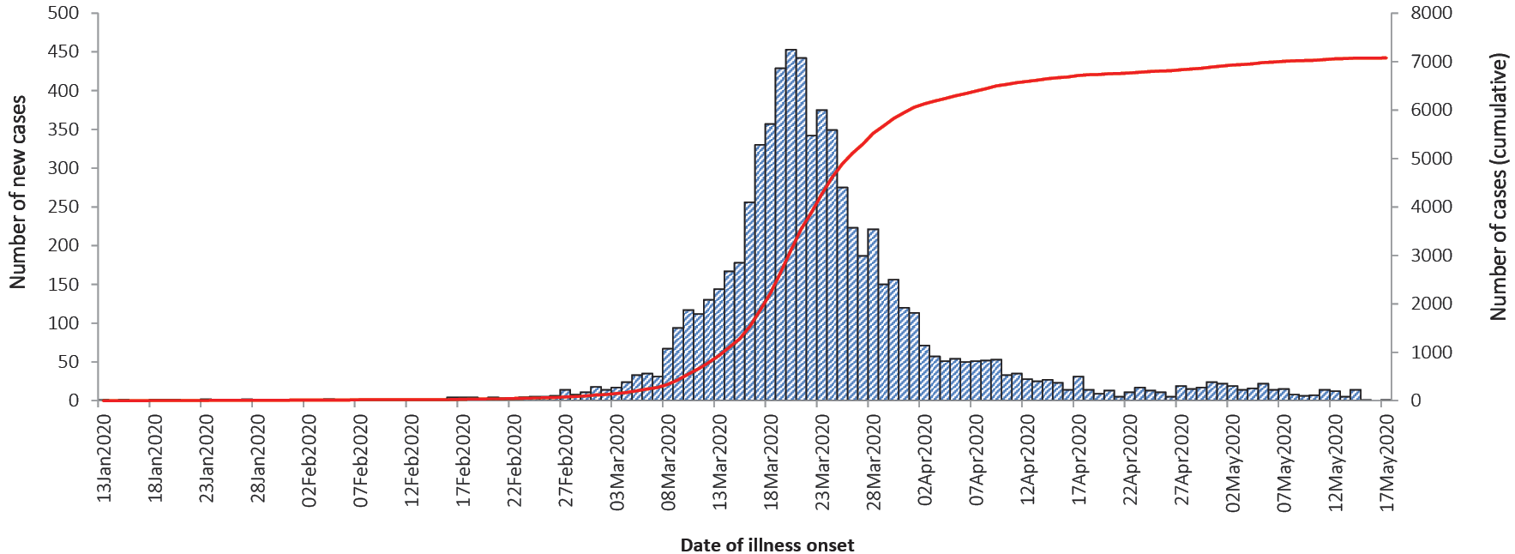
Data caveats: Based on data extracted from the National Notifiable Diseases Surveillance System (NNDSS) on 19 May 2020. Due to the dynamic nature of the NNDSS, data in this extract are subject to retrospective revision and may vary from data reported in published NNDSS reports and reports of notification data by states and territories.

Australian cases: descriptive epidemiology

National trends and geographical distribution
Following the national peak in cases during the week 16–22 March, the incidence of new cases has continued to decrease, indicative of a steady reduction in transmission. The incidence of new cases continues to be low, with very few cases reported by most jurisdictions. Over the past fortnight there were no cases reported in SA, the NT or the ACT.
At the jurisdictional level NSW, Vic, Qld, SA and the ACT reported their highest rates of new cases during the week 16–22 March, with WA, Tas and the NT experiencing their peaks just a few weeks later (Figure 1). The majority of cases continue to be notified from major metropolitan areas with very few cases for remote or very remote areas (Figures 2 and 3). The highest cumulative rates of COVID-19 have been reported from NSW and Tasmania (Table 1). The high rates in these states have likely been driven by outbreaks or large clusters, including cruise-ship-related outbreaks in NSW and a recent large outbreak in hospitals in North West Tasmania.
Across all cases notified since January, the median time between onset of symptoms and laboratory testing was 3 days (interquartile range, IQR: 1–7 days). This reflects an increase from a median of 2 days in the week of 13–19 April but is still lower than at the beginning of the epidemic.
Table 1: Notifications and rates of COVID-19 and diagnostic tests performed, Australia, by jurisdiction
Jurisdiction | Cases per 100,000 population |  | Total cases | Cumulative rate  (per 100,000 population) | Cumulative number of tests performed (proportion of tests positive %)
 | 11–17 May | 4–10 May
NSW | 0.14 | 0.2 | 3,102 | 38.3 | 365,917 (0.84)
Vic | 0.45 | 1.06 | 1,573 | 23.8 | 338,219 (0.46)
Qld | 0.06 | – | 1,058 | 20.8 | 154,220 (0.68)
WA | 0.08 | 0.04 | 539 | 20.6 | 65,698 (0.84)
SA | – | – | 439 | 25.1 | 78,833 (0.56)
Tas | 0.19 | 0.19 | 228 | 42.7 | 21,886 (1.04)
NT | – | – | 29 | 11.8 | 6,370 (0.46)
ACT | – | – | 107 | 25.1 | 14,058 (0.76)
Australia | 0.19 | 0.35 | 7,075 | 27.9 | 1,045,201 (0.67)

Figure 1: Weekly COVID-19 new case notifications per 100,000 population, as at 17 May 2020, by jurisdiction
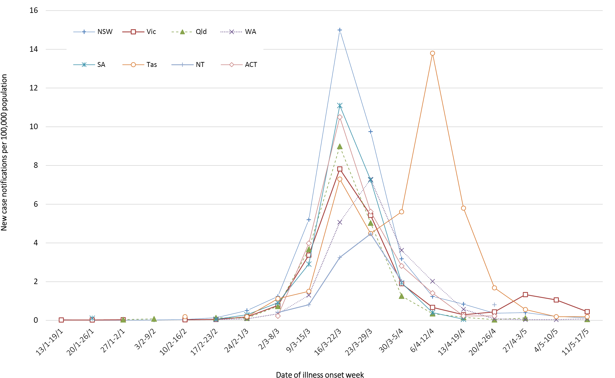
Figure 2: Number of cumulative new confirmed cases of COVID-19, Australia, by location of usual residence and statistical area level 3 (SA3),ª 7 day heat maps for the four most recent weekly reporting periods^{b}
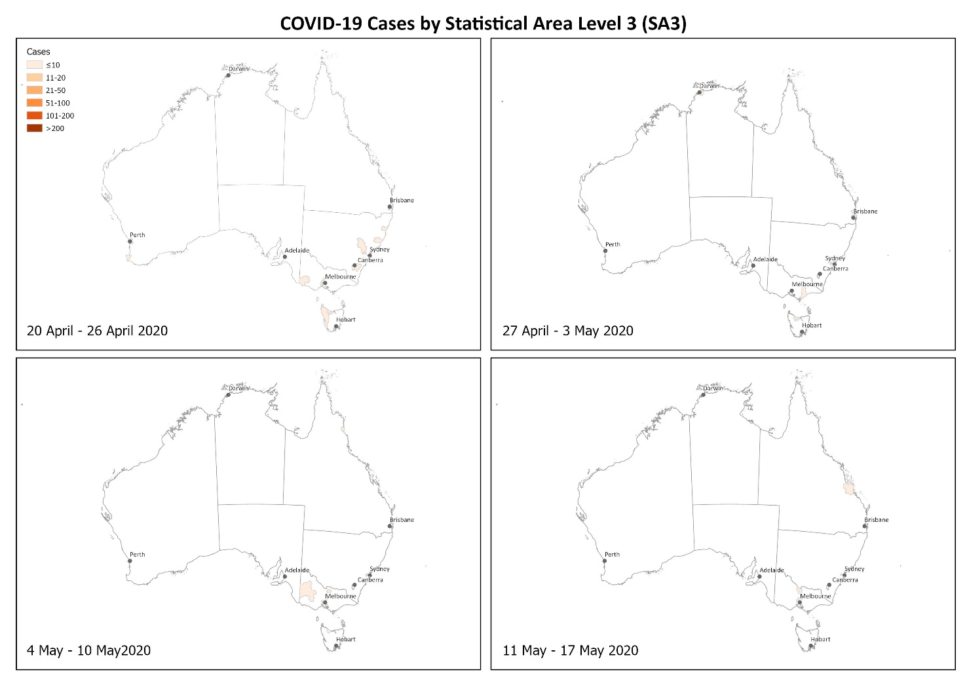⁻⁻
a Represents the usual location of residence of a case, which does not necessarily mean that this is the place where they acquired their infection or were diagnosed. Overseas residents who do not have a usual place of residence in Australia are not shown.
b Based on diagnosis date from NNDSS reporting period up to 23:59 AEST 17 May 2020.
Figure 3: Number of cumulative new confirmed cases of COVID-19, Australia, by location of usual residence and selected areas,ª 7 day heat maps for the four most recent weekly reporting periods^{b}
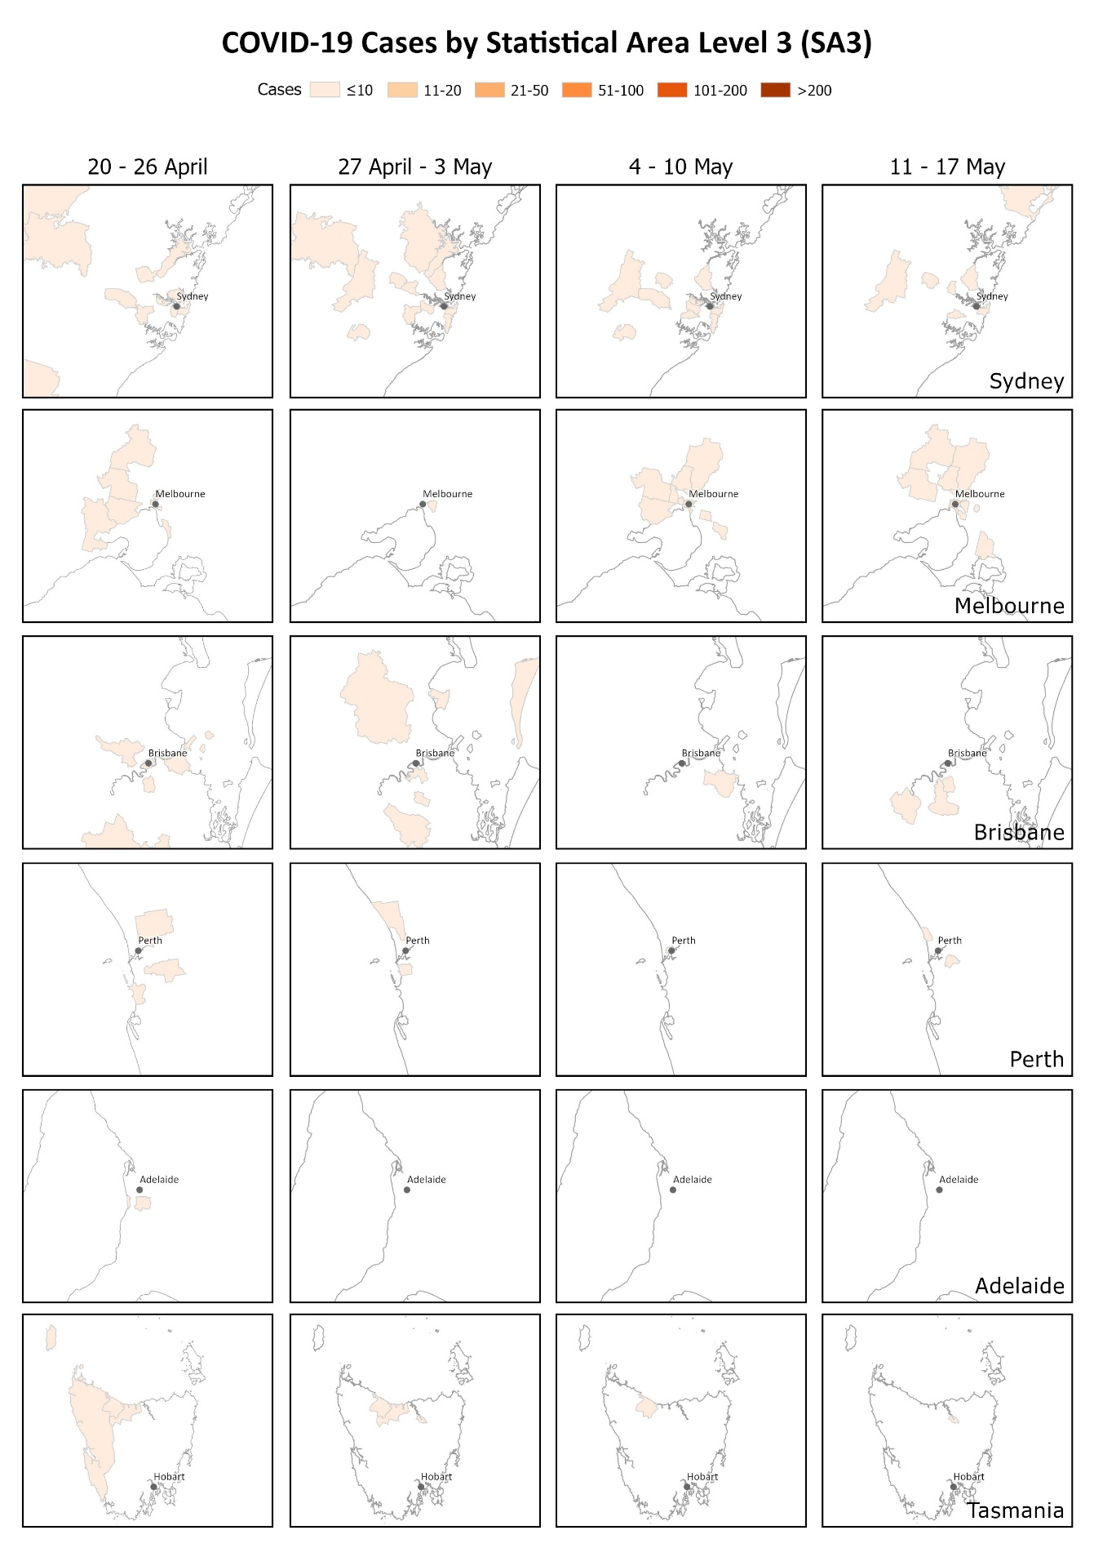
a Represents the usual location of residence of a case, which does not necessarily mean that this is the place where they acquired their infection or were diagnosed. Overseas residents who do not have a usual place of residence in Australia are not shown.
b Based on diagnosis date from NNDSS reporting period up to 23:59 AEST 17 May 2020.

Aboriginal and Torres Strait Islander persons
Fifty-nine cases (0.8%) have been reported in Aboriginal and Torres Strait Islander persons since the start of the epidemic in Australia. These cases were reported across several jurisdictions, with the majority reported in areas classified as ‘Major cities of Australia’ based on the case’s usual place of residence (Table 2). No cases among Aboriginal and Torres Strait Islander persons have been notified from remote or very remote areas of Australia.
Across all Australian cases, completeness of the Indigenous status field was approximately 95%.
Table 2: COVID-19 cases, Australia, notified among persons by remoteness classification
Population | Major cities of Australia | Inner regional Australia | Outer regional Australia | Remote/very remote Australia | Total
Aboriginal and Torres Strait Islander persons | 38 | 14 | 7 | 0 | 59
All persons | 5,531 | 841 | 379 | 37 | 7,075ª
a Total includes 183 overseas residents and 104 persons with unknown remoteness classification.
Thirty-seven percent (n = 22) of cases in Aboriginal and Torres Strait Islander persons acquired their infection overseas, while 51% (n = 30) of cases acquired their infection domestically. Seven (12%) cases were still under investigation at the time of this report.
The median age of COVID-19 cases among Aboriginal and Torres Strait Islander persons is 34 years (interquartile range: 21–56 years), which is lower than the median age of non-Indigenous COVID-19 cases.
Of the cases notified amongst Aboriginal and Torres Strait Islander persons, 10% were admitted to hospital, which is similar to the proportion of all cases hospitalised (all cases = 13%). Of cases in Aboriginal and Torres Strait Islander persons, none were reported as being admitted to ICU.

Age and gender distribution
The highest rate of disease was among those in the 60–69 years age group, followed closely by the 70–79 years age group, with 44 cases and 42 cases per 100,000 population respectively (Figure 4). The high rate amongst those in the 60–69 and 70–79 years age groups is linked to outbreaks on cruise ships, with 29% of cases in the 60–69 years age group and 43% in the 70–79 years age group acquiring their infection at sea. For those aged 80–89 years, 42% acquired their infection at sea.
The lowest rate of disease was among children in the 0–9 years age group, with 2.9 cases per 100,000 population. Among those in the 10–19 years age group, the rate of disease was 7.3 cases per 100,000 population. The number of cases among school-aged children aged 5–18 years was 185 cases (2.6% of total cases). This is consistent with international reports, which indicate a low rate of infection among children. A similar pattern was observed with other coronaviruses such as SARS and MERS with low rates of infection in children.¹
Notifications by gender differed by age group with a higher rate of notifications in females in the 20–29 age group and a higher rate in males for those aged 40–49 years age group and aged 60 years and over (Figure 4). It is unlikely that this disparity reflects differences in underlying susceptibility to COVID-19; instead, it is more likely linked to transmission and possibly to differences in travel patterns.

Figure 4: COVID-19 rates per 100,000 population of all cases notified in Australia, by age group and gender
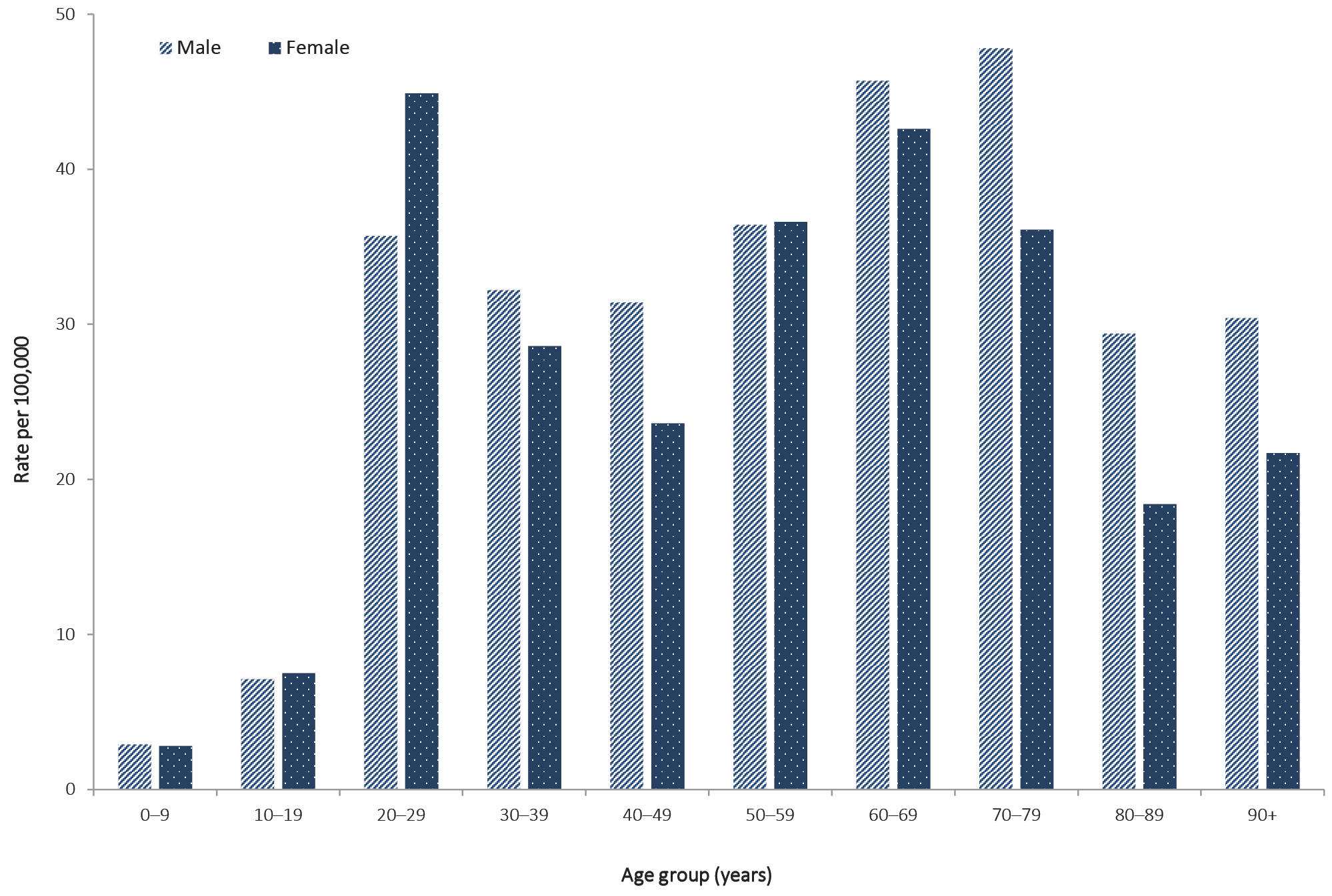

Source of infection
The rate of new cases continues to be low, irrespective of place of acquisition, with a decrease in rate observed for all sources of infection. Of the cases considered to be locally acquired, most are associated with contacts of confirmed cases or are associated with known outbreaks.
Of all cases with a reported place of acquisition, 70% had a recent international travel history and 24% were considered to have been locally acquired from a confirmed case. The rate of new cases has declined in all place of acquisition categories, with the steepest decline observed in cases acquired overseas – likely due to the reduction in international travel (Table 3, Figure 5). Of the locally-acquired cases, most were considered to be contacts of a confirmed case, with a very small proportion of cases not able to be epidemiologically linked to a confirmed case. Cases where a place of acquisition has not been reported (4.8%) are currently under public health investigation.
In this reporting week, most overseas-acquired cases have reported travel history to the Southern and Central Asia and Sub-Saharan Africa regions (Figure 6). In the previous reporting week, 3–10 May, the number of overseas-acquired cases was highest among those who reported travel history to Southern and Central Asia.

Figure 5: Rate of weekly confirmed cases in Australia by date of illness onsetª and place of acquisition
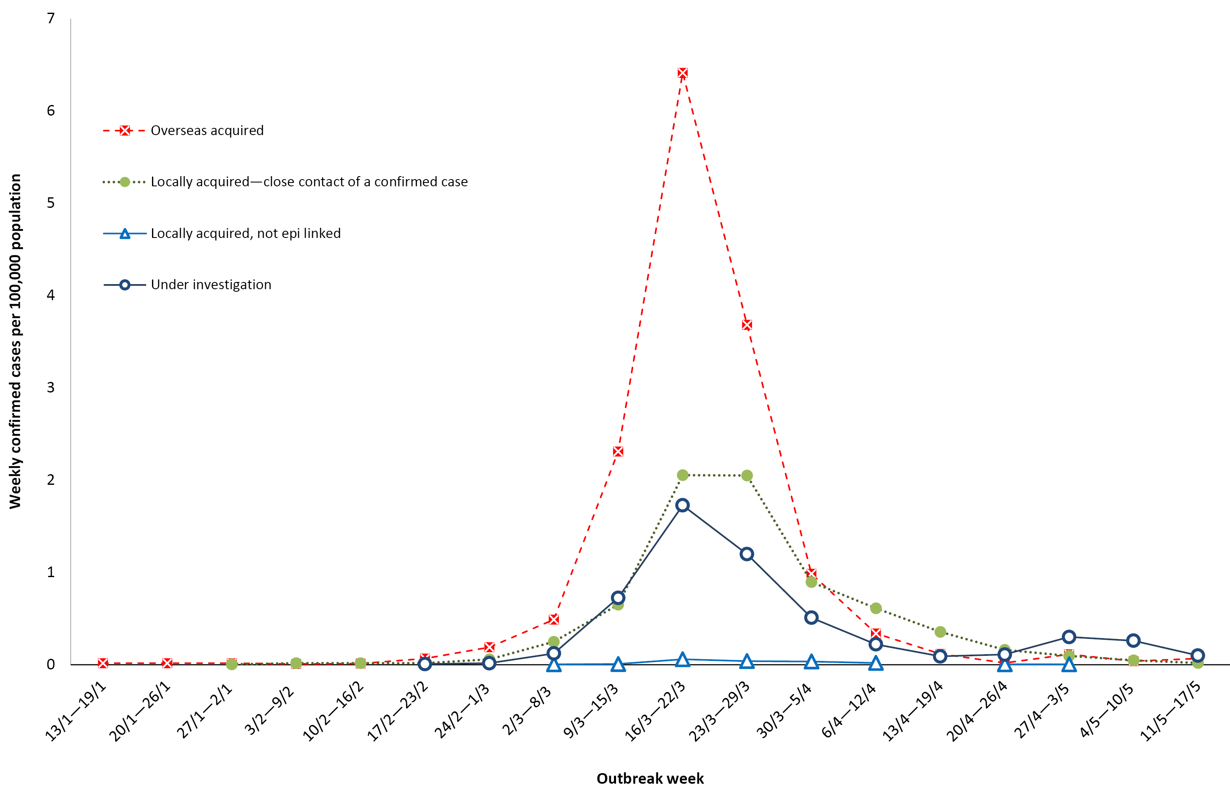
a Note that this graph is from NNDSS where there is a data completeness lag compared to more current proportions presented in text.

Table 3: Rate of weekly confirmed cases in Australia (per 100,000 population) by date of illness onsetª and place of acquisition
Week | Overseas acquired | Locally acquired—close contact of a confirmed case | Locally acquired, not epi linked | Under investigation
20–26 April | 0.020 | 0.162 | 0.004 | 0.11
27 April – 3 May | 0.114 | 0.095 | 0.004 | 0.30
4–10 May | 0.039 | 0.047 |  | 0.26
11–17 May | 0.067 | 0.020 |  | 0.099
a Based on diagnosis date from NNDSS reporting period up to 23:59 AEST 17 May 2020
Figure 6: Overseas-acquired confirmed cases in Australia by week of date of illness onset, by travel history regions
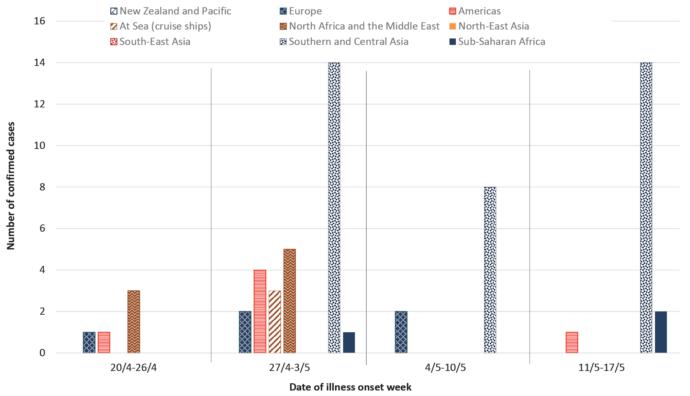

Cluster and outbreak investigations
Investigations are taking place in states and territories in relation to a number of clusters and outbreaks of COVID-19. To date the largest outbreaks have been associated with cruise ships, with some other large domestic clusters associated with aged care and healthcare facilities and private functions, such as weddings.
Cluster:
- The term ‘cluster’ in relation to COVID-19 refers to two or more cases (who do not reside in the same household) that are epidemiologically related in time, place or person where a common source (such as an event or within a community) of infection is suspected but not yet established.
Outbreak:
- The term ‘outbreak’ in relation to COVID-19 refers to two or more cases (who do not reside in the same household) among a specific group of people and/or over a specific period of time where illness is associated with a common source (such as an event or within a community).
Cruise ships account for a substantial proportion of cases of COVID-19 in Australia. Of cases with a reported place of acquisition, 18% (n = 1126) were acquired at sea on a cruise ship. The number of new cases acquired at sea on cruise ships has decreased in comparison to previous weeks; this, in part, reflects the implementation of public health measures and responses, in particular the cruise ship arrivals ban. In Australia, there have been 26 deaths among cases acquired at sea on cruise ships.
Residents of aged care facilities are at increased risk of COVID-19 infection due to the environment of communal living facilities and are more vulnerable to serious complications if they do become infected. As of 17 May 2020, there have been 124 cases of COVID-19 associated with 27 residential aged care facilities, with 47 recoveries and 26 deaths. Sixty-three of these cases occurred in aged care residents, with the remaining 61 cases occurring in care staff. In addition, there have been 42 cases associated with 30 in-home Commonwealth-funded aged care services providing support to older Australians who live at home, with 34 recoveries and 3 deaths. Thirty-one of these cases occurred in care recipients, with the remaining 11 cases occurring in care staff. Advice and guidelines have been provided to aged care services, including the release of an outbreak management guide.

Symptom profile
The symptoms reported by COVID-19 cases in Australia are consistent with a mild respiratory infection in the majority of cases. The most common symptoms reported (Figure 7) were cough (69%), fever (47%), sore throat (40%) and headache (36%). In addition, loss of smell was reported from 627 cases and loss of taste from 601 cases. These conditions were reported in approximately 12% of cases, noting that this is currently not a standard field in NNDSS, and is likely to under-represent those presenting with these symptoms.
In a minority of cases more severe complications are reported, with pneumonia and/or acute respiratory disease (ARD) reported in 3% of cases with symptoms.
The symptom profile of children and young adults aged 19 years and under was broadly similar to that of all cases. One exception was among children aged 5–9, with fever the most common symptom (46%, n = 13) followed by cough, runny nose and headache (each 25%, n = 7).
The symptom profile of Australian cases is broadly similar to the symptoms reported by COVID-19 cases internationally. Among EU/EEA countries and the UK, fever/chills and dry or productive cough were the most commonly reported symptoms.² Cough, headaches and weakness were the most commonly reported symptoms among cases in Canada.³ Differences in reported symptoms will be influenced by differences in surveillance strategies and symptom reporting across countries.

Figure 7: Variation in combinations of COVID-19 symptoms in confirmed cases, Australiaª
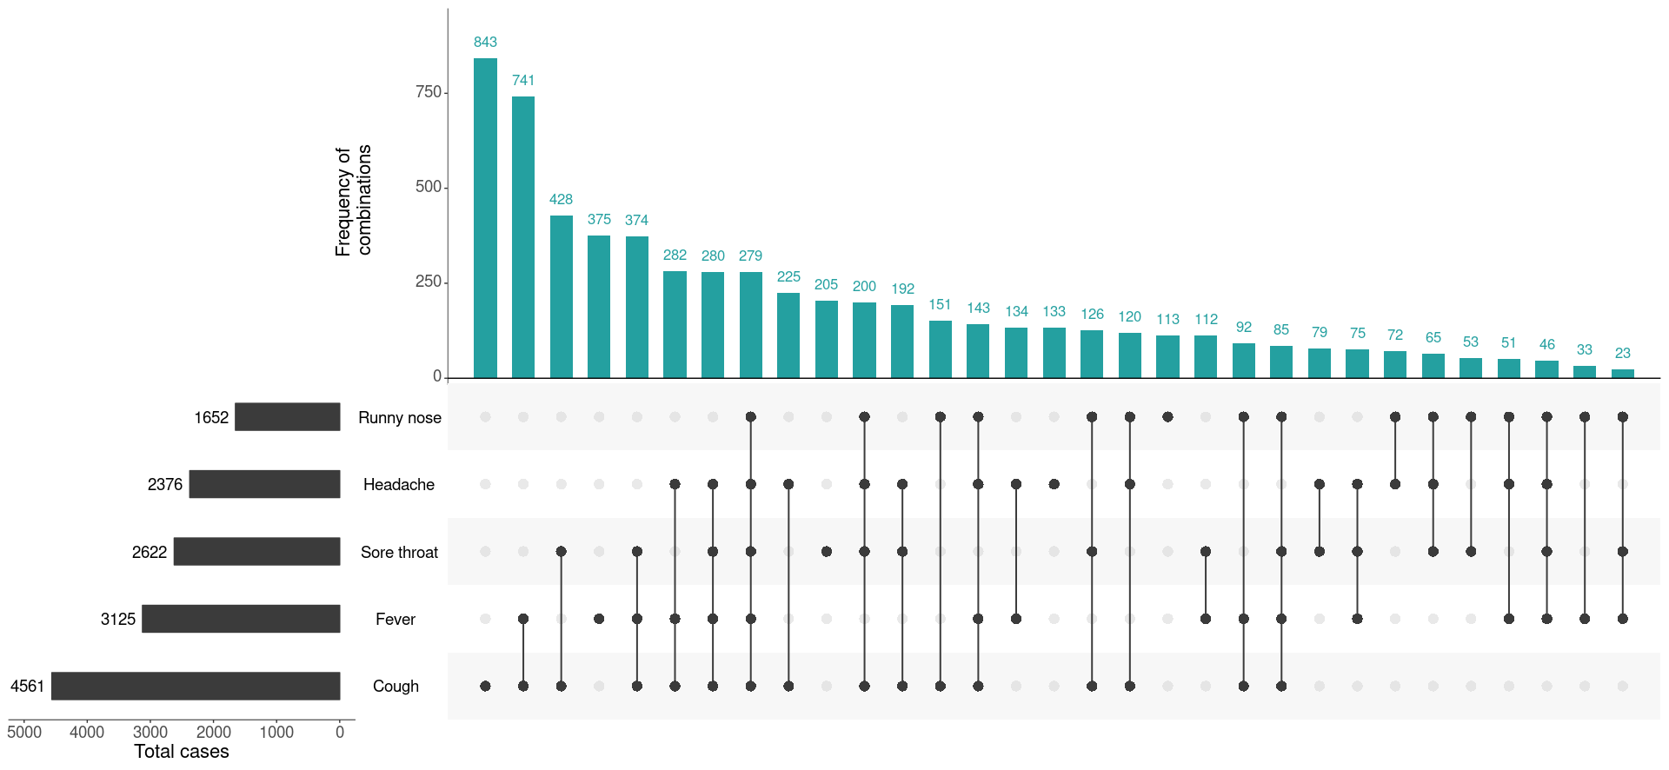
a This figure shows the variation in combinations of symptoms observed in reported cases (n = 6,600) for the five most frequently observed symptoms (cough, fever, sore throat, headache, runny nose). The horizontal bars on the left show the frequency of symptom occurrence in any combination with other symptoms. The circles and lines indicate particular combinations of symptoms observed in individual patients. The vertical green bars indicate the frequency of occurrence of the corresponding combination of symptoms.

Severity
Higher disease severity, as indicated by hospitalisation and death, was associated with increased age and comorbidities (Figure 8). The median age of cases who were hospitalised (median: 61, interquartile range (IQR): 43–72 years) and died (median: 80, IQR: 74–86) was higher than for cases overall (median: 47 years, IQR: 29–62 years). This is consistent with international reporting and reflects a greater risk of severe disease, complications, and deaths in the elderly (Tables 4 and 5).
Figure 8: Age distribution of all cases, hospitalised cases, and deaths with median, interquartile range, and range
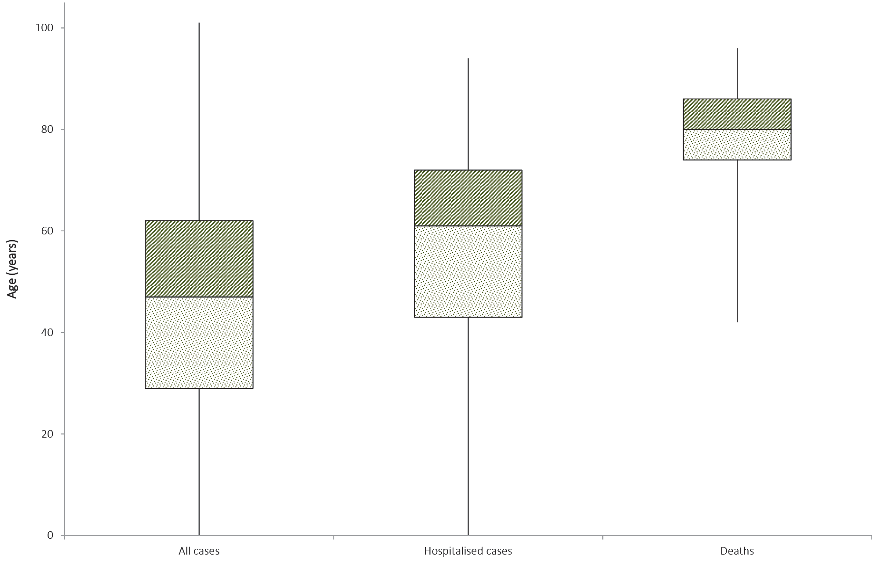
Table 4: Demographics of all cases, hospitalised cases and deaths, Australia
 | All cases |  |  | Hospitalisation |  |  | Death
 | Male | Female | Persons | Male | Female | Persons | Male | Female | Persons
Median age (IQR) | 48  (30–63) | 47  (28–62) | 47  (29–62) | 62  (45–73) | 59  (40–70) | 61  (43–72) | 79  (74–85) | 81  (76–89) | 80  (74–86)
Crude CFRª | 1.6% | 1.3% | 1.4% | 8.6% | 6.9% | 7.8% | – | – | –
a CFR = case fatality rate.

Table 5: Crude CFR of all cases and hospitalised cases, Australia, by age groupª
Age group | All cases |  | Hospitalisation
 | CFR | Total cases | CFR | Total cases
Under 50 | 0.03% | 3,807 | 0.4% | 283
50–59 | 0.2% | 1,127 | 1.4% | 140
60–69 | 1.0% | 1,152 | 5.8% | 189
70–79 | 4.3% | 749 | 12.0% | 191
80 and over | 22.1% | 240 | 35.1% | 94
All age groups | 1.4% | 7,075 | 7.8% | 897

a An earlier version of this report incorrectly identified the total hospitalisations across all age groups as 283 cases. This has now been amended.
The crude case fatality rate and the proportion of cases requiring hospitalisation in Australia both remain substantially lower than the corresponding values reported from many other comparable high-income countries. Of total cases of COVID-19 notified in Australia, 897 (13%) were admitted to hospital, compared with 16% of cases reported as requiring hospitalisation in Canada⁴ and 36% of cases in the EU/EEA.⁵ It is noted that the higher proportion reported by EU/EEA is affected by each country’s testing strategies, with some European countries now only testing hospitalised individuals for COVID-19.⁵
The highest rate of hospitalised cases in Australia was among the 70–79 age group (10.7 per 100,000 population), followed by those 80–89 years (9.4 per 100,000 population) and persons 90 years and over (8.4 per 100,000 population).
Approximately 3% of hospitalised cases were children and young adults aged 19 years and under. Of this group, the highest proportion of hospitalised cases was among children aged 5 and under, with hospitalisation of 13% of cases. Some of these hospitalisations may be precautionary, rather than necessarily being due to illness severity. Of the hospitalised cases among children and young adults, two were admitted to ICU with one receiving ventilation; both cases were aged 10–19 years. A higher rate of hospitalisation among young children was also reported by several EU/EAA countries and the UK, with 12.5% of cases under 5 hospitalised; it was hypothesised this may be due to a lower threshold for hospitalisation of young children rather than severity.⁶
The most commonly reported comorbid conditions among hospitalised cases were cardiac disease (19%), diabetes (18%) and chronic respiratory conditions (13%). Obesity was reported as a comorbid condition by 7% (n = 44) of hospitalised cases (Table 6).
Of the hospitalised COVID-19 cases, 19% (n = 170) were admitted to an intensive care unit (ICU), with 50 cases receiving ventilation. The most commonly reported comorbid conditions among cases admitted to an ICU were diabetes (26%) and cardiac disease (21%), which is similar to the most commonly reported comorbid conditions among hospitalised cases. Compared with hospitalised cases, a greater proportion of cases admitted to an ICU or receiving ventilation (13% and 21% respectively) were reported as being obese.
Among those aged 19 years and under, asthma was the most common comorbid condition, reported by 10% (n = 23) of all cases and 19% (n = 3) of hospitalised cases in this age group. This aligns generally with the broader population, with 10.3% (95% CI 9.3–11.3%) of young Australians aged 0–17 estimated to have asthma in 2017–2018.⁷
Of all cases, 29% reported one or more comorbid conditions, 6% reported two or more and 2% reported three or more. The proportion of COVID-19 cases who reported one or more comorbid conditions increased with the level of care required, with 76% of ventilated cases reporting comorbid conditions.
The median age of cases who died was 80 years (IQR: 74–86 years). Fifty-six of the cases were male and 44 were female. The most commonly reported comorbid conditions among COVID-19 deaths were cardiac disease (34%), diabetes (26%) and chronic respiratory disease (22%). Immunosuppressive condition/therapy (19%) and neurological disorder (17%) were also more commonly reported among deceased cases. Comorbid conditions were more common among cases who died, with 75% reported to have one or more specified comorbid conditions, 43% with two or more and 14% with three or more.
Similar comorbidities have been reported from COVID-19 cases internationally, with cardiovascular disease, hypertension, chronic lung disease (excluding asthma), diabetes and obesity the most commonly reported underlying health conditions in EU/EEA countries and the US.^{2,8} As in Australia, the proportion of cases with underlying conditions in these countries increased with COVID-19 severity.
Table 6: Common COVID-19 comorbidities for all cases, hospitalised cases, cases admitted to ICU and cases ventilated in ICU
 | All cases  (n = 5,268)ª | Hospitalised cases (n = 639)ª | Cases admitted to ICU (n = 137)ª | Cases ventilated in ICU (n = 38)ª
Common comorbidities
Cardiac disease (excluding hypertension) | 428 (8%) | 119 (19%) | 29 (21%) | 9 (24%)
Diabetes | 379 (7%) | 113 (18%) | 35 (26%) | 11 (29%)
Chronic respiratory condition (excluding asthma) | 186 (4%) | 80 (13%) | 17 (12%) | 4 (11%)
Obesity | 198 (4%) | 44 (7%) | 18 (13%) | 8 (21%)
Number of specified comorbidities^{b}
One or more | 1,535 (29%) | 350 (55%) | 90 (66%) | 29 (76%)
Two or more | 339 (6%) | 110 (17%) | 34 (25%) | 10 (26%)
Three or more | 83 (2%) | 40 (6%) | 15 (11%) | 4 (11%)
a Excludes those with missing data on comorbidities or where comorbidity is unknown.
b Includes asthma, chronic respiratory conditions (excluding asthma), cardiac disease (excluding hypertension), immunosuppressive condition/therapy, diabetes, obesity, liver disease, renal disease and neurological disorder.

Additional surveillance activities

Influenza Complications Alert Network (FluCAN) and Paediatric Active Enhanced Disease Surveillance System (PAEDS)
FluCAN, in partnership with PAEDS, together form a national hospital sentinel surveillance system for influenza which has been enhanced to also capture demographic and clinical information about confirmed COVID-19 cases hospitalised at participating sites.
Between 16 March and 11 May, 2020, there were 121 hospital admissions with laboratory-confirmed COVID-19 reported across 16 sentinel sites (Table 7). Of these, 24 (20%) had been admitted to ICU and four (3%) had died. The median age of hospitalised persons was 58 years (range < 1–87); 62 (51%) were male. In general, the length of hospital stay increased with advancing age category (Table 8). The most common comorbidity for hospitalised adults (≥16 years) with COVID-19 was obesity which was reported in 20 cases (37%).
Table 7: Confirmed cases of COVID 19 hospitalised between 16 March and 11 May, 2020 at sentinel sites by age group and ICU/HDU admission status (n = 111)ª
Age group (years) | General Ward  n (%) | Cases admitted to ICU/HDU  n (%) | Total  n (%)
< 16 | 10(12) | 0(0) | 10 (9)
16 – < 40 | 13(15) | 5 (21) | 18(16)
40 – < 65 | 35 (40) | 11 (46) | 46 (42)
65 – < 80 | 26 (30) | 8 (33) | 34 (31)
80+ | 3 (3) | 0 (0) | 3 (3)
Total | 87 (100) | 24 (100) | 111 (100)
a Data are included for all those with required data fields completed (n=111).
Table 8: Hospital length-of-stay for confirmed COVID-19 cases discharged from sentinel sites by ICU/HDU admission status (n = 74), median, interquartile range (IQR) and mean, standard deviation (SD)ª
Age group (years) | n | General ward  median (IQR) | Cases admitted to ICU/HDU  median (IQR) | Total  median (IQR) | Total  mean (SD)
< 16 | 10 | 6.5 (5.0–9.0) | – | 6.5 (5.0–9.0) | 7.6 (5.6)
16–65 | 42 | 5.0 (3.0–9.0) | 14.0 (7.0–25.0) | 6.0 (3.0–12.0) | 8.5 (7.2)
65+ | 22 | 6.0 (3.0–17.0) | 22.0 (20.0–24.0) | 9.5 (3.0–19.0) | 12.2 (10.2)
Total | 74 | 6.0 (3.0–12.0) | 20.0 (7.0–25.0) | 6.5 (3.0–15.0) | 9.5 (8.1)
a Deceased persons excluded

Figure 9: Proportion of confirmed adult COVID19 cases (> 16 years) hospitalised between 16 March and 11 May, 2020 with selected comorbidities (n = 65)^{a,b}
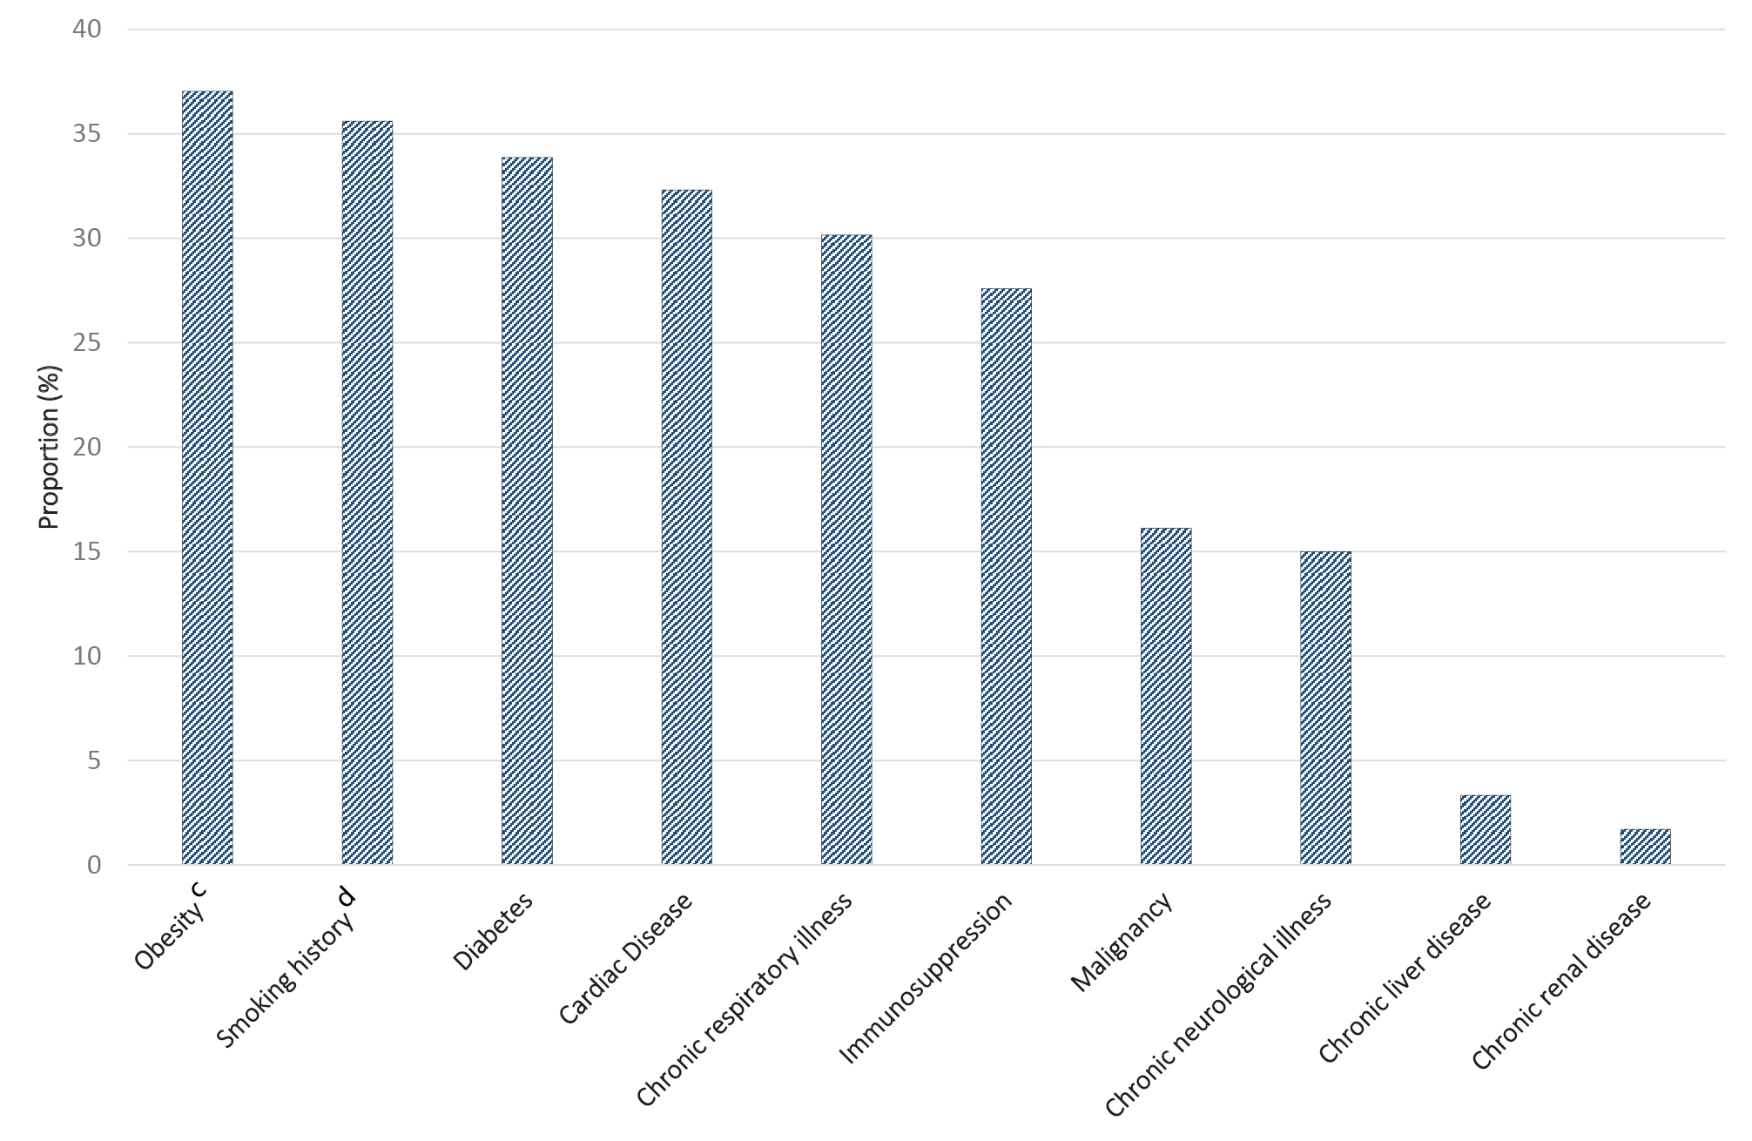
a Includes only those cases for which the relevant fields are complete and comorbidity status is known.
b Differences in comorbidity prevalence among hospitalised cases from FluCAN and NNDSS data reflect differences between sentinel (FluCAN) and passive (NNDSS) surveillance systems. FluCAN comorbidity data are ascertained from patients’ medical records and are likely to better capture this information.
c Defined as body mass index (BMI) > 30 or body weight > 120 kg.
d Includes past and current smokers.

Risk factors of hospitalisation and death
A preliminary analysis of COVID-19 cases among those aged 50 years and above (n = 2,475) found that having one or more chronic conditions, increasing age, and living outside major cities were significantly associated with an increased risk of death and hospitalisation (Table 9). Gender was not found to be a significant risk factor.
Table 9: Multivariate logistic regression analysis^{a,b,c} on death and hospitalisation among COVID-19 cases aged 50 years and above
Risk factors | Death (n = 76) |  | Hospitalisation (n = 436)
 | OR | 95% CI | OR | 95% CI
One/more conditions vs no conditions | 2.65 | (1.51–4.65) | 2.35 | (1.89–2.93)
Age at onset (one year increase) | 1.15 | (1.12–1.18) | 1.04 | (1.03–1.05)
Outside major cities vs major cities | 2.11 | (1.25–3.55) | 1.41 | (1.11–1.79)
a Analysis undertaken using 3-predictor model, excluding those with missing information on chronic conditions.
b Due to the dynamic nature of the NNDSS data collection, number of reported death and hospitalisation are subject to retrospective revision. Therefore, this analysis needs to be interpreted with caution as the NNDSS extract may vary over time.
c OR= Odds Ratio; CI= Confidence Interval.

Public health response measures
Since COVID-19 first emerged internationally, Australia has implemented public health measures in response to the disease’s epidemiology, both overseas and in Australia (Figure 10). These measures are focused on domestic and international travel and public gatherings; priorities for testing and quarantining of suspected cases and close contacts; guidance on effective social distancing; and the protection of vulnerable populations such as those in residential care facilities and remote Aboriginal and Torres Strait Islander communities.
On Friday 8 May, the Australian Government announced a three-step framework for easing COVID-19 restrictions. Progress will be reviewed every three weeks to assess the impact of these changes, with the intention of achieving a COVID safe Australia in July 2020. States and territories will ease restrictions at their own pace depending on the current public health situation and local epidemiology, noting that restrictions in these jurisdictions also differ slightly. All Australian states and territories have now commenced easing restrictions. The Northern Territory, Western Australia, South Australia, Victoria and Tasmania have announced ‘roadmaps’ for easing of restrictions with set dates for each step of their respective plans. New South Wales, Queensland and the Australian Capital Territory have announced or commenced initial or further easing of restrictions during this reporting period, but have not published roadmaps for future easing of restrictions. A summary of key announcements and activities from this reporting week regarding easing of restrictions in states and territories is at Table 10.
The Australian Health Protection Principal Committee issues advice to inform the national public health response to the pandemic. This has most recently included advice on Paediatric Inflammatory Multisystem Syndrome, the role of asymptomatic testing, and the utility of testing for COVID-19 to reduce the requirement for 14 days of quarantine. Since the release of the COVIDSafe app, a tool designed to enhance contact tracing, more than 5.7 million Australians have downloaded the app. Key aspects of Australia's evolving public health response are summarised in Table 11.

Table 10: State and territory announcements and actions for easing COVID-19 restrictions, from 11 May to 17 May 2020
Jurisdiction | Announcement or restrictions which have been eased
New South Wales | From 15 May the following restrictions were eased:¹⁰  - Gatherings of up to 10 people permitted outdoors, in cafes and restaurants, or in places of worship;  - Up to 5 visitors may gather in a household;  - Weddings up to 10 guests, indoor funerals up to 20 mourners and outdoor funerals up to 30 mourners; and  - Use of outdoor equipment and outdoor pools permitted with restrictions.
Victoria | From 12 May the following restrictions were eased:¹¹  - Up to 5 visitors may gather in a household; and  - Gatherings of up to 10 people permitted for non-contact sport and recreation, and in places of worship.
Queensland | From 16 May the following restrictions were eased:¹²  - Up to 5 visitors may gather in a household;  - Gatherings of up to 10 people permitted outdoors;  - Recreational activities permitted within 150km of an individual’s household, provided they do not enter the Outback;  - Weddings up to 10 guests, indoor funerals up to 20 mourners and outdoor funerals up to 30 mourners; and  - Children permitted to attend childcare, community kindergarten, and years prep, 1, 11 and 12 of schooling in person.  From 16 May the following concessions were made for outback Queensland:  - A maximum of 20 local people permitted in restaurants, cafes, and pubs; and  - Recreational travel permitted up to 500km within Outback Queensland if you live in the Outback.
Western Australia | Western Australia continues to plan for phase 2 of easing of restrictions. It is anticipated from 18 May the following restrictions will be eased:¹³  - Indoor and outdoor gatherings of up to 20 people permitted. Weddings and funerals may have 20 indoor or 30 people outdoors. Cafes and restaurants, places of worship, sports classes and community facilities permitted up to 20 patrons; and  - Regional travel restrictions to be relaxed.
South Australia | From 11 May the following restrictions were eased:^{14,15}  - Regional travel permitted;  - Universities and TAFEs recommenced face-to-face learning;  - Gatherings of up to 10 people permitted outdoors, including in cafes and restaurants, community gatherings, auctions, libraries, and sporting clubs, places of worship, camping grounds and swimming pools; and  - Weddings up to 10 guests, indoor funerals up to 20 mourners and outdoor funerals up to 30 mourners.
Tasmania | On 17 May, the Tasmanian Government confirmed it would commence phase 1 easing of restrictions on 18 May, as planned in their roadmap.¹⁶ The following restrictions will be eased:  - Up to 5 visitors may gather in a household;  - Gatherings of up to 10 people permitted indoors and outdoors, including in restaurants, cafes, and community facilities including libraries and parks;  - Up to 20 mourners permitted for indoor funerals and 30 mourners for outdoor; and  - Pools, community sports and boot camps permitted up to 10 people.  - In addition, returning Tasmanian residents will be permitted to quarantine in their primary residence if suitable.
Australian Capital Territory | ACT commenced easing of restrictions on 8 May:¹⁷ From 15 May the following restrictions were also eased:¹⁸  - Non-contact outdoor sporting activities can recommence with up to 10 participants; and  - Pools can reopen for up to 10 people per pool.  The ACT Government have announced that public schools will return to on-campus learning over a four week period commencing from 18 May.¹⁷
Northern Territory | From 15 May, the Northern Territory commenced phase 2 easing of restrictions. The following activities are permitted however it is recommended people undertake these activities in less than 2 hours:¹⁹  - Cafes, restaurants, food courts, indoor markets and bars reopened;  - Sporting clubs, gymnasiums, physical training and exercise classes including dance recommenced; and  - Libraries, playgrounds, places of worship, art galleries, museums and zoos reopened.

Table 11: Timeline of key COVID-19 related events, including Australian public health response activities.
Date | Event / response activity
8 May 2020 | The Australian Government announces a three-step plan to ease COVID-19 restrictions.²⁰
1 May 2020 | AHPPC releases a statement on risk management for re-opening boarding schools and school-based residential colleges.²¹
26 April 2020 | The Australian Government launches a new voluntary coronavirus app, COVIDSafe.²²
24 April 2020 | AHPPC provides statements on the recommencement of kidney transplantation, updated advice regarding schools, and use of PPE in hospital with patients with COVID-19.²³
21 April 2020 | AHPPC provides advice for residential aged care facilities about minimising the impact of COVID-19 with information on entry restrictions, managing illness in visitors and staff, and hygiene measures.²⁴
21 April 2020 | The Australian Government announces the gradual ease of restrictions on elective surgery from Tuesday 28 April 2020.²⁵
16 April 2020 | AHPPC provides advice on reducing the potential risk of COVID-19 transmission in schools.²⁶
9 April 2020 | Air crew on international flights will be required to self-isolate at their place of residence (or hotel if not in their local city) between flights or for 14 days, whichever is shorter.²⁷
30 March 2020 | Special provisions be applied to vulnerable people in the workplace and application of additional regional social distancing measures to combat COVID-19.²⁸
29 March 2020 | Both indoor and outdoor public gatherings limited to two persons only.
28 March 2020 | All people entering Australia required to undertake a mandatory 14-day quarantine at designated facilities (e.g. hotels) in their port of arrival.
26 March 2020 | Restricted movement into certain remote areas to protect community members from COVID-19.
24 March 2020 | - Temporary suspension of all non-urgent elective procedures in both the public and private sector;  - Progressive scale up of social distancing measures with stronger measures in relation to non-essential gatherings, and considerations of further more intense options; and  - Aged care providers limit visits to a maximum of two visitors at one time per day.
25 March 2020 | - School-based immunisation programs, with the exception of the delivery of meningococcal ACWY vaccine, are paused; and  - Australian citizens and Australian permanent residents are restricted from travelling overseas.
21 March 2020 | Qld, WA, NT and SA close borders to non-essential travellers.
20 March 2020 | - Travel ban on foreign nationals entering Australia;  - Restriction of travel to remote communities; and  - Tasmania closes borders to non-essential travellers.
18 March 2020 | - DFAT raises travel advice for all overseas destinations to Level 4 'Do Not Travel';  - Continuation of a 14-day quarantine requirement for all returning travellers; and  - Restrictions on indoor gatherings.
16 March 2020 | Non-essential static gatherings of > 500 people banned.
15 March 2020 | All overseas arrivals required to self-isolate for 14 days and cruise ship arrivals banned.
8 March 2020 | Restrictions on COVID-19 contacts and travellers from listed higher risk countries.
5 March 2020 | Restrictions on travel from Republic of Korea.
1 March 2020 | Restrictions on travel from Islamic Republic of Iran.

Figure 10: COVID-19 notifications in Australia by date of onset, from 13 January to 17 May 2020,ª with timing of key public health measures
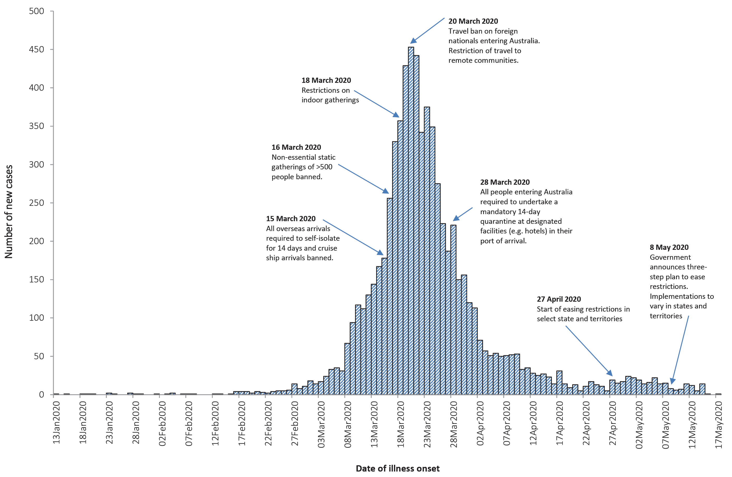
a Due to reporting delays, interpret the latest days’ new cases with caution.

International situation²⁹

Global
At 18:00 AEST 17 May 2020, the WHO reported 4,525,497 COVID-19 cases and 307,395 deaths globally. Cases have been reported in almost all countries globally. Europe and the United States of America continue to be the epicentres of the pandemic; however, Brazil and India are emerging as new epicentres (Figure 11). Overall approximately 43% of cases are from the Americas and 41% from the European Region. The WHO Situation Report indicates the majority of deaths are from the United States of America (28%), the United Kingdom (11%), Italy (11%), Spain (9%) and France (9%) (Figure 12). The global case fatality rate (CFR) is approximately 6.8%.
Each country is experiencing an individual epidemic curve which is aligned with the phase of the epidemic and the relevant local public health responses, including physical distancing measures, testing and contact tracing measures as well as broader health system capacity.

Europe
There may be a slowing of cases in the European region, as the number of new cases over the past 7 days was 14% lower than the previous 7 days, and new deaths were 19% lower. It is too soon to say if this trend will continue. Russia is emerging as another epicentre of disease, regularly reporting over 10,000 cases per day. Russia’s cumulative case count is now the highest in the European Region. However, compared to the overall European region, which has a CFR of 8.9%, Russia has a very low CFR of 0.9%. This is likely due to the way in which deaths are recorded: some regions have started reporting two death figures. The first are deaths attributable solely to COVID-19; the second are those that have other complications with COVID-19.
Germany’s recent lifting of restrictions created some concern about a possible second wave of infection, as their reproduction number (R value) briefly rose above 1.0. The increase appeared to be tied to clusters in aged care facilities and meat processing plants. It is understood that German states will re-impose restrictions (which several have done) whenever a rise in the seven-day incidence of more than 50 cases per 100,000 people is observed. The R value has since returned below 1.0 and the number of new daily cases has continued to decrease. This trend has also been observed in Italy, Spain, and France suggesting that these countries are also bringing their outbreaks under control. Turkey has continued to report high numbers of new daily cases, but their epidemic curve does not indicate that a second wave is occurring.

Americas
The United States of America has reported above 20,000 new daily cases consistently over the last week, with their total case number exceeding 1.4 million on 17 May 2020. The effects of easing restrictions throughout May are yet to be realised, noting that each US state has its own plan for easing restrictions. The epidemic in Brazil appears to be accelerating, with the number of confirmed cases exceeding 200,000 and the number of deaths exceeding 14,000. Other countries of note in this region include Peru, Mexico, Chile and Ecuador, which are all showing strong growth. Mexico and Ecuador are reporting case fatality rates higher than the global rate at 10.6% and 8.3%, respectively.

Africa
Of cases in the African region, a quarter have been in South Africa, while a third of deaths in this region have occurred in Algeria. South Africa’s outbreak has been accelerating over the past week, with an increasing numbers of daily new cases. Their cumulative case count is showing exponential growth. There has been strong growth in daily cases observed in Cameroon, Nigeria, Algeria, Gabon and Equatorial Guinea. Low case counts across many African nations may be the result of limited testing capacity across the region.

Eastern Mediterranean
Iran is experiencing a second wave of infection, which was the result of a partial reopening on their country. Saudi Arabia, Qatar, Kuwait, Bahrain and the United Arab Emirates are all showing rapid increases in their number of cases. There have been 350 new cases per 100,000 population over the past week in Qatar, the sharpest increase on the globe. A large majority of the outbreaks in these countries have been within the migrant worker and prison populations. Population migration as jobless workers return to their home countries has distributed the disease; the testing capacity of several countries in the region may be masking the true scale of the epidemic.

South East Asia
The number of new cases in the region increased by 22% in the past week. This is due to increases predominately in India and Bangladesh. India is currently reporting over 90,000 cases and approximately 4,000 new cases daily. The close living conditions experienced by many of the population are expected to result in rapid growth of the epidemic. Bangladesh has approximately 21,000 cases and is growing by approximately 1,000 cases per day. The situation in Bangladesh is similar to India, and the disease is likely to rapidly spread among migrant worker and refugee populations. The number of new cases reported in Indonesia remains consistent and they are currently seeing slow growth of their case numbers. This is likely impacted by testing capacity and there may be many unreported cases.

Western Pacific
The outbreak in the migrant worker population of Singapore continues, with 92% of all new cases in Singapore reported in dormitory workers. This represents 8% of the estimated total population of migrant workers. Dormitory workers residing in Singapore are predominantly young, healthy individuals who must pass stringent medicals before employment. This may explain the low mortality rate observed within this setting. The Philippines has reported 11,618 cases and 772 deaths (CFR: 6.6%). No new cases or deaths have been reported in Fiji, New Caledonia, Papua New Guinea, French Polynesia, or Timor-Leste over the last seven days. Northern Mariana Islands reported 2 new cases on 17 May 2020 and sporadic cases are likely to continue as travel has restarted between Guam and Saipan..
Figure 11: Number of COVID-19 cases (logarithmic scale) by selected country and days since passing 100 cases, up to 17 May 2020
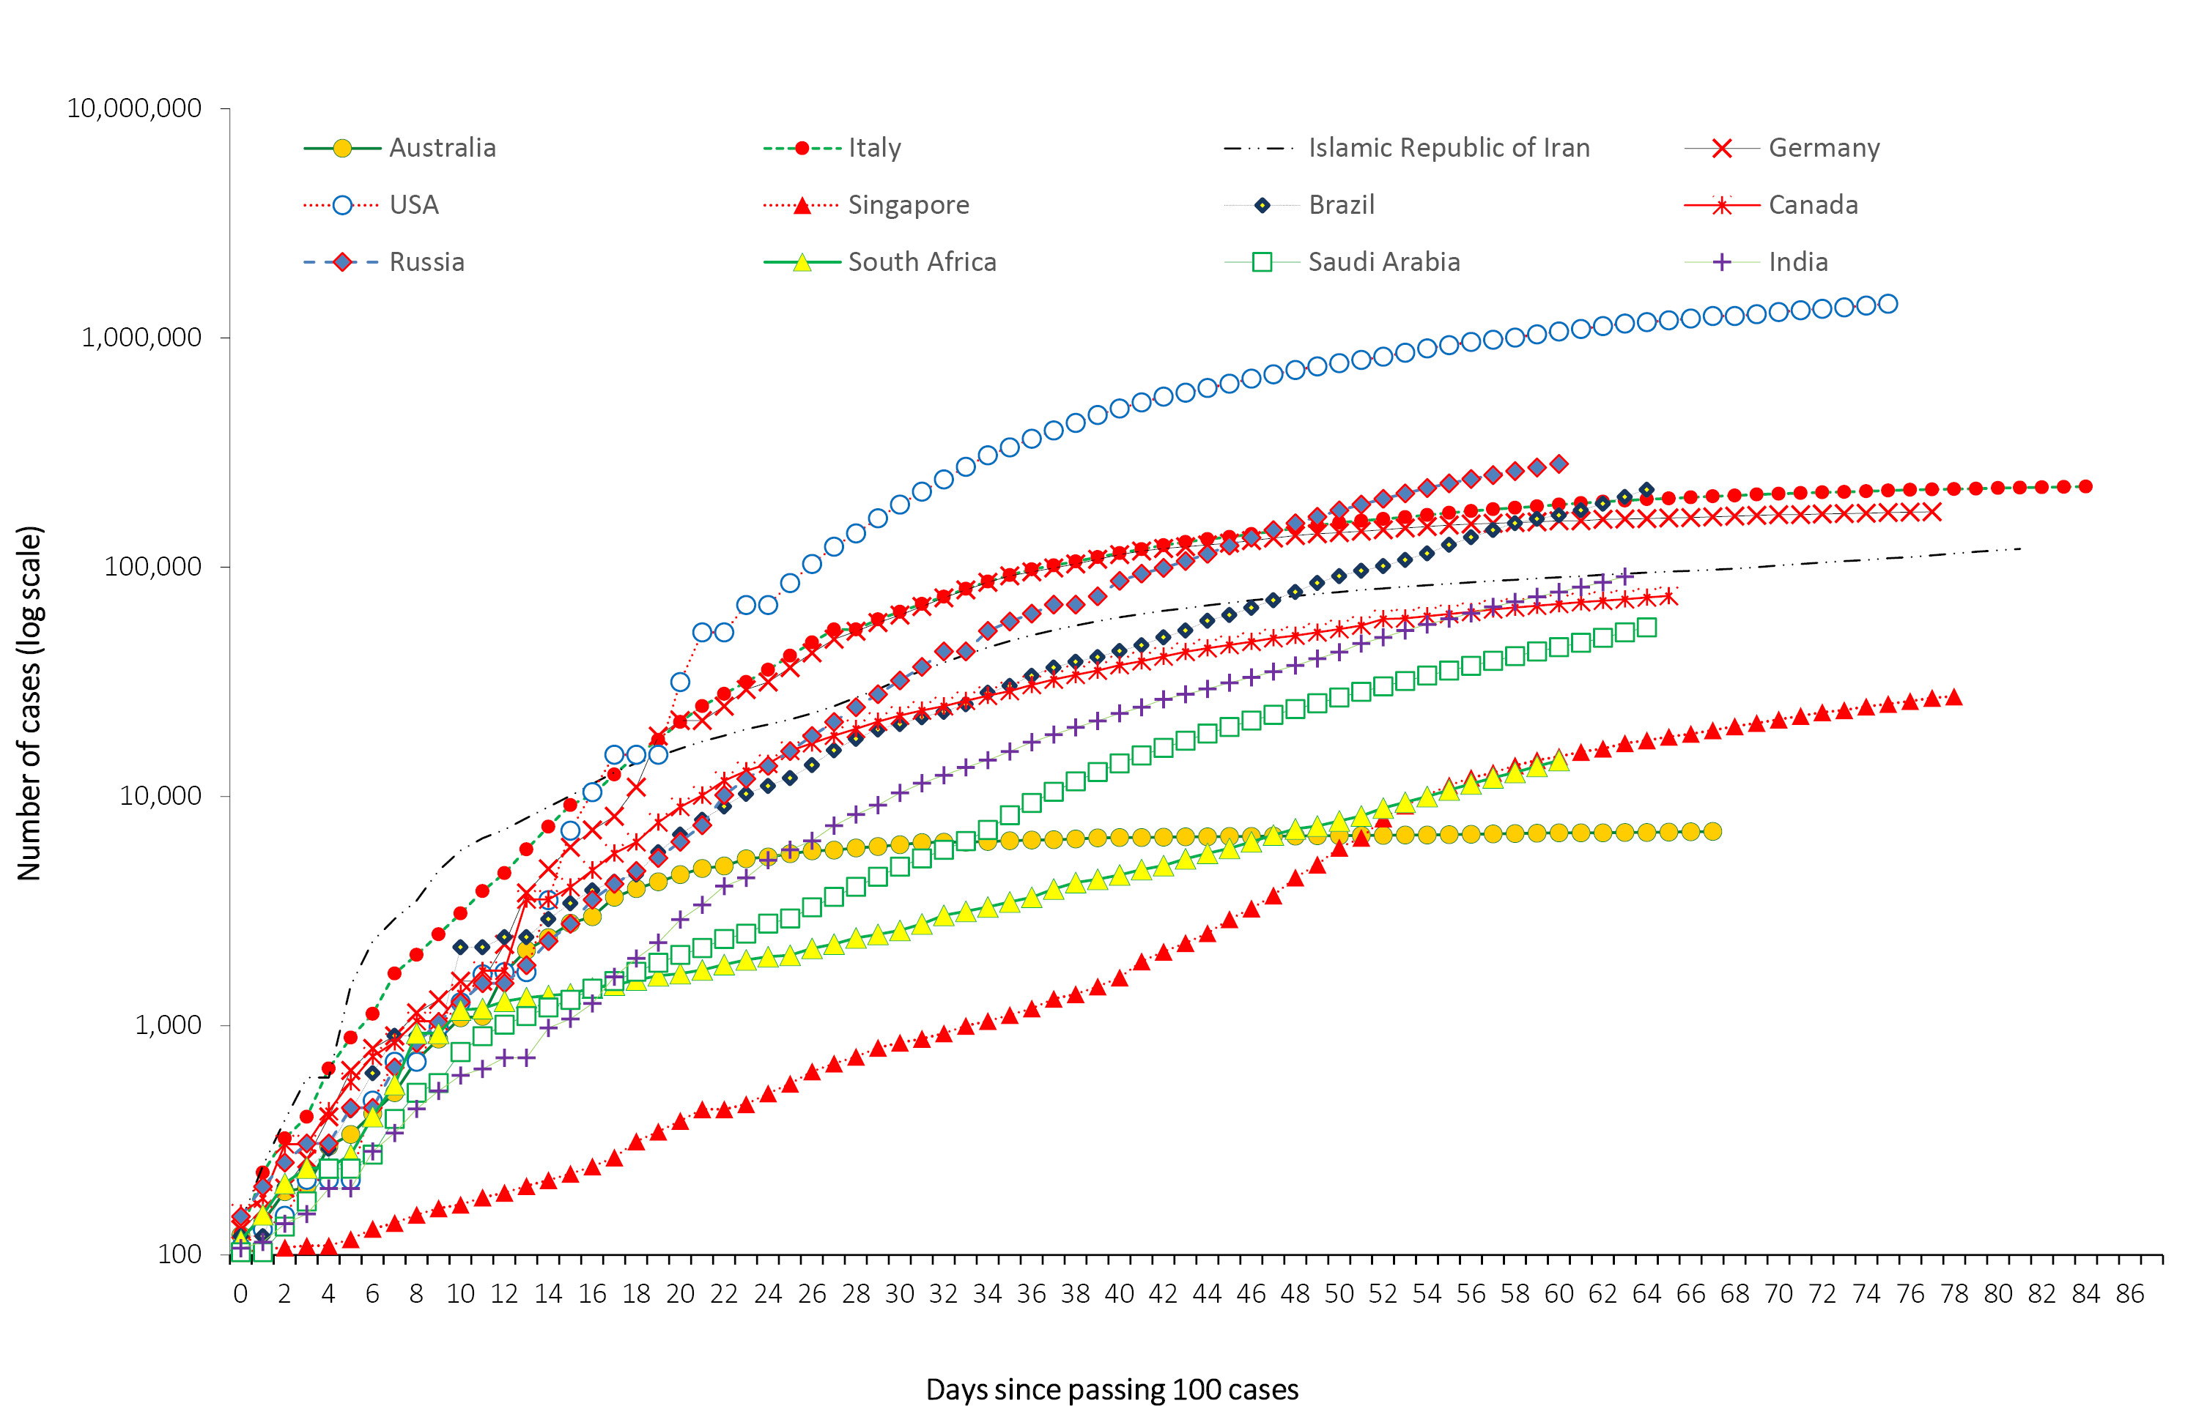
Figure 12: Number of COVID-19 deaths (logarithmic scale) by selected country and days since passing 50 deaths, up to 17 May 2020
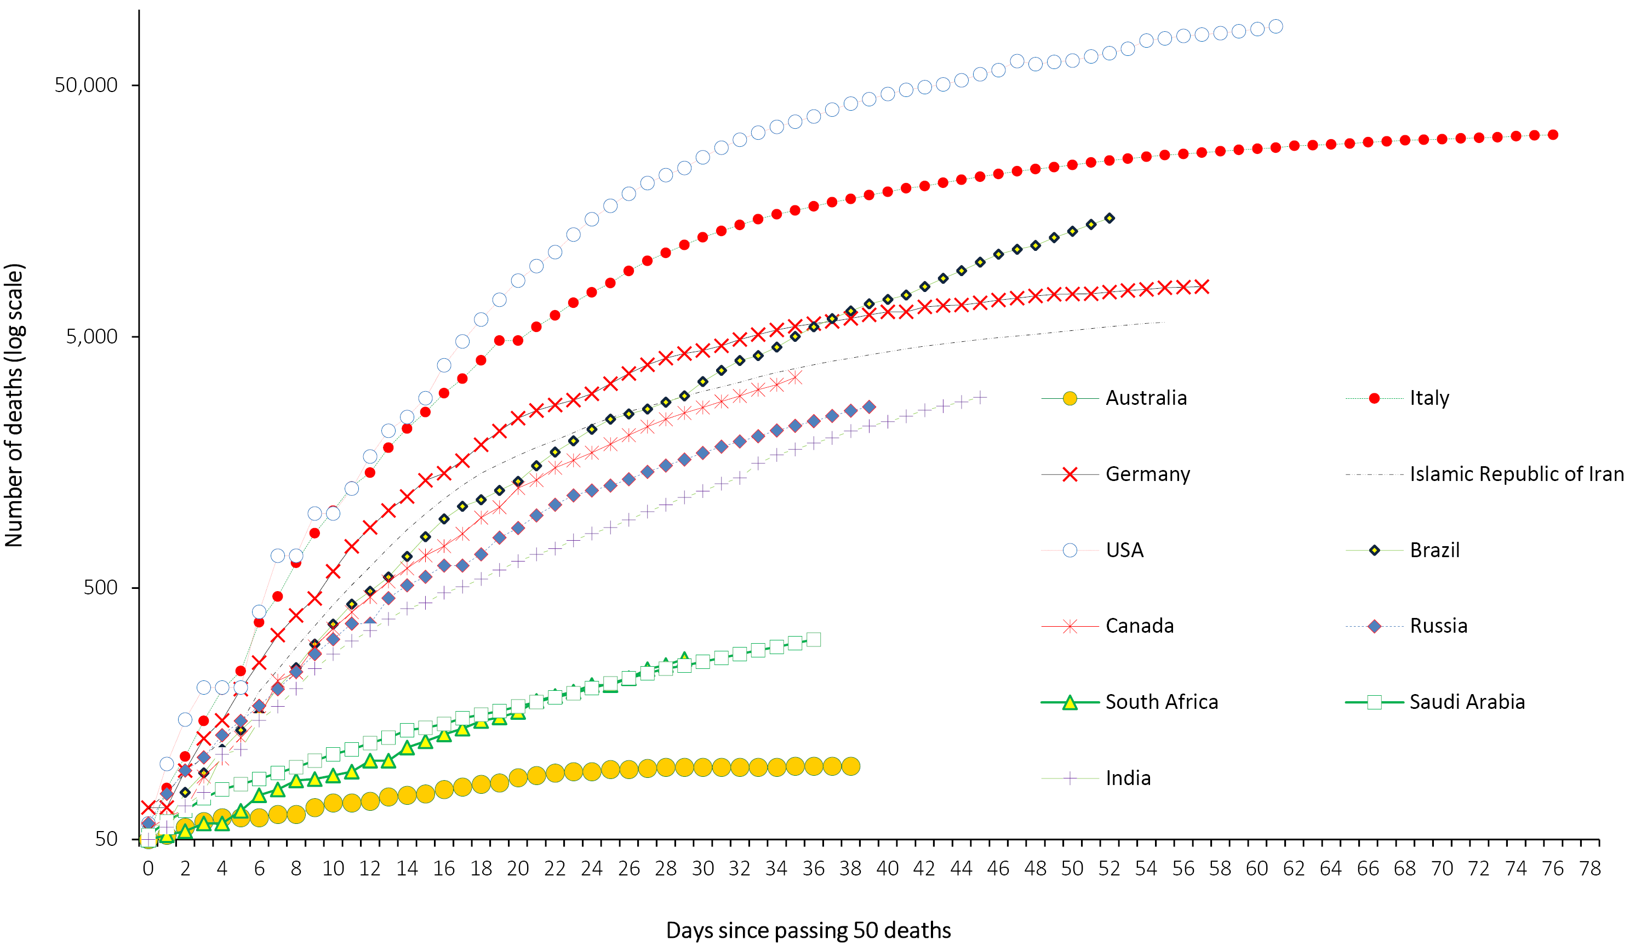

Background
The current estimates on epidemiological parameters including severity, transmissibility and incubation period are uncertain. Estimates are likely to change as more information becomes available.

Transmission
Human-to-human transmission of SARS-CoV-2 is via droplets and fomites from an infected person to a close contact.³⁰ A virological analysis of hospitalised cases found active virus replication in upper respiratory tract tissues, with pharyngeal virus shedding during the first week of symptoms.³¹ However, current evidence does not support airborne or faecal-oral spread as major factors in transmission.³⁰
Viral RNA has been identified in respiratory track specimens 1–2 days prior to symptoms onset, and has been observed after symptom cessation. In 50% of the patients, seroconversion occurred after seven days with a range of up to 14 days; this seroconversion was not followed by a rapid decline in viral load.³² However, it is unknown if detection of viral RNA correlates with shedding of live virus and transmission risk.^{2,32}
Several studies suggests that children do not play a key role in transmission and are unlikely to be the primary source of infections.³³ Studies out of the EU have suggested that child to adult transmission is uncommon.^{34,35}

Incubation period
Estimates of median incubation period, based on seven published studies, are 5 to 6 days (ranging from 1 to 14 days). Patients with long incubation periods do occasionally occur; however, they are likely to be ‘outliers’ who should be studied further but who are unlikely to represent a change in epidemiology of the virus.^{36,37}

Molecular epidemiology
Since December 2019, the virus has diversified into multiple lineages as it has spread globally, with some degree of geographical clustering. The whole genome sequences currently available from Australian cases are dispersed across these lineages, reflecting multiple concurrent introductions into Australia.^{38,39} Genomic clusters—closely related sequences reflecting local transmission chains—have also been identified in Australia.³⁸ Genomic epidemiology has successfully been used to link to known genomic clusters many cases that were epidemiologically classified as ‘locally acquired – contact not identified’.³⁸

Clinical features
COVID-19 presents as mild illness in the majority of cases, with cough and fever being the most commonly reported symptoms. Severe or fatal outcomes are more likely to occur in the elderly or those with comorbid conditions.^{30,40}
Some COVID-19 patients show neurological signs such as headache, nausea and vomiting. There is evidence that SARS-CoV-2 viruses are not always confined to the respiratory tract and may invade the central nervous system inducing neurological symptoms. As such, it is possible that invasion of the central nervous system is partially responsible for the acute respiratory failure of COVID-19 patients.⁴¹
There is some evidence to suggest that impairment or loss of the sense of smell (hyposmia/anosmia) or taste (hypoguesia/aguesia) is associated with COVID-19.^{42,43} This is supported by research finding a biological mechanism for the SARS-CoV-2 virus to cause olfactory dysfunction.^{44,45}
Several studies have identified cardiovascular implications resulting from COVID-19.^{46–48} Vascular inflammation has been observed in a number of cases and may be a potential mechanism for myocardial injury which can result in cardiac dysfunction and arrhythmias.
COVID-19 disease in children is more likely to be mild and self-limiting, compared to adults. Internationally children make up a small proportion of confirmed COVID-19 cases, with those shown to be infected either presenting with milder symptoms than adults or remaining asymptomatic; a similar pattern has been observed with SARS and MERS. However, the greater likelihood of mild clinical presentation in children may result in lower testing and case detection in this cohort. Studies have also shown that hospital admission is inversely related to age. From European reporting, death associated with COVID-19 has been rare among those aged less than 15 years, with 4 deaths reported from 44,695 cases, as at 13 May 2020.
There have been reports of a rare clinical presentation of paediatric inflammatory multisystem syndrome resembling Kawasaki disease. An association with SARS-CoV-2 infection has been hypothesised due to a temporal association with SARS-CoV-2 infection in children. This presentation remains rare with evidence of the association between COVID-19 and the development of a Kawasaki-like disease currently inconclusive; further investigation is needed due to variability in clinical presentations in reported paediatric cases.^{49,50}
Kawasaki disease is a rare acute febrile illness with inflammation of small- and medium-sized blood vessels throughout the body, in particular, the coronary arteries (blood vessels around the heart). It predominantly affects children under 5 years and the cause is unknown. In Australia, there are usually around 200 to 300 cases diagnosed per year of Kawasaki disease.⁵¹

Treatment
Current clinical management of COVID-19 cases focuses on early recognition, isolation, appropriate infection control measures and provision of supportive care.⁵² While there is no specific antiviral treatment currently recommended for patients with suspected or confirmed SARS-CoV-2 infection, multiple clinical trials are underway to evaluate a number of therapeutic agents, including remdesivir, lopinavir/ritonavir, and chloroquine or hydroxychloroquine. ^{53,54} A recent open-label randomised controlled trial did not find a significant impact of hydroxychloroquine treatment on disease progression for hospitalised patients with mild to moderate COVID-19, with those receiving treatment also reporting a higher number of adverse events.⁵⁵ Similarly, an open-label randomised controlled trial of lopinavir/ritonavir among hospitalised patients found no benefit for time to clinical improvement.⁵⁶ Results for remdesivir treatment have been mixed, with one randomised double-blind placebo-controlled trial finding patients recovered 31% faster and a lower mortality rate (8.0% compared with 11.6% among placebo patients),⁵⁷ while another found no effect.⁵⁸ Further trials are required to assess the effectiveness of these treatments on COVID-19. Multiple COVID-19 vaccines have commenced clinical trials.

Data considerations
Data were extracted from the NNDSS on 19 May 2020, by diagnosis date. Due to the dynamic nature of the NNDSS, data in this extract are subject to retrospective revision and may vary from data reported in published NNDSS reports and reports of notification data by states and territories.

Acknowledgements
This report represents surveillance data reported through CDNA as part of the nationally-coordinated response to COVID-19. We thank public health staff from incident emergency operations centres in state and territory health departments, and the Australian Government Department of Health, along with state and territory public health laboratories. We also thank Professor Allen Cheng of FluCAN for providing data for the FluCAN analyses.

Author details

Corresponding author
COVID-19 National Incident Room Surveillance Team, Australian Government Department of Health, GPO Box 9484, MDP 14, Canberra, ACT 2601.
Email: epi.coronavirus@health.gov.au

References
- Zimmermann P, Curtis N. Coronavirus infections in children including COVID-19: an overview of the epidemiology, clinical features, diagnosis, treatment and prevention options in children. Pediatr Infect Dis J. 2020;39(5):355–368. doi: https://doi.org/10.1097/INF.0000000000002660.
- European Centre for Disease Prevention and Control (ECDC). COVID-19 surveillance report: Week 2020-19. 6: Other epidemiological characteristics. [Internet.] Solna: ECDC; 14 May 2020. [Accessed on 19 May 2020.] Available from: https://covid19-surveillance-report.ecdc.europa.eu/#6_other_epidemiological_characteristics.
- Government of Canada. Epidemiological summary of COVID-19 cases in Canada: last data update May 19, 2020, 11:00 ET. [Internet.] Ottawa: Government of Canada; 2020. [Accessed on 19 May 2020.] Available from: https://health-infobase.canada.ca/covid-19/epidemiological-summary-covid-19-cases.html.
- Public Health Agency of Canada (PHAC). Coronavirus disease 2019 (COVID-19). Daily epidemiology update. Updated: 19 May 2020, 11:00 ET. Ottawa: Government of Canada, PHAC; 2020. Available from: https://www.canada.ca/content/dam/phac-aspc/documents/services/diseases/2019-novel-coronavirus-infection/surv-covid19-epi-update-eng.pdf.
- ECDC. COVID-19 surveillance report: Week 2020-19. 4: Severity. [Internet.] Solna: ECDC; 14 May 2020. [Accessed on 19 May 2020.] Available from: https://covid19-surveillance-report.ecdc.europa.eu/#4_severity.
- ECDC. Rapid risk assessment: Paediatric inflammatory multisystem syndrome and SARS-CoV-2 infection in children. [Internet.] Solna: ECDC; 15 May 2020. [Accessed on 19 May 2020.] Available from: https://www.ecdc.europa.eu/en/publications-data/paediatric-inflammatory-multisystem-syndrome-and-sars-cov-2-rapid-risk-assessment.
- Australian Bureau of Statistics. 4364.0.55.001 - National Health Survey: First Results, 2017-18. [Internet.] Canberra: Australian Government, Australian Bureau of Statistics; 2018. [Accessed on 12 May 2020.] Available from: https://www.abs.gov.au/AUSSTATS/abs@.nsf/DetailsPage/4364.0.55.0012017-18.
- Centers for Disease Control and Prevention (CDC). COVIDView: a weekly surveillance summary of U.S. COVID-19 activity. Key updates for week 19, ending May 9, 2020. [Internet.] Atlanta: United States Government Department of Health and Human Services, CDC; 2020. [Accessed on 19 May 2020.] Available from: https://www.cdc.gov/coronavirus/2019-ncov/covid-data/pdf/covidview-05-15-2020.pdf.
- Australian Government Department of Health. Australian Health Protection Principal Committee (AHPPC) coronavirus (COVID-19) statements on 14 May 2020. [Internet.] Canberra: Australian Government Department of Health; 2020. [Accessed 19 May 2020.] Available from: https://www.health.gov.au/news/australian-health-protection-principal-committee-ahppc-coronavirus-covid-19-statements-on-14-may-2020.
- Government of New South Wales. What you can and can’t do under the rules. [Internet.] Sydney: Government of New South Wales; 2020. [Accessed on 19 May 2020.] Available from: https://www.nsw.gov.au/covid-19/what-you-can-and-cant-do-under-rules.
- Department of Health and Human Services (DHHS). Your coronavirus (COVID-19) questions answered. [Internet.] Melbourne: Victoria State Government, DHHS; 2020. [Accessed on 19 May 2020.] Available from: https://www.dhhs.vic.gov.au/your-coronavirus-covid-19-questions-answered.
- Queensland Department of Health. Home Confinement, Movement and Gathering Direction (No. 6): Understanding this direction. [Internet.] Brisbane: Queensland Governent, Department of Health; 2020. [Accessed on 192 May 2020.] Available from: https://www.health.qld.gov.au/system-governance/legislation/cho-public-health-directions-under-expanded-public-health-act-powers/home-confinement-movement-gathering-direction/help.
- Department of the Premier and Cabinet. COVID-19 coronavirus: WA Roadmap. [Internet.] Perth: Government of Western Australia, Department of the Premier and Cabinet; 2020. [Accessed on 12 May 2020.] Available from: https://www.wa.gov.au/organisation/department-of-the-premier-and-cabinet/covid-19-coronavirus-wa-roadmap.
- Government of South Australia. South Australian Roadmap for Easing COVID-19 Restrictions. Adelaide: Government of South Australia; 2020. [Accessed on 20 May 2020.] https://www.covid-19.sa.gov.au/__data/assets/pdf_file/0012/195879/200059.4-COVID-19-RoadMap_FINAL.PDF.
- Government of South Australia. Latest news: COVID restrictions to ease from Monday. [Internet.] Adelaide: Government of South Australia; 2020. [Accessed on 20 May 2020.] https://www.covid-19.sa.gov.au/latest-news/covid-restrictions-to-ease-from-monday.
- Department of Premier and Cabinet. Restrictions to ease from tomorrow. [Internet.] Hobart: Tasmanian Government, Department of Premier and Cabinet; 2020. [Accessed on 19 May 2020.] Available from: http://www.premier.tas.gov.au/releases/restrictions_to_ease_from_tomorrow.
- Australian Capital Territory Government. Some easing of COVID-19 restrictions begins. [Internet.] Canberra: Australian Capital Territory Government; 2020. [Accessed on 12 May 2020.] Available from: https://www.act.gov.au/our-canberra/latest-news/2020/may/some-easing-of-covid-19-restrictions-begins.
- Australian Capital Territory Government. Easing of sport and recreation restrictions - 13 May 2020. [Internet.] Canberra: Australian Capital Territory Government; 2020. [Accessed on 19 May 2020.] Available from: https://www.covid19.act.gov.au/news-articles/easing-of-sport-and-recreation-restrictions-13-may-2020.
- Northern Territory Government. Roadmap to the new normal. [Internet.] Darwin: Northern Territory Government; 2020. [Accessed on 12 May 2020.] Available from: https://coronavirus.nt.gov.au/steps-to-restart/roadmap-new-normal.
- Department of the Prime Minister and Cabinet. Update on coronavirus measures. [Internet.] Canberra: Australian Government, Department of the Prime Minister and Cabinet; 2020. [Accessed on 12 May 2020.] Available from: https://www.pm.gov.au/media/update-coronavirus-measures-08may20.
- Australian Government Department of Health. Australian Health Protection Principal Committee (AHPPC) statement on risk management for re-opening boarding schools and school-based residential colleges. [Internet.] Canberra: Australian Government Department of Health; 2020. [Accessed 5 May 2020.] Available from: https://www.health.gov.au/news/australian-health-protection-principal-committee-ahppc-statement-on-risk-management-for-re-opening-boarding-schools-and-school-based-residential-colleges.
- Australian Government Department of Health. COVIDSafe: New app to slow the spread of coronavirus. [Internet.] Canberra: Australian Government Department of Health; 2020. [Accessed 26 April 2020.] Available from: https://www.health.gov.au/news/covidsafe-new-app-to-slow-the-spread-of-coronavirus.
- Australian Government Department of Health. Australian Health Protection Principal Committee (AHPPC) coronavirus (COVID-19) statements on 24 April 2020. [Internet.] Canberra: Australian Government Department of Health; 2020. [Accessed 28 April 2020.] Available from: https://www.health.gov.au/news/australian-health-protection-principal-committee-ahppc-coronavirus-covid-19-statements-on-24-april-2020.
- Australian Government Department of Health. Australian Health Protection Principal Committee (AHPPC) advice on residential aged care facilities. [Internet.] Canberra: Australian Government Department of Health; 2020. [Accessed 28 April 2020.] Available from: https://www.health.gov.au/news/australian-health-protection-principal-committee-ahppc-advice-on-residential-aged-care-facilities.
- Australian Government Department of Health. Government eases elective surgery restrictions. [Internet.] Canberra: Australian Government Department of Health; 2020. [Accessed 28 April 2020.] Available from: https://www.health.gov.au/news/government-eases-elective-surgery-restrictions.
- Australian Government Department of Health. Australian Health Protection Principal Committee (AHPPC) advice on reducing the potential risk of COVID-19 transmission in schools. [Internet.] Canberra: Australian Government Department of Health; 2020. [Accessed 20 April 2020.] Available from: https://www.health.gov.au/news/australian-health-protection-principal-committee-ahppc-advice-on-reducing-the-potential-risk-of-covid-19-transmission-in-schools.
- Australian Government Department of Prime Minister and Cabinet. Media Statement, 9 April 2020. [Internet.] Canberra: Australian Government Department of Prime Minister and Cabinet; 2020. Available from: https://www.pm.gov.au/media/update-coronavirus-measures-3.
- Australian Government Department of Health. Australian Health Protection Principal Committee (AHPPC) Advice to National Cabinet on 30 March 2020. [Internet.] Canberra: Australian Government Department of Health; 2020. [Accessed 8 April 2020.] Available from: https://www.health.gov.au/news/australian-health-protection-principal-committee-ahppc-advice-to-national-cabinet-on-30-march-2020.
- World Health Organization (WHO). Coronavirus disease 2019 (COVID-19) situation report – 118. [Internet.] Geneva: WHO; 2020. [Accessed 19 May 2020.] Available from: https://www.who.int/docs/default-source/coronaviruse/situation-reports/20200517-covid-19-sitrep-118.pdf.
- WHO. Report of the WHO-China joint mission on coronavirus disease 2019 (COVID-19). [Internet.] Geneva: WHO; 2020. [Accessed 1 Mar 2020.] Available from: https://www.who.int/docs/default-source/coronaviruse/who-china-joint-mission-on-covid-19-final-report.pdf.
- Zhou F, Yu T, Du R, Fan G, Liu Y, Liu Z et al. Clinical course and risk factors for mortality of adult inpatients with COVID-19 in Wuhan, China: a retrospective cohort study. Lancet. 2020;395:1054–62.
- Wölfel R, Corman VM, Guggemos W, Seilmaier M, Zange S, Müller MA et al. Virological assessment of hospitalized patients with COVID-2019. Nature. 2020. doi: https://doi.org/10.1038/s41586-020-2196-x.
- Zhu Y, Bloxham CJ, Hulme KD, Sinclair JE, Tong ZW, Steele LE et al. Children are unlikely to have been the primary source of household SARS-CoV-2 infections. medRxiv. 2020. doi: https://doi.org/10.1101/2020.03.26.20044826.
- Gudbjartsson DF, Helgason A, Jonsson H, Magnusson OT, Melsted P, Norddahl GL et al. Spread of SARS-CoV-2 in the Icelandic population. N Engl J Med. 2020. doi: https://doi.org/10.1056/NEJMoa2006100.
- European Centre for Disease Prevention and Control (ECDC). Rapid risk assessment: Paediatric inflammatory multisystem syndrome and SARS-CoV-2 infection in children – 15 May 2020. Solna: ECDC; 2020. [Accessed on 19 May 2020.] Available from: https://www.ecdc.europa.eu/sites/default/files/documents/covid-19-risk-assessment-paediatric-inflammatory-multisystem-syndrome-15-May-2020.pdf.
- WHO. Coronavirus disease 2019 (COVID-19) situation report – 29. [Internet.] Geneva: WHO; 2020. [Accessed 22 Feb 2020.] Available from: https://www.who.int/docs/default-source/coronaviruse/situation-reports/20200218-sitrep-29-covid-19.pdf.
- Pung R, Chiew CJ, Young BE, Chin S, Chen M, Clapham HE. Investigation of three clusters of COVID-19 in Singapore: implications for surveillance and response measures. Lancet. 2020;395(10229):1039–46.
- Rockett RJ, Arnott A, Lam C, Sadsad R, Timms V, Gray KA et al. Revealing COVID-19 transmission by SARS-CoV-2 genome sequencing and agent based modelling. bioRxiv. doi: https://doi.org/10.1101/2020.04.19.048751.
- Nextstrain team. Genomic epidemiology of novel coronavirus – Oceania-focused subsampling. [Internet.] [Accessed on 5 May 2020.] Available online: https://nextstrain.org/ncov/oceania?c=division&f_country=Australia&l=radial.
- Sun P, Qiu S, Liu Z, Ren J, Xi JJ. Clinical characteristics of 50466 patients with 2019-nCoV infection. medRxiv. 2020. doi: https://doi.org/10.1101/2020.02.18.20024539.
- Li B, Bai W, Hashikawa T. The neuroinvasive potential of SARS-CoV-2 may be at least partially responsible for the respiratory failure of COVID-19 patients. J Med Virol. 2020. doi: https://doi.org/10.1002/jmv.25728.
- Mao L, Jin H, Wang M, Hu Y, Chen S, He Q et al. Neurological manifestations of hospitalized patients with coronavirus disease 2019 in Wuhan, China. JAMA Neurol. 2020;e201127. doi: https://doi.org/10.1001/jamaneurol.2020.1127.
- Drew DA, Nguyen LH, Steves CJ, Wolf J, Spector TC, Chan AT. Rapid implementation of mobile technology for real-time epidemiology of COVID-19. medRxiv. 2020. doi: https://doi.org/10.1101/2020.04.02.20051334.
- Venkatakrishnan AJ, Puranik A, Anand A, Zemmour D, Yao X, Wu X et al. Knowledge synthesis from 100 million biomedical documents augments the deep expression profiling of coronavirus receptors. bioRxiv. 2020. doi: https://doi.org/10.1101/2020.03.24.005702.
- Brann DH, Tsukahara T, Weinreb C, Logan DW, Datta SR. Non-neural expression of SARS-CoV-2 entry genes in the olfactory epithelium suggests mechanisms underlying anosmia in COVID-19 patients. bioRxiv. 2020. doi: https://doi.org/10.1101/2020.03.25.009084.
- Inciardi RM, Lupi L, Zaccone G, Italia L, Raffo M, Tomasoni D et al. Cardiac involvement in a patient with coronavirus disease 2019 (COVID-19). JAMA Cardiol. 2020. doi: https://doi.org/10.1001/jamacardio.2020.1096.
- Guo T, Fan Y, Chen M, Wu X, Zhang L, He T et al. Cardiovascular implications of fatal outcomes of patients with coronavirus disease 2019 (COVID-19). JAMA Cardiol. 2020. doi: https://doi.org/10.1001/jamacardio.2020.1017.
- Madjid M, Safavi-Naeini P, Solomon SD, Vardeny O. Potential effects of coronaviruses on the cardiovascular system: a review. JAMA Cardiol. 2020. doi: https://doi.org/10.1001/jamacardio.2020.1286.
- Riphagen S, Gomez X, Gonzalez-Martinez C, Wilkinson N, Theocharis P. Hyperinflammatory shock in children during COVID-19 pandemic. Lancet. 2020. doi: https://doi.org/10.1016/S0140-6736(20)31094-1.
- Morand A, Urbina D, Fabre A. COVID-19 and Kawasaki like disease: the known-known, the unknown-known and the unknown-unknown. Preprints. 2020;2020050160. doi: https://doi.org/10.20944/preprints202005.0160.v1.
- Royal Children's Hospital Melbourne (RCH). Kids health info: Kawasaki disease. [Internet.] Melbourne: RCH; 2020. [Accessed on 14 May 2020.] Available from: https://www.rch.org.au/kidsinfo/fact_sheets/Kawasaki_disease/.
- WHO. Clinical management of severe acute respiratory infection when novel coronavirus (nCoV) infection is suspected. [Internet.] Geneva: WHO; 2020. [Accessed 23 Feb 2020.] Available from: https://www.who.int/publications-detail/clinical-management-of-severe-acute-respiratory-infection-when-novel-coronavirus-(ncov)-infection-is-suspected.
- Harrison C. Coronavirus puts drug re-purposing on the fast track. Nat Biotechnol. 2020. doi: https://doi.org/10.1038/d41587-020-00003-1.
- Wang M, Cao R, Zhang L, Yang X, Liu J, Xu M et al. Remdesivir and chloroquine effectively inhibit the recently emerged novel coronavirus (2019-nCoV) in vitro. Cell Research. 2020;30;269–71.
- Tang W, Cao Z, Han M, Wang Z, Chen W, Sun W et al. Hydroxychloroquine in patients with mainly mild to moderate coronavirus disease 2019: open label, randomised controlled trial. BMJ. 2020. doi: https://doi.org/10.1136/bmj.m1849.
- Cao B, Wang Y, Wen D, Liu W, Wang J, Fan G et al. A trial of lopinavir–ritonavir in adults hospitalized with severe Covid-19. N Engl J Med. 2020;382:1787–99.
- National Institute of Allergy and Infectious Diseases (NIAID). NIH Clinical Trial Shows Remdesivir Accelerates Recovery from Advanced COVID-19. [Internet.] Bethesda: Government of the United States of America, National Institutes of Heath, NIAID; 2020. [Accessed on 19 May 2020.] Available from: https://www.niaid.nih.gov/news-events/nih-clinical-trial-shows-remdesivir-accelerates-recovery-advanced-covid-19.
- Wang Y, Zhang D, Du G, Du R, Zhao J, Jin Y et al. Remdesivir in adults with severe COVID-19: a randomised, double-blind, placebo-controlled, multicentre trial. Lancet. 2020;395(10236);1569–78.

Appendix A: Frequently asked questions
Q: Can I request access to the COVID-19 data behind your CDI weekly reports?
A: National notification data on COVID-19 confirmed cases is collated in the National Notifiable Disease Surveillance System (NNDSS) based on notifications made to state and territory health authorities under the provisions of their relevant public health legislation.
Requests for the release of data from the NNDSS requires agreement from states and territories via the Communicable Diseases Network Australia, and depending on the sensitivity of the data sought and proposed use ethics approval may also be required. Requests for NNDSS data must be lodged through NNDSS data requests: Please send an email to NNDSS.datarequests@health.gov.au and you will be sent the request forms and information about the process. Please note that the time it takes to process your request may vary depending on the type(s) of data you request and the necessary approval steps.
Due to the COVID-19 response, unfortunately, specific requests for NNDSS data are delayed.
We will continue to publish regular summaries and analyses of the NNDSS dataset and recommend the following resources be referred to in the meantime:
- NNDSS summary tables: http://www9.health.gov.au/cda/source/cda-index.cfm
- Daily case summary of cases: https://www.health.gov.au/news/health-alerts/novel-coronavirus-2019-ncov-health-alert/coronavirus-covid-19-current-situation-and-case-numbers
- Communicable Diseases Intelligence COVID-19 weekly epidemiology report: https://www1.health.gov.au/internet/main/publishing.nsf/Content/novel_coronavirus_2019_ncov_weekly_epidemiology_reports_australia_2020.htm
- State and territory public health websites.
Q: Can I request access to data at post-code level of confirmed cases?
A: Data at this level cannot be released without ethics approval and permission would need to be sought from all states and territories via the Communicable Diseases Network Australia. As noted above, specific requests for NNDSS data are currently on hold.
A GIS/mapping analysis of cases will be included in each Communicable Diseases Intelligence COVID-19 weekly epidemiology report. In order to protect privacy of confirmed cases, data in this map will be presented at SA3 level.
Q: Where can I find more detailed data on COVID-19 cases?
A: We are currently looking into ways to provide more in-depth epidemiological analyses of COVID-19 cases, with regard to transmission and severity, including hospitalisation. These analyses will continue to be built upon in future iterations of the weekly Communicable Diseases Intelligence report.
Communicable Diseases Intelligence
ISSN: 2209-6051 Online

Communicable Diseases Intelligence (CDI) is a peer-reviewed scientific journal published by the Office of Health Protection, Department of Health. The journal aims to disseminate information on the epidemiology, surveillance, prevention and control of communicable diseases of relevance to Australia.

Editor: Tanja Farmer
Deputy Editor: Simon Petrie
Design and Production: Kasra Yousefi
Editorial Advisory Board: David Durrheim, Mark Ferson, John Kaldor, Martyn Kirk and Linda Selvey

Website: http://www.health.gov.au/cdi

Contacts
Communicable Diseases Intelligence is produced by:
Health Protection Policy Branch, Office of Health Protection, Australian Government Department of Health
GPO Box 9848, (MDP 6) CANBERRA ACT 2601

Email: cdi.editor@health.gov.au

Submit an Article
You are invited to submit your next communicable disease related article to the Communicable Diseases Intelligence (CDI) for consideration. More information regarding CDI can be found at: http://health.gov.au/cdi.
Further enquiries should be directed to: cdi.editor@health.gov.au.

This journal is indexed by Index Medicus and Medline.

Creative Commons Licence - Attribution-NonCommercial-NoDerivatives CC BY-NC-ND
© 2020 Commonwealth of Australia as represented by the Department of Health
This publication is licensed under a Creative Commons Attribution-NonCommercial-NoDerivatives 4.0 International Licence from https://creativecommons.org/licenses/by-nc-nd/4.0/legalcode (Licence). You must read and understand the Licence before using any material from this publication.

Restrictions
The Licence does not cover, and there is no permission given for, use of any of the following material found in this publication (if any):
- the Commonwealth Coat of Arms (by way of information, the terms under which the Coat of Arms may be used can be found at www.itsanhonour.gov.au);
- any logos (including the Department of Health’s logo) and trademarks;
- any photographs and images;
- any signatures; and
- any material belonging to third parties.

Disclaimer
Opinions expressed in Communicable Diseases Intelligence are those of the authors and not necessarily those of the Australian Government Department of Health or the Communicable Diseases Network Australia. Data may be subject to revision.

Enquiries
Enquiries regarding any other use of this publication should be addressed to the Communication Branch, Department of Health, GPO Box 9848, Canberra ACT 2601, or via e-mail to: copyright@health.gov.au

Communicable Diseases Network Australia
Communicable Diseases Intelligence contributes to the work of the Communicable Diseases Network Australia.
http://www.health.gov.au/cdna

Data were extracted on 12 May 2020. Sixteen of 22 sites were at that time providing data. Data are based on passive surveillance of admitted COVID-19 cases confirmed by nucleic acid testing.
ICU status is determined at time of admission and does not include patients subsequently transferred to ICU.
The United Kingdom, Spain, and France are not included in Figure 12 as they overlap with Italy.
The R value indicates how many new cases, on average, will arise from a single infectious person.

