COVID-19, Australia: Epidemiology Report 19:
Fortnightly reporting period ending 21 June 2020
COVID-19 National Incident Room Surveillance Team
Notified cases of COVID-19 and associated deaths reported to the National Notifiable Diseases Surveillance System (NNDSS) to 21 June 2020.
Confirmed cases in Australia notified up to 21 June 2020
Notifications | 7,491
Deaths | 102

Summary
Over the past fortnightly reporting period:
- The number of new cases in most Australian states and territories remains low; however, an increase in locally-acquired cases is observed for Victoria.
- Testing rates continue to be high across all jurisdictions, with the nationwide positivity rate remaining very low at less than 0.1%.
The incidence of COVID-19 has markedly reduced since a peak in mid-March (Figure 1). A combination of early case identification, physical distancing, public health measures and a reduction in international travel have been effective in slowing the spread of disease in Australia.
Of the 215 cases notified between 8 and 21 June, 75% (163 cases) were notified from Victoria. Most of these cases were acquired locally. In contrast, cases notified from other states (NSW, Qld and WA) over this period were mostly overseas-acquired.
Of locally-acquired cases in Victoria in this period, 51% were associated with contacts of a confirmed case or in a known outbreak, while 49% were unable to be linked to another case or were under investigation at the time of reporting. There are several clusters across a range of settings, including extended families, hotel quarantine facilities and a retail store, with most cases limited in geographic spread to a number of Local Government Areas around Melbourne. In response, the Victorian Government has re-introduced restrictions for household and outdoor gatherings, has delayed plans to ease other restrictions and has implemented enhanced public health response activities, particularly with regard to testing and contact tracing.
A small proportion of overall cases have experienced severe disease, requiring hospitalisation or intensive care, with some fatalities. The crude case fatality rate amongst Australian cases is 1.4%. People who are older and have one or more comorbidities are more likely to experience severe disease.
The highest rate of COVID-19 continues to be among people aged 65–79 years. Three-quarters of all cases in this age group have been associated with overseas travel, including several outbreaks linked to cruise ships. The lowest rate of disease is in children under 18 years, a pattern reflected in international reports.
Internationally, as of 21 June 2020, the largest numbers of both cases and deaths have been reported in the United States. Of the confirmed cases reported globally, the case fatality rate is approximately 5.3%. Other countries in the Americas region, such as Brazil and Chile, are seeing rapid growth in case numbers. Case numbers in Europe remain relatively steady, while there is significant growth in the South East Asia region, including in India and Bangladesh. Reported cases are increasing in Africa, although the numbers are much smaller. In the Pacific region there are few new cases reported daily.
Keywords: SARS-CoV-2; novel coronavirus; 2019-nCoV; coronavirus disease 2019; COVID-19; acute respiratory disease; epidemiology; Australia
Figure 1: New and cumulative COVID-19 notifications by date of illness onset, Australiaª
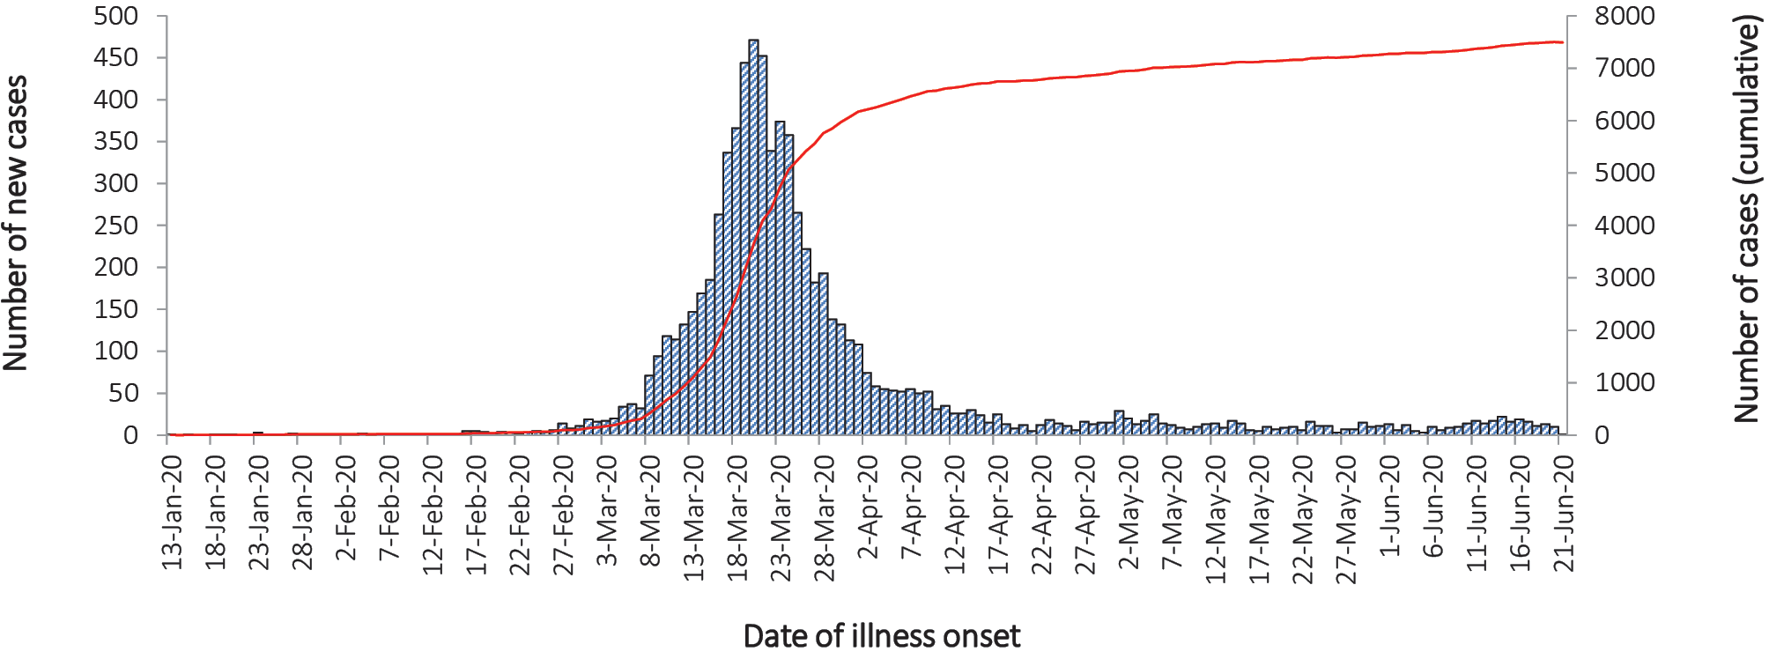a Source: NNDSS.

Australian cases: descriptive epidemiology

National trends
The incidence of COVID-19 continues to be low with very few cases reported by most jurisdictions. However, Victoria has reported an increased number of cases this period (Figure 2). Compared with the previous fortnight, the number of nationwide cases notified to the NNDSS increased from 147 (25 May to 7 June) to 215 (8 June to 21 June).
Since the epidemic began, the highest cumulative rates of COVID-19 per 100,000 population have been reported from NSW and Tasmania (Table 1). This appears to be driven by the cruise-ship-related outbreaks in NSW and by a large outbreak in hospitals in North West Tasmania.
In the latest fortnight period 8–21 June, new cases were reported from four jurisdictions: NSW, Victoria, Queensland and WA. Most cases in this period were reported to reside in major metropolitan areas (Figure 3). Cases continue to be notified in parts of Melbourne, with the Victorian Local Government Areas (LGAs) of Hume, Casey, Brimbank, Moreland, Cardinia and Darebin named as current outbreaks of concern. The Australian Health Protection Principal Committee (AHPPC) has recognised the importance of measures taken by the Victorian Government which seek to reduce further spread and the development of new outbreaks, and has strongly discouraged travel to and from these areas until control of community transmission has been confirmed.¹
Figure 2: Fortnightly COVID-19 new case notifications per 100,000 population,ª as at 21 June 2020, by jurisdiction
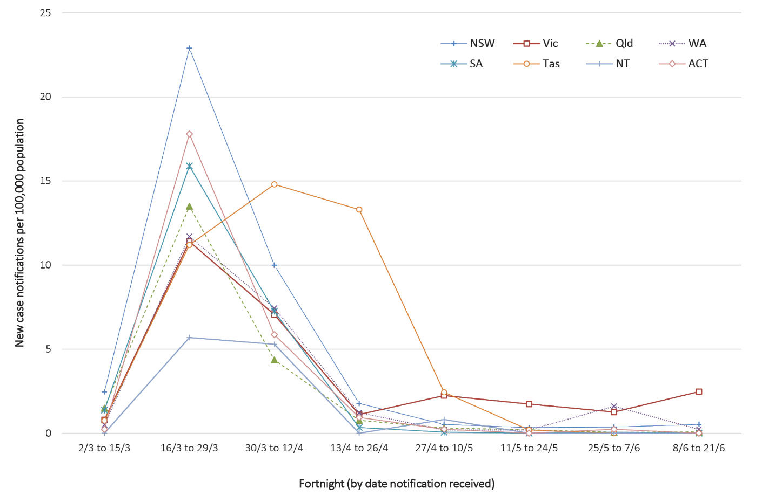
a Source: NNDSS.
Table 1: Fortnightly notifications and cumulative total cases of COVID-19,ª Australia, by jurisdiction
Jurisdiction | New cases^{b} |  | Total cases
 | 25 May – 7 June | 8 – 21 June | Number of cases | Rates per 100,000 population
NSW | 26 | 42 | 3,159 | 39.0
Vic | 74 | 163 | 1,857 | 28.2
Qld | 3 | 4 | 1,065 | 20.9
WA | 42 | 6 | 605 | 23.1
SA | 1 | 0 | 440 | 25.1
Tas | 0 | 0 | 228 | 42.7
NT | 0 | 0 | 29 | 11.8
ACT | 1 | 0 | 108 | 25.3
Australia | 147 | 215 | 7,491 | 29.5
a Source: NNDSS.
b New cases notified to NNDSS within each fortnightly period.
Figure 3: Number of COVID-19 locally-acquired case notifications, Australia, by location of usual residence and selected areas,ª 14-day heat maps for the four most recent fortnightly reporting periods^{b}
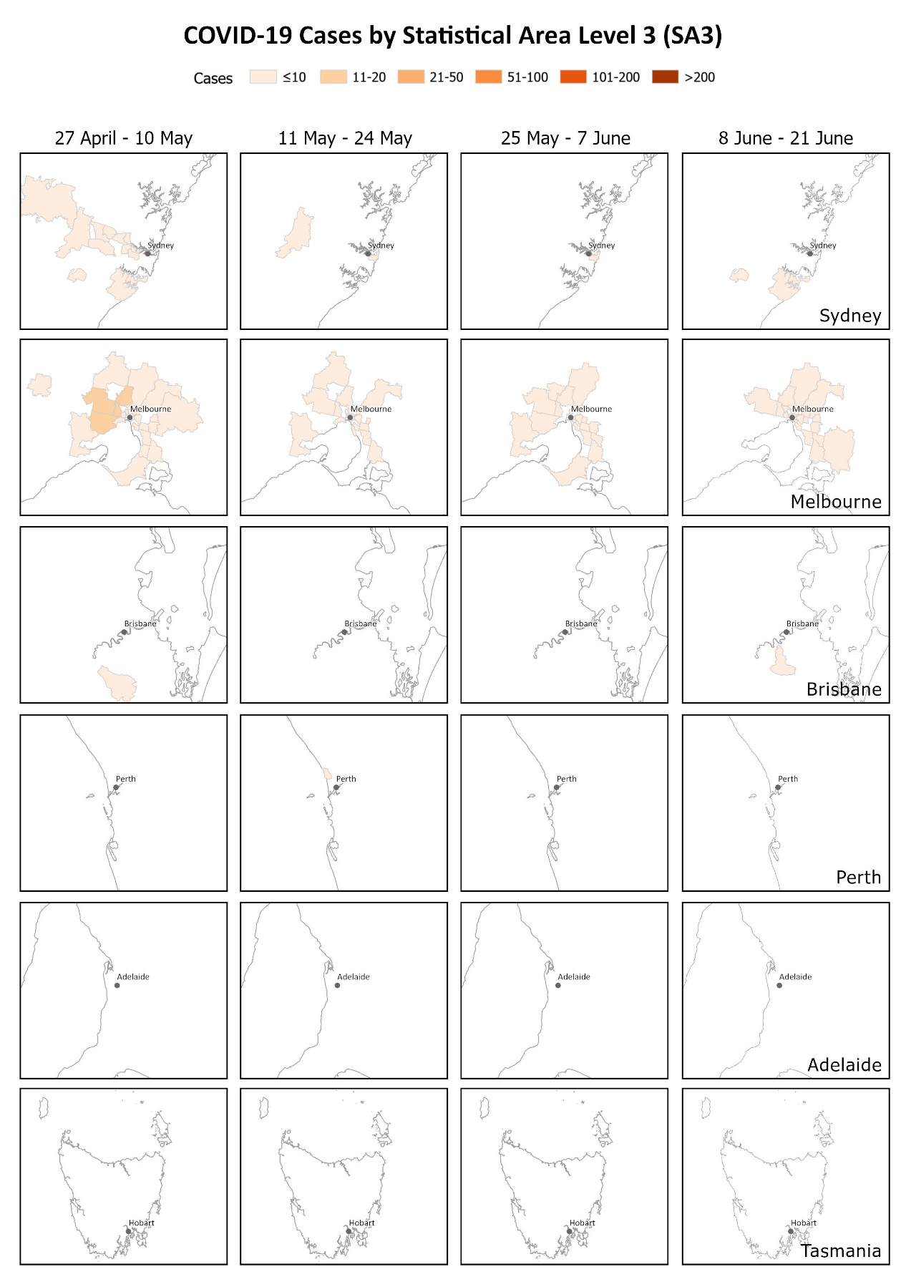
a This map requires caution especially when drawing inferences about areas of current transmission. The allocation of a case to an SA3 area represents the usual location of residence of a case, which does not necessarily mean that this is the place where they acquired their infection or were diagnosed. Overseas residents who do not have a usual place of residence in Australia are not shown.
b Source: NNDSS.

Testing
On 12 June, the COVID-19 CDNA National Guidelines for Public Health Units case definition for suspect cases was modified to include loss of smell or loss of taste in the clinical criteria alongside fever and acute respiratory infection.² This means individuals who met the epidemiological criteria and the updated clinical criteria would be eligible for testing. This change may not have made a substantial difference to testing rates, as such cases may have been tested prior to 12 June where deemed necessary based on clinical and public health judgement.
At the conclusion of the reporting period, a total of 2,041,324 tests had been conducted in Australia. High rates of testing continued across the country with the cumulative proportion of positive tests remaining low at less than 1% in each jurisdiction (Table 2). Between 8 and 21 June, 423,862 tests were conducted nationally, with an overall positivity rate of less than 0.1%. The low positivity rate is a good indication of widespread testing in the community and supports the low levels of disease being observed.
Table 2: Diagnostic tests performed as at 21 June 2020, Australia, by jurisdictionª
Jurisdiction | Tests performed  25 May – 7 June |  | Tests performed  8 – 21 June |  | Cumulative tests performed to 21 June
 | N | positivity (%) | N | positivity (%) | N | positivity (%) | per 100,000 population^{b}
NSW | 146,736 | 0.02 | 160,654 | 0.02 | 725,817 | 0.43 | 8,972
Vic | 119,710 | 0.07 | 120,845 | 0.12 | 660,801 | 0.28 | 10,018
Qld | 45,558 | 0.01 | 55,266 | 0.01 | 274,688 | 0.39 | 5,392
WA | 38,863 | 0.11 | 45,758 | 0.01 | 161,265 | 0.38 | 6,152
SA | 26,303 | 0.00 | 22,541 | 0.00 | 137,290 | 0.32 | 7,836
Tas | 8,533 | 0.00 | 11,301 | 0.00 | 44,025 | 0.52 | 8,237
NT | 2,237 | 0.00 | 2,079 | 0.00 | 11,533 | 0.25 | 4,690
ACT | 4,727 | 0.02 | 5,418 | 0.00 | 25,905 | 0.42 | 6,071
Australia | 392,667 | 0.04 | 423,862 | 0.05 | 2,041,324 | 0.37 | 8,048
a Data in this table are based on reports of notification by states and territories.
b Population data based on Australian Bureau of Statistics (ABS) Estimated Resident Population (ERP) as at 30 June 2019.

Source of acquisition
For the period 8–21 June, 45% of cases acquired their infection overseas, 51% were locally-acquired and 4% were under investigation at time of reporting. Of locally acquired cases, 73% were a contact of a case or in a known cluster, 23% were unable to be linked to another case and 4% were unable to be linked but had travelled interstate during their exposure period. Most overseas-acquired cases in the last four weeks have been from Southern and Central Asia, followed by North Africa, the Middle East, and Europe.
The source of acquisition has varied greatly by jurisdiction in the latest fortnight period. Most new cases in Victoria were locally acquired (69%, including those still under investigation), while most new cases in other jurisdictions (NSW, Queensland, WA) were overseas acquired, detected in returned travellers in hotel quarantine (87%). Although the increase in locally-acquired cases in Victoria has been driven by multiple clusters across a range of settings, 49% of locally-acquired cases were unable to be linked to another case or remain under investigation.
Of the total 7,491 cases, almost two-thirds (62%) are considered to have acquired their infection overseas (Figure 4). Cruise-ship-related travel and travel history to the European region have accounted for the majority of overseas-acquired infections overall.
Over a quarter of cases (28%) are considered to be locally-acquired and linked to a confirmed case. Many locally-acquired cases are associated with large interconnected clusters, with a small proportion (10%) unable to be linked to contact with a confirmed case. At the time of this report, approximately 1% of cases are under investigation, or are missing data on source of acquisition.
Figure 4: Number of new case notifications in Australia, by source of acquisitionª
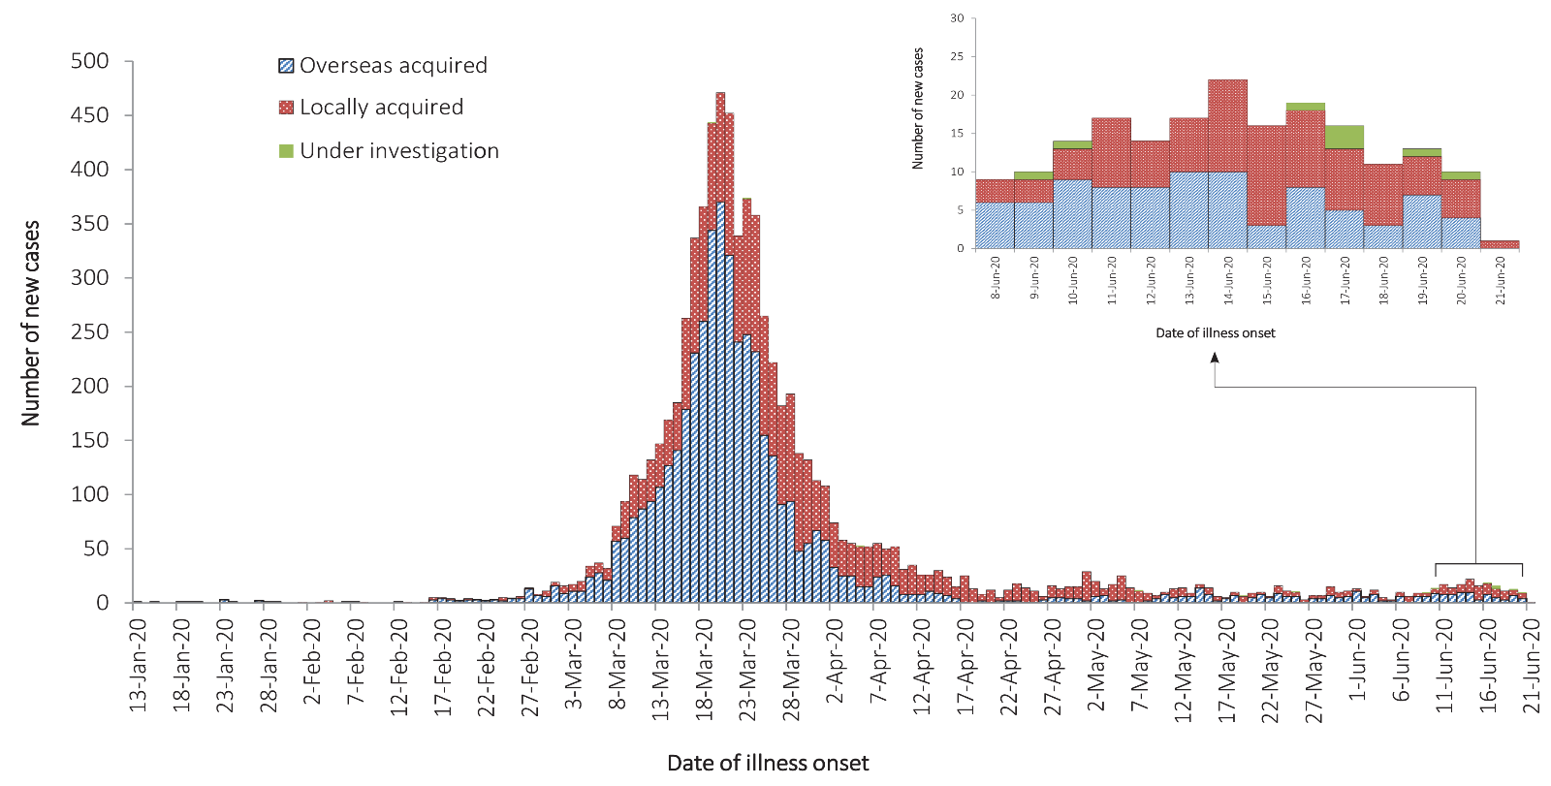
a Source: NNDSS.

Demographics of cases
The highest rate of disease has been among those in the 65–79 years age group, with 43.0 cases per 100,000 population (see Appendix B, Figure B.1). The higher rate of cases in this age group is largely driven by outbreaks on cruise ships and by overseas travel, with 75% of cases in this age group acquiring their infection outside Australia (44% at sea, 31% in other countries).
Notifications are similar by gender among those aged under 65 years; however, among those aged 65 years and over, there is a higher rate of cases for males than for females (Table B.1).
The lowest rate of disease is among children and young adults, with 4.4 cases per 100,000 population aged 5–17 and 6.3 cases per 100,000 aged under 5 years. This is consistent with international reports from China and the United States of America, which indicate a low rate of infection among children.^{3–5} A similar pattern has been observed with other coronaviruses such as SARS and MERS, with low rates of infection in children.⁶
The age distribution of cases has changed over the course of the epidemic (Figure 5). After peaking in the period 13–26 April (54 years; interquartile range [IQR] 33–71 years), the median age of cases has fallen in recent weeks to 30 years (IQR 22–41) in the period 8–21 June.
Figure 5: Age distribution of all cases by fortnight of notification with range, median and interquartile rangeª
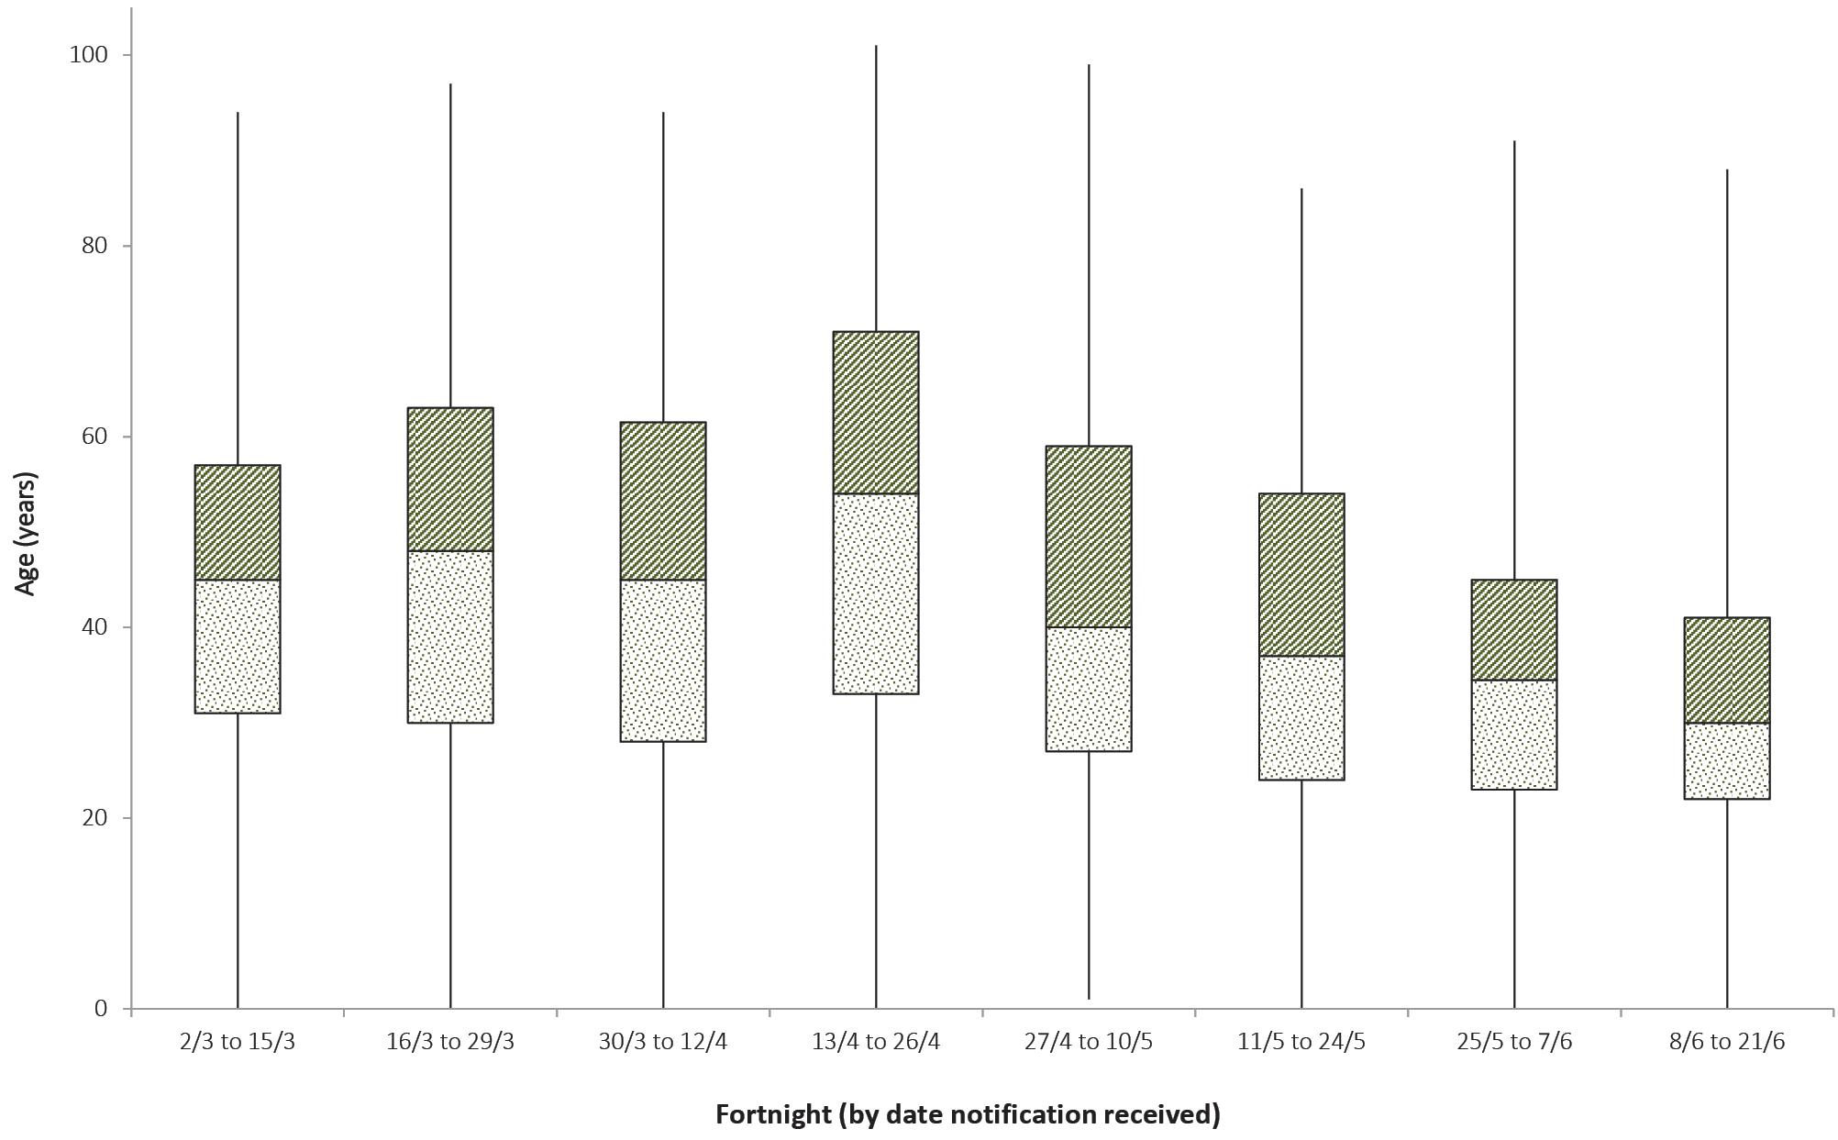
a Source: NNDSS.

Severity
Higher disease severity, as indicated by hospitalisation, admission to intensive care unit (ICU), and death, has been associated with increased age and comorbidities.⁷ The median age of cases who have been hospitalised (61 years; IQR 43–72), admitted to ICU (64 years; IQR 53–73) and died (80 years; IQR 74–86) is higher than for cases overall (46 years; IQR 29–62).
Of total cases notified in Australia, 1,136 (15%) were admitted to hospital. Of hospitalised cases, 19% (n = 213) were admitted to ICU and 5% (n = 59) were ventilated. Canada has reported a similar severity profile,⁸ with 15% of cases hospitalised, of which 20% were admitted to the ICU and 4% required mechanical ventilation. A higher proportion of cases has been hospitalised in EU/EEA countries (32% across 23 countries); however, proportions vary considerably across countries and are affected by each country’s testing strategies, with some European countries only testing hospitalised individuals for COVID-19.⁹ Within the European region, the overall severe hospitalisation rate (cases admitted to ICU and/or requiring respiratory support) from all hospitalised cases was approximately 11% across 15 countries; however large variation was seen between these countries.¹⁰ The European region also reported a decrease in both the hospitalisation and severe hospitalisation rate with increasing age beyond 80 years, which is not seen in the Australian data. Among Australian cases, the case fatality rate (CFR) for males aged 65–79 years is slightly elevated compared with females of the same age (Table 3). However, this is reversed in the population aged 80 years and over. The gender ratio (male to female) is fairly equal among all cases (1:1) and hospitalised cases (1.2:1); however, more males than females have been admitted to the ICU (1.9:1). Overall fatality rates by age group are similar to those observed in China and Italy as of 17 March 2020,^{11,12} but lower than those observed for the European region when aggregated.¹⁰ The CFR for males aged 80 years and over in the ICU is high at 60.0% (6 deaths from 10 cases in ICU). By comparison, the CFR for Canadian males meeting the same criteria was 46.3% (19 deaths from 41 cases in ICU), based on data up until 13 May 2020 (30,500 cases).¹³ Australian results are based on small numbers of cases and therefore may not be directly comparable to results from other countries.
Table 3: Number and case fatality rate (CFR) for all cases, hospitalised cases and cases admitted to ICU,ª by age group and gender, Australia
 | All cases |  |  | Hospitalisation |  |  | ICU
 | Male | Female | Persons | Male | Female | Persons | Male | Female | Persons
 | Number
Total | 3,808 | 3,669 | 7,491 | 609 | 527 | 1,136 | 139 | 74 | 213
 | Case fatality rate (%)
Under 50 | 0.1 | 0.0 | 0.0 | 0.6 | 0.0 | 0.3 | 0.0 | 0.0 | 0.0
50–64 | 0.5 | 0.3 | 0.4 | 2.6 | 1.9 | 2.2 | 10.5 | 3.9 | 7.8
65–79 | 3.6 | 2.5 | 3.1 | 10.6 | 9.3 | 10.1 | 19.7 | 14.3 | 18.0
80 and over | 21.4 | 23.3 | 22.3 | 31.3 | 35.2 | 33.1 | 60.0 | 33.3 | 50.0
All age groups | 1.5 | 1.3 | 1.4 | 7.9 | 6.6 | 7.3 | 15.8 | 9.5 | 13.6
a Source: NNDSS.

Comorbidities
Of all cases, 28% reported one or more comorbid conditions. The proportion of COVID-19 cases who reported one or more comorbid conditions increased with disease severity. Having one or more comorbid conditions was found to be significantly associated with increased odds of hospitalisation and death among COVID-19 cases aged 50 and over.
Obesity, chronic respiratory illness, diabetes and cardiac disease are the four most common comorbid conditions among hospitalised COVID-19 cases (Figure 6).
Figure 6: Proportion of confirmed adult COVID-19 cases (18 years+) hospitalised between 16 March and 22 June 2020 with selected comorbidities (n = 80)^{a,b}
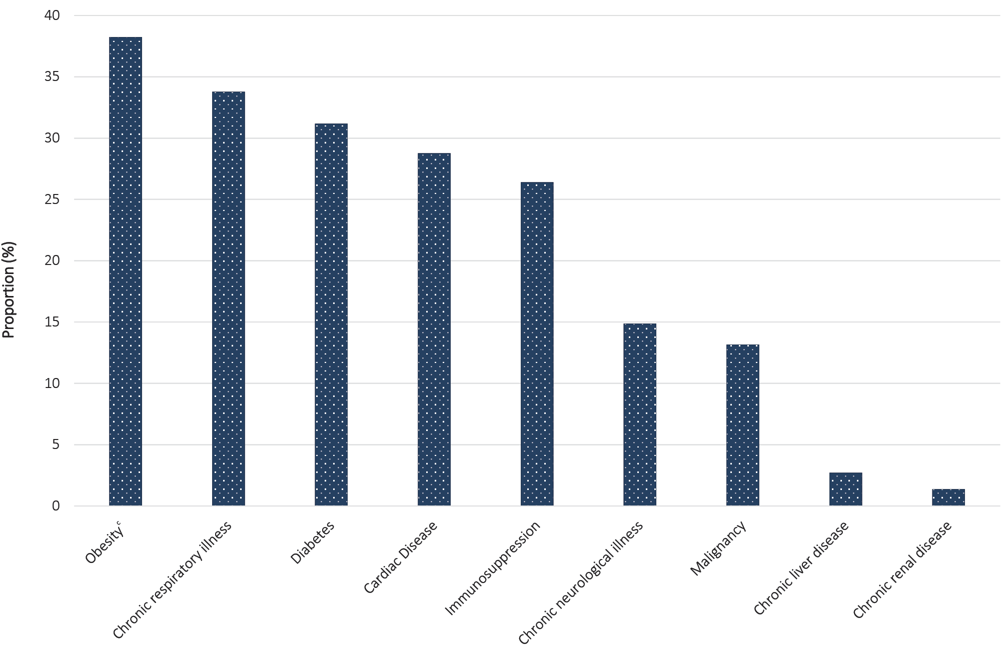
a Source: The Influenza Complications Alert Network (FluCAN). Includes only those cases for which the relevant fields are complete and comorbidity status is known.
b Differences in comorbidity prevalence among hospitalised cases from FluCAN and NNDSS data reflect differences between sentinel (FluCAN) and passive (NNDSS) surveillance systems. FluCAN comorbidity data are ascertained from patients’ medical records and are likely to better capture this information.
c Defined as body mass index (BMI) > 30 or body weight > 120 kg.
Table 4: COVID-19 comorbidities for all cases, hospitalised cases, cases admitted to ICU and deaths (number of cases, proportion of cases),ª Australia
Comorbidity | All cases  (n = 5,899) | Hospitalised cases  (n = 857) | ICU cases  (n = 177) | Deaths  (n = 85)
Common comorbidities
Asthma | 469 (8%) | 64 (7%) | 12 (7%) | 5 (6%)
Cardiac disease^{b} | 474 (8%) | 153 (18%) | 34 (19%) | 28 (33%)
Chronic respiratory condition^{c} | 198 (3%) | 87 (10%) | 17 (10%) | 18 (21%)
Diabetes | 409 (7%) | 144 (17%) | 42 (24%) | 21 (25%)
Obesity | 212 (4%) | 50 (6%) | 19 (11%) | 7 (8%)
Number of specified comorbidities^{d}
One or more | 1,654 (28%) | 440 (51%) | 104 (59%) | 64 (75%)
Two or more | 365 (6%) | 130 (15%) | 37 (21%) | 35 (41%)
Three or more | 90 (2%) | 44 (5%) | 15 (8%) | 12 (14%)
No comorbidities | 3,194 (54%) | 240 (28%) | 44 (25%) | 7 (8%)
a Source: NNDSS. Excludes those with missing data on comorbidities or where comorbidity is unknown.
b Excluding hypertension.
c Excluding asthma.
d Includes asthma, chronic respiratory conditions (excluding asthma), cardiac disease (excluding hypertension), immunosuppressive condition/therapy, diabetes, obesity, liver disease, renal disease and neurological disorder.
Comorbidity information on cases hospitalised in Australia is available through the Influenza Complications Alert Network (FluCAN) and the NNDSS.⁷ FluCAN found a greater prevalence of comorbid conditions in a sample of hospitalised COVID-19 patients aged 18 years and over (n = 132) compared to the NNDSS. This difference is most likely due to more comprehensive data being available from patient medical records assessed as part of FluCAN.⁷
Amongst FluCAN cases with at least one reported comorbidity, the most common comorbidities were obesity (37%), diabetes (34%), cardiac disease (32%) and chronic respiratory illness (30%). A history of smoking (current or past smoker) was identified in 36% of FluCAN cases.
Australian data on comorbidities are similar to results reported internationally. This includes findings from the United States CDC which published comorbidity data for a small proportion of cases where a complete chart review was available.¹⁴ In the CDC report, the most common comorbidities found for hospitalised adults with at least one reported comorbidity were hypertension (58%), obesity (50%), metabolic disease (42%) and cardiovascular disease (44%). Amongst all cases included in the CDC report, only 8.3% reported no known comorbidity.
Within the European region, analysis of comorbidities of hospitalised patients has shown 39% had no known or reported comorbidity. The most common comorbidities for hospitalised cases with at least one reported comorbidity were cardiac disorder (excluding hypertension) (13%), diabetes (12%) and chronic lung disease (9%). These findings are similar to the level of comorbidity seen for hospitalised cases in Australia.¹⁰

Symptom profile
The symptoms reported by COVID-19 cases in Australia are consistent with a mild respiratory infection in the majority of cases. The most common symptoms reported (see Appendix B, Figure B.2) were cough (68%), fever (47%), headache (43%) and sore throat (40%). Other symptoms reported include fatigue (33%), chills or rigors (14%) and loss of taste or smell (12%), noting that these are currently not standard fields in NNDSS, and are likely to under-represent those presenting with these symptoms. A small number of cases reported more severe symptoms, with pneumonia and/or acute respiratory disease (ARD) reported in 3% of cases with symptoms.
Adults and children reported similar symptoms, with cough and fever the most commonly reported symptoms across all age groups. Shortness of breath was more commonly reported among older cases, particularly those aged 80 and over (32%).
The symptom profile of Australian cases is broadly similar to the symptoms reported by COVID-19 cases internationally. Among EU/EEA countries and the UK, fever/chills and dry or productive cough were the most commonly reported symptoms.¹⁵ Cough, headaches and fever and chills were the most commonly reported symptoms among cases in Canada.¹⁶ Differences in reported symptoms will be influenced by differences in surveillance strategies and symptom reporting across countries.

Populations of Interest

Aboriginal and Torres Strait Islander persons
Sixty cases (0.8%) have been reported in Aboriginal and Torres Strait Islander persons since the start of the epidemic in Australia. Half of these cases acquired their infection overseas. Of locally-acquired cases, the majority were reported in areas classified ‘Major cities of Australia’ based on the case’s usual place of residence (Table 5). No cases among Aboriginal and Torres Strait Islander persons have been notified from remote or very remote areas of Australia.
Table 5: COVID-19 cases,ª notified among Aboriginal and Torres Strait Islander persons, and among all Australian cases, by remoteness classification and source of acquisition
 | Locally-acquired^{b} |  |  |  | Overseas-acquired | Total
 | Major cities of Australia | Inner regional Australia | Outer regional Australia | Remote/very remote Australia
Aboriginal and Torres Strait Islander cases | 20 | 4 | 6 | 0 | 30 | 60
All Australian cases^{c} | 2,409 | 181 | 186 | 19 | 4,620 | 7,491
a Source: NNDSS.
b ‘Locally-acquired’ comprises all cases without an overseas place of acquisition.
c Total for all Australian cases includes 49 cases with missing remoteness information and 27 cases classified overseas residents.
Across all Australian cases, completeness of the Indigenous status field was approximately 95%.
The median age of COVID-19 cases among Aboriginal and Torres Strait Islander persons is 33 years (IQR: 22.5–55 years), which is lower than the median age of non-Indigenous COVID-19 cases (46; IQR: 29–62 years).
Of the cases notified amongst Aboriginal and Torres Strait Islander persons, 12% were admitted to hospital, which is similar to the proportion of all cases hospitalised (15%). Of cases in Aboriginal and Torres Strait Islander persons, no cases were reported as being admitted to ICU or requiring ventilation and no fatalities have been reported.

School-aged children and older populations
Similar to the wider population, the peak period of illness onset for COVID-19 cases among school-aged children (5–17 years old) and older populations in Australia was between 16 and 29 March 2020. The epidemic curves for these two groups (Figures 7 and 8) show new cases declining in the following fortnight after the introduction of overseas travel restrictions, implemented on 20 March 2020. This decline in new cases indicates that the measures were effective in preventing the spread of COVID-19 in Australia. A small increase in cases has been observed in the last 14 days, reflecting an overall increase in cases.
There have been 178 case notifications in total among school-aged children, accounting for 2.0% of all cases. Fourteen new cases within this age group were reported in this reporting period. Of the 178 cases, 70% reported no recent overseas travel history.
Figure 7: Number of COVID-19 case notifications in Australia by date of illness onset for school-aged children (aged 5 to 17), from 13 January to 21 June, by source of acquisitionª
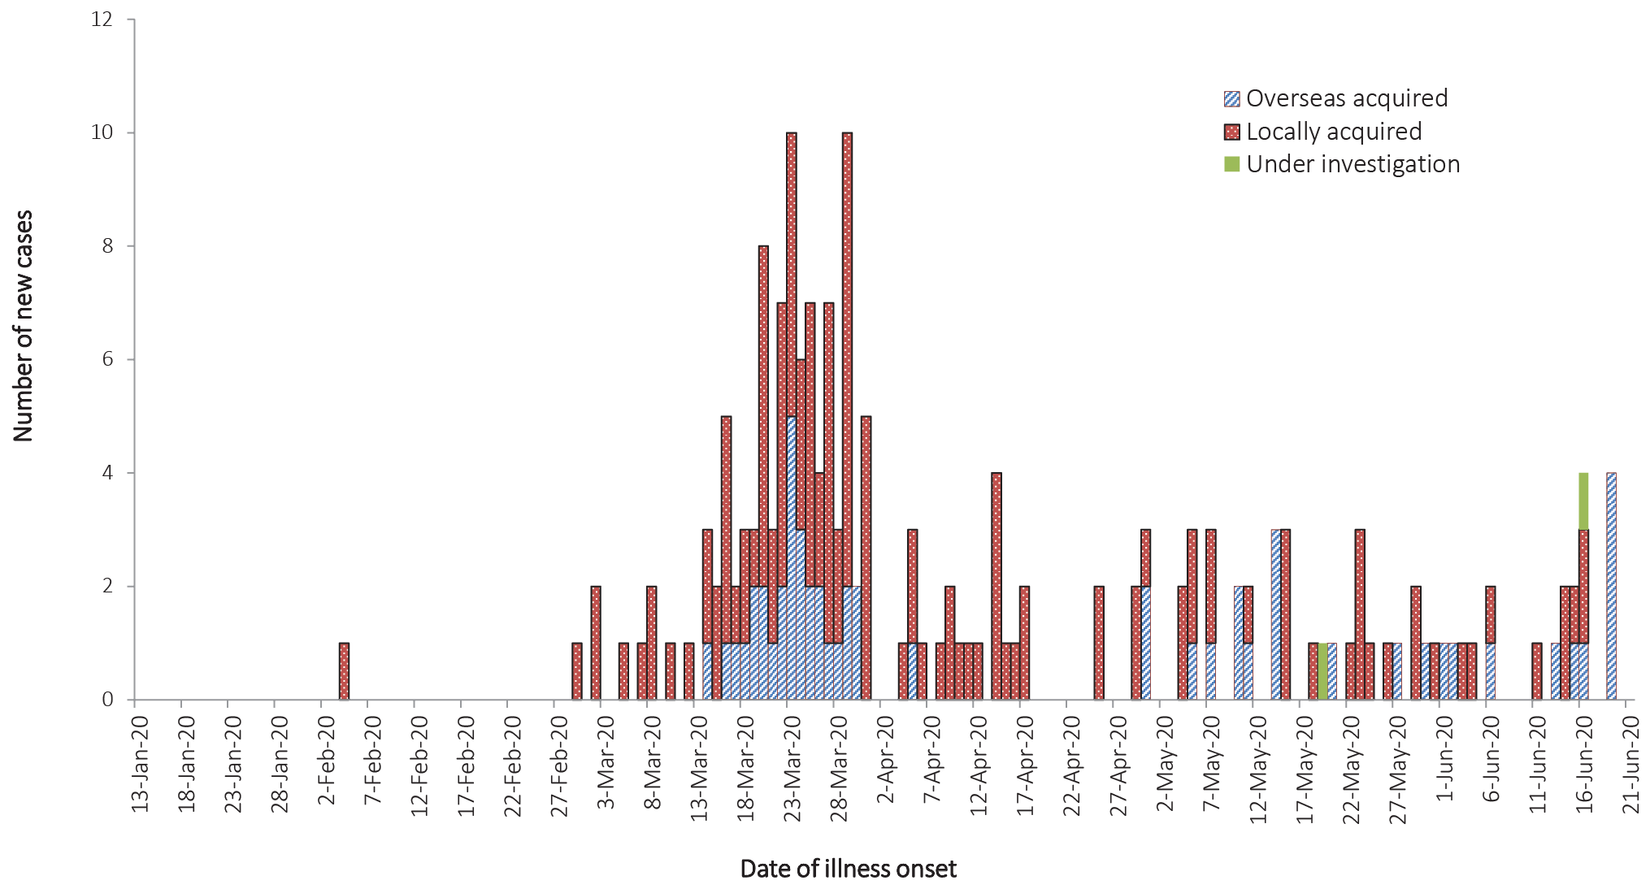
a Source: NNDSS.

Figure 8: Number of COVID-19 case notifications in Australia by date of illness onset for persons aged 65 and over, from 13 January to 21 June, by source of acquisitionª
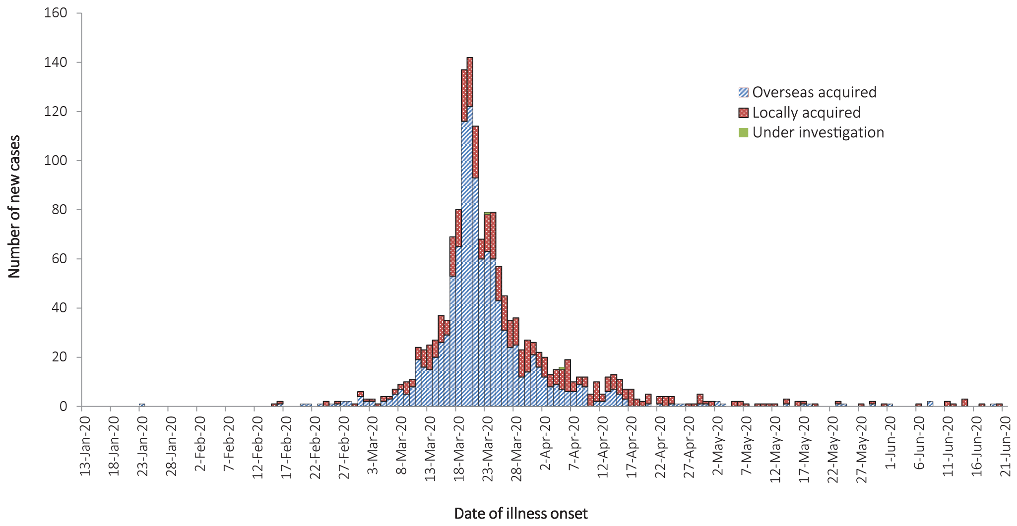
a Source: NNDSS.
Older people aged 65 years and over are at an increased risk for severe disease from COVID-19. In Australia, there have been 1,548 cases notified among older people. The majority of these cases (71%) reported recent overseas travel history. Of the overseas-acquired infection cases in older populations, cruise-ship-acquired infection make up 62% of the cases, with approximately 1 in 2 of the cruise-ship-acquired cases among those aged 70–79 years old.

Cluster and outbreak investigations
To date the largest outbreaks of COVID-19 in Australia have been associated with cruise ships, with some other large domestic clusters associated with aged care and healthcare facilities, workplaces and private functions.
Cluster
- The term ‘cluster’ in relation to COVID-19 refers to two or more cases (who do not reside in the same household) that are epidemiologically related in time, place or person where a common source (such as an event or within a community) of infection is suspected but not yet established.
Outbreak
- The term ‘outbreak’ in relation to COVID-19 refers to two or more cases (who do not reside in the same household) among a specific group of people and/or over a specific period of time where illness is associated with a common source (such as an event or within a community). Some states and territories may report a single case associated with a residential aged care facility as an outbreak.
In the week ending 21 June 2020, state and territories reported 10 open clusters and outbreaks of COVID-19, an increase of three outbreaks compared to the preceding week ending 14 June 2020. Open clusters and outbreaks are defined as those where a new case was identified in the last 14 days as at the end of the reporting period. Of the 10 open clusters and outbreaks, three were in residential aged care facilities, one was associated with a GP practice and six were associated with various other settings including hotel quarantine facilities, extended families, and a retail store. The number of open clusters and outbreaks may be revised as a result of ongoing investigations in states and territories.
Residents of aged care facilities are at increased risk of COVID-19 infection due to the environment of communal living facilities and are more vulnerable to serious complications if they do become infected. As of 21 June 2020, there have been 138 cases of COVID-19 associated with 37 residential aged care facilities, with 106 recoveries and 29 deaths. 71 of these cases occurred in aged care residents, with the remaining 67 cases occurring in care staff. In addition, there have been 42 cases associated with 30 in-home Commonwealth funded aged care services providing support to older Australians who live at home, with 39 recoveries and 3 deaths. Thirty-one of these cases occurred in care recipients, with the remaining 11 cases occurring in care staff. The Commonwealth is actively supporting services with reported incidents and outbreaks of COVID-19 providing access to personal protective equipment and additional staffing resources where required. Advice and guidelines have been provided to aged care services,¹⁷ including the release of an outbreak management guide.¹⁸

Public health response measures
Since COVID-19 first emerged internationally, Australia has implemented public health measures in response to the disease’s epidemiology (Figure 9). Key aspects of Australia’s evolving public health response are summarised in previous reports.
On Friday 8 May, the Australian Government announced a three-step framework for easing COVID-19 restrictions, with states and territories easing restrictions at their own pace depending on the current public health situation and local epidemiology.
During this reporting period, Victoria has reported an increase in COVID-19 cases and in consequence has delayed further easing of restrictions, with reversion of some previously eased restrictions from step 2 to step 1 levels. Conversely, Western Australia has updated its roadmap for easing restrictions to include steps beyond step 3.¹⁹ Under this roadmap, Western Australia plans to further ease restrictions beyond the three-step framework from 27 June 2020. A summary of the restrictions that have been eased is listed at Table 6.

Table 6: State and territory actions for easing COVID-19 restrictions, from 8 June to 21 June 2020
Jurisdiction | Summary of restrictions which have been eased
New South Wales | From 13 June the following restrictions were eased:^{20,21}  - Gatherings of up to 20 people permitted in households and outdoors  - Food courts permitted to reopen to a maximum of 50 patrons  - Public schools permitted to commence excursions, camps and assemblies  - Commercial vessels permitted up to 50 customers
Victoria | Victoria has announced that from 22 June:²²  - Number permitted to gather in a household reduced to 5 people  - Number permitted to gather outdoors reduced to 10 people  - Restrictions on restaurants, cafes and community services will remain at up to 20 patrons  - Further easing of restrictions will be considered from 12 July subject to the effective management of the spread of COVID-19
Queensland | No further easing of restrictions has occurred during this reporting period.²³
Western Australia | No further easing of restrictions has occurred during this reporting period.¹⁹
South Australia | From 19 June the following restrictions were eased:^{24,25}  - A maximum of 300 people may gather at a venue with no more than 75 per separated room  - Dance and fitness classes permitted with up to 20 people, with up to 1 person per 7 square metres  - Travellers from NT, QLD, TAS and WA no longer required to quarantine for 14 days
Tasmania | From 17 June the following restrictions were eased:²⁶  - Gatherings of up to 20 permitted in households  - Public gatherings of up to 80 permitted indoors and outdoors  - Businesses permitted up to 80 patrons with some exceptions  - Sporting and gym facilities permitted up to 20 per room  - Restrictions on weddings, funerals and religious ceremonies further eased
Australian Capital Territory | From 19 June the following restrictions were eased:²⁷  - No restrictions on household visitation  - Public gatherings of up to 100 permitted indoors and outdoors  - Most businesses permitted up to 100 patrons provided 4 square metre rule maintained  - Full contact sport, dance and training permitted  - Organised tour groups of up to 20 permitted
Northern Territory | No further easing of restrictions has occurred during this reporting period.²⁸

Figure 9: COVID-19 notifications in Australia by date of illness onset, to 21 June 2020ª with timing of key public health measures
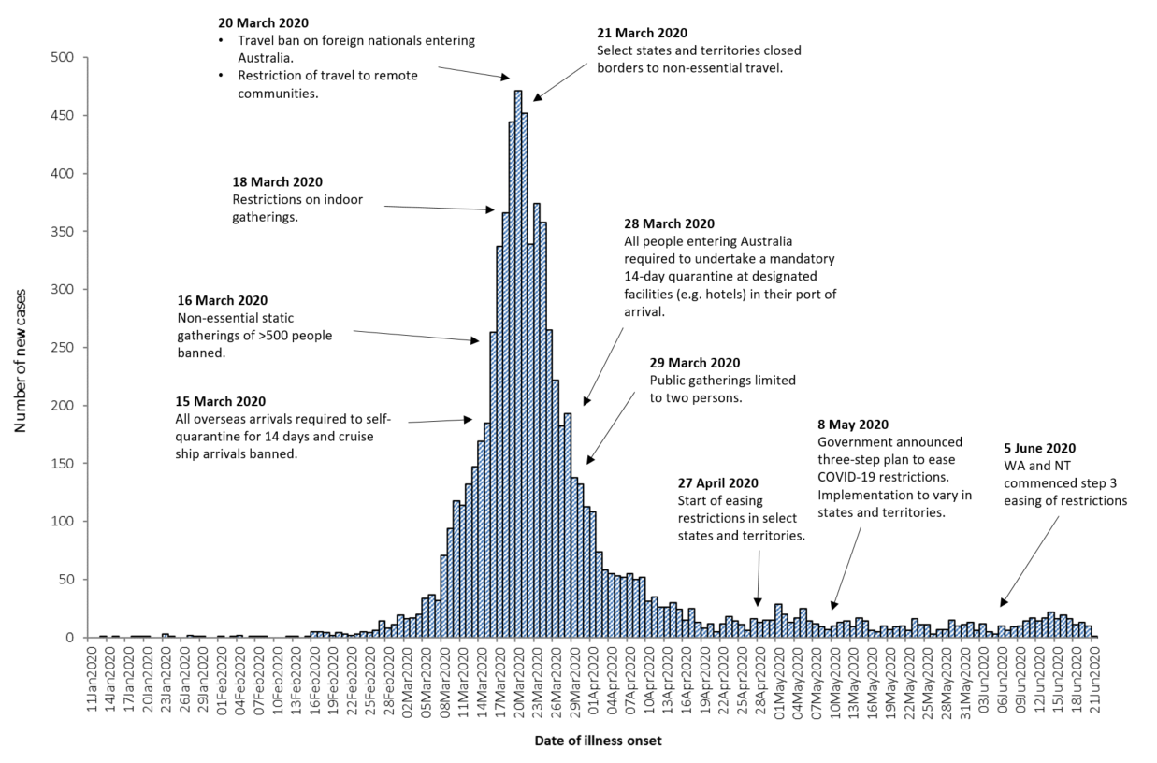
a Source: NNDSS. Due to reporting delays, interpret the latest days’ new cases with caution.

International situation
As at 21 June 2020, more than 216 countries, regions and areas had reported 8,708,008 COVID-19 cases and 461,715 deaths to WHO.²⁹ All data is WHO unless otherwise specified. By region, approximately 49% of all global cases and 47% of all global deaths are from the Americas, while 29% of cases and 42% of deaths are from the European Region. The global case fatality rate (CFR) is approximately 5.3%.
- By country, the largest numbers of cases are from: the United States of America (2,208,000); Brazil (1,033,000); and the Russian Federation (585,000).
- By country, the largest numbers of deaths are from: the United States of America (118,900); Brazil (49,000); and the United Kingdom (42,600).
Europe and the United States of America continue to be the epicentres of the pandemic. However, as shown in Figure 6, some South American countries (Brazil and Peru) and India are emerging as hotspots. There are also several countries not previously highlighted that are seeing a strong growth in new cases, with each accounting for over 3% of the total cases reported globally in the previous fortnight. These countries include Chile, Pakistan, Mexico and Saudi Arabia, which are not shown in Figure 10.

Western Pacific Region
On 21 June 2020 the cumulative number of cases in the region stands at approximately 205,000.²⁹ The number of cases reported in the region over the previous fortnight was 15,000, which represents a 7.7% rise in the cumulative case count. Globally, the region accounts for 2.4% of cumulative cases and 1.6% of cumulative deaths, though it only accounts of 0.8% of the global cases observed in the last fortnight. This region is also the least affected by COVID-19, with a prevalence of 10.8 cases per 100,000 people and a mortality rate of 0.3 deaths per 100,000 population,³⁰ compared to the global average of 113.4 cases per 100,000 people and a mortality rate of 6.0 deaths per 100,000 population.³⁰
The majority of the cases in the region are observed in China, Singapore and the Philippines, though in the past fortnight the greatest numbers of new cases have been observed in the Philippines (51%), Singapore (24%) and Japan (5%). Their epidemic trajectories are shown in Figure 6. There were four countries that did not report any new cases in the previous fortnight (Brunei Darussalam, Fiji, French Polynesia and Lao People's Democratic Republic).³⁰
In this fortnight, Singapore saw low but fluctuating numbers of community cases, reporting 18 in a single day. The number of new infections in dormitory residents in Singapore is slowing with 12.3% of this population infected, an increase from 11.0% at the start of the fortnight.³¹ A resurgence has been reported in the Republic of Korea; however, this is localised to Seoul and is attributed to door-to-door sales. In the previous fortnight 58% of new cases in the country have been attributed to clusters and 22% to international travel³². China has reported an outbreak in a wholesale market in Beijing. The SARS-CoV-2 virus was detected on a cutting board and caused China to ban meat and seafood importation while an investigation into foodborne transmission was conducted. The ban was modified to specific food processing plants which had reported outbreaks of COVID-19, particularly in the United States of America and Germany. Beijing has reported over 200 cases since 11 June 2020 and it is noted that the laboratory capacity of the city has increased to more than 230,000 nucleic acid tests per day,³³ up from 30,000 tests per day in March.
Figure 10: Number of COVID-19 cases (logarithmic scale) by selected country and days since passing 100 cases, up to 21 June 2020
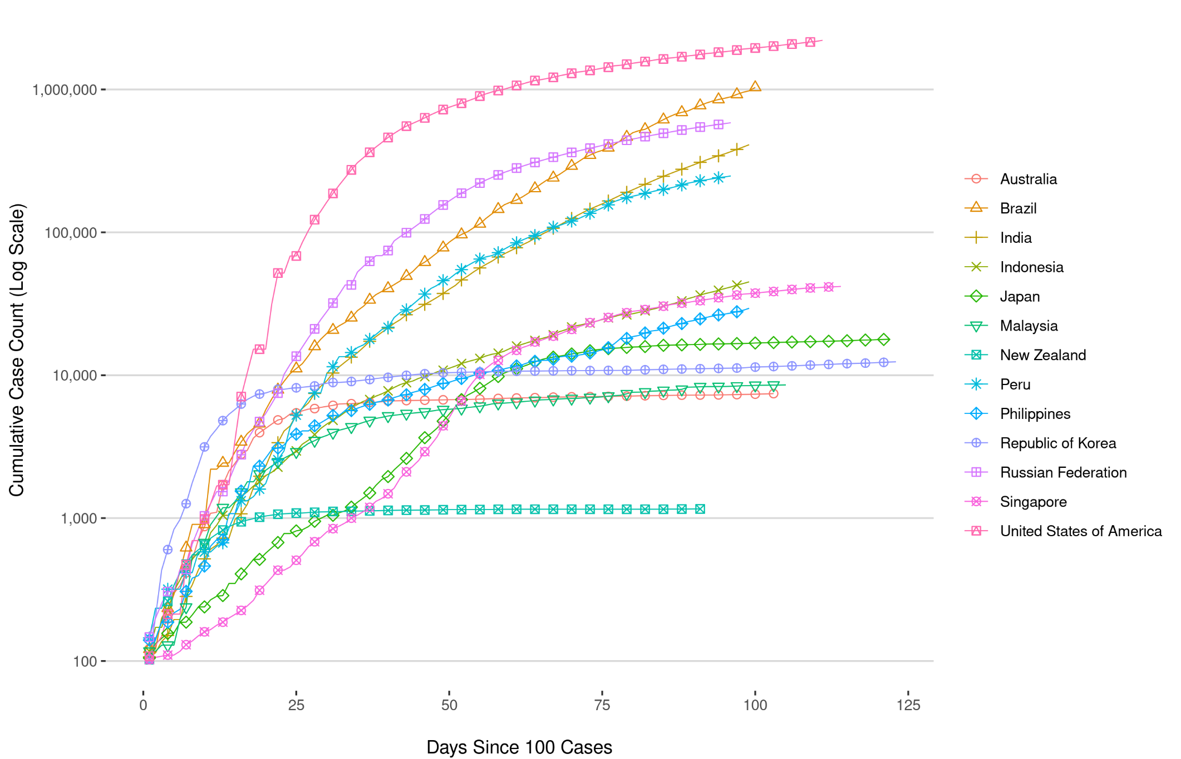

Background
The current estimates on epidemiological parameters including severity, transmissibility and incubation period are uncertain. Estimates are likely to change as more information becomes available.

Transmission
Human-to-human transmission of SARS-CoV-2 is via droplets and fomites from an infected person to a close contact.³⁴ Several studies have detected that viral RNA levels peak in the first week of illness, suggesting transmission is most likely to occur early in the illness with infectivity gradually decreasing over time.³⁵ In a Taiwanese study examining over 2,500 close contacts of 100 patients with COVID-19, all 22 secondary cases had their first exposure to the index case within six days of symptom onset. No infections were documented in the 850 contacts whose exposure was after six days.³⁶
Viral RNA has been identified in respiratory track specimens 1–2 days prior to symptom onset, and has been observed after symptom cessation.³⁵ In 50% of the patients, seroconversion occurred after seven days with a range of up to 14 days; this seroconversion was not followed by a rapid decline in viral load.³⁵ However, the detection of viral RNA does not always correlate with transmission risk. A study of nine patients with mild COVID-19 infection found infectious virus was not able to be isolated from naso/oropharyngeal and sputum samples after the first 8 days of illness, despite continued high viral RNA levels.³⁵ Recent analysis from the Korea Centres for Disease Control and Prevention of cases who tested positive after previously being cleared from isolation found live virus was unable to be cultured from any cases selected for testing (n = 108).³⁷
Several studies suggests that children do not play a key role in transmission and are unlikely to be the primary source of infections.³⁸ Studies out of the EU have suggested that child to adult transmission is uncommon.^{39,40}
Current evidence does not support airborne or faecal-oral spread as major factors in transmission.³⁴

Incubation period
Estimates of median incubation period, based on seven published studies, are 5 to 6 days (ranging from 1 to 14 days). Patients with long incubation periods do occasionally occur; however, they are likely to be ‘outliers’ who should be studied further but who are unlikely to represent a change in epidemiology of the virus.^{41,42}

Molecular epidemiology
Since December 2019, the virus has diversified into multiple lineages as it has spread globally, with some degree of geographical clustering. The whole genome sequences currently available from Australian cases are dispersed across these lineages, reflecting multiple concurrent introductions into Australia.^{43–45} Multiple genomic clusters, closely related sequences reflecting local transmission chains, have also been identified in Australia.^{43,44} Genomic epidemiology has successfully been used to link many cases that were epidemiologically classified as ‘locally-acquired – contact not identified’ to known genomic clusters, highlighting the utility of virus sequencing to informing the public health response.^{43,44}

Clinical features
COVID-19 presents as mild illness in the majority of cases, with cough and fever being the most commonly reported symptoms. Severe or fatal outcomes are more likely to occur in the elderly or those with comorbid conditions.^{34,46}
Some COVID-19 patients show neurological signs such as headache, nausea and vomiting. There is evidence that SARS-CoV-2 viruses are not always confined to the respiratory tract and may invade the central nervous system inducing neurological symptoms. As such, it is possible that invasion of the central nervous system is partially responsible for the acute respiratory failure of COVID-19 patients.⁴⁷
There is some evidence to suggest that impairment or loss of the sense of smell (hyposmia/anosmia) or taste (hypoguesia/aguesia) is associated with COVID-19.^{48,49} This is supported by research finding a biological mechanism for the SARS-CoV-2 virus to cause olfactory dysfunction.^{50,51}
Several studies have identified cardiovascular implications resulting from COVID-19.^{52–54} Vascular inflammation has been observed in a number of cases and may be a potential mechanism for myocardial injury which can result in cardiac dysfunction and arrhythmias.
COVID-19 disease in children is more likely to be mild and self-limiting, compared to adults. Internationally, children make up a small proportion of confirmed COVID-19 cases, with those shown to be infected either presenting with milder symptoms than adults or remaining asymptomatic, a similar pattern has been observed with SARS and MERS. However, the greater likelihood of mild clinical presentation in children may result in lower testing and case detection in this cohort. Studies have also shown that hospital admission is inversely related to age. From European reporting, death associated with COVID-19 has been rare among those aged less than 15 years, with 4 deaths reported from 44,695 cases, as at 13 May 2020.⁴⁰
There have been reports of a rare clinical presentation of paediatric inflammatory multisystem syndrome resembling Kawasaki disease temporally associated with SARS-CoV-2 infection in children. However, evidence of the association between COVID-19 and the development of a Kawasaki like disease is currently inconclusive and further investigation is needed due to variability in clinical presentations in reported paediatric cases.^{55,56}

Treatment
Current clinical management of COVID-19 cases focuses on early recognition, isolation, appropriate infection control measures and provision of supportive care.⁵⁷ Whilst there is no specific antiviral treatment currently recommended for patients with suspected or confirmed SARS-CoV-2 infection, multiple clinical trials are underway to evaluate a number of therapeutic agents, including remdesivir, lopinavir/ritonavir, and chloroquine or hydroxychloroquine.^{58,59}
An open-label randomised controlled trial did not find a significant impact of hydroxychloroquine treatment on disease progression for hospitalised patients with mild to moderate COVID-19, with those receiving treatment also reporting a higher number of adverse events.⁶⁰ Similarly, an open-label randomised controlled trial of lopinavir/ritonavir among hospitalised patients found no benefit for time to clinical improvement.⁶¹
Results for remdesivir treatment have been mixed, with one randomised double-blind placebo-controlled trial finding patients recovered 31% faster and there was a lower mortality rate (8.0% compared with 11.6% among placebo patients),⁶² while another found no effect.⁶³ Taiwan Food and Drug Administration (TFDA) has recently approved remdesivir for the treatment of patients with severe SARS-CoV-2 infection based on preliminary evidence on its safety and effectiveness. Further trials are required to assess the effectiveness of these treatments on COVID-19. Multiple COVID-19 vaccines have commenced clinical trials.
Research from the UK has found dexamethasone could significantly reduce death in critically ill patients.⁶⁴ Yet to be published, the preliminary findings announcing by Oxford University reported a 30% reduction in deaths for patients with severe respiratory symptoms. Reduced mortality was observed in ventilated cases and cases requiring oxygen support. No benefit was observed for mild to moderate cases.

Data considerations
Data were extracted from the NNDSS on 22 June 2020 for notifications received up to 21 June 2020. Due to the dynamic nature of the NNDSS, numbers presented in this report are subject to revision and may vary from numbers previously reported and from case notifications released by states and territories.

Definitions
‘Date of illness onset’ is derived from data collected by the NNDSS and represents the diagnosis date, or reported true onset of disease date. If unknown, the earliest of specimen collection date, notification date or notification receive date is used.
‘Notification received date’ is reported in the NNDSS and represents the date the case is first notified on the NNDSS. As notification can only occur after testing is completed and information processed, counts for a defined period will vary according to the date type used.

Acknowledgements
This report represents surveillance data reported through CDNA as part of the nationally-coordinated response to COVID-19. We thank public health staff from incident emergency operations centres in state and territory health departments, and the Australian Government Department of Health, along with state and territory public health laboratories.

Author details

Corresponding author
COVID-19 National Incident Room Surveillance Team, Australian Government Department of Health, GPO Box 9484, MDP 14, Canberra, ACT 2601. Email: epi.coronavirus@health.gov.au

References
- Australian Government Department of Health. Australian Health Protection Principal Committee (AHPPC) statement on recent outbreaks of COVID-19 in Victoria. [Internet.] Canberra: Australian Government Department of Health; 21 June 2020. [Accessed on 24 June 2020.] Available from: https://www.health.gov.au/news/australian-health-protection-principal-committee-ahppc-statement-on-recent-outbreaks-of-covid-19-in-victoria.
- Australian Government Department of Health. Series of National Guidelines (SoNGs): Coronavirus Disease 2019 (COVID-19). CDNA National guidelines for public health units. [Internet.] Canberra: Australian Government Department of Health; 12 June 2020. [Accessed on 24 June 2020.] Available from: https://www1.health.gov.au/internet/main/publishing.nsf/Content/cdna-song-novel-coronavirus.htm.
- Wu Z, McGoogan JM. Characteristics of and important lessons from the coronavirus disease 2019 (COVID-19) outbreak in China: summary of a report of 72314 cases from the Chinese Center for Disease Control and Prevention. JAMA. 2020. doi: https://doi.org/10.1001/jama.2020.2648.
- Su L, Ma X, Yu H, Zhang Z, Bian P, Han Y et al. The different clinical characteristics of corona virus disease cases between children and their families in China – the character of children with COVID-19. Emerg Microbes Infect. 2020;9(1):707–13. doi: https://doi.org/10.1080/22221751.2020.1744483.
- CDC COVID-19 Response Team. Coronavirus disease 2019 in children — United States, February 12–April 2, 2020. MMWR Morb Mortal Wkly Rep. 2020;69(14):422–6. doi: http://dx.doi.org/10.15585/mmwr.mm6914e4.
- Zimmermann P, Curtis N. Coronavirus infections in children including COVID-19: an overview of the epidemiology, clinical features, diagnosis, treatment and prevention options in children. Pediatr Infect Dis J. 2020;39(5):355–68. doi: https://doi.org/10.1097/INF.0000000000002660.
- COVID-19 National Incident Room Surveillance Team. COVID-19, Australia: Epidemiology Report 16: Reporting week ending 23:59 AEST 17 May 2020. Commun Dis Intell (2018). 2020;44. doi: https://doi.org/10.33321/cdi.2020.44.45.
- Public Health Agency of Canada (PHAC). Coronavirus disease 2019 (COVID-19). Epidemiology update. Updated: June 22, 2020, 7 pm EDT. [Internet.] Ottawa: Government of Canada, PHAC; 2020. [Accessed on 23 June 2020.] Available from: https://health-infobase.canada.ca/covid-19/epidemiological-summary-covid-19-cases.html.
- European Centre for Disease Prevention and Control (ECDC). COVID-19 surveillance report: Week 24, 2020. [Internet.] Solna: ECDC; 18 June 2020. [Accessed on 22 June 2020.] Available from: https://covid19-surveillance-report.ecdc.europa.eu/.
- ECDC. COVID-19 surveillance report: Week 21, 2020. [Internet.] Solna: ECDC; 2 June 2020. [Accessed on 3 June 2020.] Available from: https://covid19-surveillance-report.ecdc.europa.eu/.
- Zheng Z, Peng F, Xu B, Zhao J, Liu H, Peng J et al. Risk factors of critical & mortal COVID-19 cases: a systematic literature review and meta-analysis. J Infect. 2020. doi: https://doi.org/10.1016/j.jinf.2020.04.021.
- Onder G, Rezza G, Brusaferro S. Case-fatality rate and characteristics of patients dying in relation to COVID-19 in Italy. JAMA. 2020;323(18):1775-1776. doi: https://doi.org/10.1001/jama.2020.4683.
- Statistics Canada. Table 13-10-0775-01. Detailed preliminary information on cases of COVID-19: 4 Dimensions (Aggregated data), Public Health Agency of Canada. [Internet.] Ottawa: Statistics Canada; 2020. [Accessed on 3 June 2020.] Available from: https://www150.statcan.gc.ca/t1/tbl1/en/tv.action?pid=1310077501.
- Centers for Disease Control and Prevention (CDC). COVID-Net: a weekly summary of U.S. COVID-19 hospitalization data. COVID-19 laboratory-confirmed hospitalizations: preliminary data as of May 23, 2020. [Internet.] Atlanta: United States Government Department of Health and Human Services, CDC; 2020. [Accessed on 3 June 2020.] Available from: https://gis.cdc.gov/grasp/COVIDNet/COVID19_5.html.
- ECDC. COVID-19 surveillance report: Week 2020-19. 6: Other epidemiological characteristics. [Internet.] Solna: ECDC; 14 May 2020. [Accessed on 19 May 2020.] Available from: https://covid19-surveillance-report.ecdc.europa.eu/#6_other_epidemiological_characteristics.
- Government of Canada. Epidemiological summary of COVID-19 cases in Canada: last data update May 19, 2020, 11:00 ET. [Internet.] Ottawa: Government of Canada; 2020. [Accessed on 19 May 2020.] Available from: https://health-infobase.canada.ca/covid-19/epidemiological-summary-covid-19-cases.html.
- Australian Government Department of Health. Coronavirus (COVID-19) advice for the health and aged care sector. [Internet.] Canberra: Australian Government Department of Health; 2020. [Accessed 3 June 2020.] Available from: https://www.health.gov.au/news/health-alerts/novel-coronavirus-2019-ncov-health-alert/coronavirus-covid-19-advice-for-the-health-and-aged-care-sector.
- Communicable Diseases Network Australia (CDNA). Coronavirus disease 2019 (COVID-19) outbreaks in residential care facilities: CDNA national guidelines for the prevention, control and public health management of COVID-19 outbreaks in residential care facilities in Australia. Canberra: Australian Government Department of Health, CDNA; 13 March 2020. [Accessed on 3 June 2020.] Available from: https://www.health.gov.au/sites/default/files/documents/2020/03/coronavirus-covid-19-guidelines-for-outbreaks-in-residential-care-facilities.pdf.
- Government of Western Australia. COVID-19 coronavirus: WA Roadmap. Phase 4. [Internet.] Perth: Government of Western Australia; 2020. [Accessed on 23 June 2020.] Available from: https://www.wa.gov.au/organisation/department-of-the-premier-and-cabinet/covid-19-coronavirus-wa-roadmap#phase4.
- Government of New South Wales. COVID-19 (coronavirus): Latest news and updates. [Internet.] Sydney: Government of New South Wales; 2020. [Accessed on 23 June 2020.] Available from: https://www.nsw.gov.au/covid-19/latest-news-and-updates.
- Government of New South Wales. Answers to your questions about the rules: FAQs about changes to the rules, effective from Saturday 13 June. [Internet.] Sydney: Government of New South Wales; 2020. [Accessed on 22 June 2020.] Available from: https://www.nsw.gov.au/covid-19/what-you-can-and-cant-do-under-rules/changes.
- Department of Health and Human Services (DHHS). Victoria’s restriction levels. [Internet.] Melbourne: Victoria State Government, DHHS; 2020. [Accessed on 22 June 2020.] Available from: https://www.dhhs.vic.gov.au/victorias-restriction-levels-covid-19.
- Queensland Government. Roadmap to easing Queensland’s restrictions. A step-down approach to COVID-19. Brisbane: Queensland Government; 2020. [Accessed on 22 June 2020.] Available from: https://www.covid19.qld.gov.au/__data/assets/pdf_file/0016/127150/DPC7309-COVID-19-Restrictions-roadmap.pdf.
- Government of South Australia. Recovery from COVID-19. [Internet.] Adelaide: Government of South Australia; 2020. [Accessed on 22 June 2020.] Available from: https://www.covid-19.sa.gov.au/recovery.
- Government of South Australia. South Australian roadmap for easing COVID-19 restrictions. Adelaide: Government of South Australia; 2020. [Accessed on 22 June 2020.] Available from: https://www.covid-19.sa.gov.au/__data/assets/pdf_file/0012/195879/200059.4-COVID-19-RoadMap-19June-V7.pdf.
- Tasmanian Government. Roadmap to recovery. [Internet.] Hobart: Tasmanian Government; 2020. [Accessed on 22 June 2020.] Available from: https://coronavirus.tas.gov.au/families-community/roadmap-to-recovery.
- Australian Capital Territory Government. COVID-19: Summary of key changes. [Internet.] Canberra: Australian Capital Territory Government; 2020. [Accessed on 22 June 2020.] Available from: https://www.covid19.act.gov.au/faqs-old/summary-of-key-changes.
- Northern Territory Government. Roadmap to the new normal. Stage 3 – Friday 5 June (current). [Internet.] Darwin: Northern Territory Government; 2020. [Accessed on 22 June 2020.] Available from: https://coronavirus.nt.gov.au/roadmap-new-normal#/stage_3_friday_5_june_current.
- World Health Organization (WHO). Coronavirus disease 2019 (COVID-19) situation report – 153. [Internet.] Geneva: WHO; 2020. [Accessed on 22 June 2020.] Available from: https://www.who.int/docs/default-source/coronaviruse/situation-reports/20200621-covid-19-sitrep-153.pdf.
- WHO. WHO Coronavirus Disease (COVID-19) dashboard. [Internet.] Geneva: WHO; 21 June 2020. [Accessed on 22 June 2020.] Available from: https://covid19.who.int/.
- Singapore Government Ministry of Health. 21 June 2020 Daily Report on COVID-19. Singapore Government Ministry of Health; 2020. [Accessed on 23 June 2020.] Available from: https://www.moh.gov.sg/docs/librariesprovider5/local-situation-report/situation-report---21-june-2020.pdf.
- Ministry of Health and Welfare. Situation report 21 June 2020. Sejong: Republic of Korea, Ministry of Health and Welfare; 2020. [Accessed on 23 June 2020.] Available from: http://ncov.mohw.go.kr/upload/viewer/skin/doc.html?fn=1592804217267_20200622143657.pdf&rs=/upload/viewer/result/202006/.
- National Health Commission. Beijing doubles daily nucleic acid testing capacity to over 230,000. [Internet.] Beijing: People’s Republic of China, National Health Commission; 2020. [Accessed on 23 June 2020.]
- WHO. Report of the WHO-China joint mission on coronavirus disease 2019 (COVID-19). [Internet.] Geneva: WHO; 2020. [Accessed 1 Mar 2020.] Available from: https://www.who.int/docs/default-source/coronaviruse/who-china-joint-mission-on-covid-19-final-report.pdf.
- Wölfel R, Corman VM, Guggemos W, Seilmaier M, Zange S, Müller MA et al. Virological assessment of hospitalized patients with COVID-2019. Nature. 2020. doi: https://doi.org/10.1038/s41586-020-2196-x.
- Cheng HY, Jian SW, Liu DP, Ng TC, Huang WT, Lin HH. Contact tracing assessment of COVID-19 transmission dynamics in Taiwan and risk at different exposure periods before and after symptom onset. JAMA Intern Med. 2020. doi: https://doi.org/10.1001/jamainternmed.2020.2020.
- Korea Centers for Disease Control and Prevention (KCDC). Division of risk assessment and international cooperation. Findings from investigation and analysis of re-positive cases. [Internet.] Cheongju: Government of South Korea, KCDC; 2020. [Accessed on 24 May 2020.] Available from: https://www.cdc.go.kr/board/board.es?mid=a30402000000&bid=0030&act=view&list_no=367267&nPage=1.
- Zhu Y, Bloxham CJ, Hulme KD, Sinclair JE, Tong ZW, Steele LE et al. Children are unlikely to have been the primary source of household SARS-CoV-2 infections. medRxiv. 2020. doi: https://doi.org/10.1101/2020.03.26.20044826.
- Gudbjartsson DF, Helgason A, Jonsson H, Magnusson OT, Melsted P, Norddahl GL et al. Spread of SARS-CoV-2 in the Icelandic population. N Engl J Med. 2020. doi: https://doi.org/10.1056/NEJMoa2006100.
- ECDC. Rapid risk assessment: Paediatric inflammatory multisystem syndrome and SARS-CoV-2 infection in children – 15 May 2020. Solna: ECDC; 2020. [Accessed on 19 May 2020.] Available from: https://www.ecdc.europa.eu/sites/default/files/documents/covid-19-risk-assessment-paediatric-inflammatory-multisystem-syndrome-15-May-2020.pdf.
- WHO. Coronavirus disease 2019 (COVID-19) situation report – 29. [Internet.] Geneva: WHO; 2020. [Accessed 22 Feb 2020.] Available from: https://www.who.int/docs/default-source/coronaviruse/situation-reports/20200218-sitrep-29-covid-19.pdf.
- Pung R, Chiew CJ, Young BE, Chin S, Chen M, Clapham HE. Investigation of three clusters of COVID-19 in Singapore: implications for surveillance and response measures. Lancet. 2020;395(10229):1039–46.
- Rockett RJ, Arnott A, Lam C, Sadsad R, Timms V, Gray KA et al. Revealing COVID-19 transmission by SARS-CoV-2 genome sequencing and agent based modelling. bioRxiv. doi: https://doi.org/10.1101/2020.04.19.048751.
- Nextstrain team. Genomic epidemiology of novel coronavirus – Oceania-focused subsampling. [Internet.] [Accessed on 5 May 2020.] Available online: https://nextstrain.org/ncov/oceania?c=division&f_country=Australia&l=radial.
- Seemann T, Lane C, Sherry N, Duchene S, Goncalves da Silva A, Caly L et al. Tracking the COVID-19 pandemic in Australia using genomics. medRxiv. 2020 doi: https://doi.org/10.1101/2020.05.12.20099929.
- Sun P, Qiu S, Liu Z, Ren J, Xi JJ. Clinical characteristics of 50466 patients with 2019-nCoV infection. medRxiv. 2020. doi: https://doi.org/10.1101/2020.02.18.20024539.
- Li B, Bai W, Hashikawa T. The neuroinvasive potential of SARS-CoV-2 may be at least partially responsible for the respiratory failure of COVID-19 patients. J Med Virol. 2020. doi: https://doi.org/10.1002/jmv.25728.
- Mao L, Jin H, Wang M, Hu Y, Chen S, He Q et al. Neurological manifestations of hospitalized patients with coronavirus disease 2019 in Wuhan, China. JAMA Neurol. 2020;e201127. doi: https://doi.org/10.1001/jamaneurol.2020.1127.
- Drew DA, Nguyen LH, Steves CJ, Wolf J, Spector TC, Chan AT. Rapid implementation of mobile technology for real-time epidemiology of COVID-19. medRxiv. 2020. doi: https://doi.org/10.1101/2020.04.02.20051334.
- Venkatakrishnan AJ, Puranik A, Anand A, Zemmour D, Yao X, Wu X et al. Knowledge synthesis from 100 million biomedical documents augments the deep expression profiling of coronavirus receptors. bioRxiv. 2020. doi: https://doi.org/10.1101/2020.03.24.005702.
- Brann DH, Tsukahara T, Weinreb C, Logan DW, Datta SR. Non-neural expression of SARS-CoV-2 entry genes in the olfactory epithelium suggests mechanisms underlying anosmia in COVID-19 patients. bioRxiv. 2020. doi: https://doi.org/10.1101/2020.03.25.009084.
- Inciardi RM, Lupi L, Zaccone G, Italia L, Raffo M, Tomasoni D et al. Cardiac involvement in a patient with coronavirus disease 2019 (COVID-19). JAMA Cardiol. 2020. doi: https://doi.org/10.1001/jamacardio.2020.1096.
- Guo T, Fan Y, Chen M, Wu X, Zhang L, He T et al. Cardiovascular implications of fatal outcomes of patients with coronavirus disease 2019 (COVID-19). JAMA Cardiol. 2020. doi: https://doi.org/10.1001/jamacardio.2020.1017.
- Madjid M, Safavi-Naeini P, Solomon SD, Vardeny O. Potential effects of coronaviruses on the cardiovascular system: a review. JAMA Cardiol. 2020. doi: https://doi.org/10.1001/jamacardio.2020.1286.
- Riphagen S, Gomez X, Gonzalez-Martinez C, Wilkinson N, Theocharis P. Hyperinflammatory shock in children during COVID-19 pandemic. Lancet. 2020. doi: https://doi.org/10.1016/S0140-6736(20)31094-1.
- Morand A, Urbina D, Fabre A. COVID-19 and Kawasaki like disease: the known-known, the unknown-known and the unknown-unknown. Preprints. 2020;2020050160. doi: https://doi.org/10.20944/preprints202005.0160.v1.
- WHO. Clinical management of severe acute respiratory infection when novel coronavirus (nCoV) infection is suspected. [Internet.] Geneva: WHO; 2020. [Accessed 23 Feb 2020.] Available from: https://www.who.int/publications-detail/clinical-management-of-severe-acute-respiratory-infection-when-novel-coronavirus-(ncov)-infection-is-suspected.
- Harrison C. Coronavirus puts drug re-purposing on the fast track. Nat Biotechnol. 2020. doi: https://doi.org/10.1038/d41587-020-00003-1.
- Wang M, Cao R, Zhang L, Yang X, Liu J, Xu M et al. Remdesivir and chloroquine effectively inhibit the recently emerged novel coronavirus (2019-nCoV) in vitro. Cell Research. 2020;30;269–71.
- Tang W, Cao Z, Han M, Wang Z, Chen W, Sun W et al. Hydroxychloroquine in patients with mainly mild to moderate coronavirus disease 2019: open label, randomised controlled trial. BMJ. 2020. doi: https://doi.org/10.1136/bmj.m1849.
- Cao B, Wang Y, Wen D, Liu W, Wang J, Fan G et al. A trial of lopinavir–ritonavir in adults hospitalized with severe Covid-19. N Engl J Med. 2020;382:1787–99.
- National Institute of Allergy and Infectious Diseases (NIAID). NIH Clinical Trial Shows Remdesivir Accelerates Recovery from Advanced COVID-19. [Internet.] Bethesda: Government of the United States of America, National Institutes of Heath, NIAID; 2020. [Accessed on 19 May 2020.] Available from: https://www.niaid.nih.gov/news-events/nih-clinical-trial-shows-remdesivir-accelerates-recovery-advanced-covid-19.
- Wang Y, Zhang D, Du G, Du R, Zhao J, Jin Y et al. Remdesivir in adults with severe COVID-19: a randomised, double-blind, placebo-controlled, multicentre trial. Lancet. 2020;395(10236);1569–78.
- University of Oxford. Low-cost dexamethasone reduces death by up to one third in hospitalised patients with severe respiratory complications of COVID-19. [News release.] Oxford: University of Oxford; 16 June 2020. [Accessed on 24 June 2020.] Available from: https://www.recoverytrial.net/files/recovery_dexamethasone_statement_160620_final.pdf.

Appendix A: Frequently asked questions
Q: Can I request access to the COVID-19 data behind your CDI fortnightly reports?
A: National notification data on COVID-19 confirmed cases is collated in the National Notifiable Disease Surveillance System (NNDSS) based on notifications made to state and territory health authorities under the provisions of their relevant public health legislation.
Normally, requests for the release of data from the NNDSS requires agreement from states and territories via the Communicable Diseases Network Australia, and, depending on the sensitivity of the data sought and proposed, ethics approval may also be required.
Due to the COVID-19 response, unfortunately, specific requests for NNDSS data have been put on hold. We are currently looking into options to be able to respond to data requests in the near future.
We will continue to publish regular summaries and analyses of the NNDSS dataset and recommend the following resources be referred to in the meantime:
- NNDSS summary tables: http://www9.health.gov.au/cda/source/cda-index.cfm
- Daily case summary of cases: https://www.health.gov.au/news/health-alerts/novel-coronavirus-2019-ncov-health-alert/coronavirus-covid-19-current-situation-and-case-numbers
- Communicable Diseases Intelligence COVID-19 epidemiology report: https://www1.health.gov.au/internet/main/publishing.nsf/Content/novel_coronavirus_2019_ncov_weekly_epidemiology_reports_australia_2020.htm
- State and territory public health websites.
Q: Why have the reports changed from weekly to fortnightly?
A: With the number of new cases in Australia slowing, this report has moved from a weekly to a fortnightly reporting schedule. The change to fortnightly reporting is to allow more time for an in-depth analysis of the NNDSS data, therefore enhancing the contents of the report.
Q: Can I request access to data at post-code level of confirmed cases?
A: Data at this level cannot be released without ethics approval and permission would need to be sought from all states and territories via the Communicable Diseases Network Australia. As noted above, specific requests for NNDSS data are currently on hold.
Where current or recent reported case numbers are high enough to justify it, a GIS/mapping analysis of cases will be included in the Communicable Diseases Intelligence COVID-19 epidemiology report. In order to protect privacy of confirmed cases, data in this map will be presented at SA3 level.
Q: Where can I find more detailed data on COVID-19 cases?
A: We are currently looking into ways to provide more in-depth epidemiological analyses of COVID-19 cases, with regard to transmission and severity, including hospitalisation. These analyses will continue to be built upon in future iterations of the Communicable Diseases Intelligence report.

Appendix B: Supplementary figures and tables
Table B.1: COVID-19 case notifications and rate per 100,000 population in Australia as at 21 June 2020,ª by age group and gender
 |  |  | Cases^{b} |  |  | Rate (per 100,000 population)^{b}
 | Male | Female |  | Persons | Male |  | Female | Persons
Under 5 | 48 | 37 |  | 99 | 6.0 |  | 4.9 | 6.3
5 to 17 | 92 | 86 |  | 178 | 4.4 |  | 4.4 | 4.4
18 to 64 | 2,833 | 2,833 |  | 5,666 | 36.3 |  | 35.8 | 36.1
65 to 79 | 704 | 593 |  | 1,297 | 48.0 |  | 38.2 | 43.0
80 and over | 131 | 120 |  | 251 | 30.7 |  | 20.2 | 24.6
- The age group 5–17 years was selected to broadly represent school students in Australia. The cut-off of 17 years was selected due to a sharp increase in cases seen among those aged 18 and 19 that is associated with overseas travel and likely to be people who have left school.
- Cases and rates for persons include 68 cases with unknown gender.
Figure B.1: COVID-19 rates per 100,000 population of all cases notified in Australia as at 21 June 2020, by age group and gender
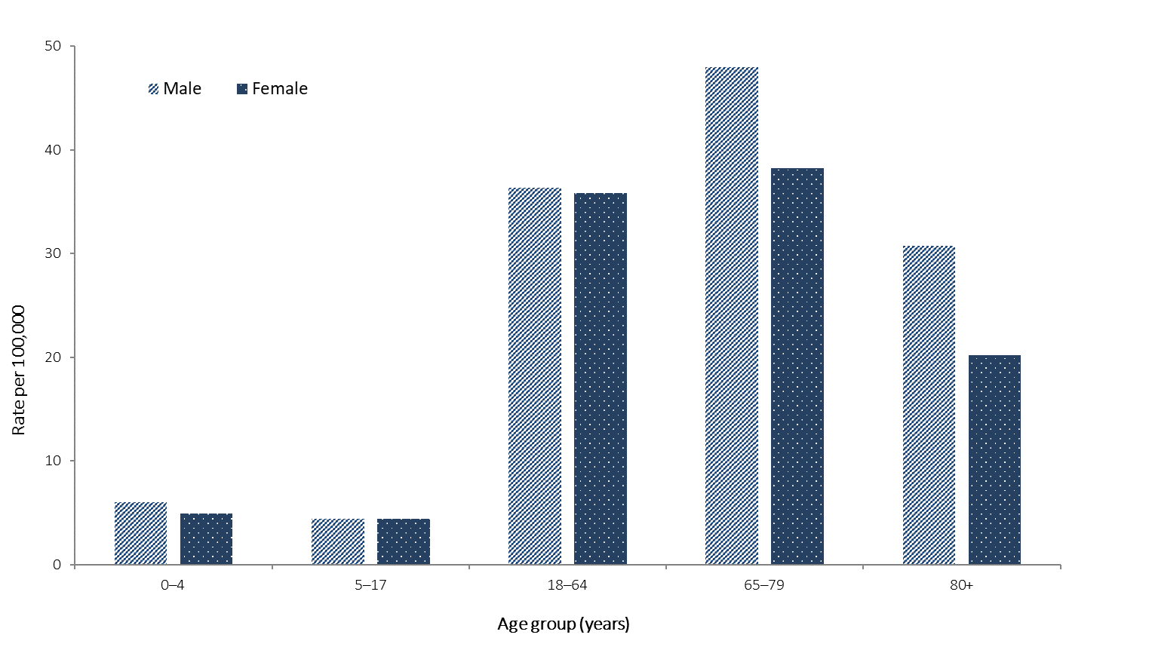
Figure B.2: Variation in combinations of COVID-19 symptoms in confirmed cases as at 21 June 2020, Australiaª
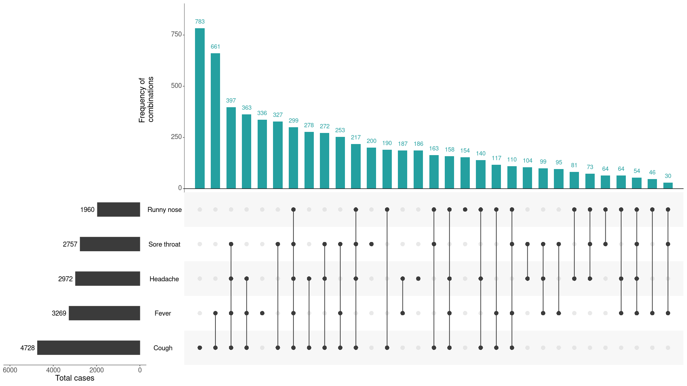a This figure shows the variation in combinations of symptoms observed in reported cases (n = 6,657) for the five most frequently observed symptoms (cough, fever, headache, sore throat, runny nose). The horizontal bars on the left show the frequency of symptom occurrence in any combination with other symptoms. The circles and lines indicate particular combinations of symptoms observed in individual patients. The vertical green bars indicate the frequency of occurrence of the corresponding combination of symptoms.
Communicable Diseases Intelligence
ISSN: 2209-6051 Online

Communicable Diseases Intelligence (CDI) is a peer-reviewed scientific journal published by the Office of Health Protection, Department of Health. The journal aims to disseminate information on the epidemiology, surveillance, prevention and control of communicable diseases of relevance to Australia.

Editor: Tanja Farmer
Deputy Editor: Simon Petrie
Design and Production: Kasra Yousefi
Editorial Advisory Board: David Durrheim, Mark Ferson, John Kaldor, Martyn Kirk and Linda Selvey

Website: http://www.health.gov.au/cdi

Contacts
Communicable Diseases Intelligence is produced by:
Health Protection Policy Branch, Office of Health Protection, Australian Government Department of Health
GPO Box 9848, (MDP 6) CANBERRA ACT 2601

Email: cdi.editor@health.gov.au

Submit an Article
You are invited to submit your next communicable disease related article to the Communicable Diseases Intelligence (CDI) for consideration. More information regarding CDI can be found at: http://health.gov.au/cdi.
Further enquiries should be directed to: cdi.editor@health.gov.au.

This journal is indexed by Index Medicus and Medline.

Creative Commons Licence - Attribution-NonCommercial-NoDerivatives CC BY-NC-ND
© 2020 Commonwealth of Australia as represented by the Department of Health
This publication is licensed under a Creative Commons Attribution-NonCommercial-NoDerivatives 4.0 International Licence from https://creativecommons.org/licenses/by-nc-nd/4.0/legalcode (Licence). You must read and understand the Licence before using any material from this publication.

Restrictions
The Licence does not cover, and there is no permission given for, use of any of the following material found in this publication (if any):
- the Commonwealth Coat of Arms (by way of information, the terms under which the Coat of Arms may be used can be found at www.itsanhonour.gov.au);
- any logos (including the Department of Health’s logo) and trademarks;
- any photographs and images;
- any signatures; and
- any material belonging to third parties.

Disclaimer
Opinions expressed in Communicable Diseases Intelligence are those of the authors and not necessarily those of the Australian Government Department of Health or the Communicable Diseases Network Australia. Data may be subject to revision.

Enquiries
Enquiries regarding any other use of this publication should be addressed to the Communication Branch, Department of Health, GPO Box 9848, Canberra ACT 2601, or via e-mail to: copyright@health.gov.au

Communicable Diseases Network Australia
Communicable Diseases Intelligence contributes to the work of the Communicable Diseases Network Australia.
http://www.health.gov.au/cdna

