COVID-19 Australia: Epidemiology Report 29
Fortnightly reporting period ending 8 November 2020
COVID-19 National Incident Room Surveillance Team

Summary
Nationally, there was a continuing downward trend in notifications of COVID-19. The daily average number of cases for this reporting period was nine, compared to an average of 14 cases per day in the previous fortnight. There were 123 cases of COVID-19 and two deaths this fortnight, bringing the cumulative case count to 27,743 and 904 deaths. New South Wales reported the highest proportion of cases this fortnight (56%; 69/123), the majority of which were overseas acquired (54). Locally-acquired cases accounted for 15% (18/123) of all cases reported this fortnight. Victoria has seen a continuing decline of cases: at the end of this reporting period, 10 days had passed since the last locally-acquired case was reported in this jurisdiction. Testing rates increased during the reporting period and remain high overall at 11.0 tests per week per 1,000 persons. There was variability in the testing rate by jurisdiction, with testing rates depending on the epidemic context. The overall positivity rate for the reporting period was 0.03%, with the Northern Territory reporting a positivity rate of 0.12% for this reporting period. In all other jurisdictions the positivity rate was ≤ 0.06%.
Keywords: SARS-CoV-2; novel coronavirus; 2019-nCoV; coronavirus disease 2019; COVID-19; acute respiratory disease; epidemiology; Australia

Introduction
Coronavirus disease 19 (COVID-19), caused by the novel severe acute respiratory syndrome coronavirus 2 (SARS-CoV-2), was first identified in humans in Wuhan, China, in December 2019. The disease subsequently spread rapidly, leading to a global pandemic.¹ The predominant modes of transmission for COVID-19 are through direct or close contact with an infected person via respiratory droplets, or indirectly via contact with contaminated fomites.² The median incubation period of COVID-19 is 5–6 days, ranging from 1 to 14 days.^{3,4} The infectious period remains uncertain; however, it has recently been estimated to be from 48 hours before symptoms develop until two weeks after symptom onset.^{3,5} The predominant symptoms reported in COVID-19 cases are cough, sore throat, fatigue, runny nose and fever.⁶ The majority of cases recover from the disease without clinical intervention; however, approximately 20% of global cases result in more severe outcomes, such as shortness of breath and pneumonia, necessitating hospitalisation and the requirement of additional oxygen or ventilation.^{7,8} Severe or fatal outcomes are generally more common among elderly cases or those with comorbid conditions.⁸ A visual depiction of the severity spectrum of COVID-19, and of the data sources that we use in this report to measure aspects of severity, is provided in Figure 1.
The epidemiology of COVID-19 in Australia has continued to evolve since cases were first detected in the country in late January 2020. This report provides an overview of the Australian COVID-19 epidemic, and compiles data from a variety of sources to describe cases and clusters, testing patterns, disease severity, public health response measures and the international situation. The report addresses indicators listed in the Australian National Disease Surveillance Plan for COVID-19,⁴ which describes a national approach for disease surveillance for COVID-19 and its causative agent, SARS-CoV-2. The sources of surveillance data used in this report relate to different parts of the severity spectrum of COVID-19 (Figure 1).
Figure 1: Severity spectrum of COVID-19 cases and data sources used to measure severity in Australia
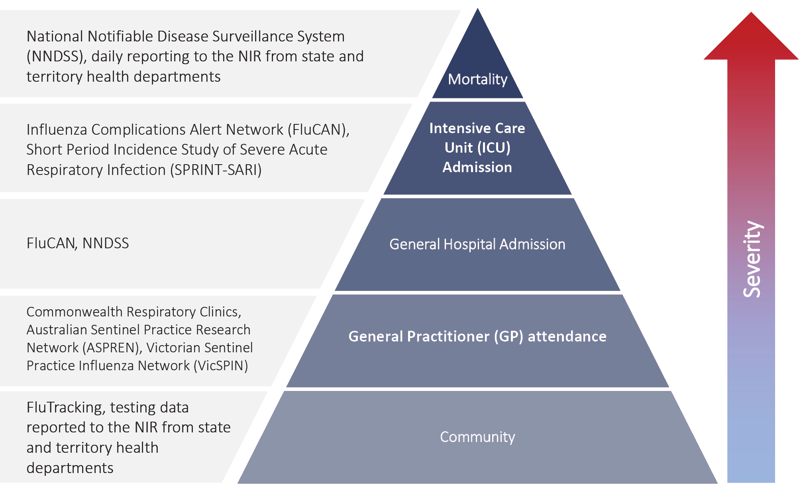

Data sources

Notifications to health departments
The majority of data presented in this report were derived from the National Notifiable Diseases Surveillance System (NNDSS). COVID-19 is a notifiable disease under public health legislation in all states and territories and is listed on the National Notifiable Diseases List under the National Health Security Act (2007). Accordingly, all jurisdictions report confirmed and probable cases of COVID-19 through the NNDSS. The national case definition for surveillance is available in the COVID-19 Series of National Guidelines.⁹ Due to the dynamic nature of the NNDSS, numbers presented in this report may be subject to revision and may vary from numbers previously reported and from case notifications released by states and territories. Case numbers for the most recent dates of illness onset may be subject to revision, due to reporting delays. Data for the current report were extracted from the NNDSS on 10 November 2020 for notifications received up to 8 November 2020. Data for COVID-19 deaths notified in this reporting period were extracted from daily notifications from state and territory health departments to the National Incident Room (NIR), received up to 8 November 2020.

Acute respiratory illness
We report data from surveillance systems that monitor trends in the number of people reporting symptoms of mild respiratory illnesses in the community and in primary care settings. These systems gathered information from across Australia and include the online FluTracking syndromic surveillance system,¹⁰ the Commonwealth General Practice (GP) Respiratory Clinics, and the Australian Sentinel Practice Research Network (ASPREN) and Victorian Sentinel Practice Influenza Network (VicSPIN) GP sentinel surveillance systems. These systems capture data on any respiratory illness experienced by participants, including pathogens such as SARS-CoV-2.

Hospitalisations
To report on COVID-19 disease severity, we draw on hospitalisations and intensive care unit (ICU) admissions data provided from two sentinel surveillance systems: the Influenza Complications Alert Network (FluCAN)¹¹ and the Short Period Incidence Study of Severe Acute Respiratory Infection Study (SPRINT-SARI).¹² FluCAN is a real-time hospital sentinel surveillance system for acute respiratory disease requiring hospitalisation. Established to monitor for seasonal influenza, FluCAN has been modified to include surveillance for COVID-19. Participating sites collect detailed clinical and laboratory information from all hospitalised patients with a confirmed diagnosis of COVID-19. SPRINT-SARI is a sentinel system that collects detailed data on the characteristics and outcomes of and interventions for patients admitted to ICUs or High Dependency Units with COVID-19 at participating sites across Australia. Data on severity is presented in the report each month, rather than on a fortnightly basis.

Viral genomics
The Global Initiative on Sharing All Influenza Data (GISAID) is an international virus sequence database that provides open access to SARS-CoV-2 genomic data.¹³ Phylogenetic analyses are publicly available through the Nextstrain platform, which uses virus sequence data from GISAID to track the global evolution and spread of SARS-CoV-2.¹⁴

Testing data
Aggregated testing data are reported daily to the NIR by jurisdictions. Testing data by demographic breakdown are also reported on a weekly basis by jurisdictions.

Denominators
We use population data from the Australian Bureau of Statistics (ABS) Estimated Resident Population (as at 30 December 2019) to estimate rates of infection by jurisdiction, age group, sex and Indigenous status.

International
All data reported in the international section have been extracted from the World Health Organization (WHO) Dashboard on 8 November 2020 unless otherwise specified.¹⁵

Figure 2: Weekly trends in respiratory illness amongst FluTracking survey participants (age-standardised) compared to the average of the previous five years, Australia, 1 March to 8 November 2020ª
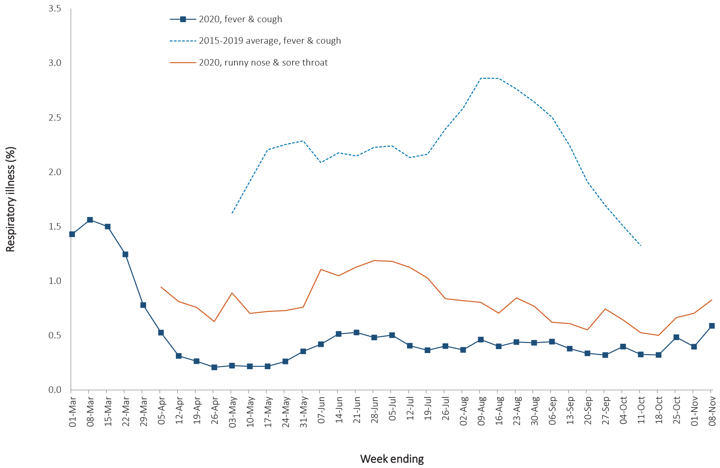
a In previous years, FluTracking was activated during the main Influenza season from May to October. A historical average beyond the week ending 11 October is therefore not available. In 2020, FluTracking commenced 10 weeks early to capture data for COVID-19. Data on runny nose and sore throat were only collected systematically after 29 March 2020, therefore a historical average for this symptom profile is unavailable.

Activity

Acute respiratory illness

(FluTracking / Commonwealth Respiratory Clinics)
Based on self-reported FluTracking data, fever and cough in the community is three times lower than the historical average ending at 11 October each year (Figure 2). Runny nose and sore throat symptoms in the community increased across this reporting period, however the prevalence in the community remains at less than 1%.
In this reporting period, acute respiratory illness was highest in those aged 0–9 and 30–39 years old, based on both self-reported FluTracking data and presentations to Commonwealth Respiratory Clinics. Females reported respiratory illness more frequently than males. Rates of fever and cough by jurisdiction were generally similar to the rates reported in the previous fortnight, ranging from 2.3/1,000 FluTracking participants in Victoria to 4.9/1,000 participants in Western Australia.
FluTracking data indicate that 50% of those in the community with ‘fever and cough’ and 22% of those with ‘runny nose and sore throat’ were tested for SARS-CoV-2. Testing rates varied by jurisdiction, being lowest in Western Australia and highest in Victoria, New South Wales and Tasmania. It is important to acknowledge that there may be legitimate reasons why people did not get tested, including barriers to accessing testing. Symptoms reported to Flutracking are not specific to COVID-19 and may also be due to chronic diseases.
During this reporting period, there were 34,835 assessments at Commonwealth Respiratory Clinics with > 95% tested for SARS-CoV-2. There were no positive SARS-CoV-2 test results in these Clinics for this reporting period.
In patients experiencing influenza-like illness in this reporting period and tested through the ASPREN and VicSPIN GP sentinel surveillance systems, the most frequent respiratory viruses detected were rhinoviruses.
The rate of self-reported fever and cough among Aboriginal and Torres Strait Islander peoples over this reporting period was similar to that observed in all other participants based on FluTracking data.
Rates of respiratory illness in health care worker populations were similar to those observed in the wider community, based on FluTracking data.
Based on all presentations to Commonwealth Respiratory Clinics to date, the principal symptoms reported in COVID-19 cases were cough, sore throat, tiredness, runny nose, and fever.
Figure 3: COVID-19 notified cases by source of acquisition and diagnosis date, Australia, week ending 08 November 2020 (Source: NNDSS)

Transmission trends of confirmed COVID-19

(NNDSS and jurisdictional reporting to NIR)
As at 8 November 2020, there were 27,743 COVID-19 cases including 904 deaths reported nationally, with two distinct peaks in March and July (Figure 3). In this reporting period, there were 123 cases. Two deaths were notified by jurisdictional health departments to the NIR in this reporting period. On average, nine cases were notified each day over this reporting period, a decrease from the average of fourteen cases reported per day over the previous reporting period. The largest number of cases diagnosed this fortnight was from New South Wales (56%; 69/123), followed by South Australia (18%; 22/123) and Western Australia (10%; 12/123). Small numbers of cases were reported in Queensland (9), Northern Territory (7), and Victoria (4). No new cases were reported in Tasmania and the Australian Capital Territory.

Source of acquisition

(NNDSS)
In this reporting period, the majority of cases were reported as overseas acquired (80%; 99/123). Locally-acquired cases accounted for 15% (18/123) of cases, and the contact was not identified for 11% (2/18) of these cases, which is lower than the previous reporting period (32%; 65/201). In total, 5% (6/123) of cases reported this fortnight were under investigation at the time of reporting (Table 1).
Table 1: COVID-19 notifications by jurisdiction and source of acquisition, Australia, 26 October – 8 November 2020
Source | NSW | Vic. | Qld | WA | SA | Tas. | NT | ACT | Australia
Overseas | 54 | 0 | 9 | 11 | 18 | 0 | 7 | 0 | 99
Local — source known | 13 | 3 | 0 | 0 | 0 | 0 | 0 | 0 | 16
Local — source unknown | 1 | 1 | 0 | 0 | 0 | 0 | 0 | 0 | 2
Under investigation | 1 | 0 | 0 | 1 | 4 | 0 | 0 | 0 | 6
Total | 69 | 4 | 9 | 12 | 22 | 0 | 7 | 0 | 123

In this reporting period, the largest number of overseas-acquired cases was reported in New South Wales (55%; 54/99), followed by South Australia (18%; 18/99). The higher number of overseas-acquired cases reported in New South Wales and South Australia reflects the number of returned travellers managed there. New South Wales had the highest proportion of locally-acquired cases with a known source of infection (81%; 13/16). Locally-acquired cases with unknown source were from New South Wales (1) and Victoria (1).
Cumulatively, the infection rate to date for all locally-acquired cases was highest in Victoria with 293.6 infections per 100,000 population (Table 2). The rate of infection in Tasmania was 28.4 infections per 100,000 population, largely as a result of an outbreak in North West Tasmanian hospitals in April 2020, which represented half of all the state’s cases.

Table 2: Locally-acquired COVID-19 case numbers and rates per 100,000 population by jurisdiction and reporting period, Australia, 8 November 2020
Jurisdiction | Reporting period | Reporting period | Cumulative cases
 | 12 Oct—25 Oct | 26 Oct—8 Nov
 | Number of cases | Number of cases | Number of cases | Rates per 100,000 population
NSW | 26 | 15 | 1,979 | 24.5
Vic | 39 | 4 | 19,360 | 293.6
Qld | 0 | 0 | 303 | 5.9
WA | 0 | 1 | 103 | 3.9
SA | 0 | 4 | 155 | 8.8
Tas | 0 | 0 | 152 | 28.4
NT | 0 | 0 | 6 | 2.4
ACT | 0 | 0 | 26 | 6.1
Australia | 65 | 24 | 22,084 | 87.1

Nationally, in the last two days of this reporting period, there were no locally-acquired cases reported. The Australian Capital Territory has the longest period of time (225 days) since a case of unknown source. New South Wales reported the most recent case of a locally-acquired case of unknown source on 5 November 2020. At the time of reporting, there had been 10 days since the last locally-acquired case reported in Victoria (Table 3).

Demographic features

(NNDSS)
In this reporting period, the largest number of cases occurred in those aged 30–39 years (34 cases). For all notifications to date, the highest rate of infection was in those aged ≥ 90 years old with a rate of 386.8 per 100,000 population (Appendix A, Table A.1). Children aged 0–9 years old had the lowest rate of infection (44.6 cases per 100,000 population), despite comparable testing rates to other age groups.
Cumulatively, the male-to-female rate ratio of cases was approximately 1:1 in most age groups. Notification rates were highest among females in the 20–29 years age group and those aged ≥ 80 years old, and highest among males in the 70–79 years age group (Figure 4). The largest difference in cumulative rates was in the ≥ 90 years age group, where the cumulative rate among males was 333.7 cases per 100,000 population and among females 413.3 cases per 100,000 population (Appendix A, Table A.1).
Since the beginning of the epidemic in Australia, the median age of all cases was 37 years old (interquartile range, IQR: 25–56) which has not changed since the beginning of August. Prior to 1 June 2020, COVID-19 cases were slightly older with a median age of 46 years old (IQR: 29–62), associated with a high proportion of cases having a recent travel history or acquisition on a cruise ship. In cases reported after 1 June 2020, the median age was 34 years old (IQR: 23–53) reflecting transmission in the community and across a range of settings, especially in Victoria. The median age of cases in this reporting fortnight was 33 years old (IQR: 21–45).

Aboriginal and Torres Strait Islander persons

(NNDSS)
There have been 147 confirmed cases of COVID-19 notified in Aboriginal and Torres Strait Islander persons since the beginning of the epidemic. This represents approximately 0.5% of all confirmed cases. There were no cases among Aboriginal and Torres Strait Islander persons in the past eight weeks. Table 4 compares the remoteness of cases in Aboriginal and Torres Strait Islander persons with those in the Non-Indigenous population. No new overseas-acquired cases have been reported among Aboriginal and Torres Strait Islander persons since the end of August.
The median age of COVID-19 cases in Aboriginal and Torres Strait Islander persons was 31 years old (IQR: 21–49), which was younger than for Non-Indigenous cases where the median age was 37 years old (IQR: 25–57).
The notification rate across all age groups was higher in Non-Indigenous persons than in Aboriginal and Torres Strait Islander persons (Figure 5). The age-standardised Aboriginal and Torres Strait Islander:Non-Indigenous notification rate ratio was 0.2, indicating that the Aboriginal and Torres Strait Islander population had a lower COVID-19 case rate than the Non-Indigenous population after accounting for differences in age structure. Amongst Aboriginal and Torres Strait Islander cases, the highest notification rate was in those aged 70–79 years (36.0 cases per 100,000 population), followed by the 60–69 years age group (34.4 cases per 100,000 population). Similar to Non-Indigenous cases, children aged 0–9 years had the lowest notification rate among Aboriginal and Torres Strait Islander cases (6.9 cases per 100,000 population).
Table 3: Days since last locally-acquired COVID-19 case (source known and source unknown), by jurisdiction, reported by notification received date, 8 November 2020
Jurisdiction | Locally acquired — source unknown |  | Locally acquired — source known
 | Date of last case | Days since last case | Date of last case | Days since last case
NSW | 5/11/2020 | 3 | 6/11/2020 | 2
Vic. | 29/10/2020 | 10 | 29/10/2020 | 10
Qld | 26/08/2020 | 74 | 15/09/2020 | 54
WA | 12/04/2020 | 210 | 2/06/2020 | 159
SA | 15/04/2020 | 207 | 22/08/2020 | 78
Tas. | 11/08/2020 | 89 | 1/09/2020 | 68
NTª | N/A | N/A | 4/04/2020 | 218
ACT | 28/03/2020 | 225 | 9/07/2020 | 122
a The Northern Territory has not reported any locally-acquired cases with an unknown source of infection.

Figure 4: Cumulative COVID-19 cases, by age group and sex, Australia, 23 January 2020 to 8 November 2020
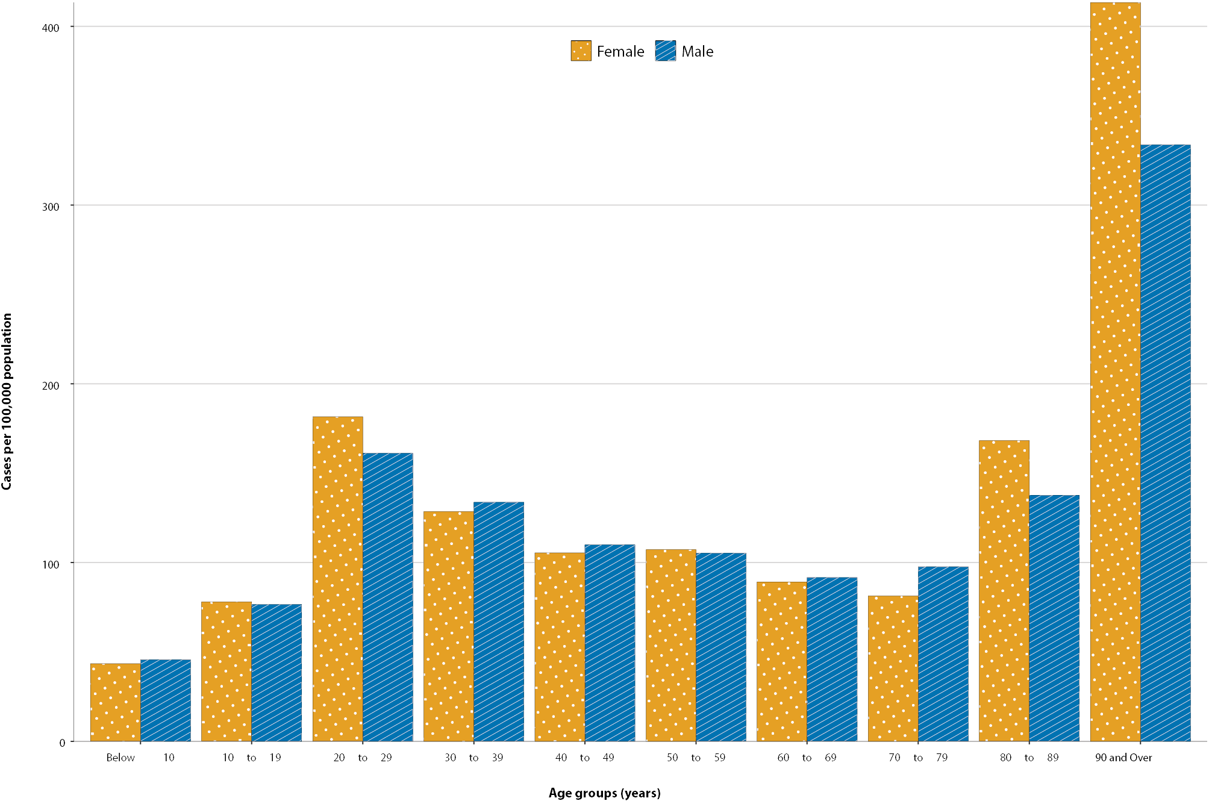

Table 4: COVID-19 notifications by Aboriginal and Torres Strait Islander status by jurisdiction, source of acquisition and remoteness classification, Australia, 8 November 2020
 | Locally-acquired |  |  |  | Interstate acquired | Overseas acquired | Unknownª | Total
 | Major Cities of Australia | Inner Regional Australia | Outer Regional Australia | Remote / Very Remote Australia
Aboriginal and  Torres Strait Islanderb | 89 | 15 | 6 | 1 | 4 | 31 | 1 | 147
Non-Indigenous | 20,417 | 916 | 224 | 21 | 149 | 5,628 | 241 | 27,596
a Includes 28 Non-Indigenous cases classified as overseas residents who were diagnosed in Australia; and 213 Non-Indigenous cases and 1 Aboriginal and Torres Strait Islander case with an unknown remoteness classification.
b Excludes 1 probable Aboriginal and Torres Strait Islander case.

COVID-19 deaths

(NNDSS)
To date, 904 COVID-19 deaths have been recorded in the NNDSS (as per the SoNG definition),⁹ reflecting an overall crude case fatality rate (CFR) of 3.3%. Deaths were recorded for those aged between 27 and 106 years old, with a median age of 86 years (IQR: 80–91); and the distribution between males and females was roughly equal (1:1.07). Of those recorded in the NNDSS as having died, valid ‘date died’ information was available for 93% (842/904) of cases. The time to death was calculated as the difference between date died and the diagnosis date. For almost four-fifths of those who died from COVID-19, time to death was 19 days or less, with 40% of deaths occurring 10–19 days after diagnosis (40%; 339/842) and a similar proportion of deaths within 9 days from diagnosis (39%; 325/842).
When analysing the differences between the two peaks in the epidemic curve, the periods were defined relative to 1 June 2020. In the first time period (‘peak 1’), prior to 1 June, the mean time to death for males was 14.2 days, which decreased slightly to 13.8 in the second period (‘peak 2’) (Figure 6). For females, the mean time to death in the second period increased slightly to 13.8 days from 12.7 days the first period.
Amongst those who died, the age at diagnosis has shown changes between time periods, and slight differences between sexes (Figure 7). In the first time period, females who died were older and had a mean age of 81.2 years, while males were 78.1 years. In the second period, females were older with a mean age of 87.5 years compared to males at 83.1 years.
In the first time period, 36% (37/104) of deaths were in those who acquired their infection overseas. In contrast, no deaths were reported amongst overseas-acquired cases in the second time period. This trend is consistent with the broader epidemic trends observed during each peak.

Clusters and outbreaks

(State and territory reporting)
For the fortnight ending 8 November 2020, there was a total of six outbreaks associated with 45 cases. Of these, three were in Victoria (50%; 3/6) and three in New South Wales (50%; 3/6). Outbreaks were reported in the following settings: residential aged care facility (1), health care clinic (1), childcare (1), indoor recreational centre (1), primary-secondary school (1), and a community cluster (1).
Nationally, since the beginning of the epidemic, there have been 825 outbreaks associated with 13,187 cases, 2,007 hospitalisations, and 799 deaths. Consistent with the national epidemic case trend, the first peak in outbreaks occurred in mid-March (Figure 8). This was followed by a rapid increase in outbreaks beginning in early July, corresponding with community transmission in Victoria.
The median number of cases in each outbreak was 6 (range 2–331). The largest number of outbreaks (39%, 321/824) had 6 to 24 cases, and a third of outbreaks (32%, 264/824) had only 3 to 5 cases (Figure 9). The largest single jurisdictional outbreak occurred in a residential aged care facility and was associated with 260 cases.
Residents of aged care facilities are at increased risk of COVID-19 infection due to the communal living environment and are more vulnerable to serious complications if they become infected. As at 8 November 2020, there have been 4,293 cases of COVID-19 associated with 218 residential aged care facilities, with 3,608 who recovered and 685 who died. Of these, 2,049 cases occurred in aged care residents, with the remaining 2,244 cases occurring in care staff. The Commonwealth is actively supporting services with reported incidents and outbreaks of COVID-19 providing access to personal protective equipment and additional staffing resources where required. Advice and guidelines have been provided to aged care services, including the release of an outbreak management guide.^{18,19}
Figure 5: National COVID-19 notification rate per 100,000 population by age group, Aboriginal and Torres Strait Islander persons and Non-Indigenous persons, Australia, 23 January 2020 to 8 November 2020

Figure 6. Days from diagnosis to death of COVID-19 cases, by sex and epidemic peak
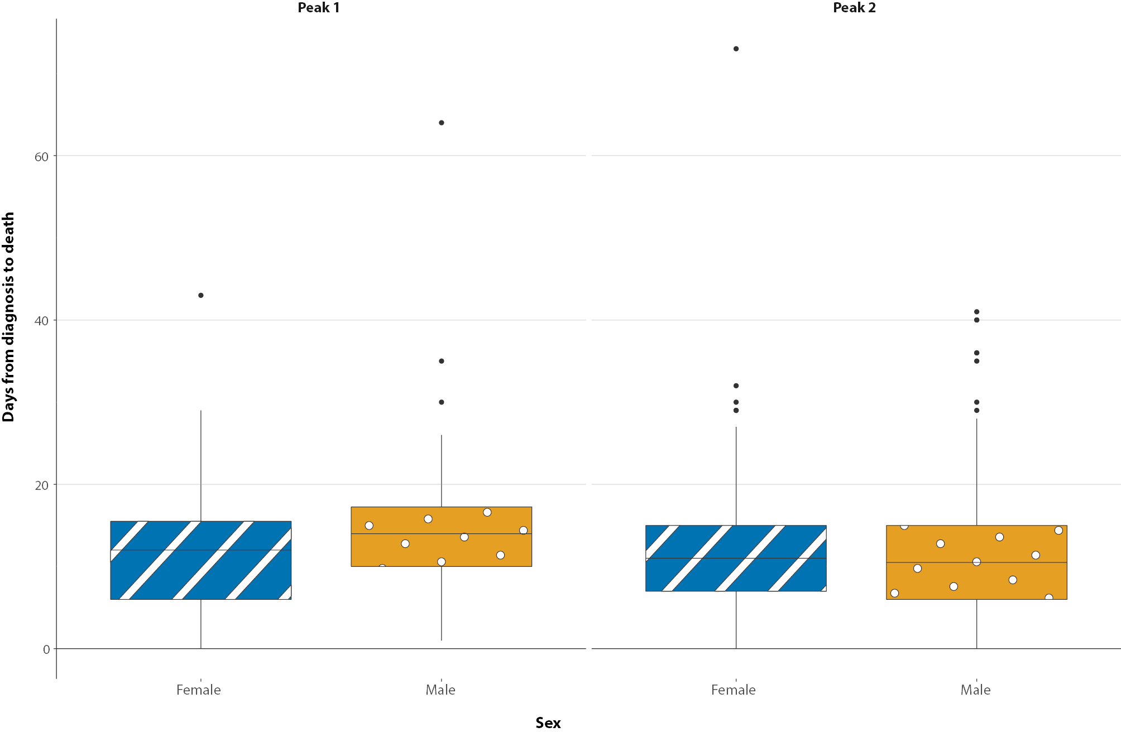
Figure 7. Age at diagnosis of COVID-19 deaths, by sex and epidemic peak
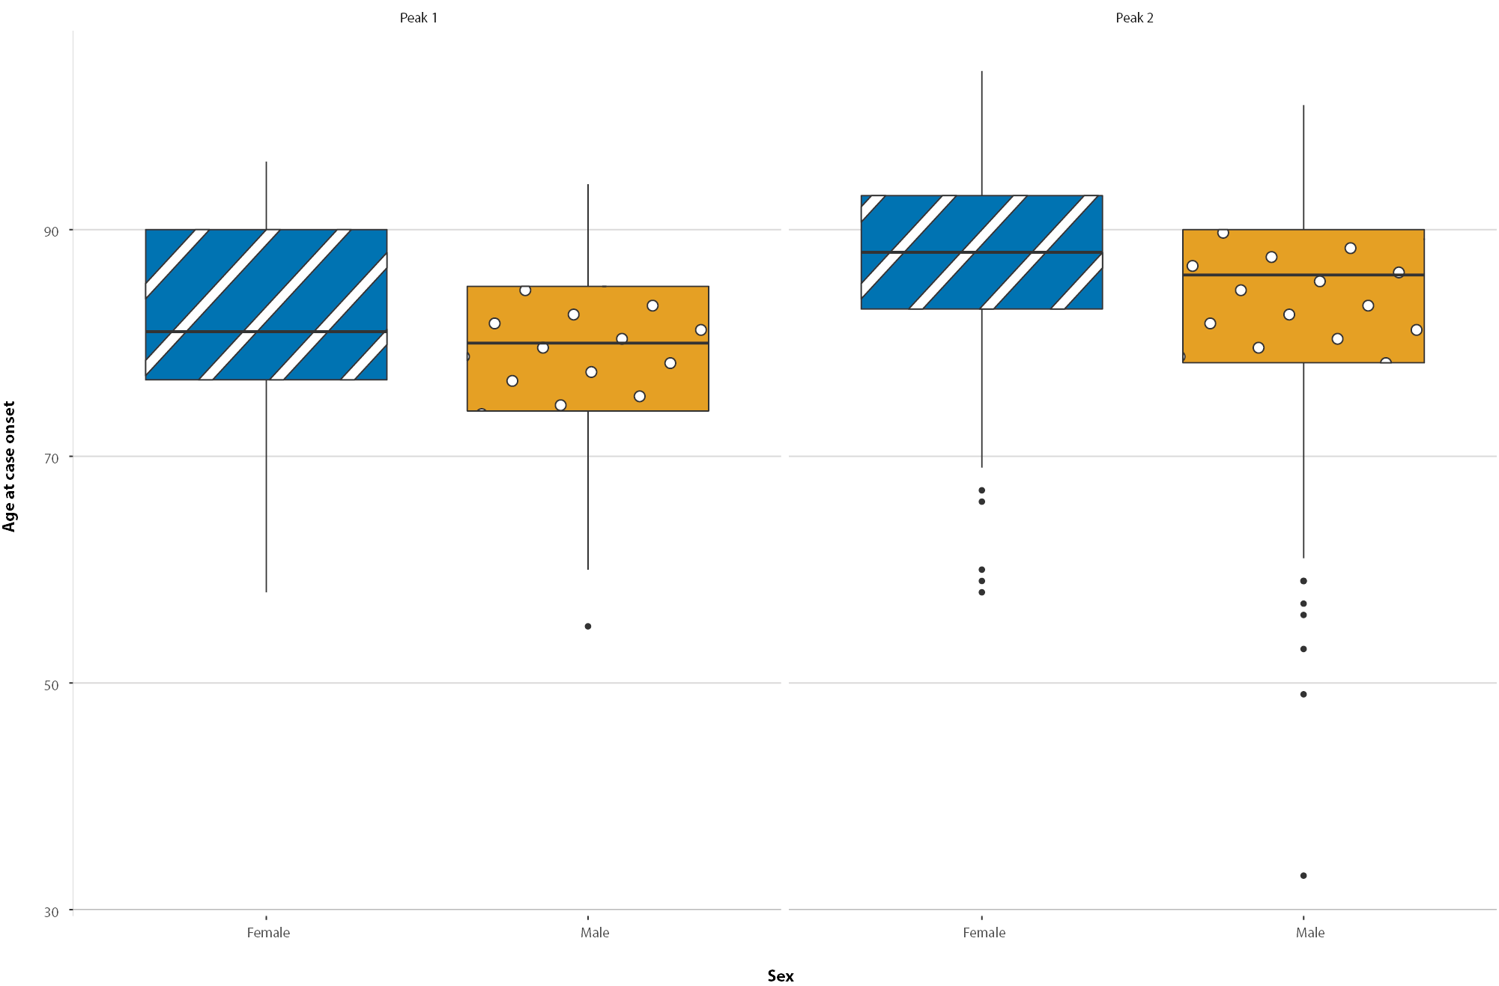
Figure 8: Number of outbreaks throughout the course of the pandemic, Australia, 8 November 2020
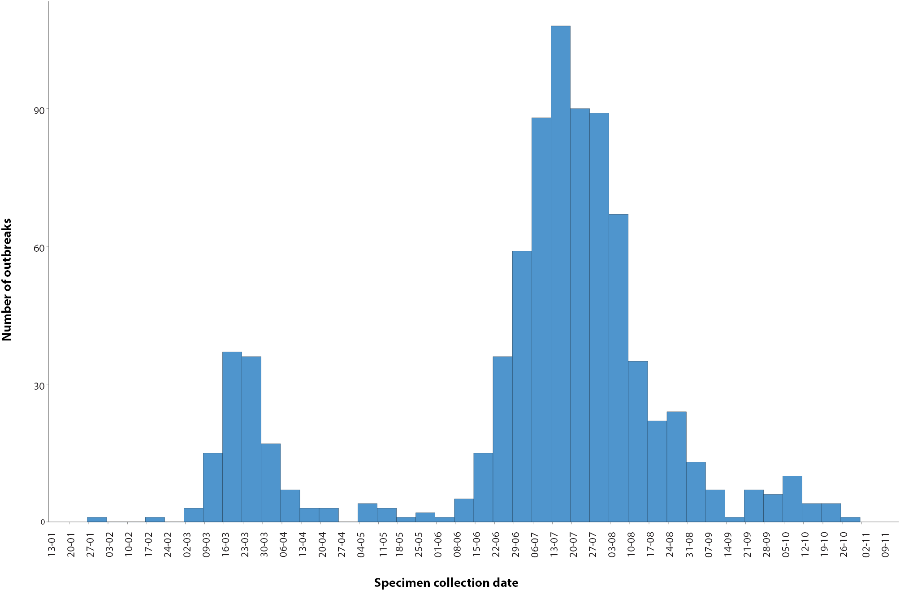
Figure 9: Number of outbreaks by size, Australia, 8 November 2020
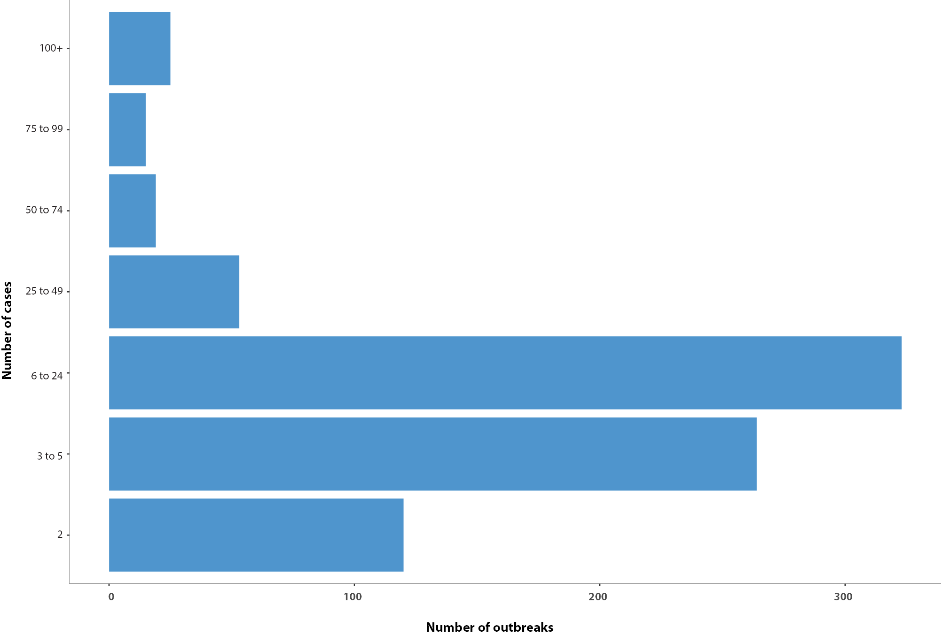
Table 5. State and territory changes to COVID-19 restrictions, Australia, 26 October to 8 November 2020
Jurisdiction | Summary of changes to COVID-19 restrictions
New South Wales | No further easing of restrictions during this reporting period.23
Victoria | From 8 November the same restrictions apply to regional Victoria and metropolitan Melbourne:24  - Travel permitted between regional Victoria and metropolitan Melbourne  - Holidays including camping permitted  - Up to two visitors permitted in private residences each day  - Outdoor gatherings of up to 10 permitted  - Cafes, pubs and restaurants permitted up to 70 outdoors or 40 indoors  - Indoor exercise and gyms up to 10 permitted (20 for non-contact sport for under-18s  - Indoor pools up to 20 permitted  - Outdoor religious gatherings of up to 50 permitted  - Indoor religious gatherings of up to 10 permitted  - Funerals permitted up to 50 outdoors or up to 20 indoors  - Community venues up to 20 permitted (10 per space)  - Real estate and auctions up to 10 permitted  - Indoor entertainment venues (e.g. cinemas) up to 20 permitted
Queensland | From 3 November, visitors and returned travellers from New South Wales (except those from jurisdictionally declared hotspots) may enter Queensland.25
Western Australia | No further easing of restrictions during this reporting period.26
South Australia | From 4 November, border restrictions for cross-border communities (within 70km) eased.27
Tasmania | From 6 November, border restrictions for travellers from New South Wales eased.28
Australian Capital Territory | No further easing of restrictions during this reporting period.29
Northern Territory | No further easing of restrictions during this reporting period.30

Virology

(GISAID)
At the time of this report, there were 13,985 SARS-CoV-2 genome sequences available from Australian cases on the global sequence repository, GISAID.¹³ These sequences were dispersed throughout the global lineages, reflecting multiple concurrent introductions into Australia.^{1,20,21} Recent Australian SARS-CoV-2 sequences from the last month include 39 collected from Western Australia, 15 from South Australia and 8 from New South Wales. In the past month there has been 11 different sequences, reflecting the recent shift from locally-acquired to overseas acquired cases in Australia.

Public health response measures
Since COVID-19 first emerged internationally, Australia has implemented public health measures informed by the disease’s epidemiology (Figure 10). On 8 May, the Australian Government announced a three-step framework for easing COVID-19 restrictions. Building on this framework, on 23 October, National Cabinet announced in-principle agreement to a ‘National Framework for Reopening’ to a COVID Normal Australia by Christmas 2020, wherever it is safe to do so.²² States and territories have decision making authority in relation to public health measures and have eased restrictions at their own pace, depending on the local public health and epidemiological situation (Table 5).²²

Testing

(State and territory reporting)
As at 8 November 2020, a cumulative total of 9,097,814 tests were conducted in Australia. The cumulative nationwide proportion of positive tests remained low at 0.3% (Table 6). With the exception of Victoria, the cumulative testing positivity in individual jurisdictions was < 0.2%.
During this reporting period, 561,972 tests were conducted nationally, with a positivity rate of 0.03%. This represented a 6% increase in fortnightly testing numbers compared to the last reporting period. Testing rates increased to 11.0 tests per 1,000 population per week during this reporting period, a rate nonetheless lower than the peak of 19.4 tests per 1,000 population per week in early August. Jurisdictional testing rates are driven by both current case numbers and numbers of people experiencing symptoms.
All states except the Northern Territory reported a positivity rate of < 0.05% in this reporting period. The Northern Territory reported a positivity rate of 0.12%, which is an increase from the previous reporting period (0.00%), reflecting an increased number of overseas-acquired cases associated with repatriation flights. Victoria reported a positivity rate of < 0.01%, which is a decrease from the previous reporting period (0.03%). The low national positivity rate, along with high rates of testing, indicates a low prevalence of COVID-19 nationally.
For the fortnight ending 6 November 2020, testing rates declined for those aged 60 years old and above and rose among children aged 0–19 years old (Figure 11). Testing rates among children aged 0–19 years have doubled since early October. Testing rates were lowest in those aged 60 years old and above.

Figure 10: COVID-19 notifications in Australia by week of diagnosis and jurisdiction to 8 November 2020, with timing of key public health measures
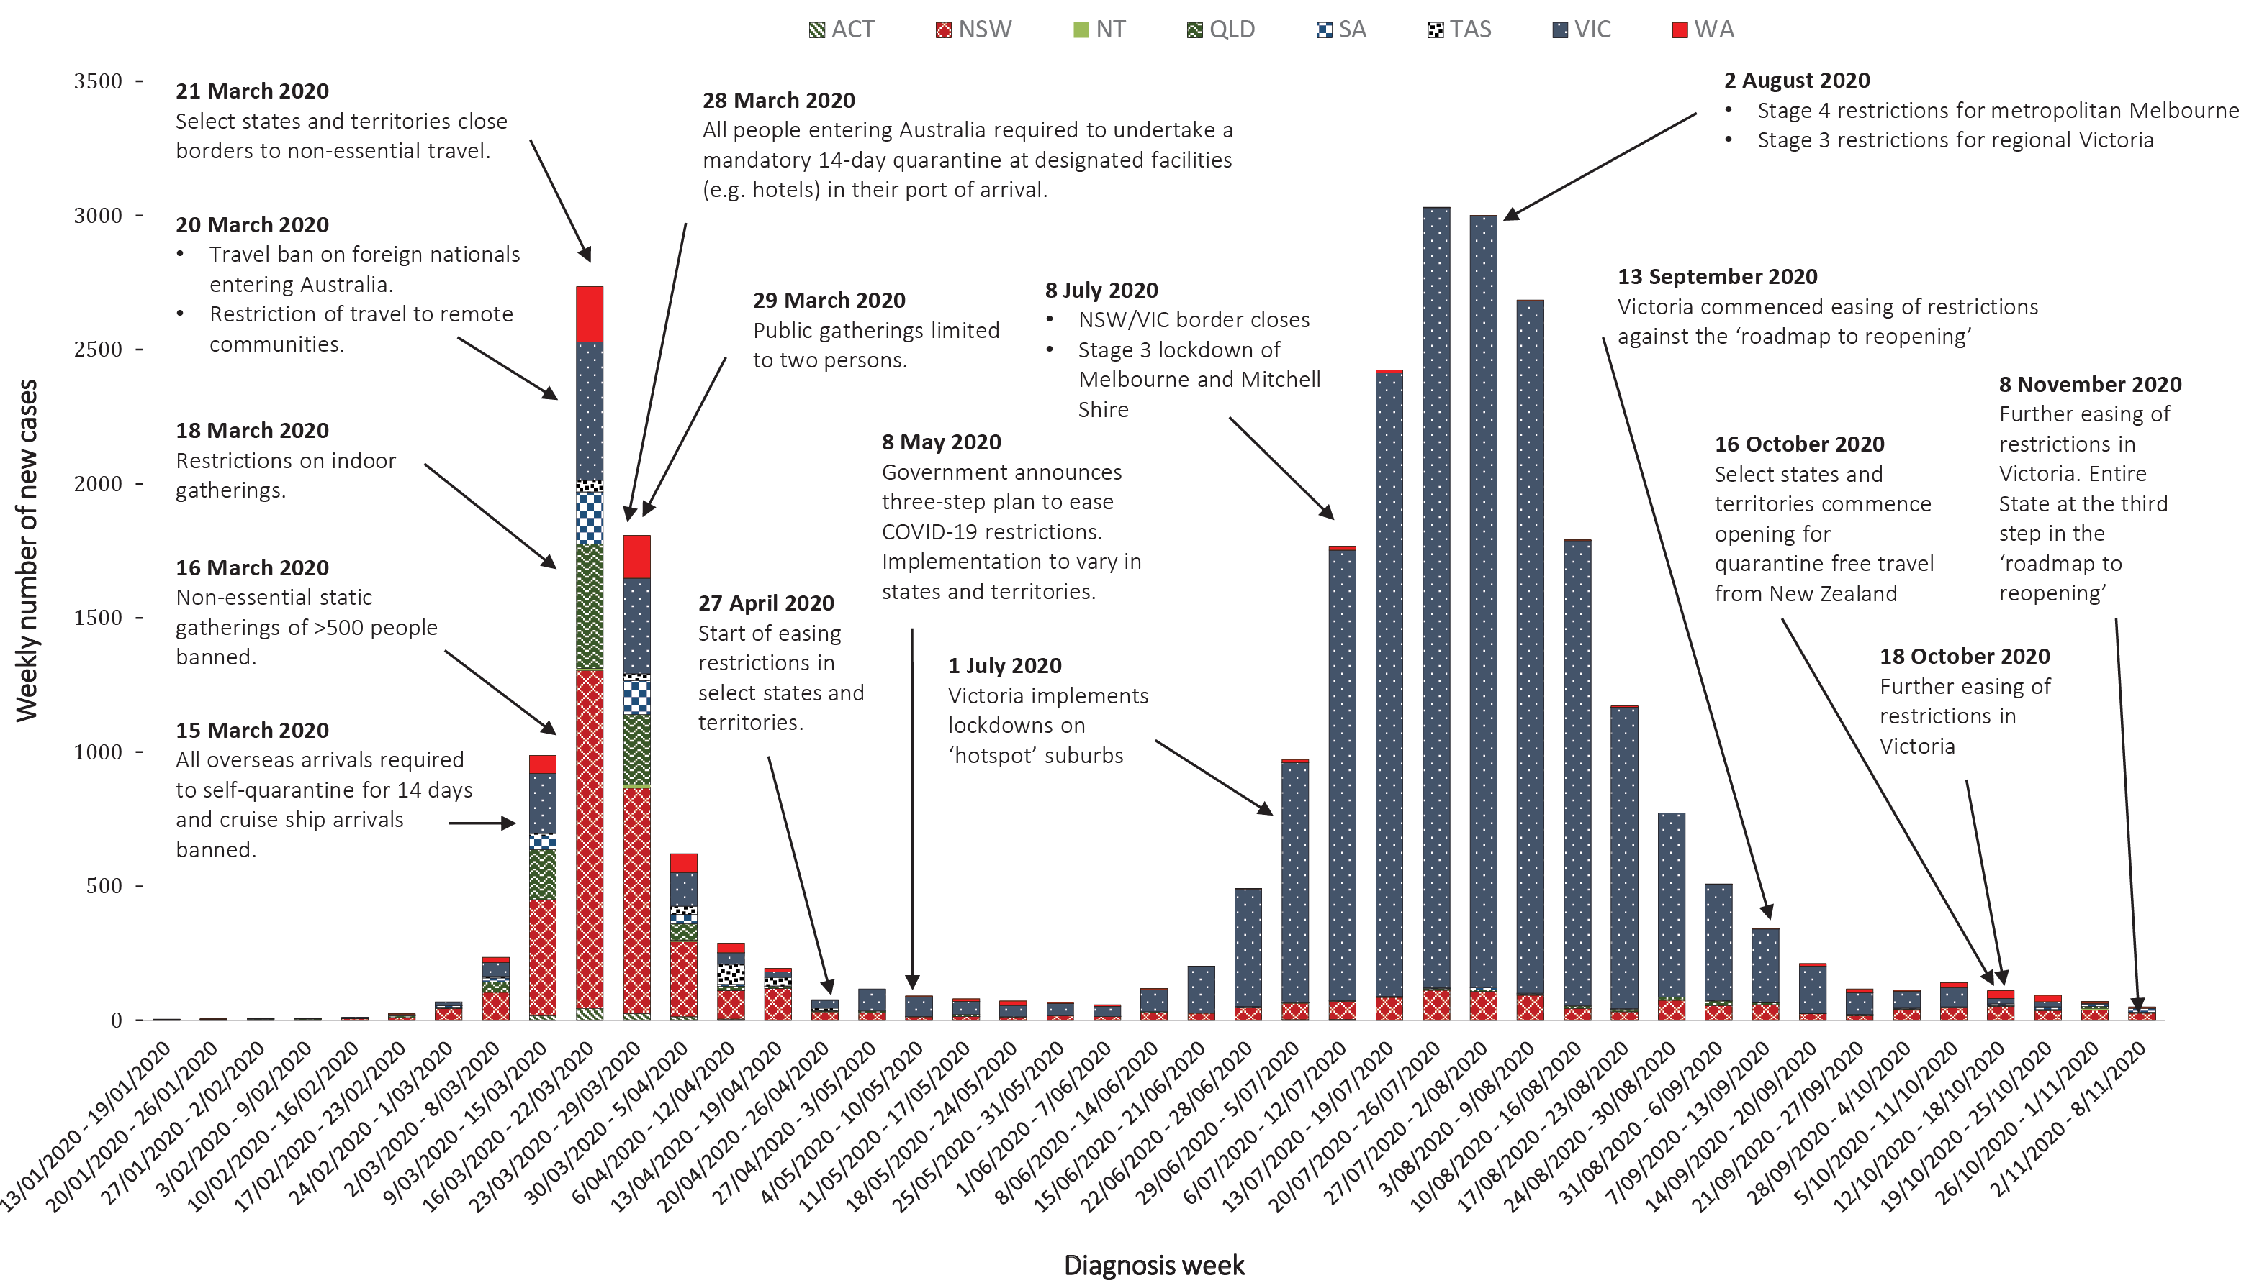

Table 6: Diagnostic tests performed, by jurisdiction, Australia, 8 November 2020
Jurisdiction | Tests performed 12 October – 25 October |  |  | Tests performed 26 October – 8 November |  |  | Cumulative tests performed to 25 October
 | n | Positivity (%) | Per 100,000 populationª | n | Positivity (%) | Per 100,000 populationª | n | Positivity (%) | Per 100,000 populationª
NSW | 175,229 | 0.06 | 2,167.21 | 180,561 | 0.04 | 2,233.15 | 3,167,317 | 0.14 | 39,172.94
Vic | 211,791 | 0.03 | 3,211.93 | 246,825 | <0.01 | 3,743.24 | 3,299,302 | 0.62 | 50,035.79
Qld | 56,548 | 0.01 | 1,110.41 | 51,446 | 0.02 | 1,010.23 | 1,265,567 | 0.09 | 24,851.46
WA | 30,821 | 0.21 | 1,175.55 | 28,308 | 0.06 | 1,079.70 | 501,428 | 0.15 | 19,125.07
SA | 36,673 | 0.04 | 2,092.82 | 38,468 | 0.06 | 2,195.25 | 572,618 | 0.09 | 32,677.60
Tas | 5,872 | 0 | 1,098.39 | 5,675 | 0 | 1,061.54 | 120,292 | 0.19 | 22,501.35
NT | 4,970 | 0 | 2,019.48 | 4,933 | 0.12 | 2,004.45 | 61,249 | 0.06 | 24,887.55
ACT | 5,827 | 0.02 | 1,367.36 | 5,756 | 0 | 1,350.70 | 110,041 | 0.1 | 25,822.19
Australia | 527,731 | 0.05 | 2,081.16 | 561,972 | 0.03 | 2,216.19 | 9,097,814 | 0.3 | 35,878.12

Figure 11: SARS-CoV-2 polymerase chain reaction (PCR) testing rates per 1,000 population per week by age group, Australia, 1 May to 6 November 2020^{a,b}
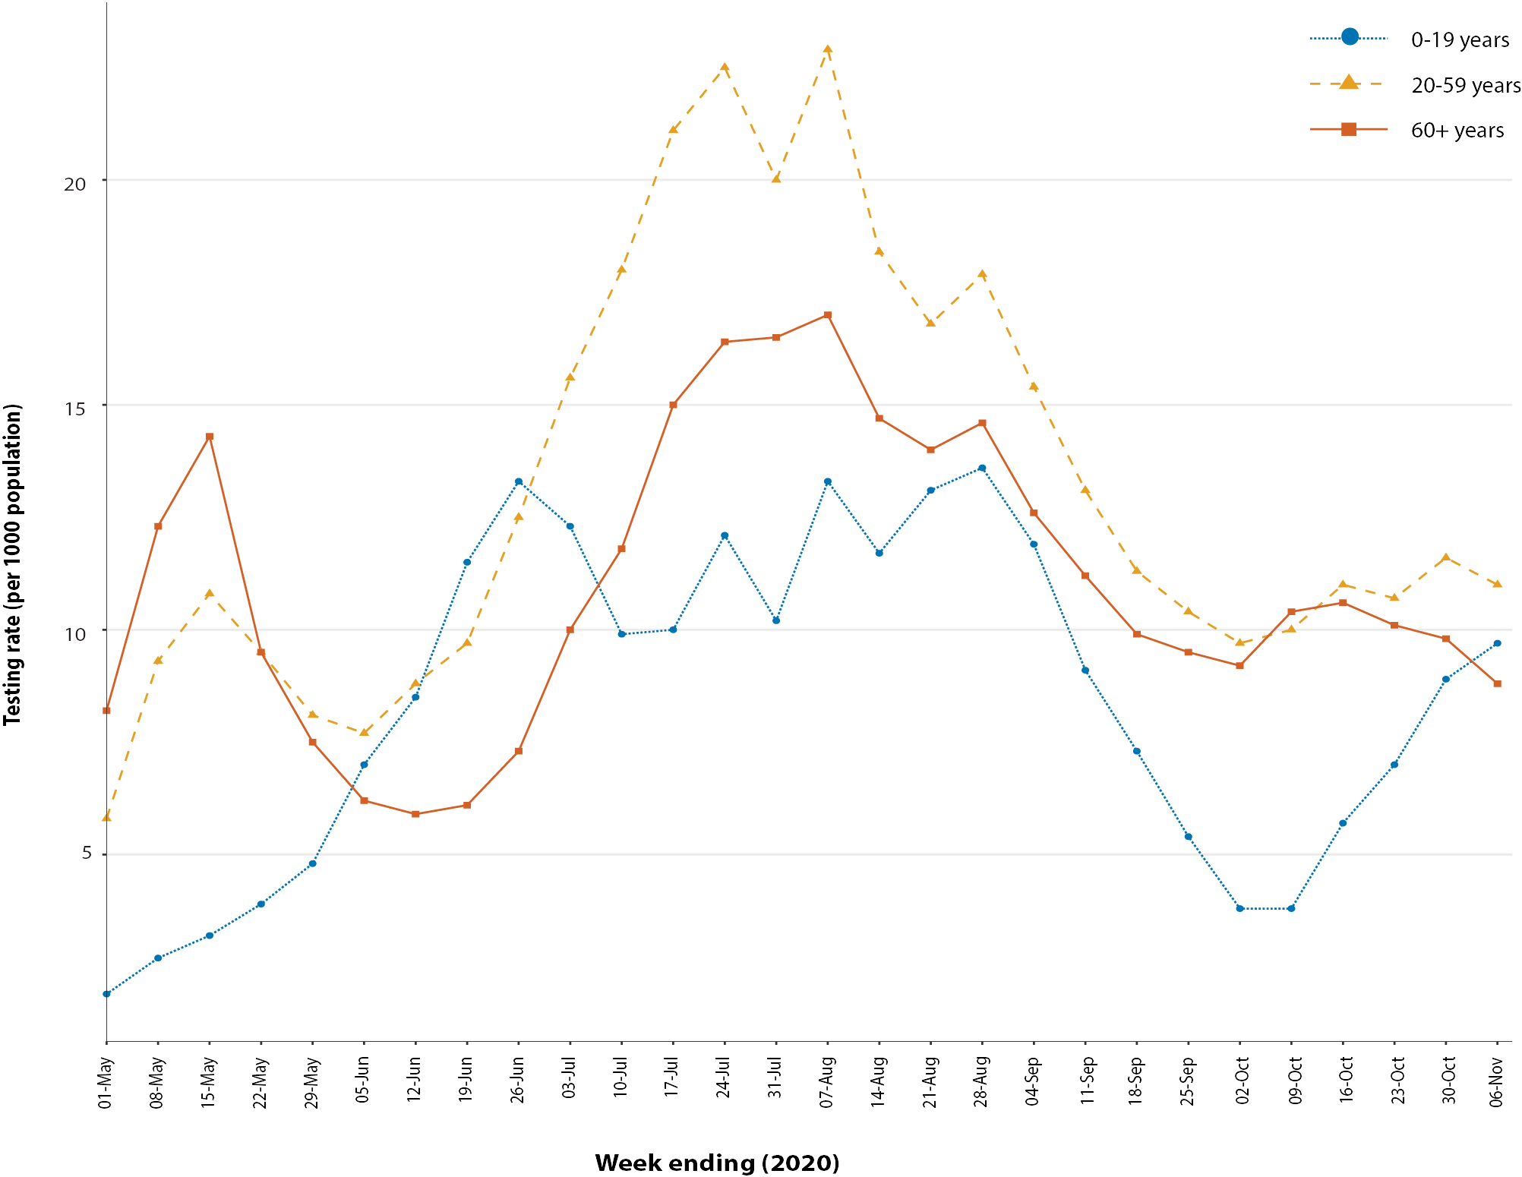
a Data provided by jurisdictions to the National Incident Room (NIR) weekly.
b The jurisdictions reporting each week (i.e. the denominator population) may vary.

Table 7: Transmission patterns for countries in Australia’s near region, 08 November 2020
Category | Country
No cases  Countries/territories/areas with no cases | Cook Islands, Kiribati, Marshall Islands, Federated States of Micronesia, Nauru, Niue, Palau, Samoa, Tokelau, Tonga, Tuvalu, and Vanuatu.
Sporadic cases  Countries/territories/areas with one or more cases, imported or locally detected | Bhutan, Cambodia, Fiji, French Polynesia, Wallis and Futuna, Lao PDR, New Caledonia, Solomon Islands, Timor-Leste.
Clusters of cases  Countries/territories/areas experiencing cases, clustered in time, geographic location and/or by common exposures | China, Guam, Japan, Malaysia, Maldives, Myanmar, Nepal, New Zealand, Republic of Korea, Singapore, Sri Lanka, Thailand, Vietnam
Community transmission  Countries /territories/areas experiencing larger outbreaks of local transmission defined through an assessment of factors including, but not limited to:  - large numbers of cases not linkable to transmission chains  - large numbers of cases from sentinel lab surveillance or increasing positive tests through sentinel samples (routine systematic testing of respiratory samples from established laboratories)  - multiple unrelated clusters in several areas of the country/territory/area. | Bangladesh, Indonesia, Papua New Guinea, Philippines

Countries and territories in Australia’s near region
According to WHO, as of 8 November 2020, 46 countries and territories in Australia’s near region (WHO’s South East Asia and Western Pacific regions, respectively SEARO and WPRO) reported 829,421 newly-confirmed cases and 10,564 deaths in this reporting period, bringing the cumulative cases in the two regions to 10.4 million and 165,268 cumulative deaths.³¹ New cases were largely concentrated in:
- India (642,943 new cases, 8,507,754 cumulative cases, 7,587 new deaths, 126,121 cumulative deaths) and
- Indonesia (47,856 new cases, 433,836 cumulative cases, 1,335 new deaths, 14,540 cumulative deaths).
The countries showing the next highest numbers of cases are:
- Nepal (35,403 new cases, 191,636 cumulative cases, 245 new deaths, 1,087 cumulative deaths)
- Philippines (26,142 new cases, 393,961 cumulative cases, 551 new deaths, 7,485 cumulative deaths).
Countries which have experienced increases in case numbers of over 50% in the past fortnight include Sri Lanka, French Polynesia, Malaysia, Myanmar, Nepal, and Guam, where community transmission continues to remain a challenge.
Other countries such as Fiji, the Solomon Islands, Singapore, Marshall Islands, Japan and New Zealand are detecting cases mainly among returnees while in quarantine thus preventing further transmission into the community.^{32,33} (Table 7).
Vanuatu, Tuvalu, Tonga, Samoa, Palau, Marshall Islands, Kiribati, and the Federated States of Micronesia continue to report no cases since the start of the pandemic.
Globally, over 6.9 million new cases and 97,570 deaths of COVID-19 have been reported across the six WHO regions in the past reporting fortnight. This is the highest number of reported cases so far in a fortnightly reporting period. To date, over 49.5 million COVID-19 cases and 1.24 million deaths have been reported globally. The European Region is now reporting the highest number of cases and deaths, with over 3.7 million new cases reported in the past reporting fortnight—a 40.3% increase in cumulative cases compared to the previous reporting fortnight—representing 54.2% of all new cases reported worldwide. The European region has reported 43,043 deaths, representing a 16% increase from the previous reporting fortnight and almost half the global deaths in the past fortnight (44.1%). The Region of the Americas reported 1.9 million new cases, an almost 10% increase on the last reporting period, and 34,426 deaths (a 5.2% increase in fortnightly deaths). Increase in the number of fortnightly cases by about 13% was also observed in the Eastern Mediterranean Region.
While the United States of America remains the country reporting the highest fortnightly case numbers to date, the order of countries reporting the highest number of confirmed cases in the past fortnight have changed, reflecting the increased case numbers concentrated in Europe: the United States of America, France, India, Italy, and the United Kingdom.
An international summary by WHO Region can be found in the WHO Epidemiology Update dated 10 November 2020.^{34,35}

Interpretation
Since the first cases of COVID-19 were identified in Australia, all states and territories have reported cases of COVID-19, with some jurisdictions experiencing higher numbers and more substantial community-associated transmission. These differences arise from factors including differences in demographic features between jurisdictions, population size, and patterns of overseas arrivals. Australia continues to experience low levels of community transmission of COVID-19 in some jurisdictions, despite testing rates remaining stable.
People aged ≥ 90 years old have the highest cumulative rate. This trend potentially reflects the large number of outbreaks that occurred in aged care settings, which has declined in recent weeks. Other demographic trends remained consistent, with children aged 0–9 years old having the lowest rate of infection, and cases in Aboriginal and Torres Strait Islander persons accounting for fewer than 1% of all confirmed cases and a considerably lower rate of notification than non-Indigenous persons.
Nationally, there has been an overall downward trend in cases following a secondary peak in late July 2020. The majority of locally-acquired cases in the last fortnight occurred in New South Wales, most of which were associated with controlled localised outbreaks or clusters. Victoria has continued to report declines in case numbers due to interventions and intensive investigations of all cases and outbreaks. At the end of this reporting period, it had been 10 days since the last locally-acquired case was reported in Victoria, representing the impact of successful control measures. The local and national epidemiology of COVID-19 continues to inform the public health response, with a number of jurisdictions further easing restrictions this fortnight as COVID-19 case numbers declined or were sustained at low levels.
Overseas-acquired cases in quarantine remain the greater proportion of new COVID-19 cases reported in Australia. As a result, Australia has seen an increase in the number of unique SARS-CoV-2 genome sequences this month. This trend is consistent with countries which are at a similar stage of managing the pandemic, such as New Zealand. Ongoing surveillance of the international situation will be vital as Australia continues to manage overseas arrivals.
As Australian states and territories are at different stages in managing the epidemic of COVID-19, there is significant variation in the public health measures implemented. It is important to note that changes in notifications over time are strongly influenced by a range of factors other than disease incidence. These factors include changes in testing policies; screening programs, including the preferential testing of high-risk populations; and periodic awareness campaigns.

Definitions
“Cluster” in relation to COVID-19 refers to two or more cases (who do not reside in the same household) that are epidemiologically related in time, place or person where a common source (such as an event or within a community) of infection is suspected but not yet established.
“COVID-19” is the disease caused by a novel coronavirus—SARS-CoV-2—that emerged in China in late 2019. ‘CO’ stands for corona-, ‘V’ stands for virus, ‘ID’ stands for infectious disease, and ‘-19’ refers to the year that this disease was first reported.
“COVID-19 associated death” is defined for surveillance purposes as a death in a probable or confirmed COVID-19 case, unless there is a clear alternative cause of death that cannot be related to COVID-19 (e.g. trauma).³⁷ There should be no period of complete recovery from COVID-19 between illness and death. Where a Coroner’s report is available, these findings are to be observed.
“Date of illness onset” is derived from data collected by the NNDSS and represents the diagnosis date, or reported true onset of disease date. If unknown, the earliest of specimen collection date, notification date or notification receive date is used.
“Notification received date” is reported in the NNDSS and represents the date the case is first notified on the NNDSS. As notification can only occur after testing is completed and information processed, counts for a defined period will vary according to the date type used.
“Outbreak” in relation to COVID-19 refers to two or more cases (who do not reside in the same household) among a specific group of people and/or over a specific period of time where illness is associated with a common source (such as an event or within a community). Some states and territories may report a single case associated with a residential aged care facility as an outbreak.
“SARS-CoV-2” is the virus that causes the disease COVID-19. It is a betacoronavirus genetically related to the 2003 Severe acute respiratory syndrome coronavirus (SARS-CoV).
“This reporting period” refers to the period covered by this report, i.e. 26 October – 8 November 2020.

Acknowledgements
This report represents surveillance data reported through Communicable Diseases Network Australia (CDNA) as part of the nationally-coordinated response to COVID-19. We thank public health staff from incident emergency operations centres and public health units in state and territory health departments, and the Australian Government Department of Health, along with state and territory public health laboratories. We thank those who provided data from surveillance systems, such as Commonwealth respiratory clinics, SPRINT-SARI, Flutracking, and FluCan.

Author details

Corresponding author
COVID-19 National Incident Room Surveillance Team, Australian Government Department of Health, GPO Box 9484, MDP 14, Canberra, ACT 2601. Email: epi.coronavirus@health.gov.au

References
- Rockett RJ, Arnott A, Lam C, Sadsad R, Timms V, Gray KA et al. Revealing COVID-19 transmission in Australia by SARS-CoV-2 genome sequencing and agent-based modeling. Nat Med. 2020. doi: https://doi.org/10.1038/s41591-020-1000-7.
- World Health Organization (WHO). Transvmission of SARS-CoV-2: implications for infection prevention precautions. Scientific brief. [Internet.] Geneva: WHO; 9 July 2020. [Accessed on 14 October 2020.] Available from: https://www.who.int/news-room/commentaries/detail/transmission-of-sars-cov-2-implications-for-infection-prevention-precautions.
- McAloon C, Collins Á, Hunt K, Barber A, Byrne AW, Butler F et al. Incubation period of COVID-19: a rapid systematic review and meta-analysis of observational research. BMJ Open. 2020;10(8). doi: https://doi.org/10.1136/bmjopen-2020-039652.
- Australian Government Department of Health. Australian National Disease Surveillance Plan for COVID-19. [Internet.] Canberra: Australian Government Department of Health; 30 May 2020. Available from: https://www.health.gov.au/resources/publications/australian-national-disease-surveillance-plan-for-covid-19.
- Yuan Z, Xiao Y, Dai Z, Huang J, Zhang Z, Chen Y. Modelling the effects of Wuhan’s lockdown during COVID-19, China. Bull World Health Organ. 2020;98(7):484–94.
- Rothan HA, Byrareddy SN. The epidemiology and pathogenesis of coronavirus disease (COVID-19) outbreak. J Autoimmun. 2020;109. doi: https://doi.org/10.1016/j.jaut.2020.102433.
- Hu Y, Sun J, Dai Z, Deng H, Li X, Huang Q et al. Prevalence and severity of corona virus disease 2019 (COVID-19): A systematic review and meta-analysis. J Clin Virol. 2020; 127. doi: https://doi.org/10.1016/j.jcv.2020.104371.
- WHO. Report of the WHO-China Joint Mission on Coronavirus Disease 2019 (COVID-19). Geneva: WHO; 2020. [Accessed on 14 October 2020.] Available from: https://www.who.int/docs/default-source/coronaviruse/who-china-joint-mission-on-covid-19-final-report.pdf.
- Australian Government Department of Health. Coronavirus Disease 2019 (COVID-19): CDNA national guidelines for public health units. Canberra: Australian Government Department of Health; 28 October 2020. [Accessed on 9 November 2020.] Available from: https://www1.health.gov.au/internet/main/publishing.nsf/Content/7A8654A8CB144F5FCA2584F8001F91E2/$File/COVID-19-SoNG-v3.10.pdf.
- Dalton C, Durrheim D, Fejsa J, Francis L, Carlson S, d’Espaignet ET et al. Flutracking: a weekly Australian community online survey of influenza-like illness in 2006, 2007 and 2008. Commun Dis Intell Q Rep. 2009;33(3):316–22.
- Monash Health. FluCAN (Influenza surveillance): FluCAN (The Influenza Complications Alert Network) [Internet.] Melbourne: Monash Health; 2020. Available from: https://monashhealth.org/services/monash-infectious-diseases/research/influenza-research/flucan-influenza-surveillance-2/.
- Australian and New Zealand Intensive Care Society (ANZICS). SPRINT-SARI: Short period incidence study of severe acute respiratory infection. [Internet.] Camberwell: ANZICS; 2020. Available from: https://www.anzics.com.au/current-active-endorsed-research/sprint-sari/.
- Global Initiative on Sharing All Influenza Data (GISAID). [Website.] Berlin: Federal Republic of Germany, Freunde von GISAID e.V.; 2020. [Accessed on 15 October 2020.] Available from: https://www.gisaid.org/.
- Bedford T, Neher R, Hadfield J, Hodcroft E, Sibley T, Huddleston J et al. Nextstrain: Genomic epidemiology of novel coronavirus – Oceania-focused subsampling. [Internet.] Nextstrain; 2020. [Accessed on 15 October 2020.] Available from: https://nextstrain.org/ncov/oceania.
- WHO. WHO Coronavirus Disease (COVID-19) dashboard. [Internet.] Geneva: WHO; 25 October 2020. [Accessed on 26 October 2020.] Available from: https://covid19.who.int/.
- Government of New South Wales. COVID-19 weekly surveillance in NSW: epidemiological week 23, ending 6 June 2020. Sydney: Government of New South Wales; 10 June 2020. [Accessed on 31 August 2020.] Available from: https://www.health.nsw.gov.au/Infectious/covid-19/Documents/covid-19-surveillance-report-20200606.pdf.
- COVID-19 National Incident Room Surveillance Team. COVID-19, Australia: epidemiology report 26: fortnightly reporting period ending 27 September 2020. Commun Dis Intell (2018). 2020; 44. doi: https://doi.org/10.33321/cdi.2020.44.78.
- Australian Government Department of Health. Coronavirus (COVID-19) advice for the health and aged care sector. [Internet.] Canberra: Australian Government Department of Health; 2020. [Accessed 13 August 2020.] Available from: https://www.health.gov.au/news/health-alerts/novel-coronavirus-2019-ncov-health-alert/coronavirus-covid-19-advice-for-the-health-and-aged-care-sector.
- Communicable Diseases Network Australia (CDNA). Coronavirus disease 2019 (COVID-19) outbreaks in residential care facilities: CDNA national guidelines for the prevention, control and public health management of COVID-19 outbreaks in residential care facilities in Australia. Canberra: Australian Government Department of Health, CDNA; 13 March 2020. [Accessed on 13 August 2020.] Available from: https://www.health.gov.au/sites/default/files/documents/2020/03/coronavirus-covid-19-guidelines-for-outbreaks-in-residential-care-facilities.pdf.
- Seemann T, Lane CR, Sherry NL, Duchene S, Goncalves da Silva A, Caly L et al. Tracking the COVID-19 pandemic in Australia using genomics. Nat Commun. 2020;11(1):4376. doi: https://doi.org/10.1038/s41467-020-18314-x.
- Eden JS, Rockett R, Carter I, Rahman H, de Ligt J, Hadfield J et al. An emergent clade of SARS-CoV-2 linked to returned travellers from Iran. Virus Evol. 2020;6(1):veaa027. doi: https://doi.org/10.1093/ve/veaa027.
- Australian Government Department of Health. Framework for national reopening – October 2020. [Internet.] Canberra: Australian Government Department of Health; 23 October 2020. [Accessed on 10 November 2020.] Available from: https://www.health.gov.au/resources/publications/framework-for-national-reopening-october-2020.
- Government of New South Wales. What you can and can’t do under the rules. [Internet.] Sydney: Government of New South Wales; 2020. [Accessed on 10 November 2020.] Available from: https://www.nsw.gov.au/covid-19/what-you-can-and-cant-do-under-rules.
- Victoria State Government. Coronavirus (COVID-19) reopening roadmap: Third Step – Victoria. [Internet.] Melbourne: Victoria State Government; 8 November 2020. [Accessed on 10 November 2020.] Available from: https://www.coronavirus.vic.gov.au/coronavirus-covid-19-reopening-roadmap-third-step-victoria.
- Queensland Government. Roadmap to easing restrictions. [Internet.] Brisbane: Queensland Government; 2020. [Accessed on 10 November 2020.] Available from: https://www.covid19.qld.gov.au/government-actions/roadmap-to-easing-queenslands-restrictions.
- Government of Western Australia. COVID-19 coronavirus: WA Roadmap. [Internet.] Perth: Government of Western Australia; 2020. [Accessed on 10 November 2020.] Available from: https://www.wa.gov.au/organisation/department-of-the-premier-and-cabinet/covid-19-coronavirus-wa-roadmap.
- Government of South Australia. COVID-19 response: COVID response updates. [Internet.] Adelaide: Government of South Australia; 2020. [Accessed on 10 November 2020.] Available from: https://www.covid-19.sa.gov.au/recovery.
- Tasmanian Government. Coronavirus disease (COVID-19): Families and community. [Internet.] Hobart: Tasmanian Government; 2020. [Accessed on 10 November 2020.] Available from: https://www.coronavirus.tas.gov.au/families-community.
- Australian Capital Territory Government. Canberra’s recovery plan: easing of restrictions. [Internet.] Canberra: Australian Capital Territory Government; 2020. [Accessed on 10 November 2020.] Available from: https://www.covid19.act.gov.au/community/canberra-recovery.
- Northern Territory Government. Coronavirus (COVID-19): Roadmap to the new normal. [Internet.] Darwin: Northern Territory Government; 2020. [Accessed on 10 November 2020.] Available from: https://coronavirus.nt.gov.au/roadmap-new-normal.
- WHO. WHO Coronavirus Disease (COVID-19) dashboard. [Internet.] Geneva: WHO; 8 November 2020. [Accessed on 9 November 2020.] Available from: https://covid19.who.int/.
- Government of Singapore, Ministry of Health. Situation Report Coronavirus Disease (COVID-19). Singapore: Government of Singapore Ministry of Health; 8 November 2020. [Accessed on 9 November 2020.] Available from: https://www.moh.gov.sg/covid-19/situation-report.
- New Zealand Government Ministry of Health: Data and statistics – current cases. Wellington: New Zealand Government Ministry of Health; 8 November 2020. [Accessed on 8 November 2020.] https://www.health.govt.nz/our-work/diseases-and-conditions/covid-19-novel-coronavirus/covid-19-data-and-statistics/covid-19-current-cases#current-situation.
- WHO. Weekly operational update – 6 November 2020. [Internet.] Geneva: WHO; 6 November 2020. [Accessed on 09 November 2020.] Available from: https://www.who.int/publications/m/item/weekly-operational-update-on-covid-19---6-november-2020.
- WHO. Weekly epidemiological update – 10 November 2020. [Internet.] Geneva: WHO; 8 November 2020. [Accessed on 10 November 2020.] Available from: https://www.who.int/publications/m/item/weekly-epidemiological-update---10-november-2020.

Appendix A: Supplementary figures and tables
Table A.1: COVID-19 case notifications and rates per 100,000 population, by age group and sex, 8 November 2020, Australia
Age Group | This reporting period |  |  |  |  |  | Cumulative
 | Cases |  |  | Rate per 100,000 population |  |  | Cases |  |  | Rate per 100,000 population
 | Male | Female | People | Male | Female | People | Male | Female | People | Male | Female | People
0 to 9 | 7 | 12 | 19 | 0.4 | 0.8 | 0.6 | 736 | 659 | 1,395 | 45.0 | 42.5 | 43.8
10 to 19 | 8 | 6 | 14 | 0.5 | 0.4 | 0.5 | 1,198 | 1,153 | 2,351 | 76.3 | 77.6 | 76.9
20 to 29 | 21 | 13 | 34 | 1.1 | 0.7 | 0.9 | 2,983 | 3,254 | 6,261 | 160.5 | 180.7 | 171.1
30 to 39 | 19 | 14 | 33 | 1.0 | 0.8 | 0.9 | 2,407 | 2,359 | 4,781 | 132.3 | 127.1 | 130.1
40 to 49 | 25 | 8 | 33 | 1.5 | 0.5 | 1.0 | 1,766 | 1,734 | 3,528 | 109.1 | 104.7 | 107.7
50 to 59 | 18 | 4 | 22 | 1.2 | 0.3 | 0.7 | 1,579 | 1,682 | 3,269 | 104.7 | 106.9 | 106.1
60 to 69 | 8 | 5 | 13 | 0.6 | 0.4 | 0.5 | 1,158 | 1,194 | 2,354 | 91.1 | 88.9 | 90.0
70 to 79 | 5 | 3 | 8 | 0.6 | 0.3 | 0.4 | 847 | 749 | 1,596 | 97.4 | 81.2 | 89.1
80 to 89 | 0 | 0 | 0 | 0.0 | 0.0 | 0.0 | 490 | 775 | 1,265 | 137.1 | 168.0 | 154.5
90 and over | 0 | 0 | 0 | 0.0 | 0.0 | 0.0 | 229 | 552 | 782 | 333.7 | 413.3 | 386.8

Appendix B: Frequently asked questions
Q: Can I request access to the COVID-19 data behind your CDI fortnightly reports?
A: National notification data on COVID-19 confirmed cases is collated in the National Notifiable Disease Surveillance System (NNDSS) based on notifications made to state and territory health authorities under the provisions of their relevant public health legislation.
Normally, requests for the release of data from the NNDSS requires agreement from states and territories via the Communicable Diseases Network Australia, and, depending on the sensitivity of the data sought and proposed, ethics approval may also be required.
Due to the COVID-19 response, unfortunately, specific requests for NNDSS data have been put on hold. We are currently looking into options to be able to respond to data requests in the near future.
We will continue to publish regular summaries and analyses of the NNDSS dataset and recommend the following resources be referred to in the meantime:
- NNDSS summary tables: http://www9.health.gov.au/cda/source/cda-index.cfm
- Daily case summary of cases: https://www.health.gov.au/news/health-alerts/novel-coronavirus-2019-ncov-health-alert/coronavirus-covid-19-current-situation-and-case-numbers
- Communicable Diseases Intelligence COVID-19 epidemiology report: https://www1.health.gov.au/internet/main/publishing.nsf/Content/novel_coronavirus_2019_ncov_weekly_epidemiology_reports_australia_2020.htm
- State and territory public health websites.
Q: Can I request access to data at postcode level of confirmed cases?
A: Data at this level cannot be released without ethics approval and permission would need to be sought from all states and territories via the Communicable Diseases Network Australia. As noted above, specific requests for NNDSS data are currently on hold.
Where current or recent reported case numbers are high enough to justify it, a GIS/mapping analysis of cases will be included in the Communicable Diseases Intelligence COVID-19 epidemiology report. In order to protect privacy of confirmed cases, data in this map will be presented at SA3 level.
Q: Where can I find more detailed data on COVID-19 cases?
A: We are currently looking into ways to provide more in-depth epidemiological analyses of COVID-19 cases, with regard to transmission and severity, including hospitalisation. These analyses will continue to be built upon in future iterations of the Communicable Diseases Intelligence report.
Q: Where do I find the COVID-19 background information which was included as Appendix A in previous fortnightly epidemiology reports?
A: This information was most recently published in Epidemiology Report 24 (https://doi.org/10.33321/cdi.2020.44.75). Additional information can be found in the CDNA Series of National Guidelines (SoNG) for COVID-19. (https://www1.health.gov.au/internet/main/publishing.nsf/Content/cdna-song-novel-coronavirus.htm).

Communicable Diseases Intelligence
ISSN: 2209-6051 Online

Communicable Diseases Intelligence (CDI) is a peer-reviewed scientific journal published by the Office of Health Protection, Department of Health. The journal aims to disseminate information on the epidemiology, surveillance, prevention and control of communicable diseases of relevance to Australia.

Editor: Tanja Farmer
Deputy Editor: Simon Petrie
Design and Production: Kasra Yousefi
Editorial Advisory Board: David Durrheim, Mark Ferson, John Kaldor, Martyn Kirk and Linda Selvey

Website: http://www.health.gov.au/cdi

Contacts
Communicable Diseases Intelligence is produced by:
Health Protection Policy Branch, Office of Health Protection, Australian Government Department of Health
GPO Box 9848, (MDP 6) CANBERRA ACT 2601

Email: cdi.editor@health.gov.au

Submit an Article
You are invited to submit your next communicable disease related article to the Communicable Diseases Intelligence (CDI) for consideration. More information regarding CDI can be found at: http://health.gov.au/cdi.
Further enquiries should be directed to: cdi.editor@health.gov.au.

This journal is indexed by Index Medicus and Medline.

Creative Commons Licence - Attribution-NonCommercial-NoDerivatives CC BY-NC-ND
© 2020 Commonwealth of Australia as represented by the Department of Health
This publication is licensed under a Creative Commons Attribution-NonCommercial-NoDerivatives 4.0 International Licence from https://creativecommons.org/licenses/by-nc-nd/4.0/legalcode (Licence). You must read and understand the Licence before using any material from this publication.

Restrictions
The Licence does not cover, and there is no permission given for, use of any of the following material found in this publication (if any):
- the Commonwealth Coat of Arms (by way of information, the terms under which the Coat of Arms may be used can be found at www.itsanhonour.gov.au);
- any logos (including the Department of Health’s logo) and trademarks;
- any photographs and images;
- any signatures; and
- any material belonging to third parties.

Disclaimer
Opinions expressed in Communicable Diseases Intelligence are those of the authors and not necessarily those of the Australian Government Department of Health or the Communicable Diseases Network Australia. Data may be subject to revision.

Enquiries
Enquiries regarding any other use of this publication should be addressed to the Communication Branch, Department of Health, GPO Box 9848, Canberra ACT 2601, or via e-mail to: copyright@health.gov.au

Communicable Diseases Network Australia
Communicable Diseases Intelligence contributes to the work of the Communicable Diseases Network Australia.
http://www.health.gov.au/cdna

